Feedforward neural network to allocate movies into
classification categories.

Clelia Caetano
Departament Master of Science (MSc) in Data Analytics CCT College Dublin
Dublin, Ireland
2023060@student.cct.ie

Abstract: This report consists of discussing the methodologies customized to analyze Big Data and demonstrates how Deep Learning tools, such as the Feedforward neural network (FNN) were used to classify movies into categories through the ratings given by users.
Keywords: Feedforward neural network, classification, movies, categories.

Introduction

Nowadays, where most people lead extremely busy and stressful lives, getting home and relaxing is what most of them want. To this end, there are a variety of options for recreational and leisure activities to entertain them. One of these options that you can find in the comfort of your sofa and at a low cost are watching movies. And for this reason, the film industry invests heavily in always releasing new products and gaining viewers.
And so, it creates a problem for these people, with so many options in the catalogue, the question arises: which film is the best?
To resolve this issue, it is not uncommon to find websites that evaluate the plot with scores given by critical professionals. But why not decide the best option through the average grades given by ordinary people.
Therefore, this report aims to bring together two Big Data datasets so that, after going through the basic and necessary processes of exploratory data analysis (EDA), create a training, testing and validation model to use the average of the scores given by users within 3 categories: 0 = Bad, 1 = Fair and 2 = Good, applying the Feedforward neural network tool for this Deep Learning.

Literature Review

To better understand the concepts of this report, some basic concepts of big data and deep learning are presented in this section.
But, after all, what is Big Data?
"Big data is a shorthand label that typically means applying the tools of artificial intelligence (AI), such as advanced analytics techniques, to very large and diverse data sets. These tools can help organizations in their decision-making processes, which, in turn, can lead to significant competitive advantages." (McAfee, A., & Brynjolfsson, E. , 2012).
Although big data is commonly known by the size of its files and the memory it uses for storage, as mentioned by McAfee, A., & Brynjolfsson, E., it is more complex than this simple definition. Big data, in addition to its size, encompasses the complexity of the information contained, that is, how much knowledge can be extracted through it and the speed it possesses. To a large extent, its speed is instantaneous, that is, it is happening in real time, as happens with companies like Google and Amazon that collect information from their users at the simultaneals, they are using these environments and thus start sending advertisements for products that have been wanted.
Another concept that is also discussed in this report is deep learning. According to Goodfellow I., Bengio Y., and Courville A., deep learning is a subset of machine learning composed of data divided between training, testing and data validation that consists of several neural networks (or neural multi-layers) to train models for the purpose of solving large computational complexities and capacity problems. (Goodfellow I., Bengio Y., and Courville A., 2017).
As part of the research, we utilized a number of concepts, which are listed below for your reference.

Methodology

Data Collection

The datasets chosen to provide the theme for this assignment were taken from the website grouplens.org, which makes them available free of charge in accordance with their regulatory standards. One of them is:
"The user may not use this information for any commercial or revenue-bearing purposes without first obtaining permission from a faculty member of the GroupLens Research Project at the University of Minnesota." (F. Maxwell Harper and Joseph A. Konstan. , 2015).
The folder found consists of an evaluation "approximately 33,000,000 ratings and 2,000,000 tag applications applied to 86,000 movies by 330,975 users. Includes tag genome data with 14 million relevance scores across 1,100 tags. Last updated 9/2018". (F. Maxwell Harper and Joseph A. Konstan. , 2015).
Among the various files that make up the folder, only two of them were chosen to be analyzed and trained, movies and ratings.
Note: To see all the files that exist in the folder, please visit the website: https://grouplens.org/datasets/movielens/latest/

Data Describe

After pre-processing the data, a new DataFrame was formed with only the labels necessary to meet the objective of the analysis. These variables are movieId, Title and ratings, as can be seen below.

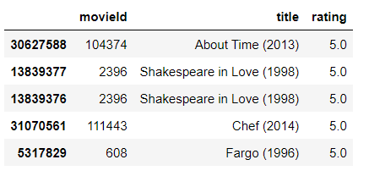

It is essential to inform that the dataset needed to be reduced to 10% of its total population, using samples, so that it would be possible for the analyzes to be carried out in order to reduce loading time and at the same time without impacting the quality of the information, or without causing loss of information. This means:

- The DataFrame has 3383216 movieId and rating lines.
- The minimum value of movieId is 1 and the minimum rating score is 0.5.
- On the other hand, the maximum value of movieId is 288977 and the maximum rating score is 5.
- The average was 28320.82 and 3.54 corresponding to the variable, and the standard deviation was 49935.93 and 1.06 respectively.

In this DataFrame, the number of lines is greater than the maximum value of movieId because it is repeated due to several users who rated the same movie. At this point in the research, it was not yet necessary to group these values ​​so that they could be analyzed more assertively.
All values ​​described were summarized in the figure below.
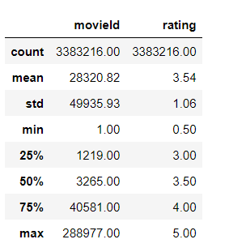
Continuing the analysis process, with the formatting of the new DataFrame, with the sample already defined, possible outliers in the numerical variables were investigated. As expected, the movieId column presented a huge amount of noise in relation to outliers in the maximum values, as it consists of continuous numbers that start at 1 up to the total number of films in the file.
For the other hand, the rating variable presented a representative volume in the lowest values ​​of the films' ratings, however these values ​​have a strong importance on the information and that is why they were not reduced so that they would not impact the loss of information and possible deviation from the trend and distribution of normality.

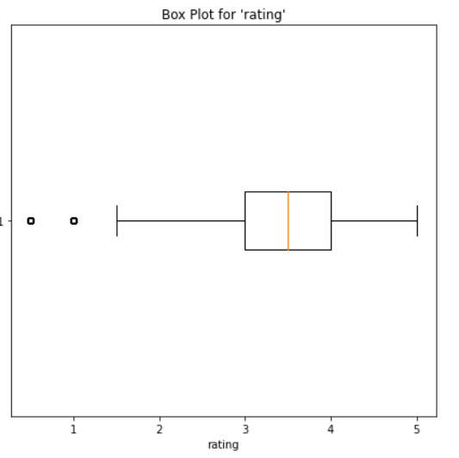

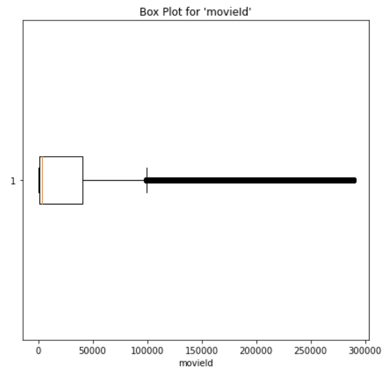

To complete this, it was investigated how the rating variables performed in relation to movieId, only for the purpose of becoming aware of this possible impact, but they do not have an analysis proposal for possible complications or changes, as they do not interfere in the individual relationship of each column.

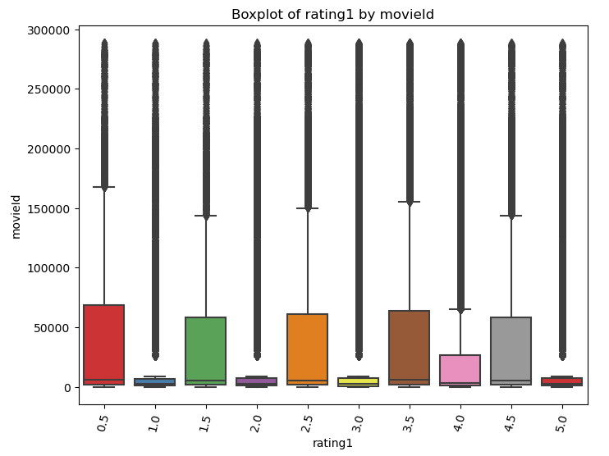

Normal Distribution (Kurtosis Test)

The next step to complete this analysis phase was to investigate the possible behaviour of the rating data. This point is fundamental to understanding how the values ​​are distributed throughout the dataset, and checking whether there is a trend in values ​​upwards or downwards.
Investigating these values, it was returned that the kurtosis test value was equal to 0.87, this means that the value is very close to 1, which means that the data is normally distributed. In other words, there is a balance between the minimum and maximum values ​​and the highest concentration is in the average.

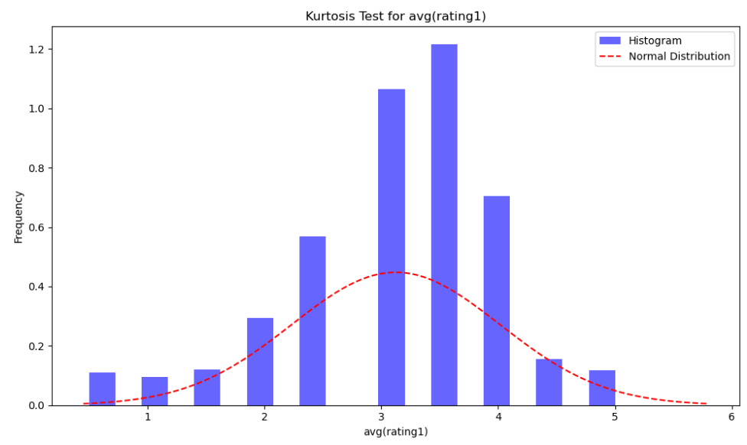

The confidence interval that the sample of values ​​has about the total population was also examined:

- Confidence Interval for 'rating' (at 95.0% confidence level):
- Mean: 3.102656349524641
- Standard Error: 0.004312033067272513
- Confidence Interval: (3.094204678680209, 3.111108020369073).

Summarizing the estimated average rating point is 3.1027.
The Standard error calculates that the sample mean is expected to differ from the population and in this case, it is 0.0043. This means that the margin of error between population and sample is very low.
The Confidence Interval allows you to evaluate the 95% reliability (in this specific case) of how much the sample value truly represents the population.
In other words, it can be stated that with 95% confidence the population average is between 3.0942 and 3.1111, while for the sample it is 3.1027. In other words, practically they have the same range.

Data Pre-Processing & Visualization

As succinctly mentioned in the previous topic, the chosen datasets were taken from the grouplens.org website and consisted of several files, of which only 2 were selected, movies and rating, to meet the objectives of this assessment. (grouplens.org, 2023).
After downloading them and reading them in the notebook, the Exploratory Data Analysis (EDA) procedure began.
The dataset named movies was composed of 86537 rows and 3 columns. The second dataset, rating, 33832162 rows and 4 columns. Both totalling a size greater than 1GB of memory usage.

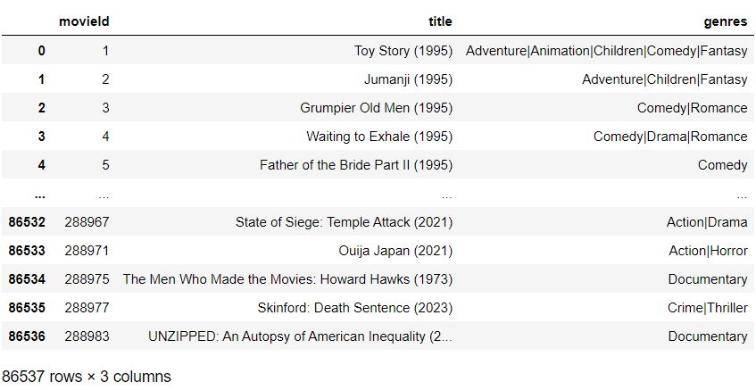

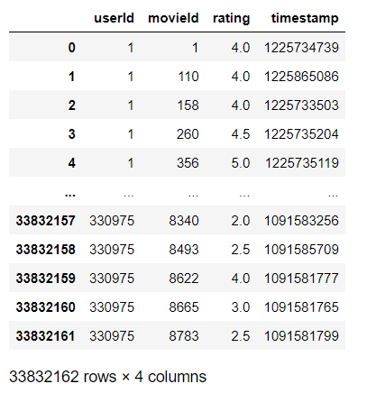

Once the datasets were presented, the first step was to merge them and drop the labels that were irrelevant. With this, a new DataFrame was structured.

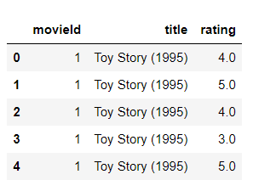

It now contains three columns, two of which are numeric variables and one of which is categorical. Counting 33,832,162 rows.
As a result, it was detected that it had 83,239 movieIds, 83,043 titles and 10 ratings in unique values. Additionally, it was checked whether there were missing values ​​and it was found that there were none. Furthermore, an aggregation was made of the numerical ratings values ​​to account for how much each value appeared.
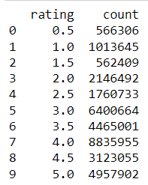

At this point in the research, it was decided that it was necessary to use samples instead of analyzing the population because as it was Big Data, the next visualization and statistics commands would take a long time to load and could possibly affect the kernel. In fact, population analysis has been tested numerous times, but they have been unsuccessful.
So, the sample contains part of the total information, but due care was taken to ensure that the values ​​represented the reality of the original. Therefore, each value is proportionally represented by 10%.
Finishing this data cleaning and formatting the information necessary to compose the DataFrame, the correlation between the various numbers was calculated and the result (-0.013) was that movieId and rating are independent variables, that is, they are not correlated as can be seen as illustrated in the correlation matrix and pairplot figures below.

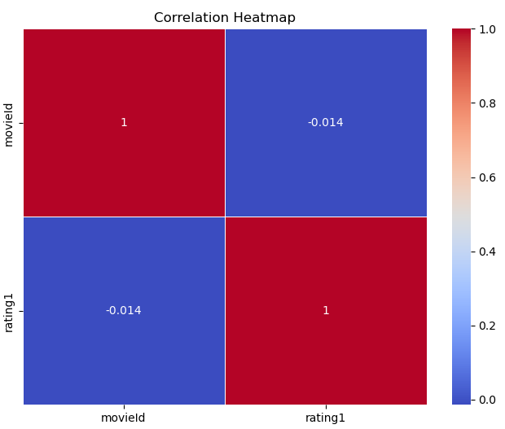

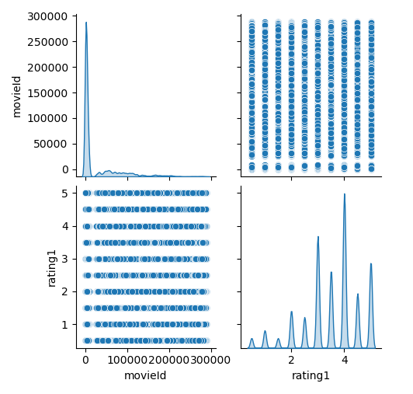

Knowing that the variables were independent, it was time to check how the ratings were distributed, in terms of numbers counted. It was detected that the majority of ratings given were 4, 3 and 5 consecutively, and the lowest rating given, in terms of numbers counted, was 1.5. Notably, no film received a score of 0.
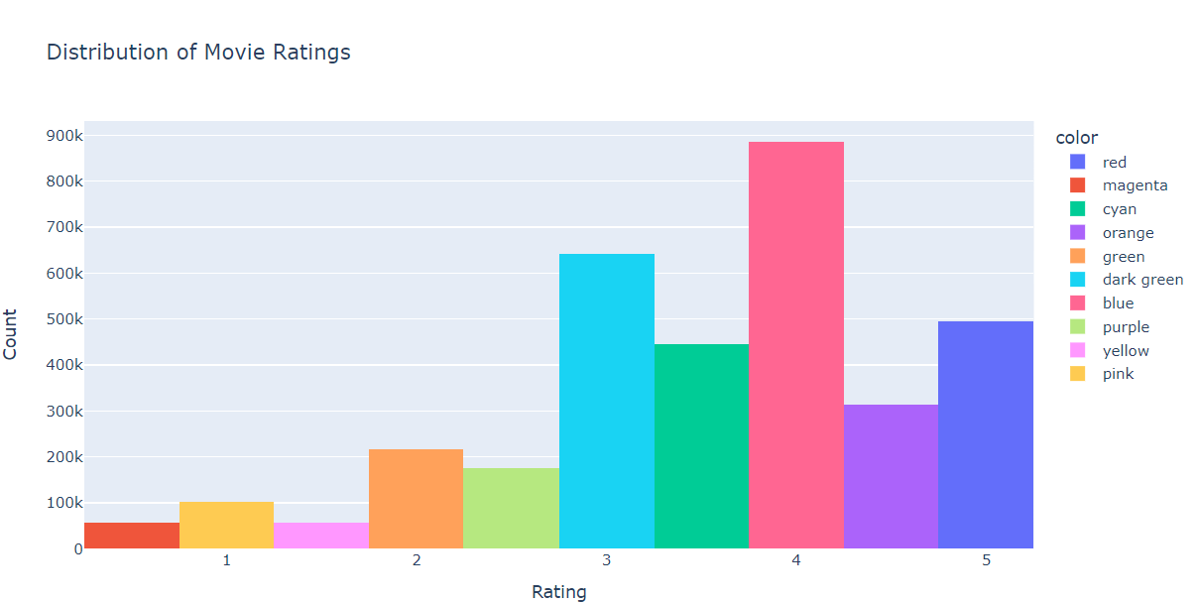

In order to build the data in the necessary shape for the next phase, Feature Engineering was started. The first action was to categorize the movieId as an index and group the film titles so that each of them appeared only once, however, the scores for each one were grouped and the average was calculated so that the information was fair and correct. The total number of rows in the DataFrame is 42389, and it contains three columns.
It can be seen that the ratings have undergone a slight change, with a rating of 3.5 being the most given among users and a rating of 1 being the least frequent on the list. The score of 0 continued not to be counted (see it in the figure below).

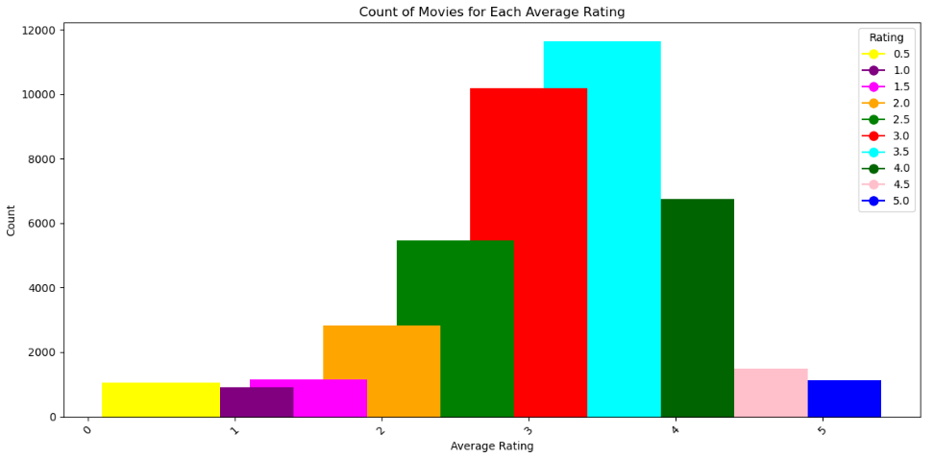

Once the format of the dataset was defined and only loaded with essential information, a customization was made where the range of notes for each category was defined and thus defined:

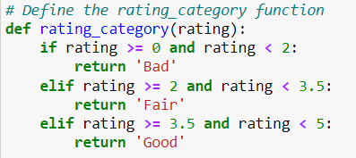

This allows the model to be trained, tested, and validated across multi-classes of three categories: 'Bad', 'Fair' and 'Good'.
Once this part was concluded, it was moved on to the next phase of analysis to build a model.

Model Building

To start building the model, the first action was to separate the data into training, testing and validation. To achieve this, it was defined that 70% of the data would be trained, and initially 30% of the data was reserved for testing. Subsequently, it was divided into 50% testing and 50% validation. In other words, 15% of the total would be tested and the other 15% to validate the results between training and testing.
Missing values ​​were also looked for among the divided data sets to ensure that no value was outside the parameters and could cause misunderstandings.
Thus this, the labels 'Bad', 'Fair' and 'Good' were encoded so that they could be transformed from categorical variables into numeric ones, to attend classification’s standards model in deep learning. Then, they became: '0', '1' and '2', respectively.
And finally, at this stage it was determined that the inputs would be the variables in ‘ratings’, and the outputs would be ‘category_rating’.
Note: As the next phase of the analysis presented technical problems in importing the TensorFlow library due to incompatibility with Pyspark and Spark or even with the virtual machine, a new notebook was created from scratch in Python and continued with the research.

Evaluation (Findings & Results)

To continue and conclude the analyses, it was determined that the neural network model that best fit this research was Feedforward Neural Networks (FNN), as it is a not very complex model and straight to the point for classifying films into categories of according to the average rating given by users.
Having divided the dataset into subsets, the next step was to define the parameters to train, test and validate the models.
For the first parameter, density 64 was used, with relu activator in the input, for the layers, density 32 was used, with relu activator, and density 3, with softmax activator as output, as it refers to the classes 'Good', 'Fair', 'Bad', it was also defined that 10 epochs would be used. Adam was defined as the optimizer. Thus, both the loss of data information and the accuracy were tested. This parameter model performed well and presented Test loss: 2.610244700917974e-05 and Test accuracy: 1.0. Which is a great result.
However, to ensure that the analysis presented a satisfactory result, a second parameter was used, being density 128, with sigmoid activator in the input, density 64, also with igmoid activator in the hidden layers, density 3, with softmax activator in the outputs. RMSprop was defined as the optimizer, and 10 epochs. This second parameter model also performed well with the result of Test loss: 4.6205055696191266e-05 and Test accuracy: 1.0.
It is important to emphasize that for an analysis to be as assertive as possible, several parameters must be tested in terms of activators and optimizers, in terms of the value defined to perform with these parameters. It is also necessary to know the value of your input and output so that there are no errors in the results.
With all this, to define and discuss which parameter model had the best performance, a Hyperparameter Tuning analysis was carried out using cross-validation, in which the models were placed side by side and calculated which one had the best result and in return we obtained Best Accuracy on Validation Set: 1.0 and Accuracy on Test Set: 1.0. In other words, the best parameter model was tested number 1.
Given this, the error analysis of test number 1 was evaluated, and the conclusion was that according to the Classification Report, the accuracy is 0.42. That is not satisfactory.
The next step was to perform the 5-fold cross-validation in test number 1 for the 10 epochs in order to validate its result. All 5 folders obtained Cross-Validation Scores: [1.0, 1.0, 1.0, 1.0, 1.0] and Mean Accuracy: 1.0. Which means that the test was validated with 100% accuracy in the scores and the average of all of them.
The last step to finalize the analyzes was to check whether the subset as well as the test and validation subsets accommodated each other, and we saw that they did not present a good model, without much variation in overfitting and underfitting, as can be seen in the graph below.

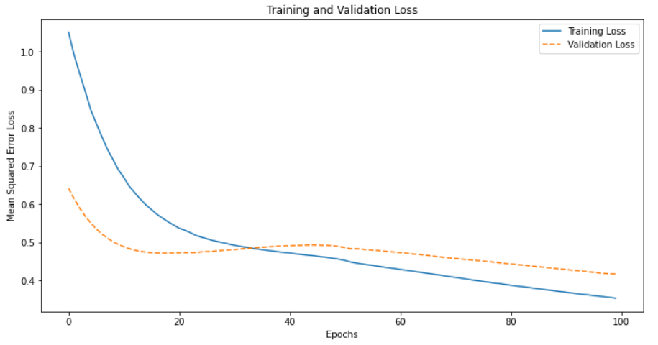

Limitations

Throughout the entire research and development process of this assessment, many limitations were experienced. First, despite there is a wide variety of free websites to consult and download datasets, finding a dataset large enough to meet the demands of the course and a topic that would be attractive to the researcher requires plenty of time.
After this first need is satisfied, running big data requires in-depth knowledge and instruction to ensure no information is lost.
Although the initial objective was to analyze the population of that data set, it became unfeasible to execute the commands due to their loading time, making it unworkable. The next step was to work with the sample, taking due care so that the values were proportionally equal to the populations.
Another fundamental limitation that must be mentioned is the difficulty of executing the TensorFlow library, which caused the kernel to automatically restart or die several times, making this part of the evaluation the most challenging, arduous, and time-consuming. The virtual machine was cloned, and its memory storage was increased to avoid crashes in the Spark’s commands. Additionally, some adjustments were needed for its version. With assistance from the technical support team and a professor, it was discovered that Tensorflow was not functioning properly within the Virtual Machine (VM). As a result, a new notebook was created within Python Jupyter notebook, but outside the VM, specifically for processing the Deep Learning part of the analysis.
Finally, more practical and laboratory classes are essential to assist with technical problems throughout the learning and execution process. After all, these were the difficulties encountered during the analysis process.

Conclusion

Despite the challenges encountered at all stages of research and execution, this assessment contributes greatly to enriching the researcher's technical knowledge, as working in two different environments Pyspark (virtual machine) and Python made it possible to understand the difference between these two systems, such as libraries and commands. Even though it did not meet 100% of the requirements of the course subjects, the assessment is considered fulfilled as it managed to achieve the objectives of classifying a list of movies from Big Data using neural network tools, which in this specific case was chosen FNN (Feedforward neural network). Even though it was less complex than other neural networks, it met the demands that this research required.
To conclude, it is attested that deep learning was used using big data and that through training, testing and validation the model obtained an insignificant loss of data and a good accuracy index.

References

F. Maxwell Harper and Joseph A. Konstan. . (2015). The MovieLens Datasets: History and Context. . Retrieved from ACM Transactions on Interactive Intelligent Systems (TiiS) 5, 4: 19:1–19:19. https://doi.org/10.1145/2827872: https://files.grouplens.org/datasets/movielens/ml-latest-README.html

Goodfellow I., Bengio Y., and Courville A. (2017). Deep Learning. Massachusetts, USA: Massachusetts Institute of Technology.

grouplens.org. (2023). grouplens.org/datasets/movielens/latest/. Retrieved from grouplens.org: https://grouplens.org/datasets/movielens/latest/

McAfee, A., & Brynjolfsson, E. . (2012). Big data: The management revolution. Harvard Business Review, 60-68.

