**CCT College Dublin**

**Assessment Cover Page**

|  |  |
| --- | --- |
| Module Title(s): | Programming for DA  Statistics for Data Analytics  Machine Learning for Data Analysis  Data Preparation & Visualisation |
| Assessment Title: | MSC_DA_CA2 |
| Lecturer(s) Names: | Sam Weiss  John O’Sullivan  Muhammad Iqbal  David McQuaid |
| Student Full Name: | Clelia Caetano |
| Student Number: | 2023060 |
| Assessment Due Date: | 26/05/2023 |
| Date of Submission: | 26/05/2023 |

**Declaration**

|  |
| --- |
| By submitting this assessment, I confirm that I have read the CCT policy on Academic Misconduct and understand the implications of submitting work that is not my own or does not appropriately reference material taken from a third party or another source. I declare it to be my work and that all material from third parties has been appropriately referenced. I further confirm that this work has yet to be submitted for assessment by myself or someone else in CCT College Dublin or any other higher education institution. |

Author: Clelia Caetano

E-mail: [2023060@student.cct.ie](mailto:2023060@student.cct.ie)

Student ID:2023060

GitHub: [CleliaCaetano/CA2_Construction_local (github.com)](https://github.com/CleliaCaetano/CA2_Construction_local)

Constructions:

Workplace Accidents

CCT College Dublin

May (2023)

# Abstract

***Keywords:***

Table of Contents

Abstract 3

List of Tables 6

1. Introduction 7

2. Statistics for Data Analytics 7

2.1 Collect Initial Data 7

2.2 Describe Data 8

Multivariate analysis (Correlation between Features): 8

Outliers: 9

2.2.1 Distribution (Kurtosis Test) 11

2.2.2 Log Transformation 12

2.2.3 Shapiro-Wilk test 12

2.2.4 Probability density function (PDF) of the normal distribution 13

2.3 The Kolmogorov-Smirnov (non-parametric) 13

test to compare the normality of the original and transformed variables: 13

2.4 Kruskal-Wallis (non-parametric) test 14

to investigate the relationship between the risk level and each variables of interest: 14

2.5 Mann-Whitney U (non-parametric) test: 15

Comparison between Ireland and other 29 Union European countries: 15

2.3 Explore Data 15

2.4 Verify Data Quality 15

3. Data Preparation 15

3.1 Dataset Description 16

3.2 Select Data 16

3.3 Clean Data 16

3.4 Construct Data 16

3.5 Integrate Data 16

3.6 Format Data 16

4. Modeling 16

4.1 Select Modeling Technique 17

4.2 Generate Test Design 17

4.3 Build Model 17

4.4 Assess Model 17

Decision Tree Model 17

Random Forest 17

K-Nearest Neighbor Classifier 17

5. Evaluation 17

5.1 Evaluate Results 18

5.2 Review Process 18

5.3 Determine Next Steps 18

6. Conclusion 20

6.1 Plan Deployment 20

6.2 Plan Monitoring and Maintenance 20

6.3 Product Final Report 20

References 20

Appendix 21

1. Evidencing statistical calculations 21

21

# List of Tables

# 1. Introduction

The construction sector is a complex business as it encompasses several sales & purchase relationships. Contracts are signed in all the processes, whether with suppliers, buyers or hiring labour. All these relationships have a direct impact on progress and compliance with financial schedules and budgets.

After some research, it was found that there are not many studies on the risks of accidents to which workers in this sector are exposed. It is worth mentioning that this workforce has a high connection with the costs and schedules of work. Because if an employee suffers an accident, he will have to be absent from his duties, leading to delays, medical expenses, demotivation and even an overload of other workers.

According to HAS, “ In 2020, the NACE economic sector with the highest rate of work-related injuries leading to four or more days of absence from work was Construction (15.5 per 1,000 workers)”. (Authority, 2022).

Thus, this project merges all the information data collected and shows the results raised.

This case study aims to statistically analyse data from the dataset to compare numerical variables across countries and apply Machine Learning models to classify 30 European Union countries into a risk range.

# 2. Statistics for Data Analytics

## 2.1 Collect Initial Data

Initially, three different datasets from the European Union (Eurostat) website were collected. These are the Number of employees (SBS_SC_CON_R2), the Number of non-fatal accidents (HSW_N2_01) and the Number of fatal accidents (HSW_N2_02). (Union, 2023).

These files have information of 30 countries of the European Union (AT: Austria, BE: Belgium, BG: Bulgaria, CY: Cyprus, CZ: Czech Republic, DE: Germany, DK: Denmark, EE: Estonia, EL: Greece, ES: Spain, FI: Finland, FR: France, HR: Croatia, HU: Hungary, IE: Ireland, IS: Iceland, IT: Italy, LT: Lithuania, LU: Luxembourg, LV: Latvia, MT: Malta, NL: Netherlands, NO: Norway, PL: Poland, PT: Portugal, RO: Romania, SE: Sweden, SI: Slovenia, SK: Slovakia and UK: United Kingdom) from the years 2011 to 2020.

## 2.2 Describe Data

After carrying out the pre-preparation and cleaning process, the three files were merged into a single dataset.

Figure 1: DataFrame head.

Which means:

* there is in a clear DataFrame a sample with 294 observations & 5 variables ('geo' is a categorical variable, and the other columns are numerical variables).
* the variables are considered multivariate analysis.
* the dataset has a continuous numerical probability, which the outcome can take any value within a certain interval.

With the Data Frame defined, it was time to observe the outliers and check their extreme values ​​and how they can interfere with the results of the analyses. It was verified that there were extremely high numbers above the maximum value in the three measured variables.

Figure 2: Outliers

It was also defined that these outliers were essential data for the project, so they were winsorized to reduce noise. But it was determined that this technique would be applied to reduce only 5% of the anomaly. Where the first variable reduced from 4M to 3M, the second variable from 1.5M to 1.2m and the third variable from 300 to 200. As it is displayed in the figure below.

Figure 3:Winsorized outliers.

Subsequently reducing anomalies and possible errors, the next point is to check the statistical metrics.

Figure 4: Statistical metrics.

It is observed:

* the average (mean) indicates that the number of employees in the construction area of the European Union countries covered in this study is 705,826.96 and that the number of non-fatal accidents is 203,102.63 and fatal accidents 53.86.
* the standard deviation shows that 940,941.73 is the value of the number of employees, 387,533.18 is the number of non-fatal accidents and 68.05 is the value of the number of fatal accidents.
* Other measures as quartiles (25%, 50% and 75%) and maximum & minimum values are also indicating in the analyse and can be observed in the table.

All this information can also be observed in an interactive graph in Jupyter notebook version.

Figure 5: DataFrame Description.

## 2.2.1 Distribution (Kurtosis Test)

To detect whether the variables are independent or random, it is essential to test the normal distribution of the data set to check the statistical probability in the distribution.

Ideally, when returning from this test, the distribution should appear symmetrical to the mean value. Unlike the ideal, the bell of the curve in this data is positively sloped to the right, meaning that there is no normal distribution and that the variables are skewed to the right.

In the kurtosis test, p-values ​​and statistics were also printed, which returned as zero, reassuring that the data does not follow a normal distribution.

Figure 6: Distribution (Kurtosis Test).

## 2.2.2 Log Transformation

Employing the log transformation to modify the scale to reduce the skewness and review the normal distribution.

For this, some rules were settled, where the value '+1' was applied to keep the '0' instead of turning it into a negative value in the variables Number of fatal accidents and Number of fatal accidents.

Figure 7: Log Transformation Applied.

Visibly, the data still does not follow the normal distribution because where it should be a bell curve, it presents a wave shape.

## 2.2.3 Shapiro-Wilk test



Figure 8: Shapiro-Wilk test results table.

## 2.2.4 Probability density function (PDF) of the normal distribution



Figure 9.: Probability density function result (table).

Figure 10: Probability density function visual result.

## 2.3 The Kolmogorov-Smirnov (non-parametric)

## test to compare the normality of the original and transformed variables:



## 2.4 Kruskal-Wallis (non-parametric) test

## to investigate the relationship between the risk level and each variables of interest:

## 2.5 Mann-Whitney U (non-parametric) test:

## Comparison between Ireland and other 29 Union European countries:

# 3. Data Preparation & Visualization

## 3.1 Dataset Description

At first, the idea was to find data from few countries to compare the metrics between them, but due to the variety of different languages ​​and also the lack of data with similar subjects, the objective became to look for files that integrated more than one country. The data required to construct this project was found after searching the Eurostat website. Both files come from the same authority and they are all open source. The copyright license can be verified in the link provided in the references. (Union, 1995).

## 3.2 Select Data

Three files, Number of employees, Number of non-fatal accidents and Number of fatal accidents, were selected to compose the analysis about the risk level of working in construction.

These row data are listed in next.

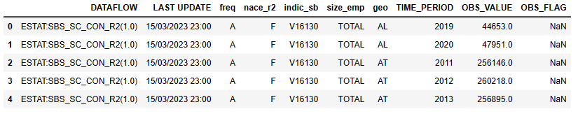

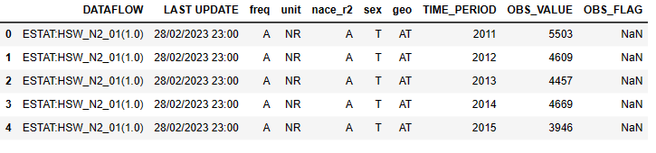

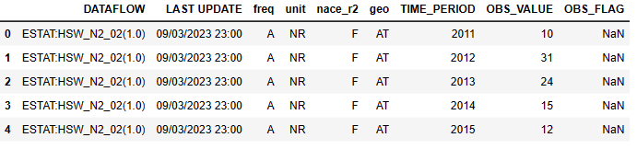

## 3.3 Clean Data

Datasets needed to be cleaned up before being merged. Features were renamed with the variable name so that they could be identified and all irrelevant and/or duplicate columns, such as search code and year of last update were dropped. The rows that divided the information between construction sub-sectors were grouped. Some data that differed from one file to another, such as countries, were also dropped. This made the data frames have the same shape.

## 3.4 Building Data

Using the functions intersections to delimit the variable, grouped so that the values ​​are integrated and merged, the datasets were allocated in a data collection.

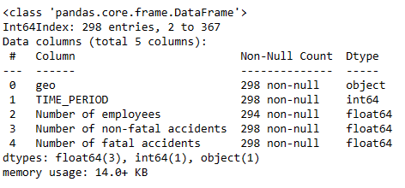

This dataframe underwent other cleaning techniques, so it was necessary to look for missing values ​​and address a possible solution for them.

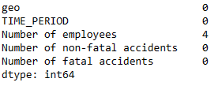

Due to the small number of missing values, they were dropped, as they would not cause major impacts on the analyses.

The column TIME_PERIOD was converted to datetime64[ns] format to validate as an index.

Along with the application of all these techniques mentioned, a new dataframe was built.

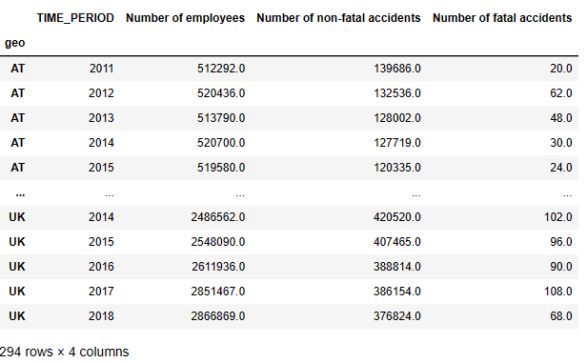

To continue the analyses, it is necessary to check the correlation between all the variables gathered within a data structure. Applying the correlation matrix implies understanding the dimension of independence or dependence among the variables and the existence of trends or patterns. A heatmap completes the analysis as a visual way to better recognize the relationships.

Figure 11: Multivariate analysis (Correlation between Features).

This figure shows that the TIME_PERIOD resource has no correlation with any other resource, as it is an independent variable. However, the Number of employees, Number of non-fatal accidents & Number of fatal accidents have a correlation above 70%, this means that they are dependent variables.

Another visual format (pair plot) was designed to illustrate the correlation of these variables.

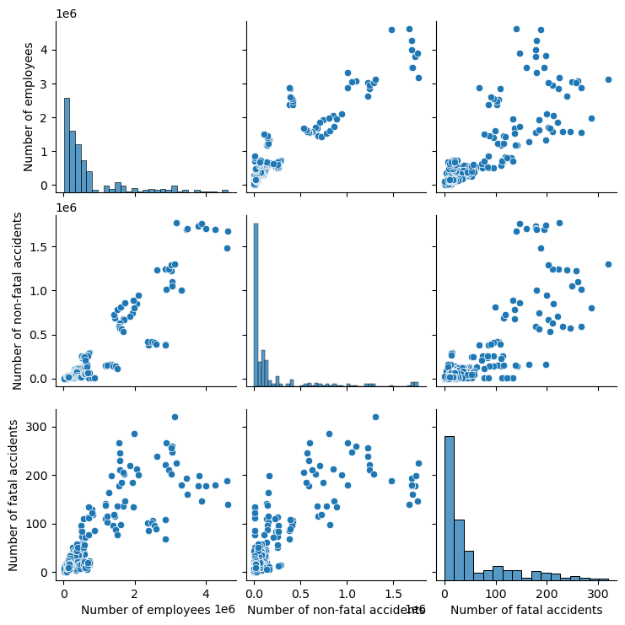

## 3.5 Format Data

Sequentially, the first analysis applications were carried out directly in the countries on the list and a comparison between them was raised. With a simple mathematical calculation (Total accidents = Number of non-fatal accidents + Number of fatal accidents) the Total number of Accidents was found and put into practice. It was verified through a choropleth of how this measure behaved over the years.

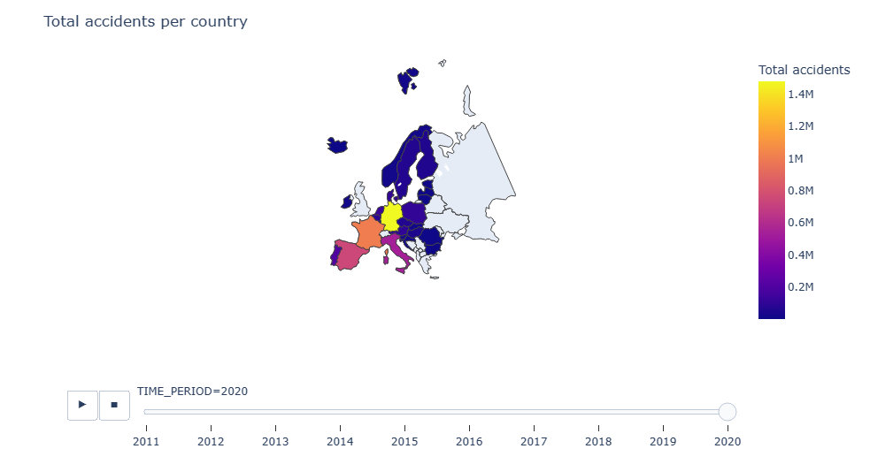

And then, an interactive graph comparing non-fatal and fatal accidents between countries was plotted.

Note that Germany, Spain, France & Italy have the highest number of accidents on the list and Ireland is among the medium-value countries.

It should be mentioned that two new features were created to allocate accident percentages by type. And once again simple calculation was applied to find these values.

* percentage_non_fatal = Number of non-fatal accidents / Number of employees * 100
* percentage_fatal = Number of fatal accidents / Number of employees * 100

Later, it was necessary to use other functions to adjust the measures, so the function scaler = MinMaxScaler() was applied to scale between 0 and 1 the selected columns 'Total accidents', 'percentage_non_fatal', 'percentage_fatal'. Other features were created to allocate risk level and risk range. Then, the mapping function was used to transform the risk range from categorical to a numerical variable.

* ['high', 'moderate', 'low']
* Categories (3, object): ['low' < 'moderate' < 'high']

# 4. Modeling

## 4.1 Select Modeling Technique

## 4.2 Generate Test Design

## 4.3 Build Model

## 4.4 Assess Model

## Decision Tree Model

## Random Forest

## K-Nearest Neighbor Classifier

# 5. Evaluation

## 5.1 Evaluate Results



## 5.2 Review Process

## 5.3 Determine Next Steps



# 6. Conclusion

## 6.1 Plan Deployment

## 6.2 Plan Monitoring and Maintenance

## 6.3 Product Final Report

# References

Authority, H. a. S., 2022. *hsa.ie.* [Online]   
Available at: https://www.hsa.ie/eng/topics/statistics/annual_review_of_workplace_injuries_illnesses_and_fatalities_20202021.pdf  
[Accessed 2 May 2023].

Union, E., 1995. *Eurostat.* [Online]   
Available at: https://ec.europa.eu/eurostat/web/main/about-us/policies/copyright  
[Accessed 3 May 2023].

Union, E., 2023. *Eurostat.* [Online]   
Available at: https://ec.europa.eu/eurostat/databrowser/view/SBS_SC_CON_R2__custom_6155496/default/table?lang=en  
[Accessed 28 April 2023].

Union, E., 2023. *Eurostat.* [Online]   
Available at: https://ec.europa.eu/eurostat/databrowser/view/HSW_N2_01__custom_6154887/default/table?lang=en  
[Accessed 28 April 2023].

Union, E., 2023. *Eurostat.* [Online]   
Available at: https://ec.europa.eu/eurostat/databrowser/view/HSW_N2_02__custom_6154914/default/table?lang=en  
[Accessed 28 April 2023].

# Appendix

## 1. Evidencing statistical calculations

# 



