mRNA Data Management Platform — Documentation
Table of Contents

mRNA Data Management Platform — Documentation
A browser-based workbench for designing, analyzing, QC-ing, scoring and assembling mRNA sequences — end to end, with no code. It gives RNA-therapeutics teams a single structured record for every construct, an explainable QC layer, pluggable AI models, and experiment tracking that lays the groundwork for a closed Design-Build-Test-Learn loop.
- Live app: https://offtargeteffect-mrna-design-studio.hf.space
- Stack: Python 3.13 · Panel/Bokeh · Plotly · pandas/NumPy · SQLAlchemy · BioPython · DNAChisel · ViennaRNA (optional)

Table of contents
- What it is
- Architecture
- The application (tab by tab)
- The analysis engine
- Liability / QC scoring
- Candidate objective scoring
- Codon-optimization analysis
- The model system (pluggable AI)
- Experiment / run tracking
- The data layer
- Configuration
- Running it
- Deployment
- Testing
- Project structure
- Extending the platform
- Scope & roadmap

1. What it is
The platform takes an mRNA construct from import → analyse & QC → compare & score → assemble, in one reactive UI. Its design goals:
- One structured record per construct (no sequences scattered across spreadsheets).
- Explainable QC — every quality flag and score traces back to a specific metric.
- Pluggable intelligence — scoring/generative models register as plugins (local code or remote API); the platform itself is the deterministic data + orchestration layer.
- Traceability — every model run is logged with its version and comparable over time.
It is a prototype: a focused workbench over curated sets, not production NGS-scale infrastructure. See Scope & roadmap.

2. Architecture
Layered, with a strict separation between a pure domain core and the UI:
┌─────────────────────────────────────────────────────────────┐
│ UI layer ui/ │
│ Panel/Bokeh reactive components; one AppState per session │
├─────────────────────────────────────────────────────────────┤
│ Domain core core/ │
│ Pure-Python analysis & models — no UI deps, fully unit-tested │
├─────────────────────────────────────────────────────────────┤
│ Model layer models/ │
│ Pluggable scoring/generative model registry + run tracking │
├─────────────────────────────────────────────────────────────┤
│ Data layer core/database/ │
│ SQLAlchemy + CSV importers, schema-mapped to a canonical model│
└─────────────────────────────────────────────────────────────┘
- core/ has no Panel/Plotly imports — it can be tested and reused headlessly.
- ui/state.py holds AppState, a param.Parameterized object instantiated once per browser session; every component reacts to its parameters.
- Data flows one way: importers → mRNASequence model → SequenceAnalyzer → AnalysisReport → scoring/UI.

3. The application (tab by tab)
Tab | Purpose
Import Data | Load sequences from CSV/Excel or PostgreSQL; columns auto-map to the mRNA model; import into a worklist.
Model Repository | Browse/register scoring & generative models (local Python or remote API), each versioned.
Worklist | Inspect sequences; run base analysis (GC, CAI, homopolymers, restriction sites) + QC score; per-row liability breakdown; score with models; export CSV.
Candidate Analysis | Multi-objective comparison scorecard (Expression / Stability / Immunogenicity / Manufacturability + Overall) with shortlist; per-candidate structure map + codon analysis.
Experiments | Registered model versions, run history, and version-to-version score comparison.
Parts Workshop | Browse/compose reusable parts (5′UTR, Kozak, CDS, 3′UTR, poly-A).
Assemble Plasmid | Pick a backbone & cloning strategy, run QC, export the assembled construct.
Generate Sequences | Produce codon-optimized variants from configurable settings.
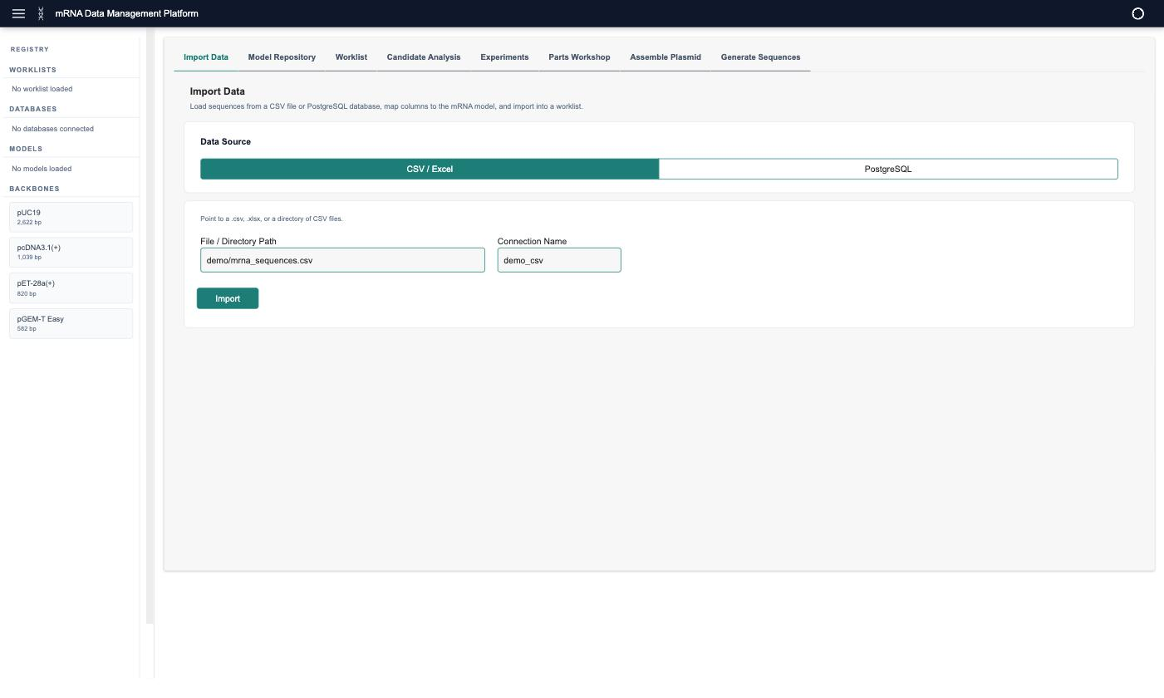
Import Data — load sequences from CSV/Excel or PostgreSQL; columns auto-map to the structured mRNA model.
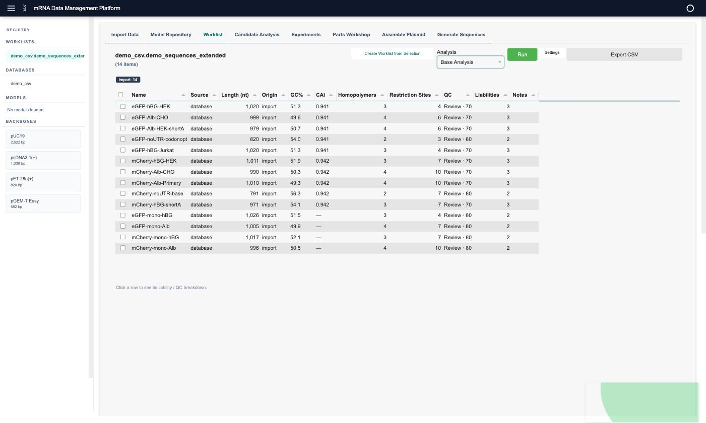
Worklist — the imported panel with base analysis run: GC%, CAI, homopolymers, restriction sites, and the QC score / liabilities count per candidate.

4. The analysis engine
core/analysis/analyzer.py → SequenceAnalyzer.run_full_analysis(seq) is the single entry point that runs the entire QC panel on one sequence and returns one AnalysisReport. It is a deterministic pipeline — not an ML model: same input → same output, every result explainable.
Pipeline steps: 1. Assemble the full sequence (5′UTR + Kozak + CDS + 3′UTR + poly-A, or the supplied full_mrna). 2. Run each analysis module: - GC content (gc_content.py) — global % + sliding window + GC-by-codon-position - CAI (cai.py) — Codon Adaptation Index + codon usage, per host organism - CDS validation — start (ATG), stop codon, in-frame (÷3) - Homopolymers (homopolymers.py) — runs of repeated bases - Restriction sites (restriction_sites.py) — common cloning enzymes - Kozak context (kozak.py) — translation-initiation strength - Secondary structure (structure.py) — ViennaRNA MFE (optional; stub if not installed) - Uridine content (uridine.py) — total % + high-U stretches - Motifs (motifs.py) — uORFs, premature polyA, AU-rich elements, splice donors 3. Aggregate a liability/QC assessment (liability.py).
Two behaviours worth knowing: - Caching — results are stored on the sequence (_analysis_cache); re-analysis is a cache hit unless force_rerun=True. - Configurable — the analyzer is constructed with gc_window, gc_step, homopolymer_min_run, restriction_enzymes, and cai_organism, so QC rules are tunable per programme/modality.
Output: an AnalysisReport dataclass holding every result + a to_dict() for the worklist/table.

5. Liability / QC scoring
core/analysis/liability.py → assess_liabilities(report, seq) rolls the analysis into a severity-ranked list of flags + a 0–100 QC score + a verdict (pass / review / fail).
- Flags (each with severity, detail, location, recommendation) cover: GC out of range, homopolymer runs (excluding the legitimate poly-A tail), restriction sites, elevated uridine, CDS integrity, weak Kozak, strong structure, and sequence motifs.
- Severity → penalty: critical −25, warning −10, info −3. Score = max(0, 100 − Σ penalties).
- Verdict: any critical → fail; else any warning → review; else pass.
Surfaced as a scorecard (analysis dashboard / candidate inspect) and as QC + Liabilities columns in the worklist.
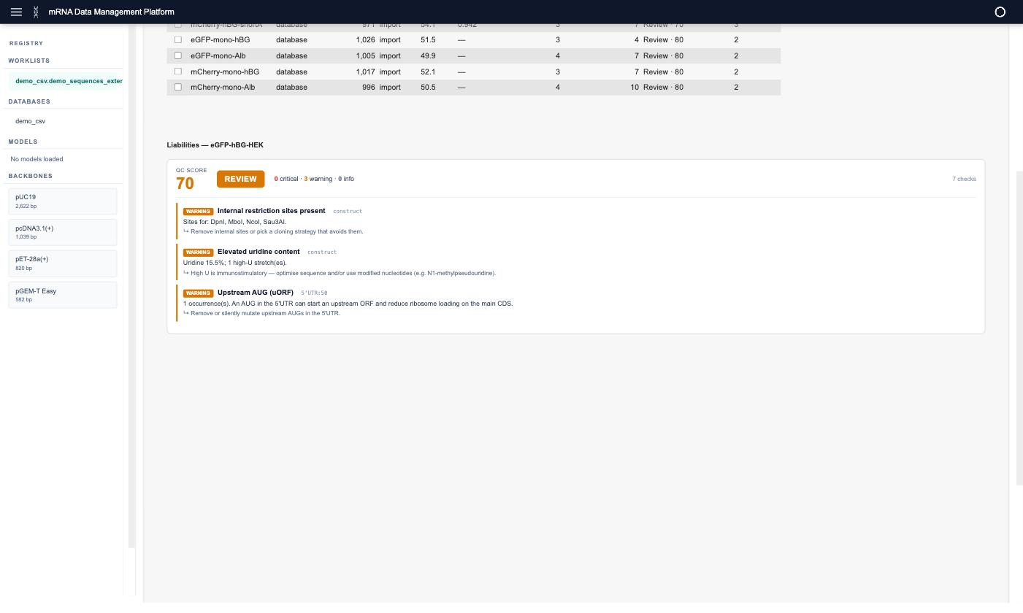
Per-sequence liability breakdown — a 0–100 QC score, a pass/review/fail verdict, severity counts, and each flag with its location and recommendation.

6. Candidate objective scoring
core/analysis/candidate_score.py → score_objectives(report) condenses the report into the four objectives mRNA designers trade off, each 0–100, higher is better. These are transparent weighted heuristics, not trained models.
Objective | Formula (summary)
Expression | 0.6 × CAI(0–100) + 0.4 × Kozak (strong 100 / adequate 70 / weak 35)
Stability | GC distance from 50–60% optimal band, − homopolymer penalty, + folding-MFE bonus if available
Immunogenicity | 100 − (uridine% − 20)×3 − 8 × high-U stretches (low U = high score)
Manufacturability | 100 − penalties for restriction sites / homopolymers / GC extremes / splice motifs
Overall | weighted mean: Expression 30% · Stability 25% · Immunogenicity 20% · Manufacturability 25%
All scores clamp to 0–100; missing metrics fall back to neutral defaults. The Candidate Analysis tab ranks by Overall, colour-codes by band, and shortlists the top N.
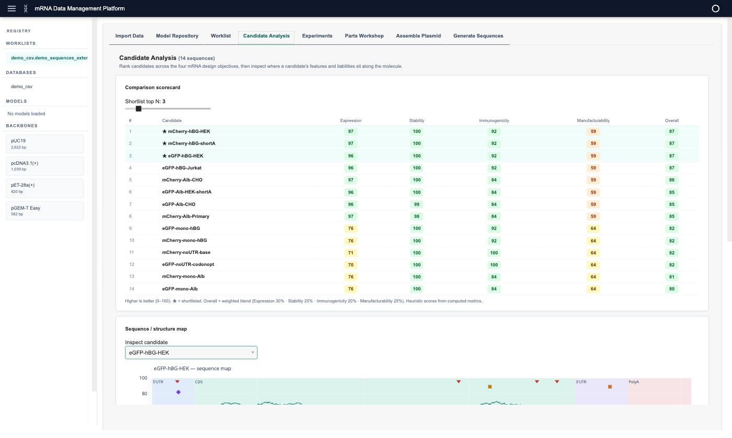
Candidate Analysis — the comparison scorecard ranking every candidate across the four objectives, with the top-N shortlist (★) and a per-candidate sequence/structure map below.

7. Codon-optimization analysis
core/analysis/codon_analysis.py → analyze_codons(cds, organism) provides per-codon detail:
- Per-codon optimality — each codon’s relative adaptiveness (0–1) vs the best synonym.
- %MinMax profile — classic sliding-window measure (positive = common/fast codons, negative = rare/slow clusters that stall ribosomes).
- Rare-codon clusters — runs of low-optimality codons worth recoding.
- Original-vs-optimized projection — projected CAI gain and rare-codon reduction if the CDS were optimized for the host (reuses core/sequence_tools/codon_optimizer.py).

8. The model system (pluggable AI)
This is where ML lives — separate from the deterministic analysis pipeline. Defined in models/base.py:
- ScoringModel (ABC) — name, description, version, score(sequence) → float, score_batch(...).
- GenerativeModel (ABC) — generate(constraints, n, seed) → [sequences].
- APIScoringModel / APIGenerativeModel — wrap a remote REST endpoint (POST sequences → scores/sequences).
- ModelRegistry — registers models from a local Python file (load_local) or an API endpoint; exposes scoring_models, generative_models, run_scoring, run_generation.
Built-in example scorers: models/mrna_stability_scorer.py, models/rna_structure_scorer.py. A models/catalog.py lists public models that can be imported.
Framing: the platform is AI-enabling infrastructure — structured data in, models run against it, every run tracked. The intelligence plugs in; the platform is not itself a model.

9. Experiment / run tracking
models/runs.py records every scoring run:
- ModelRun — model name + version + source, worklist, N, score min/max/mean/std, timestamp, and the per-sequence scores.
- RunHistory — append-only store; for_model(), model_names(), and compare(run_a, run_b) → a RunComparison with per-sequence deltas and improved/worsened/unchanged counts.
The Experiments tab shows registered model versions, the run history, and a version-to-version comparison. This is the “Learn” scaffolding of the DBTL loop.

10. The data layer
core/database/ provides a uniform import interface:
- base.py — DatabaseConnector interface + SchemaMapper (maps arbitrary source columns to the canonical mRNASequence model).
- postgres.py (SQLAlchemy + psycopg2), sqlite.py, csv_importer.py (CSV/Excel).
Core models (core/models/): - mRNASequence — the canonical record: optional components (5′UTR, Kozak, CDS, 3′UTR, poly-A) or a full_mrna, plus metadata; assembled_sequence concatenates components. - Worklist / WorklistItem, PlasmidBackbone, SequencePart.

11. Configuration
Environment variables (see .env.example; loaded via python-dotenv):
Variable | Purpose
MRNA_STUDIO_PASSWORD | Single shared password (any username) — enables the login screen
MRNA_STUDIO_USERS | JSON {"user": "pass"} for multiple users (overrides the above)
MRNA_STUDIO_COOKIE_SECRET | Session-cookie signing secret (set in production)
PORT / HOST | Server bind (default 5007 / 0.0.0.0; platforms set PORT automatically)
MRNA_STUDIO_RELOAD | 1 enables hot-reload in development
If neither password variable is set, the app runs open (no login).

12. Running it
Prerequisites: a terminal with make and curl (no system Python needed — setup installs uv + Python 3.13).
make setup # install uv, Python 3.13, venv, dependencies (~1 min)
make run # start at http://localhost:5007
make run-secure # password-protected (requires .env)
make test # run the test suite
make lint # ruff
make kill # stop the app
Optional demo database (Docker):
make db-up # start demo PostgreSQL
make db-down # stop it
Sample data lives in demo/ (demo_sequences_extended.csv is the richest).

13. Deployment
The app is containerised (Dockerfile) and reads PORT/HOST from the environment, so it runs on any container host.
- Hosted demo: Hugging Face Spaces (Docker SDK, app_port: 5007). Secrets (MRNA_STUDIO_PASSWORD, MRNA_STUDIO_COOKIE_SECRET) are set in Space settings.
- Also supported: Railway, Render, local Docker (make docker-build / make docker-run).
Note: ViennaRNA is optional and not in the hosted image — secondary-structure results show as a stub there; all other analyses run.

14. Testing
pytest suite under tests/ (run with make test): test_analysis.py, test_liability.py, test_candidate_score.py, test_codon_analysis.py, test_runs.py, test_models.py, test_database.py. The pure-core design means the analysis, scoring, and model logic are all unit-tested without the UI. 118 tests at time of writing.

15. Project structure
core/
analysis/ analyzer.py + GC, CAI, homopolymers, restriction_sites, kozak,
structure, uridine, motifs, liability, candidate_score, codon_analysis
database/ base (SchemaMapper) + postgres / sqlite / csv importers
models/ mRNASequence, Worklist, PlasmidBackbone, SequencePart
sequence_tools/ codon_optimizer, clean_for_cloning
data/ seed parts & backbones
models/ ScoringModel/GenerativeModel ABCs, ModelRegistry, runs (tracking),
built-in scorers, catalog
ui/
app.py Panel entry point (template, tabs, auth, serve)
state.py AppState (per-session reactive state)
components/ one module per tab + shared panels
tests/ pytest suite
demo/ sample data, demo DB, deck, demo script
Dockerfile, Makefile, Procfile, pyproject.toml, requirements.txt

16. Extending the platform
Add a scoring model — drop a Python file exposing a ScoringModel subclass and load it via the Model Repository (or ModelRegistry.load_local(path)), or register a REST endpoint with register_api_scorer(...). Every run is then tracked automatically.
Add an analysis — write a pure function/module under core/analysis/, add its result to AnalysisReport, compute it in run_full_analysis, and (optionally) feed it into assess_liabilities / score_objectives. Add a test under tests/.
Add a tab — create a component under ui/components/, then register it in ui/app.py (_TAB_NAMES / _TAB_KEYS + the pn.Tabs construction).

17. Scope & roadmap
Today (prototype): import & structured model · explainable QC/liability · multi-objective candidate comparison · codon analysis · pluggable model scoring · run/version tracking · parts/assembly/generation. Demonstrates DBTL steps 1 (design), 2 (automated QC), and 4 (feedback/versioning).
Not yet built: wet-lab experimental testing (step 3, external by nature), automated outcome ingestion and model retraining, NGS-scale ingestion, and structure-based developability. These are the closed-loop and scale roadmap items.

