

Project plan

2022-09-12

The Swedish Registration Office (Bolagsverket)

# 

| Wisam Orabi  Lovisa Berglund  Mattias Lindblom  Ahmad Setoodeh  Clement Lefebvre | Project Based Product Development 2022 |
| --- | --- |

# Table of contents

**Table of contents** **2**

**Problem definition: Overall aim/company need/market need** **3**

**Measurable goals (e.g. some performance measure)** **3**

**Suggested prototype (block chart/component diagram)** **5**

**Project methods and development** **7**

Project methods : 7

Development methods: 9

Development tools: 11

**Division of labor / roles in the group** **12**

**A time schedule with activities and the time you estimate for each activity** **12**

**Project risk analysis** **13**

**References** **14**

## 

## Problem definition: Overall aim/company need/market need

It’s now more important than ever to think about how we can work and live with sustainability in mind. The Swedish registration office has the idea that by helping the new entrepreneur to think about sustainability even before the company is created, it could help the company to make a large positive impact on the climate in the longer run.

The idea for helping the new entrepreneur is to create an AI-driven sustainability barometer for companies to test their business idea. This tool will help companies reach the UN’s 17 goals for sustainable development. A prototype is expected to handle some form of company information and give aggregated and relevant results.

This solution should use advanced concepts such as AI (Artificial Intelligence) and machine learning to help develop these technologies further and to give better targeted information and tips that pushes the entrepreneur in the right direction towards sustainable choices.

## Measurable goals (e.g. some performance measure)

With the use of the usability goals should ensure that the interface is easy to learn, simple and efficient to use. Rogers, Sharp and Preece [1 pp. 19-22] say there are six different goals to follow that lead to a good interface.

Of the usability goals that were mentioned, were chosen: usable, fast, good looking, informative, professional, secure, safe, educational, adaptive, interactive, reliable, effective, efficient, learnable and memorable.

With the help of the Kano model, requirements and performance goals can be divided into categories depending on how time consuming and relevant the requirement is for the project. The use for this model is to help prioritize what feature might be the most beneficial for the customer. [1] The Kano model is illustrated in image 1. Table 1 compiles information about the requirements that have been identified so far. The requirements have been divided into three groups, “shall”, “should” and “nice to have”. The table can be seen as a first version of the product backlog.

**The Shall column** in table 1 contains the requirements that are expected and must be implemented into the solution. According to the kano model, fulfilling these requirements does not increase customer satisfaction. On the other hand, if these are not fulfilled, it will affect the customer satisfaction in a negative way. [2]

**The Should** **column** in table 1contains the requirements that will help the solution deliver a more satisfying result for the customer. These goals could be specifications that would help the performance or usability of the solution. The customer satisfaction increases linearly according to the level of implementation. [2]

**Nice to have columns** in table 1 is the requirements for the solution that will result in a positive impact on the customer. These requirements greatly improve the quality of the solution. Since they are unspoken requirements that the customer doesn't know that they want, not fulfilling these will not have a negative impact on the customer satisfaction.[2]

**Table 1:** First version of the product backlog

|  | **Shall** | **Should** | **Nice to have** |
| --- | --- | --- | --- |
| **Functional**  **(features and functions)** | Information input fields | Expandable questions | Information about how to use service |
| Display feedback about sustainability | Retrieve information from web and or DB sources | Feedback quality measurement |
| Simple AI chatbot able to provide links | AI scalability, able to analyze keywords from text | Versatile AI that can handle various type of data |
| Handle input information | Use AI and algorithms | Use Machine learning for improved results |
| **Non functional**  **(quality attributes)** | Functioning UI | Simple UI | Refined UI |
| Be displayable | Be accessible | Be integrated with existing services |
| Be interactive | Be natural and intuitive to use | Follow WCAG* requirements |

* WCAG: Web Content Accessibility Guidelines provides information on how to make a website more accessible to people with disabilities.

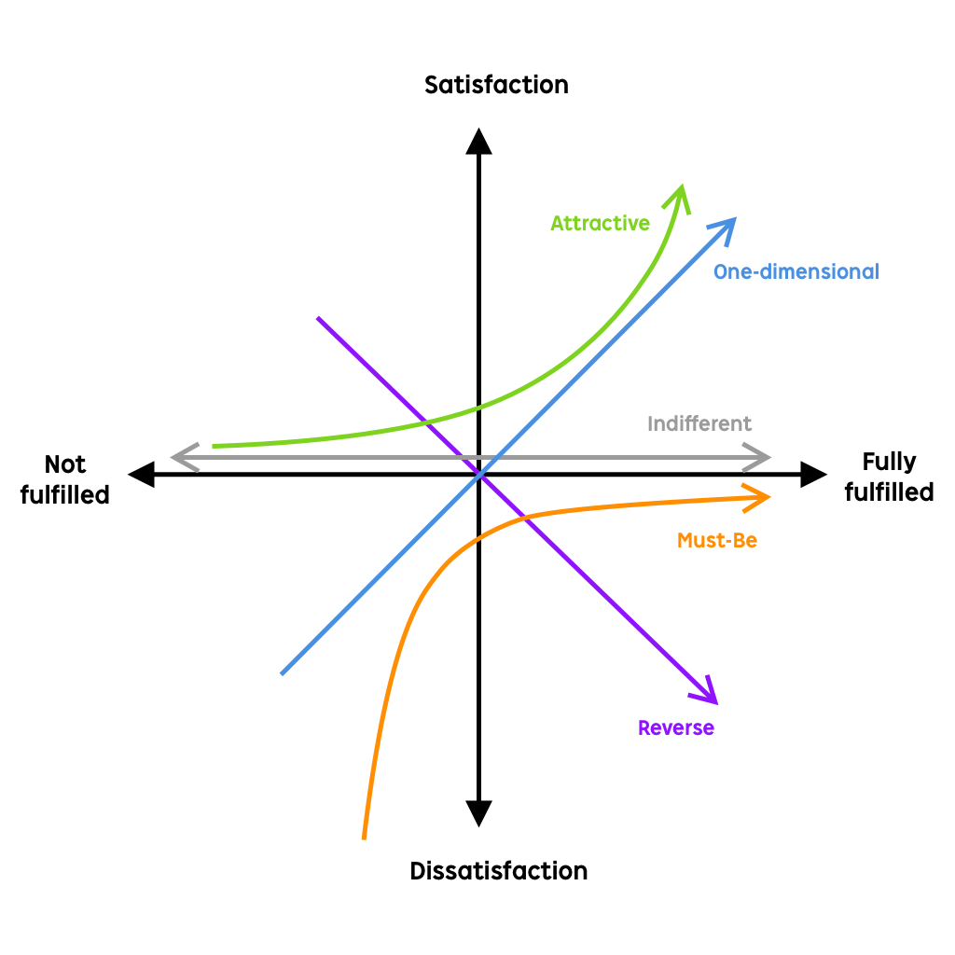

*Image 1. The Kano- model.* [3]

## Suggested prototype (block chart/component diagram)

The use case diagram in image 2 describes the actors that are going to use the solution. On the left, both actors can do various actions, being logged in grants access to more actions. On the right, the internal actors can be seen. We included a person in charge of support, able to solve problems and an administrator able to access every part of our solution to maintain it.

The “extends” arrows mean that use case 2 is adding functionality to use case 1, but use case 1 can function on its own. The “includes” arrows mean that use case 2 is a part of use case 1, and the first use case cannot function on its own.



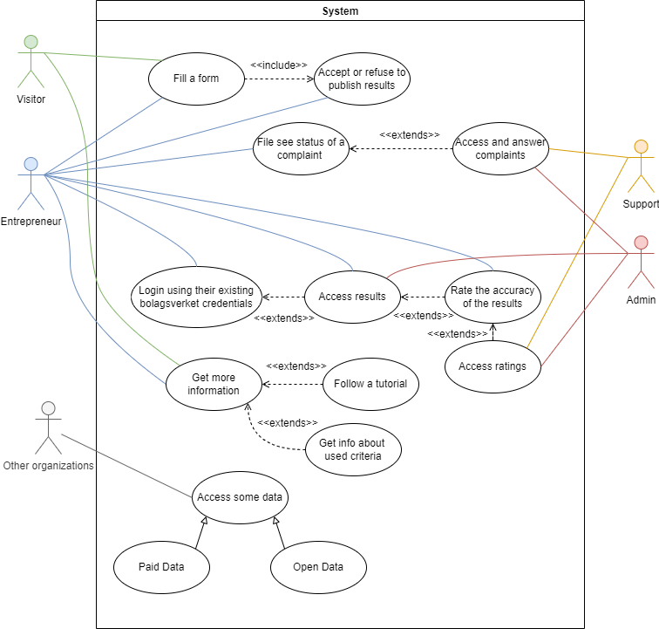

*Image 2. Use case diagram showing the users and their interactions with the solution*

The diagram in image 3 describes how the intended solution is supposed to work. The diagram starts by taking in specific information about the entrepreneurs business idea (private or public) via a form on a website, and sends the information to our solution. Having the solution on a webpage will make it accessible on multiple devices and web browsers.

In the solution, the data is taken into our module, which is constructed with an AI program which processes the data and gives a result with a description of whether the company is sustainable or not. The assessment of whether the company is sustainable or not is based on our database and input that we collect from other authorities. The result will be adapted to a specific type, such as PDF, XML, SQL, etc. It is then sent and displayed to the business and to the entrepreneur.

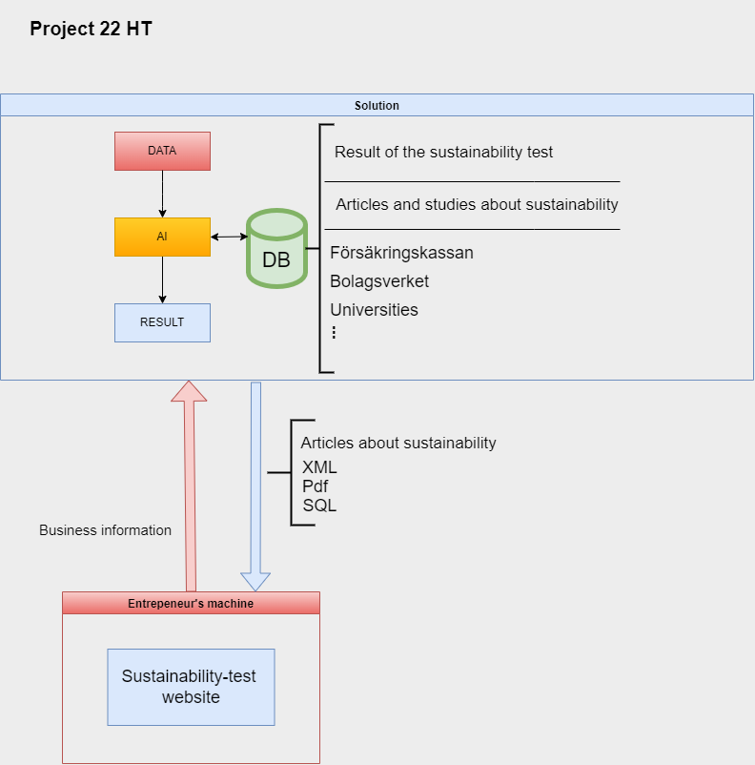

*Image 3. Block chart diagram explaining the technical concepts of the solution*

## Project methods and development

### Project methods :

In this project, product development work is planned to be structured and conducted using a combination between two agile methods, Scrum and Design Thinking.

Scrum can be described as a framework that helps organizations, teams and people to generate value through adaptive solutions for complex problems [4]. The scrum method is based on timeboxing, which means that time is the one factor in the project work that is not being compromised. Therefore work in scrum is divided into different sprints where a goal is defined and the group works to achieve this common sprint goal. When working according to the scrum method the first thing that is done is developing a product backlog. The product backlog is a prioritized list of requirements that the product should contain based on the product goal. This can be compared to a to-do list with tasks to complete during the project to meet the requirements. When the product backlog is fully developed the first sprint starts with developing a sprint backlog by selecting requirements from the product backlog. The selected requirements thus form the basis for the tasks which will be completed during the current sprint. The scrum method also contains daily scrum meetings where the progress towards the sprint goal is inspected. At the end of each sprint the results of the sprint work is presented in so-called sprint reviews. A retrospective meeting is also held to reflect about the finished sprint. After this, the previous steps are repeated in a new sprint with a new sprint goal. [5] The scrum method is illustrated in image 4.

The reason why the Scrum method is going to be used in this project is because it is suitable for small groups and provides quick and easy prototyping. The Swedish Companies Registration Office also uses agile methods when working on projects. Since this project is being done in collaboration with them, it is more appropriate to work according to similar methods. For this project each sprint will last two weeks. This is estimated to be a suitable sprint length with respect to the total project duration which is approximately two months.

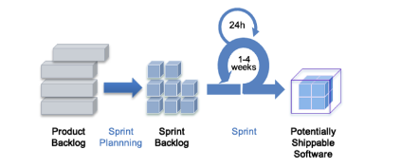

Image 4. The Scrum method illustrated. [6]

Design thinking is an agile methodology that encourages questioning, experimenting, observing, and innovating while it acknowledges that there isn’t only one way to solve a problem [7]. When working according to the methodology, the project is divided into different phases. The amount of phases the work is being divided into differs for each project. In this project, the work will be divided into five stages. These stages are empathize, define, ideate, prototype and test. It is important to clarify that these steps are not to be seen as a linear process. The Design Thinking steps are iterative and can be repeated throughout the project. The *empathize* phase is about researching the user's needs. The *define* phase is about stating the users needs and problems. The *ideate* phase is about challenging assumptions and creating ideas. The *prototype* phase is about creating solutions. The *test* phase is about trying out the solution. The design thinking methods are illustrated in image 5. [8]

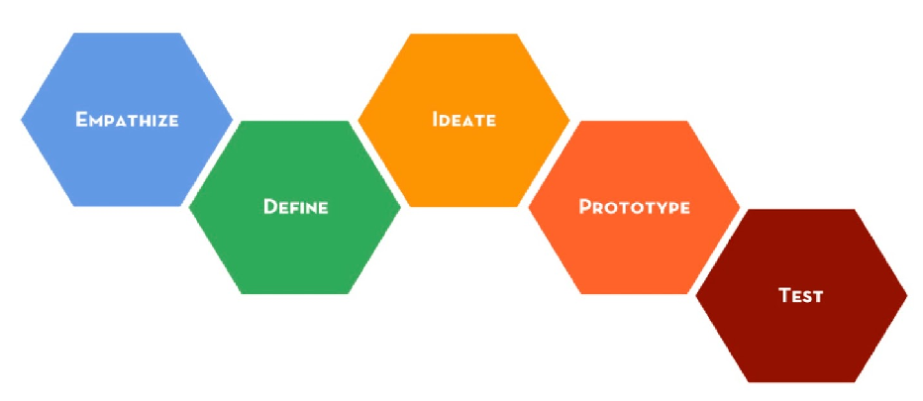

*Image 5. The Design Thinking methodology.* [9]

As previously mentioned, a combination between the agile methods Scrum and Design Thinking are planned to be used for this project. The combination motivates the choice to also use the Design Thinking method instead of only using the Scrum method. The Design Thinking method is expected to work as a suitable complement to scrum. This is because the phases from Design Thinking can be used to divide and structure work within the sprints. This means that for each sprint in the project, work will be executed according to the phases in design thinking. This will create an improvement for each sprint which will contribute to an iterative result. Going through the phases iteratively will add new knowledge for each sprint and thereby improve the result. This will also make sure that all the different skills from the group are being used during each sprint since each sprint contains a variety of phases.

For the sprints in this project, the empathize and define step of the design thinking method will be merged. This is because the amount of time that is assigned for the sprints is only two weeks and thereby it is assumed that there only will be time to cover four phases. The activities that are planned to be done during the phases emphasize and define are also cooperative with each other.

The activities and methods that are going to be used in each phase for the sprints have not yet been decided since it is hard to plan on a detailed level too far ahead. But so far the group have been discussing using the following methods for the phases in the sprints:

* **Emphasize and define:** interview,NABC, SPINN, personas, user stories, kano model, SWOT.
* **Ideate**: brainstorming, Design Studio.
* **Prototype:** developing methods described in the next chapter.
* **Test:** User tests.

The digital planning tool Trello is going to be used during the whole project to keep track of what needs to be done for each sprint.

### Development methods:

For developing the solution, Test Driven Development (TDD) will be used. TDD is a software development practice that focuses on creating unit test cases before developing the actual code.

TDD first starts by creating small test cases for every feature based on their initial understanding. However this technique is to modify or write new code only if the tests fail. This prevents duplication of test scripts. The concept of TDD is illustrated in image 6 below.

TDD test have the following steps:

1- Add a test.

2- Run tests and see if they pass or fail.

3- Change the code, if the test does not pass.

4- Run tests again and see if it passes or fails.

5- If it passes, go to step 1.

6- If it fails, go to step 3.

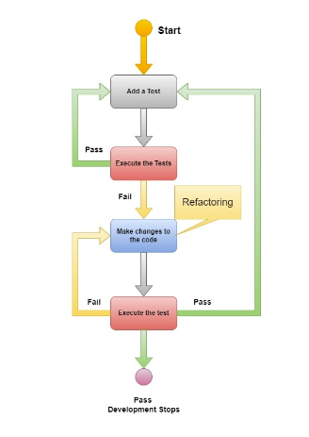

*Image 6. TDD method for software development* [10]

The data mining development in this project will be done according to the CRISP-DM process which is illustrated in image 7. The process is divided into the following different steps:

1. Business understanding - Describe what the goal of the data mining project is.
2. Data understanding - Gather and decide what data to use based on the goal.
3. Data preparation - Clean the data, fix missing values, remove attributes and normalize.
4. Modeling - Create and train the mining model.
5. Evaluation - Measure the performance of the model and estimate error rates.
6. Deployment - Deploy the model on a server and feed it real data.

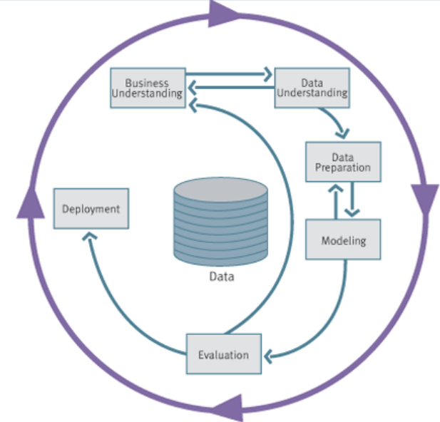

*Image 7. Cross-Industry Standard Process for Data Mining (CRISP-DM) [11]*

### Development tools:

The following list describes the development tools that are planned to be used in this project:

* ***Draw.io :*** An online tool for making diagram sketches with support for multiple types of templates and symbols.
* ***Whiteboard* :** To communicate large abstract ideas within the group for evaluation before a more in depth technical model is designed.
* ***SQL (mariaDB, mySQL, postgreSQL)* :**An SQL database is a relational database used to store and retrieve structured collection of tables and data*.*
* ***Visual studio :***A working environment that supports multiple programming languages and provides text highlighting, debugging tools and git integration*.*
* ***Programming languages :***PHP, HTML, CSS, Javascript are the languages that will make a foundation for displaying the web based solution. With HTML that follows the HTML5 standard, the solution will be available on multiple browsers and platforms*.* We will probably use a framework such as bootstrap to simplify the development process.
* ***Xampp :*** All-in-one tool that emulates a web server to develop websites with HTML, CSS, PHP, Javascript and a SQL database*.*
* ***Github :*** Will be used for the purpose of simplifying the software development process within the group. Github allows for multiple files to be shared and edited at the same time.
* ***Cloud services :*** To develop a fully managed solution involving microservices, we may have to use Cloud services such as Google Cloud or AWS. They also provide managed services to execute machine learning algorithms.

## Division of labor / roles in the group

By working with the scrum idea in mind. There will be a shifting division of labor in the group based on the group members previous knowledge and experience. The agile method will be practiced this way to improve flexibility on how assignments are being completed. Time will be reserved for group meetings where the work progress for each member will be discussed to ensure that the schedule is being followed as planned. This will also help with making sure that the whole group can contribute to the project and that nobody is blocked on a task.

| **Scrum Master** | **Product Owner** | **Test** | **Front end** | **Back end** | **AI** | **Cloud hosting** |
| --- | --- | --- | --- | --- | --- | --- |
| Wisam  Lovisa  Clément | Wisam  Lovisa | Wisam  Lovisa | Mattias  Clément | Mattias  Ahmad | Wisam | Clément |

## A time schedule with activities and the time you estimate for each activity

For this project, the time will be divided into four different sprints where each sprint covers the Design Thinking phases. It is expected that every sprint will last about two weeks. On the last days of each sprint, the work will focus more on preparing for the sprint review meetings rather than completing user stories for the actual sprint. All Design Thinking phases are planned to be covered in each sprint, the main focus might just differ a bit between the sprints.

The group has a general sense of the development phases that this project will consist of and an estimation of the duration of each phase. From this, an estimated time plan has been developed which is illustrated in the Gantt schedule in image 8.

Sprint 1 will focus a bit more on the phase emphasizing and defining than the other phases. This means that many activities will be carried out in order to state the current situation and see what the real need behind the problem that has been formulated by the client is. Roughly speaking, it is about researching and stating the user's needs and problems. This is done to a greater extent in sprint 1 because it is important to do so early in the project in order to get an overall image of the problem. Sprint 1 is estimated to last during week 36-37.

**Week 36-37:** Sprint 1- main focus empathize- and define.

**Week 38-39:** Sprint 2

**Week 40-41:** Sprint 3

**Week 42-43:** Sprint 4

**Week 44-45:** Final presentations

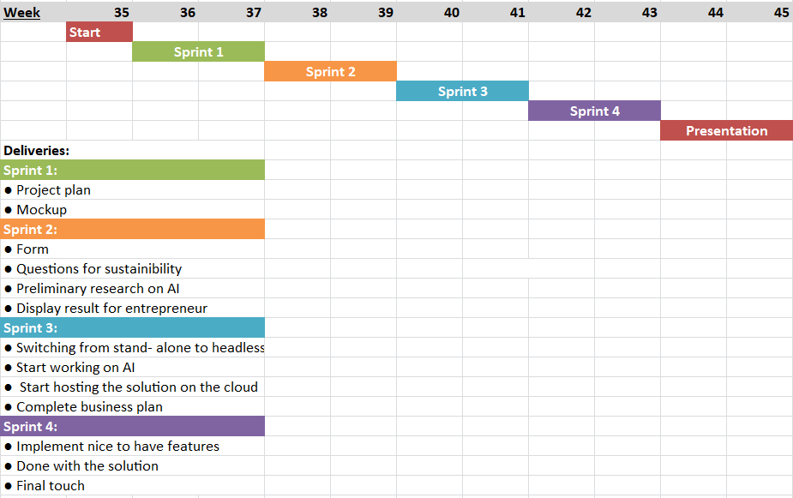

*Image 8. Gantt- schedule representing the preliminary time plan.*

## Project risk analysis

The following is a list that describes the risks that might occur during the project, and some solutions that can be implemented to reduce the risk.

* Lack of knowledge about machine learning and artificial intelligence.
  + **Solutions :** Reserve time in the schedule to learn about this technology, ask the company for a mentor or available resources.
* Lack of time to develop every part of the solution.
  + **Solution :** Share the work efficiently, organize and follow the Scrum method to respect deadlines, adapt our solution and remove unnecessary features.
* Performance : AI can require high resources.
  + **Solution :** Separate AI processing from the website.
* Cost : AI can require specific and powerful hardware.
  + **Solution :** The company can provide hardware and expertise from their AI-hub.
* Unavailability of one or few group members.
  + **Solution :** Change roles regularly for everyone to be able to work on every task.
* No access to their database or any company information.
  + **Solutions :** Ask bolagsverket for an access or create our own set of data to test our solution

## References

H. Sharp, J. Preece, och Y. Rogers, Interaction Design: Beyond Human-Computer Interaction. 2019

[1] ProductPlan. (2022). *What is the Kano Model?* Retrieved: 2022-09-12

[What is the Kano Model? | Definition and Overview of Kano (productplan.com)](https://www.productplan.com/glossary/kano-model/)

[2] Ullman, David G. (1997). *The Mechanical Design Process*. McGraw-Hill. pp. 105–108. [ISBN](https://en.wikipedia.org/wiki/ISBN_(identifier)) [978-0-07-065756-4](https://en.wikipedia.org/wiki/Special:BookSources/978-0-07-065756-4). [book].

[3] Uxplanet. (2019). *Kano Model Analysis in Product Design.* Retrieved: 2022-09-12.

<https://uxplanet.org/kano-model-analysis-in-product-design-7a3cca3e51ed>

[4] Scrumguid.org (2020) *The 2020 Scrum Guide*. Retrieved: 2022-09-09

<https://scrumguides.org/scrum-guide.html>

[5] Thomas Gustavsson. (2020). *Agil projektledning.* (4 th edition). Publisher: Sanoma utbildning [book]

[6] Thomas Gustavsson. (2020). *Agil projektledning.* (4 th edition). Publisher: Sanoma utbildning [book]

[7] CIO. (2021). *What is design thinking? An agile method for innovation.* Retrieved: 2022-09-12

<https://www.cio.com/article/196199/what-is-design-thinking-an-agile-method-for-innovation.html>

[8] Interaction design foundation. (2022). *The 5 Stages in the Design Thinking Process.* Retrieved:2022-09-12

<https://www.interaction-design.org/literature/article/5-stages-in-the-design-thinking-process>

[9] ReashearshGate (2019). *Figure 2.* Retrieved: 2022-09-12

<https://www.researchgate.net/figure/Phases-of-the-Design-Thinking-process-with-emphasis-on-the-beginning-Source-David_fig16_335391703>

[10] BrowserStack. (2021). *What is Test Driven Development (TDD) : Approach & Benefits.*  Retrived: 2022-09-12

[https://www.browserstack.com/guide/what-is-test-driven-development#:~:text=In%20 layman's%20 terms%2C%20Test%20 Driven,of%20unit%20tests%2C%20and%20refactoring.](https://www.browserstack.com/guide/what-is-test-driven-development#:~:text=In%20layman's%20terms%2C%20Test%20Driven,of%20unit%20tests%2C%20and%20refactoring.)

[11] I. H. Witten, E. Frank, M. A. Hall. (2011). DATA MINING: Practical Machine Learning Tools and Techniques. (3 edition). Publisher: Elsevier- Morgan Kaufman Publishe. [book]