CATEST Documentation (07/27/2008, ver.1.06)

Clemens Lode
clemens@lode.de
University Karlsruhe
for Thomas Worsch, Hidenosuke Nishio

Outline of this documentation

- Code and Algorithms
- Deployed algorithm for testing a graph for strongly connected components
- Description of the GUI elements (Parameters & Test, Results)
- Permutations and variations

1. Code and Algorithms

The only code I used from elsewhere was the code for the TableSorter (TableSorter.java, by Philip Milne, Brendon McLean, Dan van Enckevort and Parwinder Sekhon, version 2.0 02/27/04). I'm using DOT (which is part of the graphviz package, see http://www.graphviz.org/) to draw the De Bruijn graphs, currentl mainly for debug issues of the core algorithm.

The basic idea, i.e. using De Bruijn automata / graphs as a representation of a CA rule in order to determine the injectivity and surjectivity of a cellular automata, is based on the work of Klaus Sutner (Linear Cellular Automata and Finite Automata).
According to Sutner the following three conditions are equivalent:
- Cellular automata p is surjective
- de Bruijn automata B(p) is balanced
- de Bruijn automata B(p) is unambigious

To test a de Bruijn automata for unambiguousness we need to construct a product automata and test it for strongly connected components. Iff the diagonal is the only strongly connected component then the CA is also injective.
2. Deployed algorithm for testing a graph for strongly connected components

In CATEST I'm using an optimized version of Tarjan's algorithm based on own ideas and some ideas from the paper “On Finding the Strongly Connected Components in a Directed Graph” by Esko Nuutila and Eljas Soisalon-Soininen.

The idea is to iterate through all nodes (in the worst case no nodes are connected) starting with the diagonal elements. If the diagonal elements are not strongly connected then we can cancel the calculation early.

Visiting a node is done by calling a recursive function (“visit”) that will visit other, connected nodes. Because of this we ignore already visited nodes in the main loop.

In order to save time and memory we initialize the nodes and edges of the graph online during the run when they are visited. The speed-up occurs because in many cases we can cancel the calculation early.

Each node we visit gets a unique ID, gets a secondary ID that marks its component number (all members of a component will have the same secondary ID at the end of the algorithm), is marked and is pushed on a stack (in order to trace back the connected graph later).

Then the up to <number of cell states>^2 connections are calculated and yet unvisited nodes are visited. If we hit a node that we already have visited we check if it is still marked (more about that later) and if the secondary ID is lower than ours. If that's the case we change the secondary ID to that lower value.

The interesting part comes when no more unvisited nodes are available, then we test if the nodes on the stack form a strongly connected component and return the result to our calling node. If it isn't strongly connected we can cancel the calculation for the whole set of nodes on the stack and move on to the next unvisited node.
If it is strongly connected we check again for a lower secondary ID of the node we just called and continue visiting unvisited nodes.

The final part is the test for strongly connected components on the stack. If the node in question isn't the root node (i.e. the secondary id differs from the id) we cancel and return true so that the calling node can continue to visit other unvisited connected nodes.
But if we reached the root node (secondary id == id) we go through the stack and count the number of elements on the diagonal.
If all elements of the diagonal were on the stack we know that the rule is surjective.
If only some elements of the diagonal were on the stack we know that the rule is neither surjective nor injective and we can cancel the calculation.
If we have established that the rule is surjective and we now find another strongly connected component we can cancel, too, because we know that the rule is surjective but not injective.
Only in the case where no other strongly connected component is found we can complete the calculation with the result that the rule is surjective and injective (worst case concerning time and memory consumption).

3. Description of the GUI Elements

3.1. Parameters & Test

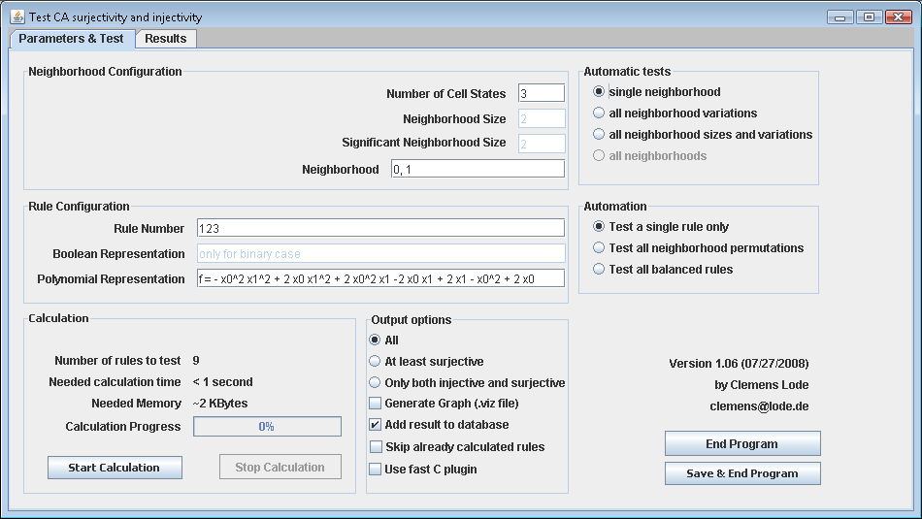
Neighborhood Size
The maximum number m of cells relevant for the rule, i.e. a neighborhood “0, 1, 4” woud have neighborhood size 5, a neighborhood “0,1” would have neighborhood size 2.

Significant Neighborhood Size
The number of significant positions of the neighborhood, i.e. a neighborhood “0, 1, 4” would have significant neighborhood size of 3, a neighborhood of “0, 1” would have significant neighborhood size 2.

Neighborhood
Neighborhoods can be entered using points (“.”), commas (“,”) or blanks as delimiter. The values have to be integers, they can be negative and can be entered in any order.
Internally the neighborhood will be standardized so that the first entry of the neighborhood is always 0, e.g. if you enter the neighborhood string “-2, -1, 4” it will be transformed to “0, 1, 6”. As we are testing only for surjectivity and injectivity adding an index to the neighborhood does not affect the result.
The neighborhood doesn't need to be in order, e.g. (0, -1, 3) will be processed properly.

Automatic Test: Single neighborhood
The neighborhood size and the significant neighborhood size values are ignored, only the single neighborhood that was entered in the Neighborhood field is tested.

Automatic Test: All neighborhood variations
Using this option will disable out the neighborhood field. The program will test all variations with the fixed neighborhood and significant neighborhood size that were given. The tested neighborhoods of this test will always include the borders, e.g. a test for neighborhood size 6 and significant neighborhood size 4 will test the cases (0, 1, 2, 5), (0, 1, 3, 5), (0, 1, 4, 5), (0, 2, 3, 5), (0, 2, 4, 5) and (0, 3, 4, 5)

Automatic Test: All neighborhood sizes
This test will calculate the same neighborhoods as the “All neighborhood variations”does but includes neighborhoods with lower neighborhood sizes (down to the significant neighborhood size). Using the example from above (neighborhood size 6, significant neighborhood size 4) this would also examine the cases (0, 1, 2, 4), (0, 1, 3, 4), (0, 2, 3, 4) and (0, 1, 2, 3)

Automatic Test: All neighborhoods
This test will calculate the same neighborhoods as the “All neighborhood sizes” does but will also test all significant neighborhood sizes up to the neighborhood size. With a given neighborhood size of 6 the test calls the “All neighborhood sizes” test with significant neighborhood size of 2, 3, 4, 5 and 6.

Automation: Test a single rule only
Use any neighborhood permutations specified above but keep the rule number constant.

Automation: Test all balanced rules
Use any neighborhood permutations specified above and also permutate the rules

Automation: Test all neighborhood permutations
Use any neighborhood permutations specified above, use the rule but permutate the neighborhood to include unordered neighborhoods I.e. if the neighborhood (0, 1, 2) was specified then test (0, 1, 2), (0, 2, 1), (1, 0, 2), (1, 2, 0), (2, 0, 1) and (2, 1, 0).

Wolfram / Boolean / Polynomial expression
All three fields are representations of the same rule, when one field is updated the other two will be updated approprietly. The boolean expression will only be shown for cases with two cell states.
Entering a function will not affect the neighborhood size, e.g. with neighborhood size 2 and 2 cell states there will be an error if you enter “100” as rule number or “x0 + x1 + x2” as boolean representation. The first index of the variables is 0, i.e. x_0 denotes the first index. The index numbers are in ascending order and do not represent the neighborhood, i.e. “x0 + x2 + x3” with the neighborhood (0, 4, 5, 7) refers to positions 0, 5 and 7.

Boolean representation
Infix “ , ” : logical OR
Nothing or Infix “ * ” : logical AND
Postfix “ ' ” : negation of a single variable
Constants 1 and 0 can be used freely, spaces are ignored, the “f = “ expression at the beginning is optional, braces ( ) and other logical operators are not yet implemented.

Polynomial representation
“p” being the number of cell states
Infix “ + “ : addition with modulo p, in the case of multiple summands the modulo operator will be applied after all summands were added
Nothing or Infix “ * “ : multiplication with modulo p, in the case of multiple factors the modulo operator will be applied after all factors were multiplicated
Integral constants (positive and negative ones) can be used anywhere
Note that the transformation from Wolfram numbers / Boolean representations to Polynomial representation can take a long time, the algorithm still needs to be optimized.

Output options: All
All results will be put into the table in the 'Results' tab.

Output options: At least surjective
Only output results that are either surjective or surjective and injective.

Output options: Only injective
Only output results that are both surjective and injective

Output options: Add result to database
All results fulfilling above conditions will be added to the database.

Output options: Generate Graph
A .viz file will be created for each result that is put into the database. The .viz file can be either converted manually to a .png file or automatically converted using the results tab, see below.

Output options: Use fast C plugin
Calls the external C implementation of the core algorithm. It is about 100% faster and uses 50% less memory usage but has a calling overhead, maybe useful for few larger calculations (large neighborhood and/or large number of cell states)

End Program
Quit the program.

Save&End Program
Saves the settings and database to a temporary file which will be reloaded the next time you start CATEST so you can continue where you left the program. This does not work during a calculation.

3.2. Results

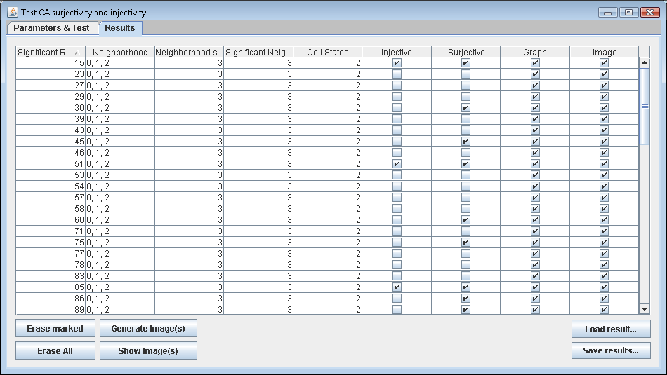

Erase marked / Erase All
Remove items from the database, either all you have selected or every single on in the database.

Generate Image(s)
If the test was run with the option “Generate Graph (.viz file)” you can create a .png file automatically with the DOT program (which is part of the archive). If you use linux you have to create a soft-link from the dot directory to your dot binary.

Show Image(s)
Show the png files (if available) of all marked entries.

Load/Save result(s)...
Load or save the results from or to a separate raw text file.

Note
You can sort each column by clicking on the column name.

4. Permutations and variations

The main calculation consists of a number of nested loops. In order to understand what is going on I outline the loop:

do {
do {
do {
do {
do {
do {
*** Calculate surjectivity and injectivity with the current settings ***
} while nextFunctionNeighborhoodPermutation
} while nextFunctionPermutation
} while nextCellStatePermutation
} while nextNeighborhoodPermutation
} while nextSignificantNeighborhoodSizePermutation
} while nextNeighborhoodSizePermutation

nextFunctionNeighborhoodPermutation: (“Test all neighborhood permutations”)
Permutates the neighborhood, e.g. (0,1,2) → (0,2,1) → (1,0,2) → ...

nextFunctionPermutation: (“Test all balanced rules”)
Permutates the table of the rule creating a new (balanced) function, e.g. rule 12 → 10 → 6 → 9 → 5 → 3 (1100 → 1010 → 0110 → 1001 → 0101 → 0011)

nextCellStatePermutation (not yet implemented)
Cycles through all number of cell states

nextNeighborhoodPermutation (“all neighborhood variations”)
Cycles through all neighborhood variations, e.g. (0,3,4,5) → (0,2,4,5) → (0,1,4,5) → (0,1,3,5) → (0, 1, 2, 5)

nextSignificantNeighborhoodSizePermutation (“all neighborhood sizes and variations”)
Cycles through all maximum neighborhood sizes from the significant neighborhood size up to the neighborhood size, e.g. 4 → 5 → 6 with the setting “significant neighborhood size = 4” and “neighborhood size = 6”

nextNeighborhoodSizePermutation (“all neighborhoods”)
Cycles through all significant neighborhood sizes up to the neighborhood size, e.g. 2/2 → 2/3 → 3/3 → 2/4 → 3/4 → 4/4 with the setting “neighborhood size = 4”

