INTERNATIONAL CYBERSECURITY AND DIGITAL FORENSICS ACADEMY
CORE102
NETWORK AUTOMATION AND INTEGRATED SECURITY CHALLENGE
Laboratory 5 — Practical Laboratory Report

Student information | Details
Student name | Clement Eneji
Registration number | C11_26_OCO_17773
Course | CORE102 TCP IP Networking and Linux Network Tools
Instructor | Aminu Idris AMCPN
Platform | Kali Linux / Ubuntu Linux authorised laboratory environment
Submission date | 3 October 2026
Maximum score | 100 marks

Assessment evidence report

Contents
01 Part 1 — Automation Plan and Scope
02 Part 2 — Bash Network Inventory
03 Part 3 — Controlled Bash Ping Sweep
04 Part 4 — Python Service Checker
05 Part 5 — Offline PCAP Summary with Scapy
06 Part 6 — Integrated Security Challenge
07 Part 7 — Code Review Checklist
08 Operational Summary
09 Reflection Questions
10 Evidence and Submission Checklist

Authorised network scope: 192.168.56.0/24

Part 1 — Automation Plan and Scope
The laboratory automation is restricted to the authorised private network 192.168.56.0/24. The control plan below defines the permitted input, expected output, operational limit and safe failure behaviour for each tool.
Tool | Permitted input | Output | Timeout / limit | Failure behaviour
Network inventory  network_inventory.sh | Local host only | Timestamped text report | Read-only commands | Reports command errors and exits on failure
Ping sweep  authorised_ping_sweep.sh | 192.168.56.1–192.168.56.254 | Responsive hosts (.txt) | 1 second per probe (-c 1, -W 1) | Rejects non-authorised prefix; exit 2
Service checker  service_check.py | One authorised host in 192.168.56.0/24 | Selected TCP port state | 1 second per port | Rejects invalid IP / out-of-scope host; exit 1/2/3
PCAP summary  pcap_summary.py | Existing local .pcap/.pcapng | Protocol, endpoint and TCP-port counts | Offline read; supplied file only | Rejects missing or unsupported PCAP; exit 1/2

Scope control: Network actions are limited to the explicitly authorised private laboratory range. The ping-sweep script uses a fixed prefix gate, while the service checker uses an IP-network membership test before opening any socket.
Safety control: Network probes are bounded by a one-second timeout and the PCAP exercise reads an existing file offline rather than sniffing live traffic.

Part 2 — Bash Network Inventory
The network inventory script collects local network state without modifying network configuration. It writes a timestamped report and uses strict Bash error handling.

2.1 Strict Bash options
set -e: Stops the script when a command returns a non-zero status, preventing execution from continuing after a command failure.
set -u: Treats expansion of an unset variable as an error, reducing failures caused by missing variables or typographical mistakes.
set -o pipefail: Makes a pipeline fail when a command within the pipeline fails, rather than allowing a successful final command to hide an earlier failure.

2.2 Default and custom output directories
Default directory: Running ./network_inventory.sh created a timestamped report in the evidence directory.
Custom directory: Running ./network_inventory.sh custom_evidence directed the timestamped report to the specified custom directory. The submitted evidence also shows a custom_inventory run.
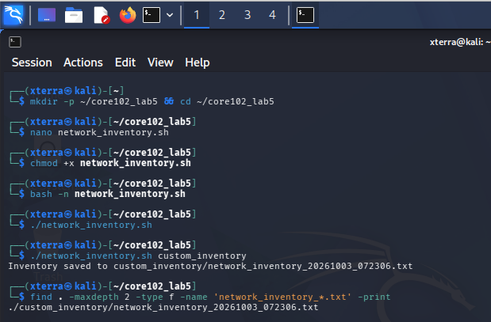
Evidence 2.1 — Syntax check and network inventory execution with timestamped output.
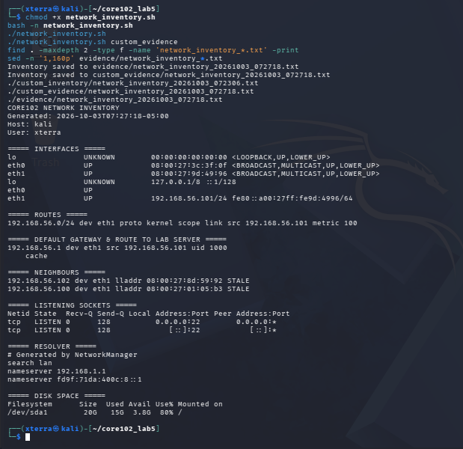
Evidence 2.2 — Generated inventory report and recorded network state.

2.3 Default gateway and route enhancement
Enhancement: The inventory was extended to record the default route and the route Linux would use to reach 192.168.56.1. The recorded result identifies interface eth1 and source address 192.168.56.101 for the laboratory route.
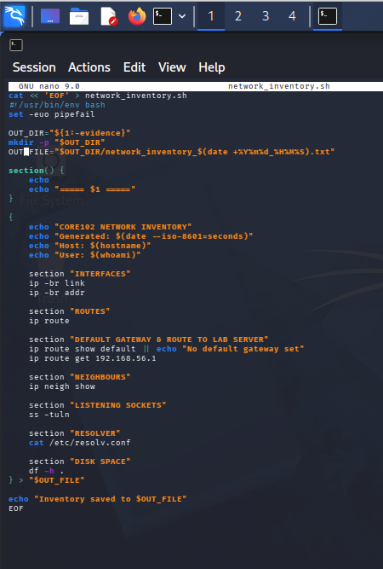
Evidence 2.3 — Inventory script showing the added route/gateway collection commands.

2.4 Read-only behaviour
Result: The inventory commands are status-retrieval operations: ip -br link, ip -br addr, ip route, ip neigh show, ss -tuln, /etc/resolv.conf inspection and df -h. The only intended disk change is creation of the report file in the selected output directory.

Part 3 — Controlled Bash Ping Sweep
The sweep enforces the approved 192.168.56 prefix before entering the host loop. Each ICMP probe is limited to one packet with a one-second wait.
Out-of-scope validation: The test using 203.0.113 was rejected before any sweep was performed, returning exit status 2 and displaying the authorised-prefix message.
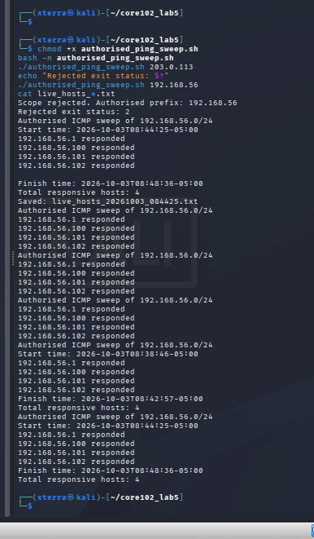
Evidence 3.1 — Rejected out-of-scope test followed by the authorised sweep and responsive-host results.
Authorised sweep result: The successful sweep recorded four responsive hosts: 192.168.56.4, 192.168.56.100, 192.168.56.101 and 192.168.56.102. The evidence also records the sweep start/finish information and a total responsive-host count of four.
Why an online host may not answer ICMP: A host can be operational while ignoring ICMP echo requests because of a host firewall, network filtering, disabled ICMP handling, routing restrictions or another security policy. Therefore, lack of an ICMP response is not proof that the host is offline.

3.1 Scope enforcement implementation
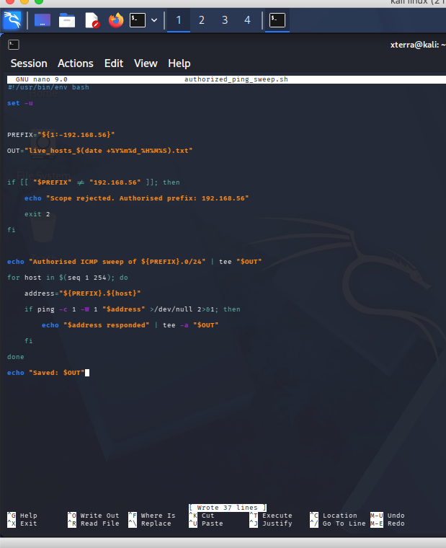
Evidence 3.2 — Authorised ping-sweep script showing the fixed prefix gate and one-second ICMP probe.

Part 4 — Python Service Checker
The service checker validates the target as an IPv4 address, confirms membership of 192.168.56.0/24, and uses socket.create_connection() with a one-second timeout for the approved TCP ports 22, 53, 80, 443 and 8080.

4.1 Input and scope validation
Invalid input: A non-IPv4 value is rejected with an invalid-address message and exit status 2.
Out-of-scope input: The address 8.8.8.8 is rejected by the authorised-network check and the recorded exit status is 3.
Authorised target: The checker was run against 192.168.56.100/101 in the supplied evidence and returned bounded states for the selected ports.
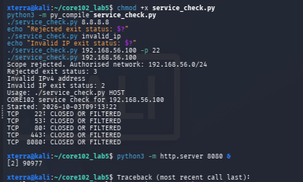
Evidence 4.1 — Invalid input, out-of-scope address rejection and authorised service-check execution.

4.2 Service availability change detection
Test service: A temporary Python HTTP server was started on TCP port 8080. The service checker then reported TCP 8080 as OPEN. After the temporary server process was terminated, a subsequent check reported TCP 8080 as CLOSED OR FILTERED.
Interpretation: The change demonstrates that the checker can detect a change in TCP service reachability. The result does not distinguish a closed service from a filtered service when the connection attempt does not succeed.
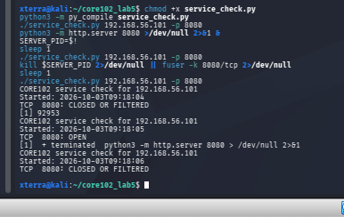
Evidence 4.2 — TCP 8080 changes from OPEN while the HTTP test service is running to CLOSED OR FILTERED after termination.

4.3 Bounded socket checks
Timeout control: Each socket connection uses timeout=1, ensuring the checker does not wait indefinitely on a non-responsive port.

Part 5 — Offline PCAP Summary with Scapy
The supplied evidence uses core102_http.pcap copied from the earlier laboratory and analyses it offline. No live packet sniffing is required for the summary operation.
PCAP validation: The program checks that the supplied path is a file and that its extension is .pcap or .pcapng before opening it with PcapReader.
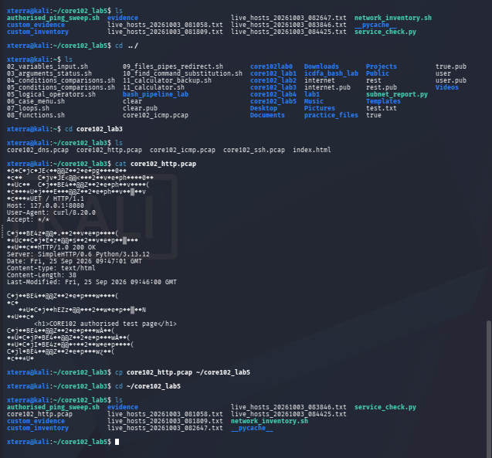
Evidence 5.1 — Authorised PCAP present in the laboratory workspace and copied into the Lab 5 directory.

5.1 Parsing and protocol results
Packet total: The supplied execution reports 12 packets.
Protocol result: All 12 packets were classified as TCP.
Endpoint result: 127.0.0.1 appears as the top endpoint with 24 endpoint occurrences, reflecting source and destination accounting across the packets.
TCP ports: Ports 35890 and 8080 each occur 12 times in the TCP port counter.
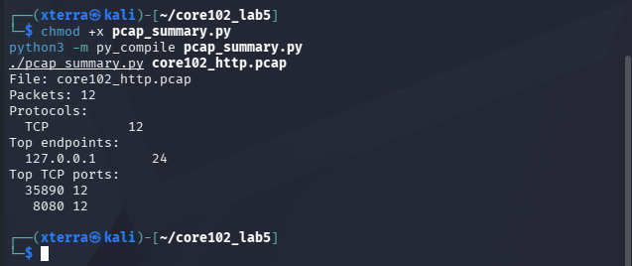
Evidence 5.2 — pcap_summary.py compilation and offline summary output for core102_http.pcap.

5.2 Required analysis questions
1. Packet-total comparison: The script reports 12 packets. No separate capinfos or Wireshark Statistics result is included in the submitted evidence, so an independent second-source packet-total comparison is not claimed.
2. Why both source and destination ports are counted: Every TCP segment has both a source and destination port. Counting both captures the communicating endpoints of each segment and allows the ephemeral client port and service port to be identified.
3. DNS counter enhancement: DNS traffic can be counted by checking UDP or TCP port 53 before the general protocol classification. A suitable enhancement is shown below.
if TCP in packet:
tcp_ports.update([packet[TCP].sport, packet[TCP].dport])
if packet[TCP].sport == 53 or packet[TCP].dport == 53:
protocols['DNS'] += 1
protocols['TCP'] += 1
elif UDP in packet:
if packet[UDP].sport == 53 or packet[UDP].dport == 53:
protocols['DNS'] += 1
protocols['UDP'] += 1
4. Port-based classification limitation: Port numbers are only an indicator. Applications can use non-standard ports, ports can be reused by different services, and encryption can prevent application-layer identification from port information alone.

Part 6 — Integrated Security Challenge
The integrated evidence was reviewed against the required final-state controls. The table below distinguishes what the submitted evidence demonstrates from controls that remain unresolved.
Control | Evidence result | Conclusion
Address and route | Recorded result: both VMs were assigned within 192.168.56.0/24 and the laboratory host route was valid. | Private laboratory topology was documented and scoped.
Firewall policy | UFW was active with default deny incoming and allow outgoing. However, the captured rules show 22/tcp ALLOW IN Anywhere and 22/tcp (v6) ALLOW IN Anywhere (v6). | The default incoming policy is restrictive, but the required SSH source restriction to 192.168.56.0/24 is not demonstrated by the captured rule set.
SSH key authentication | An SSH session to 192.168.56.20 was established. The screenshot also shows: 'Identity file .../.ssh/id_rsa not accessible: No such file or directory'. | SSH connectivity is demonstrated, but key-based authentication is not conclusively verified by the supplied evidence.
Listening services | ss -tulpn shows TCP listeners on 0.0.0.0:22 and [::]:22. | The captured socket evidence supports SSH as the listening service and shows no additional listening TCP service in that output.
Host discovery | The authorised sweep returned four responsive hosts: .4, .100, .101 and .102 within 192.168.56.0/24. | Controlled host discovery was demonstrated inside the authorised private range.
PCAP summary | core102_http.pcap produced 12 TCP packets, with loopback endpoint 127.0.0.1 and ports 35890/8080. The attempted ssh_capture.pcap was not present in the captured workspace. | Offline PCAP parsing was demonstrated, but the submitted evidence does not establish the required SSH packet capture.
Cleanup | The http.server process was successfully stopped with pkill -f http.server. Subsequent commands intended as file-cleanup commands returned pkill usage errors. | The test HTTP service was stopped; complete temporary-file cleanup is not demonstrated by the captured evidence.

6.1 Firewall and SSH evidence
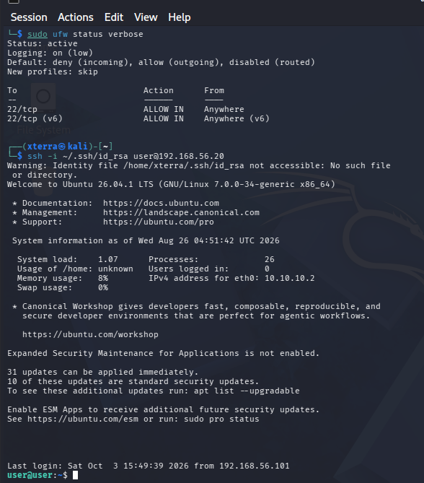
Evidence 6.1 — UFW status and SSH connection attempt/session. The captured UFW rule set is recorded exactly as observed.

6.2 Listening services and PCAP evidence
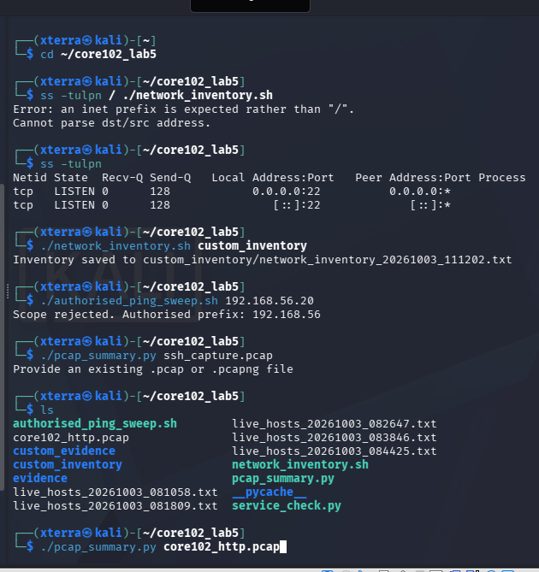
Evidence 6.2 — Listening sockets, inventory execution, scope rejection and the missing ssh_capture.pcap test.
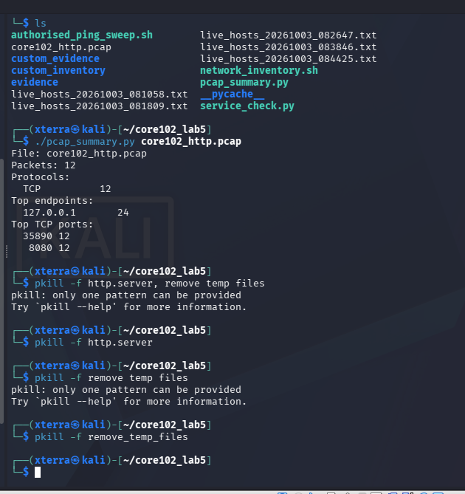
Evidence 6.3 — Successful offline analysis of core102_http.pcap and cleanup commands.

6.3 Final network state
Verified controls: The authorised private subnet, controlled ICMP discovery, bounded TCP service checks, local network inventory, offline PCAP parsing and SSH listening service were evidenced.
Unresolved issues: The captured UFW rule permits SSH from Anywhere rather than only 192.168.56.0/24; the SSH key file was reported missing during the connection command; and the required ssh_capture.pcap was not available in the captured workspace.
Cleanup state: The temporary HTTP server was stopped. The evidence does not establish removal of all temporary files, so the retained Lab 5 evidence files should be treated as deliberate submission artefacts rather than proof of complete filesystem cleanup.

Part 7 — Code Review Checklist
Script | Interpreter | Scope bounding | Syntax verification
network_inventory.sh | #!/usr/bin/env bash | Local host / interface state; no remote target input | bash -n network_inventory.sh
authorised_ping_sweep.sh | #!/usr/bin/env bash | Fixed 192.168.56 prefix check | bash -n authorised_ping_sweep.sh
service_check.py | #!/usr/bin/env python3 | ipaddress membership check for 192.168.56.0/24 | python3 -m py_compile service_check.py
pcap_summary.py | #!/usr/bin/env python3 | Offline file and extension validation; Scapy packet parsing | python3 -m py_compile pcap_summary.py

Code review findings
- Each submitted script uses an appropriate interpreter line.
- Inputs are validated before the corresponding network action or file parse begins.
- The authorised address scope is explicit in the ping sweep and service checker.
- Network operations use bounded packet counts or connection timeouts.
- Outputs include timestamps for the network inventory and service checker; the PCAP summary identifies its input file.
- Error messages explain rejected scope or invalid input.
- No passwords, private keys or tokens are included in the supplied scripts or report text.

Operational Summary
The Lab 5 exercise produced a repeatable set of network-automation checks for the authorised 192.168.56.0/24 laboratory environment. The Bash inventory generated timestamped local network evidence and was extended to record the route toward the laboratory address. The controlled ICMP sweep rejected an out-of-scope prefix before probing and identified four responsive hosts inside the authorised range.
The Python service checker validated IPv4 input and network scope and used one-second socket timeouts. The temporary HTTP service on TCP 8080 was observed as OPEN while running and CLOSED OR FILTERED after termination, demonstrating service-change detection. The Scapy utility successfully parsed the supplied core102_http.pcap offline and reported 12 TCP packets, loopback endpoint activity and ports 35890/8080.
The integrated evidence also identified controls requiring correction before the environment can be described as fully compliant with the challenge requirements. The captured UFW rules allow SSH from Anywhere rather than only 192.168.56.0/24. The SSH command reported that the specified private-key file was not accessible, so key-based authentication is not independently established by the evidence. In addition, the requested SSH PCAP was not present; the available PCAP evidence is the earlier HTTP test capture. These points are recorded as unresolved rather than being represented as verified controls.
The final evidence therefore separates observed results from conclusions and avoids treating an unsuccessful or incomplete test as proof of a successful security control.

Reflection Questions
1. Which validation control most effectively prevented an out-of-scope action? The fixed authorised-prefix gate in authorised_ping_sweep.sh is the clearest preventive control because it checks the supplied prefix before the host loop begins. A non-authorised prefix returns exit status 2 and no ICMP sweep is started.
2. What can a service checker conclude, and what can it not conclude, from a timeout? It can conclude that a TCP connection was not successfully established within the configured one-second timeout. It cannot by itself conclude that the service is definitely closed: packet filtering, host firewall rules, routing problems, congestion or temporary unavailability can also produce a timeout. The script therefore reports the state as CLOSED OR FILTERED.
3. How did automation improve repeatability compared with running commands manually? The scripts standardised the scope, validation sequence, timeout values, output format and evidence generation. The same commands can be repeated with less variation, while timestamps and saved reports provide a consistent record for comparison.
4. Which additional control would you add before these scripts could support a larger authorised environment? I would add a centrally maintained allowlist of approved CIDRs/hosts with explicit change control and audit logging. The scripts should validate every target against that allowlist, record the operator, target, timestamp and result, and retain the evidence for review. This would reduce the risk of accidental expansion of the testing scope as the environment grows.

Evidence and Submission Checklist
Assessment item | Evidence / answer | Status
Student identity | Clement Eneji and C11_26_OCO_17773 included | Complete
Automation plan | Scope, inputs, outputs, limits and failure behaviour documented | Complete
Network inventory | Syntax, execution, timestamped report and route enhancement evidenced | Complete
Ping sweep | Out-of-scope rejection, authorised results and ICMP limitation explained | Complete
Service checker | Invalid/out-of-scope validation and 8080 change detection evidenced | Complete
PCAP summary | Offline parse, 12-packet result and protocol/endpoint/port interpretation evidenced | Complete
Integrated challenge | Addressing, firewall, SSH, services, discovery and PCAP evidence reviewed | Partial — unresolved controls explicitly identified
Code review | Interpreter, scope, bounded operations and syntax checks documented | Complete
Operational summary | Findings, limitations and cleanup state documented | Complete
Reflection | All four required questions answered | Complete

End of report

