INTERNATIONAL CYBERSECURITY AND DIGITAL FORENSICS ACADEMY

CORE102
LINUX FIREWALL AND SECURE REMOTE ACCESS
Laboratory 4 — Practical Evidence Report

SUBMISSION STATUS
Prepared from the supplied practical workbook and completed-answer evidence. Screenshots are retained as captured evidence; observations are described only where supported by that evidence.

Field | Submission detail
Student | CLEMENT ENEJI
Registration Number | C11/26/OCO/17773
Course | CORE102 TCP/IP Networking and Linux Network Tools
Instructor | Aminu Idris AMCPN
Laboratory | Laboratory 4 — Linux Firewall and Secure Remote Access
Environment | Kali Linux / Ubuntu client on authorised isolated lab network
Submission Date | 30 September 2026

Maximum assessment value: 100 marks

Contents
- 1. Executive Summary
- 2. Laboratory Context and Topology
- 3. Assessment Coverage Matrix
- 4. Part 1 — Baseline and Recovery Preparation
- 5. Part 2 — Controlled Test Service
- 6. Part 3 — UFW Policy Implementation
- 7. Part 4 — Firewall Rule Verification
- 8. Part 5 — Safe iptables Custom-Chain Exercise
- 9. Part 6 — SSH Key Authentication
- 10. Part 7 — SSH Server Hardening
- 11. Part 8 — Final Exposure Review and Cleanup
- 12. Reflection Questions
- 13. Evidence Integrity and Residual Risk Notes
- 14. Final Submission Checklist

1. Executive Summary
This report documents the practical work completed for ICDFA CORE102 Laboratory 4, focused on Linux host firewall controls and secure remote administration. The practical sequence covered a temporary HTTP test service, UFW policy enforcement, client-side connectivity tests, inspection of UFW/iptables counters and logs, a non-attached iptables custom-chain exercise, Ed25519 SSH key generation and deployment, SSH server hardening, and final cleanup.
The supplied evidence demonstrates successful SSH connectivity, successful access to the temporary HTTP service when permitted, blocking of TCP/23, creation and complete removal of the CORE102_LAB custom chain, Ed25519 key deployment, successful public-key login, successful sshd configuration validation/reload, and final removal of the temporary HTTP service.
Important evidence qualification
Two presentation inconsistencies are preserved and explicitly identified rather than silently corrected: (1) early controlled-service screenshots use 192.168.56.101/192.168.56.102, while later firewall evidence uses the workbook topology 192.168.56.10/192.168.56.20; and (2) one draft table entry described an HTTP/8080 result as HTTP 200 while later evidence shows the port timing out after the rule was removed. The report distinguishes these stages and relies on the visible command/output evidence for each stage.

2. Laboratory Context and Topology
The laboratory scenario requires hardening a Linux server before it joins an internal training network. The workbook specifies a server VM and an authorised client VM on an isolated 192.168.56.0/24 network, with SSH permitted before a default-deny incoming policy is enabled.
System | Address in workbook | Role
Server VM | 192.168.56.10 | UFW, service inventory and SSH hardening
Client VM | 192.168.56.20 | Authorised connectivity and firewall testing
Private network | 192.168.56.0/24 | Host-only/internal virtual network

Operational safety
The practical brief requires console recovery access, a snapshot before firewall/SSH changes, an open authenticated session while testing SSH changes, and protection of the private SSH key. The report does not reproduce or expose any private-key material.

3. Assessment Coverage Matrix
The matrix below maps the supplied work to the assessment areas in the laboratory workbook. It is a coverage map, not a claim of marks awarded.
Assessment area | Marks | Evidence included in this report
Baseline and service inventory | 15 | Baseline service table; controlled-service setup evidence; evidence limitations identified
UFW policy | 20 | UFW default-policy screenshot; numbered-rule and cleanup evidence
Firewall testing | 15 | SSH/8080/Telnet client tests; UFW logs and iptables counters
iptables chain exercise | 10 | Rule anatomy, zero-reference explanation and removal proof
SSH key authentication | 20 | Ed25519 generation, fingerprint, key installation and successful login
SSH hardening and recovery | 15 | Backup, drop-in configuration, sshd -t, reload and public-key retest
Final review and report | 5 | Temporary service removal, rule deletion, final socket review and residual-risk notes
TOTAL | 100 | Complete practical evidence package as supplied

4. Part 1 — Baseline and Recovery Preparation
The completed answer records two listening services from the baseline inventory: SSH on TCP/22 and a NetworkManager-managed UDP/546 listener bound to the link-local IPv6 address on eth0.
Port / protocol | Bind address | Process | Expected purpose | Disposition
22/TCP | 0.0.0.0 / [::] | sshd (PID 15066) | Remote SSH administrative access | Keep
546/UDP | [fe80::a00:27ff:fe3c:3f0f]%eth0 | NetworkManager (PID 594) | DHCPv6 client auto-configuration | Keep

Evidence limitation
The supplied answer document contains the populated service-inventory table, but it does not contain a complete screenshot set for every baseline command listed in the workbook (interfaces, routes, full socket inventory, running services, UFW status and iptables status before changes). Those outputs are therefore not presented as if they had been captured.

5. Part 2 — Controlled Test Service
A temporary Python HTTP server was used to create a controlled TCP/8080 test target. The evidence shows the service listening on 0.0.0.0:8080 and serving the CORE102 test content.
mkdir -p ~/core102_lab4/web
echo 'CORE102 authorised firewall test' > ~/core102_lab4/web/index.html
python3 -m http.server 8080 --bind 0.0.0.0

Evidence 1 — Temporary HTTP service listening on TCP/8080
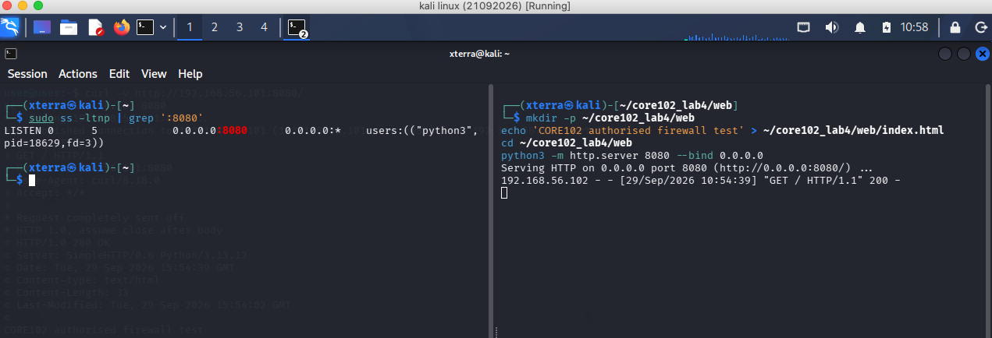
Figure 1. Temporary HTTP service listening on TCP/8080

Evidence 2 — Client-side pre-firewall HTTP/8080 connectivity test
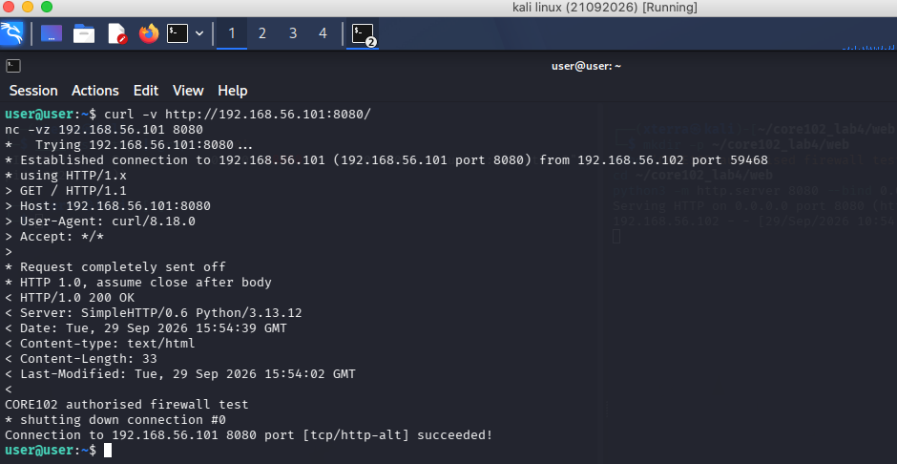
Figure 2. Client-side pre-firewall HTTP/8080 connectivity test
Evidence note
This early connectivity evidence uses 192.168.56.101 (server) and 192.168.56.102 (client), whereas the later firewall evidence uses 192.168.56.10 and 192.168.56.20. The address change is recorded rather than hidden.

6. Part 3 — UFW Policy Implementation
The firewall was enabled with an incoming default-deny policy and outgoing default-allow policy. SSH/TCP 22 was explicitly allowed before firewall activation. The captured implementation evidence shows SSH allowed from Anywhere rather than restricted to the 192.168.56.0/24 subnet specified in the workbook.
sudo ufw default deny incoming
sudo ufw default allow outgoing
sudo ufw allow 22/tcp
sudo ufw enable
sudo ufw status verbose

Evidence 3 — UFW enabled with default-deny incoming and SSH permitted
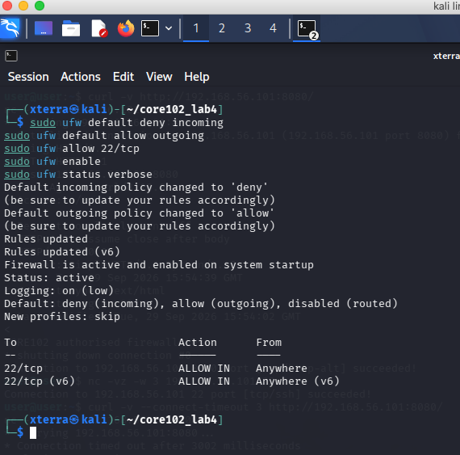
Figure 3. UFW enabled with default-deny incoming and SSH permitted
Configuration-scope note
The workbook's intended command is a subnet-scoped SSH rule (192.168.56.0/24). The supplied screenshot instead shows 22/tcp ALLOW IN Anywhere. This report records the actual evidence and does not describe the rule as subnet-restricted. If the instructor requires exact scope compliance, the practical should be corrected and a replacement screenshot captured before final submission.

7. Part 4 — Firewall Rule Verification
The client-side tests demonstrate three important firewall behaviours: SSH/22 is reachable, HTTP/8080 is reachable while its allow rule is present, and TCP/23 is blocked. Server-side evidence also shows UFW block logging and iptables counters.
Test | Expected | Evidence-supported observation | Interpretation
SSH from authorised client | Allowed | Connection to 192.168.56.10:22 succeeded | SSH traffic permitted
HTTP/8080 while allowed | Allowed | Connection to 192.168.56.10:8080 succeeded; HTTP response returned | Temporary web service reachable
TCP/23 Telnet | Denied | Connection timed out; UFW BLOCK entries recorded | No allow rule; traffic dropped
HTTP/8080 after cleanup | Denied / no listener | Final client test reports timeout and 'Port 8080 unreachable as expected' | Temporary service/rule removed

Evidence 4 — Client tests: allowed SSH/8080 followed by blocked 8080 after rule/state change
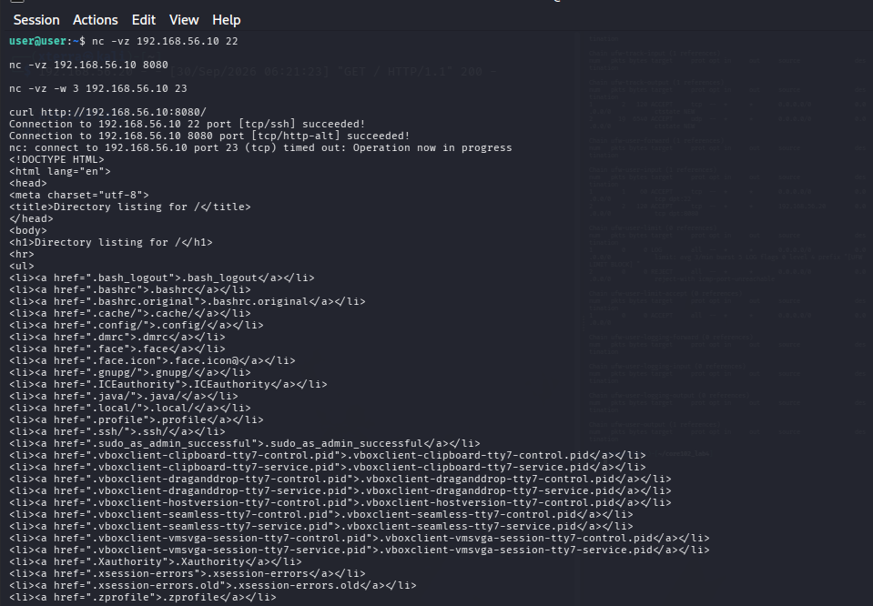
Figure 4. Client tests: allowed SSH/8080 followed by blocked 8080 after rule/state change
Evidence note
This screenshot contains both successful access and a later timeout in the same terminal capture, reflecting the state change during the exercise.

Evidence 5 — UFW numbered rules, kernel block logs and iptables counters
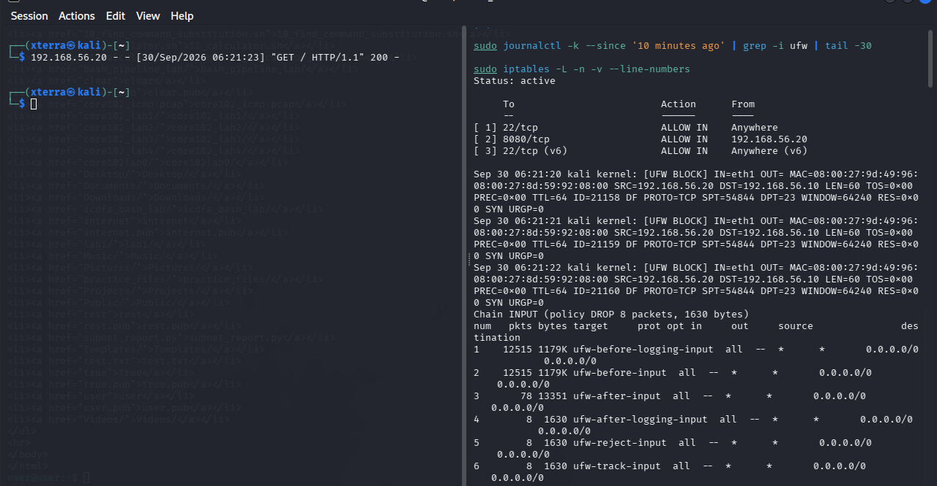
Figure 5. UFW numbered rules, kernel block logs and iptables counters

Evidence 6 — Client-side SSH, HTTP/8080 and Telnet tests
Figure 6. Client-side SSH, HTTP/8080 and Telnet tests
Evidence reconciliation
The draft answer table contains an 'HTTP 8080 from other client' row with an HTTP 200 observation, which conflicts with the intended denied result. The supplied screenshots show successful access during the allowed state and a timeout after the rule/state changed. The final report therefore does not claim that the same client simultaneously received HTTP 200 while denied.

8. Part 5 — Safe iptables Custom-Chain Exercise
A user-defined iptables chain named CORE102_LAB was created, populated with two rules, inspected, flushed and deleted. The chain remained unreferenced, so it did not alter live INPUT, OUTPUT or FORWARD traffic.
Rule element | TCP/23 rule | TCP/22 rule
Tool | iptables | iptables
Action | -A CORE102_LAB | -A CORE102_LAB
Protocol match | -p tcp | -p tcp
Destination port | --dport 23 | --dport 22
Target | DROP | ACCEPT

sudo iptables -N CORE102_LAB
sudo iptables -A CORE102_LAB -p tcp --dport 23 -j DROP
sudo iptables -A CORE102_LAB -p tcp --dport 22 -j ACCEPT
sudo iptables -L CORE102_LAB -n -v --line-numbers
sudo iptables -S CORE102_LAB
sudo iptables -F CORE102_LAB
sudo iptables -X CORE102_LAB

Evidence 7 — Custom-chain creation, inspection and complete removal
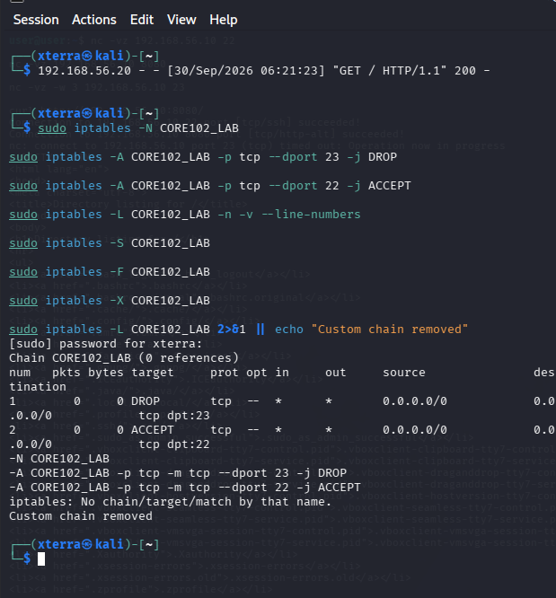
Figure 7. Custom-chain creation, inspection and complete removal
A user-defined chain is not automatically traversed by packets entering the firewall. It must be reached by a jump from a built-in chain such as INPUT. The screenshot shows '0 references' before removal, confirming that CORE102_LAB was not attached to the live traffic path.
Cleanup result
After flushing and deleting the chain, the verification command returned 'Custom chain removed'. This confirms that the temporary chain and its rules were removed.

9. Part 6 — SSH Key Authentication
An Ed25519 key pair was generated on the client using a dedicated filename and the laboratory label. The public-key fingerprint was displayed, the public key was installed on the server with ssh-copy-id, and a subsequent SSH session successfully authenticated with the key.
ssh-keygen -t ed25519 -a 64 -f ~/.ssh/core102_ed25519 -C "CORE102 authorised lab"
ssh-keygen -lf ~/.ssh/core102_ed25519.pub
ssh-copy-id -i ~/.ssh/core102_ed25519.pub xterra@192.168.56.10
ssh -i ~/.ssh/core102_ed25519 xterra@192.168.56.10
Item | Evidence-supported value
Key type | ED25519
Key filename | ~/.ssh/core102_ed25519
Fingerprint | SHA256:KuKWlxkYnHEwgtsItRXRksCghoNOsnMtCyh3/fl0gV0
Server | 192.168.56.10
Successful authentication | Yes — accepted publickey/session opened

Evidence 8 — Ed25519 key generation, fingerprint and public-key installation
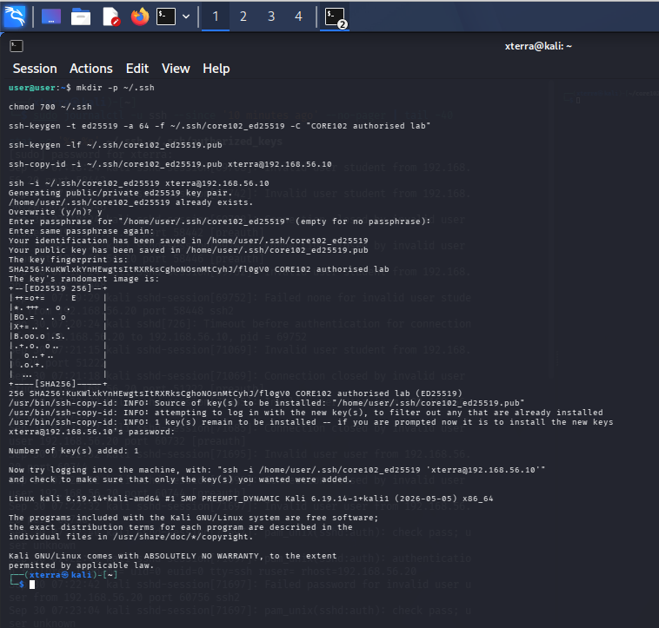
Figure 8. Ed25519 key generation, fingerprint and public-key installation

Evidence 9 — Successful key-based SSH login and sshd public-key acceptance
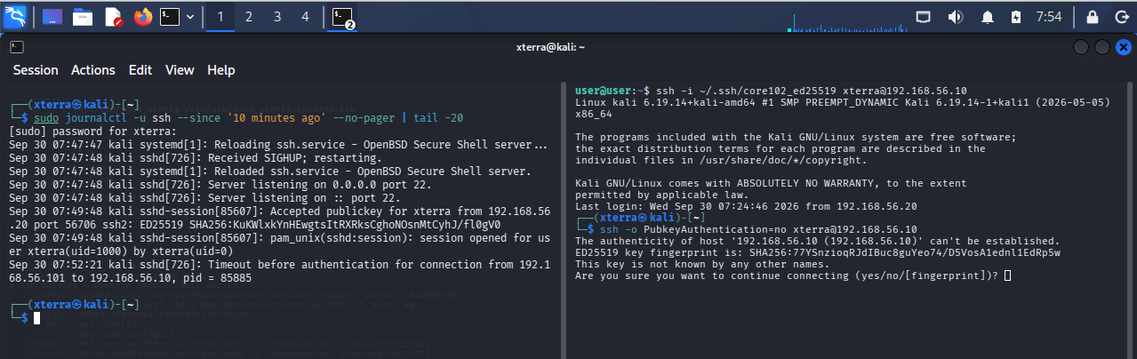
Figure 9. Successful key-based SSH login and sshd public-key acceptance
Private-key handling
Only the public-key fingerprint and public-key setup process are documented here. The private key contents are intentionally not reproduced in this report.

10. Part 7 — SSH Server Hardening
The SSH server configuration was backed up, a dedicated drop-in configuration file was created, the configuration was validated with sshd -t, and the SSH service was reloaded. The evidence then shows a successful public-key login.
sudo cp /etc/ssh/sshd_config /etc/ssh/sshd_config.core102.bak
sudo bash -c 'cat <<EOF > /etc/ssh/sshd_config.d/90-core102-hardening.conf
PermitRootLogin no
PubkeyAuthentication yes
PasswordAuthentication no
KbdInteractiveAuthentication no
EOF'
sudo sshd -t
sudo systemctl reload ssh
Hardening setting | Configured value | Purpose
PermitRootLogin | no | Prevents direct root SSH login
PubkeyAuthentication | yes | Enables SSH public-key authentication
PasswordAuthentication | no | Disables password-based SSH authentication after key verification
KbdInteractiveAuthentication | no | Disables keyboard-interactive authentication

Evidence 10 — SSH configuration backup, hardening drop-in, validation and reload
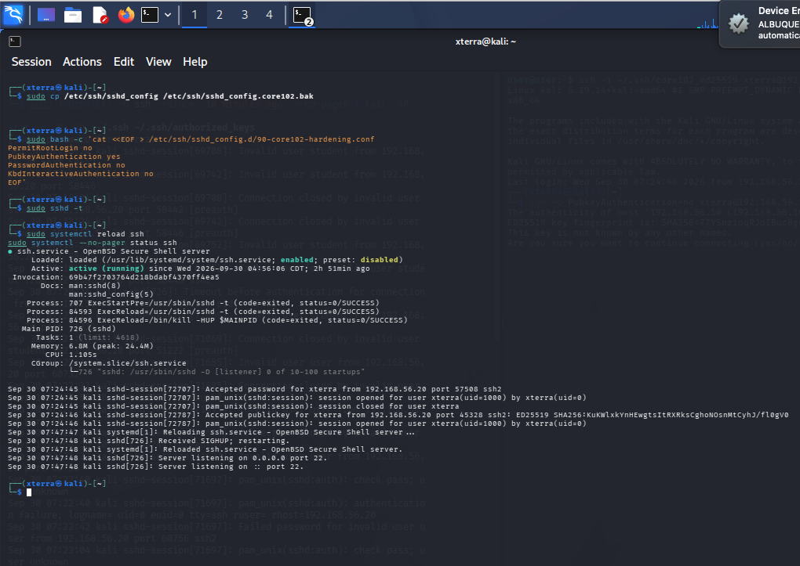
Figure 10. SSH configuration backup, hardening drop-in, validation and reload

Evidence 11 — Second-session key-based login and sshd confirmation
Figure 11. Second-session key-based login and sshd confirmation
Hardening gate satisfied
The supplied evidence shows successful public-key authentication before the hardening state was relied upon, and the later log records an accepted ED25519 public key. The sshd -t validation returned successfully and the service was reloaded.

11. Part 8 — Final Exposure Review and Cleanup
The temporary 8080 UFW rule was deleted, the rule list was rechecked, and ss confirmed that the temporary HTTP service was no longer listening. The final socket inventory shown in the evidence contains SSH on TCP/22 as the remaining TCP listener.
sudo ufw status numbered
sudo ufw delete 2
sudo ufw status numbered
sudo ss -ltnp | grep ':8080' || echo "Temporary web service stopped"
sudo ss -tulpn

Evidence 12 — Deletion of the temporary 8080 rule and final socket inventory
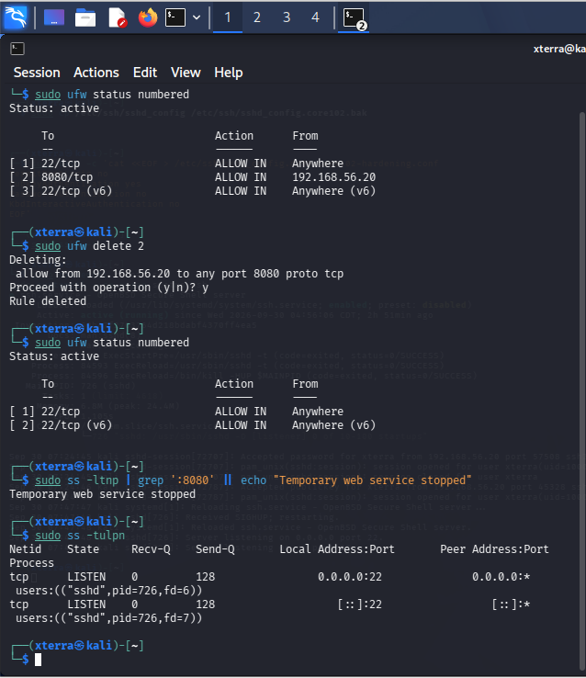
Figure 12. Deletion of the temporary 8080 rule and final socket inventory

Evidence 13 — Final client verification: SSH key login active and port 8080 unreachable
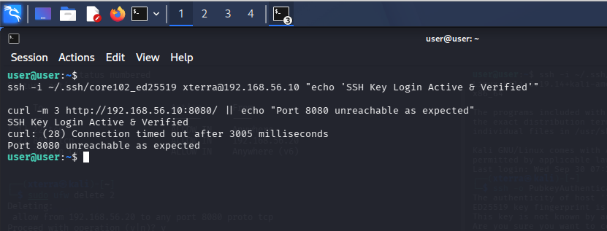
Figure 13. Final client verification: SSH key login active and port 8080 unreachable
Cleanup result
The final evidence explicitly reports 'Temporary web service stopped' and shows no TCP/8080 listener. The client also confirms that SSH key login remains active while port 8080 is unreachable.

12. Reflection Questions

1. Why must SSH access be allowed before a default-deny firewall is enabled?
A default-deny incoming policy drops traffic that has not been explicitly permitted. If SSH is the management path and port 22 is not allowed first, enabling the policy can terminate or prevent administrative access. The laboratory therefore requires SSH to be permitted and tested before enabling the deny policy.

2. What is the difference between an open port and an authorised service?
An open/listening port means a process is accepting traffic on that port. Authorisation is a policy decision about whether that service and its exposure are permitted for the intended hosts and purpose. A listening service can therefore be technically reachable but still outside the approved security policy.

3. Why does the server need the public key while the client must protect the private key?
The server uses the public key to verify a signature produced with the corresponding private key. The private key is the secret credential; disclosure would allow another party to attempt authentication as the key holder. The public key is designed to be installed on the server and does not reveal the private key.

4. Which rollback step would recover access after an invalid SSH configuration?
Use the VM console rather than relying on the broken SSH path, restore the backed-up /etc/ssh/sshd_config (or remove the faulty drop-in), run sudo sshd -t to validate the restored configuration, and reload the SSH service only after validation succeeds.

13. Evidence Integrity and Residual Risk Notes
The following points are retained so that the report accurately represents the supplied practical evidence and does not overstate what was demonstrated:
- SSH scope: the captured UFW rule permits TCP/22 from Anywhere, while the workbook's intended implementation specifies the 192.168.56.0/24 laboratory subnet. The screenshot is reported as captured.
- Addressing stages: the early HTTP test uses 192.168.56.101/192.168.56.102; the later firewall and cleanup evidence uses 192.168.56.10/192.168.56.20.
- HTTP/8080 state: the supplied evidence shows successful HTTP access while the rule/service was active and a timeout after the temporary service/rule was removed. A conflicting draft table entry was not used to claim a denied HTTP 200 result.
- Baseline completeness: the service inventory is present, but the supplied answer does not contain complete before-change interface/route/service/firewall screenshots. This is identified as an evidence gap rather than filled with invented output.
- Temporary web-service exposure: one captured client response shows a directory listing, demonstrating that the temporary service exposed files from its serving directory during the test. The service was subsequently stopped and port 8080 removed from UFW.
- SSH authentication: the supplied logs include earlier failed/invalid-user attempts, followed later by accepted ED25519 public-key authentication. The successful key-based event is the relevant evidence for the laboratory objective.
Residual-risk interpretation
The main residual configuration concern visible in the supplied evidence is the broader-than-specified SSH source scope (Anywhere). If the lab is being graded strictly against the workbook command, capture a corrected subnet-scoped rule and replacement evidence before submission.

14. Final Submission Checklist
- ☐ Student name and registration number completed.
- ☐ Report reviewed for screenshots, captions and command/output visibility.
- ☐ No private SSH key, password, token or secret material included.
- ☐ Evidence filenames and report filename use the required registration-number convention before final upload.
- ☐ Temporary HTTP service stopped and TCP/8080 rule removed.
- ☐ Custom iptables chain removed.
- ☐ SSH key-based access verified in a separate session.
- ☐ SSH configuration validated with sshd -t before reload.
- ☐ Any required correction to the SSH source scope is evidenced before final submission.
Submission filename
Recommended final filenames after entering the registration number:
REGNO_CORE102_Lab4_Report.pdf
REGNO_CORE102_Lab4_Files.zip

