Machine Learning Project
on Startup Success Prediction

Ognjen Maricic, Yuzhen NI
PSL M1 — March 2026

Table of contents
Introduction 3
1 Dataset Description 3
2 Exploratory Data Analysis 4
2.1 Class Distribution 4
2.2 Feature Distributions and Skewness 4
2.3 Feature Quality Analysis 4
3 Preprocessing 5
4 Supervised Learning 5
4.1 Hyperparameter Tuning 5
4.2 Model Comparison 6
4.3 Final Model Evaluation — Logistic Regression 6
4.4 Binary Classification — Failure vs Acquisition 7
5 Unsupervised Learning 9
5.1 PCA — Variance Analysis 9
5.2 Choosing k — Comparing k=2 and k=3 10
5.3 k=2 vs Failure / Non-Failure 10
5.4 Cluster Profiles 10
5.5 Cluster Archetypes 11
5.6 Hierarchical Clustering 11
Conclusion 12

Introduction
Predicting whether a startup will succeed is a challenging and economically important problem. In this project, we apply both supervised and unsupervised machine learning methods to a dataset of 100,000 startup profiles sourced from Kaggle. Each sample is described by 7 numerical features — funding rounds, founder experience, team size, market size, product traction, burn rate, and revenue — along with 3 categorical features: investor type, sector, and founder background.
The target variable, outcome, takes three values: Failure (55.6%), Acquisition (42.3%), and IPO (2.1%). Our primary objectives are:
- Explore the data through exploratory data analysis (EDA) and assess feature quality.
- Build and compare supervised classifiers (k-NN, Decision Tree, Logistic Regression, LDA) using cross-validated hyperparameter tuning.
- Apply unsupervised clustering (K-Means, Hierarchical) and PCA to discover latent structure in the data.
- Critically evaluate results of the dataset.

1 Dataset Description
The dataset was obtained from Kaggle and consists of 100,000 rows and 11 columns (7 numerical, 3 categorical, 1 target). There are no missing values. Table 1 summarizes the features.
Feature | Type | Description
funding_rounds | Numerical (int) | Number of funding rounds received
founder_experience_years | Numerical (int) | Years of experience of the founder
team_size | Numerical (int) | Number of employees
market_size_billion | Numerical (float) | Addressable market size (USD billion)
product_traction_users | Numerical (int) | Number of active users
burn_rate_million | Numerical (float) | Monthly cash burn (USD million)
revenue_million | Numerical (float) | Annual revenue (USD million)
investor_type | Categorical | angel / tier1_vc / tier2_vc / none
sector | Categorical | AI, SaaS, Fintech, Health, Ecommerce, Climate, Crypto
founder_background | Categorical | academic / first_time / ex_bigtech / serial_founder
outcome (target) | Categorical | Failure / Acquisition / IPO
Table 1 — Feature overview of the startup success dataset.

2 Exploratory Data Analysis

2.1 Class Distribution
The target variable is severely imbalanced. As shown in Table 2, Failure accounts for 55.6% of samples, Acquisition for 42.3%, and IPO for only 2.1% (2,055 samples). This imbalance — particularly the rarity of IPO — has direct consequences for model performance: classifiers trained without special treatment tend to under-predict IPOs.
Outcome | Count | Proportion
Failure | 55,610 | 55.61%
Acquisition | 42,335 | 42.34%
IPO | 2,055 | 2.06%
Table 2 — Class distribution of the target variable.

2.2 Feature Distributions and Skewness
Histograms reveal that several numerical features have right-skewed distributions, as quantified in Table 3. In particular, market_size_billion (skewness = 5.26) and burn_rate_million (skewness = 3.35) are heavily skewed, while revenue_million shows moderate skewness (1.25). Features such as founder_experience_years and team_size are approximately symmetric (skewness ≈ 0).
Feature | Skewness | Transform applied
funding_rounds | 0.69 | log1p
founder_experience_years | -0.01 | none (symmetric)
team_size | ~0.00 | none (symmetric)
market_size_billion | 5.26 | log1p
product_traction_users | 0.59 | log1p
burn_rate_million | 3.35 | log1p
revenue_million | 1.25 | log1p
Table 3 — Skewness of numerical features and applied log1p transformations.

2.3 Feature Quality Analysis
A key finding of our EDA is that most features have very low predictive power for the outcome. We computed Spearman rank correlations* between each numerical feature and the target (encoded ordinally). The results, shown in Table 4, reveal that only revenue_million (r = −0.34) and product_traction_users (r = −0.32) carry meaningful signal. The remaining five features — notably market_size_billion (r = 0.001) and burn_rate_million (r = −0.001) — are essentially noise.
Feature | Spearman r with outcome | Signal quality
revenue_million | -0.345 | Moderate
product_traction_users | -0.321 | Moderate
funding_rounds | -0.184 | Weak
founder_experience_years | -0.162 | Weak
team_size | -0.076 | Very weak
burn_rate_million | -0.001 | Noise
market_size_billion | 0.001 | Noise
Table 4 — Spearman correlation of each feature with the target variable.
Furthermore, the maximum inter-feature Pearson correlation is 0.714 (between revenue_million and product_traction_users), but most pairs are near zero. This absence of natural structure limits the discriminative power of all models trained on this data.

3 Preprocessing
We built a modular preprocessing pipeline using scikit-learn's Pipeline and ColumnTransformer (following the TD07 pattern), which ensures identical transformations are applied at training and inference time with no data leakage.
Numerical features were transformed with log1p (to reduce skewness) followed by StandardScaler (zero mean, unit variance). Categorical features (investor_type, sector, founder_background) were encoded with OrdinalEncoder, assigning an integer rank to each category. The dataset was split 80/20 into training (80,000 samples) and test sets (20,000 samples) using stratified sampling to preserve class proportions.

4 Supervised Learning
We evaluated four classifiers: k-Nearest Neighbours (k-NN), Decision Tree, Logistic Regression, and Linear Discriminant Analysis (LDA). k-NN and Decision Tree were tuned via GridSearchCV with 5-fold StratifiedKFold. Logistic Regression and LDA were evaluated directly with cross_val_score (no hyperparameter grid), following the course approach: LR uses max_iter=1000 with default regularization, LDA has no critical hyperparameters.

4.1 Hyperparameter Tuning
Table 5 summarises the best hyperparameters and cross-validated accuracy for each model.
Model | Search grid | Best params | CV Accuracy
k-NN | k ∈ {3,5,7,…,201} | k = 201 (boundary!) | 0.7144
Decision Tree | max_depth ∈ {5,10,15,20,None}, min_split | max_depth=10, min_split=50 | 0.7198
Logistic Regression | no tuning (max_iter=1000) | — | 0.7300 ✓
LDA | No hyperparameters (cross-validated directly) | — | 0.7258
Table 5 — Hyperparameter search results for each classifier.
A notable finding is that the best k for k-NN reached the upper boundary of the search grid (k = 201), even after extending the grid to 201. This indicates that k-NN performs best with maximal smoothing — a strong signal that the data has no meaningful local neighborhood structure.

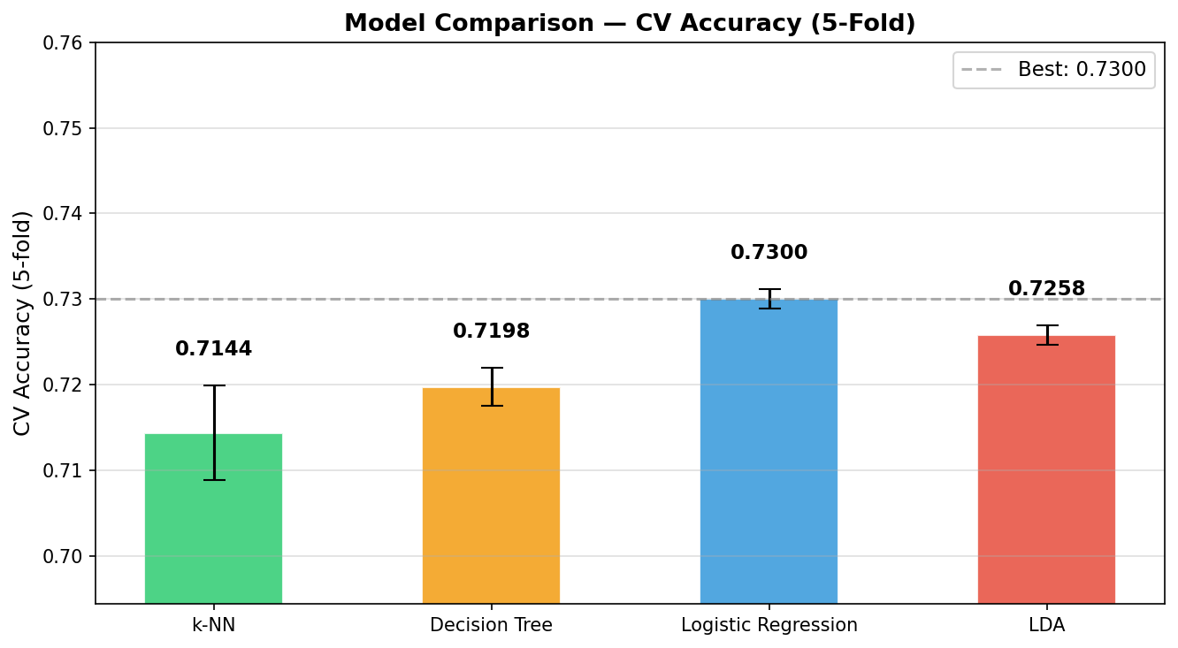
Figure 1 — CV accuracy comparison for all four tuned models (5-fold StratifiedKFold).

4.2 Model Comparison
Figure 1 (in the notebook) shows a bar chart comparing the four tuned models. Logistic Regression achieves the highest cross-validated accuracy (73.00%), followed closely by LDA (72.58%) and Decision Tree (71.98%). k-NN lags behind (71.44%). The narrow spread between models (< 2 pp) further confirms that the dataset's weak feature-target correlations form the true performance ceiling.

4.3 Final Model Evaluation — Logistic Regression
Logistic Regression was selected as the best model and evaluated on the held-out test set (20,000 samples). Test accuracy was 72.90%, consistent with the cross-validated estimate. Table 6 presents the full classification report.
Class | Precision | Recall | F1-score | Support
Acquisition | 0.6785 | 0.6851 | 0.6818 | 8,467
Failure | 0.7677 | 0.7823 | 0.7749 | 11,122
IPO | 0.6724 | 0.1898 | 0.2960 | 411
Accuracy | — | — | 0.7290 | 20,000
Macro avg | 0.7062 | 0.5524 | 0.5842 | 20,000
Weighted avg | 0.7280 | 0.7290 | 0.7257 | 20,000
Table 6 — Classification report for Logistic Regression on the test set (3-class).
The model performs well on Failure (F1 = 0.775) and reasonably on Acquisition (F1 = 0.682), but struggles with IPO (F1 = 0.296, Recall = 0.190). The low recall for IPO is a direct consequence of class imbalance: with only 2.1% of samples, the model rarely predicts this class. The ROC curves (one-vs-rest) confirm this, and feature importances show that revenue_million and product_traction_users dominate the decision boundary.

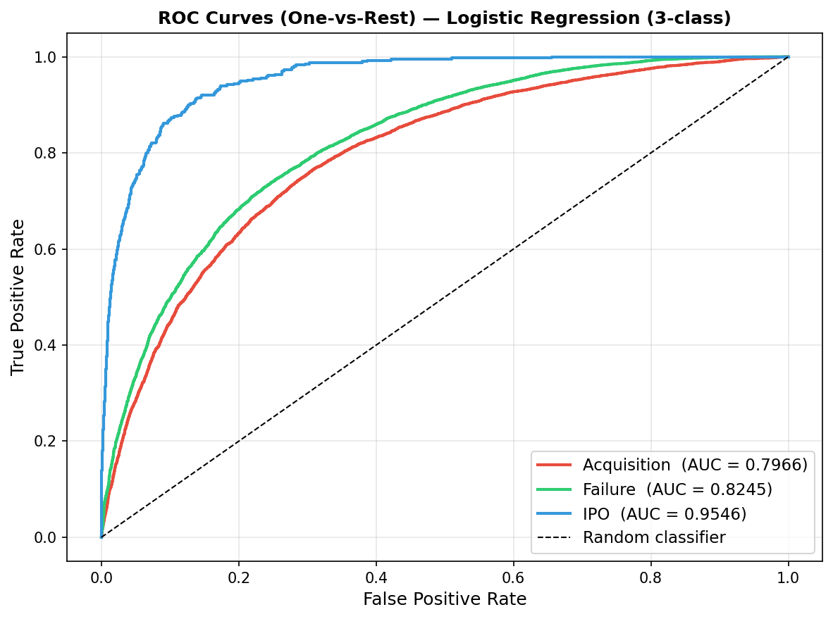
Figure 2 — ROC Curves (One-vs-Rest) for Logistic Regression on the 3-class test set.

4.4 Binary Classification — Failure vs Acquisition
Given the near-impossibility of learning the IPO class (2.1% of data), we remove IPO rows and repeat the full pipeline on the remaining two classes (97,945 samples: 57% Failure, 43% Acquisition). This binary setting produces a cleaner and more balanced problem.
Table 7 summarizes the GridSearchCV results on the binary dataset.
Model | Best params | CV Accuracy
k-NN | k = 51 | 0.7248
Decision Tree | max_depth=10, min_split=50 | 0.7338
LDA | — | 0.7408
Logistic Regression | no tuning (max_iter=1000) | 0.7426 ✓
Table 7 — Binary classification GridSearchCV results.
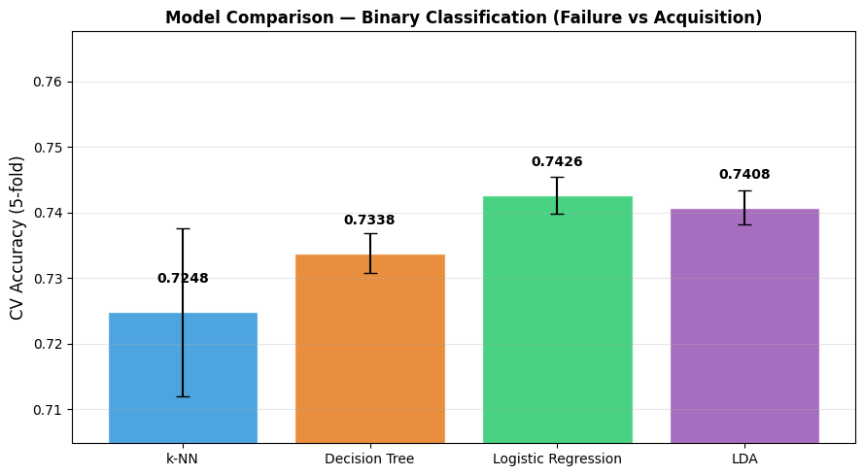
Figure 3 — CV accuracy comparison for the four models on the binary dataset (Failure vs Acquisition).

Class | Precision | Recall | F1-score | Support
Acquisition | 0.7074 | 0.6888 | 0.6980 | 8,467
Failure | 0.7677 | 0.7831 | 0.7754 | 11,122
Accuracy | — | — | 0.7424 | 19,589
Macro avg | 0.7376 | 0.7360 | 0.7367 | 19,589
Table 8 — Classification report for binary Logistic Regression.
Removing IPO raises the macro F1 from 0.584 to 0.737, confirming that class imbalance was the primary bottleneck in the 3-class setting. The ROC curve yields AUC = 0.816, indicating good discriminative power between Failure and Acquisition.

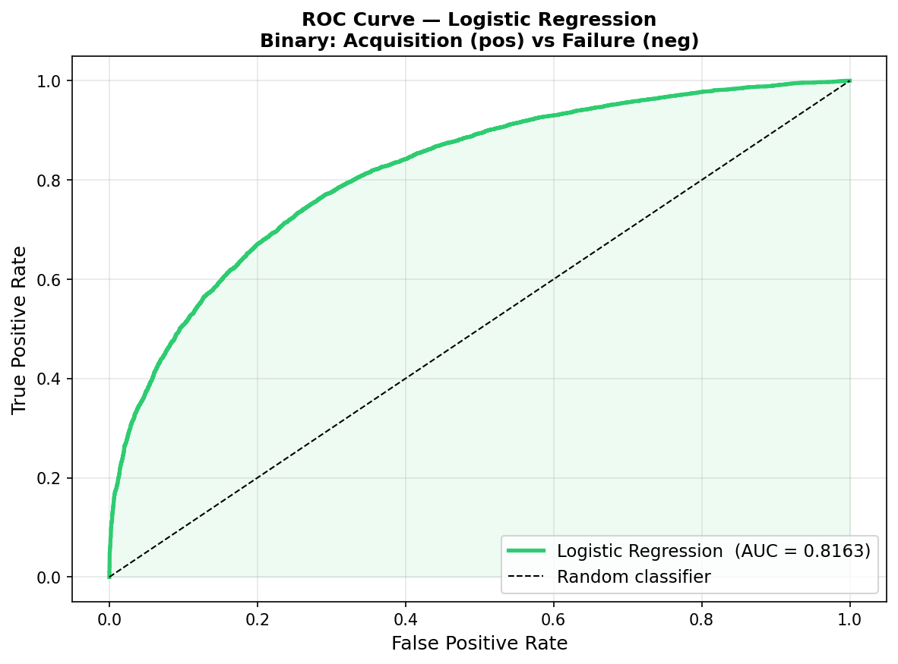
Figure 4 — ROC Curve for binary Logistic Regression (Acquisition vs Failure), AUC = 0.8163.

5 Unsupervised Learning
In Part 2, we apply unsupervised methods to the full dataset (100,000 samples) to discover latent groupings without using outcome labels.

5.1 PCA — Variance Analysis
We applied PCA to the scaled numerical features (7 dimensions). The first two components capture only 39.65% of total variance (PC1: 25.23%, PC2: 14.42%). This low cumulative explained variance is consistent with the near-independence of features in the dataset.
Component | Explained Variance | Cumulative
PC1 | 25.23% | 25.23%
PC2 | 14.42% | 39.65%
PC3 | 14.33% | 53.98%
Table 9 — PCA explained variance for the first three components.

5.2 Choosing k — Comparing k=2 and k=3
We compare k=2 and k=3 (because it is consistent with the natural classification of the data by the outcome (IPO, Acquisition, Failure)) by examining the silhouette score and visual separation in PCA space. Table 10 shows the results.
k | Inertia | Silhouette score
2 | 588,571 | 0.1612
3 | 532,371 | 0.1553
Table 10 — K-Means comparison for k=2 and k=3.
Both scores are low (< 0.2), confirming that the dataset has no strong natural cluster structure. The silhouette scores are nearly identical for k=2 and k=3. We can choose both of them. In our project, we choose k=2 for comparison between the clusters and a binary outcome grouping (failure, non-failure). Then we choose k=3 because it is consistent with the number of types of groups distinct by outcome.

5.3 k=2 vs Failure / Non-Failure
As a sanity check, we compare k=2 clusters with a binary outcome grouping (Failure vs Non-Failure). Table 13 shows the composition.
Cluster | Failure % | Non-Failure % | Dominant profile
0 (high revenue) | 43.4% | 56.6% | Mostly Non-Failure
1 (low revenue) | 79.7% | 20.3% | Strongly Failure
Table 13 — k=2 cluster composition vs binary outcome.
With k=2, Cluster 1 aligns strongly with Failure (79.7%). This is the clearest alignment between unsupervised clustering and supervised labels in the entire analysis, and is consistent with the finding that revenue and traction are the only informative features.

5.4 Cluster Profiles
Cluster labels are reordered by descending revenue mean, ensuring Cluster 0 always corresponds to the highest-revenue group. Table 11 shows the mean feature values per cluster.
Feature | Cluster 0 | Cluster 1 | Cluster 2
revenue_million | 1,038,320 | 847,137 | 234,260
product_traction_users | 360,632 | 310,499 | 119,455
founder_experience_years | 15.0 | 2.3 | 13.3
funding_rounds | 2.0 | 2.0 | 2.0
team_size | 150.6 | 151.4 | 150.6
market_size_billion | 33.2 | 33.3 | 33.1
burn_rate_million | 16.8 | 16.7 | 16.9
Table 11 — Mean feature values per K-Means cluster (original scale, ordered by revenue).
The clusters are differentiated almost exclusively by revenue and product traction. team_size, market_size_billion, burn_rate_million, and funding_rounds are nearly identical across all three clusters, confirming they carry no structural information.
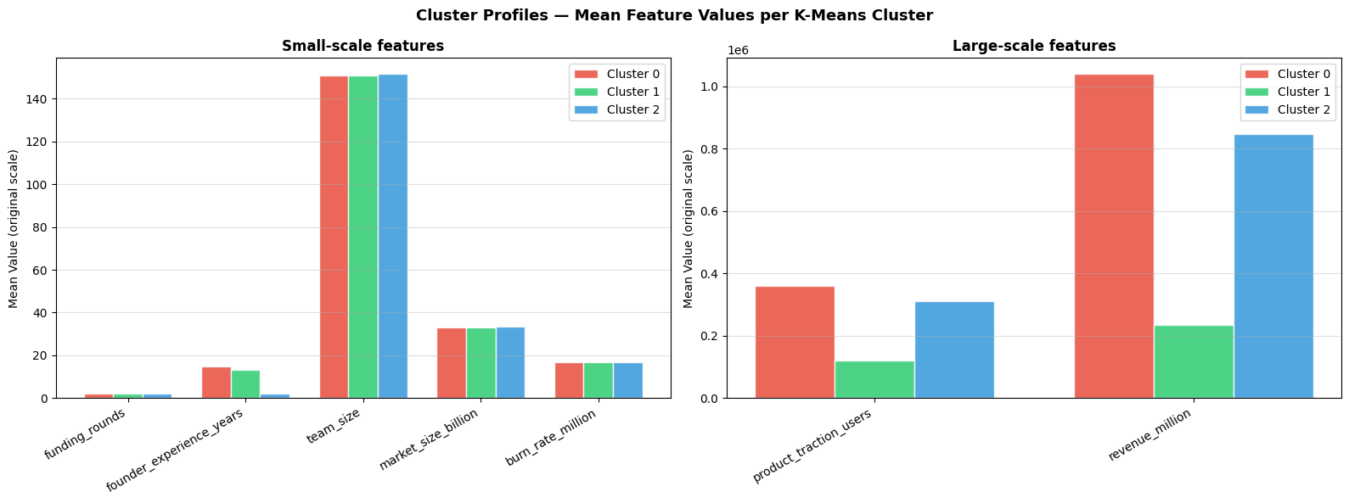
Figure 5 — Cluster profiles (mean feature values). Left: small-scale features; Right: large-scale features.

5.5 Cluster Archetypes
Rather than comparing clusters to outcome labels, we interpret each cluster on its own terms as a startup archetype:
Cluster | Revenue | Traction | Founder exp. | Archetype
0 (53%) | High | High | ~15 yrs | Mature, high-revenue companies
1 (20%) | Mid | Mid | ~2 yrs | Early-stage, young-founder startups
2 (27%) | Low | Low | ~13 yrs | Low-traction, struggling companies
Table 12 — Cluster archetypes interpreted by feature profiles.
This interpretation is independent of the outcome labels and has its own business logic: the feature space naturally separates companies by their revenue level and traction, which reflects their development stage. Note that K-Means clusters do not correspond one-to-one with the outcome classes — this would only be possible if the features perfectly predicted the outcome, which they do not because of the limitation of the data.

5.6 Hierarchical Clustering
We applied Agglomerative Clustering with Ward linkage on a 2,000-row subsample. The dendrogram was reconstructed from the sklearn model using the TD06 method. With k=3, the hierarchical solution produces a more imbalanced partition (Cluster 0: 78%, Cluster 1: 15%, Cluster 2: 7%) compared to K-Means (53/27/20%). This is expected: Ward linkage minimizes intra-cluster variance without any constraint on cluster size, while K-Means tends toward more balanced partitions.
The side-by-side PCA comparison confirms that both methods identify a similar large high-revenue group and a smaller low-traction group, but differ in how they split the intermediate region.

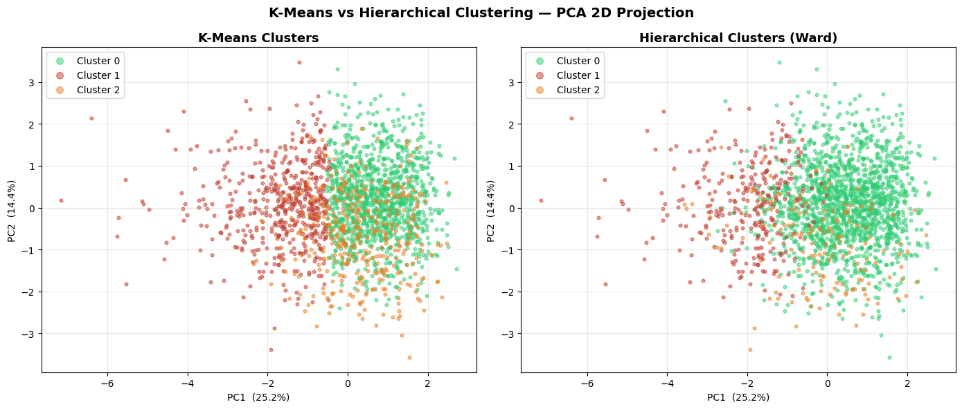
Figure 6 — Side-by-side PCA projection: K-Means (left) vs Hierarchical / Ward (right). Both methods identify the same three groups.

Conclusion
Supervised learning (3-class): Logistic Regression achieves the best CV and test accuracy (CV = 73.00%, test = 72.90%), closely followed by LDA (72.58%) and Decision Tree (71.98%). The narrow gap between models (< 2 pp) reflects the dataset's weak feature-target correlations rather than model capacity. The macro F1 of 0.584 is dragged down by the near-unlearnable IPO class (2.1% of data, recall = 0.19), which the model almost never predicts. Binary classification (Failure vs Acquisition): removing the 2,055 IPO samples and retraining on the remaining 97,945 samples raises macro F1 from 0.584 to 0.737 and ROC AUC to 0.816. All four models improve, with LR again performing best (CV = 74.26%). This confirms that class imbalance — not model architecture — was the primary bottleneck in the 3-class setting.
Unsupervised learning: PCA captures only 39.65% of variance in two components, and both k=2 and k=3 yield low silhouette scores (< 0.17), indicating no strong natural cluster structure. Nevertheless, three interpretable startup archetypes emerge: mature high-revenue companies (Cluster 0), early-stage young-founder startups (Cluster 1), and low-traction struggling companies (Cluster 2). With k=2, Cluster 1 aligns strongly with Failure (79.7%), providing the clearest unsupervised-to-supervised link in the analysis.
The fundamental limitation of this work is the nature of the dataset: five of seven features carry near-zero signal, imposing a hard ceiling on both classification accuracy (~73%) and clustering quality. In a better startup dataset, richer feature dependencies would likely yield higher model performance and more coherent cluster structure.

