Genealogic tree: Manuel

Table of content
I/ Launch the program
II/ Test the program

I/ Launch the program

> Open a terminal
> Go to the methodologie folder
> $cd src/ –Folder containing the project
> $gnatmake -gnatawa -I./ -gnata -g start.adb –To compile the project
> $./start

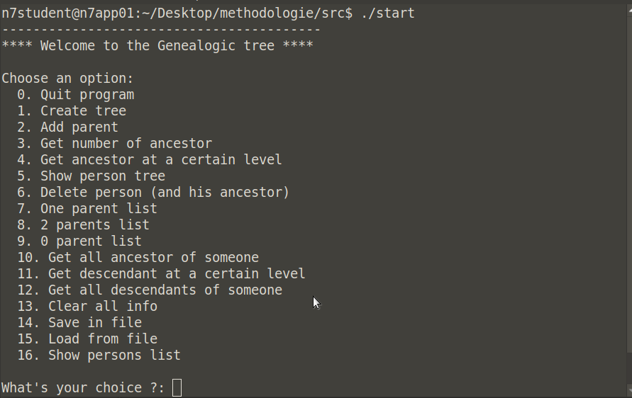

Menu

Now you can play with the program by providing an option:
- You first need to create a tree (option 1) and then display it (option 16).
- After each action, you are asked to enter a random character to proceed.

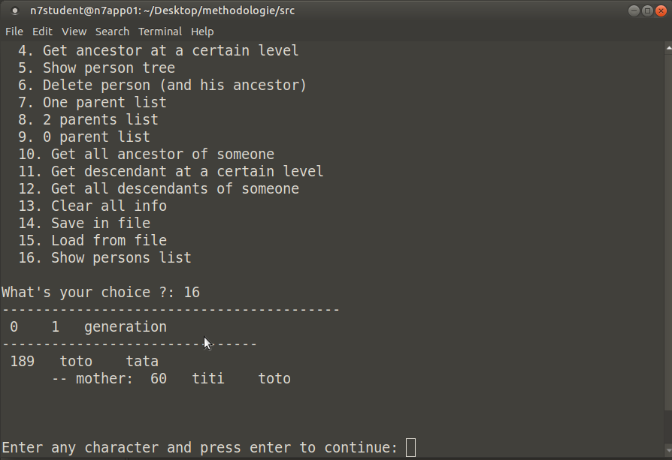

Option 16- Showing trees

- After having played with the program, you can save your tree by choosing option 14. Call it gen for instance.
- Then you can stop the program (ctrl+C or option 0) and launch it again.
- Try to load the data by using option 15. Type gen and tadaa… You tree is loaded in memory!

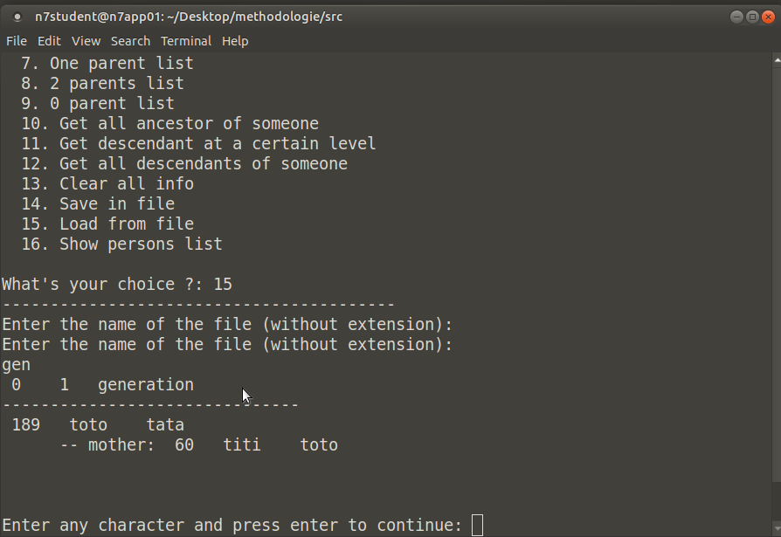

Option 15- Loading
II/ Test the program

> Open a terminal
> Go to the methodologie folder
> $cd livrables/tests/ –Folder containing tests
> $gnatmake -gnatawa -I../../src/ -gnata -g tests.adb –To compile the tests, it need sources files
> $./tests

— Un manuel utilisateur (manuel.pdf) qui décrit comment utiliser les programmes
développés et qui est illustré avec des copies d’écran.

As a side note, we have to include the src/ folder containing the modules to test. This is done by adding the -I parameters in the compiler commands (more on that in the manuel section). The resulting command to compile is:
$ gnatmake -gnatawa -I../../src -gnata -g tests.ads

Use the program

Test the program

