Genealogic tree: Report

Table of content:
I/ Genealogic tree: Summary
II/ Strategy
A- Tools
B- Development cycle
C- Principles
III/ Architecture
IV/ Data-Types
V/ Algorithms
VI/ Tests
VII/ Difficulties
VIII/ What’s next ?
IX/ Personal sumup

I/ Genealogic tree: Summary

The aim of the projet was to create a console program allowing a user to interact with genealogic trees. This was a single person project. You will find in this report a description of the program at all level of abstraction, from the specifications down to the actual implementation and the tests. I will also tackle the dificulties I faced while developing it, what I learned from them and I will give you a brief idea of what could be upgrade or added to the program.

II/ Strategy

A- Tools

I developped this program in Ada. I used visual studio code as my integrated development tool and gnat as a compiler. All the project, including the code, tests and documentation were kept in my personal github account.

B- Development cycle

Before going down to the actual coding, I dedicated an hour to the specification reading, putting in place the global folder structure of the project, and thinking about the different data types and their interactions.
This project was really similar to others I did at the university, so I quickly had a good idea of the project as a whole.

I divided the whole project into smaller goals achievable in a typical 2 hours session. I added all the features of the program when I was certain that the existing ones worked properly. This allowed me to have a program always ready to run, but made me re-organized files/functions a couple of time to avoid redundancy.

Concerning tests, I did them at the end once everything was coded. While developping features, I wrote a list of possible failures to be tested later on. I should point out that writing tests let me spot errors I did not see.

C- Principles

While designing the program, I kept in mind:

- The single responsability principle, so that each file/function has it own purpose. The aim is to avoid large files and allow to easily add features to the program (See the arctitecture section). For the functions, this resulting in the raffinage process learned at school.

- Code encapsulation. I made sure subtypes were private when necessary, and gave functions/procedures to interact with them in a defined and controlled way.

- Genericity, making a part of my code reusable for futur project.

III/ Architecture

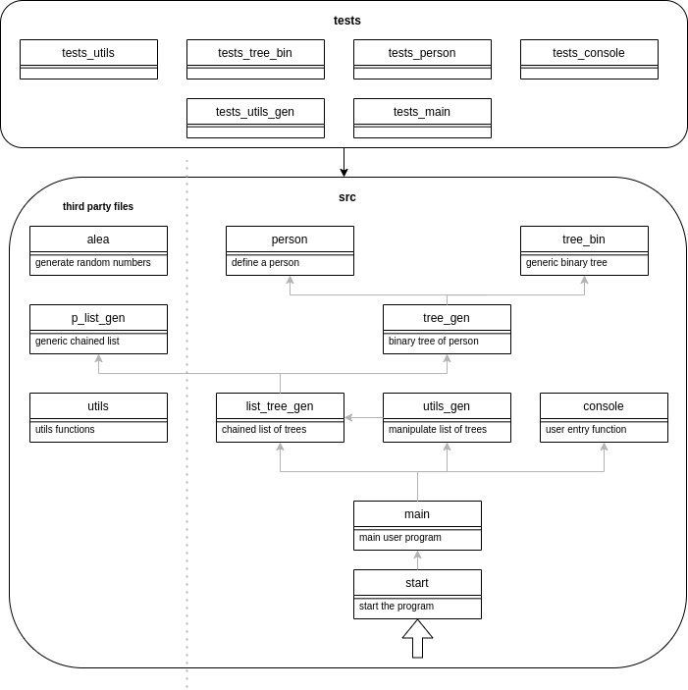
Genealogic tree module architecture

Warning:
gen refers to the genealogic term in all files except p_list_gen. Here gen means generic.

This graph is pretty straightforward, it should be read bottom-to-top. The start file launchs main. Main presents the user with all the available options by using the console module. Main manipulates concrete data-types that derived from generic ones. utils_gen provides other functions to manipulates a list of trees, to save and load them for instance. The utils and alea are not specific to this project and were used as a helper throughout the project.

IV/ Data-Types

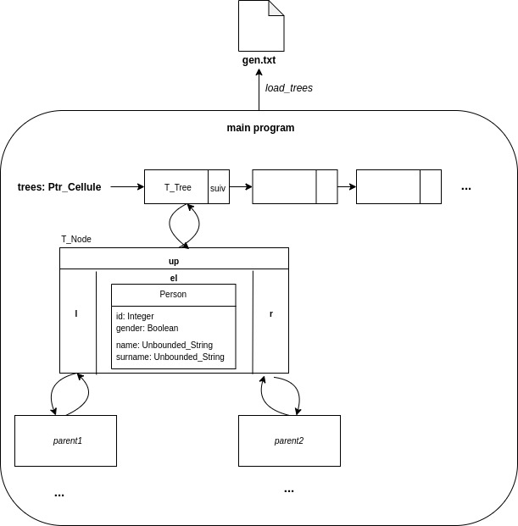
Genealogic tree data organisation

The data is organised as such.
- The main.adb contains one trees variable, which is a chained list of T_Tree.

- Each tree represents the genealogic tree of a person. It is a binary tree data structure pointing to a node T_Node.

-T_Node is a structure containing the actual person, one pointer for each parent (l and r) and a pointer to it descendant (up). I choosed to introduced up due to the specifications. Indeed, some features of the program were about showing descendants of someone. Having this pointer lets the algorithms being simpler to write and with a lower complexity.

- Person is a structure containing the person’s info.

- The variable trees can be loaded from a formatted text file via the load_trees methods (more on that in the algorithm section).

V/ Algorithms
In /src

In this section, I will explain some functions that desearve a detailed explanation. For the other ones, please refer to the comments directly in code. I used both iterative and recursive functions/procedures throughout the project, depending mostly on my subjective code style.

File | Porpuse | Steb by step explanation
procedure enlever(e: in T_Element; l: in out Ptr_Cellule) with Post => not exist(e, l);
p_list_gen | Remove element e from list l. | Iterative.  - Check if it is the first element to remove. If so, it just returns the next element.  -Otherwise, check out the next element. If the next element if the one to delete, change it to the one after.  Otherwise, loop until you find it or you reach the end.
function stringify_person(el: in T_Person; ancestor_id: in Integer := -1) return Unbounded_String;

person | Convert a person into a string (to save him into a file later). | - Some persons do not have descendant (root of the tree). Let stringify know by providing a -1 for ancestor_id.  Create an Unbounded_String str.  - concat the ancestor id to str if it is not -1.  - concat the gender to str (0 for man, 1 for woman)  - concat the name and surname to str  - return the Unbounded_String.
function person_from_line(line: in Unbounded_String; ancestor_id: in out Integer; root: in Boolean) return T_Person;
person | Convert a string into a person (the reversed process of stringify_person). | Iterative.  - The string line is read character by character. To isolate a field of the string, we look for a white space. When found, the corresponding field is the substring starting from last_index to current_index.  - El: Integer is the index of the reading part of the string. It helps to know which field of the person we are reading.  - So we loop throught each character of line. Isolate the field when there is a whitespace. See what is that field via a switch on el. And save the info into a person via some conversion.  - We return the final person.
procedure show_descendant(tree: in T_Tree; descendant: in Integer; cur_desc: in Integer := 0);
tree_bin | Show all descendants at a given level. | Recursive.  - We stop when a tree is empty.  - If this is the right level or if level is -1, we show the person info for the current tree.  - We loop iteratively to the descendant by using the up pointer, incrementing the level.
function stringify_tree(tree: in T_Tree; ancestor_id: in Integer := -1) return Unbounded_String;
tree_bin | Convert a tree into a string. | Recursive.  - If the tree is empty, return an empty string.  - Otherwise, return the stringify person of that tree, followed by the stringify version of the 2 subtrees.
function find_el_trees(id: in Integer; trees: in Ptr_Cellule; root: in Boolean := false) return T_Tree;
utils_gen | Find a tree element inside a chained list of trees. | Iterative.  For each tree of the trees: Ptr_Cellule:  - try to find the element with id inside that tree.  - If found, we can whether return the subtree containing the element at id, or we can return the whole tree (based on the use of the function).  - Otherwise, find the element in the next tree of the list.
function save_trees(trees: in Ptr_Cellule; file_name: in Unbounded_String) return Boolean;
utils_gen | Save a chained list of trees inside a text file. | Iterative.  Create an empty Unbounded_String trees_str.  - Go throught each tree, and concat trees_str with the stringify_tree procedure.  - Open/create a text file with the provided file_name  - Write trees_str into that file  - Close the file.
function load_trees(file_name: in Unbounded_String) return Ptr_Cellule;
utils_gen | Create a chained list of trees Ptr_Cellule out of a text file. | Iterative.  -Create an empty Ptr_Cellule.  - Open the file and loop over each line.  -If the line is “arbre”, that mean that the following lines correspond to a new tree. So we get the root person out of the next line, create a new tree with him and insert that tree into the list of trees.  - Otherwise, we create a new person out of the line and get his ancestor id. This id is used to insert this person at the right place.  - We close the file and return the tree.
procedure user_program(trees: in out Ptr_Cellule);
main | Program interacting with the user to let him manipulates genealogic trees. | The trees parameters is the variable holding all the data (chained list of trees). It is a parameter for testing purposes (more on that in the tests section).  This program is an infinite loop. One iteration corresponds to one user action in the system. For each iteration:  - We show every options the user has and get his choice, using the console module.  - Do the right action via a switch. Each action consists of getting more user input if necessary and call the diferent module’s procedures/functions on our trees variable.

VI/ Tests
In /livrables/tests

Each module has it own test module, For instance, utils.ads → test_utils.ads. A test module consists of one test per function/procedure. The point is to make sure every functions work as expected by delivering the correct result.
One test consist of:
- A prepare phase: Initialising variable we need as parameters.
- Running phase: Calling the function to test with those variables.
- Assert phase: Comparing the result given by the function to what is expected, using the assert procedure.

A test passes if the assert is correct, it fails otherwise.

tests.adb is the starting point. It includes every test modules, call them and is successful if every tests passed. The order it calls the tests matter. Indeed, we first test the most generic functions available, aka the ones that don’t depend on the others. By doing this, we ensure that a bug in a function come from this function and not subfunctions it uses. That is why the test of utils come first. Then, the order follows the Genealogic tree module architecture graph, going from top to bottom for the exact same reason.

let’s have a look at every test files:

Name  tests.adb | Strategy
tests_utils | Nothing particular. It is a typical test file on it simplest form.
tests_tree_bin | Here, tree bin is tested containing Integer and not T_Person.  This does not matter as what we test here is the behavior of the binary tree generically speaking. Furthermore, using simple integers allowed to greately simplify our tests.  Again, each procedure/function is tested following the specification order.
tests_person | Here, stringify_person and person_from_file supposedly have the inverted behavior. We use that to test both functions at once. Don’t worry, in case of a bug we are still able to tell which function has a problem.
tests_console | Here, the tester is asked to enter specific user input supposed to cover all the different possibilityies. The tester is the one judging if a test is successful or not. This could leads to some problems discussed in the What’s next section.
tests_utils_gen | Here, save_trees and load_trees are also complementary.  The tester is also the one judging the success of some tests.
tests_main | All the other tests above could be considered as unit tests, as they focus on one function/procedure.  The test of main was thought as an integration test. The tester is placed in the user’s shoes and is guided to follow a defined scenario supposed to test every features of the program. Basically, the tester is asked to enter defined user input, and is telled what should be the resulting consequences.  By passing the trees as an in out parameter in the user_program, I was able to do most of the assert based on that variable. However, the tester judgement was still required.

VII/ Difficulties

I did not face any major difficulty. As I said, I was familiar with those kind of program and everything flew as expected. The difficulties mostly came from ADA due to it differences with programming languages more common like C or java. For instance:
- The way we use a concrete type derived from a generic module in different files. Doing that was essential to divide the code into multiple files and respect the single responsibility principle.
- How to deal with strings to cut them into substrings separated by whitespace.
...

The persistence part was the trickiest. Doing it was optional and made me add new functions that slightly changed (for the good) the way the project was organised. One difficulty was to include the ancestor id into a string line corresponding to a person. Indeed, this information is not kept within a T_Person structure but inside the generic tree.
I also spend more time than expected on the deletion of a person in tree_bin. Due to the up pointer, I over-ingeneered this procedure while I just had to set the right T_Node to null.

We have not done any test in ADA previously, so it tooks me some time to understand what we really wanted to do and how everything should be organised. Writing test is verbose and tooks a lot of time to do.

VIII/ What’s next ?

This program could be improved in different ways. We could:

- Use an id that is sure to be unique. Currently, the id is a random number considered big enough to be unique. What we could do is changing the create_person signature by adding an id parameter. user_program would be in charge of getting an id, making sure it is not taken by calling a new function exist_id_trees in utils_gen. Exist_id_trees would then check inside every trees if the id is taken. If yes, user_program would ask for another one… Finally, user_program would give it to the create_person.

- Keep new information into a person like a birthdate or a size. Adding this would be simple. Changing the T_Person, create_person, show_person, save_person and load_person to take into account those new info.

- Convert this program into a proper software with a graphical interface. This would be a radical change that could take some time to implement. I used javafx in the pass to do this kind of program, but I am not aware of the existing technologies in ADA.

- Tests fully automatised that do not required any human interaction. This is the most important improvement to make. Indeed, having to let the tester enter input data and judge the result of some tests is both long and prone errors. To do this, I would have to do two things. Know how to automatically provide user input into the test program, and rework some function to let them be asserted. For the first part, I have not really searched any solution because while important, this seemed out of the scope of this project.

IX/ Personal sumup

This project was really fun to code. I tried to push myself to deliver the cleanest code possible in a short amount of time, and then explaining it the clearest. Doing it allowed me to finally be confident with ADA, which is something I can now add into my CV. By programing alone, I always stayed extremely focused and coherent throughout the project. Doing this in pair or in group might have been more challenging, especially the repartition of tasks and the merging of everyone’s code.
I stopped coding like this for about a year now and rediscovering the sensation of holding a project was satisfying and comfort my will of being a developper.

