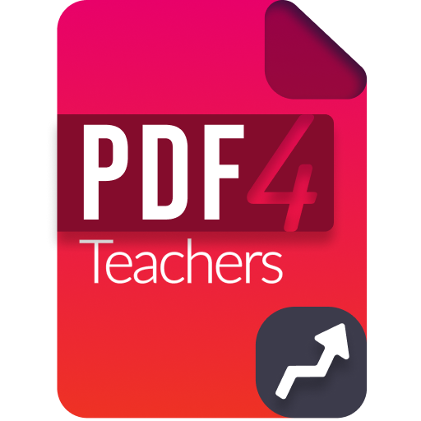

v1.4.2

User Manual

Software overview
PDF4Teachers is a software dedicated to annotation of learners assessments, in PDF file format (or image files of the assessments). It focuses on maximum productivity in annotating / marking this kind of documents.
PDF4Teachers allows user to quickly add and save recurrent annotations. Edited PDF files can then be exported to generate new PDF files including the edits. When using the grades / marking tool, setting up a marking scale, summing points, and exporting marks of all documents to a CSV spreadsheet is made extremely efficient. A skills evaluation tool allows to create different assessments, and then to pair each document to an assessment. Skills levels can be imported / exported from / to the SACoche tool.
PDF4Teachers concept is to add elements on the document before exporting it, as a new PDF file. Elements can be text annotations, LaTeX or LibreOffice Math formulas, marks, SVG drawings and images. Elements are saved in distinct files, each edited PDF file has an associated edit set of informations (see 2. Edit functions)

A set of image files can be converted in PDF documents, and pages format can be edited (rotation, position, add pages…) through the edit pages mode or through buttons located on the top right corner of each page, or using the edit pages mode. It is also possible to take screenshots of pages with a configurable definition, possibly higher than the screen one.

PDF4Teachers conforms to EU GDPR (General Data Protection Regulation): edits and PDF files are locally stored. Web accesses purposes are only: check for updates, new interface languages download and anonymized statistics.
Anonymized statistics only include:
- total time spent with PDF4Teachers main window in foreground,
- number of times application was launched,
- selected language.

Edit functions
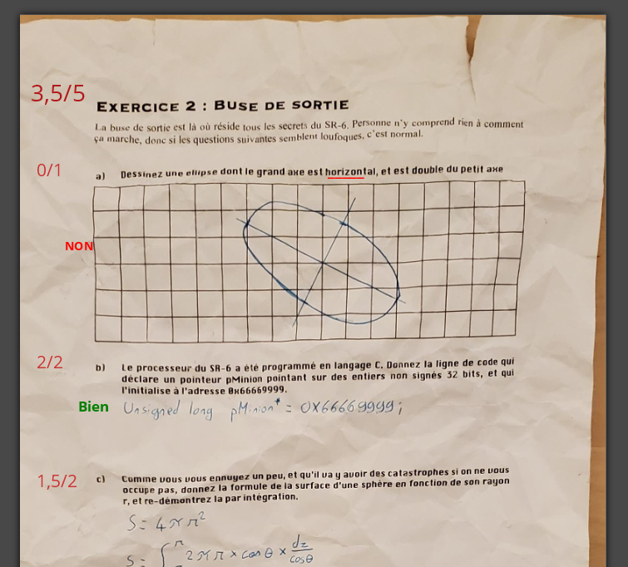
Various elements can be added on the document (text, grades / marks). These elements constitute the edit of the document which is stored separately.
(See Tools → Debug → Open the data folder).

Left side figure shows texts elements and grades. Elements can be moved, and edited in the left panel tabs of PDF4Teachers.

Document edit is loaded as an overlay every time the document is opened in the main panel, but the PDF file is not modified (except when rotating, adding, removing and moving pages).

Once editing is finished, document should be exported, in order to create a new PDF file, on which the whole edit will be permanently added (File → Export).
It is possible to export/import one/some edits with Tools → Export/Import edits.

Files Tab
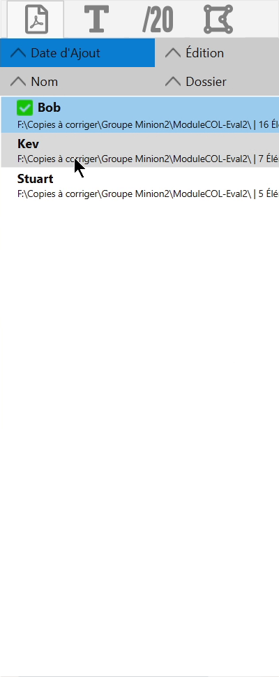
Left panel is composed of 4 tabs. First tab (showed on the left side figure) lists all the opened documents, ready to be edited.

This tab is just a list of files that you decided to add to this set (File → Open […]).
It allows a quick access to a set of files and shows details about the files edits.

It is possible to edit files (double click) or do other actions (right click).

Drag and drop some files, folders or pictures on this tab is also possible.
File sorting in the tab can be set through the 4 top buttons of the tab.

Text elements tab
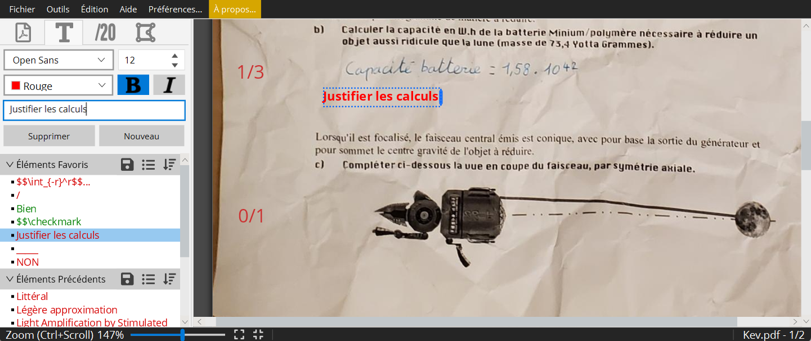
Creating a new text element is done by a click on new. Text is written in the form field of the tab. The element displays on the left side of the sheet.
The height of the insertion point is determined by the last flyover of the mouse pointer when leaving the sheet to the left panel. Anticipating this behavior will help you placing immediately the element at the correct height on the page.

It is also possible to add a new text element with a double-click on the page or with shortcut + . In this case, the element is inserted at the exact location of the pointer. A double click, after selecting an element, duplicates it.
Ctrl
T
When typing an element in the text field, similar elements are highlighted. You can navigate among them with the keyboard arrows, and add one with .
Enter

Categories “Favorite elements”, “Previous elements”, “Current document elements” allow a quick access to already inserted text elements. Elements can be dragged & dropped on the sheet, or inserted with a left click. A right click on a listed element, on a category, or on an element inserted on the page, gives access to the contextual menu, with various shortcut functionalities.

The maximum width of a text element can be defined with it’s right border. This border become red when the element text has been wrapped due to the maximum width.
The default maximum width can be defined in the settings.

Saving elements lists
Icon allows to save the content of the favorites list. Thus, favorites can be organized and loaded for future corrections of similar assessments.
Icon gives access to previously saved favorites elements. Loading or deleting is possible. After loading, modifications in the panel list will not affect the saved list. To modify a saved list, a new one must be created, with the same name.

Details about the different elements lists
Favorite Elements: Adding to Favorite Elements is done through the context menu on elements present in others lists or in the page. When done from a list, default behavior will move the element from the list to the Favorite Elements list. In order to have a copy behavior, a setting can be done in the Settings menu.
Previous Elements: Each new element is added in the Previous Elements list. This list stores a limited number of elements (see settings). List can be flushed through context menu, on the category. When an element shows up in Previous Elements, it is linked to the page element that was just created. The link symbol  means that any further modification of the specific element on the sheet will update the element in the list. It can be unlinked through the context menu. It is possible to add and link an element by pressing when adding it.
Shift
It is possible to add an element from a list replacing the currently selected element by pressing (or ).
Ctrl
Cmd
The elements lists, the favorites elements and previous elements are saved in a file named which can be found with Tools → Debug → Open the data folder.
textelements.yml

Writing math formulas (LaTeX or LibreOffice Math)
LaTeX elements can be inserted by starting the text element with or by enclosing the LaTeX formula with . Likewise, you can write in LibreOffice Math language, by enclosing the formula with
$$
$$
&&
for π or other maths characters & symbols
$$\pi

$$\checkmark
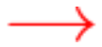
$$\to
“The vector 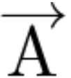 is vertical”
The vector $$\overrightarrow{\rm A}$$ is vertical
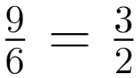
&&9 over 6 = 3 over 2

Marking Tab
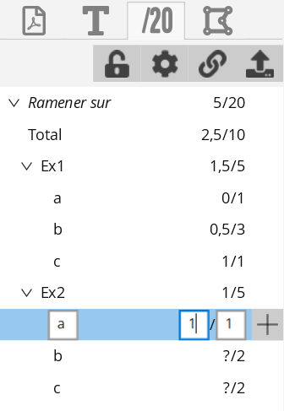
The buttons on top of the tab have info-bubbles detailing their use when leaving the pointer device on it.
This Tab potentially allows the user to enter a grade scale (marking scheme) while correcting the first document of a set. Same tool allows to enter marks. Marking scale can then be copied on other documents thanks to the button . Of course only the scale will be copied, not the marks possibly entered. In case a marking scale already exists in the destination files, merging options will be displayed.

At anytime, all the marks of a set of documents (or of a single document) can be exported to a spreadsheet file in .csv type with the button .

Marks and marking scale are managed through a hierarchical scheme. This allows to automatically add marks of an exercise to show the exercise sum, and to automatically add the marks of each exercise to a total. A maximum of 4 levels + total is possible. Display options are set with .
Add of a new mark in the marking scale is done with the button which will add a mark of a lower hierarchical level: on the above figure, a click on the button right to the Ex1 mark would create a sub-mark after the c mark, with same hierarchical level, and automatically named d.
Unentered marks are not visible on the sheet, they will show up at the last position of the pointing device, once enstered. Unentered marks count for 0 in the sum.
When copying a marking scale, it it possible to store the page locations of the marks. In this case, all the marks will be visible on the others documents. This option avoids positioning again and again the marks on each document (when the students reply directly on the same formatted subject of questions). Marks without value will not be visible on exported PDF, even though they are visible when editing.
It is possible to give the name "Bonus<...>" to a mark, so its marking scale value will not be added to the total of the marking scale (but the Bonus mark will be summed).

Skills acquisitions tab
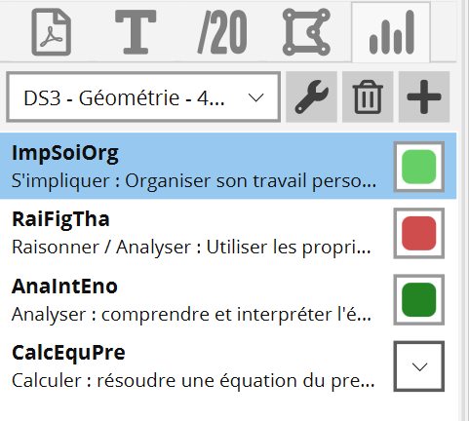
Unlike the numerical marking, the skills marking is organized by assessment. A new assessment must be created with the button. Skills can then be added to the assessment in the first tab, and the marking mode is handled in the second one.

Once the assessment is configured, each document can be associated to the assessment, thanks to the drop down menu at the top of the tab.

It is then possible to pick an acquisition level for each skill listed in the tab (drop down menu or associated key). To reset an acquisition level, hit or use the contextual menu.

A skills table element will show up on the document, it can be moved and resized. It will be by default displayed on the exported document.

Assessment configuration can be imported from the SACoche skills acquisition follow-up tool. In this case, “Ajout d’informations sur les codes de notation pour PDF4Teachers” should be checked, in order to get the SACoche informations about the different skill marking modes.
Each document can then be paired to a SACoche student, in order to export the acquisitions levels to a CSV spreadsheet, which will then be re-imported into SACoche.

Standard CSV export may also be achieved by using the buttons at the bottom of the assessment settings window ().

Images and vector elements tab
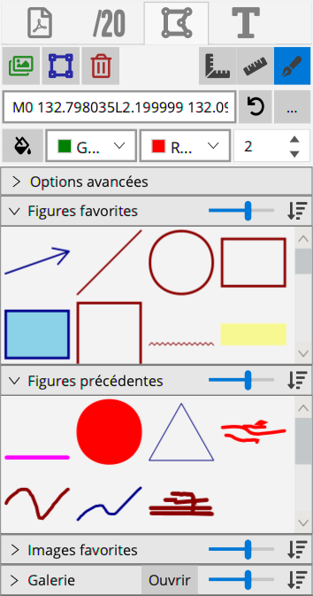
Just like any text element, images and vector elements can be added to favorites, and are handled through lists.
- A simple click on an image or a vector drawing from a list activates its placement on the sheet. It is then placed on the page with another click and a drag to fix its size.
- A double click places directly the element on the page, like the single click does it for text elements (default size, height on page determined by the last flyover of the pointer)
- The element can also be dragged & dropped to the sheet. It is faster, but the immediate resize is not available.
The button  allows to replace the selected element by another file, or do actions on the element.

Images
Images can be added to PDF4Teachers thanks to the gallery window (Button , or menu ). Folders are added to the gallery by using its drop down menu on the right:
Open
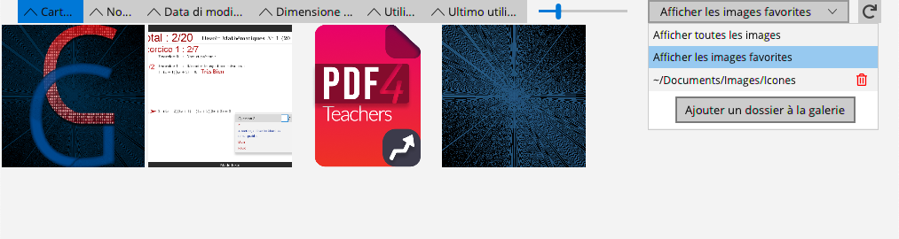
It is also possible to add images to the edit, bypassing the gallery with the menu .
Images are not stored in the edit, PDF4Teachers links it to the image file on the source folder. May the image be deleted or moved, PDF4Teachers would not be able to display it anymore.

Vector elements
Vector elements enable to add customized shapes, which can also be freeform lines. These are encoded as a Scalable Vector Graphics (SVG) path.
Basic commands to draw SVG are to move on the drawing (pen up), and to draw a segment from current position to a point of coordinates (x, y). A series of commands forms a curve. Hence, a vector element can be a series of curves.
M <x> <y>
L <x> <y>
L <x> <y>
A new element can either be created with the menu , or by using + , which will directly launch the drawing mode.
Ctrl
D
Each vector element can only be made of a single filling color (disabled with ) and of a single line color (line width is set with 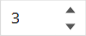).

Vector figures: vector elements drawing mode
The drawing mode of a vector element allows to draw with a mouse, a trackpad, or a drawing tablet, on the whole page extent. It can be activated/deactivated with , or with a double click, or on a selected vector element.
Enter
Figures panel options allow to draw straight line or forced horizontal/vertical lines. One can draw without clicking, by simultaneously pressing ; this special feature is particularly useful when drawing on a trackpad.
spacebar
The drawing mode leaves access to the other features of PDF4Teachers: one can still access to pages context menu, or add a text element with a double click. However, creating an other kind of element will end the drawing mode.
While annotating mainly with freeform lines, it is strongly recommended to enable the element automatic splitting in the settings for not having a unique large element on each page.
Button  or key deletes only the last segment of a curve.

In drawing mode, deletes the last curve of an element.
Del
+ cancels the last curve of an element.
Ctrl
Z

More information about images and vector elements
When added to favorites or previous elements, the element on the page is linked to the one in the list: any further modification of the linked element placed on the document will affect the list.
Images inserted from favorites are always linked. But only size an options are concerned: changing the source path of a linked image in the document will not affect the list.
In the Drawings tab, the menu gives:
Advanced settings
, which allows to lock proportions, and offers some special modes. With , these settings are mainly meant for special modifications on default vector elements included in the application. , if >0, allows to automatically add an arrow to each segment, and set a size.
Resize mode
Risizing holds
Arrows lenght

Shortcuts
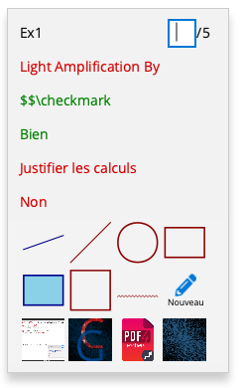
A double click on a page allows to create a new text element at the exact position of the pointer.

A right click on the page opens the contextual menu to:
- enter the next mark at the location of the mouse pointer,
- insert one of the mostly used text elements,
- insert one of the mostly used vector elements,
- or one of the mostly used images
On this contextual menu, a left click on the name of the suggested mark to enter, gives all the points, a right click allows to enter them from a list, without the keyboard.

A double click on a mark element sets it to 0.

Other shortcuts: (Use instead of on Mac keyboards)
Cmd
Ctrl
- : Creates a new empty text element at the location of the pointer. If is pressed, the new element will not be added to the previous elements list.
Ctrl
T
Shift
- : Creates a new vector element and launches the drawing mode. If is pressed, the new element will be added or not in the previous elements list, depending of the settings.
Ctrl
D
Shift
- : Selects the next mark field to enter.
Ctrl
N
- : Adds a new mark to the marking scale, at the same hierarchical level of the selected mark.
Ctrl
G
- : Adds the corresponding favorite text element at the pointer position.
Ctrl
1-9
- : Select the matching favorite color for the selected text or vector element ( to toggle the filling of vector elements).
Ctrl
Alt
1-9
Ctrl
Alt
0
- and : Change the size or thickness of selected element.
Ctrl
Alt
+
Ctrl
Alt
-
- : Navigate between text elements tab and vector elements tab.
TAB
- or : Zoom more ( to zoom less).
Ctrl
↑
Ctrl
+
Ctrl
-
- : Fit Zoom to page width.
Ctrl
↓
- : Load the next file listed in the files tab.
Ctrl
Alt
→
- : Load the previous file listed in the files tab.
Ctrl
Alt
←

