
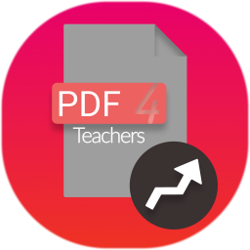
v1.2.1

User Manual

Software overview
PDF4Teachers is a software dedicated to annotation of learners assessments, in PDF file format. It focuses on maximum productivity in annotating / marking this kind of documents.
PDF4Teachers allows user to quickly add and save recurrent annotations. Edited PDF files can then be exported to generate new PDF files including the edits. When using the grades tool, exporting grades of all documents in CSV file format is made possible.
A set of pictures can be converted in PDF documents, and pages format can be edited (rotation, position…) through buttons located in the footer of each page.
Le principe est d’ajouter des éléments sur le document PDF avant de l’exporter, ce qui crée un nouveau fichier PDF. Les éléments sont enregistrées dans des fichiers séparés, chaque fichier PDF édité a une édition associé (C.f. « Le Principe d’édition »).
L’outil d’évaluation chiffré permet de créer un barème, de le copier sur d’autres copies avec le bouton  et d’exporter les notes d’un lot d’éditions au format CSV ().
Il est possible de convertir des images en document PDF (ou de générer des PDF par lot à partir de dossiers d’images), et d’éditer les pages des documents (rotation, position...) avec des boutons rouges situés en haut à droite de chaque page. Il est aussi possible d’effectuer des capture d’écran des pages avec une définition paramétrable.

PDF4Teachers est conforme au RGPD de l’Union Européenne : toutes les éditions et fichiers PDF sont stockés en local, les seuls accès réseau de l'application concernent la vérification des mises à jour, le téléchargement de nouveaux langages de traduction, et l’envoi de statistiques anonymes.
Les statistiques anonymes comprennent :
- Le temps total passé avec la fenêtre principale de l’application en avant-plan
- Le nombre de fois que l’application a été démarré

Edit functions
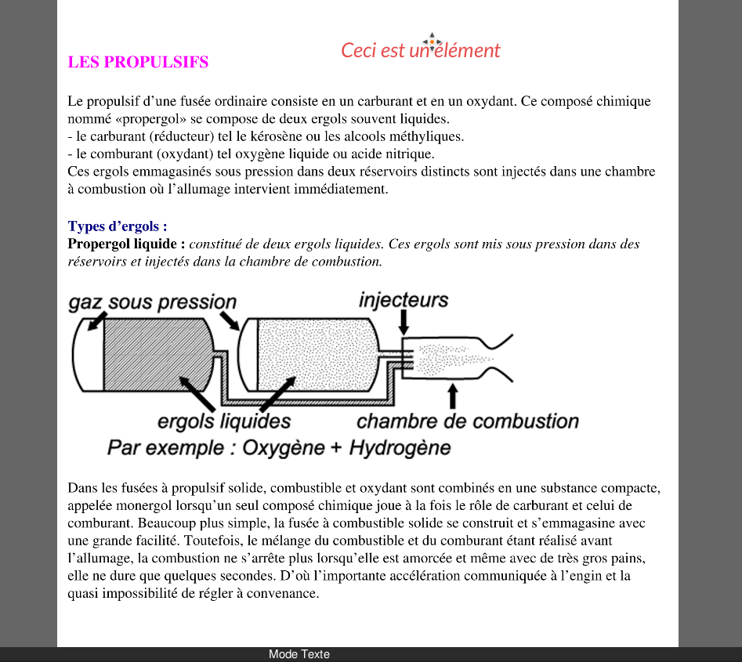
Various elements can be added on the document (text, grades). These elements constitute the edit of the document which is saved separately.
(see Tools → Open the data folder).

Left side figure shows a text element. Elements can be moved and edited in the left panel tabs of PDF4Teachers.

Document edit is loaded as an overlay every time the document is opened in the main panel, but the PDF file is not modified. (except when rotate, add, remove and move pages).

Once editing is finished, document should be exported, in order to create a new PDF file, on which the whole edit will be permanently added (File → Export).
It is possible to export/import one/some édits with Tools → Export/Import the edit.

Files Tab
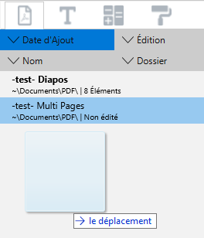
Left panel includes 4 tabs. First tab (showed on the left side figure) lists all the opened documents, ready to be edited.

This tab is just a list of files that you decided to add to this list (File → Open […]).
It allows a fast access to a list of files and shows details about the files edits.
It is possible to edit files (double clic) or various actions (right clic)

Drag and drop of a file or a folder is also possible.
File sorting in the tab can be set through the top buttons of the tab.

Text elements tab
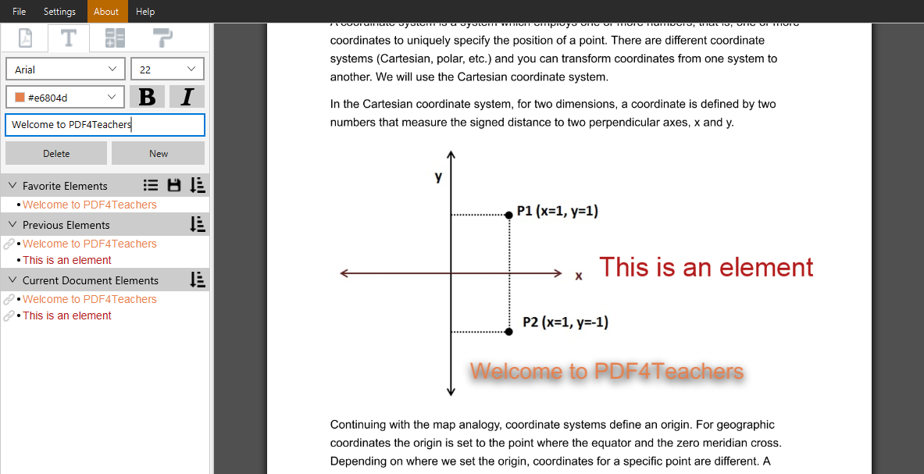
Creating a new text element is done by a clic on new. Text is written in the form field of the tab. The element displays on the left side of the sheet.
The height of the insertion point is determined by the last flyover of the mouse pointer when leaving the sheet to the left panel. Anticipating this behavior will help you placing immediately the element at the correct height on the sheet.

It is also possible to add a new text element with a double-clic on the page or with shortcut + . In this case, the element is inserted at the exact position of the pointer. A double click on an element duplicates it.
Ctrl
T
May the element be longer than the page width, carriage returns will be added automatically. After modification, useless returns can be removed through the context menu (right click), on the text edit field.
When writing an element on the text field, the similar elements are highlighted. You can navigate among them and add one with the keyboard arrows and then .
Enter

Categories Favorite elements, Previous elements, Current document elements allow a quick access to already inserted text elements. A clic inserts on the sheet, and a context clic on a listed element, on a category, or on an element inserted on the sheet gives access to the context menu, with various shortcut functions.
Help bubbles will popup with more detailed information when leaving the pointer device over buttons or interface elements.

Saving éléments lists
Icon allows to save the content of the favorites list. Thus, favorites can be organized and loaded for future corrections of similar assessments.
Icon gives access to previously saved favorites elements. Loading or deleting is possible. After loading, modifications in the list will not affect the saved list. To modify a saved list, a new one must be created, with the same name.
Icon  sets the sorting options of the listing.

Details about the different elements lists
Favorite Elements : Adding to Favorite Elements is done through the context menu on elements present in others lists or in the sheet. When done from a list, default behavior will move the element from the list to the Favorite Elements list. In order to have a copy behavior, a setting can be done in the Settings menu.
Previous Elements : Each new element is added in the Previous Elements list. This list stores the only the 50 last inserted text elements. List can be flushed through context menu, on the category. When an element shows up in Previous Elements, it is linked to the sheet element that was just created. The link symbol  means that any further modification of the specific element on the sheet will update the element in the list. It can be unlinked through the context menu. It is possible to add and link an element by pressing when adding it.
Shift
Current Document Elements : Displays all the elements present on the current document.
The elements lists, the favourites elements and previous elements are saved in a file named textelements.yml which can be found with Tools→ Debug → Open the data folder

Grades Tab
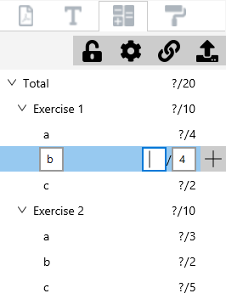
The buttons on top of the tab have info-bubbles detailing their use when leaving the pointer device on it.

This Tab potentially allows the user to enter a grade scale (marking scheme) while correcting the first document of a set. Same tool allows to enter grades. Grade scale can then be copied on other documents thanks to the button . Of course only the scale will be copied, not the grades. In case a grade scale already exists in the destination files, merging options will be displayed.

At anytime, all the grades of a set of documents (or of a single document) can be exported to a spreadsheet file in .csv format with the button .

Grades and grading scale are managed through a hierarchical scheme. This allows to add automatically grades of an exercise to show the exercise sum, and to add automatically the grades of each exercise to a total. A maximum of 4 levels + total is possible. Display options are set with .
Add of a new grade in the grade scale is done with the button which will add a grade of a lower hierarchical level : a click on the button showed on the above figure would create a sub-grade in the b question of the exercise 1.
Unentered grades are not visible on the sheet, they will show up at the last position of the pointing device once entered. Unentered grades count for 0 in the sum.
When copying a grade scale, it it possible to keep the locations of the grades. In this case, all the grades will be visible on the others documents. This option allows us to not have to place the grades for each document (when the students reply on the same page of the questions). The grades without value will never be visible on exported PDF. Even if they are visible when editing.
It is possible to give the name "Bonus [...]" to a grade, so its grade scale value will not be added to the total of the grade scale.

Shortcuts
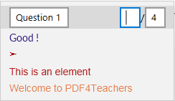
Context menu on the sheet gives access to entering the next grade, at the exact position of the mouse pointer. It also shows the 8 most used text elements.

A double click on a page allows you to create a new text element.

More than the menu bar shortcuts, you can use theses ones :
- + : Creates a new empty text element at the position of the pointer.
Ctrl
T
- + : Selects the next grade field to enter.
Ctrl
N
- + : Add a new grade to the grade scale, at the same hierarchical level of the selected grade.
Ctrl
G
- + : Adds the corresponding favourite text element at the pointer position.
Ctrl
1-9
- + + : Quick load of the saved favourites list corresponding to the number.
Ctrl
Alt
1-9
- + + : Saves the current favourites list to a new saved list.
Ctrl
Alt
0

Depending on the keyboard configuration, pressing may be necessary to access shortcuts using numbers.
Shift
Use instead of for the Mac keyboards.
Cmd
Ctrl

