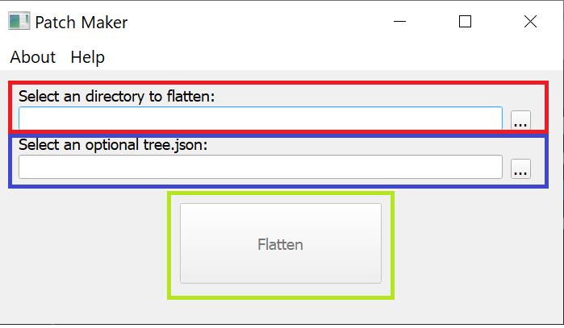

**Making a new release**

1. [Red] Select the directory containing the Age of the Ring files, the one where the data, art, lang, ect.. folders are located.
2. [Blue] Select the tree.json from the previous release, this is to avoid having to re-upload the entire game everytime allows you to only upload the files that have changed since the last patch. If somehow it disappeared, the software can generate its own from scratch but you will have to re-upload every mod file.
3. [Green] Click flatten and wait for the software to confirm that it has finished flattening.
4. Go to the folder where the folder you just flattened is, next to it you should see a new folder called “release”. This contains the files that have been changed since the last patch. Those are in the files that you need to drag and drop into the google drive folder. **Note:** Uploading files to the release folder will lock out users from the updater and repair function until the all the files have been uploaded and for 30 minutes after that (to allow for caching).
5. Once uploaded make sure that the files are shared with the AOTR Updater account and that the share link is enabled. Usually leaving 12 hours for the all the files to get properly shared and cached is best.

Update Account

[Aotr.updater@gmail.com](mailto:Aotr.updater@gmail.com)

walls4Mordor