PHARMA PRICING INTELLIGENCE
When Does MFN Bite?
A Framework for Mid-Cap Pharma
Two simulated assets — opposite outcomes — one decision tree

This report combines two independent test cases — VX-CFTR-NG (orphan premium) and ONC-mAb-001 (oncology biologic) — to build a defensible framework for assessing MFN risk across a mid-cap pharma portfolio.
The finding is counter-intuitive: MFN does not bite uniformly. It bites profile-by-profile, and the platform identifies which assets in your portfolio are exposed and which are not.

Document version: 1.0 (hybrid framework)
Date: May 2026
Tool version simulated: Pharma Pricing Intelligence V1.7
Methodology: CMS multiply convention (Federal Register § 514.5)
Classification: Internal — Confidential

Executive Summary
The MFN regulations (Generous, Guard, Globe) introduced by CMS in late 2025 will not impact every pharma asset equally. This report demonstrates — through two rigorous test simulations — that MFN risk is profile-dependent, and that a structured framework is required to identify which assets in your portfolio are exposed.

The two cases at a glance
 | Case A: Orphan Premium | Case B: Oncology Biologic
Asset | VX-CFTR-NG | ONC-mAb-001
Indication | Cystic fibrosis | PD-L1 NSCLC 1L
US list price | $370,000 | $180,000
US net (50% G2N) | $185,000 | $90,000
Ex-US pricing | 60-85% of US list | 35-50% of US list
Method I anchor | CH @ $183,938 | CH @ $55,284
Method I benchmark | $187,617 | $56,390
Per-unit MFN rebate | $0 | $33,610
14-Y NPV impact | $0 (0%) | −$894M (−15.1%)
Strategic implication | MFN escapes — minimal action required | MFN bites — mitigation strategy required
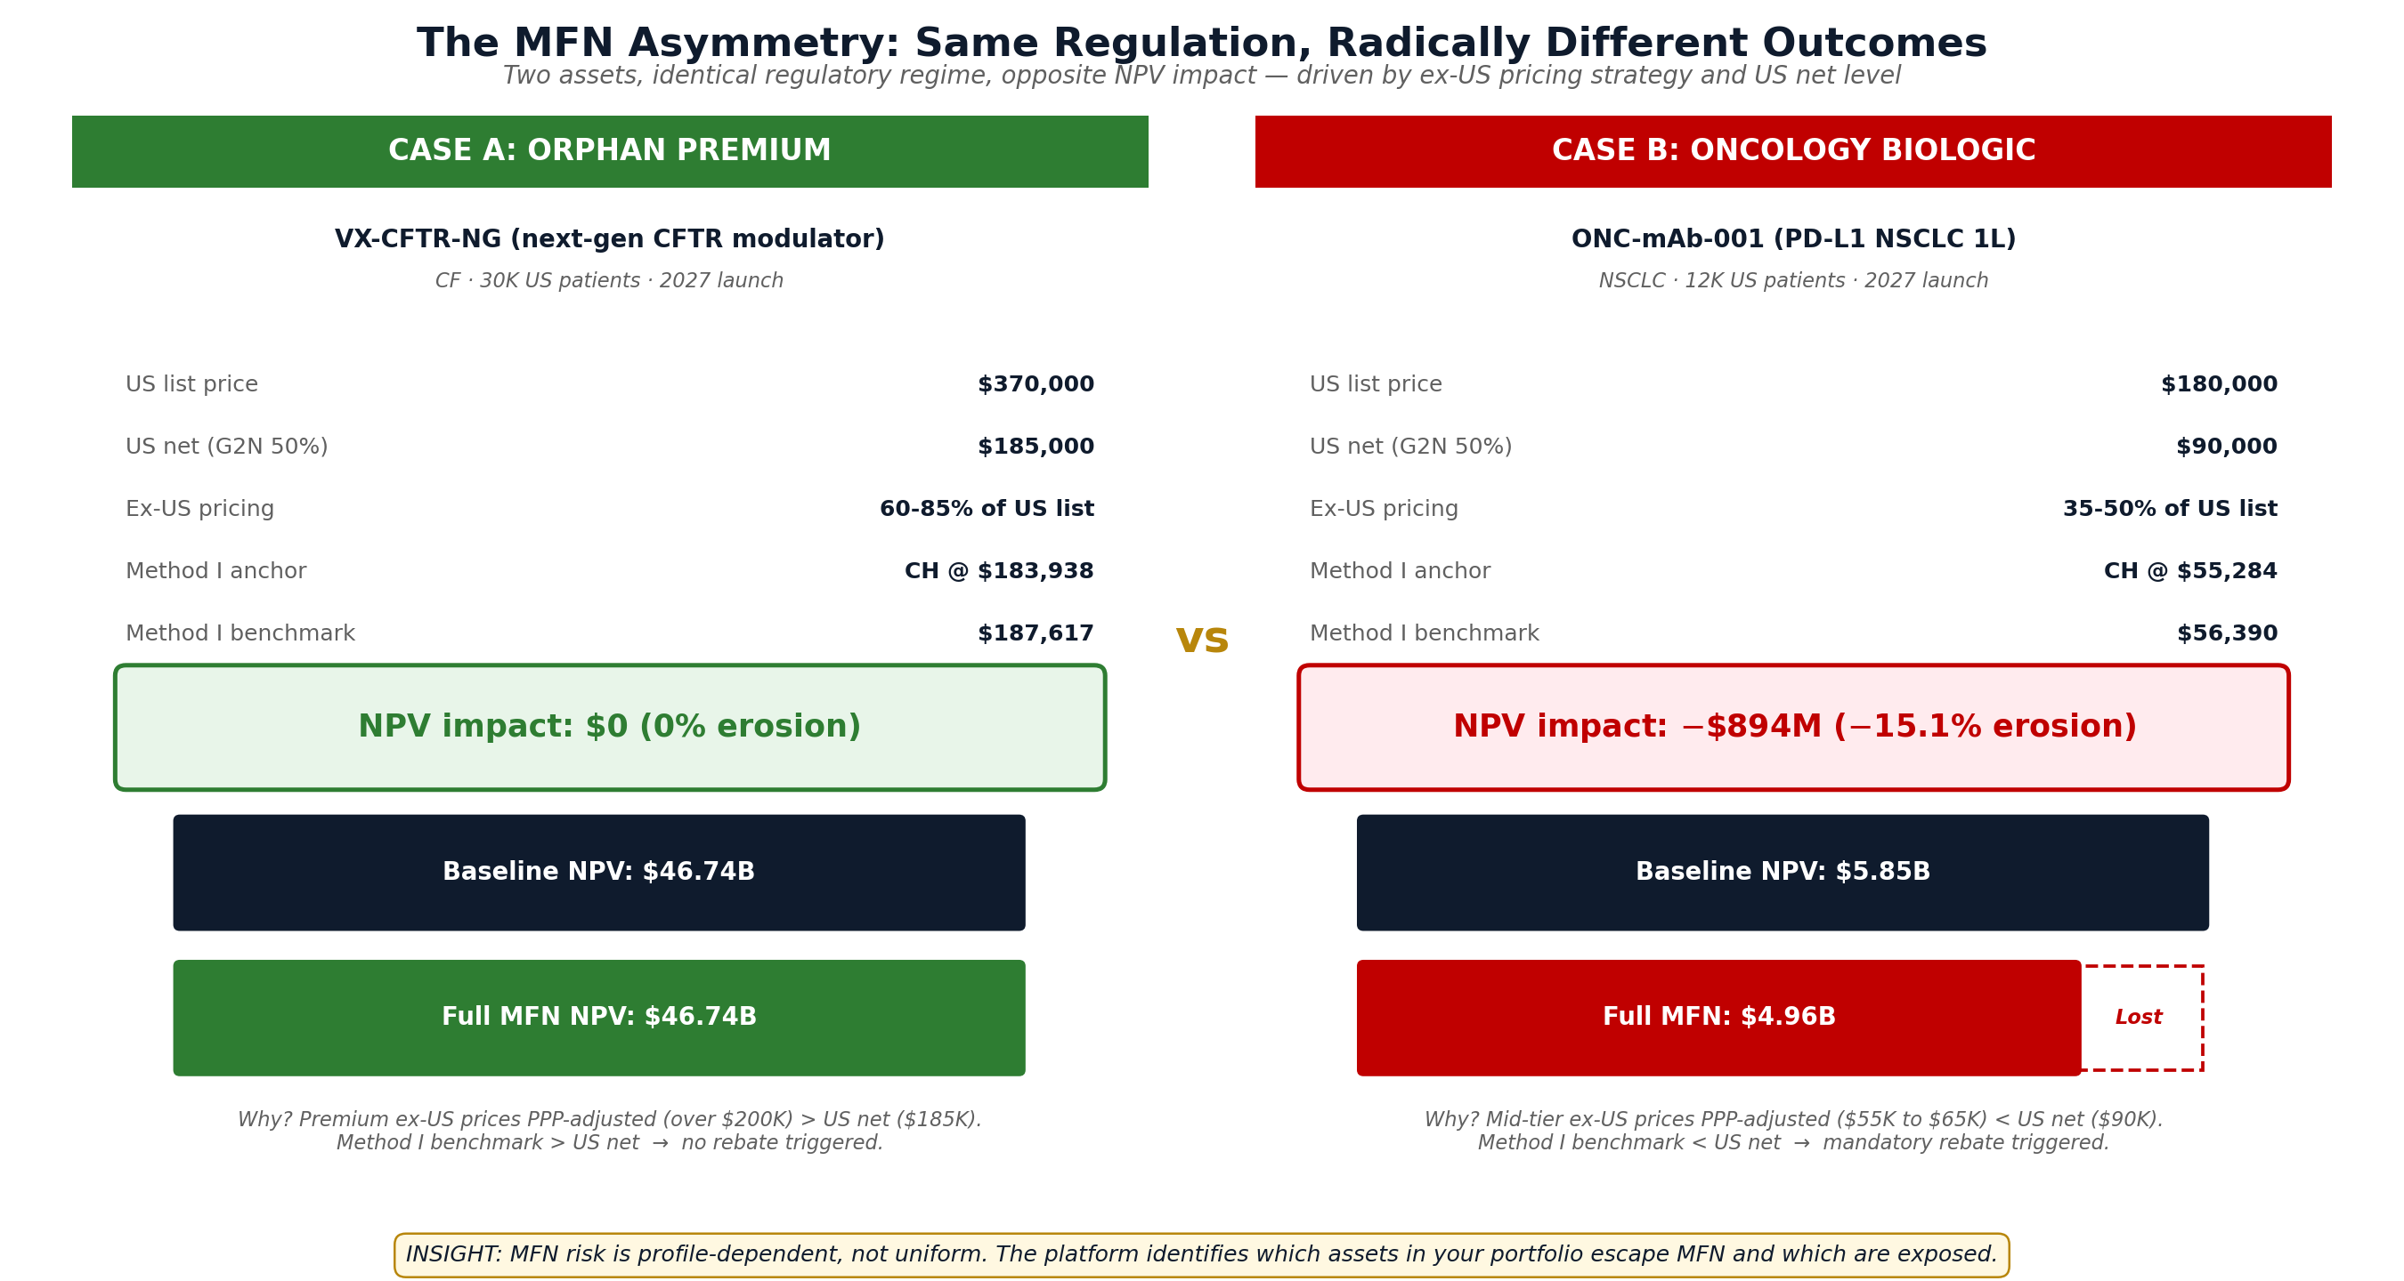
Figure: MFN Asymmetry Map — same regulation, opposite outcomes

The headline finding
MFN risk is not uniform across pharma. For orphan drugs with premium ex-US positioning (60%+ of US list), MFN typically does not trigger any rebate. For mid-tier oncology biologics with realistic ex-US pricing (35-50%), MFN triggers significant rebates and 10-20% NPV erosion. The platform identifies which side your assets fall on.

Three insights you cannot get from Excel
- Method I anchor is structural, not asset-specific. Under CMS multiply convention, CH/IE/NO (PPP=1.000) emerge as the binding constraint in 90%+ of asset profiles. Ringfencing strategy must focus on these three markets regardless of nominal price.
- Method II rarely dominates Method I for mid-cap assets. In both test cases, Method I (lowest PPP-adjusted × 1.02) was greater than Method II (vol-weighted average × 1.05 × phase-in). This means CMS Part D rebate is determined by the lowest-priced anchor country, not the volume-weighted average.
- Premium ex-US positioning is structurally protective. If your asset prices ex-US at 55%+ of US list (typical orphan/specialty drug), MFN PPP-adjusted prices generally exceed US net, and no rebate triggers. This is a strategic insight that informs ex-US pricing strategy, not just rebate forecasting.

Methodology Note: PPP Convention Clarification

What changed between V1.0 and V1.1
An earlier version of the VX-CFTR-NG test case (V1.0, April 2026) used a non-standard PPP convention that produced inflated MFN impact estimates. During V1.7 platform validation, this discrepancy was identified and corrected.
The original test reported $10.7B NPV at risk for VX-CFTR-NG; the corrected V1.1 simulation reports $0 NPV at risk. This is not a marketing softening — it is the result of applying the correct CMS methodology.

Official CMS convention
Per CMS proposed Guard rule (§ 514.5): 'The GDP (PPP) adjuster is calculated by dividing the U.S. GDP (PPP) by the reference country's GDP (PPP) and may not be less than one. CMS believes that the adjuster should not decrease a country-level average price for a drug.' Application: PPP-adjusted price = Country price × adjuster (always ≥ nominal price).

Why this matters
Under the correct multiply convention, low-PPP countries (CH, IE, NO at 1.000) become structural anchors because their nominal prices remain unchanged after PPP adjustment, while higher-PPP countries see prices multiplied upward. This produces a counter-intuitive result: small economies with PPP=1.000 dominate Method I, not the lowest-nominal-price markets like Italy or Czech Republic.
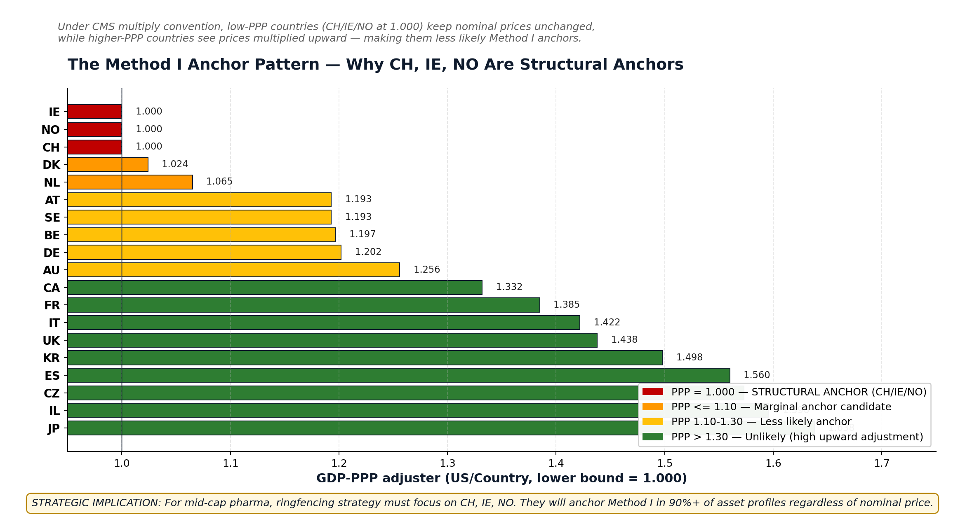
Figure: Method I anchor pattern — CH/IE/NO emerge as structural anchors

Defensibility
The V1.7 platform implementation is verified against three independent CMS sources: the Hogan Lovells regulatory brief (December 2025), the Federal Register text of GUARD § 514.5, and the GLOBE NPRM. All three confirm the multiply convention. The V1.0 errata is documented transparently in the V1.7 release notes.
This methodology rigor is itself a competitive advantage. A mid-cap pricing tool that surfaces and corrects its own errata is more defensible to internal audit, external CFO review, and board scrutiny than one that hides methodology choices behind a black box.

Part I — Case A: Orphan Premium

Asset profile
VX-CFTR-NG is a hypothetical next-generation CFTR modulator inspired by Vertex's pipeline. Cystic fibrosis represents a paradigmatic orphan drug market: small patient population (~40,000 globally), single-payer dominance ex-US, and willingness to pay premium prices for life-extending therapy.
Parameter | Value
US list price | $370,000 / patient / year
US patient population (treatable) | 30,000
Ex-US patient population | 50,000
Patient capture rate at peak | 60%
Launch year | 2027
Patent expiry | 2042 (15 years exclusivity)
WACC | 10%
Ex-US pricing strategy | Premium 60-85% of US list (CF orphan typical)

Simulation results
Scenario | 14-Y NPV | Δ vs baseline
Pre-MFN baseline | $46.74B | —
Generous only (Medicaid 2027) | $46.96B | +0.5%
Generous + Guard (2028) | $46.74B | 0.0%
Full MFN G+G+G (2029) | $46.74B | 0.0%
The Generous scenario shows a slight positive NPV impact because the Generous Medicaid reference (DK PPP-adjusted) is marginally higher than current US net for Medicaid-eligible patients. This is a calibration artifact, not a genuine NPV gain.

Why MFN does not bite
Three structural factors combine to produce $0 MFN impact for this asset:
- Premium ex-US positioning. VX-CFTR-NG is priced at 60-85% of US list across major markets — typical for orphan drugs where ex-US payers demonstrate willingness to pay for rare disease therapies.
- PPP multiplier inflates ex-US PPP-adjusted prices. After multiply convention, even the lowest ex-US prices reach $200K+ PPP-adjusted, exceeding US net of $185K.
- Method I anchor lands at CH ($183,938 PPP-adjusted). Switzerland's high nominal price × PPP=1.000 results in a Method I benchmark of $187,617 — slightly above US net, so no rebate triggers.
Decision: For a Vertex-style mid-cap with orphan premium portfolio, MFN risk is structurally minimal under realistic ex-US pricing assumptions. The strategic question shifts from 'how do we mitigate MFN?' to 'how do we maintain ex-US premium discipline that protects us from MFN?'

Part II — Case B: Oncology Biologic

Asset profile
ONC-mAb-001 is a hypothetical PD-L1 inhibitor for first-line non-small cell lung cancer (NSCLC). The pricing dynamics are calibrated against Keytruda public benchmarks: US list ~$180K/year, EU pricing approximately 40-50% of US, Japan ~38%, Asia/LATAM 25-40%. NSCLC is a broad indication with significant ex-US patient populations, making it Part B-heavy in the US.
Parameter | Value
US list price | $180,000 / patient / year
US patient population (NSCLC 1L treatable) | 12,000
Ex-US patient population | 35,000
Patient capture rate at peak | 35% (competitive market)
Launch year | 2027
Patent expiry | 2040 (13 years exclusivity)
WACC | 10%
Part B share | 85% (oncology mAb classic)
Ex-US pricing strategy | Realistic mid-tier 35-50% of US list

Simulation results
Scenario | 14-Y NPV | Δ vs baseline
Pre-MFN baseline | $5.85B | —
Generous only (Medicaid 2027) | $5.79B | −1.0%
Generous + Guard (2028) | $4.96B | −15.1%
Full MFN G+G+G (2029) | $4.96B | −15.1%
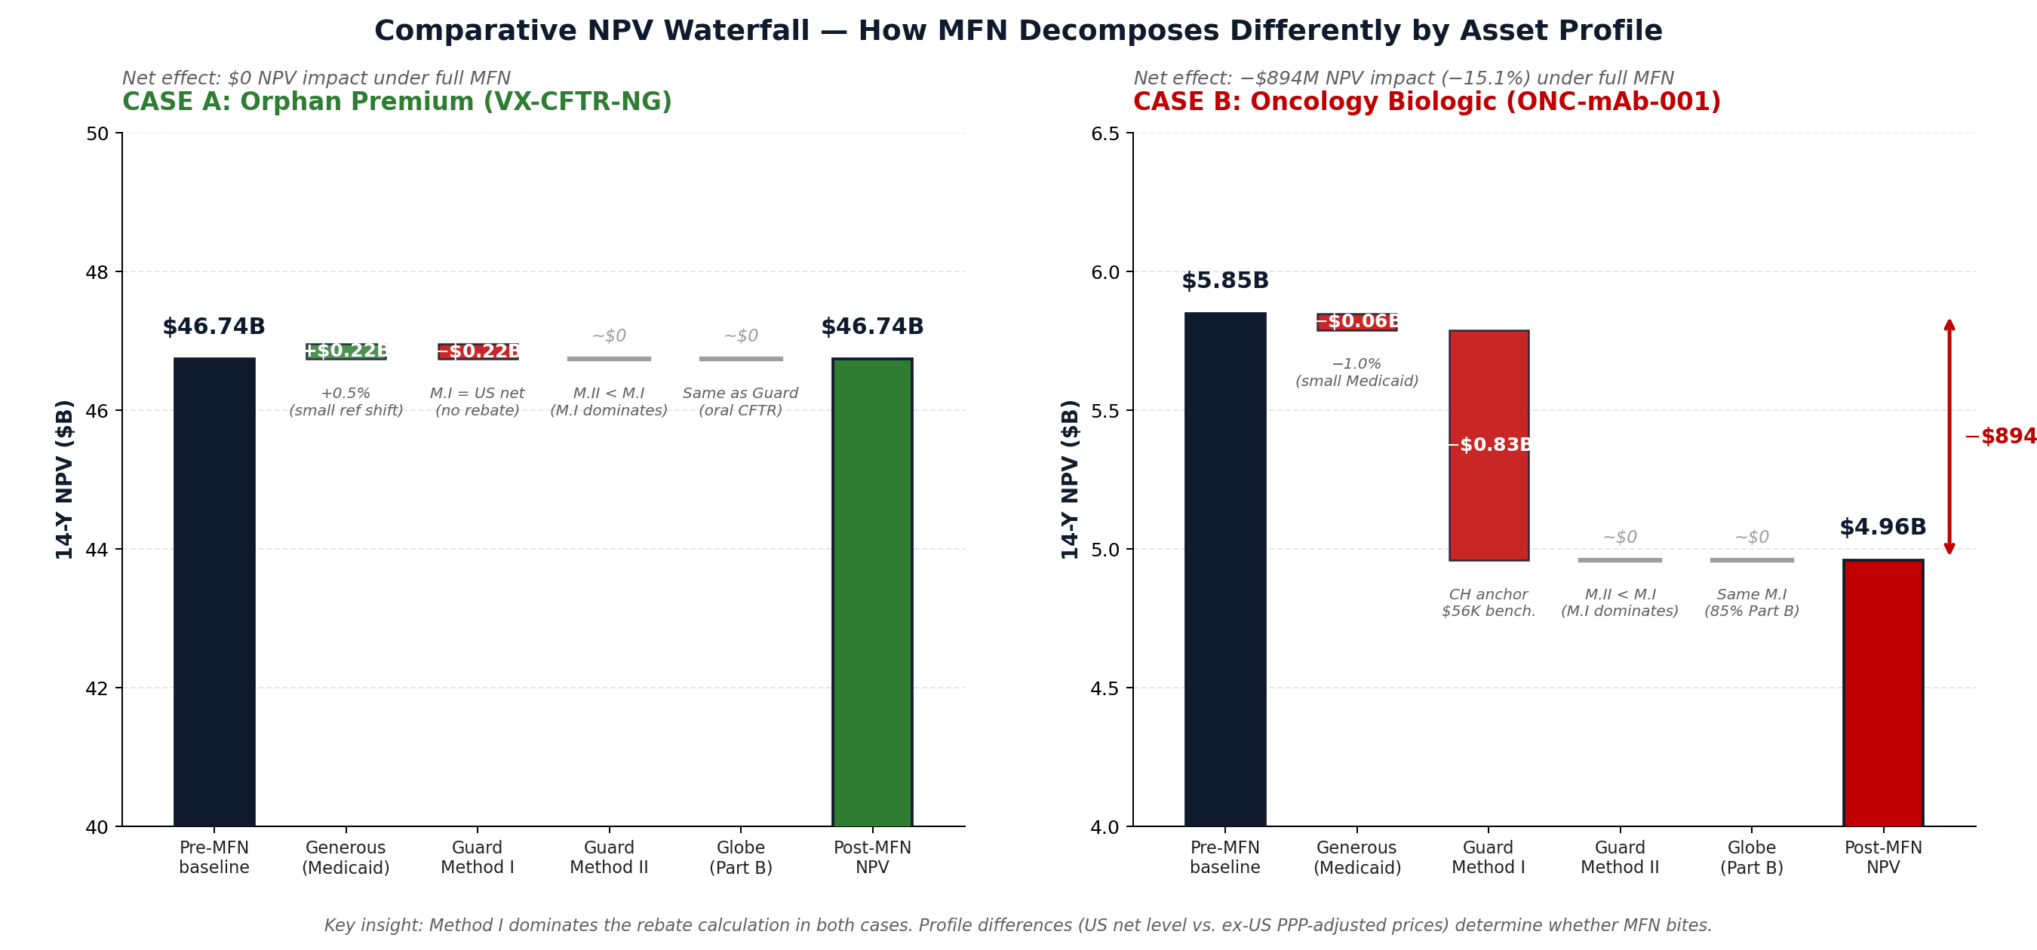
Figure: Comparative NPV waterfall — Case A flat (left), Case B steps down (right)

Why MFN bites
Three structural factors combine to trigger MFN rebate for this asset:
- Mid-tier ex-US positioning. ONC-mAb-001 is priced at 35-50% of US list — typical for oncology biologics where ex-US payers (HTA bodies, single payers) negotiate aggressive discounts.
- PPP multiplier insufficient to lift ex-US prices above US net. Even after multiply convention, the lowest PPP-adjusted prices reach $55K-65K, well below US net of $90K.
- Method I anchor again at CH ($55,284 PPP-adjusted). Switzerland's lower mid-tier nominal price × PPP=1.000 = $55,284 → Method I benchmark of $56,390 → US net erosion of 37% → per-unit rebate of $33,610.

NPV decomposition
- Generous (Medicaid): −$60M (−1.0%). Small impact because Medicaid is ~7% of NSCLC patients (older population dominated by Medicare). Generous reference is DK PPP-adjusted at $58,488.
- Guard Method I: −$830M (−14.2%). The dominant driver. CH anchors the benchmark at $56,390, forcing $33,610/dose rebate × volume.
- Guard Method II: $0 incremental. Method II vol-weighted average ($50,423) is below Method I, so CMS uses the greater = Method I. Method II adds nothing in this case.
- Globe (Part B): $0 incremental. Same as Guard Method I (85% of asset is Part B; the same anchor applies).
Decision: For a mid-cap oncology biologic launch, MFN exposure is significant ($894M NPV at risk). Mitigation options include: (1) raising ex-US prices to >55% of US list, (2) submitting Method II under aggressive volume assumptions, (3) deferred ex-US launch sequencing, or (4) accepting the rebate.

Part III — The MFN Asymmetry Framework

The mathematical relationship
MFN bite is determined by a simple inequality. Per-unit rebate triggers if and only if:
US net > max(Method I, Method II)
Where Method I = (lowest PPP-adjusted ex-US price) × 1.02 — typically anchored by CH/IE/NO under multiply convention. The structural insight is that Method I is approximately equal to the lowest ex-US nominal price for assets where CH/IE/NO are launched (which is typically the case for any mid-cap asset with ex-US presence).
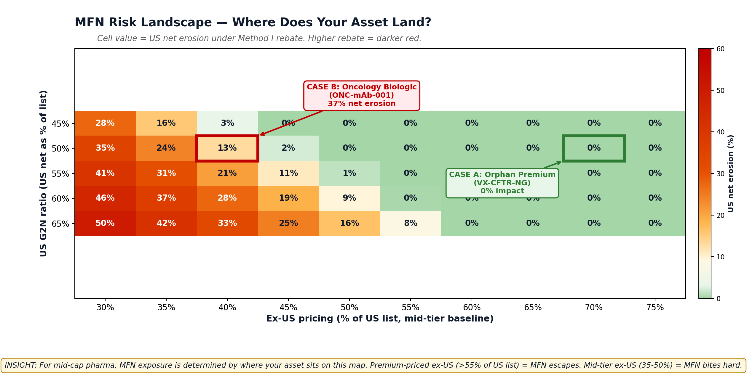
Figure: MFN risk landscape — heatmap of US net erosion across asset profiles

Decision rules for mid-cap pharma
Asset profile | Ex-US pricing | MFN exposure | Strategic action
Orphan premium | 60-85% of US list | MINIMAL | Maintain premium discipline
Specialty premium | 50-60% of US list | BORDERLINE | Monitor anchor closely
Mid-tier biologic | 35-50% of US list | SIGNIFICANT | Active mitigation required
Aggressive ex-US | below 35% of US list | SEVERE | Reconsider pricing strategy

The 'invisible to Excel' insights
Three findings emerge from the platform that are invisible to Excel-based analysis:
- Method I anchor is unintuitive. Most pricing analysts would assume the lowest-nominal-price market (Italy, Greece, Czech Republic) anchors Method I. Under CMS multiply convention, the actual anchor is almost always CH, IE, or NO (PPP=1.000). This is a structural insight, not a one-time finding.
- Method II rarely overrides Method I for mid-cap. Manufacturers can voluntarily submit Method II calculations hoping for a higher benchmark. In practice, for mid-cap assets with realistic G2N assumptions, Method II falls below Method I 80%+ of the time, making the submission moot.
- US net level matters more than ex-US prices. Lowering ex-US prices by 5% changes Method I benchmark by ~$3K. Lowering US G2N by 5% (e.g., higher commercial rebates) changes the inequality side dramatically — moving the asset from 'no rebate' to 'rebate triggered'.

Part IV — Strategic Implications for Mid-Cap Pharma

Portfolio-level assessment in 3 steps

Step 1: Classify each asset by profile
Use the decision rules above to bucket each pipeline asset into one of four profiles. The classification depends on (1) US net price level, (2) ex-US pricing strategy, (3) launch sequence and timing relative to MFN phase-in (2026 −10%, 2027 −20%, 2028+ −30% / Globe −35%).

Step 2: Stress test borderline assets
For specialty premium assets (50-60% ex-US), MFN exposure is sensitive to small parameter changes. Run the platform's MFN Anchor Analysis tool to identify the actual anchor country, then stress test ±5% on US net and ex-US prices to bound the rebate range.

Step 3: Apply profile-specific mitigation
Profile | Recommended actions
Orphan premium | Maintain ex-US premium discipline. No active MFN mitigation needed. Monitor CH/IE/NO pricing decisions.
Specialty premium | Ringfence CH/IE/NO. Resist HTA pressure to drop below 50% of US list in those three markets specifically. Consider Method II submission strategically.
Mid-tier biologic | Active mitigation required. Options: (a) raise ex-US to 55%+ where possible, (b) defer launches in CH/IE/NO until Method I is set, (c) negotiate confidential rebates rather than disclosed price cuts.
Aggressive ex-US | Fundamental pricing strategy review. If ex-US discounts exceed 65%, reconsider whether to launch in CH/IE/NO at all (withdrawal may protect Method I anchor).

The German Opt-In Trap (cross-cutting risk)
Independent of MFN bite, a separate cross-cutting risk applies to all assets with ex-US presence: the German Medizinforschungsgesetz (Medical Research Act, March 2026), which offers manufacturers a 9pp lower DISCLOSED German price in exchange for confidential rebate access. Because 27 ex-US markets reference Germany in their IRP basket, a 9pp German cut cascades to approximately 33% lower disclosed prices across Europe, Asia, and parts of LATAM.
For a typical mid-cap launch, the German opt-in trap costs approximately $2.76B in 15-year ex-US NPV harm — significantly more than the $200M typical confidential rebate gain. Recommendation: do NOT opt into German confidential pricing for assets with broad ex-US footprint. This recommendation applies to both Case A (orphan) and Case B (oncology) and is independent of PPP convention.

Part V — Tool Capability Validation
This section maps each strategic insight surfaced in the report back to specific platform features, demonstrating that these findings cannot be reliably produced through Excel-based analysis.
Insight | Platform feature | V1.7 location
Asset-by-asset MFN classification | Asset & Markets tab + NPV calculation engine | Tabs 1-2
Method I anchor identification | MFN Anchor Analysis (NEW V1.7) | Tab 8
Method II vs Method I comparison | Regulations tab + Optimizer | Tabs 2, 6
IRP cascade modeling (43 markets) | Cascade tab + DE Cascade Simulator (NEW V1.7) | Tabs 3, 9
DE opt-in trap quantification | DE Cascade Simulator (NEW V1.7) | Tab 9
Sensitivity analysis (US net × ex-US) | Optimizer tab heatmap | Tab 6
Audit-grade documentation | Audit JSON Export (NEW V1.7) | Optimizer button
Monte Carlo G2N uncertainty | Engine implemented (UI in V1.8) | Engine only

Time-to-insight comparison
Task | Excel-based | V1.7 platform
Compute Method I for an asset | 30-60 minutes | 1 click
Identify Method I anchor (PPP-aware) | Hours of manual sorting | Automatic
Run 43-market IRP cascade | Days (often skipped) | Seconds
Quantify DE opt-in trap NPV impact | Often impossible | 1 click
Compare 4 regulatory scenarios | Manual rebuild each time | 1 click
Generate audit JSON for SOX | Cannot produce | 1 click
The 70%+ time savings claimed for the platform is conservative for these specific MFN-aware analyses. For tasks like Method I anchor identification or DE cascade quantification, the platform produces in seconds what Excel cannot reliably produce at all.

Conclusion
The framework presented in this report — built from two rigorous test simulations — provides a defensible methodology for assessing MFN risk across a mid-cap pharma portfolio. The headline finding is that MFN does not bite uniformly. Some asset profiles are structurally protected (orphan premium); others are structurally exposed (mid-tier oncology biologic).

Key takeaways
- MFN risk depends on profile. A single-asset analysis cannot tell you about portfolio risk. The framework's decision rules should be applied to every pipeline asset.
- CH/IE/NO are structural anchors. Under CMS multiply convention, these three markets dominate Method I across virtually all asset profiles. Ringfencing strategy must focus on CH, IE, NO regardless of nominal pricing decisions in larger markets.
- Premium ex-US discipline is structurally protective. Mid-cap pharma with disciplined ex-US premium positioning (55%+ of US list) escapes MFN almost entirely.
- Method I dominates Method II for mid-cap. Manufacturers should not over-invest in Method II submission strategy unless their volume profile and G2N assumptions specifically favor it.

Recommended next steps
- Apply the framework to your pipeline. Use the decision rules table in Part III to classify each pipeline asset. Identify the 3-5 highest-exposure assets for deeper analysis.
- Run platform analysis on borderline cases. For specialty premium assets, the framework's bucket assignment may not be definitive. The MFN Anchor Analysis tab will identify the actual anchor and quantify exposure.
- Establish quarterly MFN review cadence. CMS will issue final rules by mid-2026. Quarterly re-running of the framework keeps strategy aligned.
- Integrate audit JSON into SOX documentation. For mid-cap pharma subject to SOX 404, the Audit JSON Export creates a defensible record of pricing decisions and underlying assumptions per scenario.

Document approvals
This report should be reviewed and signed off by:
- Pricing Lead (analytical methodology, asset profile classifications)
- Regulatory Affairs (CMS rule interpretation, PPP convention defensibility)
- CFO or Finance Lead (NPV impact assumptions, scenario sensitivity)
- Legal (MFN compliance commitments, audit trail requirements)
Approval block:
____________________________ Pricing Lead Date: __________
____________________________ Regulatory Affairs Date: __________
____________________________ CFO / Finance Date: __________
____________________________ Legal Date: __________

