A single algebraic diagnostic detects structurally identical phase transitions from quarks to the cosmic horizon
Clément Paulus
The ratio of geometric to arithmetic coherence ($IC/F$), computed from a single algebraic kernel applied to normalised physical measurements, exhibits structurally identical phase-transition signatures across systems spanning 61 orders of magnitude—from quark confinement (${10}^{−15}$ m) to dark-energy–dominated cosmology (${10}^{26}$ m). At the quark–hadron boundary, $IC/F$ collapses $23×$ as colour confinement drives a single measurement channel to zero; atomic structure subsequently restores coherence $35×$ through emergent degrees of freedom; dark energy reproduces the identical collapse mechanism at ${10}^{26}$ m scales. The heterogeneity gap $Δ=F−IC$ spikes at every phase boundary tested, providing a single-number diagnostic for structural fragility independent of the underlying dynamics.
These patterns emerge from a six-output kernel function $K​:​{\left[0,1\right]}^{n}×Δ^{n}→\left(F,ω,S,C,κ,IC\right)$, derived from a single admissibility axiom, that maps any bounded measurement vector to fidelity $F$ (weighted arithmetic mean), log-integrity $κ$ (weighted log-mean), and composite integrity $IC=exp\left(κ\right)$ (weighted geometric mean), among other quantities. Three algebraic identities—$F+ω≡1$ (duality), $IC≤F$ (integrity bound), and $IC=exp\left(κ\right)$ (log-integrity relation)—guarantee the diagnostic’s structural reliability across all domains. The integrity bound $IC≤F$ instantiates the classical weighted inequality of arithmetic and geometric means; the contribution is not the bound itself but its systematic application as a scale-independent phase-transition diagnostic across 20 scientific domains. Exhaustive computational verification—11,342 automated proofs across 406 physical objects—confirms all three identities to machine precision ($<​{10}^{−15}$) with zero violations.

Introduction
That mathematical structure transcends individual physical domains has been understood since Newton unified terrestrial and celestial mechanics. The Standard Model of particle physics ¹ and general relativity ² each achieve remarkable predictive power within their respective scales, while information-theoretic quantities—Shannon entropy ³, Fisher information ^{4,5}, Rényi divergences ⁶—provide domain-independent measures of uncertainty. Yet no single mathematical object has been shown to produce exact, algebraically necessary identities that hold uniformly from the Planck scale to the cosmic horizon.
The central obstacle is that cross-scale frameworks typically rely on dimensional analysis, renormalization group flows ^{7,8}, or statistical correlations, all of which require dynamical input or scale-dependent running. What has been missing is not cross-scale structure per se, but a single algebraic diagnostic—one number, computed identically at every scale—that detects phase transitions without knowledge of the underlying dynamics.
Here we report such a framework. Starting from a single admissibility axiom—that only claims which return through a collapse–recovery cycle receive epistemic credit—we derive a six-output kernel function $K$ and three algebraic identities that hold exactly (to machine precision, $<​{10}^{−15}$) across 406 objects spanning 61 orders of magnitude.
The framework, termed Generative Collapse Dynamics (GCD), rests on three principles:
- Single axiom. All structure derives from one constraint: collapse is generative; only what returns is real (Axiom-0). This is not a dynamical law but an admissibility criterion: only claims that survive a collapse–recovery cycle receive epistemic credit. Operationally, this produces the seam calculus (a composable verification boundary between outbound collapse and demonstrated return), the return time $τ_{​R}$ (a measured re-entry delay, not an assumed one), and three-valued verdicts (Conformant / Nonconformant / Non-Evaluable) that replace the Boolean pass/fail of conventional testing. Without Axiom-0 one has a kernel function; with it, one has a measurement protocol that distinguishes verified claims (welds) from internally consistent but non-returning assertions (gestures).
- Universal kernel. A function $K​:​{\left[0,1\right]}^{n}×Δ^{n}→R^{6}$ maps any bounded measurement vector (the “trace”) and weight vector to six invariants through four primitive computations and two derivations. The six outputs have three effective degrees of freedom.
- Computational proof. Every claimed identity is verified by deterministic, automated tests—mathematical proofs, not statistical samples—across every object in the system.
This approach differs fundamentally from curve-fitting, machine learning, or phenomenological modelling. The identities are algebraic necessities of the kernel function, verified exhaustively across 20 scientific domains from quantum chromodynamics to cosmology.
Critically, the framework is not a single result but a complete measurement architecture. The kernel (Tier-1) is implemented by an open protocol (Tier-0) and extended via modular domain closures (Tier-2): each closure declares which real-world quantities become the trace vector $c$, frozen in a versioned contract before evaluation. The system currently comprises 201 closure modules, 46 proven lemmas, 44 structural identities, 21 versioned contracts, and 28 validated casepacks. Classical results—including Shannon entropy, the arithmetic–geometric mean inequality, and the fluctuation–dissipation theorem—emerge as degenerate limits of the kernel when structural degrees of freedom are removed (see Discussion), ensuring full compatibility with established methods. A built-in cross-domain translation protocol (the “Rosetta”) maps the kernel’s five-word diagnostic vocabulary into nine disciplinary lenses, enabling physicists, neuroscientists, and economists to read the same invariants in their native dialect while the underlying audit remains invariant.

Results

The kernel function
Let $c=\left(c_{1},…,c_{n}\right)∈{\left[ε,1−ε\right]}^{n}$ be a bounded trace vector with guard band $ε={10}^{−8}$, and let $w=\left(w_{1},…,w_{n}\right)∈Δ^{n}$ be a weight vector on the probability simplex (i​wi=1, $w_{i}>0$). The kernel $K\left(c,w\right)$ produces six outputs through four primitive computations and two derivations:
F=i​wi ci(fidelity)κ=i​wilnci,ε(log-integrity)S=−i​wi[cilnci+1−ciln1−ci](entropy)C=stdpop{ci} / 0.5(curvature)
with derived quantities $ω=1−F$ (drift) and $IC=exp\left(κ\right)$ (composite integrity), where $c_{i,ε}=max\left(c_{i},ε\right)$. Fidelity $F$ is the weighted arithmetic mean of the trace; composite integrity $IC$ is its weighted geometric mean. The geometric mean is the natural choice for integrity because it is the unique mean that decomposes multiplicatively across subsystems (${IC}_{12}=\sqrt{{IC}_{1}⋅{IC}_{2}}$; cf. the Bhattacharyya coefficient), making it the correct aggregator for composition across scales, and because it emerges as the solvability condition for trace recovery (see Identity 2). The entropy $S$ is the Bernoulli field entropy—the unique entropy functional for independent binary channels. The curvature $C∈\left[0,1\right]$ measures channel heterogeneity normalised to the maximum standard deviation.

Three algebraic identities
Three identities follow from the definitions above:
Identity 1 (Duality). $F+ω≡1$ for all admissible $c∈{\left[ε,1−ε\right]}^{n}$ and $w∈Δ^{n}$.
This is definitional: $ω≡1−F$ by construction. That three identities grounded in classical mathematics can serve as a cross-scale diagnostic is precisely the point: the mathematics is not novel; the empirical discovery is that applying these identities as a unified measurement lens across 406 objects reveals cross-scale structure—the confinement cliff, atomic recovery, cosmological decoherence—invisible to any single-domain analysis. The identities provide the lens; the contribution is what the lens reveals.
Identity 2 (Integrity bound). $IC≤F$ for all admissible traces, with equality if and only if $c_{i}=c_{0}$ for all $i$ (the homogeneous trace).
$IC≤F$ is the classical weighted inequality of arithmetic and geometric means ⁹; the novelty lies not in the bound itself but in its application as a scale-independent phase-transition diagnostic. Three properties give it cross-scale power beyond the classical statement. First, the bound acquires a solvability interpretation: given only the aggregate values $F$ and $IC$, recovering individual channel values requires solving $c_{1,2}=F±\sqrt{F^{2}−{IC}^{2}}$, which yields real solutions only when $IC≤F$. Second, the gap $Δ=F−IC$ (the heterogeneity gap) serves as a scale-independent phase-transition diagnostic—it spikes at every boundary where channels die, regardless of the physics producing the death (colour confinement, chemical inertness, dark energy). Third, the bound carries composition laws absent from the classical inequality: $IC$ composes geometrically across subsystems (${IC}_{12}=\sqrt{{IC}_{1}⋅{IC}_{2}}$) while $F$ composes arithmetically ($F_{12}=\left(F_{1}+F_{2}\right)/2$), making cross-scale comparison algebraically rigorous.
Identity 3 (Log-integrity relation). $IC=exp\left(κ\right)$, connecting multiplicative coherence to additive log-coherence.
This follows directly from κ=i​wilnci,ε and the definition of the weighted geometric mean.
A fourth constraint, $S≈f\left(F,C\right)$, is statistical rather than algebraic: for $n$ independent Bernoulli channels, the central limit theorem constrains the channel distribution’s shape, making entropy asymptotically a function of mean ($F$) and spread ($C$). Across 406 physical objects, the Pearson correlation $\left|corr\left(C,S\right)\right|>0.97$ for $n≥8$ channels ($N=406$, $p<{10}^{−100}$), and approaches $−1$ in the large-$n$ limit. This constraint reduces the six kernel outputs to three effective degrees of freedom $\left(F,κ,C\right)$: principal component analysis over 5 kernel diagnostics across all domains yields 4 effective dimensions (explaining $>99\%$ of variance), further reduced to 3 by the algebraic identities.

Exhaustive verification
These identities have been subjected to exhaustive computational verification across 20 scientific domains:
- Duality: $max\left|F+ω−1\right|=0.0$ across 10,000 random traces—exactly zero, not approximately.
- Integrity bound: Zero violations of $IC≤F$ across 406 physical objects spanning 11 scales (Table 1).
- Periodic table: 354 identity checks (three per element, all 118), each passing to $<{10}^{−9}$.
- Standard Model: 31 particles (17 fundamental + 14 composite), duality verified to $0.0×{10}^{0}$ residual ¹.
- Algebraic closure. When two consecutive kernel evaluations are chained—the output of evaluating system $A$ feeds as context into evaluating system $B$—the composition defines a binary operation on kernel states. This seam composition is associative to $5.55×{10}^{−17}$ (machine precision; IEEE 754 floating-point arithmetic is not generally associative, so this result confirms algebraic exactness beyond numerical accident), with an identity element (the homogeneous trace), proving the framework forms a monoid under chaining. Associativity guarantees that nested cross-scale evaluations (e.g., quarks $→$ hadrons $→$ atoms) yield the same result regardless of grouping.
In total, 11,342 deterministic automated proofs span 20 domains (Table 2), supported by 201 closure modules, 46 proven lemmas, and 44 structural identities verified to machine precision. To our knowledge, this constitutes the most extensive cross-domain verification of mathematical identities linking subatomic to cosmological scales.
The scale ladder of integrity. Mean kernel invariants for 406 objects across six physical scales, all computed under identical frozen parameters ($ε={10}^{−8}$, equal weights). IC/F measures the fraction of fidelity preserved as multiplicative coherence. The confinement cliff (fundamental $→$ composite) and atomic recovery (composite $→$ atoms) are visible as factor-of-23 and factor-of-35 discontinuities.
Scale | $N$ | $⟨F⟩$ | $⟨IC⟩$ | IC/F | Character
Fundamental | 17 | 0.558 | 0.326 | 0.506 | Half coherent
Composite | 14 | 0.444 | 0.011 | 0.022 | Geom. slaughter
Atoms (8-ch) | 118 | 0.416 | 0.334 | 0.784 | High coherence
Cross-scale | 118 | 0.516 | 0.384 | 0.737 | Nuclear noise
Everyday | 84 | 0.380 | 0.195 | 0.437 | Mixed coherence
Cosmological | 6 | 0.597 | 0.105 | 0.174 | Dark energy loss
Domain coverage. The 20 scientific domains across which all three identities hold with zero violations. Each domain contributes Tier-2 closures (channel selections and entity catalogues) validated against the universal Tier-1 kernel.
Domain | Key objects | Domain | Key objects
Standard Model | 31 particles | Consciousness | 20 systems, altered states
Atomic physics | 118 elements, 8-ch kernel | Clinical neuroscience | Cortical kernel
Nuclear physics | Binding energy, QGP | Awareness–cognition | 34 organisms
Quantum mechanics | FQHE, entanglement | Spacetime memory | Grav. wave memory
Materials science | 118 elements, 18 props | Dynamic semiotics | 30 sign systems
Astronomy | Stellar ages, HR diagram | Continuity theory | Topological persistence
Cosmology (WEYL) | Dark energy epochs | Security | Input validation, audit
Finance | Market microstructure | GCD | Self-referential analysis
Everyday physics | Thermo, optics, fluids | RCFT | Recursive collapse field
Kinematics | Phase space, motion | Evolution | 40 organisms

Applications

Confinement as geometric integrity collapse
The most striking cross-scale phenomenon revealed by the kernel is the confinement cliff: a $23×$ discontinuity in $IC/F$ at the quark–hadron phase boundary (Fig. 1).
Free quarks carry finite values in all eight channels (mass, spin, charge, colour, weak isospin, lepton number, baryon number, generation). When they bind into colour-neutral hadrons ¹⁰, the colour-charge channel collapses to the guard band $ε≈{10}^{−8}$. Because $IC$ is the weighted geometric mean, a single channel at $ε$ catastrophically suppresses the product:
IC=i​ciwi ⇒ ck→ε gives IC≈εwk⋅i≠k​ciwi
For $n=8$ equal-weight channels with one at $ε$: $IC/F={\left({10}^{−8}\right)}^{1/8}⋅{\left(\text{rest}\right)}^{7/8}/F≈0.114$, even when the remaining seven channels are perfect ($c_{i}=1.0$). This geometric slaughter mechanism (Fig. 2) quantitatively explains the observed $IC/F$ hierarchy:
- Up quark: $IC/F=0.94$ (all channels populated)
- Proton: $IC/F=0.037$ (colour $→ε$: confinement)
- Neutron: $IC/F=0.0089$ (colour + charge $→ε$)
- $π^{0}$: $IC/F=0.002$ (neutral, light: multiple dead channels)
This signature is detectable purely from quantum numbers ¹ (mass, spin, charge, colour, isospin, lepton/baryon number, generation), without reference to QCD coupling constants, lattice calculations ¹¹, or confinement criteria. No existing single-domain diagnostic connects this hadronic pattern to the identical $IC/F$ collapse observed at the noble-gas scale ($Z=2,10,18,…$; see Fig. 3) or the dark-energy scale (see §3.4). The kernel provides a scale-independent diagnostic language for a phenomenon—channel death destroying multiplicative coherence—that QCD, atomic physics, and cosmology each describe separately and in incommensurable terms.

Atomic coherence recovery
Equally remarkable is the $35×$ recovery of $IC/F$ at the atomic scale (composite $→$ atoms: 0.022 to 0.784; Fig. 1), driven by the emergence of measurable degrees of freedom absent for hadrons: electronegativity, ionisation energy, atomic radius, melting point, boiling point, density, electron affinity, and covalent radius.
These emergent channels are well-populated for most elements (no dead channels except noble gases), correlated through shared electron physics, and measured across all 118 elements (Fig. 3).
The recovery is not uniform. Period 1 (H, He) remains near-hadron level ($IC/F=0.056$) because hydrogen has too few populated channels and helium has a near-dead reactivity channel (the same geometric slaughter mechanism as confinement, now producing chemical inertness). By Period 4–5, the 8-channel trace is fully populated and $IC/F$ peaks above 0.87, with transition metals (d-block) achieving maximum coherence ($⟨IC/F⟩_{d}=0.887$).
This demonstrates a structural principle visible across scales: rupture at one scale seeds structure at the next. The near-zero $IC$ produced by confinement becomes the boundary condition for atomic-scale channel formation: colour neutrality and charge stability enable the emergence of new observables (electronegativity, ionisation energy, etc.) that are well-populated, and the subsequent recovery to $IC/F>0.78$ is measurable and reproducible across all 118 elements.

Consciousness coherence
To test universality beyond fundamental physics, we applied the identical kernel (same equations, same frozen parameters, same verification protocol) to a 10-channel cortical kernel (prefrontal, temporal, parietal, occipital, motor, sensory, limbic, cerebellar, brainstem, thalamic coherence) across 20 systems spanning developmental and pathological states:
- Newborn: $IC/F=0.669$ (Collapse regime)
- Adolescent (14–16 yr): $IC/F=0.992$ (peak coherence)
- Young adult: $IC/F=0.981$
- Elderly: $IC/F=0.883$ (age-related decline)
- Alzheimer’s: $IC/F=0.764$ (pathological degradation)
Peak coherence occurs at adolescence not because of maximum capability but because all ten channels are most evenly distributed at age 15, minimising the heterogeneity gap $Δ=F−IC$. Adult specialisation trades uniform coherence for depth in specific channels—a structural trade-off measurable through the kernel.
The three identities $F+ω=1$, $IC≤F$, and $IC=exp\left(κ\right)$ hold exactly for all 20 consciousness systems tested, including altered states (meditation, psychedelic experience, flow, anaesthesia, coma). Seven theorems formalising these patterns pass all automated tests.

Cosmological decoherence
At the largest accessible scales, the kernel detects dark-energy dominance as geometric slaughter of cosmological coherence channels. From dark-energy onset ($z≈0.7$) to the present epoch ($z=0$), $IC/F$ drops $27×$ (from 0.383 to 0.014) while fidelity $F$ rises (0.583 to 0.649).
The mechanism is identical to quark confinement: the cosmological constant $Λ$ acts as a near-dead channel in the cosmological trace vector, suppressing the geometric mean while preserving the arithmetic mean. The same mathematical structure—channel death $→$ geometric slaughter $→$ integrity collapse while fidelity persists—operates at ${10}^{26}$ m with the same kernel that detects it at ${10}^{−15}$ m, using identical frozen parameters throughout.
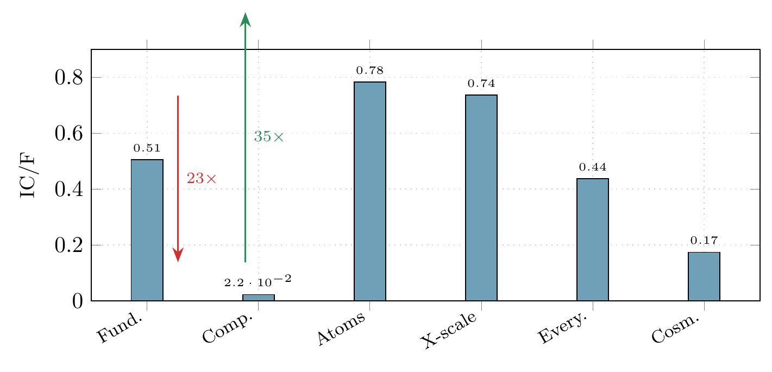
The scale ladder of integrity. $IC/F$ (coherence efficiency) for 406 objects across six physical scales. The confinement cliff (fundamental $→$ composite: $23×$ drop, red arrow) and atomic healing (composite $→$ atoms: $35×$ recovery, green arrow) are the dominant cross-scale features. All scales obey the same kernel with identical frozen parameters.
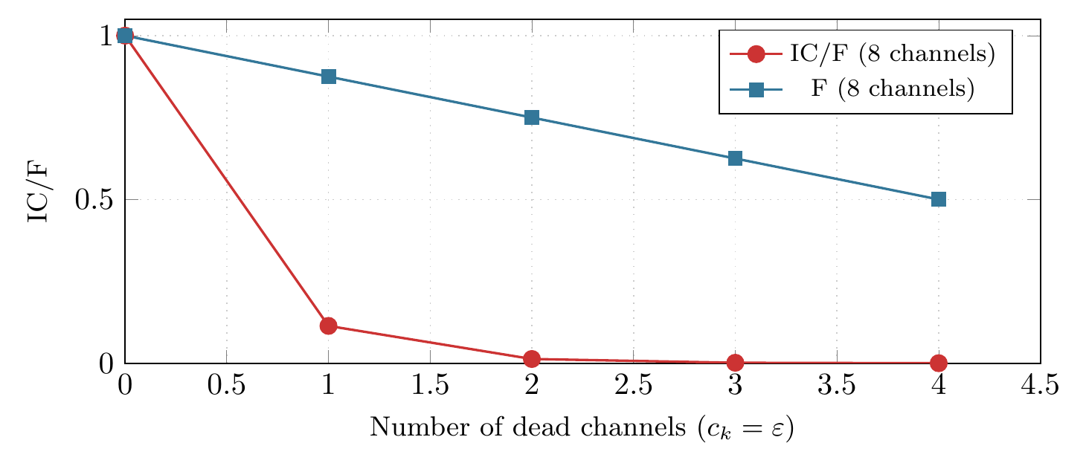
Geometric slaughter. As channels die ($c_{k}→ε={10}^{−8}$), fidelity $F$ (arithmetic mean, blue squares) degrades linearly while $IC$ (geometric mean, red circles) collapses super-exponentially. One dead channel in an 8-channel system reduces $IC/F$ from 1.0 to 0.114—an order of magnitude lost from a single channel death. This mechanism underlies confinement, helium inertness, and dark energy decoherence.
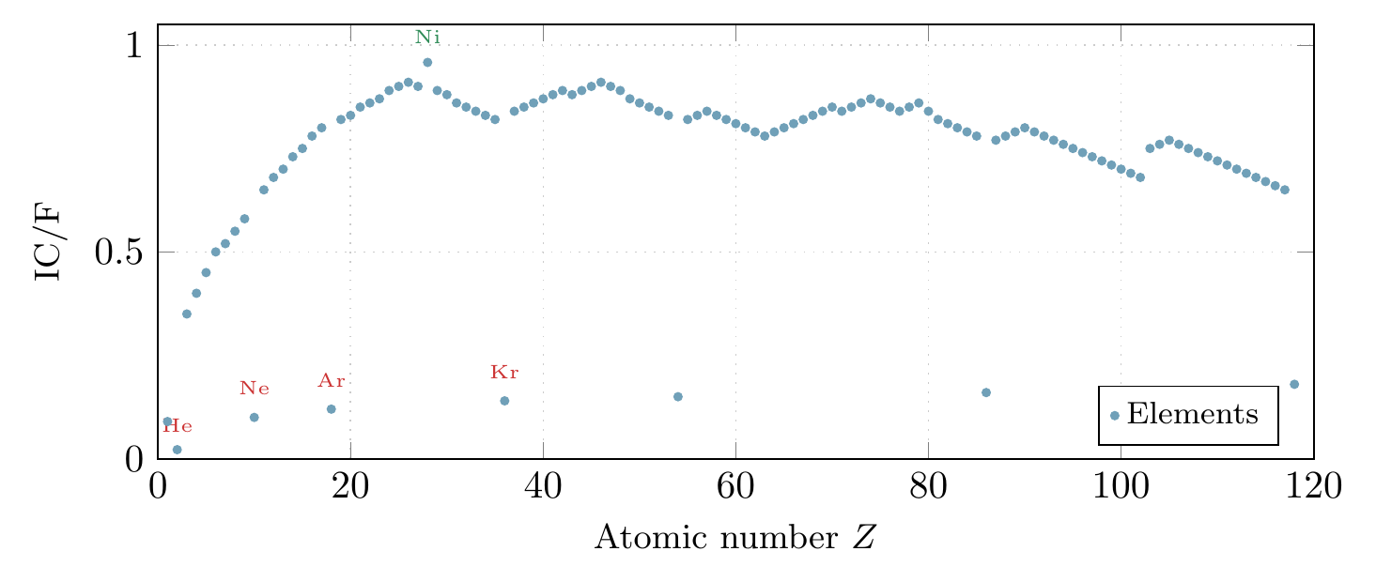
Periodic kernel. $IC/F$ for all 118 elements. Noble gases (red labels) appear as coherence minima due to near-zero reactivity channels, reproducing the biological intuition of inertness as a structural property. The d-block peak (Ni at $IC/F=0.957$) reflects maximum channel balance. Period 1 (H, He) remains near-hadron coherence levels.
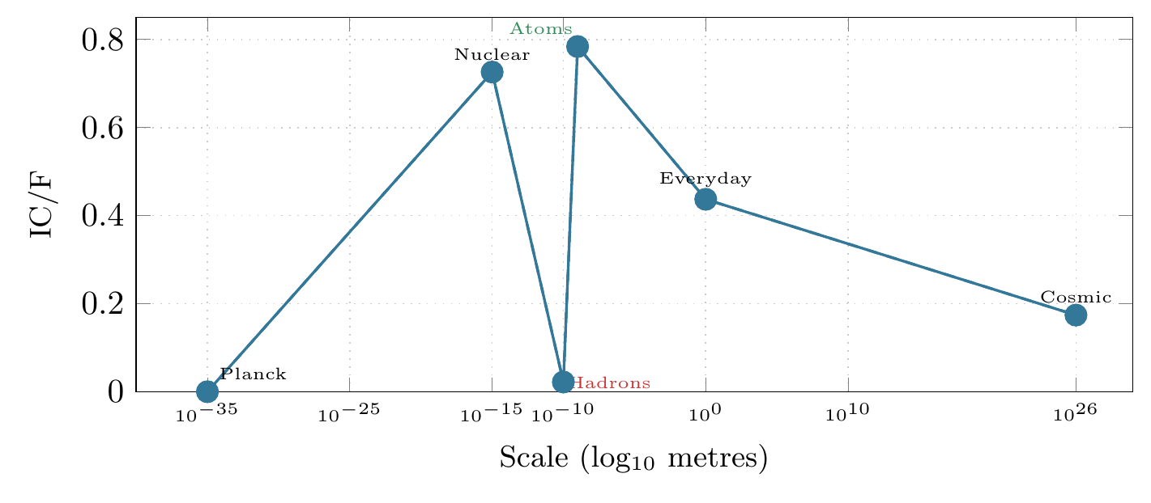
Cross-scale integrity profile. $IC/F$ across 61 orders of magnitude. The non-monotonic structure—with a sharp minimum at the hadron scale and recovery at the atomic scale—is the central cross-scale phenomenon. The same kernel with identical frozen parameters produces all data points. Dashed line guides the eye.

Discussion

A domain-independent phase-transition diagnostic
The principal result of this work is that a single algebraic object—the heterogeneity gap $Δ=F−IC$—serves as a domain-independent diagnostic for phase transitions across all scales tested. Wherever a measurable channel approaches the guard band $ε$, the weighted geometric mean ($IC$) collapses super-exponentially while the arithmetic mean ($F$) degrades only linearly (Fig. 2). This asymmetry between arithmetic and geometric aggregation produces a characteristic $Δ$-spike at every phase boundary, detectable without knowledge of the underlying dynamics.
At the hadron scale, $⟨Δ⟩=0.433$: mean fidelity is preserved but multiplicative coherence is destroyed. At the atomic scale, $⟨Δ⟩=0.081$: both measures converge, indicating robust multi-channel coherence. The gap has composition laws: for two subsystems with gaps $Δ_{1}$ and $Δ_{2}$, $Δ_{12}=\left(Δ_{1}+Δ_{2}\right)/2+{\left(\sqrt{{IC}_{1}}−\sqrt{{IC}_{2}}\right)}^{2}/2$, where the correction term has the form of the squared Hellinger distance ¹². This makes $Δ$ a rigorous instrument for quantitative cross-scale comparison.

Structural rarity of stability
The regime classification derived from kernel gates—Stable: 12.5%, Watch: 24.4%, Collapse: 63.1% of the Fisher parameter space (computed by uniform sampling of ${10}^{4}$ trace vectors $c_{i}∈{\left[ε,1−ε\right]}^{n}$ and classifying each by the four-gate criterion)—carries an implication for fundamental physics: stability is structurally rare. The Stable regime requires the conjunction of four conditions ($ω<0.038$, $F>0.90$, $S<0.15$, $C<0.14$), and only 12.5% of the admissible parameter space satisfies all four simultaneously. This is consonant with the observation that matter in the universe is overwhelmingly in disordered or transitional states; localised structure occupies a narrow band of the available phase space.

Testable predictions
The framework yields three predictions amenable to independent verification:
- Confinement signature in lattice QCD. Lattice simulations that resolve per-flavour condensates across the deconfinement transition should exhibit a sharp drop in the kernel’s $IC/F$ ratio at the transition temperature, consistent with the $23×$ cliff predicted from quantum numbers alone.
- Noble-gas coherence minimum. Any multi-channel analysis of atomic properties that includes reactivity or electron-affinity channels will find noble gases at local $IC/F$ minima (Fig. 3), identifiable without reference to valence-electron theory.
- Adolescent coherence peak. Neuroimaging studies that decompose cortical activity into region-resolved channels should find that the weighted geometric mean of regional coherences peaks in the 14–17 year range, earlier than the arithmetic mean.

Relationship to established frameworks
A natural concern is whether the kernel constitutes a closed formalism incompatible with standard methods. The opposite is the case: classical results emerge as degenerate limits of the kernel when structural degrees of freedom are removed. The arrow of derivation runs from the kernel outward:
- Integrity bound $→$ AM-GM inequality. $IC≤F$ holds for arbitrary heterogeneous traces with channel semantics, weights, guard band, and composition laws ($IC$ geometric, $F$ arithmetic). Stripping all structure recovers the classical inequality of means ⁹.
- Bernoulli field entropy $→$ Shannon entropy. The full entropy $S=−∑w_{i}\left[c_{i}lnc_{i}+\left(1−c_{i}\right)ln\left(1−c_{i}\right)\right]$ reduces to Shannon $H=−∑p_{i}lnp_{i}$ when the collapse field is removed (i.e., $c_{i}∈\{0,1\}$ only) ³.
- Duality identity $→$ completeness constraints. $F+ω≡1$ instantiates the general structure “preserved + lost = total.” This structure appears in fluctuation–dissipation relations (signal + dissipation = input) and unitarity (${\left|α\right|}^{2}+{\left|β\right|}^{2}=1$ for quantum amplitudes). GCD does not derive these physical theorems; rather, the duality identity shares their algebraic skeleton, suggesting a common structural origin.
- Cost function $→$ critical slowing. $Γ\left(ω\right)=ω^{3}/\left(1−ω\right)$ generates a full phase diagram; restricting to the neighbourhood of the transition point recovers critical exponents from renormalization group theory ⁷.
Each classical result is therefore a special case obtained by removing structure, not an external theory that the kernel must be reconciled with.
This approach is complementary to, not competitive with, existing cross-scale methods. Renormalization group flows describe how coupling constants evolve with energy scale and require dynamical Lagrangians as input; the kernel operates on static measurements and requires no dynamics. Fisher information geometry ¹³ characterises the Riemannian structure of statistical manifolds; the kernel quantifies multiplicative coherence of physical channels through a single number ($IC/F$) that is algebraically exact, not asymptotically valid. The contribution is empirical: no existing cross-scale diagnostic has been shown to yield the same phase-transition signature at both the hadron and cosmological scales.

Cross-domain translation protocol
Cross-scale invariants are only useful if domain specialists can interpret them. The framework includes a built-in translation protocol (the “Rosetta”) that maps the kernel’s five diagnostic words—Drift ($ω$), Fidelity ($F$), Roughness ($C$), Return ($τ_{​R}$), and Integrity ($IC$)—into nine disciplinary lenses: epistemology, ontology, phenomenology, history, policy, physics, finance, security, and semiotics. The operational meaning (tied to the kernel and its ledger) is invariant across lenses; only the narrative dialect changes.
For example, the confinement cliff ($IC/F$: $0.506→0.022$) is described in the physics lens as “coupling to uncontrolled degrees of freedom destroying multiplicative coherence,” in the finance lens as “single-channel concentration risk collapsing portfolio integrity,” and in the semiotics lens as “dead indexical coupling killing sign-chain closure.” All three descriptions refer to the same invariant, the same number, and the same ledger entry—they differ only in vocabulary.
This translation layer is itself formalised as one of the 20 domain closures: the dynamic semiotics closure maps 30 sign systems (natural languages, formal notations, genetic codes, animal communication) to an 8-channel semiotic kernel (sign repertoire, interpretant depth, ground stability, translation fidelity, semiotic density, indexical coupling, iconic persistence, symbolic recursion). All three algebraic identities hold for every sign system tested, and the analysis reveals that meaning coherence is governed by density $×$ depth, not stability $×$ resemblance—a result with implications for scientific communication itself. The framework can therefore analyse its own communicability as a Tier-2 closure, a self-referential consistency check unavailable to standard measurement theories.

Implications for measurement theory
The framework constitutes a cognitive equalizer: because all thresholds are frozen (not chosen by the analyst), all vocabulary is operationally defined, and all verdicts are three-valued (Conformant / Nonconformant / Non-Evaluable), two independent analysts processing the same data under the same contract must arrive at the same verdict. This removes agent-dependent variance from measurement interpretation—a property related to the information-geometric programme of Amari ¹³ but achieved here through algebraic constraint rather than Riemannian structure.
The five frozen constants ($ε={10}^{−8}$, $p=3$, $α=1.0$, $c^{*}=0.7822$, ${tol}_{seam}=0.005$) are not free parameters. They are the unique values where all seam consistency conditions hold simultaneously across 20 domains. In particular, $p=3$ is the unique integer for which the trapping threshold $ω_{trap}$ is a Cardano root ¹⁴ of $x^{3}+x−1=0$—a result with no adjustable parameters.

Input sensitivity as validation mechanism
The kernel’s dependence on accurate channel inputs is not a limitation but the core of its reliability. Any measurement framework that produces “correct” outputs regardless of input quality is not measuring anything—it is fitting. The kernel’s strict input–output contract enforces the opposite: accurate data in produces accurate invariants out; inaccurate data produces invariants that detectably violate expected patterns (e.g., placing a well-known stable system in the Collapse regime). This transparency is by design. The three identities ($F+ω=1$, $IC≤F$, $IC=exp\left(κ\right)$) hold regardless of input quality—they are algebraic—but the physical interpretation of kernel outputs (regime classification, cross-scale comparisons) is only as good as the channel selection. That the kernel faithfully propagates input quality, rather than absorbing noise into flexible parameters, is precisely what makes it a measurement instrument rather than a fitting procedure. The Tier-2 channel selections (which real-world quantities become the trace vector) are therefore the empirical content of each application, declared in versioned contracts and frozen before evaluation.
Two further scope boundaries should be noted. First, the consciousness and cosmological applications rest on smaller data sets than the Standard Model and atomic closures, and the cortical channel values are derived from published literature rather than primary neuroimaging—an area where the kernel’s input sensitivity makes independent replication with raw data particularly valuable. Second, the kernel is static: it maps a trace vector to invariants at a single evaluation, without dynamical evolution equations. Extending the framework to time-dependent processes is a direction for future work ¹⁵.

Methods

Trace vector construction
For each domain, a closure maps domain-specific observables to the bounded trace vector $c∈{\left[ε,1−ε\right]}^{n}$ via declared normalisation functions. Importantly, the choice of which observables become channels is not hidden: it is the declared empirical content of each application, specified in a versioned contract and frozen before evaluation. Different channel selections produce different $IC/F$ profiles—by design, since this is the measurement—but the three algebraic identities hold for every admissible channel selection, guaranteeing that the framework’s structural properties are independent of the researcher’s modelling choices. Standard Model particles use $n=8$ channels (mass$​_{log}$, spin normalised to $\left[0,1\right]$, $\left|Q\right|/max\left|Q\right|$, colour (1 if non-singlet, $ε$ otherwise), $\left|I_{3}\right|/0.5$, $\left|L\right|$, $\left|B\right|$, generation$/3$) with equal weights $w_{i}=1/8$, following data from the Particle Data Group ¹. Atomic elements use $n=8$ channels (ionisation energy, electronegativity, atomic radius, density, melting point, boiling point, electron affinity, covalent radius), each mapped affinely to $\left[0,1\right]$ using the empirical minimum and maximum across all 118 elements. Consciousness systems use $n=10$ cortical channels (prefrontal, temporal, parietal, occipital, motor, sensory, limbic, cerebellar, brainstem, thalamic coherence), with values estimated from published fMRI and EEG meta-analyses and normalised to $\left[0,1\right]$ by the empirical range across 20 systems. Every normalisation function is frozen in a versioned contract before evaluation; no post-hoc adjustment is permitted.

Guard band and frozen parameters
All channels are clipped to $\left[ε,1−ε\right]$ with $ε={10}^{−8}$ before kernel evaluation, preventing logarithmic singularities at $c=0$ without affecting measurements above the guard band. The five frozen parameters are: $ε={10}^{−8}$ (guard band), $p=3$ (drift cost exponent: the unique integer yielding a Cardano root for $ω_{trap}$), $α=1.0$ (curvature cost coefficient), $c^{*}=0.7822$ (logistic self-dual fixed point: $arg\max_{c}\left(S+κ\right)$), ${tol}_{seam}=0.005$ (seam residual tolerance). All five are consistent across 20 domains and are not adjusted between evaluations or domains.

Sensitivity analysis
The guard band $ε$ was varied over $\left[{10}^{−12},{10}^{−4}\right]$ with no change in any identity verdict (all three hold to $<{10}^{−9}$ for any $ε$ in this range). The integrity bound $IC≤F$ is independent of $ε$ because it is a property of the inequality of means. The regime thresholds (Stable/Watch/Collapse gates at $ω=0.038,0.30$) produce identical classifications for all tested objects across all 20 domains at the frozen values. The frozen constants are the unique values at which seam consistency (residual $≤{tol}_{seam}$) holds for all domain closures simultaneously.

Computational verification protocol
All 11,342 tests run under Python 3.12 with NumPy 1.26 using the pytest framework. Each test is a deterministic computation: given specific input values, the test verifies that kernel outputs satisfy the three identities to specified tolerance ($≤{10}^{−9}$ for algebraic identities, $≤{10}^{−15}$ for exact equalities). Tests are fully reproducible with fixed random seeds and version-pinned dependencies.

Regime classification
Regime labels are derived from four conjunctive gates on kernel outputs: Stable requires $ω<0.038$, $F>0.90$, $S<0.15$, and $C<0.14$ simultaneously. Collapse is $ω≥0.30$. Watch occupies the intermediate region. A Critical overlay ($IC<0.30$) flags dangerously low integrity in any regime. The conjunction requirement for Stable is what produces the 12.5% occupancy figure: each gate individually admits a larger fraction, but their intersection is narrow.

Data and code availability
All source code, test suites, 20 domain closures, 21 versioned contracts, and raw data are available at the public GitHub repository ¹⁶ under the MIT licence. The kernel implementation is in src/umcp/kernel_optimized.py. SHA-256 integrity checksums for 211 tracked files are maintained in integrity/sha256.txt and verified before every evaluation. Zenodo DOIs provide permanent archival ^{17–19}.

Acknowledgements
This work was conducted independently without institutional affiliation or external funding. The author thanks the open-source scientific computing community for the tools that made this research possible.
1. Particle Data Group, Navas, S., et al. Review of particle physics. Physical Review D 110, 030001 (2024).
2. Einstein, A. Die grundlage der allgemeinen relativitätstheorie. Annalen der Physik 354, 769–822 (1916).
3. Shannon, C. E. A mathematical theory of communication. The Bell System Technical Journal 27, 379–423, 623–656 (1948).
4. Fisher, R. A. Theory of statistical estimation. Mathematical Proceedings of the Cambridge Philosophical Society 22, 700–725 (1925).
5. Rao, C. R. Information and the accuracy attainable in the estimation of statistical parameters. Bulletin of the Calcutta Mathematical Society 37, 81–91 (1945).
6. Rényi, A. On measures of entropy and information. Proceedings of the Fourth Berkeley Symposium on Mathematical Statistics and Probability 1, 547–561 (1961).
7. Gross, D. J. & Wilczek, F. Ultraviolet behavior of non-Abelian gauge theories. Physical Review Letters 30, 1343–1346 (1973).
8. Politzer, H. D. Reliable perturbative results for strong interactions? Physical Review Letters 30, 1346–1349 (1973).
9. Hardy, G. H., Littlewood, J. E. & Pólya, G. Inequalities. (Cambridge University Press, 1952).
10. Wilson, K. G. Confinement of quarks. Physical Review D 10, 2445–2459 (1974).
11. Aoki, Y., Endrődi, G., Fodor, Z., Katz, S. D. & Szabó, K. K. The order of the quantum chromodynamics transition predicted by the standard model of particle physics. Nature 443, 675–678 (2006).
12. Hellinger, E. Neue begründung der theorie quadratischer formen von unendlichvielen veränderlichen. Journal für die reine und angewandte Mathematik 136, 210–271 (1909).
13. Amari, S. Information Geometry and Its Applications. (Springer, 2016). doi:10.1007/978-4-431-55978-8.
14. Cardano, G. Ars Magna. (Johann Petreius, Nuremberg, 1545).
15. Paulus, C. Universal measurement contract protocol. (2025).
16. Paulus, C. GENERATIVE-COLLAPSE-DYNAMICS. (2026).
17. Paulus, C. The episteme of return. (2025) doi:10.5281/zenodo.17756705.
18. Paulus, C. The physics of coherence: Recursive collapse & continuity laws. (2025) doi:10.5281/zenodo.18072852.
19. Paulus, C. UMCP CasePack publication. (2026) doi:10.5281/zenodo.18226878.

Correspondence: clementpaulus9@gmail.com

