Requêtes SQL Base de données Chinook
1. Quel pays a le plus grand nombre de clients ?
SELECT Country, COUNT(*) AS NombreClients
FROM Customer
GROUP BY Country
ORDER BY NombreClients DESC
FETCH FIRST ROW ONLY;
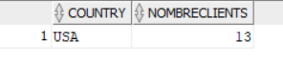

2. Quel client a dépensé le plus d'argent ?
SELECT
c.CustomerId,
c.FirstName,
c.LastName,
SUM(i.Total) AS TotalDepense
FROM Customer c
JOIN Invoice i ON c.CustomerId = i.CustomerId
GROUP BY c.CustomerId, c.FirstName, c.LastName
ORDER BY TotalDepense DESC
FETCH FIRST ROW ONLY;

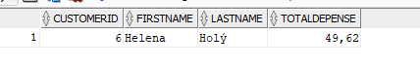

3. Quel album et de quel artiste, contient le plus de titres ?
SELECT
ar.Name AS Artiste,
al.Title AS Album,
COUNT(t.TrackId) AS NombreTitres
FROM Album al
JOIN Artist ar ON al.ArtistId = ar.ArtistId
JOIN Track t ON al.AlbumId = t.AlbumId
GROUP BY ar.Name, al.Title, al.AlbumId
ORDER BY NombreTitres DESC
FETCH FIRST ROW ONLY;

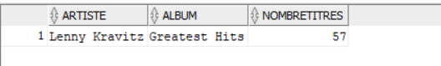
4. Quel genre de musique est le plus représenté ?
SELECT
g.Name AS Genre,
COUNT(t.TrackId) AS NombreTitres
FROM Genre g
JOIN Track t ON g.GenreId = t.GenreId
GROUP BY g.Name, g.GenreId
ORDER BY NombreTitres DESC
FETCH FIRST ROW ONLY;
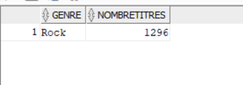

5. Affichez la durée en minutes et secondes de l'album le plus long.
SELECT
ar.Name AS Artiste,
al.Title AS Album,
FLOOR(SUM(t.Milliseconds) / 60000) AS Minutes,
FLOOR((SUM(t.Milliseconds) / 60000 - FLOOR(SUM(t.Milliseconds) / 60000))*60) AS SECONDE
FROM Album al
JOIN Artist ar ON al.ArtistId = ar.ArtistId
JOIN Track t ON al.AlbumId = t.AlbumId
GROUP BY al.AlbumId, ar.Name, al.Title
ORDER BY Minutes DESC
FETCH FIRST ROW ONLY

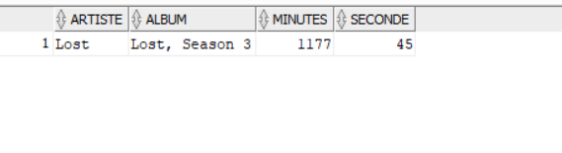

6. Combien d'artistes ne sont associés à aucun album ?
SELECT COUNT(*) AS ArtisteSansAlbum
FROM Artist ar
WHERE NOT EXISTS (
SELECT 1
FROM Album al
WHERE al.ArtistId = ar.ArtistId
);

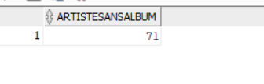
7. Le nombre d'albums composés de chansons de genres différents ?
SELECT COUNT(*) AS AlbumsMultiGenres
FROM (
SELECT al.AlbumId
FROM Album al
JOIN Track t ON al.AlbumId = t.AlbumId
GROUP BY al.AlbumId
HAVING COUNT(DISTINCT t.GenreId) > 1
) AlbumsAvecPlusieursGenres;

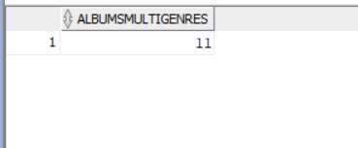

8. Le pourcentage de chansons jamais achetées
WITH
TotalPistes AS (
SELECT COUNT(*) AS total FROM Track
),
PistesPasAchetees AS (
SELECT COUNT(DISTINCT t.TrackId) AS pas_achetees
FROM Track t
WHERE NOT EXISTS (
SELECT 1
FROM InvoiceLine il
WHERE il.TrackId = t.TrackId
)
)
SELECT
ROUND((pas_achetees * 100.0 / total), 2) AS PourcentageChansonsPasAchetees
FROM TotalPistes, PistesPasAchetees;
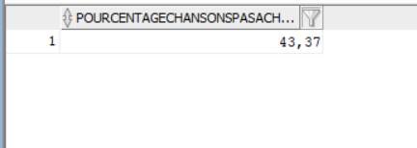

9.Le nombre de clients qui ont dépensé plus que le montant total moyen dépensé par tous les clients
WITH DepensesClients AS (
SELECT
c.CustomerId,
COALESCE(SUM(i.Total), 0) AS TotalDepense
FROM Customer c
LEFT JOIN Invoice i ON c.CustomerId = i.CustomerId
GROUP BY c.CustomerId
),
MoyenneDepenses AS (
SELECT AVG(TotalDepense) AS MoyenneGlobale
FROM DepensesClients
)
SELECT COUNT(*) AS ClientsAuDessusMoyenne
FROM DepensesClients, MoyenneDepenses
WHERE TotalDepense > MoyenneGlobale;

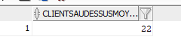
10. Identifiez l'artiste le plus vendu du genre musical le plus populaire

WITH GenrePlusPopulaire AS (
SELECT g.GenreId, g.Name
FROM Genre g
JOIN Track t ON g.GenreId = t.GenreId
GROUP BY g.GenreId, g.Name
ORDER BY COUNT(t.TrackId) DESC
FETCH FIRST 1 ROW ONLY
),
VentesParArtiste AS (
SELECT
ar.ArtistId,
ar.Name AS Artiste,
SUM(il.Quantity) AS TotalVentes
FROM Artist ar
JOIN Album al ON ar.ArtistId = al.ArtistId
JOIN Track t ON al.AlbumId = t.AlbumId
JOIN InvoiceLine il ON t.TrackId = il.TrackId
JOIN GenrePlusPopulaire gpp ON t.GenreId = gpp.GenreId
GROUP BY ar.ArtistId, ar.Name
)
SELECT Artiste, TotalVentes
FROM VentesParArtiste
ORDER BY TotalVentes DESC
FETCH FIRST 1 ROW ONLY;
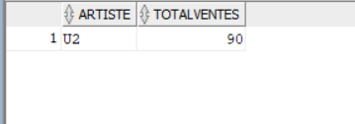

11.Classez les pistes de chaque album par durée
SELECT
ar.Name AS Artiste,
al.Title AS Album,
t.Name AS Titre,
t.Milliseconds,
ROUND(t.Milliseconds / 60000.0, 2) AS DureeMinutes,
RANK() OVER (PARTITION BY al.AlbumId ORDER BY t.Milliseconds DESC) AS RangDansAlbum
FROM Track t
JOIN Album al ON t.AlbumId = al.AlbumId
JOIN Artist ar ON al.ArtistId = ar.ArtistId
ORDER BY ar.Name, al.Title, RangDansAlbum;
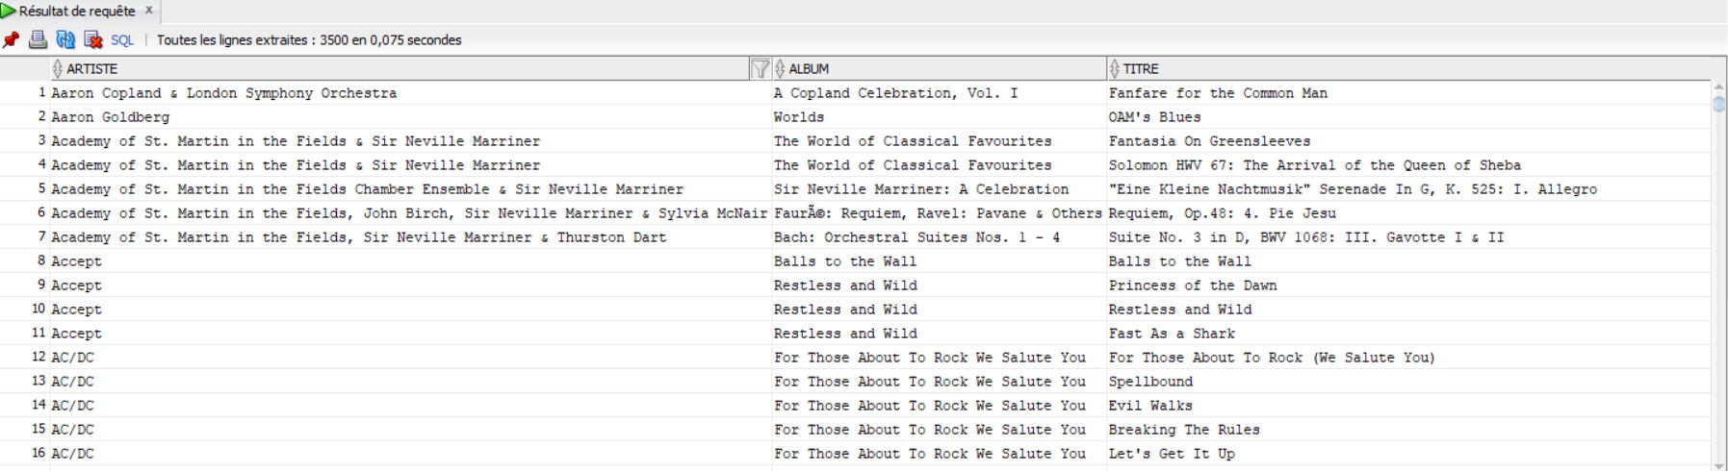

12. Calculez les dépenses des clients par rapport à la moyenne de leur pays
WITH DepensesParClient AS (
SELECT
c.CustomerId,
c.FirstName,
c.LastName,
c.Country,
COALESCE(SUM(i.Total), 0) AS DepenseClient
FROM Customer c
LEFT JOIN Invoice i ON c.CustomerId = i.CustomerId
GROUP BY c.CustomerId, c.FirstName, c.LastName, c.Country
),
MoyenneParPays AS (
SELECT
Country,
AVG(DepenseClient) AS MoyennePays
FROM DepensesParClient
GROUP BY Country
)
SELECT
dpc.CustomerId,
dpc.FirstName,
dpc.LastName,
dpc.Country,
ROUND(dpc.DepenseClient, 2) AS DepenseClient,
ROUND(mpp.MoyennePays, 2) AS MoyennePays,
ROUND(dpc.DepenseClient - mpp.MoyennePays, 2) AS EcartMoyenne,
ROUND((dpc.DepenseClient / NULLIF(mpp.MoyennePays, 0)) * 100, 2) AS PourcentageMoyenne
FROM DepensesParClient dpc
JOIN MoyenneParPays mpp ON dpc.Country = mpp.Country
ORDER BY dpc.Country, dpc.DepenseClient DESC;

