Annex Engineering part:

• Installation & quick-start
$ tar -xzf kafka_2.11-0.10.2.0.tgz
$ cd kafka_2.11-0.10.2.0
Step 1: Download the code
$ bin/zookeeper-server-start.sh config/zookeeper.properties
[DATE] INFO Reading configuration from: config/zookeeper.properties (org.apache.zookeeper.server.quorum.QuorumPeerConfig)
…
After downloading 0.10.2.0 release and un-tar file do:
Step 2: Start the server
Kafka uses ZooKeeper so you need to first start a ZooKeeper server if you don't already have one. You can use the convenience script packaged with kafka to get a quick-and-dirty single-node ZooKeeper instance.
$ bin/kafka-server-start.sh config/server.properties
[DATE] INFO Verifying properties (kafka.utils.VerifiableProperties)
[2013-04-22 15:01:47,051] INFO Property socket.send.buffer.bytes is overridden to 1048576 (kafka.utils.VerifiableProperties)
…
Now, start the Kafka server

Step 3: Create a topic

For the quickstart demo we will create a first topic named « test » with a single partition and only one replica. To have the specific information of our Kafka, please refer to the part VII of this chapter: About our Kafka.
$ bin/kafka-topics.sh --create --zookeeper localhost:2181 --replication-factor 1 --partitions 1 --topic test
We can now see that topic if we run the list topic command:
$ bin/kafka-topics.sh --list --zookeeper localhost:2181
test

Step 4: Send some messages

Kafka comes with a command line client that will take input from a file or from standard input and send it out as messages to the Kafka cluster. By default, each line will be sent as a separate message.
$ bin/kafka-console-producer.sh --broker-list localhost:9092 --topic test
Clément Tailleur first message
Cyril Monti second message
Rémi Ferreira third message
Run the producer and then type a few messages into the console to send to the server.

Step 5: Start a consumer

Kafka also has a command line consumer that will dump out messages to standard output.
$ bin/kafka-console-consumer.sh --bootstrap-server localhost:9092 --topic test --from-beginning
Clément Tailleur first message
Cyril Monti second message
Rémi Ferreira third message

Now that we have each of the above commands running in a different terminal then we are able to type messages into the producer terminal and see them appear in the consumer terminal.
All of the command line tools have additional options; running the command with no arguments will display usage information documenting them in more detail.

• ZooKeeper
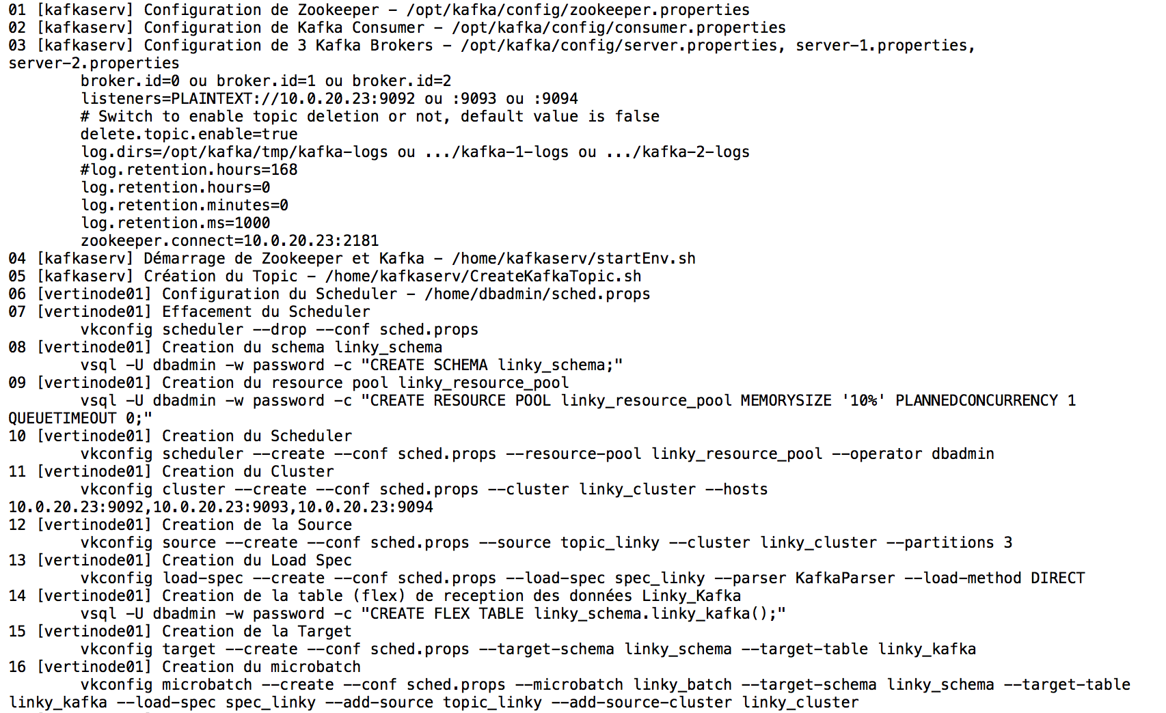

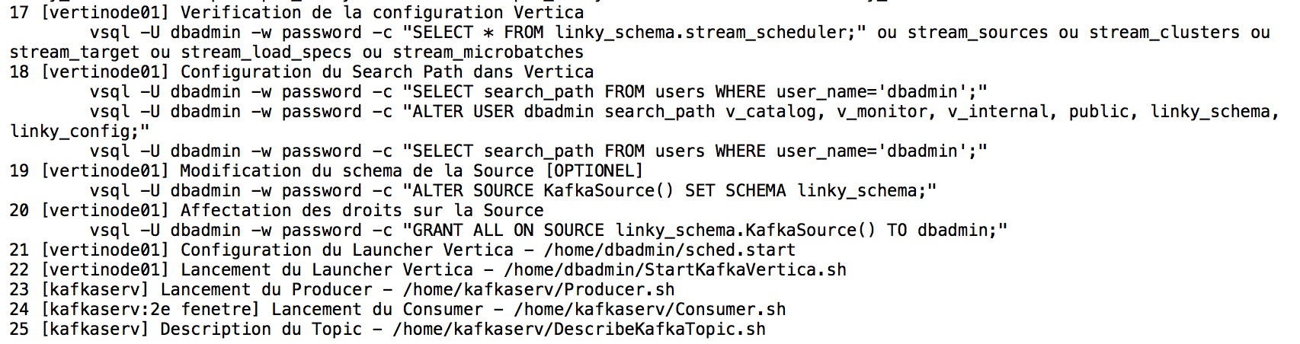

How a server work:

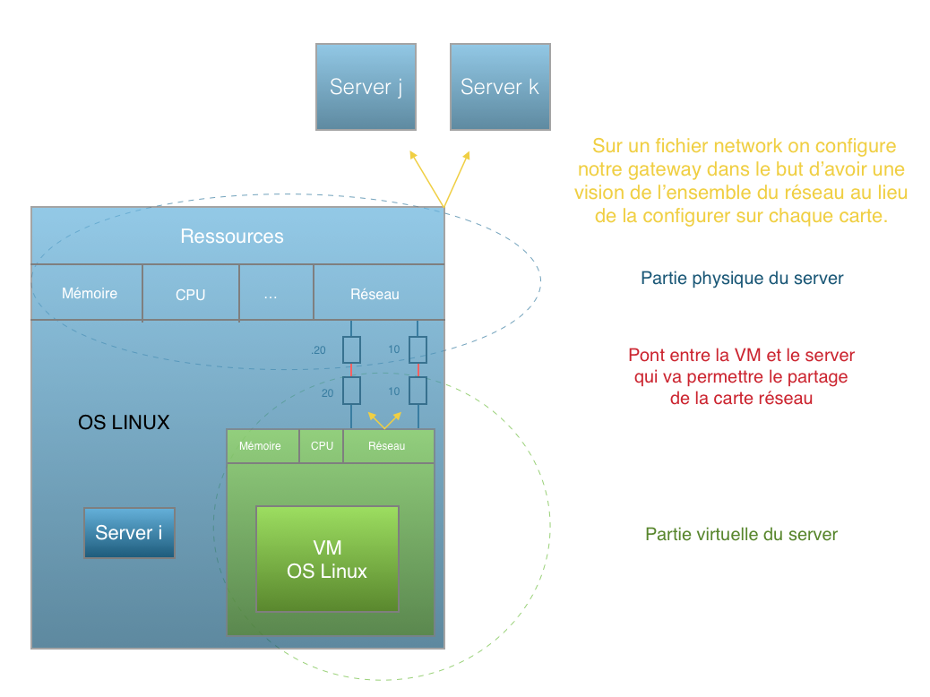

How servers work with each other:
