Cyril Monti
Clément Tailleur
Rémi Ferreira

Project
Specifications
Project linkyd
HPE

Table des matières
1. Introduction: 6
2. Project Specifications: 7
2.1. RESEARCH: 9
LINKYD-RSH-001: 9
LINKYD-RSH-002: 9
LINKYD-RSH-003: 9
LINKYD-RSH-003: 9
2.2. LINKY SIMULATION – DATA GENERATOR: 9
LINKYD-SIM-001: 9
LINKYD-SIM-002: 9
LINKYD-SIM-003: 9
LINKYD-SIM-004: 9
2.3. LINK BETWEEN DATA GENERATOR AND ANALYTIC PART: 9
LINKYD-LNK-001: 9
LINKYD-LNK-002: 9
LINKYD-LNK-003: 9
LINKYD-LNK-004: 9
LINKYD-LNK-005: 9
LINKYD-LNK-006: 9
2.4. DATA ANALYSIS: 10
LINKYD-DAN-001: 10
LIKYD-DAN-002: 10
LINKYD-DAN-003: 10
LINKYD-DAN-004: 10
LINKYD-DAN-005: 10
Some more details about the project 11
1. Architecture of the desired cluster 11
2. GANTT 12
Use Case Diagram 13
1. Diagram 13
2. Administrate system 14
2.1. Objective 14
2.2. Actors 14
2.3. Data exchanged 14
2.4. Description of the sequence 14
2.5. Pré-condition 14
3. Test Linkyd with real data 14
3.1. Objective 14
3.2. Actors 14
3.3. Data exchanged 14
3.4. Description of the sequence 14
3.5. Pre-condition 14
4. Test Linkyd via UI. 15
4.1. Objective 15
4.2. Actors 15
4.3. Data exchanged 15
4.4. Description of the sequence 15
4.5. Pre-condition 15
5. Generate Usage Hours 15
5.1. Objective 15
5.2. Actors 15
5.3. Data exchanged 15
5.4. Description of the sequence 15
5.5. Pre-condition 15
6. Generate Monthly usage 16
6.1. Objective 16
6.2. Actors 16
6.3. Data exchanged 16
6.4. Description of the sequence 16
6.5. Pre-condition 16
7. Generate devices specifications for each home 16
7.1. Objective 16
7.2. Actors 16
7.3. Data exchanged 16
7.4. Description of the sequence 16
7.5. Pre-condition 16
8. Generate Home total consumption profile 17
8.1. Objective 17
8.2. Actors 17
8.3. Data exchanged 17
8.4. Description of the sequence 17
8.5. Pre-condition 17
9. Simulate home consumption 17
9.1. Objective 17
9.2. Actors 17
9.3. Description of the sequence 17
9.4. Pre-condition 17
10. Build/ Send Frame 18
10.1. Objective 18
10.2. Actors 18
10.3. Data exchanged 18
10.4. Description of the sequence 18
10.5. Pre-condition 18
11. Receive/Decode Frame 19
11.1. Objective 19
11.2. Actors 19
11.3. Data exchanged 19
11.4. Description of the sequence 19
11.5. Pre-condition 19
12. Store data 19
12.1. Objective 19
12.2. Actors 19
12.3. Data exchanged 19
12.4. Description of the sequence 19
12.5. Pre-condition 19
13. Build resultant graph 20
13.1. Objective 20
13.2. Actors 20
13.3. Data exchanged 20
13.4. Description of the sequence 20
13.5. Pre-condition 20
14. Check if it fits to a device’s consumption profile 20
14.1. Objective 20
14.2. Actors 20
14.3. Data exchanged 20
14.4. Description of the sequence 20
14.5. Pre-condition 20
15. Subtract signals 21
15.1. Objective 21
15.2. Actors 21
15.3. Data exchanged 21
15.4. Description of the sequence 21
15.5. Pre-condition 21
Activity Diagram 22
1. Generate home profile 22
1.1. Diagram 22
1.2. Explanations 23
2. Electricity meter simulation 24
2.1. Diagram 24
2.2. Explanations 25
3. Frame management 26
3.1. Diagram 26
3.2. Explanations 27
4. Analyze final signal 28
4.1. Diagram 28
4.2. Explanations 29
Class Diagram 30
1. Diagram 30
2. Home class 31
2.1. Attributes 31
2.2. Methods 31
3. Device class 32
3.1. Attributes 32
3.2. Methods 32
4. Analyzer class 33
4.1. Attributes 33
4.2. Method 33
5. Frame class 33
5.1. Methods 33
State diagrams 34
1. Home 34
1.1. Diagram 34
1.2. Explanation 34
2. Device 35
2.1. Diagram 35
2.2. Explanations 35
3. Analyzer 36
3.1. Diagram 36
3.2. Explanations 36
4. Frame 37
4.1. Diagram 37
4.2. Explanations 37
Sequence Diagram 38
1. Diagram 38
2. Explanations 38

Introduction:
Our project is in collaboration with Hewlett Packard Enterprise and the goal is to do a POC (proof of concept) on the smart electricity meter theme. We will have to simulate the functioning of a smart electricity meter, put those generated data on a big data system powered by HPE, Vertica. Finally we will have to analyze this data and build a predictive model that will be able to recreate the energy consuming model in French homes.
The system can be divided in three main part, a data generator part, a frame management part and a data analyzing part. Basically we want to generate data to fill a database, our goal is to simulate 600 000 Linky electricity meters over 1 year, which will sent a frame that will contain the house electricity consumption every second. Once the database is full of data, we want to plot the evolution of energy consumption of houses over a period that we can modulate, and to identify which device has be turned on, and when for example, and much more information about household consumption. After this we will be able to make a predictive model that will be able to recreate the energy consuming model in France.
The data generator will have to simulate a home consumption profile, for this we will simulate the consumption of each device that a home can contain, and simulate what a home contain, depending on the home size or the number of persons in the family for example. A complicated part is the fact that a lot of parameters have an influence on others. For example in a family of 2 adults and 2 children the energy consumption is not the same as in a family of 1 adult. The devices will not be turned on at the same hours in those two families as they may have not the same lifestyle.
The frame management part is the part where we build the frame that will be sent to database, the frame as to be in the same format as the one used by EDF because we want our system to be usable with real EDF’s data. The frame will be sent to database after being decoded.
The last part is the data analyzing part, we will try to find the consumption pattern of each device in the total consumption graph of a home. After this we will be able to do some more analyzes.
The technologies that we are going to use, are Python for the data generator. In order to build the cluster, we are going to use Hadoop, and cloudera to create a cluster with it’s 3 nodes and VMs. The database available in the cluster will be under Vertica system. For the data analysis we are not going to use SAS software as it not a free software. We will not use R neither because there is some inconvenient with this language. So, we decided to use Python, with pandas library to manipulate data frames., aside of this we are going to use Jupyter to present our code and to explain it much more clearly and also Spark that will be used to execute our scripts directly on the cluster that we will have previously build.

Project Specifications:
Project Spécifications
Shall | Should | May | Category | ID
Find the domestic appliances that use the most energy |  |  | RESEARCH | LINKYD-RSH-001
Find the energy consumption of the selected devices |  |  | RESEARCH | LINKYD-RSH-002
Get a model of the different home energy consumption |  |  | RESEARCH | LINKYD-RSH-003
 | Find samples of some data collected by Linky |  | RESEARCH | LINKYD-RSH-004
Generate data by simulating Linky's data collection with statistical model (Gaussian) for every domestic appliance |  |  | SIMULATION OF LINKY - DATA GENERATOR | LINKYD-SIM-001
 | Generate data following the different home usages |  | SIMULATION OF LINKY - DATA GENERATOR | LINKYD-SIM-002
Generate data knowing time (hours, days) and the domestic appliance usages depending on time |  |  | SIMULATION OF LINKY - DATA GENERATOR | LINKYD-SIM-003
 |  | Build an User Interface | SIMULATION OF LINKY - DATA GENERATOR | LINKYD-SIM-004
 |  | Get an example of the frame send by linky to EDF database | LINK BETWEEN DATA GENERATOR AND ANALYTIC PART | LINKYD-LNK-001
Create an architecture for the database |  |  | LINK BETWEEN DATA GENERATOR AND ANALYTIC PART | LINKYD-LNK-002
Project Specifications(2)
Shall | Should | May | Category | ID
Encode data following the frame |  |  | LINK BETWEEN DATA GENERATOR AND ANALYTIC PART | LINKYD-LNK-003
Decode the framed data |  |  | LINK BETWEEN DATA GENERATOR AND ANALYTIC PART | LINKYD-LNK-004
Send data simulated in a Vertica database system |  |  | LINK BETWEEN DATA GENERATOR AND ANALYTIC PART | LINKYD-LNK-005
Link the data generator with the analytic part |  |  | LINK BETWEEN DATA GENERATOR AND ANALYTIC PART | LINKYD-LNK-006
analyze the data and be able to crosscheck our data with the statistics of the power consumption in France |  |  | DATA ANALYSIS | LINKYD-DAN-001
 |  | Do a live analysis | DATA ANALYSIS | LINKYD-DAN-002
realize a predictive model that fit with the household’s power consumption |  |  | DATA ANALYSIS | LINKYD-DAN-003
 |  | Show results with graphical tools | DATA ANALYSIS | LINKYD-DAN-004
 |  | Test the predictive model with real data provided by EDF | DATA ANALYSIS | LINKYD-DAN-005

RESEARCH:

LINKYD-RSH-001:
The domestic appliances that use the most energy shall be found and selected to be added in our simulation.

LINKYD-RSH-002:
For the selected devices we shall find the energy consumption of each one.

LINKYD-RSH-003:
A model of the different home energy consumption behavior shall be found.

LINKYD-RSH-003:
Samples of some data collected by Linky should be found to build a better simulation that would be more accurate.

LINKY SIMULATION – DATA GENERATOR:

LINKYD-SIM-001:
The simulator shall generate data by simulating Linky’s data collection with a statistical model (Gaussian) for every domestic appliance.

LINKYD-SIM-002:
The simulator should as a parameter the different family and home behaviors to generate data.

LINKYD-SIM-003:
A timer has to be added in the simulator, and it shall generate data depending on the appliances usage that will be different for each hour.

LINKYD-SIM-004:
The simulator may also contain a User Interface in which the user should “customize” the data that will be generated.

LINK BETWEEN DATA GENERATOR AND ANALYTIC PART:

LINKYD-LNK-001:
To build the link between the data generator and the analytic part, we should get an example of the frames send by Linky to the EDF database to create our own frame.

LINKYD-LNK-002:
An architecture for the database shall also be created.

LINKYD-LNK-003:
To send data through database and to analytic part, a proper frame format has to be build, and the data shall be encoded.

LINKYD-LNK-004:
The data once in analytic part shall be decoded.

LINKYD-LNK-005:
All the data simulated shall be sent in a Vertica database system.

LINKYD-LNK-006:
Finally, the data generator shall be linked to the data analysis part

DATA ANALYSIS:

LINKYD-DAN-001:
The data shall be analyzed, and afterwards it will be crosschecked with the statistics of the power consumption in France.

LIKYD-DAN-002:
The data analysis should be done in live.

LINKYD-DAN-003:
A predictive model that fit with the household’s power consumption shall be built.

LINKYD-DAN-004:
The results of the analysis should be showed using different graphical tools to explain them to the users.

LINKYD-DAN-005:
The predictive model should be tested with real data provided by EDF to verify if our data generator was close enough to reality.

Some more details about the project

Architecture of the desired cluster
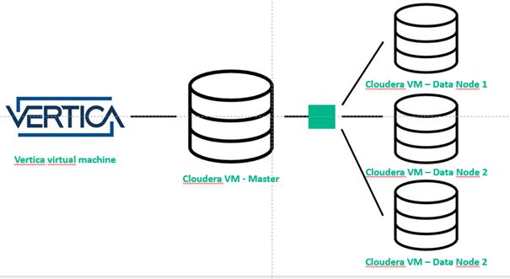
As explained before we want to build a cluster to store our data into it and do the analysis more efficiently thanks to it. You will find the architecture in the figure before.

GANTT

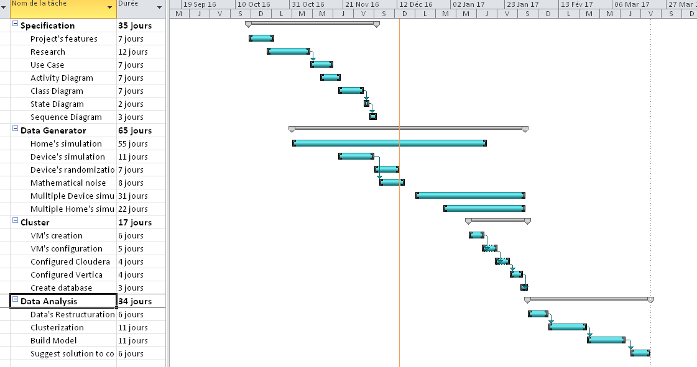
Here you can find the GANTT of our project, with the estimated time of every action that we think we will do. Most of the actions are already explained before.

Use Case Diagram

Diagram
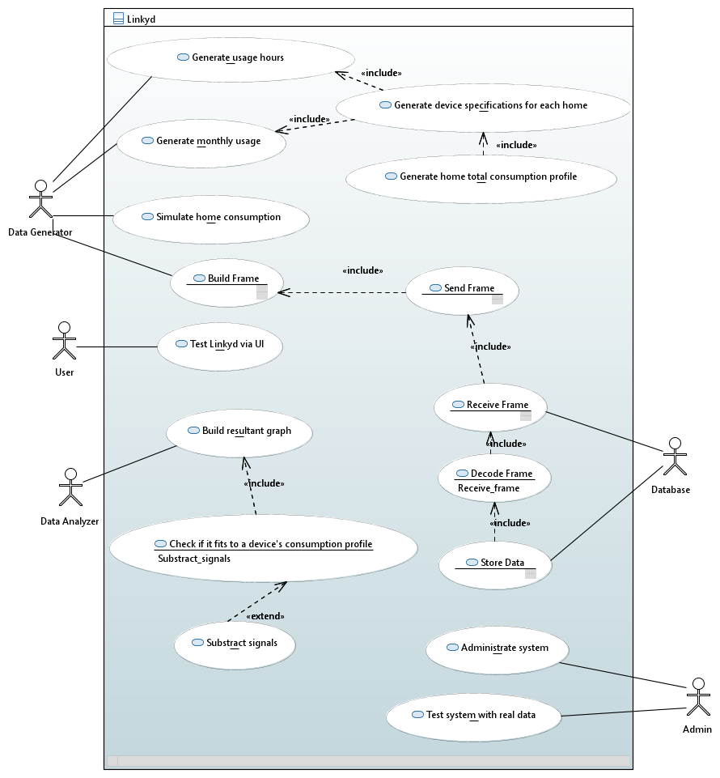

Administrate system

Objective
This use case enable admin to turn the system on/off

Actors
The administrator is concerned by this usage

Data exchanged
Information about system state.

Description of the sequence
The administrator will turn on the system, this will permit the data generator to start generating the necessary profiles, the data for each home (and for 700 000 homes). This will normally also turn on data analyzer on real time. When the system will be turned off, the data generator will stop generating data and filling the database. However it will still be possible to analyze stored data.

Pré-condition
The only pré-condition is that the system is not already on/off…

Test Linkyd with real data
This correspond to the task n° LINKYD-DAN-005

Objective
This use case enable the admin to test the final version not with the data generated with the Data Generator but with real home consumption’s data provided by EDF for example.

Actors
The administrator is concerned by this usage.

Data exchanged
The data provided in entry with this use case will not be the data provided by the data generator but a database provided by EDF.

Description of the sequence
The system should be adaptable to EDF’s data type, that is why the frames should be the same as the one used by EDF so the admin should put in entry the an EDF database.

Pre-condition
A database provided by EDF should be provided.
The new database should fit the database that we use normally populated by data generator’s data (same variable name, same number of variables, same number of columns etc.)

Test Linkyd via UI.
This correspond to the task n°LINKYD-SIM-004 and LINKYD-DAN-004

Objective
The user should test the system with a user interface.

Actors
The User is concerned by this usage.

Data exchanged
Information concerning number of homes to simulate, and other parameters of the simulation that should be used in data generator and entered by the user thanks to a user interface.

Description of the sequence
The user will be able to input some parameters. Those parameters will be used in the Data Generator to influence on the Profile building phase. They could be the number of houses to simulate, time gap to simulate, household devices included or not in the simulation. The simulation will be adapted with the user’s input.

Pre-condition
A user interface will have to be built to permit the user to enter his parameters. The parameters entered by the user should also be plausible, otherwise the data simulated will have no sense.

Generate Usage Hours
This correspond to the task n°LINKYD-SIM-004

Objective
The objective is to generate data usage by hours for each devices of the home

Actors
The data generator is concerned by this usage

Data exchanged

Description of the sequence
The generator will create data usage by hours for each device. Based on the home’s characteristics (number of people etc.). This will basically generate an array filled by Booleans. For example for a toaster there will be ones between 7 a.m. and 10 a.m. and zeroes after, because there is chances that this device will be used between those hours and not outside.

Pre-condition
To generate this, a home must be created, containing all its devices.

Generate Monthly usage
This correspond to the task n°LINKYD-SIM-004

Objective
The objective is to simulate the monthly usage for each device of the home

Actors
The data generator is concerned by this usage.

Data exchanged

Description of the sequence
The generator will create monthly usage data. Just like for the usage hours it will create an array full of Booleans, for example radiators will have ones between November and April, and zeroes between May and October, as they are used in cold periods.

Pre-condition
To generate this, a home must be created, containing all its devices.

Generate devices specifications for each home
This correspond to the task n°LINKYD-SIM-002

Objective
The objective is to generate specification for each device of a home

Actors
The data generator is concerned by this usage

Data exchanged

Description of the sequence
With the data that we generate before, we will be able to generate a profile of each device in a home. By multiplying usage hours profile with monthly usage profile and the consumption profile, we will be able to say if at a given time, the device could be running or not.

Pre-condition
The pre-condition is that the data usage hours and monthly has to be generated before

Generate Home total consumption profile
This correspond to the task n°LINKYD-SIM-004

Objective
The objective is to generate the total consumption profile of a house.

Actors
The data generator is concerned by this usage

Data exchanged

Description of the sequence
We will be able to generate the total home’s consumption profile with the data that we generated before by simply adding the consumption profile of each devices that this home contains. We will be able to get at each second the total consumption of a home.

Pre-condition
We need to generate each devices specification for the current home to be able to add them.

Simulate home consumption
This correspond to the task n°LINKYD-SIM-001

Objective
The objective is to generate home consumption data according to the Home profile.

Actors
The actors concerned by this usage is the data generator.

Description of the sequence
Following the home profile the data generator will simulate the consumption of a home and store data in the database. The simulation will depend on all the parameters expressed above.

Pre-condition
The home profile has to be built first.

Build/ Send Frame
This correspond to the task n°LINKYD-LNK-003 and LINKYD-LNK-005

Objective
The objective is to build a frame with our generated home consumption data and send it to database.

Actors
The actor involved to build and send the frame is the data generator.

Data exchanged
The data we generated for the total home’s consumption profile.

Description of the sequence
The system should encode a frame that contains the data that we generated in order to send the data to our database. We should encode the frame in the same format that EDF do for Linky’s frames, so it will contain much more information than necessary, but it is a condition if we want our system to be adaptable with real EDF’s data. To fit with Linky’s behavior we will sent a frame each simulated second (not real time seconds, the system will generate data for one year faster than one real year…).

Pre-condition
We need the home total consumption that we generated.

Receive/Decode Frame
This correspond to the task n°LINKYD-LNK-004

Objective
The objective is to receive and decode the frame with the data.

Actors
The database is concerned by this usage

Data exchanged
The data we generated for the total home’s consumption profile

Description of the sequence
The system should decode the frame received. It should erase all the useless bits and decode the home’s consumption bits sent.

Pre-condition
The frame has to be encode and send correctly.

Store data
This correspond to the task n° LINKYD-LNK-002

Objective
The objective is to store the data that we generated

Actors
The database is concerned by this usage

Data exchanged
The data we generated for the total home’s consumption profile

Description of the sequence
This system must store our data decoded in order to allow us to analyze them. The data should be in the correct format to be able to analyze it.

Pre-condition
The frame received has to be decoded.

Build resultant graph
This correspond to the task n° LINKYD-DAN-004

Objective
The objective is to build graph with all the data generated.

Actors
The data analyzer is concerned by this usage.

Data exchanged
Data generated about homes consumption.

Description of the sequence
The system must build graph (an array with the consumptions each second) representing the consumption of a home with the data that we generated.

Pre-condition
Our data should be store in the database in correct format.

Check if it fits to a device’s consumption profile
This correspond to the task n°LINKYD-DAN-001

Objective
The objective is to compare the graph build with our data with the consumption of each device

Actors
The Data analyzer is concerned by this usage

Data exchanged

Description of the sequence
The data analyzer should compare the graph with each device’s consumption profile order to find when a device is used. It will compare patterns just like a calque superposition.

Pre-condition
The graph must exists.

Subtract signals
This correspond to the task n°LINKYD-DAN-001

Objective
The objective is to subtract two signals if a pattern have been recognized.

Actors
The Data analyzer is concerned by this usage.

Data exchanged

Description of the sequence
The data analyzer should subtract resultant signal to device’s consumption profile if a pattern has been recognized. Then it will analyze again to check if there is another pattern present.

Pre-condition
A pattern must be recognized.

Activity Diagram

Generate home profile

Diagram
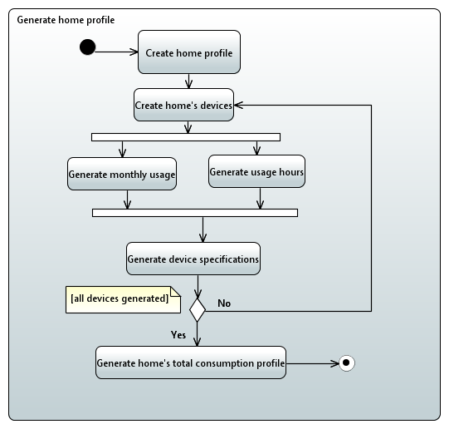

Explanations
This activity diagram correspond to the generation of the home profile use case and will describe how actions are supposed to follow, as each action as already been described in the previous part, we will not describe them as much as in the use case part. This correspond to the tasks n°LINKYD-SIM-002 and LINKYD-SIM-003.

Generating home:
We first need to create a home by generating all the variables of a home like the number of people in the house, or the number of TVs for example. All this numbers will be created following a Gaussian random function.

Generate device
A home contains many devices that consume electricity, we need to generate all the devices of a home and the variables linked to each device.

Generate monthly usage / Generate usage hours
In the same time we will generate the monthly usage and usage hours of each device. This two arrays populated with Booleans will be different for each device as you don’t use your dryer and your microwave the same way.

Generate device specifications
After all types of usages defined for a device, we can create this device with all its parameters.

Test all devices generated
If all devices of a home are generated then we can go to next step, generating home’s total consumption profile, otherwise we just repeat the process for creating a new device.

Generate home’s total consumption profile
After generating all devices we can generate the home’s consumption profile by adding all the devices together to build a home.

Electricity meter simulation

Diagram
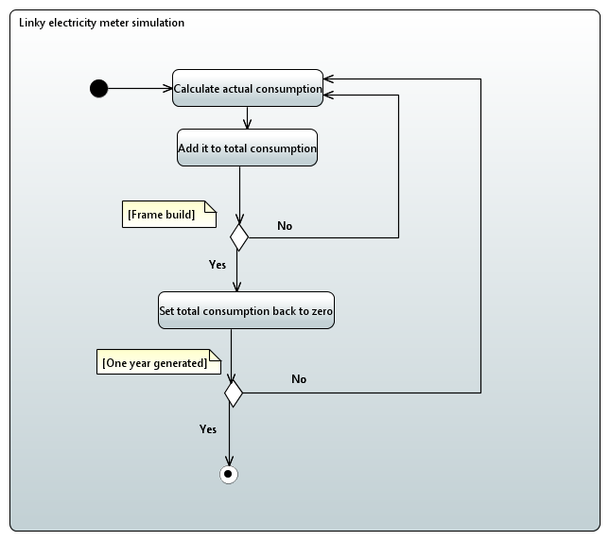

Explanations
This Activity diagram correspond to the Linky electricity meter simulation, the data generator will simulate the behavior of the created electricity meter thanks to the home profile. This correspond to the task n°LINKYD-SIM-001.

Calculate consumption
At each instant the system will calculate the actual consumption of each home, by simply adding the consumption of all the devices that a home owns.

Add it to total consumption
The actual consumption will we added into the total consumption of the house, to be able to send it in a frame to the database each second.

Frame build
We test if a frame was build, if not we add another time the actual consumption to the total consumption.

Set total consumption back to zero
If a frame has been built then we set back the total consumption to zero. To be able to put it back to another frame next second.

One year generated
We test if one year of data has been generated, if yes the system will stop generating data, if not it will continue.

Frame management

Diagram
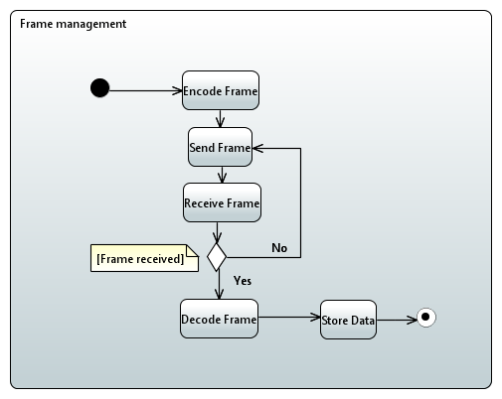

Explanations
This activity diagram is linked to the frame management case. When we have built the home and all its devices, the data generator will be able to generate data. All this data has to be stored in a database. As our data generator is supposed to reproduce Linky’s behavior to be able to replace it with a bunch of Linkys electricity meters, we have to generate data that is a replica of what a Linky electricity meter would generate. The electricity meters send frames every seconds, this frame contains the actual consumption of a house, but also many other information that will not be used for our project. That is why we have to build a specific format of frame to send in database. This correspond to the tasks n°LINKYD-LNK-003, LINKYD-LNK-004 and LINKYD-LNK-005.

Encode frame
We have to encode frame according to EDF’s format, the useless information will be filled with useless bits. The actual consumption has to be in the same place as in EDF’s frame.

Send frame
The data generator will have to send the frame to the database

Receive frame
The database will receive the frame

Test if frame is received
If the frame is not received the system will ask to send it again

Decode frame
The frame will have to be decoded to erase useless information, the information we want to keep has to be highlighted.

Store data
Once the data is cleaned the system will store it in database.

Analyze final signal

Diagram
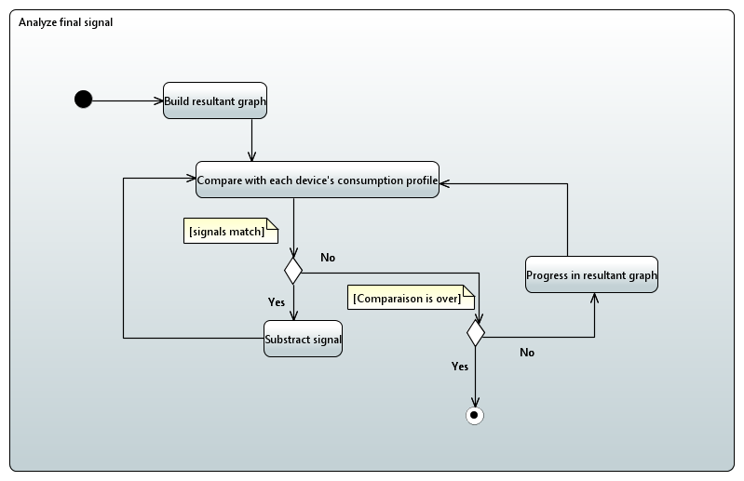

Explanations
When the data is stored we can build a graph to display it and analyze it. To do this analyze we will compare the final signal to the usual consumption of each device, by superposing the curves, if we see the same pattern it means that the device has been used. So we can subtract signals and try the pattern recognition again with all the devices to see if there was multiple devices consuming electricity at the same time. This correspond to the tasks n°LINKYD-DAN-001 and LINKYD-DAN-004.

Build resultant graph
With the data present in the database we can create a resultant graph for each home.

Compare patterns
We compare the patterns with the total signal and all devices consumption signal, to see if we can detect somewhere they will match.

Test if the signals match
If the signals match we subtract them, otherwise we check if the comparison is over.

Test if comparison is over
We test if we have compared all the devices signals everywhere in the resultant signal. If yes, the analyze is over, if not we progress in the resultant signal (by moving our “cursors”)

Subtract signals
We can subtract signals if they matched by removing the device’s consumption signal to the resultant signal, then we will try again each device’s after the resultant signal has been modified.

Class Diagram

Diagram
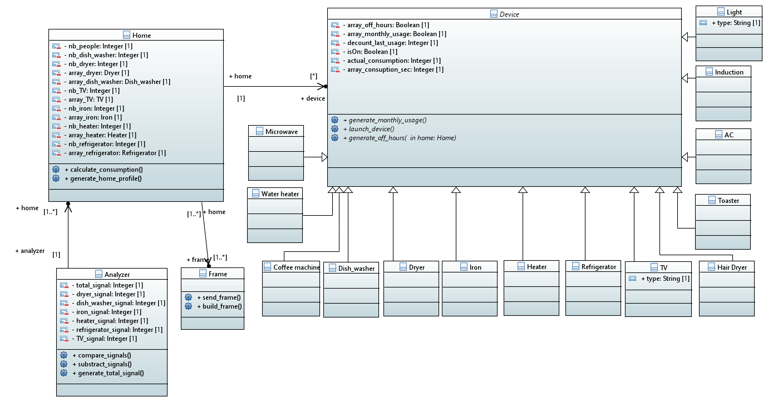

Home class
The Home class is the one that will contain all the characteristics of a home.

Attributes
In this class the variables are:
- nb_people: an integer that will contain the number of people in the house, it will be generated randomly at the creation of a home.
- Variables like “nb_deviceX”: an integer that will specify the number of a same type of device in the house, like nb_TV could be from 0 to 5 depending on the characteristics of the house.
- Variables like “array_deviceX”: an array of integer that will contain as many of deviceX defined in the nb_deviceX variable. It will contain the created devices of each home.

Methods
- Generate_home_profile(): this method will change the values of the Home variables according to a Gaussian random distribution or with the models that we defined. This is the function that will decide the value of “nb_deviceX” for example.
- Calculate_consumption(): this method will calculate the consumption of a home, it will be called every second to add all the devices consumption.

Device class
This class is an abstract class that contains all the variables and method that are common to all devices that will inherit from this class. All the devices will inherit from this class and have all the same attributes and method, but the methods will be defined for each device class.

Attributes
In this class the variables are:
- Array_off_hours, an array containing Booleans. For each device, we create this array depending on the Home parameters and the device. For example for a family with 2 children the microwave will have chance to be used sooner than for a working man living on his own. A 1 means that for this hour, the device could possibly be used, a 0 means that the device could not be used (for example it is absurd or very rare to use a microwave at 4 a.m.)
- Array_monthly_usage, an array containing Booleans. Same principle as the previous attribute, it will contain 1 for months where a device could possibly be used, and 0 when it could not be used (for example a heater will not be used during summer).
- Decount_last_usage, an integer that will increment each day, if a device has not been used. It will be useful for devices like a washing machine the more days this device stay without being used, the chances of using it increases.
- isOn, a Boolean that will be true if the device is consuming electricity and false if it is not.
- Actual_consumption, an integer that will contain the actual consumption of a device.
- Array_consumption_sec, an array that will contain the consumption of the device in watts/sec. It is the same for all the same devices (same for all refrigerators etc.) and have been made according to the device’s constructor specs.

Methods
All the methods are abstract methods that will be override in the different devices class
- Generate_monthly_usage(): this method will create the array_monthly_usage
- Generate_off_hours(): this method will create the array_off_hours
- Launch_device(): this method will launch the device, so it will start consuming energy until its cycle is over (if the device works with cycles (ex: washing machine))

Analyzer class
The analyzer works pretty much like the home class excepted that instead of adding all the devices consumption to build one total signal. It will subtract the devices’ consumption profile to the total signal to identify which device is running and when.

Attributes
- Total_signal: an array of integer that will contain the total consumption signal.
- deviceX_signal: an array containing the consumption profile of each device.

Method
- Generate_total_signal(): this method will use the data in database to generate the total_signal attribute.
- Compare_signal(): this method will compare the patterns of the signals to see when a device has been launched.
- Subtract_signal(): when a pattern has been recognized, we subtract signals.

Frame class
The frame class is the one that will manage the frame Objects.

Methods
- Build_frame(): this method will take as parameter the consumption and build a frame that will contain it to be able to send it.
- Decode_frame(): this method will decode frame to be able to get back consumptions values.
- Send_frame(): this method will send frame to database.

State diagrams
The class concerned by the states diagrams are the main class of our system, Home, Devices, Analyzer and Frame.

Home

Diagram
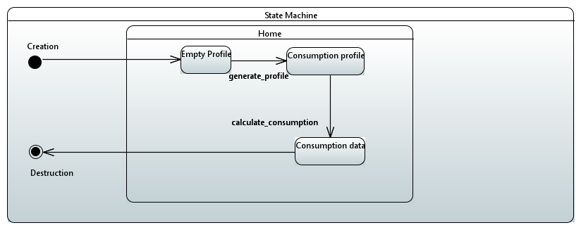

Explanation
When a home is created it is first an Empty profile, then thanks to the generate_profile method it will build a consumption profile that will be used to generate consumption data thanks to a dedicated method.

Device

Diagram
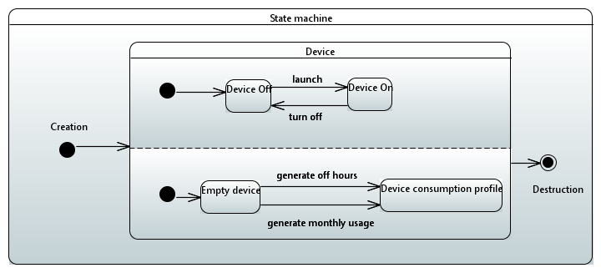

Explanations
The device can be turned on and off thanks to appropriate method, this will alternate its state between Device on and Device Off. When generated the device is empty, thanks to 2 functions explained before, generate off hours and generate monthly usage it will fill up the device consumption profile and it will be used in the Home class to calculate consumption.

Analyzer

Diagram
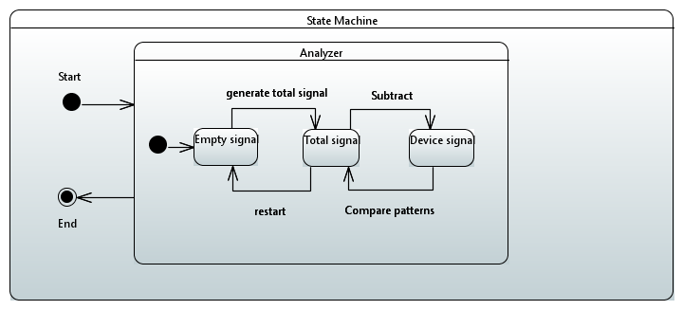

Explanations
The analyzer start with an Empty signal, generate total signal will create a total signal according to values available in database, this signal can be deleted by restarting the analyzer. The total signal will be subtracted with the device signal if it the device pattern has been recognized in the total signal.

Frame

Diagram
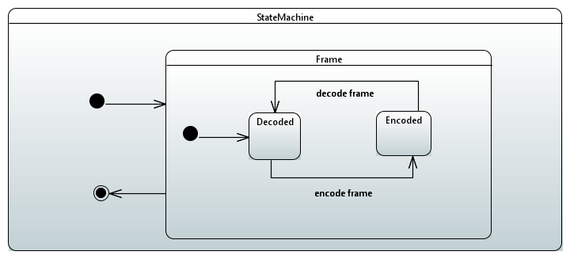

Explanations
The Frame can be between two states, encoded and decoded, an encoded frame, if decoded goes to decoded state, same for a decoded frame, if it is encoded it become an encoded Frame...

Sequence Diagram

Diagram
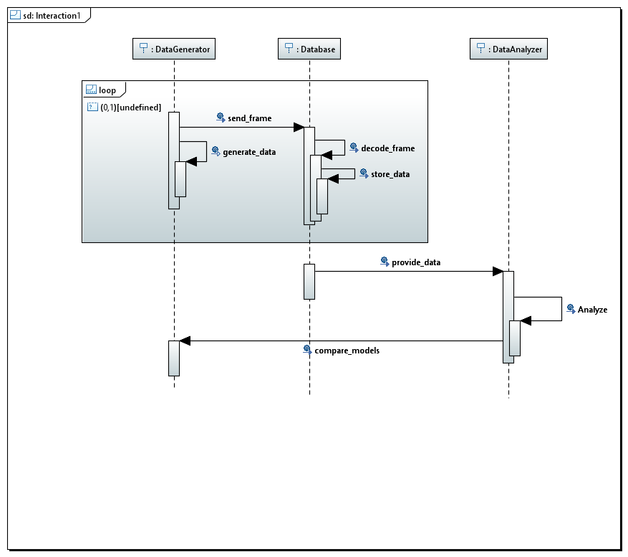

Explanations
This diagram describes the interaction between the actors involved in our project over time.
The data generator will generate data, and send a frame containing this data to the Database. The frame will be decoded and stored in database. All of this actions are looped every generated second, for one generated year, for multiple generated houses. Then the database will provide data to the Data Analyzer. It will analyze the data, and finally compare it with the models that we created in the data generator to check if they truly are the same.

