II] Data Engineering
A. Architecture
B. Tools
a. Imported useful python libraries for generation
b. Store data in a cluster column oriented Vertica plateform
• Nodes
• Console
• Connectors
c. Dispatch data using Apache Kafka and Apache ZooKeeper
• Introduce Kafka (quick-start in annex)
• Topics and Logs
• Distribution
• Producer / Consumer
• Partition
• Brookers and ZooKeeper
• About our Kafka
• Vertica connectors

c. Dispatch data using Apache Kafka and Apache ZooKeeper

• Introduction

This streaming platform has three key capabilities:
1. It lets us publish and subscribe to streams of records. In this respect it is similar to a message queue or enterprise messaging system.
2. It lets us store streams of records in a fault-tolerant way.
3. It lets us process streams of records as they occur.

What is Kafka good for?
It gets used for two broad classes of application:
1. Building real-time streaming data pipelines that reliably get data between systems or applications
2. Building real-time streaming applications that transform or react to the streams of data

To understand how Kafka does these things, let's dive in and explore Kafka's capabilities from the bottom up.
First a few concepts:
• Kafka is run as a cluster on one or more servers.
• The Kafka cluster stores streams of records in categories called topics.
• Each record consists of a key, a value, and a timestamp.

Kafka has four core APIs:
• The Producer API allows an application to publish a stream of records to one or more Kafka topics.
• The Consumer API allows an application to subscribe to one or more topics and process the stream of records produced to them.
• The Streams API allows an application to act as a stream processor, consuming an input stream from one or more topics and producing an output stream to one or more output topics, effectively transforming the input streams to output streams.
• The Connector API allows building and running reusable producers or consumers that connect Kafka topics to existing applications or data systems. For example, a connector to a relational database might capture every change to a table.
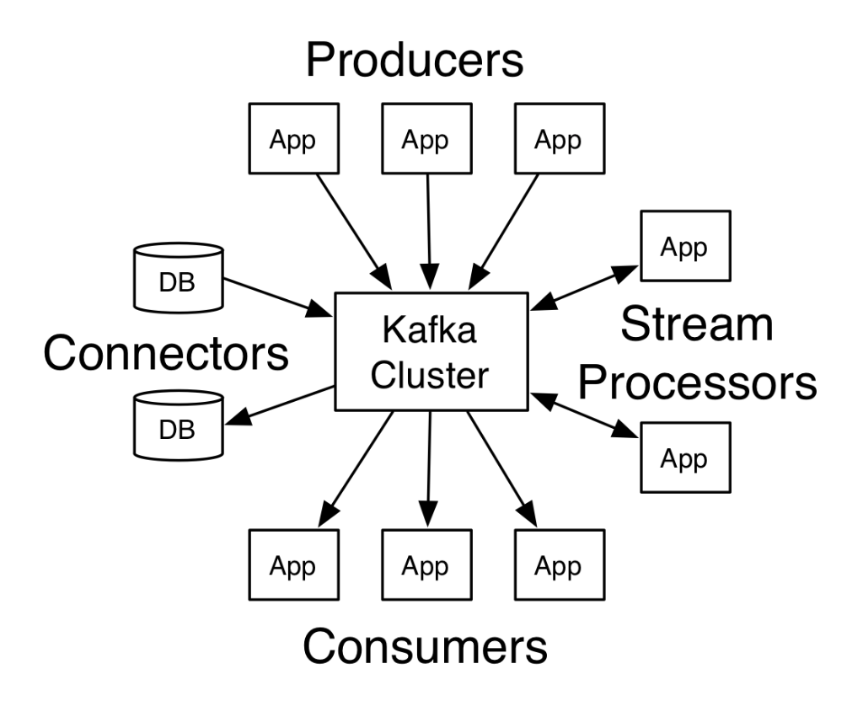


In Kafka the communication between the clients and the servers is done with a simple, high-performance, language agnostic TCP protocol. This protocol is versioned and maintains backwards compatibility with older version. We provide a Java client for Kafka, but clients are available in many languages.

• Topics and Logs

Let's first dive into the core abstraction Kafka provides for a stream of records—the topic.
A topic is a category or feed name to which records are published. Topics in Kafka are always multi-subscriber; that is, a topic can have zero, one, or many consumers that subscribe to the data written to it.
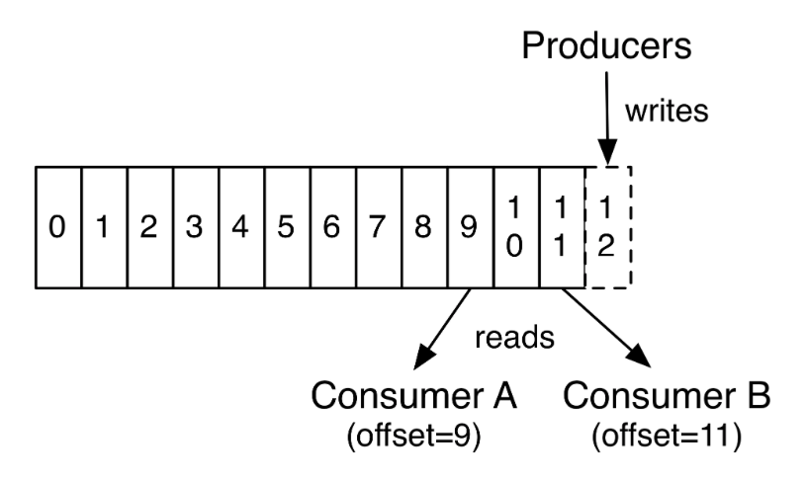

For each topic, the Kafka cluster maintains a partitioned log that looks like this:

In fact, the only metadata retained on a per-consumer basis is the offset or position of that consumer in the log. This offset is controlled by the consumer: normally a consumer will advance its offset linearly as it reads records, but, in fact, since the position is controlled by the consumer it can consume records in any order it likes. For example a consumer can reset to an older offset to reprocess data from the past or skip ahead to the most recent record and start consuming from "now".
This combination of features means that Kafka consumers are very cheap—they can come and go without much impact on the cluster or on other consumers. For example, you can use our command line tools to "tail" the contents of any topic without changing what is consumed by any existing consumers.
The partitions in the log serve several purposes. First, they allow the log to scale beyond a size that will fit on a single server. Each individual partition must fit on the servers that host it, but a topic may have many partitions so it can handle an arbitrary amount of data. Second they act as the unit of parallelism—more on that in a bit.

• Distribution

The partitions of the log are distributed over the servers in the Kafka cluster with each server handling data and requests for a share of the partitions. Each partition is replicated across a configurable number of servers for fault tolerance.
Each partition has one server which acts as the "leader" and zero or more servers which act as "followers". The leader handles all read and write requests for the partition while the followers passively replicate the leader. If the leader fails, one of the followers will automatically become the new leader. Each server acts as a leader for some of its partitions and a follower for others so load is well balanced within the cluster.

• Producers

Producers publish data to the topics of their choice. The producer is responsible for choosing which record to assign to which partition within the topic. This can be done in a round-robin fashion simply to balance load or it can be done according to some semantic partition function (say based on some key in the record). More on the use of partitioning in a second!

• Consumers

Consumers label themselves with a consumer group name, and each record published to a topic is delivered to one consumer instance within each subscribing consumer group. Consumer instances can be in separate processes or on separate machines.
If all the consumer instances have the same consumer group, then the records will effectively be load balanced over the consumer instances.
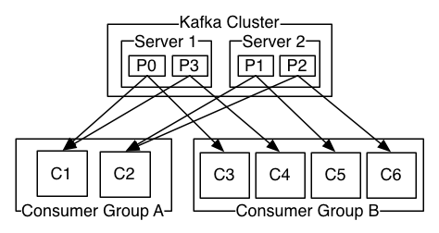

If all the consumer instances have different consumer groups, then each record will be broadcast to all the consumer processes.

A two server Kafka cluster hosting four partitions (P0-P3) with two consumer groups. Consumer group A has two consumer instances and group B has four.
More commonly, however, we have found that topics have a small number of consumer groups, one for each "logical subscriber". Each group is composed of many consumer instances for scalability and fault tolerance. This is nothing more than publish-subscribe semantics where the subscriber is a cluster of consumers instead of a single process.
The way consumption is implemented in Kafka is by dividing up the partitions in the log over the consumer instances so that each instance is the exclusive consumer of a "fair share" of partitions at any point in time. This process of maintaining membership in the group is handled by the Kafka protocol dynamically. If new instances join the group they will take over some partitions from other members of the group; if an instance dies, its partitions will be distributed to the remaining instances.
Kafka only provides a total order over records within a partition, not between different partitions in a topic. Per-partition ordering combined with the ability to partition data by key is sufficient for most applications. However, if you require a total order over records this can be achieved with a topic that has only one partition, though this will mean only one consumer process per consumer group.

• Partition

Each topic is associated with one to several partitions that are defined and replicated when the topic is created. Each partition contains a message sequence, with a sequential, ordered and immutable ID starting from the oldest to the most recent. The benefit is double: reading and writing side.

Reading side: As each message is identified by a sequential ID, the consumer just needs the message ID. More precisely on the consumer side, the ID of a current message is called offset. The offset is controlled by the consumer, leaving him a great flexibility on his navigation of the messages. Thus, starting the oldest message as well as the most recent one is not a problem.
Knowing that access to a message is done directly via this offset system, the reading is extremely fast. Finally, when sending a message, no copy is made.

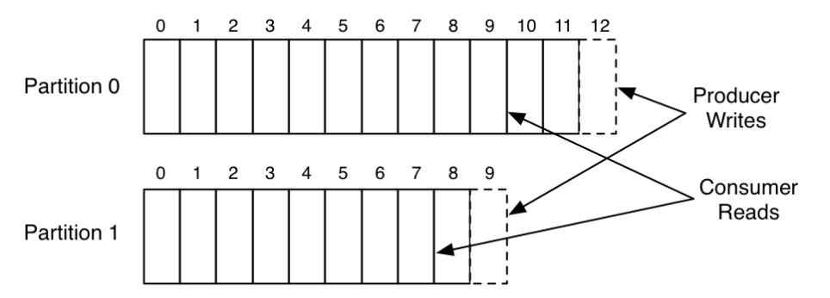

Write side: performance is increased thanks to the partitions: each partition can be the subject of a broker. This performance can be applied to both writing and reading.

Write and read of a topic in parallel with 2 partitions

• Brokers and ZooKeeper

Kafka is a solution offering speed, flexibility and above all guaranteeing the integrity of our data. But this solution has the gift of being scalable and therefore of increasing its performance when it has a greater number of brokers.
Within our cluster of brokers, we have a coordinator: The zookeeper. The role of the broker is to be able to manage brokers overall but also to share information. To take an example, consumers use the zookeeper to navigate, through messages, with their offsets.
As we saw earlier, a cluster can contain several brokers and a zookeeper. Each partition / replica belongs to a single broker.

The fact of being able to have several partitions allows a gain of performance and speed (writing and reading in parallel). However, the number of partition is limited by the maximum number of consumers

Let's take an example: We have 1 Kafka cluster with 3 brokers. On the other side, 1 topic with 3 partitions and a replication factor of 2. Here, the zookeeper is not taken into account however, it is part of the cluster.

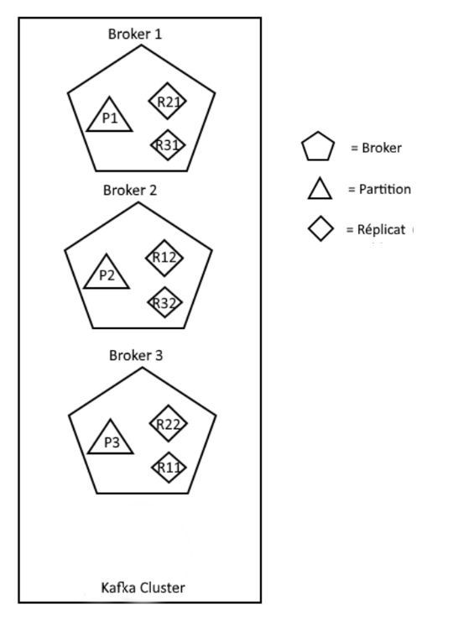

Knowing that we have 3 partitions with a replication factor of 2, the number of replicas is 2 * 3 = 6. Thus, the brokers will share these replicas uniformly, and so as to be "fault tolerance" (No equivalent replicas in the same broker). Here we have a "fault tolerance" of 2: two brokers may fall.

• About our Kafka

Our own Kafka runs with 1 topic named:
- topic_linky

Basically the messages we send are our own data in a simple text file.
This is our producer.

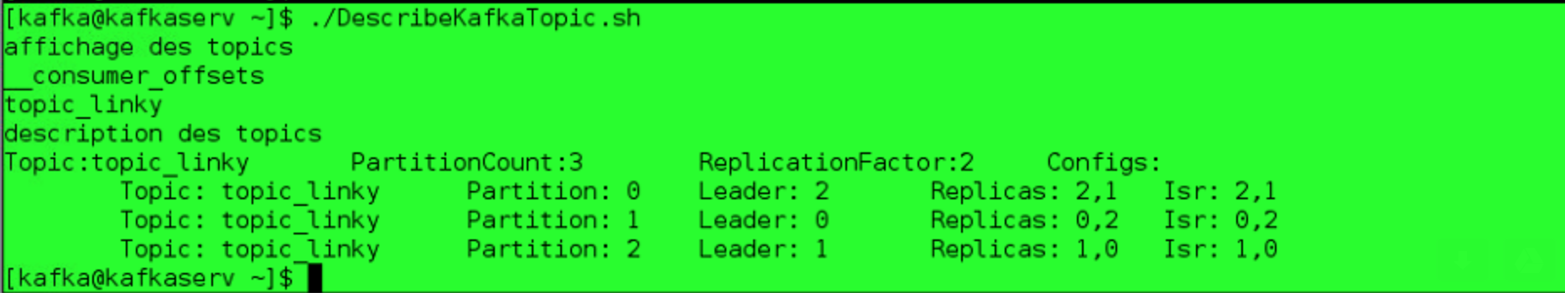

To show you that we have well our topic with its partitions its replications we used a bash file returning all the necessaries information named « DescribeKafkaTopic.sh ».

It shows you also leaders that will change if a node fall for example.

Now, we will also show you how work our streaming loader in Vertica and how visualize it.
To do that you can either count the number of line in our text file our create a Vertica request.

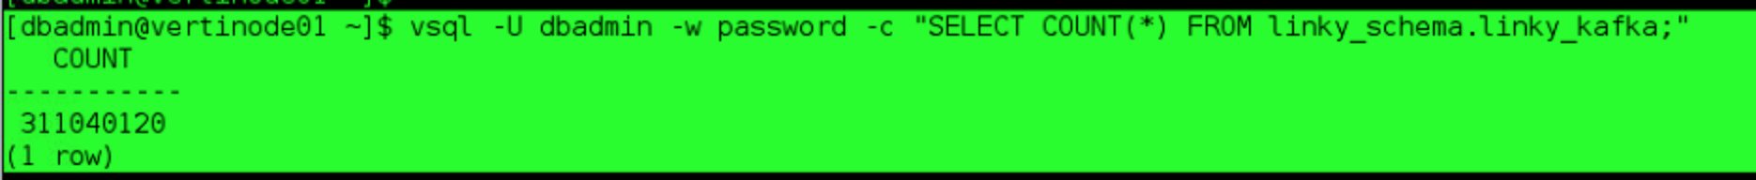

The Vertica request is:
As data are loaded step by step, it’s streaming process, you will see the count request progress until reaching the number of line of the text file like below:

As we have the same number displayed we can say that we loaded well all our data.

Annex:

• Installation & quick-start

Step 1: Download the code

After downloading 0.10.2.0 release and un-tar file do:
$ tar -xzf kafka_2.11-0.10.2.0.tgz
$ cd kafka_2.11-0.10.2.0
Step 2: Start the server
$ bin/zookeeper-server-start.sh config/zookeeper.properties
[DATE] INFO Reading configuration from: config/zookeeper.properties (org.apache.zookeeper.server.quorum.QuorumPeerConfig)
…
Kafka uses ZooKeeper so you need to first start a ZooKeeper server if you don't already have one. You can use the convenience script packaged with kafka to get a quick-and-dirty single-node ZooKeeper instance.

Now, start the Kafka server
$ bin/kafka-server-start.sh config/server.properties
[DATE] INFO Verifying properties (kafka.utils.VerifiableProperties)
[2013-04-22 15:01:47,051] INFO Property socket.send.buffer.bytes is overridden to 1048576 (kafka.utils.VerifiableProperties)
…
Step 3: Create a topic

For the quickstart demo we will create a first topic named « test » with a single partition and only one replica. To have the specific information of our Kafka, please refer to the part VII of this chapter: About our Kafka.
$ bin/kafka-topics.sh --create --zookeeper localhost:2181 --replication-factor 1 --partitions 1 --topic test
We can now see that topic if we run the list topic command:
$ bin/kafka-topics.sh --list --zookeeper localhost:2181
test

Step 4: Send some messages

Kafka comes with a command line client that will take input from a file or from standard input and send it out as messages to the Kafka cluster. By default, each line will be sent as a separate message.
$ bin/kafka-console-producer.sh --broker-list localhost:9092 --topic test
Clément Tailleur first message
Cyril Monti second message
Rémi Ferreira third message
Run the producer and then type a few messages into the console to send to the server.

Step 5: Start a consumer

Kafka also has a command line consumer that will dump out messages to standard output.
$ bin/kafka-console-consumer.sh --bootstrap-server localhost:9092 --topic test --from-beginning
Clément Tailleur first message
Cyril Monti second message
Rémi Ferreira third message

Now that we have each of the above commands running in a different terminal then we are able to type messages into the producer terminal and see them appear in the consumer terminal.
All of the command line tools have additional options; running the command with no arguments will display usage information documenting them in more detail.

• ZooKeeper
