Network Intrusion detection system using artificial intelligence
Clementine Mamogale – 216025117
clementinemamogale@gmail.com
Abstract. The widespread use of the Internet and communication devices and the development of new technologies that can connect to one another has advanced, they increased the volume of data transfer over the internet. Simultaneously, this has opened many novel attacks which are beyond the human control capabilities, which also poses challenges to the current network securities. One tool that is used by the network securities to prevent possible network exploit is an Intrusion Detection System (IDS), it is a tool that monitors traffic over a network to ensure the availability, integrity, and confidentiality of the network. This tool used to be effective over the past years, but as the internet grows, the IDS has become less and less effective. Hence in this paper, I am introducing a Network Intrusion detection system (NIDS) architecture that uses Artificial Intelligence (AI) as its backbone. This architecture will feature deep learning and machine learning techniques to develop a system that is adaptive and resilient to network intrusions, including zero-day intrusions. To demonstrate the effectiveness of this model, we use the old KDD+ and the new CICIDS 2017 datasets. The reason for these two datasets is because the KDD+ is widely used because it has well-known intrusions and can be used to create the baseline of the NIDS. Then the CICIDS is new and has new attacks that happened recently. Hence it can be used for training for zero-day attacks.

Keywords: Network Intrusion Detection System (NIDS), machine learning, deep learning, Network Security, Support Vector Machine, Naïve Bayes, Neural Networks.
- Introduction
In this modern life, our daily activities are influenced by the widespread use of computer devices, which are connected to one another and share data and information. Using the information and communication technology (ICT) and its resilience, businesses and individuals were able to offer real-time global business continuity and a frontier solutions of interoperability [1]. The rise of this interoperability and data exchange among computers on the internet has opened vulnerabilities that are exploitable, and they can result in harmful effects on the end-users of the computers. Hence a resistant and resilient intrusion detection system (IDS) is needed, an IDS which will be able to maintain and provide availability, integrity, and confidentiality of network. After all, an IDS is recognized as the first layer of defense among the defensive mechanisms that address all the attack vectors [1].
A Network Intrusion Detection System (NIDS) works by scanning a network traffic as it comes and identify any violations if they exist based on customized detection levels that are preconfigured on the network and then report them, then block them from going through the network before they cause any damage to the data that is being protected by the network. IDS use the idea of behavioral features to differentiate between a legitimate and non-legitimate traffic. Hence the development of Intelligent Intrusion Detection system is needed, which will be able to learn about different behaviors of normal and abnormal network and use that learned behaviors to detect intrusions [2]. In this paper I propose a Network Intrusion Detection System (NIDS) that uses AI as its backbone to detect intrusion on a network in real time, automatic and fast, which aims to provide minimum false alerts. The KDD+ and CICIDS 2017 datasets will be used to demonstrate the effectiveness of the system and it will make use of the Naïve Bayes classification technique, Support Vector Machine and the Neural Networks which will work together to complement each other for maximum security of a network.
The rest of the paper is organized as follows, section two is the literature review, we discuss the background of Intrusion detection systems along with similar works out there. In section three we discuss the three proposed methods. I.e., discussion of the Deep Neural Network, Support Vector Machine and Naïve Bayes classifier. Section four is the discussion of the results of the models, how good or bad they did and discussion of future work on this topic, then lastly is section five which is the conclusion of the paper.
- Literature review
The concept of intrusion on a network have been around for a very long time and having intrusion detection systems which worked by monitoring networks for any anomalous behaviors or misuse. It is only now that there is a rise of this intrusions on networks, and mainly because of the rise of the internet with Internet of Things connecting and sharing data over networks [4].
James Anderson wrote a paper in 1980 for a government organization, which is accredited for introducing automatic IDS, a paper that was used to build the first IDS [4]. With the rise of the internet, some problems for that system arose, since it was using the signature based algorithm, it was a bit slow in terms of registering new signature from new threats and the system was only effective against known threats. Zero-day attacks could compromise it, easily [4].

Since then, other models have been developed in the industry to try and fix the problem that were present on the system that was built using the paper from James Anderson. Until the year 1999 when Todd Heberlein introduced a different kind of system called Network Security Monitor (NSM) which helped in monitoring and collecting data about network traffic [4]. This opened new ideas and there were more interests in the intrusion detection environment and new investments were made towards the market. This project featured some of the other projects that were made before it, such as the Distributed Intrusion Detection System which introduced the idea of hybrid intrusion detection. As a results, the IDS field was revolutionized and brought to the commercial world [4].
Currently, by statistics. It shows that in the market of security vendors, IDS remains one of the top selling ones. Some of the commercial IDS that were introduced in the early years includes Network Flight Recorder (NFR) which uses libpcap, it was introduced in 1999, then 1998 APE which was later changed to Snort which is a packer sniffer that was also developed. It uses libpcap also. And it remained the world’s largest IDS that was used, with active users of over 300 000 [4]. However, due to fast growth of the internet and almost everything connecting to the internet. These methods become ineffective. at least, on their own. Hence the introduction of NIDS which uses AI which features more than one technique to get the work done.

  - Different types of intrusion detection systems
- Host based intrusion detection system (HBIDS) runs and monitors the network of machines, at the endpoints on which they are installed on. NBIDS analyzes and log any behaviors that are malicious. It can be used to view what is happening on security systems that are critical [5][7]. But it is not enough on its own since it does not give a bigger picture of the whole system, hence it must be used in conjunction with other IDS [7].

- Network intrusion detection system (NIDS) runs on the network and monitors the whole system at the network level, it complements the flaws of HBIDS to securely protect an organization’s system. Unlike the NBIDS, they scan data packets and check for any signs of malicious activities [5]

- Network node intrusion detection system (NNIDS) works like to NIDS, but on micro level. It checks for malicious activities and threats on each node that is connected to the network [5]. NNIDS adds more security to the NIDS to protect a network system.

All these types of intrusion detection systems can be approached using Signature-based IDS (SIDS), Anomaly-based IDS (AIDS) or a hybrid of both Signature and Anomaly-based IDS. Their differences are that SIDS is knowledge based, it has signatures of known attacks stored in databases and use them to compare with the data patterns on the network as they come [3]. SIDS is very good for known attacks, but very poor for zero-day attacks. On the other hand, AIDS is based on machine learning algorithms, a profile is built for a normal activity, and any activity that does not satisfy that profile, it is considered abnormal and get flagged [3]. AIDS is good for detecting not known intrusions, but is it is not perfect since it can misclassify activities. A hybrid of both SIDS and AIDS is combining both SIDS and AIDS for maximum protection of systems.

  - Recent similar work
Ensemble Core Vector Machine (CVM) which is a better version of Support Vector Machine (SVM), which are a supervised learning machines. They are used for regression analysis and classifications [5]. The algorithms that are used in CVM and SVM are based on concept of minimum Enclosing Ball basis, which is an adopted function from statistic. The function helps in producing less false-positive rates and improvement in performance. Hence, they are considered the best prediction methods. However, unlike the SVM, the CVM has low overhead computation which makes it better than the SVM [2].

Internet of Things (IoT) is another field of study that has shown some interesting studies in IDS. IoT is a new and growing technological advancement, whereby the day-to-day “smart” devices, from different domains, connect and communicate to each other over the internet via data sharing [6]. These smart devices are embedded with sensors which generate high volume of data on the internet [5]. IoT brings lots of benefits to out everyday lives, but they also have vulnerabilities that can be exploited over the internet. These vulnerabilities on these devices exist because most of them lack hardware security support, and their gateways also does not support such securities. IDS require high computational power which these smart devices gateways do not provide. They also have their own specifications and protocols that they follow. Implementing these complicated hardware and software security features on these smart devices, can cause them to misbehave or break. As a results, it remains a challenge to secure the environment of these smart devices while having them working perfect [6].
There is a huge gap between security capability and requirements, which puts these smart devices at risks of cyber-attacks such as DoS and spoofing attacks. Many records of IoT devices being attacked are recorded, and it shows how bad they can affect these devices, such as damaging the hardware, or interrupting the system. The Marian malware is one example that was recorded to be the most famous attack that happened in 2017 which affected 300 000 IoT devices, which further turned the devices into zombies to create DDoS attack [6].
For security purposes, IDS for smart devices are placed at the gateways to monitor the network for incoming and outgoing traffic and checks for malicious activities. This is still not enough since it does not check the internal interconnected traffic of the devices, which might cause internal attacks [6]. A better solution that was proposed for IoT was the use of Deep Neural Network (DNN) which will learn and create profiles for abnormal and normal networks from already existing datasets and based on that, it can find abnormalities in a network easily, and it get deployed live on the IoT. This method worked so well because it could identify even non-linear complex features which are used in real life attacks [6].

  - Proposed methods

    - Deep Neural Network (DNN)
DNN is a better version of Neural Network (NN), which is a supervised type of machine learning algorithm that give computers the intelligence to process data, learn from it and make predictions. The NN is inspired by how the human nervous system of the brain works. NN is made up of processing elements called nodes or neurons, which are connected to one another to form layers of the NN system. These layers are organized to form input layer, many hidden layers, and output layer as shown below in fig 1 [1,3].
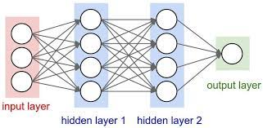

Fig. 1. Neural network

DNN is a creative system, unlike the NN because it can process complex data and make predictions on non-linear data. It can recognize sounds, voices, and graphics, then do some expert review on those data. And also, do other functions such as creative thinking and predictions from those complex data [1].
The neurons in the DNN are nothing but mathematical functions which, when given some input data via the input layer, they process it from the input layer, through to the many hidden layers to the output layer, then give out an output via the output layer. The inputs of the neurons and its parameters will determine the output. The parameters are the weighs and biases of the neuron. They can be adjusted to produce desired outputs from the network [3]. The movement of data from input, processing and output is called forward propagations, how it works is that outputs of one layer, becomes inputs to the next layer, until they reach the final output layer to make a prediction. Sigmoid function which, given an input produces an output between zero and one, is used to normalize the data as it moves from one layer to another, and the higher the value the sigmoid function produces, will determine which node to be activated in the next layer [3].
Once a prediction is made, we can make a cost function, which is a function to check how correct is the prediction, which is compared with the known truth to see the difference between the predicted value and the truth value. The aim is to make sure that the cost function value is as low as possible. This can be achieved by using an algorithm that will update the parameters’ values of the network to produce cost function’s value that is as low as possible [3]. A mathematical cost function is displayed in fig 2 below, with hypothesis, parameters and the goal to minimize the value.

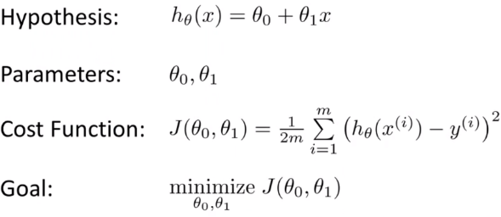

Fig. 2. Cost function

A gradient descent which is displayed on image 3 is used as the algorithm to produce such minimal value of cost function. The gradient descent function will update the values of the biases and weights of the network to produce the minimum value of the cost function. This process if called back propagation [3].
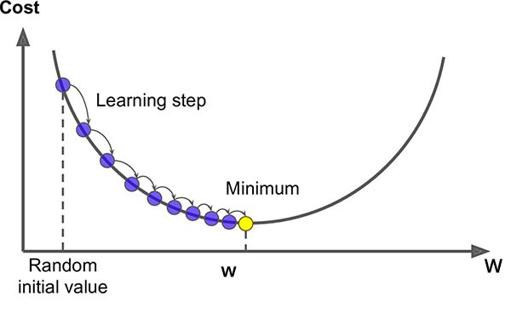

Fig. 3. Gradient descent function

    - Naïve Bayes
Naïve bayes classifiers are family of classification algorithms that are based on the Bayes’ theorem. The algorithms share a common principle that is based on the fact that features that are being classified are independent of each other. This means that the presence of a particular feature in one category is unrelated to any feature that might be present on the data on the other category that is being classified.
Naïve Bayes are amongst the Bayesian Network (BN) models which is a probabilistic graphical mode that represent knowledge about uncertain domain. It has nodes and edges, whereby the nodes represent random variables, and the edges represents conditional probability for the corresponding nodes [9]. BN are sometimes called Bayes Nets or belief networks. NB are directed acyclic graph whereby self-connections or loops are not allowed. This is due to the conditional probabilities and dependencies. BNs are ideal for situations where an event has occurred and finding the likelihood that one of the known causes from the several possibilities was the contributing factor [9].
Naïve Bayes classifies are easy to build, they are highly scalable and very useful for very large dataset. Along with that, they are known to outperform even highly experienced classification methods that exists.

Below is the formula of Naïve Bayes
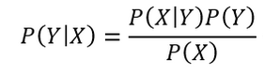

- P(Y|X) – posterior probability of class Y, which is the target, when predictor X, which is the attribute.
- P(Y) – prior probability of the class
- P(X|Y) – the likelihood. i.e., the probability of predictor, given the class
- P(X) – the prior probability of the predictor

How it works:
To train and create a model. Firstly, a dataset is provided, and it will be divided into two classes namely feature matrix and response vector. The dependent features are contained in the feature matrix rows (vectors) of the datasets and the class variable (output or prediction) of the datasets are contained in the response vector. The concept of assumption for Naïve Bayes features is that each of them contribute equally towards the outcome, each feature is given the same influence or importance, and all of them are independent of each other.
Using the above Naïve Bayes equation, the class P(Y|X) can be calculated given then features by firstly creating a frequency table for each attribute against the target. Then using the frequency table to create the likelihood table. Then by using the Naïve Bayes equation to find the posterior probability for each class. Then finally checking the posterior values for each class. The class with highest outcome value is the prediction. When working with Naïve Bayes, a ‘zero-frequency-problem’ which is when a test data has a category that was not present during training data and that data category will be given the value zero during testing, and when it is multiplied by the other features, it gives the prediction of zero which will always not be taken as the final answer since it will always be the lowest. To solve that problem, a value of one is added on all categories attributes so that no category is zero on the datasets.
The Gaussian Naïve Bayes is a proposal for continues data to complement the Naïve Bayes classifier. An assumption in continues data is that the continuous data that are associated with each class are distributed according to the Gaussian (Normal) distribution. The likelihood assumption for the features follows this formula:
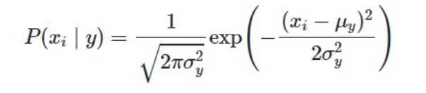

Where the sigma is the variance and mu is the mean of the continuous variable Xi computed for a given X|Y
The formula calculates the frequencies for the probabilities for input values of each class. And for the entire distribution, the standard deviation and the mean for X’s can be calculated as follows:

Mean: m(x) = 1/n * sum(x)
Standard deviation: st(x) = sqrt(1/n * sum(xi-mean(x)^2 ))

Where,
- x is the input variable,
- sum is the sum function
- sqr is the square root function
- n is the number of instances
- xi is a specific x value

The Gaussian Naïve Bayes classifier is simple and quick classifier technique that works so well without putting too much effort and complexity. And it has better accuracy results.

    - Support Vector Machines (SVM)
Support Vector Machines (SVM) are types of supervised learning methods used for regression, classifications and outlier detections. SMV are mathematical equations that aim to give the most accurate answers in machine learning (ML). SVM are based on the vector machine (VC) theory which is from the statistical learning frameworks which was proposed by Vapnik and Chervonenkis [8]. SVM uses classes to categorize data given as inputs during training and testing. They use a decision boundary to choose a maximized distance from the classes using their closest data points. This boundary line is called a maximum margin hyper line.
A simple linear SVM classifier make use of classes that are separated by a straight line between them and data on one side of the straight line are categorized as one and data on the other side of the line are categorized as different from the data on the other side of the straight line [8]. This means that there can be infinite number of lines to choose from. The best line is the line that is the farthest away from the closet data points, or a line that maximize the margins.
Different kernel functions exist for SVM, this makes it easier to choose which function to pick based on the type of data that will be processed.
- Linear functions – These functions are commonly used in text classification because usually these kind of problems can be solved linearly. Linear functions are fast, and they work well when there are lot of features in the problems. The formula for this function is: f(x) = w^T * X * b, whereby w is the weight of the vector that need to be minimized. X is the data that need to be classified and then b is the estimated linear coefficient from the training data.
In linear function, hyperline can be defined using some set of points of x such that w * x + b = 0 This equation is useful because any point of x that does not satisfy this equation means that point belongs to one of two classes, where by the other class will satisfy this equation w * x + b = -1 for any values of x and the other class will satisfy this equation w * x + b = 1 for any x values that are encountered. This means that the hyberline divides the data points according to their classes in this range {-1, 1}. Below is the graphical representation of the function
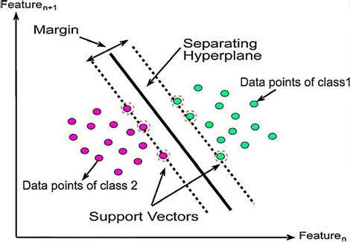

Fig. 4. Linear function for SVM

- Polynomial function – This function is not used often in practice because of its poor accuracy and the poor computation compared to the other kernel functions. The formula for this function is: f(x1, x2) = (a + x1^T * x2) ^b
- Gaussian Radial Basis Function (RBF) – This is the mostly used kernel function and it is so powerful. It is used usually for non-linear data processing. The formula for the function is: f(x1, x2) = exp(-gamma * ||x1-x2|| ^2)
The gamma in this equation represents how much influence does one single training point has on other data points around it. The dot product between the features is represented by ||x1 – x2||
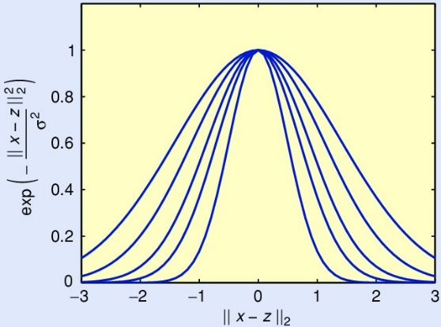

Fig. 5. Gaussian Radial Basis Function for SVM
There are other kernel functions that are used in SVM such as the sigmoid, the hyperbolic tangent, ANOVA radial basis, and many more. The selection is based on the computational speed and the accuracy they produce. Proposed Method
This paper proposes a network intrusion detection system that uses artificial intelligence, the processes to automatically and efficiently detect intrusions on a network. Different machine learning (ML) algorithms are used and compared to pick one that is the best. Deep neural networks (DNN), Naïve Bayes classifier and Support vector machines (SVM) are the three types of ML algorithms that are being compared. All of them are supervised learning machines. It can be said that DNN create the best model for our NIDS. This might be influenced by the fact that DNN uses unlimited hidden layers which helps the model to learn and give better predictions.
- Results
The results for testing my models once they have been trained on different datasets are given on the table below:
As it can been seen here on the table that SVM does indeed give great results, especially on the CICIDS 2017 dataset. Naïve Bases also gives great results on the CICIDS 2017 datasets, while DNN give wonderful results on KDD+ dataset. and for some reason, the CICIDS 2017 does not work during testing for this dataset, hence the accuracy is not there. The differences in accuracies on this different datasets can be influenced by the difference in the structure of the dataset on how they are structured and how the program read them. Hence, perhaps, the DNN is not able to read the CICIDS2017 dataset due to the difference in structure from the other ones.

Model | Dataset | Accuracy
Deep Neural Network (DNN) | KDD+ | ~91.1%
Deep Neural Network (DNN) | CICIDS 2017 | N/A
Naïve Bayes | KDD+ | ~57.85%
Naïve Bayes | CICIDS 2017 | ~93.85%
Support Vector Machine (SVM) | KDD+ | ~46.9%
Support Vector Machine (SVM) | CICIDS 2017 | ~98.1%

- Critique and Analysis
Network intrusion detection systems already exist out there, using different methods. With the latest ones using some sort of machine learning methods to predict network traffic as normal or malicious. Most of them are based on a binary classification whereby only four predictions can be made, i.e., true positive, which is predicting attacks correctly, then second one is false negative, which is predicting incorrectly as normal, then third is true negative, which is correctly predicting normal as normal, then lastly is false positive, which is predicting incorrectly as an attack.
Comparing my results with the results of the already existing libraries of the models I created, I can say that their libraries do much better. Perhaps because they know how to scale the models as they develop, and also, they are able to collaborate on creating the best classes that one can use on any datasets of their own. This generalization helps to even compare different results as they develop to test again and again to make sure that the end result is the best. Although they are not on 100% yet, but they will get there. Same as mine, if given enough time, I can try to scale my codes to be able to work with different dataset and be able to give better results.

For my deep neural network, I used two hidden layers which have nodes which are two times the number of input nodes. The number of hidden layers and the number of the nodes for each layer affect how the model learns, hence it might produce better accuracy with more or lesser number of layers and nodes. Then for Naïve Bayes, it is known that all features are treated unrelated, and they all contribute equally towards the end goal. But chances are in my case, the features that I selected on my database are not that important or are not enough to make a prediction, since we know that a typical packet will have more features than the one, I selected for my project. Hence the accuracy is affected.

SVM on the other hand is widely used, in different domains and it give quite great results in networking because of the continuous data. it makes use of a margin line which is used to differentiate between two different categories. Using features provided, it can find if the current data belongs to class 1 or -1. What affect the learning accuracy of these models is the kernel functions that are used during the training and the number of features present. And again, with the fewer features that I selected, will affect the accuracy of the model since a typical will have more features to learn about which will help in producing better results. The libraries for all of the models, all make use of extra parameters to make sure that their results are as accurate as they can be.

Despite the wonderful results these models are giving, even in industry using the libraries. There is still lot of work to be done to create models that will be much better. The aim is to create models that are 100% accurate. Hence, there is still lot of work to be done in the industry of machine learning.
- Conclusion
This paper addressed an extensive review of the network intrusion detection system (NIDS) that is based on artificial intelligence. Simulation of this system is based on two datasets, namely KDD and CICIDS 2017, one is and old for creating a good baseline and the other is more recent to feature recent network protocols. In this paper, I created three models using deep neural networks (DNN), Naïve Bayes and Support Vector Machine (SVM) which are all machine learning algorithms. They all learn in their own ways, suing different mathematical equations, hence they produce different results even on the same dataset, with SVM having the highest accuracy of ~98.1% on CICIDS 2017 data, followed by Naïve Bayes with accuracy of 93.85% also on the CICIDS 2017, and then DNN with accuracy of ~91.1% on the KDD+ dataset. SVM is also the lowest with accuracy of ~46.9 when running on the KDD dataset.

Although this proposed models are showing great results, there is still room for big improvements, especially to make all these models behave almost similar despite the kind of dataset that is being fed. Because, based on my models, it can be seen that some of the models have very low accuracy on certain dataset, with DNN not working at all with CICIDS 2017 dataset. So, this is one of the things that should be looked into as part of future work. NIDSs are very important, especially when it come to securing a corporate networks, hence they should be designed and deployed perfectly to make sure that there is no room for even zero-day network attacks.

References
- Ashiku, L., Dagli, C.: Network Intrusion Detection System using Deep Learning. Procedia Computer Science (185), 239-247 (2021).
- Divyasree, T., Sherly, K.: A Network Intrusion Detection System Based On Ensemble CVM Using Efficient Feature Selection Approach. Procedia Computer Science (143) 442-449 (2018).
- Ahmad, Z., Shahid Khan, A., Wai Shiang, C., Abdullah, J., Ahmad, F.: Network intrusion detection system: A systematic study of machine learning and deep learning approaches. Transactions on Emerging Telecommunications Technologies 32(1), (2020).
- Deepa, A., Kavitha, V., 2012. A Comprehensive Survey on Approaches to Intrusion Detection System. Procedia Engineering (38), 2063-2069 (2012).
- Ahmad, I., Ul Haq, Q., Imran, M., Alassafi, M. and AlGhamdi, R.: An Efficient Network Intrusion Detection and Classification System. Mathematics, 10(3), 530- (2022).
- Chauhan, A., Singh, R., Jain, P.: A Literature Review: Intrusion Detection Systems in Internet of Things. Journal of Physics: Conference Series, 1518(1), 012040 (2020).
- Deshpande, P., Sharma, S., Peddoju, S., Junaid, S.: HIDS: A host based intrusion detection system for cloud computing environment. International Journal of System Assurance Engineering and Management, 9(3), 567-576 (2014).
- Lanhenke, M. "Implementing Support Vector Machine From Scratch." Medium. N.p., 2022. Web. 18 Oct. 2022.
- Yang, X.: Introduction to Algorithms for Data Mining and Machine Learning. 1st ed. London, United Kingdom: Academic Press (19-43).

