**Network Intrusion detection system using**

**Artificial Intelligence**

*Clementine Mamogale – 216025117*

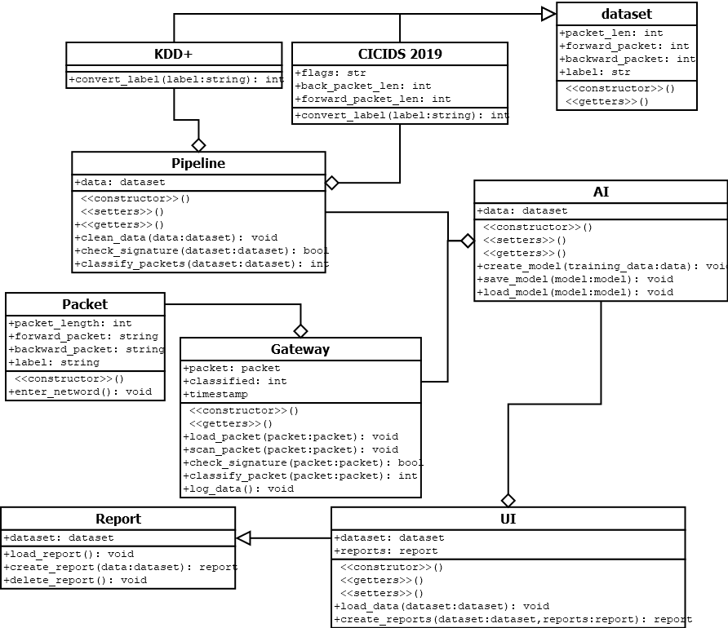

**Test plan**

Since planning has at least three testing techniques, we will be using those three here to test the system. Namely unit testing, integration testing, and system testing (Hamilton, 2022).

* **Unit testing**

Unit testing is the process of testing a certain portion of code in a system (TechTarget Contributor, 2022), this is usually done by programmers since they are working on the code directly, it is usually at the functional level or class level if is done in object oriented programming environment. Some of the functions that can be tested are the constructors and the destructors of the classes (TechTarget Contributor, 2022). These functions are tested to make sure that they are working as expected at their level of construction. Usually, functions have different potions within themselves and hence unit tests can be done multiple times on one function to make sure that all the potions of the function are tested to make sure they are working fine (TechTarget Contributor, 2022). Unit testing is used to test that a blocks of codes are working in a software, it does not test for the functionality of the overall functionality of a system

In the system, the first thing that will be done is to test for the dataset, to see if the dataset can be cleaned and be presented in the right form before it will be used by other system. Then the two pipelines will also be tested on their own with made up data, a system generated data to see if they are working on their own before they will be tested with the data from the test data. The last the gateway will also be tested on its own to see if it can process packets on its own and be able to classify the packets and forward them to the relevant department of the system.

* **Integration testing**

Integration testing is a type of testing in software that tries to make sure that different departments of a software can communicate together (www.softwaretestinghelp.com, 2022). This type of testing can be accomplished in an interactive way which is a better way or a way that is usually preferred since it allows for easy management of interfaces, then the other way of accomplishing integration testing is by combining everything together. Integration testing can be a bit difficult to maintain since it involves lots of codes from all different places, hence they can be difficult to be traced to their exact locations whenever errors occur.

In the system, the integration testing is done by supplying the dataset on the pipelines to see how they behave and see if the two can be able to produce results that are expected. Another integration testing is done on the Artificial Intelligence (AI) machine. The AI combines make use of the dataset from the pipeline to create a learning model and save it. Then the model can be used to create a useful information that can be used by users to see reports. The gateway also makes use of the integration testing technique to test for the packets that get through the gateway, the packets use the trained model since it already knows of the types of networks to expect and how to classify them, this is because it takes time to create a learned model and that will slow down the network if every time a packet is loaded create its own model. Hence it used the already created model and it just load it from where it is saved.

* **System testing**

System testing is a process whereby different components of a system are combined and tested all together as one, the aim is to see how everything interact together as one (Black, 2022). This kind of testing involves taking the outmost input and processing it thought the internal structures of the system and then looking at the output and seeing if it produce results that are supposed to be produced. The aim is to satisfy the functional or system requirements specifications

System testing in this system will be the testing of the whole system and seeing how everything come together. This includes taking all the integration testing components and combining them all to see how they interact with each other. Because the AI and gateway have been tested in integrating testing, then they get combined to be called by the User Interface (UI) which will also integrate the reports class to create reports of the tests that are being done. The reports can be created from the datasets or from the gateway when new network is experienced, and it get treated by the AI as it is supposed to. The system testing should be able to create reports from the AI, be able to present them in a graphical form for people to interpreted and also be able to delete the reports to creates another one when there is a need to.

**References**

Black, R., 2022. *What is system testing? - Definition from WhatIs.com*. [online] SearchSoftwareQuality. Available at: <https://www.techtarget.com/searchsoftwarequality/definition/system-testing> [Accessed 17 May 2022].

Hamilton, T., 2022. *TEST PLAN: What is, How to Create (with Example)*. [online] Guru99. Available at: <https://www.guru99.com/what-everybody-ought-to-know-about-test-planing.html> [Accessed 17 May 2022].

TechTarget Contributor, 2022. *What is Unit Testing? Definition from WhatIs.com*. [online] SearchSoftwareQuality. Available at: <https://www.techtarget.com/searchsoftwarequality/definition/unit-testing> [Accessed 17 May 2022].

www.softwaretestinghelp.com, 2022. *What is Integration Testing (Tutorial with Integration Testing Example)*. [online] Software Testing Help. Available at: <https://www.softwaretestinghelp.com/what-is-integration-testing/> [Accessed 17 May 2022].