**Network Intrusion detection system using**

**Artificial Intelligence**

*Clementine Mamogale – 216025117*

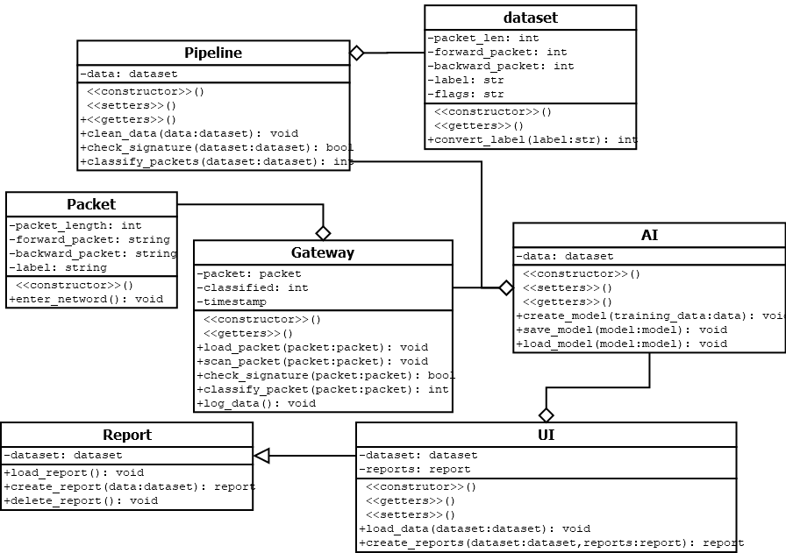

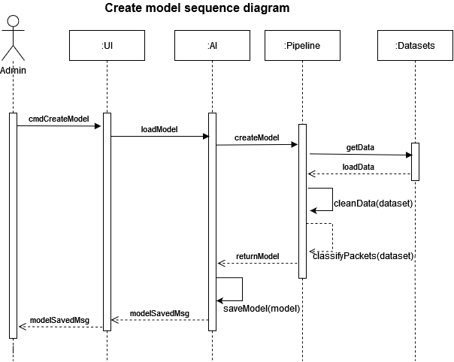

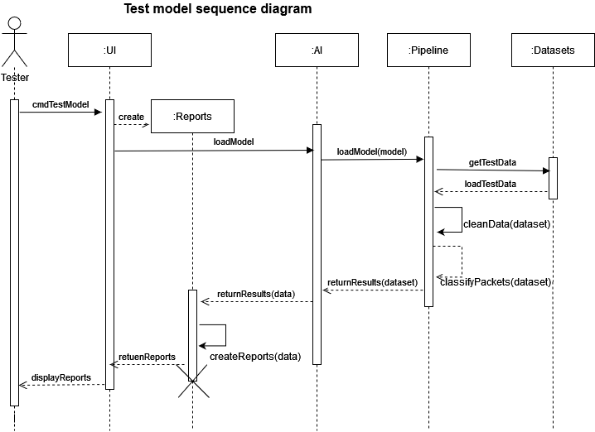

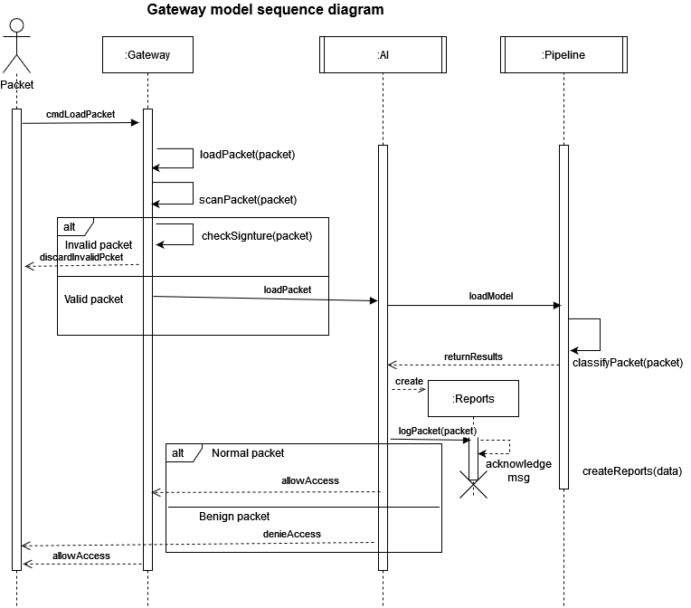

My project is based on a file structure whereby the structures are based on datasets. Then the files will be pre-processed as to be cleaned and be ready for actual processing.