UNIVERSITY OF NIGERIA, NSUKKA

FACULTY OF PHYSICAL SCIENCES

DEPARTMENT OF COMPUTER SCIENCE WITH STATISTICS

A REPORT PRESENTED IN PARTIAL FULFILLMENT OF THE

REQUIREMENT OF THE COURSE COS384

STUDENTS INDUSTRIAL WORK EXPERIENCE SCHEME (SIWES)

TECHNICAL SIWES REPORT (COS384)

PLACE OF ATTACHMENT: NANOCODES PROGRAMMING LIMITED

BY

CLEMENT NZUBECHUKWU CLEMENT

REG.NO: 2020/242037

SUPERVISOR: SIR. CHINONSO EVANS EKWO

JANUARY 2024.

DEDICATION

This report is dedicated to my parents, whose unwavering support, encouragement, and love have been my guiding light throughout my academic journey. Your belief in me has been the cornerstone of my success.
I also dedicate this work to my tutors at Nanocodes whose guidance, knowledge, and mentorship have been invaluable during my industrial training. Your dedication to teaching and your commitment to my learning have significantly enriched my experience.

Thank you all for your endless support and inspiration.

ACKNOWLEDGMENT
I would like to express my deepest gratitude to my parents for their unwavering support and encouragement throughout my academic journey.
I am profoundly grateful to Sir. Harrison, Sir. Chinonso Ekwo and the team at Nanocodes for their invaluable guidance and mentorship during my SIWES journey.
Lastly, I appreciate the support and camaraderie of my colleagues and friends, as well as everyone who contributed to this training and report.
Thank you all.

ABSTRACT
This report outlines my internship experience as a Django backend developer intern at Nanocodes. It covers an introduction to the company, my roles, training, skills acquired, and a significant project I worked on.
My training emphasized developing APIs, managing databases, and resolving software issues using Python and Django. My responsibilities included creating and maintaining web applications, handling database operations, and debugging software.
Furthermore, I gained expertise in developing secure backends utilizing JWT (JSON Web Tokens) and implementing two-factor authentication. Throughout the internship, I became proficient with tools and technologies such as the Django REST framework, PostgreSQL, and various debugging utilities.
One of my key contributions was developing a robust API for a web application, significantly improving its functionality and security. This internship enabled me to translate academic knowledge into practical skills in web development, database management, and security protocols, thereby solidifying my interest in pursuing a career in software engineering and backend web development.

TABLE OF CONTENTS
DEDICATION.........................................................................................................2
ACKNOWLEDGEMENT...................................................…...............................3
ABSTRACT..............................................................................…............................4
TABLE OF CONTENTS..........................................................................…...........5
CHAPTER ONE.......................................................................................................7
1.0. INTRODUCTION....................................................................................................7
Mandate of the ITF...........................................................................................….......7
VISION STATEMENT......................................................................................…......8
MISSION STATEMENT...................................................................................…......8
1.1. The SIWES - Student Industrial Work Experience Scheme.........................8
1.2. PLACE OF ATTACHMENT..............................….........................................10
1.3. ORGANIZATIONAL BACKGROUND/STRUCTURE OF PLACE OF ATTACHMENT…………………………………………………………………..11
1.3.1. Company Profile......................…….............................................................11
1.3.2. Vision and Mission.................................................……….............................11
1.3.3. Objectives of Nanocodes Programming Limited............………….............12
1.3.4. Organizational Chart of Nanocodes Programming Limited.....…….........13

CHAPTER TWO: TRAINING AND EXPERIENCES..........…………………....14
2.1. Overview of Backend Developer Role....................……...................................14
2.1.1. My Responsibilities and Tasks................................................……................14
2.1.2. Importance of Backend development in an Organization......……..............15
2.2. Training Sessions and Learning Objectives.................................…….............15
2.2.1. API Development.....................……………………………………….......15
2.2.2. Database Management........................................………………………...15
2.2.3. Debugging and Troubleshooting...............................................................17
2.2.4. Security Practices.........................................…………………………......18
2.3. Software and Technologies Used........................................................................18

2.3.1. Django REST Framework..........................................................................18
2.3.2. PostgreSQL.........................................…………………………….............19
2.3.3. Debugging Tools..................................................…….................................19
2.3.4. JWT and Two-Factor Authentication..................…..................................19

CHAPTER THREE: PROJECT.............................…..............................…........21
3.1. PROJECT BUILT.................................................................................…........21
3.2. EXPLANATION OF THE CODE.........................................................….......30
3.2.1. Output of the Program.....................................................…….......................31

CHAPTER FOUR: SUMMARY, CHALLENGES ENCOUNTERED, RECOMMENDATIONS AND CONCLUSION....................…............................34
4.1. SUMMARY........................................................................................…...........34
4.2. CHALLENGES ENCOUNTERED..................................................…..........34
Pre-IT Limitations.....................................................................................……...........34
IT Limitations..................................................................................................……....35
4.3. RECOMMENDATIONS...................................................................................35
4.4. CONCLUSION.....................................................................................…..........36
REFERENCES.........................................................................................................38

CHAPTER ONE
1.0 INTRODUCTION
Established in 1971, the Industrial Training Fund (ITF) stands as a pivotal Nigerian government agency, dedicated to the advancement and development of human resources within the realms of industry and commerce. Its core mission is to facilitate skill acquisition and training initiatives aimed at bolstering workforce efficiency, productivity, and overall employability. Over its five decades of operation, ITF has remained steadfast in its commitment to empowering individuals with the necessary tools and competencies to thrive in diverse professional landscapes.
Through strategic collaborations with a wide spectrum of industries and educational institutions, ITF orchestrates a range of comprehensive training programs, apprenticeships, and technical skill-building initiatives. These endeavors are meticulously crafted to align with the evolving demands of the labor market, ensuring that participants are equipped with up-to-date proficiencies that resonate with industry standards and best practices.
Operating under the auspices of the Federal Ministry of Industry, Trade and Investment, ITF holds the prestigious status of a grade ‘A’ parastatal. This positioning underscores its pivotal role as a specialized agency entrusted with the vital task of fostering the acquisition, promotion, and cultivation of industrial and commercial skills indispensable for driving national economic development forward.
With a rich legacy spanning half a century, ITF continues to serve as a beacon of excellence in the realm of human resource development. Its enduring commitment to nurturing talent, fostering innovation, and propelling socio-economic progress remains unwavering, thus solidifying its status as a cornerstone of Nigeria's industrial landscape.

Mandate of the ITF
The Fund was established by Decree No.47 of 8 th October 1971(Now an Act of the National Assembly), with the following Mandate:
- To Provide, Promote, and Encourage the Acquisition of Skills in Industry and Commerce with a view to generating a pool of indigenous trained manpower sufficient to meet the needs of the private and public sectors of the economy.
- To Provide Training for Skills in Management for Technical and Entrepreneurial Development in the Public and Private Sectors of the Nigerian Economy.
- To set Training Standards in all sectors of the Economy and Monitor Adherence
- To Evaluate and Certify Vocational Skills acquired by Apprentices, Craftsmen, and Technicians in Collaboration with Relevant organizations.
- To manage and administer on behalf of the government's Students Industrial Work Experience Scheme (SIWES).

VISION STATEMENT
To be the leading Skills Training and development organization in Nigeria and one of the best in the world.

MISSION STATEMENT
To set and regulate standards and offer direct training interventions in industrial and commercial skills training and development, using a corps of highly competent professional staff, modern techniques, and technology.

1.1 The SIWES - Student Industrial Work Experience Scheme
The Student Industrial Work Experience Scheme (SIWES) was initiated by the Industrial Training Fund (ITF) in 1973 as a proactive measure to address the prevailing challenge of inadequate practical skills among Nigerian graduates from tertiary institutions, hindering their seamless integration into industrial settings.
SIWES serves as a vital bridge between academic learning and professional practice, providing students with invaluable exposure to industry-specific skills essential for a successful transition from theoretical studies to practical application in real-world scenarios.
By immersing students in hands-on experiences within industrial environments, the Scheme equips them with the requisite competencies to operate machinery and equipment, thereby supplementing the theoretical knowledge acquired within educational institutions with practical expertise essential for career advancement and professional growth.

Industrial training combines classroom learning with practical work experiences, allowing students to apply theoretical knowledge to real-world situations. These internships serve as invaluable opportunities for students to acquire hands-on skills relevant to their academic majors and future careers. Additionally, they foster the development of essential leadership qualities crucial for professional success.
The Student Industrial Work Experience Scheme (SIWES) aims to cultivate students' leadership abilities through immersive internship experiences. However, the effectiveness of these experiences may vary depending on factors such as individual aptitude, the complexity of assigned tasks, and the level of mentorship provided. To optimize learning outcomes, it is imperative that each internship position is accompanied by clear and specific learning objectives tailored to enhance leadership skill development.
Participation in SIWES has become a prerequisite for obtaining diplomas and degrees in many tertiary institutions across the country. This requirement aligns with governmental education policies aimed at equipping students with the practical skills and competencies necessary for successful entry into the workforce.
Operators - The ITF, the coordinating agencies (NUC, NCCE, NBTE), employers of labor, and the institutions.
Funding – The Federal Government of Nigeria.
Beneficiaries - Undergraduate students of the following: Agriculture, Engineering, Technology, Environmental Science, Education, Medical Science, and Pure and Applied Sciences.

The following are some of the objectives of SIWES:
- SIWES will provide students with the opportunity to test their interest in a particular career before permanent commitments are made.
- SIWES students will develop skills in the application of theory to practical work situations.
- SIWES will provide students with the opportunity to test their aptitude for a particular career before permanent commitments are made.
- SIWES students will develop skills and techniques directly applicable to their careers.
- SIWES will aid students in adjusting from college to full-time employment.
- SIWES will provide students the opportunity to develop attitudes conducive to effective interpersonal relationships.
- SIWES will increase a student's sense of responsibility.
- SIWES students will be prepared to enter full-time employment in their area of specialization upon graduation.
- SIWES students will acquire good work habits.
- SIWES students will develop employment records/references that will enhance employment opportunities.
- SIWES will provide students with the opportunity to understand informal organizational interrelationships.
- SIWES will reduce student dropouts.

1.2. PLACE OF ATTACHMENT
My place of attachment was Nanocodes Programming Limited. It is located at 31 Enugu Road Opp. St. Theresa's Cathedral Catholic Church, Nsukka, Enugu State.

1.3. ORGANIZATIONAL BACKGROUND/STRUCTURE OF PLACE OF ATTACHMENT

1.3.1. Company Profile
Founded by Sir Harrison, Nanocodes Programming Ltd is a leading provider of IT solutions, catering to diverse industries and clients with a wide range of needs. With a commitment to excellence and innovation, Nanocodes handles every aspect of the development process, from initial conceptualization to final deployment, ensuring that clients' websites and software solutions are tailored to meet their specific requirements and objectives.
Nanocode’s portfolio boasts a remarkable track record of success, with over 80% positive feedback from satisfied clients. Nanocodes’s expertise encompasses a variety of projects, including optimizing performance for existing websites, developing new websites, creating mobile apps and desktop applications, providing corporate branding services, offering networking solutions, implementing automation services, and much more.
At Nanocodes Programming Ltd, they pride themselves on their professionalism, reliability, and dedication to customer satisfaction. Whether you're a small business looking to establish your online presence or a large corporation seeking to streamline your operations, they have the skills and experience to bring your vision to life.

1.3.2. Vision and Mission
Vision - Nanocodes Programming aims at using technology to build the country and the society; by harnessing the rich resources that the society presents.
Mission - To use the resources and materials that our immediate environment presents to build a society and a country where we have smart cities and technologically driven infrastructures. Starting with tech enlightenment and coaching of society as well as providing services and tech products and devices to the populace. Through which the society will gradually evolve to that standpoint where tech will be in the sectors where it should be.

1.3.3. Objectives of Nanocodes Programming Limited
Nanocodes Programming Ltd has consistently pursued a variety of key objectives that align with its mission and drive its success in the IT industry. Some of these objectives include:
- Impacting Knowledge on Students: Empowering the future, one student at a time. Nanocodoes mission goes beyond technology — they’re catalysts for change, instilling essential tech knowledge in students. By creating a generation equipped with valuable tech skills, we're shaping a transformative society.
- Clients Satisfaction: At Nanocodes, customer satisfaction is paramount. They strive to understand our clients' needs and tailor our solutions to meet their specific requirements.
- Innovation and Creativity: Nanocodes Programming Ltd embraces innovation and creativity in all aspects of our work. They continually seek out new technologies, methodologies, and approaches to stay ahead of the curve and deliver cutting-edge solutions to our clients.
- Continuous Improvement: They are dedicated to continuous improvement and learning. Nanocodes Programming Ltd encourages a culture of growth and development among our team members, fostering an environment where everyone is empowered to expand their skills and knowledge.
- Community Engagement: Nanocodes Programming Ltd recognizes the importance of giving back to the community. They actively engage in initiatives and projects that contribute to the betterment of society, whether through charitable contributions, mentorship programs, or volunteer work.

1.3.4. Organizational Chart of Nanocodes Programming Limited

CHAPTER TWO
TRAINING AND EXPERIENCE

2.1. Overview of Backend Developer Role
A backend developer is responsible for building and maintaining the server-side components of websites, web applications, and software systems. They focus on writing code that runs on the server and interacts with databases, external services, and other backend components. Backend developers handle tasks such as data storage, business logic implementation, APIs (Application Programming Interfaces), and server-side security, ensuring that the application functions smoothly and efficiently.

2.1.1. My Responsibilities and Tasks
As a Django backend developer intern, I was tasked with the following responsibilities and tasks, which include;
- Project Setup and Configuration:
a. Setting up Django projects and configuring development environments
b. Installing necessary dependencies and packages for project development
- Database Management:
a. Designing database schemas using Django ORM (Object-Relational Mapping)
b. Creating database migrations to manage changes in data models
c. Implementing database queries, indexing, and optimization techniques
- API Development:
a. Developing RESTful APIs (Application Programming Interfaces) using Django REST Framework
b. Defining API endpoints for client-server communication
c. Implementing CRUD (Create, Read, Update, Delete) operations for database entities
- Authentication and Authorization:
a. Implementing user authentication and authorization mechanisms using Django's built-in authentication system or third-party libraries like JWT (JSON Web Tokens)
b. Managing user sessions, permissions, and access control lists (ACLs)
- Testing and Debugging:
a. Writing unit tests and integration tests to ensure the reliability and functionality of backend components
b. Debugging and troubleshooting issues in Django applications using debugging tools and techniques
- Deployment and Maintenance:
a. Deploying Django applications to production servers using platforms like Railway, Render, Heroku and AWS (Amazon Web Serivce).
b. Performing routine maintenance tasks such as database backups, software updates, and security patches
- Collaboration and Documentation:
a. Collaborating with frontend developers, designers, and project managers to ensure seamless integration of frontend and backend components
b. Documenting codebase, API endpoints, and development processes for future reference and knowledge sharing.
- Continuous Learning and Improvement:
a. Staying updated on latest Django releases, best practices, and industry trends
b. Actively participating in team meetings, code reviews, and learning sessions to enhance skills and knowledge as a backend developer

2.1.2. Importance of Backend Developement in an organization
Backend development is essential for managing data, implementing business logic, ensuring scalability and performance, maintaining security, integrating external services, customizing software, supporting frontend development, and ensuring reliability and stability in organizational applications.

2.2. Training Sessions and Learning Objectives
In training sessions, I learned the fundamentals of backend development, including database management, API development, security implementation, and deployment strategies, with the objective of gaining practical skills in building scalable, secure, and efficient backend systems to support organizational needs in software development projects. Through hands-on experiences and mentorship, my goal was to develop proficiency in backend programming languages, frameworks, and tools, and I aimed to be equipped to contribute effectively to backend development tasks in real-world projects.

2.2.1. API Development
I learned the following while building API’s:
- Designing RESTful APIs to facilitate client-server communication.
- Implementing authentication and authorization mechanisms to secure API endpoints.
- Testing APIs using tools like Postman, CURL, Swagger, or writing unit tests to ensure reliability and functionality.
- Serializing and deserializing data to ensure compatibility between frontend and backend systems.
- Documenting APIs using tools like Swagger or OpenAPI specifications for clear and comprehensive documentation.
- Versioning APIs to support backward compatibility and introduce new features without disrupting existing clients.
- Optimizing API performance by minimizing response times and reducing unnecessary data transfer.

2.2.2. Database Management
Here are some key aspects I learnt during database management:
a) Designing database schemas using Django ORM (Object-Relational Mapping) to structure and organize data effectively.
b) Creating database migrations to manage changes in data models and ensure consistency between database versions.
c) Implementing database queries, indexing, and optimization techniques to improve query performance and enhance overall database efficiency.
d) Ensuring data integrity by enforcing constraints such as unique constraints, foreign key constraints, and check constraints.
e) Implementing database transactions to maintain data consistency and reliability, particularly in multi-user environments.
f) Performing database backups and recovery procedures to safeguard data against loss or corruption and ensure business continuity.

2.2.3. Debugging and Troubleshooting
The following are what I learnt:
- Identifying and diagnosing software bugs by analyzing error messages, stack traces, and log files to pinpoint the root cause of issues.
- Utilizing debugging tools and techniques such as breakpoints, logging, and code profiling to trace the execution flow and track down problematic code.
- Applying systematic troubleshooting methodologies like divide and conquer, hypothesis testing, and binary search to isolate and resolve issues efficiently.

2.2.4. Security Practices
I learned the following security practices:
- Implementing authentication mechanisms such as username/password authentication or token-based authentication to verify the identity of users accessing the system.
- Enforcing authorization policies to control access to sensitive resources and functionalities based on user roles and permissions.
- Employing encryption techniques such as SSL/TLS for secure communication over the network, and hashing algorithms for storing passwords securely in the database.

- Implementing input validation to sanitize and validate user input, preventing common vulnerabilities such as SQL injection, cross-site scripting (XSS), and command injection.
- Conducting security audits and vulnerability assessments to identify potential security weaknesses in the application and infrastructure, and taking remedial actions to mitigate risks.
- Keeping software dependencies up to date by regularly applying security patches and updates to address known vulnerabilities and ensure the overall security posture of the system.

2.3. Software and Technology Used
In my role as a Django backend developer intern, I had the opportunity to work with a variety of softwares and technologies essential for building robust and scalable web applications. Leveraging the power of Django, I gained proficiency in designing and implementing backend systems using Python, ensuring the efficient management of data with databases like PostgreSQL and SQLite. Throughout the development process, I utilized Git for version control, enabling seamless collaboration with team members and tracking changes in the codebase. Additionally, I leveraged Docker for containerization, facilitating the deployment and scalability of applications in diverse environments. With these tools at my disposal, I was able to contribute effectively to backend development tasks and gain valuable hands-on experience in building reliable and secure software solutions.

2.3.1 Django REST Framework
The Django REST Framework (DRF) is a powerful and flexible toolkit for building Web APIs in Django, the popular Python web framework. It provides a set of reusable components and conventions for creating RESTful APIs, allowing developers to quickly and efficiently develop APIs that follow best practices.
DRF simplifies the process of designing, developing, and documenting APIs by providing built-in features such as serialization, authentication, authorization, and pagination. With DRF, developers can define API endpoints using class-based views and serializers, which handle the translation of complex data types (such as Django model instances) into JSON or XML format for communication over the web.
One of the key benefits of DRF is its modularity and extensibility. It offers a wide range of built-in authentication schemes and permission classes, making it easy to implement secure APIs with features like token-based authentication, JWT authentication, and OAuth2 authentication. Additionally, DRF supports integration with third-party packages and libraries, allowing developers to extend its functionality with custom authentication backends, pagination styles, and other features.
Overall, Django REST Framework streamlines the process of building RESTful APIs in Django, providing developers with the tools and infrastructure needed to create scalable, secure, and maintainable web services.

2.3.2 PostgreSQL
PostgreSQL is an open-source relational database management system (RDBMS) known for its reliability, robust features, and extensibility. As a software used in backend development, PostgreSQL serves as a powerful tool for managing structured data and supporting the storage and retrieval of information in web applications.
PostgreSQL offers a wide range of features that make it well-suited for backend development tasks. These include:
- Relational Database Model: PostgreSQL follows the relational database model, allowing data to be organized into tables with rows and columns. This structure facilitates the storage and retrieval of structured data in a consistent and efficient manner.
- ACID Compliance: PostgreSQL ensures data integrity and consistency by adhering to the principles of atomicity, consistency, isolation, and durability (ACID). This means that database transactions are processed reliably and securely, even in the event of system failures or errors.
- Advanced Data Types: PostgreSQL supports a variety of advanced data types, including JSON, XML, arrays, and geometric data types. This flexibility enables developers to store and manipulate complex data structures within the database, making it suitable for a wide range of application scenarios.
- Community and Support: PostgreSQL has a vibrant and active open-source community that provides ongoing support, documentation, and resources for developers. This ensures that developers have access to a wealth of knowledge and expertise to help them effectively utilize PostgreSQL in their backend development projects.
Overall, PostgreSQL is a versatile and reliable database management system that plays a crucial role in backend development, providing developers with the tools and capabilities needed to build scalable, secure, and performant web applications.

2.3.3. Debugging Tools
Debugging tools are software utilities or features used by developers to identify, analyze, and resolve issues or bugs in software applications. These tools provide insights into the behavior of the code during execution, helping developers to pinpoint and address errors efficiently. Some common types of debugging tools include:
- Integrated Development Environment (IDE) Debuggers: Many IDEs, such as PyCharm, Visual Studio Code, and Eclipse, come with built-in debugging capabilities. These debuggers allow developers to set breakpoints, step through code line by line, inspect variables and data structures, and track the flow of execution to identify and fix issues.
- Logging Libraries: Logging libraries like Python's logging module or the Winston library for Node.js enable developers to log messages, warnings, errors, and other information during program execution. By strategically placing log statements in the code, developers can gain insights into the program's behavior and identify potential issues

2.3.4 JWT and Two-Factor Authentication
JSON Web Tokens (JWT) are a way to securely transmit information between parties in the form of a JSON object. They are commonly used in authentication systems to encode user information and permissions.
Two-factor authentication (2FA) adds an extra layer of security to the login process by requiring users to provide two different authentication factors. This typically involves something the user knows (like a password) and something the user has (like a smartphone or hardware token).
Together, JWT and 2FA help improve the security of authentication systems by providing a secure way to transmit user information and by requiring multiple forms of verification before granting access to sensitive resources.

CHAPTER THREE
PROJECT
3.1 PROJECT BUILT
During my internship, I had the opportunity to work on an exciting project aimed at developing a backend system for a mobile application designed to help students find roommates. The project involved creating essential endpoints for user matching, user profiles, and notifications, as well as implementing authentication using JSON Web Tokens (JWT) and sending tokens to users via email for verification. Additionally, I handled authorization mechanisms to ensure secure access to the application's features.
Project Overview:
The goal of the project was to create a robust backend infrastructure to support the functionalities of the student roommate finder app. This included designing and implementing RESTful APIs for user registration, profile management, roommate matching, and notification delivery. Leveraging Django REST Framework, I developed endpoints to facilitate seamless communication between the frontend client and the backend server.
Key Achievements:
- Endpoint Development: I successfully designed and implemented the necessary endpoints required for the app, allowing users to register, create profiles, search for roommates based on preferences, and receive notifications about potential matches.
- Authentication and Authorization: I integrated JWT-based authentication into the backend, ensuring secure user authentication and authorization. Users were required to authenticate themselves using a username and password combination, with JWT tokens being sent to their email addresses for verification before gaining access to the application.
- Version Control and Deployment: To ensure efficient collaboration and version control, I utilized GitHub as a version control system, regularly pushing code updates and collaborating with team members. Furthermore, I deployed the backend application to Render, a reliable hosting platform, and deployed the database to Railway for seamless data management.

Below are some of the code snippets for the matching of roomates, endpoint, authentication and database
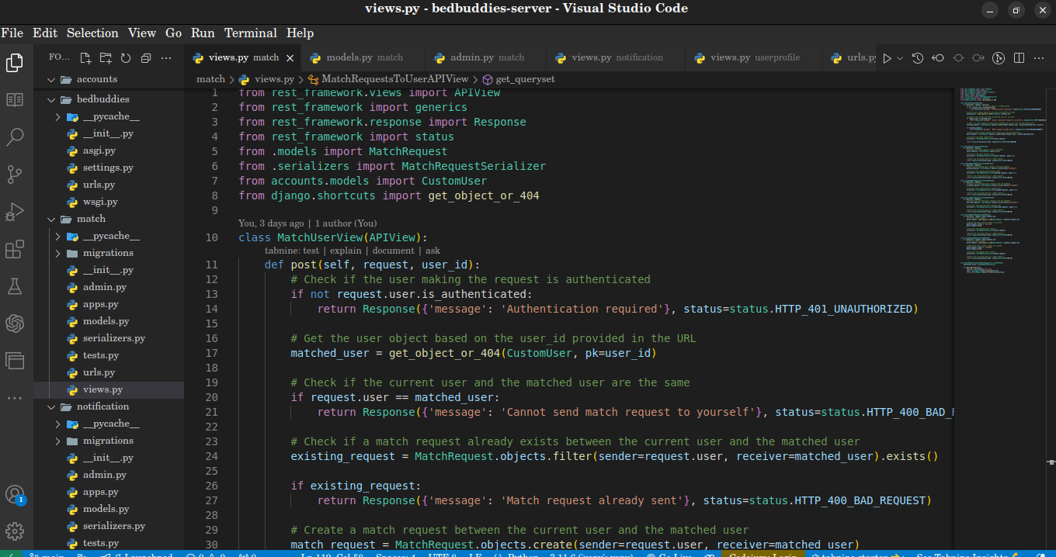
(This image is code snippet of the API that matches roomates)

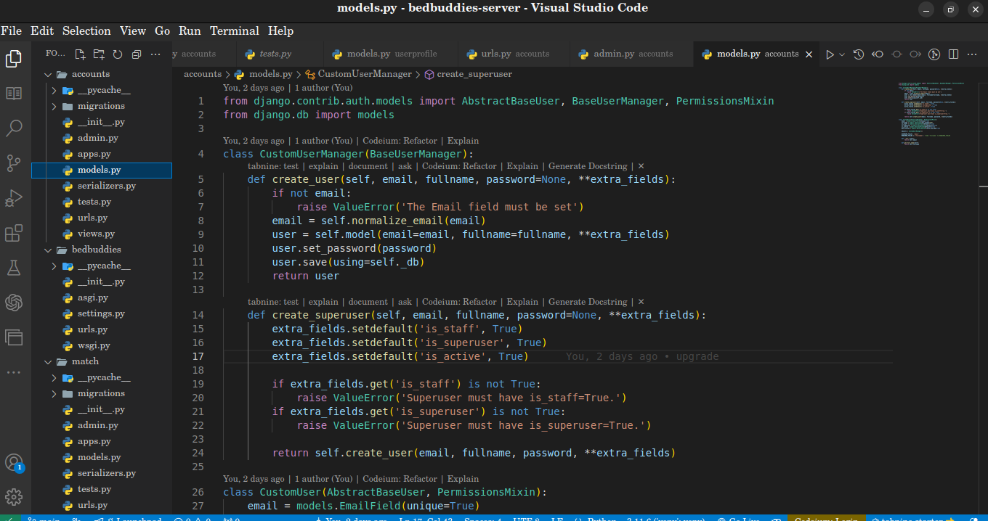
(This image is a code snippet of the database model that stores the user’s authentication details. It checks if the user is either the Super user (the admin) or a Custom user (end user) and perform some functions like permissions and activating account)
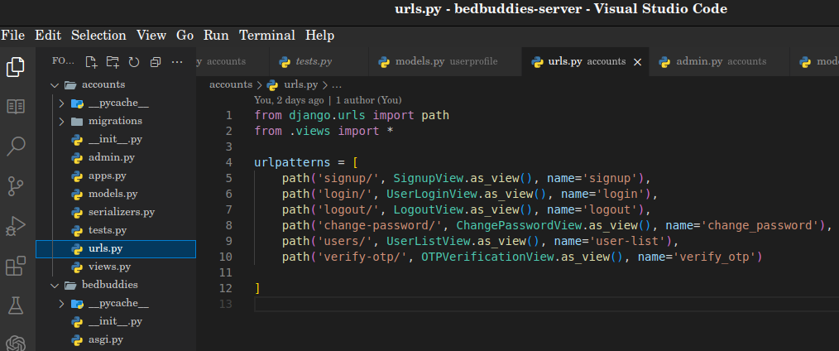
(This image is the code snippet of the endpoints for the authentication, signup, login, logout, and verifying of OTP (One Time Password))

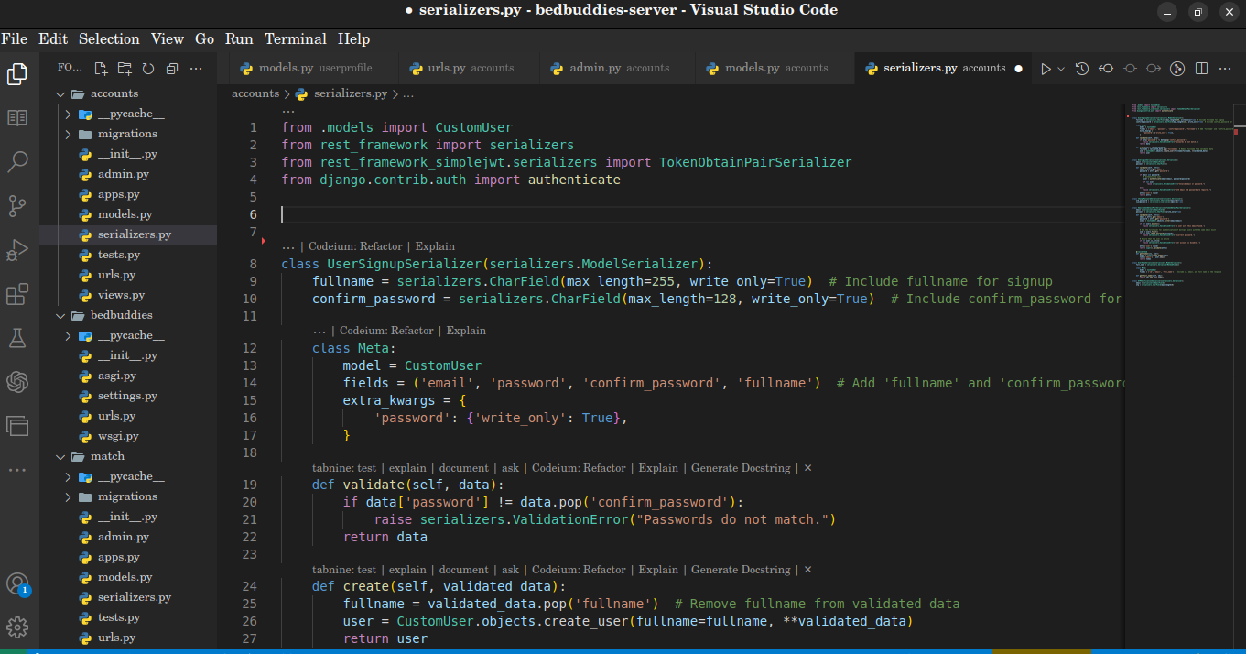
(This image is represents the code snippet of the serializer which serializes the data coming from the client to the server so that it can be stored in the database)

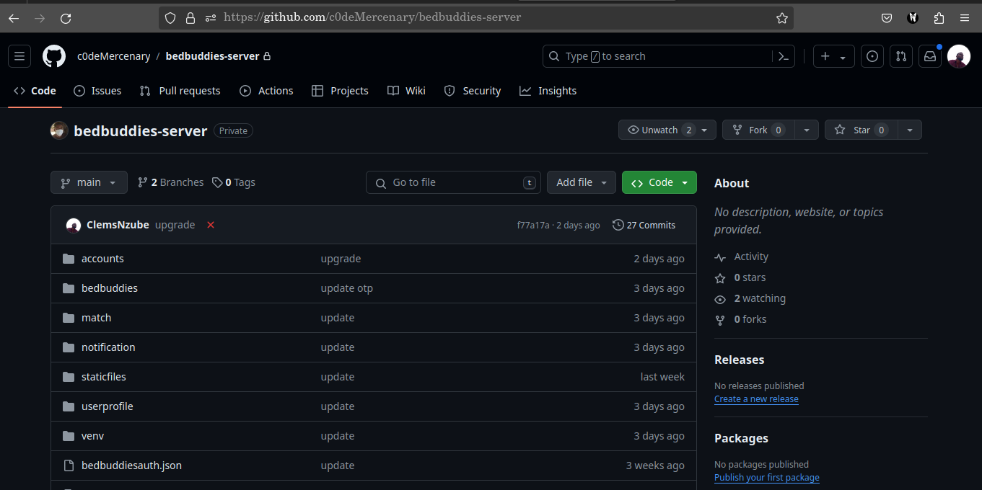
(This image represents the github interface which was used for version control and enable collaboration with other developers)

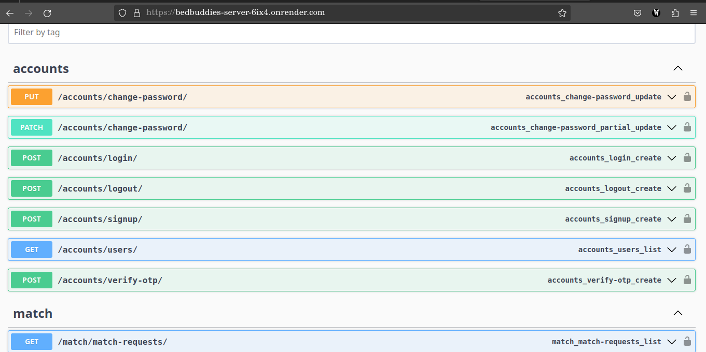
(This image represents the swagger documentation which I used to test the API endpoints)

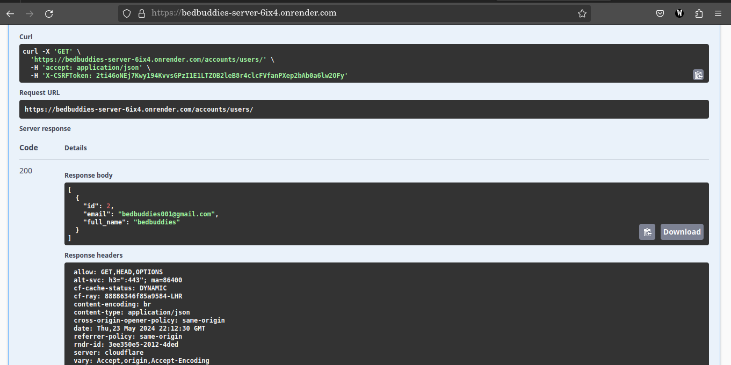
(This image represents the result I got from testing an API endpoint (/accounts/users/) which returned a 200 status code representing a success response)

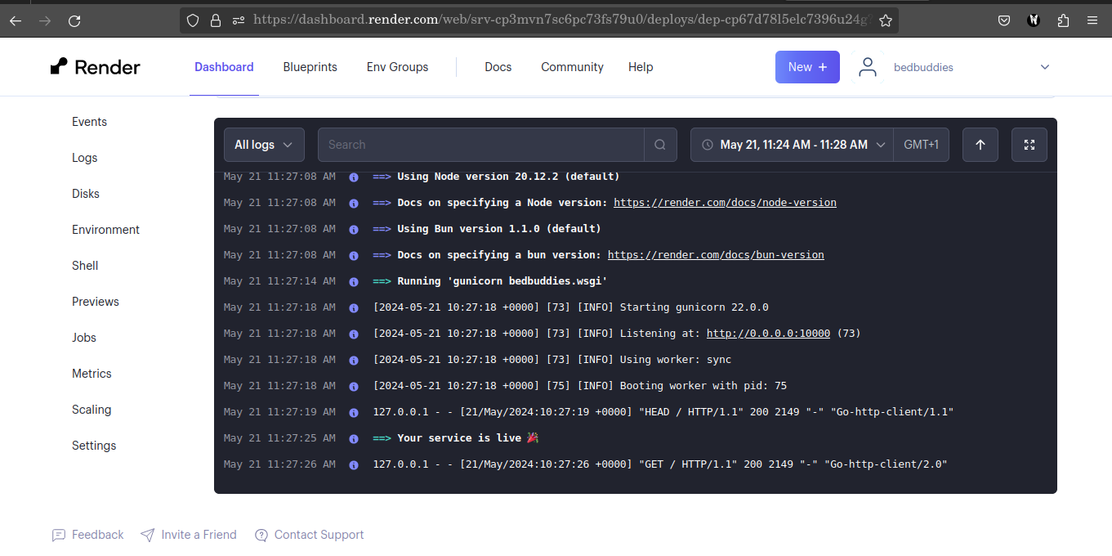
(This image represent the deployment log I got while deploying the server on Render.)
The server can be found on “https://bedbuddies-server-6ix4.onrender.com/”

3.2 Explanation of the Code
- Setting Up the Project: I started by setting up a new Django project, which involved configuring the necessary settings and creating a dedicated app for handling the roommate finder functionality.
- Defining Models: I created models to represent the different entities in the application. This included a user model to manage user information and profiles, a roommate profile model to store user preferences and bio details, and a notification model to handle messages sent to users about potential matches.
- Creating API Endpoints: Using Django REST Framework, I developed RESTful APIs to enable communication between the frontend and backend. These APIs facilitated user registration, profile management, roommate matching, and notification delivery. The endpoints were designed to handle various HTTP methods, ensuring smooth data flow and interaction within the application.
- Authentication and Authorization: To secure the application, I implemented JSON Web Token (JWT) based authentication. This involved configuring the system to generate JWTs for user login and sending these tokens to users via email for verification. I also set up authorization mechanisms to control access to different parts of the application based on user roles and authentication status.
- Email Verification: As part of the authentication process, I configured Django to send verification emails containing JWT tokens to users. This ensured that only verified users could access the application's features, enhancing security and preventing unauthorized access.
- Version Control and Deployment: Throughout the development process, I used GitHub for version control, regularly pushing code updates to the repository. This facilitated collaboration and allowed for efficient tracking of changes. For deployment, I used Render to host the backend application and Railway to manage the PostgreSQL database. This setup ensured that the application was accessible and that the data was securely stored and managed.

CHAPTER FOUR
SUMMARY, CHALLENGES ENCOUNTERED, RECOMMENDATIONS AND CONCLUSION
4.1. SUMMARY
During my internship as a Django Backend Developer at Nanocodes Programming Ltd, I gained invaluable hands-on experience and insights into the dynamic world of web development. Collaborating closely with the development team, I actively participated in building and maintaining robust backend systems for various applications. My responsibilities included designing and implementing APIs, managing databases, and ensuring seamless data flow between the server and clients. I engaged in developing secure authentication mechanisms, optimizing code for performance, and troubleshooting backend issues. Additionally, I contributed to deploying applications to cloud platforms and version controlling projects using GitHub. Through this immersive internship, I not only honed my technical skills in Django but also developed effective communication and problem-solving abilities. Overall, my time at Nanocodes Programming Ltd allowed me to apply classroom knowledge to real-world situations, fostering professional growth and a deeper understanding of backend development practices.

4.2. CHALLENGES ENCOUNTERED
I encountered several limitations before, during, and after my industrial training. These limitations are categorized as follows:

Pre-IT Limitations:
- Finding a place of attachment for the industrial training.
- Working with new technologies.
- New environment with new rules and regulations

IT Limitations:
- Cost of transportation from my house to my place of attachment.
- Working under pressure so as to deliver tasks efficiently when due.
- Short duration for the industrial training.

4.3 RECOMMENDATIONS
Upon the completion of a successful and enriching internship at Nanocodes Programming Ltd, I would recommend the following:
- The Industrial Training Fund (ITF) should establish partnerships with more tech companies, which will assist students who face challenges in securing internship placements.
- The internship program should include structured mentorship sessions where students can receive guidance and feedback from experienced developers.
- Companies should provide interns with access to a variety of projects to enhance their learning experience and expose them to different aspects of backend development.
- The duration of the internship should be extended to allow students more time to deeply engage with projects and fully develop their skills.

4.4. CONCLUSION
My internship at Nanocodes Programming Ltd as a Django Backend Developer was a transformative experience that significantly enhanced my technical and professional skills. The comprehensive training and hands-on projects provided a deep dive into the practical aspects of backend development, allowing me to apply theoretical knowledge in a real-world setting. Throughout my time at Nanocodes, I had the opportunity to work on a variety of tasks, from designing and implementing APIs to managing databases and ensuring secure authentication processes. This multifaceted exposure was instrumental in developing a holistic understanding of backend systems and their critical role in modern web applications.
The internship was not without its challenges. Encountering and overcoming various technical issues during the development and deployment phases sharpened my problem-solving skills and resilience. These experiences underscored the importance of meticulous planning, testing, and debugging in software development. Furthermore, the collaborative environment at Nanocodes provided invaluable insights into effective teamwork, communication, and project management. Working closely with senior developers and other team members, I learned the significance of code reviews, agile methodologies, and maintaining clear and open lines of communication to ensure project success.
One of the highlights of my internship was the development of a backend system for a student roommate finder app. This project was particularly rewarding as it involved end-to-end development, including setting up the database, creating and securing APIs, implementing JWT-based authentication, and deploying the application. The project not only honed my technical skills but also gave me a sense of accomplishment and confidence in my ability to handle complex backend development tasks.
In addition to the primary project, I contributed to several other company projects, such as 9app (a crypto exchange platform) and Nanocodes’ own website. These experiences broadened my expertise and provided exposure to a variety of technologies and development practices. Working on diverse projects allowed me to understand different business requirements and adapt my technical approach accordingly. It also emphasized the importance of scalability, security, and performance optimization in backend development.
However, the internship period felt relatively short, which limited the depth of exploration into some advanced topics. Extending the duration of industrial training programs would enable interns to delve deeper into complex projects, further refine their skills, and contribute more substantially to the host organization. A longer internship period would also provide more time for mentorship and professional development activities, such as attending workshops, seminars, and industry conferences.
In addition, I want to express my gratitude to the Federal Ministry of Science and Technology of the Federal Republic of Nigeria for conceiving the SIWES program and to the University of Nigeria, Nsukka for allowing me to participate in the SIWES program. Their support and vision made this invaluable learning experience possible.

REFERENCES
- How to solve the ten most common tech support problems yourself. Retrieved from https://www.pcworld.com/article/447413/how-to-solve-the-10-most-common-tech-
- Django Project. (n.d.). Django documentation. Retrieved from https://docs.djangoproject.com
- Django REST Framework. (n.d.). API Guide. Retrieved from https://www.django-rest-framework.org
- Render. (n.d.). Deploying Django on Render. Retrieved from https://render.com/docs/deploy-django
- GitHub. (n.d.). Understanding the GitHub flow. Retrieved from https://guides.github.com/introduction/flow/
- Real Python. (n.d.). Django REST Framework – An Introduction. Retrieved from https://realpython.com/getting-started-with-django-rest-framework/
- Mozilla Developer Network (MDN). (n.d.). JWT (JSON Web Token) Introduction. Retrieved from https://developer.mozilla.org/en-US/docs/Web/HTTP/Authentication
- Twilio. (n.d.). Two-Factor Authentication with Django. Retrieved from https://www.twilio.com/docs/verify/two-factor-authentication

