

**Contains user instructions and documentation on how to use CCGT scripts that processes digital images through an Agisoft PhotoScan Network Server and produces 3D spatial data.**

Justin Dowd

Clemson Center for Geospatial Technologies

PhotoScan Network Processing Instructions and Documentation, Version 1

**PhotoScan Network Processing Instructions and Documentation, Version 1**

Publication date 2018

**Table of Contents**

**Overview** ii

**Step 1 Obtaining CCGT Files and Connecting to Palmetto:** 1

**Step 2 Installing PhotoScan:** 6

**Step 3 Uploading Scripts and Photos:** 9

**Step 4 Uploading Arguments Document:** 12

**Step 5 Editing Arguments Document:** 13

**Step 6 Starting an interactive session:** 14

**Step 7 Starting Network Processing Monitor:** 15

**Step 8 Starting Network Processing:** 17

# **Overview**

The following document contains step by step instructions on how to use scripts developed by CCGT that allow users to photogrammetrically process images using an Agisoft PhotoScan Network Processing Server that distributes the data processing across eight parallel processing nodes and produces 3D spatial data. These instructions are to be used with Version 1 of our scripts and no other, when future versions of our scripts are released, new instructions and documentation will be released alongside it.

Each step provides the user with detailed information on how to handle our scripts and prepare them for processing using the Palmetto Cluster.

Our scripts require that you have a Clemson Palmetto Cluster account and the details on how to obtain one can be found in step one of our instructions.

Our scripts also require that you have Agisoft PhotoScan installed in your user directory of your Palmetto Cluster accounts, installation details can be found in step two of our instructions.

Lastly our scripts require Xming Server which allows tunneling in order to produce graphical user interfaces started from the command line of the Palmetto Cluster, installations details can be found in step six of our instructions.

# **Step 1 Obtaining CCGT Files and Connecting to Palmetto:**

First we need to download all of the necessary CCGT files required for processing your data. To do this you must first navigate to the [Clemson GIS GitHub page](https://github.com/ClemsonGIS). From there select the ‘PhotoScan_Scripts’ repository.

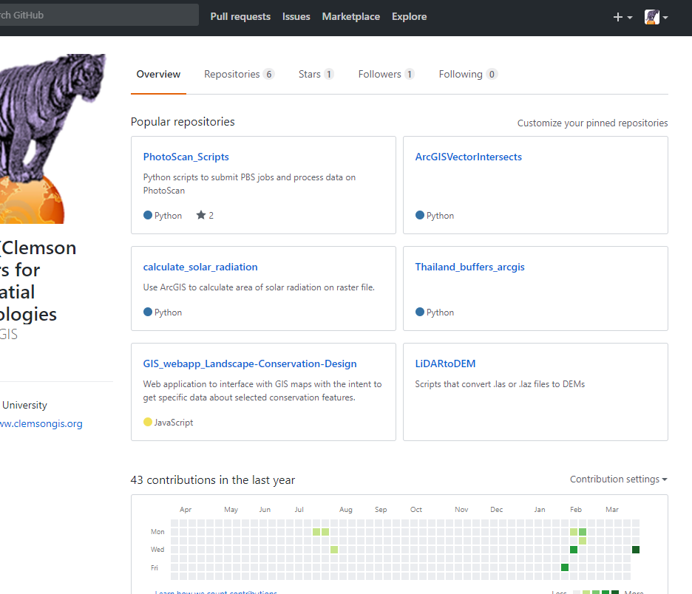

After that, on the right-hand side click ‘Clone or Download’ and then select ‘Download ZIP’ and when you do that the zip file should now start downloading. Make note of where the zip file has been downloaded and open file explorer and navigate to that location.

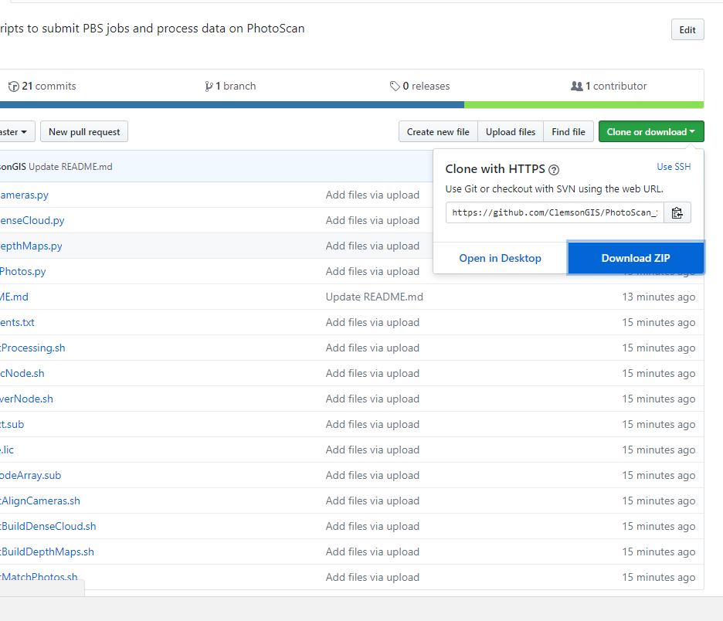

After navigating to where the CCGT zip file was downloaded, you can copy and paste them to whatever folder on your local machine that you would like. After they are in their final place on your local machine we need to extract all of the files from the zip. To do this we are going to use WinRAR to unzip and extract the files, Clemson Students and Staff can get WinRAR [here](https://ccit.clemson.edu/support/current-students/software-and-applications/web-downloads/). After you have installed WinRAR, right-click on the zip file containing the CCGT Files and select ‘Extract Here’. This should now give you a folder containing all of the CCGT Files, make note of its location because it will be needed later.

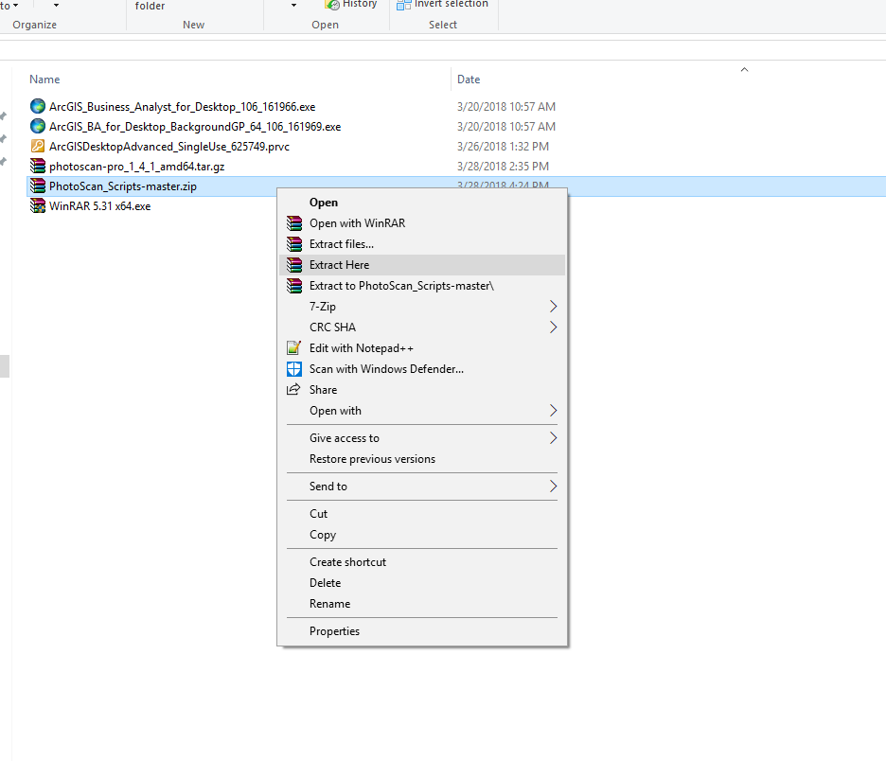

On Windows, using an SSH client of your choice (We recommend Secure Shell Client as these instructions will explain everything using this specific client and it can be downloaded [here](https://www.wm.edu/offices/it/services/software/licensedsoftware/webeditingsftp/sshsecureshell/index.php)):

If you are using Secure Shell Client we will first have to install Xming Server, to do that, first go [here](http://www.straightrunning.com/XmingNotes/) (Choose Xming under Public Domain releases) to download the installer. (An alternate download location can be found [here](https://sourceforge.net/projects/xming/files/latest/download)).

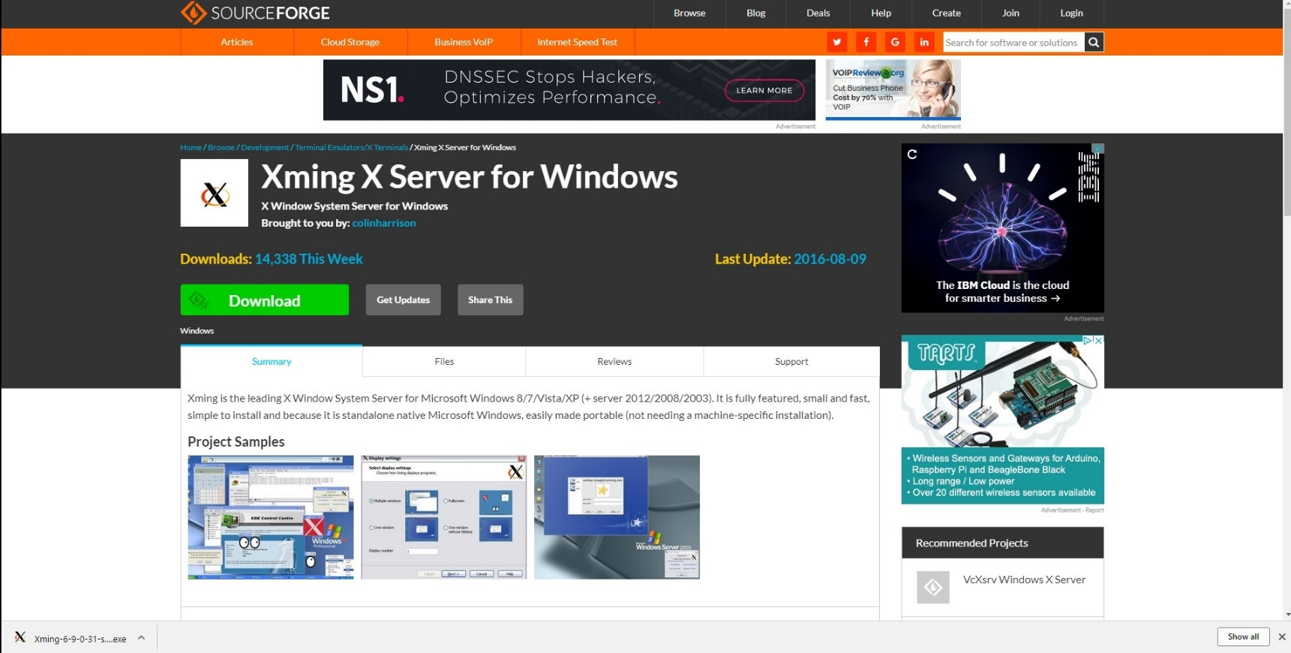 After it finishes installing run the installer by clicking on the download in your browser and follow the ensuing instructions that appear on the screen

After it finishes installing we are going to then start the Xming Server.

To do this, in the bottom left corner, in the “Type Search Here Box”, search Xming and then select Xming Desktop App.

Alternatively, select the windows icon in the bottom left corner, a menu will appear on the left side of your screen. From there, all the programs are organized alphabetically, so scroll down to ‘X’ and select the ‘Xming’ folder and then select ‘Xming’.

Both will start the Xming server, to verify it is working you go to the bottom right hand corner of your screen and click on the carrot icon and appearing in the box should be the Xming logo.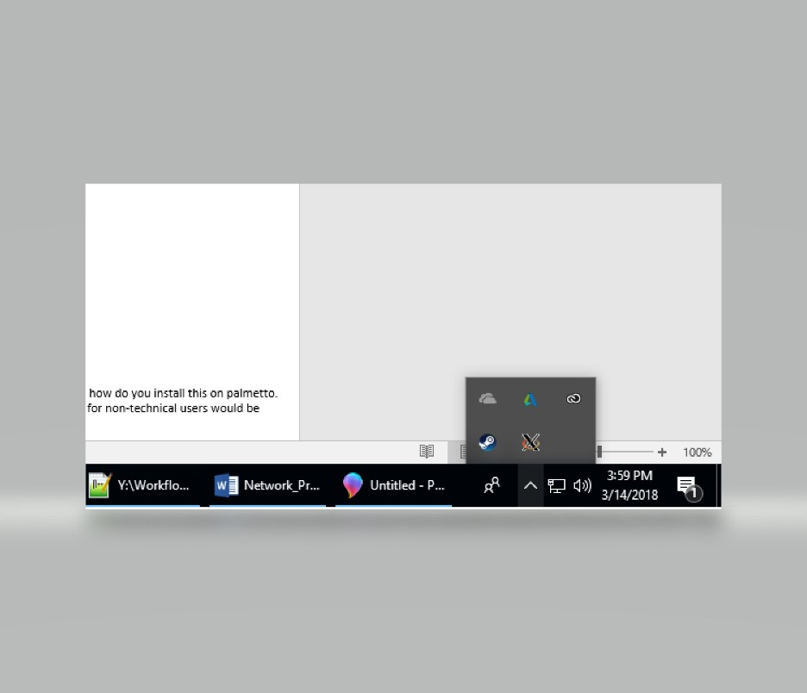

Now you will connect to Palmetto using your Clemson Credentials and Palmetto Account

#If you do not have a Palmetto Account, one can be requested [here](https://www.palmetto.clemson.edu/palmetto/index.html)

Open SSH Secure Shell and press the space bar and a login box should appear

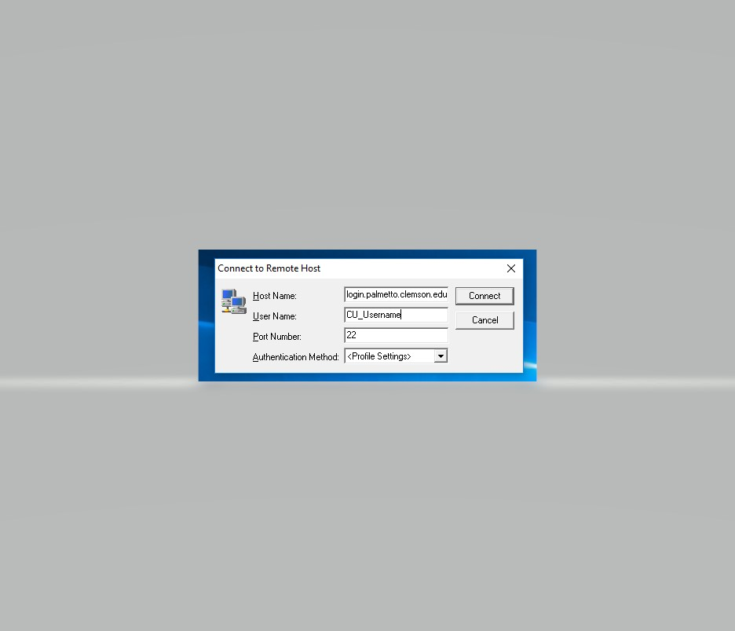There you will enter your Clemson Username in the “User Name” box and in the “Host Name” box enter “login.palmetto.clemson.edu” (without the quotes), finally ensure “Port Number” is 22 and select “Connect”.

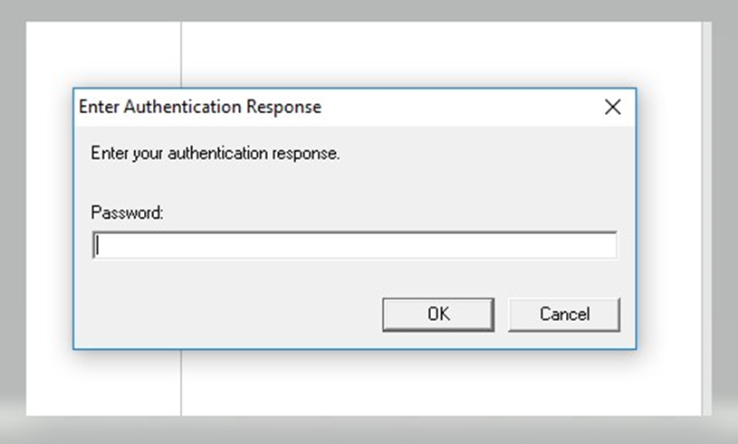Next it will prompt you for a password, in the box provided enter your Clemson User Password and select “Ok”

Next it will ask you to select your Two-Factor Authentication Method via Duo

Type “1” to send a push notification

Type “2” to authenticate via phone call

Type “3” to receive passcode verification

After typing one of the three numbers press “OK”

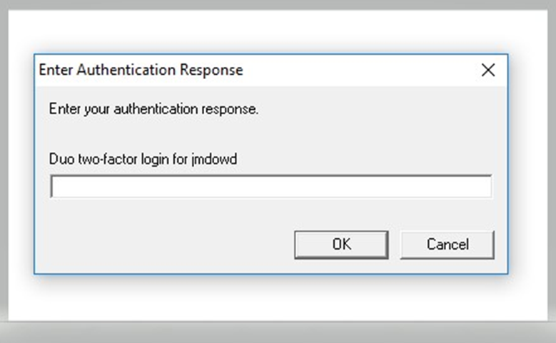

Duo two-factor login for CU_Username

Authenticate and then press “OK” and you will now be logged into the login001 node

# **Step 2 Installing PhotoScan:**

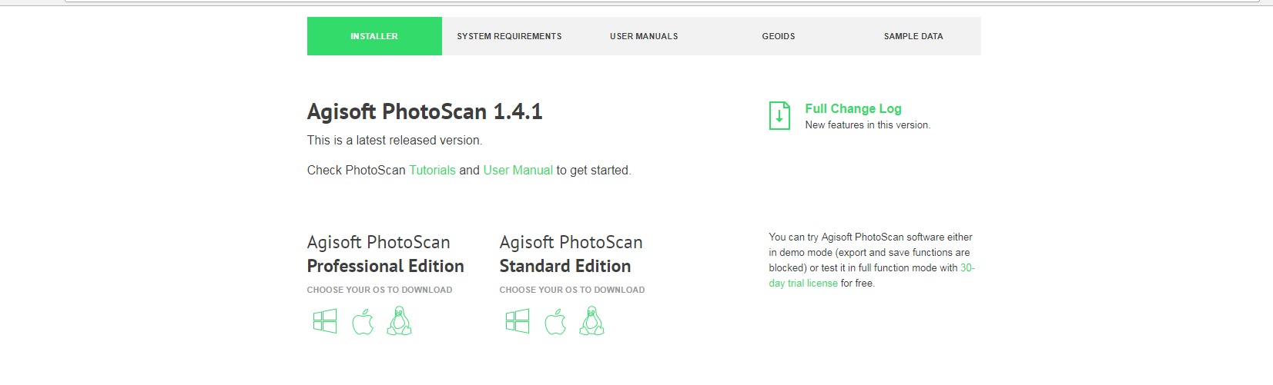 ## If you already have PhotoScan 1.4.1 installed on your Palmetto Account, continue to step 3 ##

**Be sure to download the proper version**

**Linux Version of PhotoScan Professional Edition**

Download the latest Linux version of [PhotoScan](http://www.agisoft.com/downloads/installer/), currently 1.4.1, onto your local machine from Agisoft Website, be sure to download the PhotoScan Professional Edition.

The download should give you a file with the name ‘photoscan-pro_1_4_1_amd64.tar’

Now using the SSH Window we logged into in the previous step, we are going to transfer the ‘.tar’ file to our Palmetto Account.

SSH Secure Shell has a built-in file transfer client and to access it you need to click on the folder icon in the toolbar of the SSH Window.

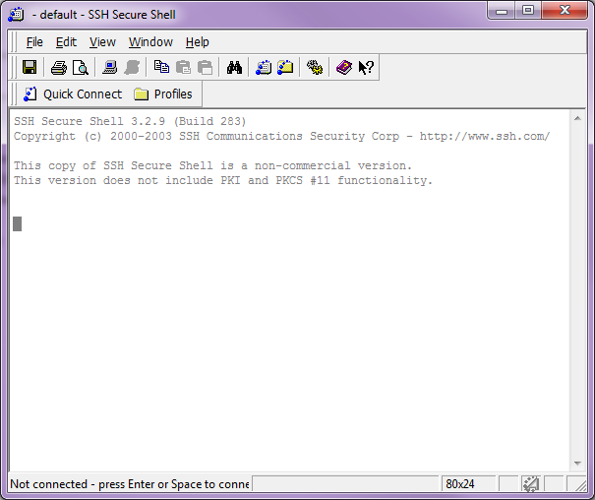

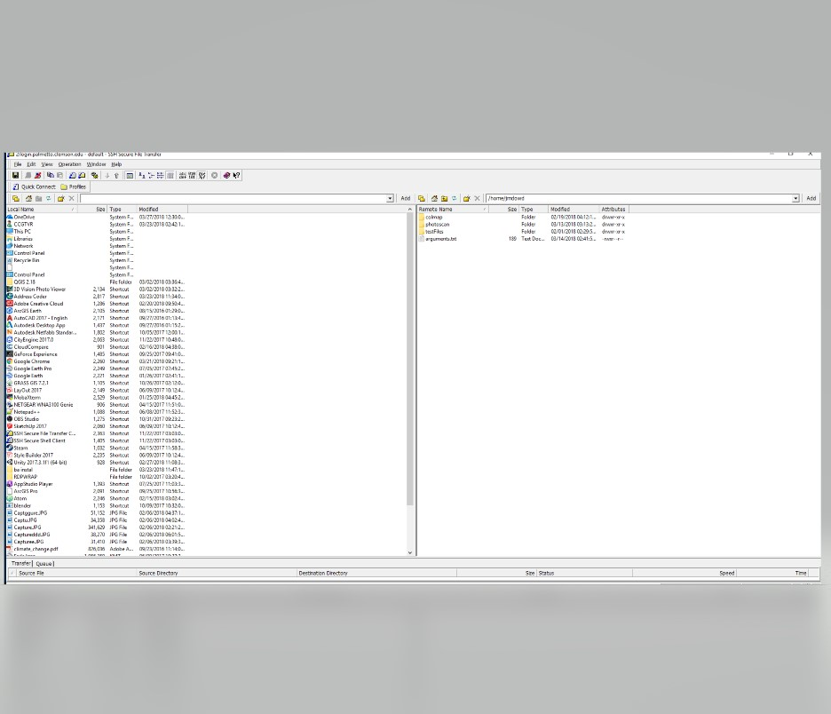Clicking this icon will now bring up the file transfer window, on the left-hand side you will see file structure for your local machine and on the right-hand side you will see the file structure for Palmetto Account. The right-hand side starts in your default user directory of your Palmetto Account, /home/USERNAME, which is where we want to be.

Local Machine File Structure

Palmetto Account File Structure

On the left-hand side, navigate to the folder where the PhotoScan .tar file is located. After that right-click on the right-hand side file structure and select ‘New Folder’ and name it ‘photoscan’ (Figure 2.1). Now double-click on the newly created folder to enter it. Now go back to the left-hand side file structure and right-click on the PhotoScan ‘.tar’ file and select ‘upload’ (Figure 2.2). This will now place the ‘.tar’ file in the ‘photoscan’ folder on your Palmetto Account (Figure 2.3). Now change back to the original SSH Window open with the command line.

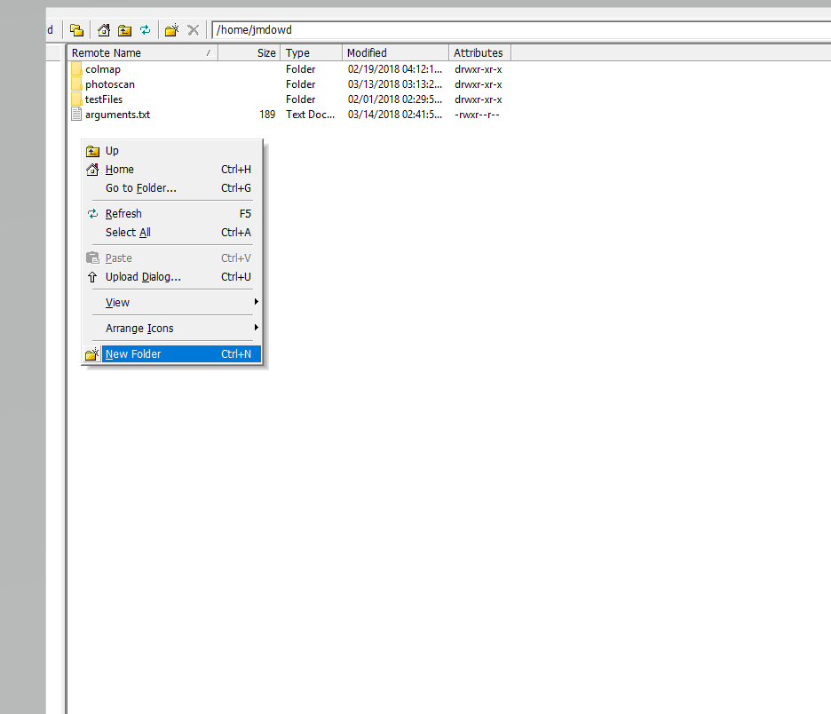

**Figure 2.1**

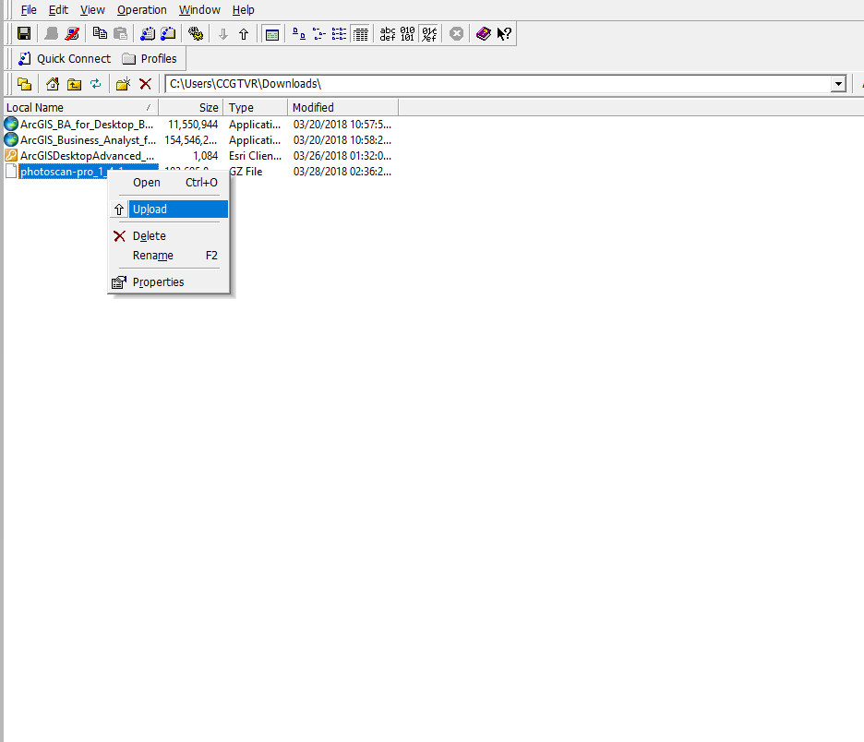

**Write this path down for later use, be sure to change ‘jmdowd’ to your username**

**Figure 2.2**

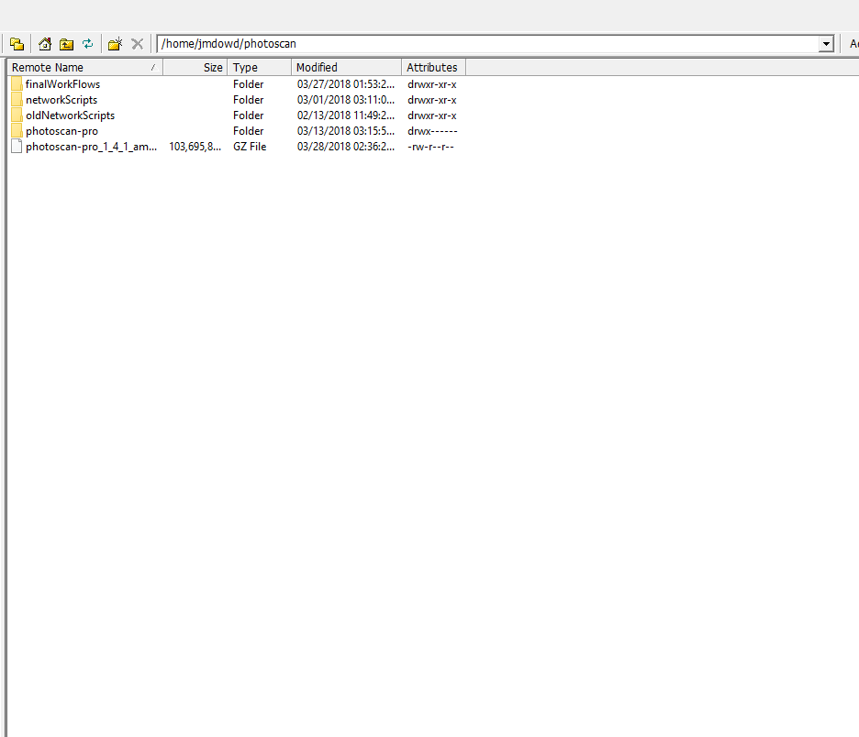

**Figure 2.3**

We now need to go to the directory where the PhotoScan ‘.tar’ file is located; to do this we are going to use the ‘cd’ command to change directories. Now, type ‘cd photoscan’ and this will move you into the ‘PhotoScan’ directory, type ‘ls’ and you should see the ‘.tar’ file and it now has an additional ‘.gz’ extension. We now need to use the ‘.tar’ file to download PhotoScan onto your account. To do this we are going to type the following command: ‘tar xzf photoscan-pro_1_4_1_amd64.tar.gz’

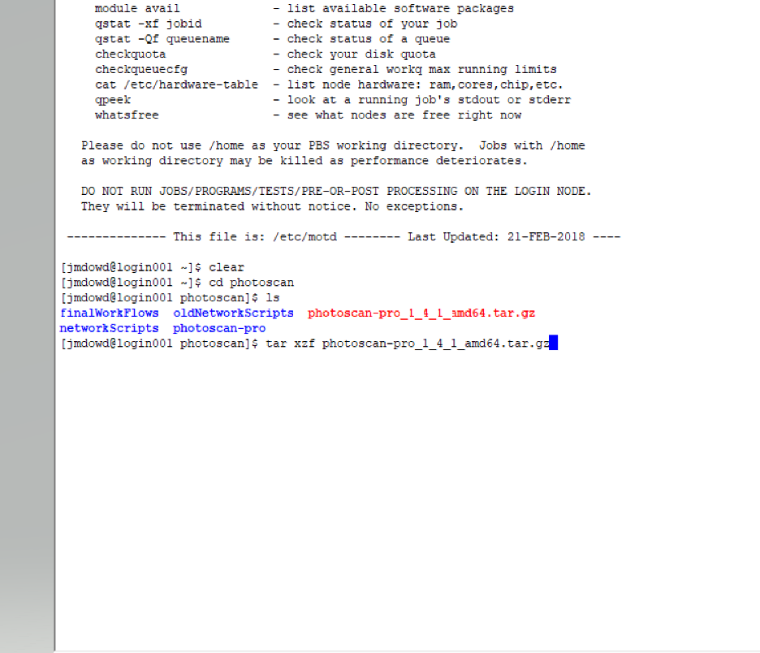

**Change Directories**

**Show contents of directory**

**Extract Files from .tar and install PhotoScan**

The ‘x’ flag tells the command to extract the files, the ‘z’ flag tells the command the file is a ‘gzip’ file (.gz), and the ‘f’ flag tells the command to extract files from the file we give the command, which in this case is the PhotoScan ‘.tar.gz’ file. To verify the download, type the ‘ls’ command and there should be a blue colored directory with the name ‘photoscan-pro’. We no longer need the download file, to remove it type the following command: ‘rm photoscan-pro_1_4_1_amd64.tar.gz’

**Show contents of Directory**

**Remove PhotoScan .tar file**

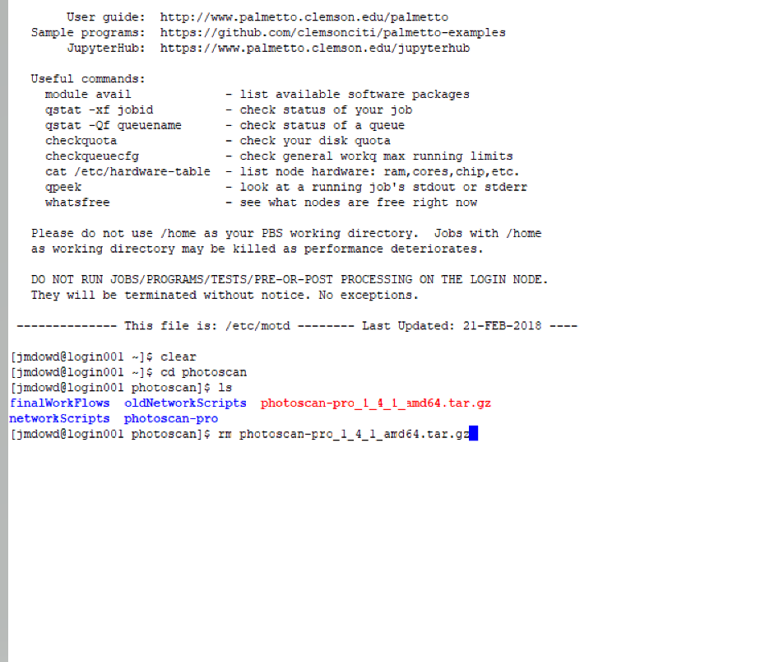

This will remove that file and we have successfully completed installing PhotoScan onto our Palmetto Account. The last thing we need to do is tell PhotoScan where our licenses are. To do this, reopen the Network Transfer Client we just used and in the right-hand column, navigate to where you saved the CCGT Processing Scripts. Locate the file names ‘license.lic’ and before uploading it to Palmetto, go into the Directory labeled ‘photoscan-pro’ and now you can right-click on ‘license.lic’ and select ‘Upload’ and now the license file is in its proper location and we can move onto step 3.

# **Step 3 Uploading Scripts and Photos:**

Like the previous step, we are going to be using the Network Transfer Client to move files from our local machine to our Palmetto Account. Refer to the steps in step 2 on how to open the Network Transfer Client and after doing that navigate to where you have saved the CCGT Processing Scripts. Now on the right-hand side make sure you are in your default home directory and once there, right-click and select ‘New Folder’ and name it whatever you wish, this is where we will be storing the CCGT Processing Scripts, the instructions will call it ‘CCGT_Scripts’. Similar to step 2, look above the right-hand column and write the path that leads to the ‘CCGT_Scripts’ Directory.

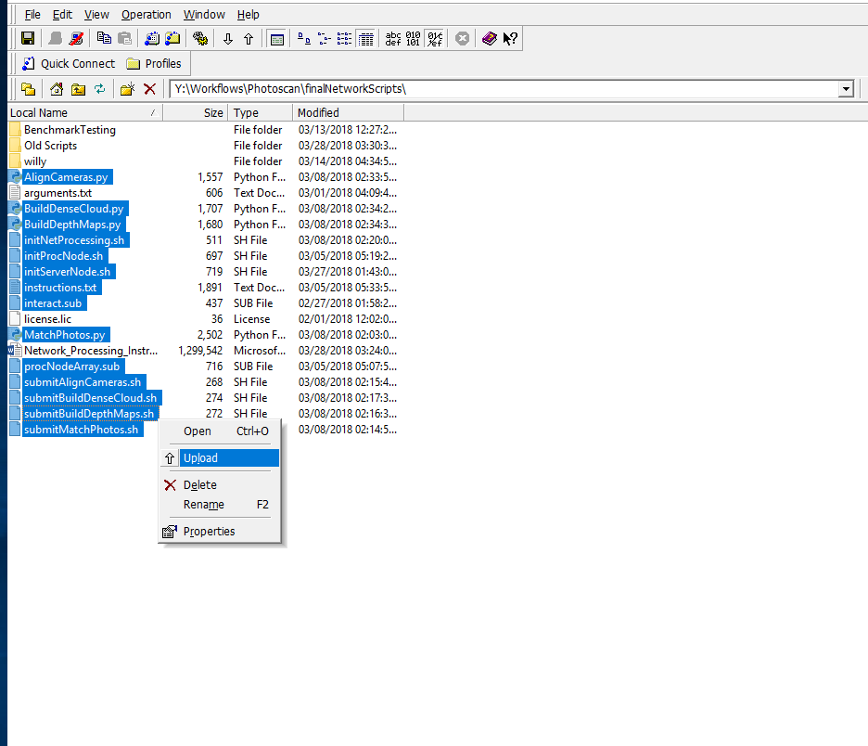

Now go back to the right-hand side and hold down ‘ctrl’ and select all of the processing scripts from the list below:

initNetProcessing.sh

initProcNode.sh

initServerNode.sh

procNodeArray.sub

interact.sub

AlignCameras.py & submitAlignCameras.sh

MatchPhotos.py & submitMatchPhotos.sh

BuildDepthMaps.py & submitBuildDepthMaps.sh

BuildDenseCloud.py & submitBuildDenseCloud.sh

After selecting them all let go of ‘ctrl’ and then right-click on one of the highlighted files and select ‘Upload’

#Note: For CCGT members, all files are in GIS libstorage under workflows/photoscan/finalNetworkScripts

Now using the Network Transfer Client, we are going to move the photos we wish to process onto our Palmetto Account. First we need to create a directory that will hold **ONLY** our photos and nothing else. It is important to give the directory a name that describes what the photos are to make future use of the photos easier. In this example the directory will be named ‘Folly_West_rs’ since they are photos of Folly Beach. Feel free to put this directory wherever you wish, just make sure to make note of the path leading to the directory, we recommend placing the directory in the ‘CCGT_Scripts’ directory. Move into the newly created directory and it should be empty.

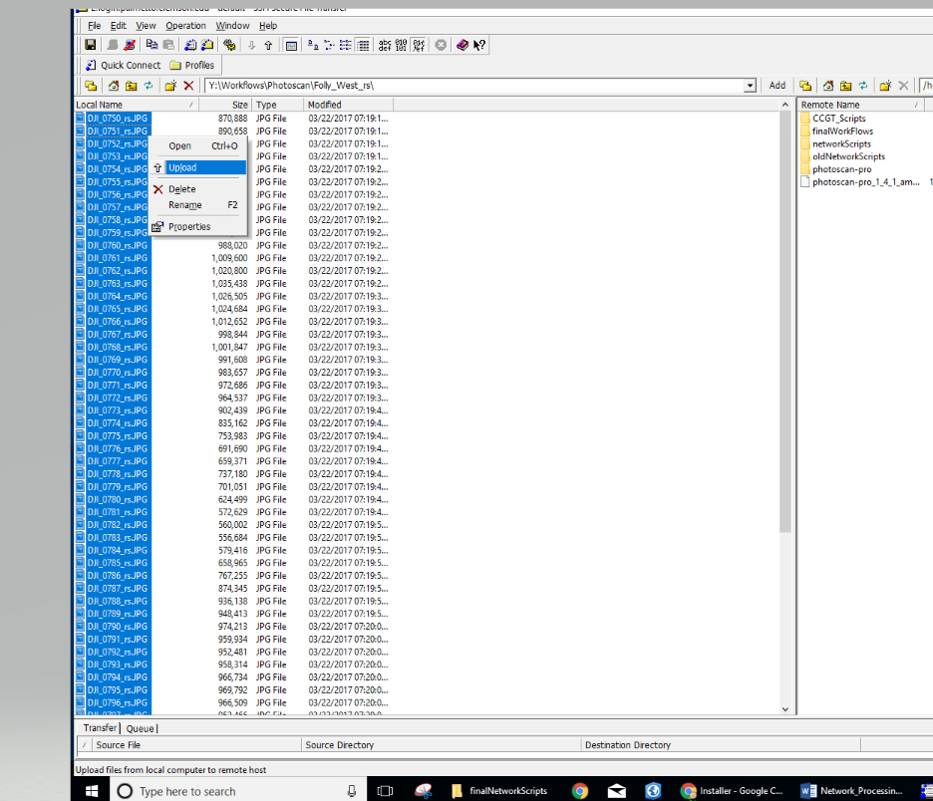

Now on the left-hand side, navigate to the folder where your photos to be processed are stored, make sure the photos are the only files in the folder and press ‘ctrl+a’ to select all your photos at once. Once they are all highlighted, right-click on one of the highlighted photos and select ‘Upload’. Now your photos should be in their own directory.

# **Step 4 Uploading Arguments Document:**

Refer to the instructions in Step 2 to open the file transfer client within SSH Secure Shell. You want to keep the right-hand side in your default home directory, /home/USERNAME, and on the left-hand side navigate to where we stored the processing scripts and documents. Find the text file labeled ‘arguments.txt’ and right-click on it and select ‘upload’ and the document should now appear in your default home directory.



**It is important to ensure the file is in this location because the other processing scripts depend on it being in this location. In the upper right-hand corner there should be a box displaying the path of the current directory the file transfer client in on your Palmetto Account, so it should display ‘/home/USERNAME’**

Now go back to the SSH Window and type the following command and hit enter:

cd ~

This command will move us into our default user directory and prepare us for our next step.

# **Step 5 Editing Arguments Document:**

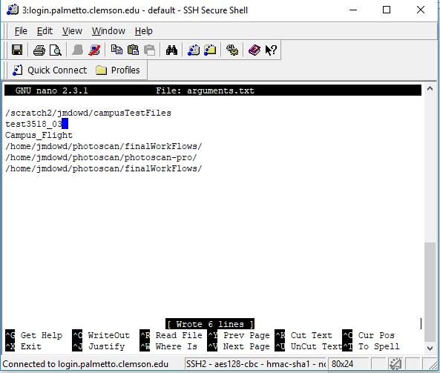In your SSH Window, open arguments.txt using the command ‘nano arguments.txt’ and follow its instructions, ensure that there are only 6 lines of text and no spaces in between each line. To save and exit the file enter ‘ctrl + o’ and hit enter, then press ‘ctrl + x’.

**Direct path to the directory where the network processing scripts are stored (Directory we made note of in Step 3)**

**Direct path to your PhotoScan Installation Directory**

**Direct Path to your photos folder**

**Name of your photos folder**

**Desired name of your project**

**Direct Path to the Directory you want your project saved in**

Refer to the above image to see a completed version of the ‘arguments.txt’ file

**# IF YOU WISH TO HAVE THE AGISOFT NETWORK MONITOR GUI OPEN TO MONITOR THE PROGRESS OF YOUR PROJECT FOLLOW STEP 6, IF NOT SKIP AHEAD TO STEP 8.**

# 

# **Step 6 Starting an interactive session:**

Using the current SSH Window that is logged into Palmetto we are going to open a second SSH that is also logged into Palmetto. To do this you will click the icon to the left of the icon we used open the Network File Transfer Client.



After opening the second window we need to change to the directory where we saved the CCGT Processing Scripts. To do this we are going to use the ‘cd’ command, use the path we made note we made note of in step 3 of where the files were stored and type the path, minus the ‘/home/USERNAME’ part since we are currently in that directory, after typing ‘cd’.

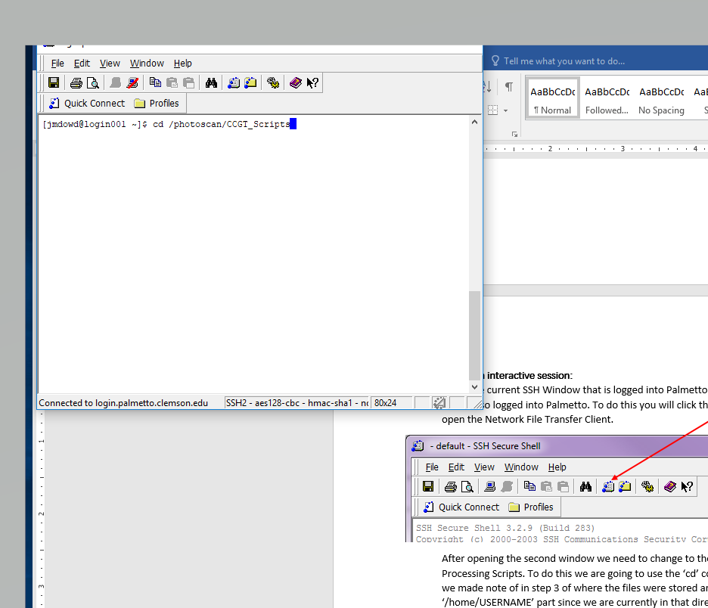

After changing into that directory we will now have to give all the files in the directory executable permissions. To do this type the following command into the terminal and hit enter:

chmod –R 777 .

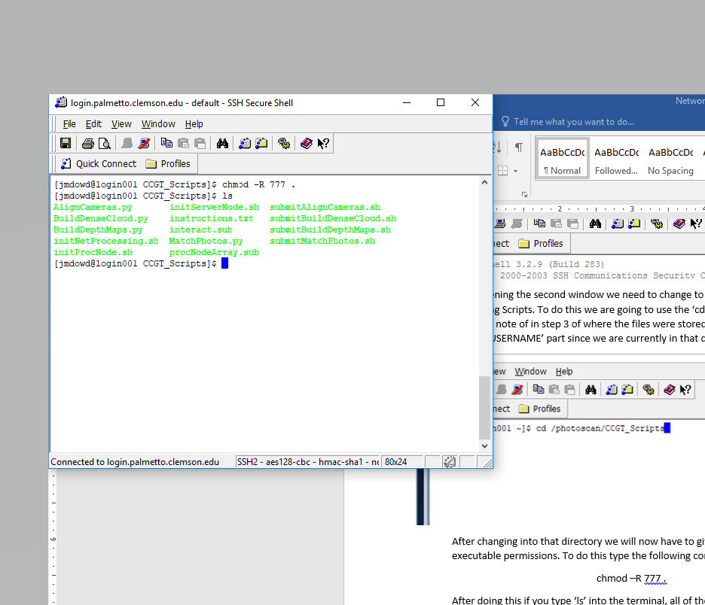

**##Be sure to include the period at the end, it tells the command to use the current directory it’s in##**

Now we are going to submit a job to Palmetto that will generate an interactive session with Palmetto. To do this we have supplied a simple script that requests the necessary hardware from Palmetto for the session. To submit the job, type the following command and hit enter:

qsub interact.sub

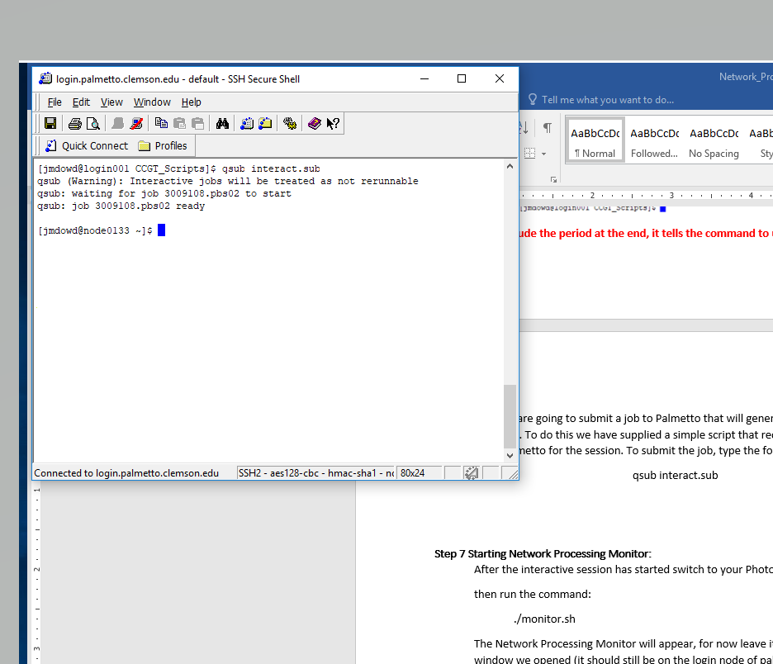

After hitting enter your screen should look like this, it can take anywhere from a few seconds to a few minutes for an interactive session to start because when we submit the job we are asking are asking for certain resources and if they are not immediately available we then must wait for them to be available. You’ll also notice that you are no longer working on the login001 node and are now on a different node on Palmetto, for this example we are now working on node0133. Now we can move onto step 7.

# **Step 7 Starting Network Processing Monitor:**

Our interactive session has now started and it has changed us back to our default user directory, home/USERNAME, from here we need to move to the directory where we installed PhotoScan. We made note of that path in step 2 and we are now going to use it. Using the ‘cd’ command once again type the following command and hit enter:

cd photoscan/photoscan-pro

Your path may differ based on where you chose to install PhotoScan but as long as you are in the PhotoScan installation directory we can move on.

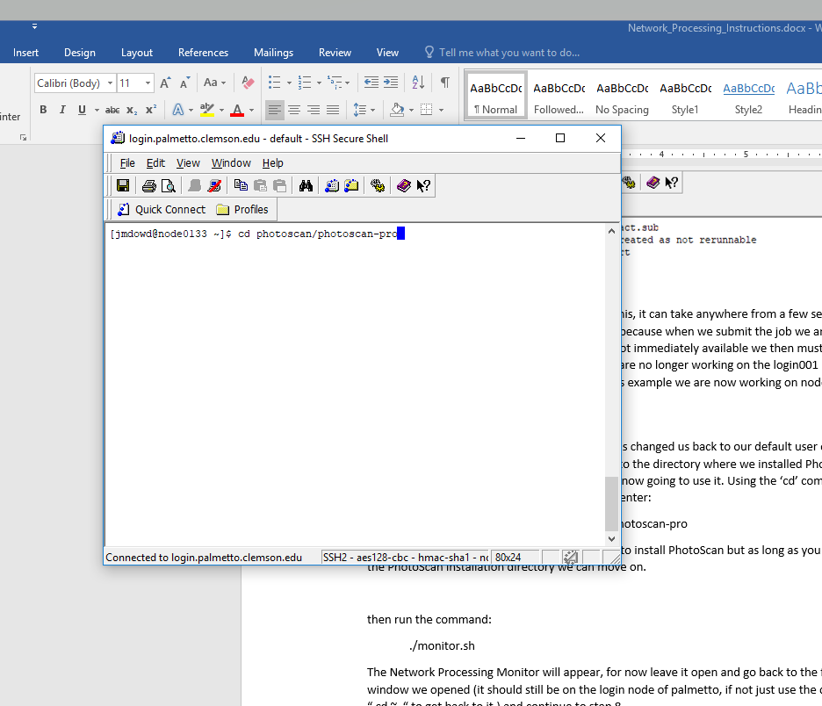

We are now going to open the PhotoScan Network Processing Monitor GUI; this will allow you monitor the progress of your data processing. To open the monitor, type the following command and hit enter:

./monitor.sh

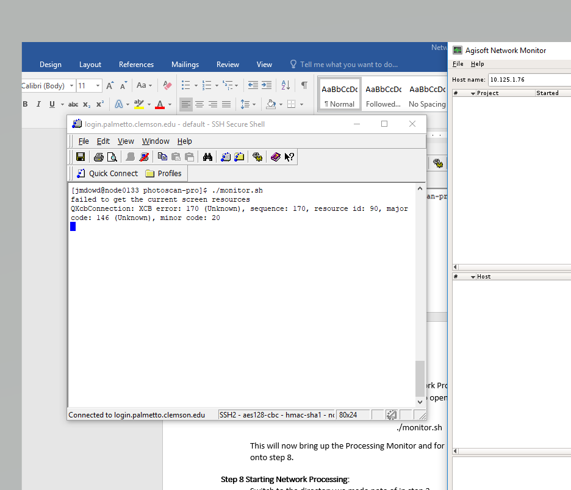

The terminal will look like this after the command and that is normal and the screen should also produce the Network Monitor GUI as well:

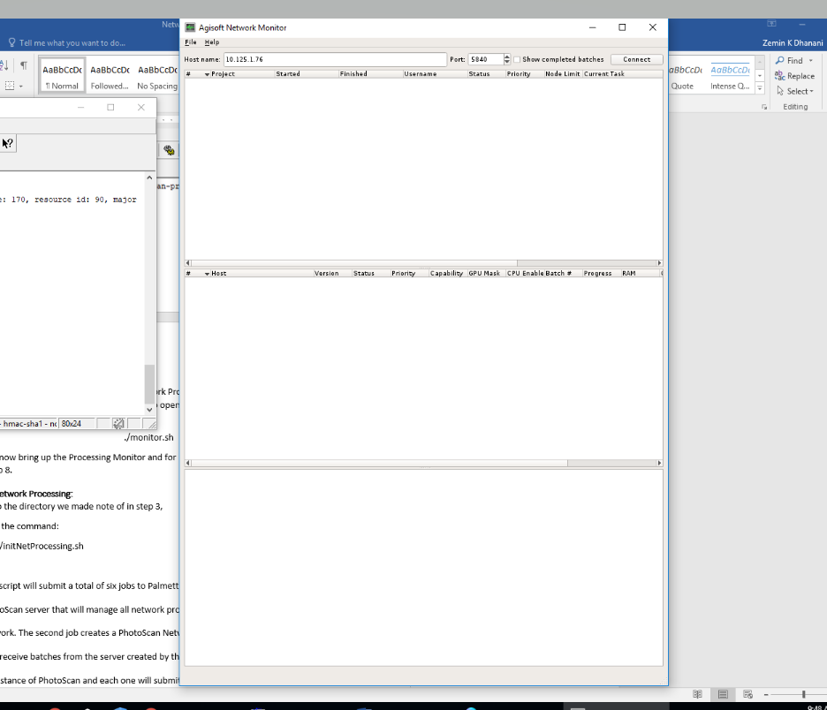

# 

# **Step 8 Starting Network Processing:**

Now with the Network Monitor running we can now submit our data for processing.

To do this switch to the first SSH Window we opened, this should be on the login001 node and switch to the directory we made note of in step 3 that contains the CCGT Processing Scripts.

Once there we are going to run one command that will submit all of the jobs necessary to conduct the processing and that command is:

./initNetProcessing.sh

After hitting enter this script will submit a total of six jobs to Palmetto through qsub, each job submission will print out a job ID which means it has been submitted to the job queue, the first creates a PhotoScan server that will manage all network processing batches that are sent to the network. The second job creates a PhotoScan Parallel Processing Array made up of 8 nodes that receive batches from the server created by the first job. The final four jobs will each run an instance of PhotoScan and each one will submit a different Python Script that submits a processing step as a batch to the PhotoScan server we created. The four processing steps submitted (in order) are Matching Photos, Aligning Cameras, Building Depth Maps, and Building a Dense Cloud. The match photos script will also upload all the photos to the PhotoScan project we created.

**## IF YOU SETUP THE AGISOFT NETWORK MONITOR ##**

this script will also print out the IP address of the PhotoScan server node to the console after the second job is complete.

Copy that IP address into the IP address box in the Agisoft network monitor GUI and select connect.

#Note: The script takes approximately 45 seconds to complete the first and second jobs and after the third job is submitted, the job ID will be displayed and the script will appear to pause, this normal because it will not submit the next processing step until the current one is done. It will take about 5-10 seconds for the batch to appear in the Network Processing Monitor after the script submits the job.

**Step 9 Viewing the Output**

Once processing has completely finished we are now ready to view our finished product. To do so we first need to close the Network Monitor window using the "**X**" in the upper right-hand corner.



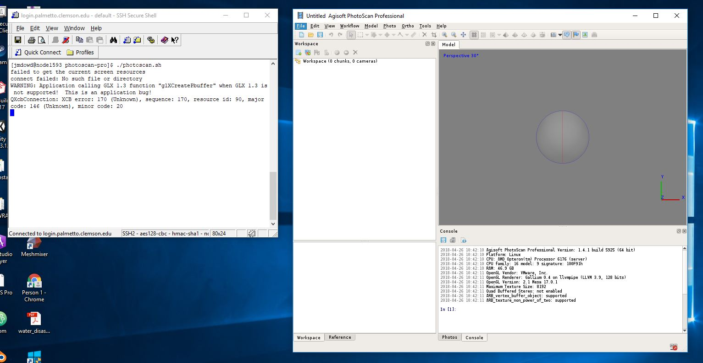Now go to your SSH window where we have an interactive session running, this should be the same window we launched the Network Monitor from. In this window we are going to type the command "./photoscan.sh" and this will launch the PhotoScan Graphical User Interface(GUI).

From here we would go to click the “Open” icon and navigate to the location on your Palmetto Account where you had PhotoScan save your project.

Once you reach that location select the file that has your project name with a ".psx" extension, double-click that name and your project will now open and you are now free to view the output.

