实验报告
2019 年 11 月 25 日 成绩：
姓名 | 易永豪 | 学号 | 17052247 | 班级 | 17052315
专业 | 计算机科学与技术 |  | 课程名称 | 《数字电路课程设计》
任课老师 | 戴均 | 指导老师 | 戴均 | 机位号
实验序号 | 1 | 实验名称 | 加法器设计
实验时间 | 10.21 | 实验地点 | 一教225 | 实验设备号
一、实验程序源代码
module add(a, b,cin, cout,f);
input a,b,cin;
output cout,f;

assign f =a^b^cin;
assign cout = a&b|a&cin|b&cin;

endmodule
二、仿真波形
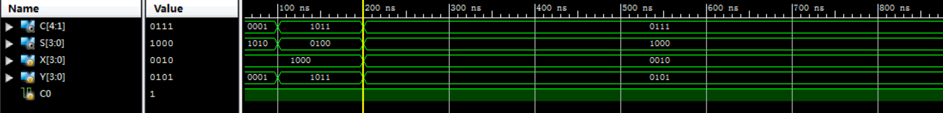
三、电路图
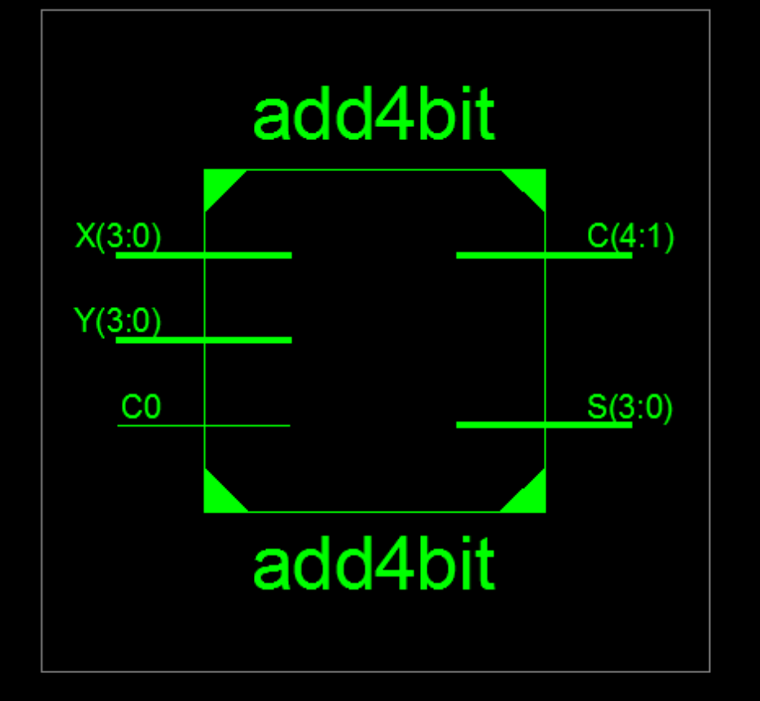
四、引脚配置（约束文件）
NET "C[4]" LOC = J2; //LED8(D26)
NET "C[3]" LOC = L1; //LED7(D24)
NET "C[2]" LOC = M2; //LED6(D22)
NET "C[1]" LOC = M1; //LED5(D18)
NET "S[3]" LOC = N2; //LED4(D14)
NET "S[2]" LOC = P1; //LED3(D10)
NET "S[1]" LOC = P2; //LED2(D6)
NET "S[0]" LOC = R1; //LED1(D4)

NET "C[4]" IOSTANDARD = LVCMOS18;
NET "C[3]" IOSTANDARD = LVCMOS18;
NET "C[2]" IOSTANDARD = LVCMOS18;
NET "C[1]" IOSTANDARD = LVCMOS18;
NET "S[3]" IOSTANDARD = LVCMOS18;
NET "S[2]" IOSTANDARD = LVCMOS18;
NET "S[1]" IOSTANDARD = LVCMOS18;
NET "S[0]" IOSTANDARD = LVCMOS18;

NET "Y[3]" LOC = Y6; //SW8
NET "Y[2]" LOC = Y4; //SW7
NET "Y[1]" LOC = W4; //SW6
NET "Y[0]" LOC = V4; //SW5
NET "X[3]" LOC = V3; //SW4
NET "X[2]" LOC = T4; //SW3
NET "X[1]" LOC = U3; //SW2
NET "X[0]" LOC = T3; //SW1
NET "C0" LOC = AB8; //SW1

NET "Y[3]" IOSTANDARD = LVCMOS18;
NET "Y[2]" IOSTANDARD = LVCMOS18;
NET "Y[1]" IOSTANDARD = LVCMOS18;
NET "Y[0]" IOSTANDARD = LVCMOS18;

NET "X[3]" IOSTANDARD = LVCMOS18;
NET "X[2]" IOSTANDARD = LVCMOS18;
NET "X[1]" IOSTANDARD = LVCMOS18;
NET "X[0]" IOSTANDARD = LVCMOS18;

NET "C0" IOSTANDARD = LVCMOS18;

NET "Y[3]" PULLDOWN;
NET "Y[2]" PULLDOWN;
NET "Y[1]" PULLDOWN;
NET "Y[0]" PULLDOWN;

NET "X[3]" PULLDOWN;
NET "X[2]" PULLDOWN;
NET "X[1]" PULLDOWN;
NET "X[0]" PULLDOWN;

NET "C0" PULLDOWN;

五、思考与探索
除本位两个数相加外，还要加上从低位来的进位数，称为全加器。
被加数Ai、加数Bi从低位向本位进位Ci-1作为电路的输入，全加和Si与向高位的进位Ci作为电路的输出。能实现全加运算功能的电路称为全加电路。
六、意见和建议

