实验报告
2019 年 10 月 28 日 成绩：
姓名 | 易永豪 | 学号 | 17052247 | 班级 | 17052315
专业 | 计算机科学与技术 |  | 课程名称 | 《数字电路课程设计》
任课老师 | 戴钧 | 指导老师 | 戴钧 | 机位号 | 91号机
实验序号 | 3 | 实验名称 | 译码器设计
实验时间 | 10.28 | 实验地点 | 一教225 | 实验设备号 | 65
一、实验程序源代码
module decoder(a, b, c, G1,G2,G3,out);

input a,b,c; // 输入信号

input G1,G2,G3; //输入是否是有效电平

output reg [7:0]out; // 输出信号

always@(a, b, c,G1,G2,G3)
begin
if(G1==1&&G2==0&&G3==0)
begin
case({a, b, c})
3'b000 : out = 8'b1111_1110;
3'b001 : out = 8'b1111_1101;
3'b010 : out = 8'b1111_1011;
3'b011 : out = 8'b1111_0111;
3'b100 : out = 8'b1110_1111;
3'b101 : out = 8'b1101_1111;
3'b110 : out = 8'b1011_1111;
3'b111 : out = 8'b0111_1111;
endcase
end
else out=8'b1111_1111;
end

endmodule
二、仿真波形
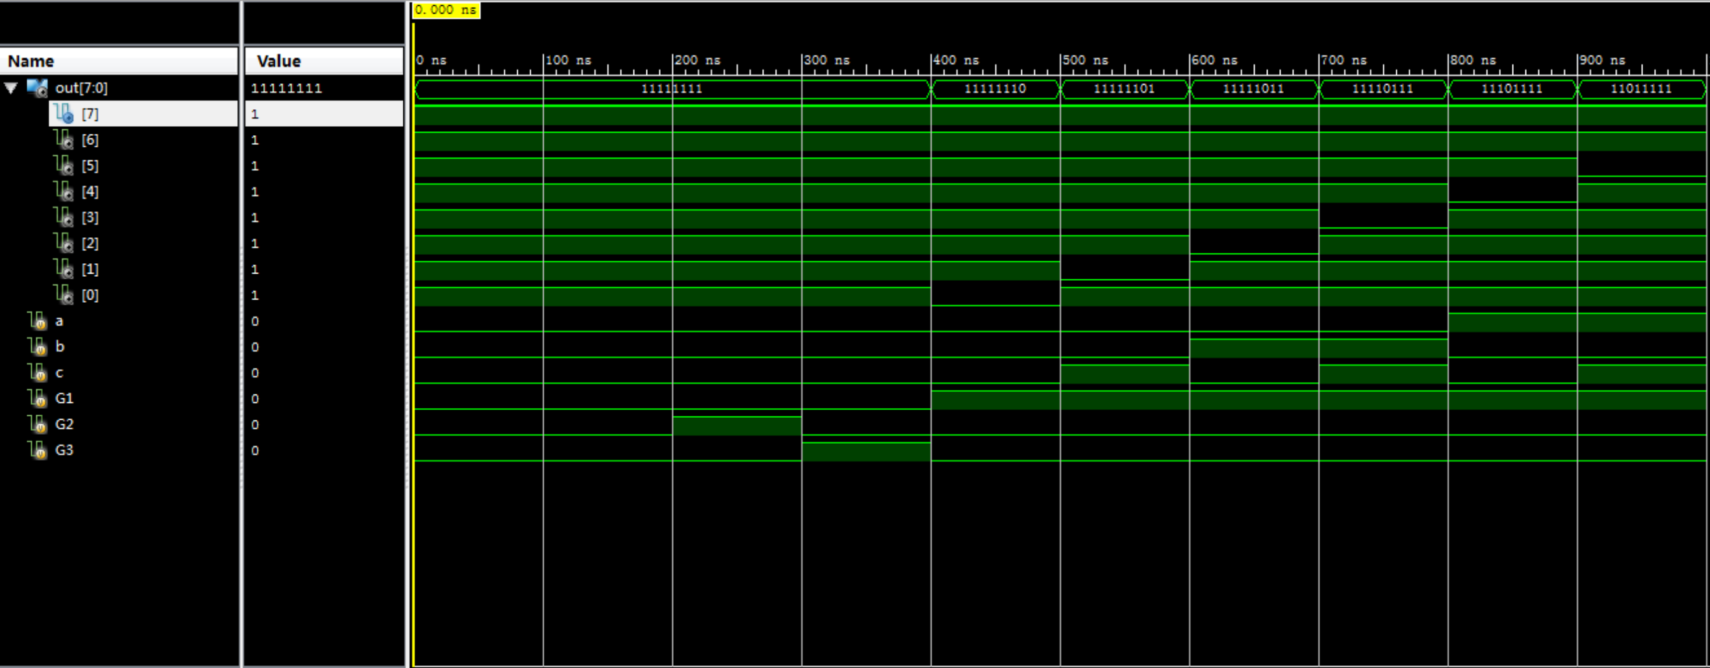
三、电路图
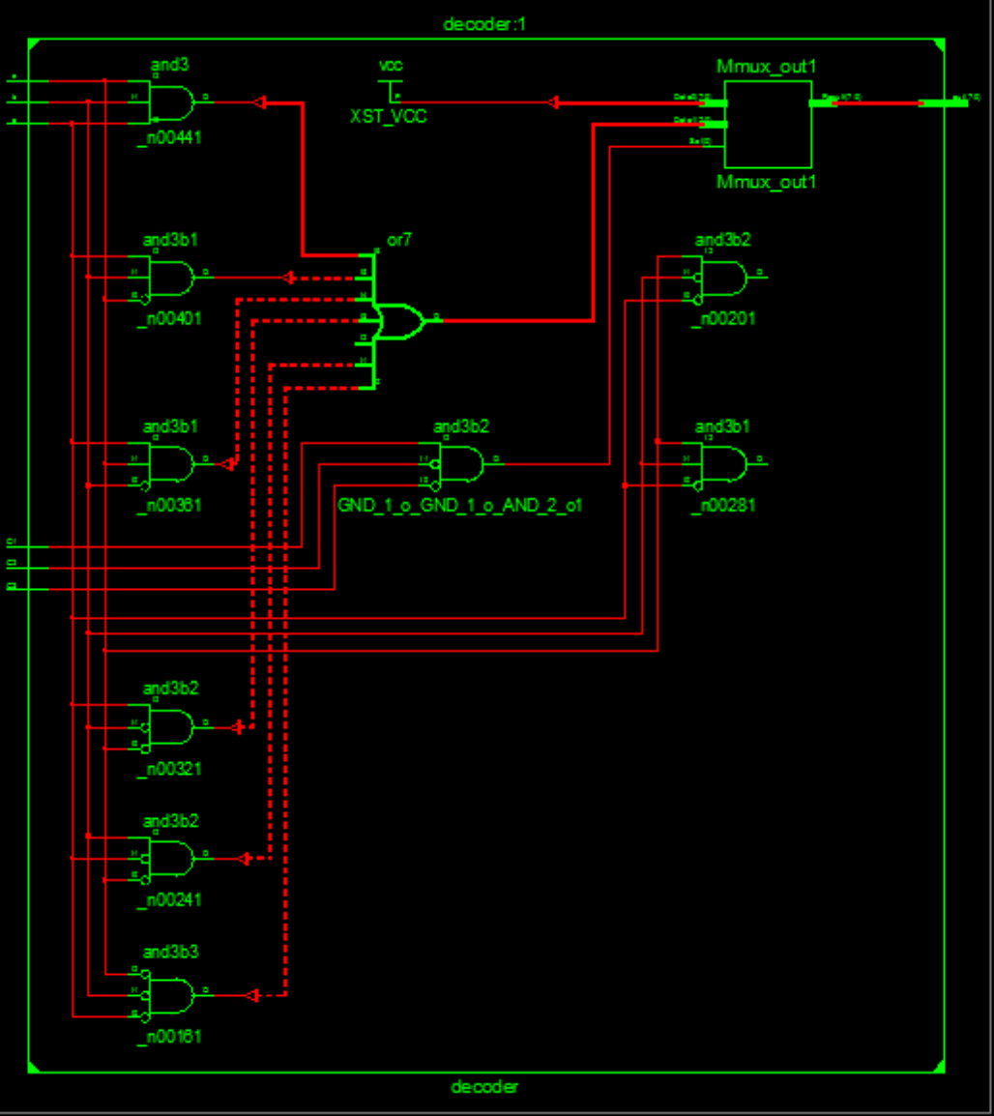

四、引脚配置（约束文件）
NET "out[0]" LOC = J2;
NET "out[1]" LOC = L1;
NET "out[2]" LOC = M2;
NET "out[3]" LOC = M1;
NET "out[4]" LOC = N2;
NET "out[5]" LOC = P1;
NET "out[6]" LOC = P2;
NET "out[7]" LOC = R1;

NET "out[7]" IOSTANDARD = LVCMOS18;
NET "out[6]" IOSTANDARD = LVCMOS18;
NET "out[5]" IOSTANDARD = LVCMOS18;
NET "out[4]" IOSTANDARD = LVCMOS18;
NET "out[3]" IOSTANDARD = LVCMOS18;
NET "out[2]" IOSTANDARD = LVCMOS18;
NET "out[1]" IOSTANDARD = LVCMOS18;
NET "out[0]" IOSTANDARD = LVCMOS18;

NET "a" LOC = T3;
NET "b" LOC = U3;
NET "c" LOC = T4;
NET "G1" LOC = V3;
NET "G2" LOC = V4;
NET "G3" LOC = W4;

NET "a" IOSTANDARD = LVCMOS18;
NET "b" IOSTANDARD = LVCMOS18;
NET "c" IOSTANDARD = LVCMOS18;
NET "G1" IOSTANDARD = LVCMOS18;
NET "G2" IOSTANDARD = LVCMOS18;
NET "G3" IOSTANDARD = LVCMOS18;

NET "a" PULLDOWN;
NET "b" PULLDOWN;
NET "c" PULLDOWN;
NET "G1" PULLDOWN;
NET "G2" PULLDOWN;
NET "G3" PULLDOWN;
五、思考与探索
输入十进制数采用四位二编码信号in[3:0]，输出格雷码采用out[3:0]，通过case语句，根据相应的输入信号输出格雷码。
六、意见和建议

