Optic Disc and Fovea Localization in Fundus Retinal Images Using Classical Image Processing
Çağdaş Kaplan, Mert Can Kalınlıoğlu
1. Department of Computer Engineering, Eskisehir Technical University
cagdaskaplan@ogr.eskisehir.edu.tr

2. Department of Computer Engineering, Eskisehir Technical University
mert_ck@ogr.eskisehir.edu.tr

Abstract
This project presents an image processing pipeline for optic disc segmentation and fovea localization in retinal fundus images from the IDRiD dataset. The method uses green-channel preprocessing with contrast enhancement and median filtering, optic disc detection based on bright-region selection and morphological cleanup, and fovea localization using anatomical constraints around the detected optic disc. The current localization run was evaluated on 413 images, showing several accurate detections but also a few severe outliers. The best optic disc and fovea errors are 27.51 px and 9.00 px, while the worst cases reach 2806.23 px and 2219.59 px, respectively. For optic disc segmentation, the method achieves a precision of 0.1908, recall of 0.7131, F-score of 0.2864, Dice coefficient of 0.2864, and IoU of 0.1809 on 81 annotated images. The results show that the pipeline is fully reproducible and interpretable, but its performance is still limited by strong illumination variation, pathological structures, and the simplicity of fixed morphological rules..
- Introduction
Optic disc and fovea are two key anatomical landmarks in retinal fundus images. Their accurate detection is important for diabetic retinopathy screening, macular assessment, and many downstream retinal analysis tasks. Automated localization reduces manual effort and provides a reproducible basis for image interpretation.
The aim of this project is to build a complete baseline pipeline for optic disc segmentation and fovea localization using classical image processing. Instead of using deep learning, the workflow relies on transparent operations such as channel selection, adaptive contrast enhancement, thresholding, morphology, and connected-component analysis. This makes the pipeline easy to inspect and useful as a baseline for comparison with more advanced methods
- Material and Method
The project uses the IDRiD dataset. Two evaluation settings are present in the current workflow: localization is evaluated on 413 fundus images using optic disc and fovea center coordinates from CSV files, while optic disc segmentation is evaluated on 81 annotated images with binary TIF masks. The images are high-resolution retinal photographs with significant illumination variation, which makes the task difficult for fixed-rule methods.

Preprocessing begins by extracting the green channel from the RGB image, because retinal structures usually appear with the highest contrast there. CLAHE is then applied with ClipLimit = 0.02 and Distribution = 'rayleigh', followed by a 5 × 5 median filter. This stage improves local contrast and suppresses small noise components.

For optic disc detection, the method uses the red channel to suppress background regions and to identify the brightest disc-like area. A foreground mask is created by thresholding the red channel at intensity 15. The red channel is then smoothed with a large Gaussian kernel, and the brightest point inside the valid foreground region is selected as the coarse optic disc center. A region of interest around this center is then thresholded at the 90th percentile of intensity in the preprocessed image. Morphological closing and hole filling are applied, and the largest connected component is retained as the optic disc candidate. Its centroid is used as the predicted optic disc center, and its equivalent diameter provides the radius estimate.

The centroid of the selected region can be expressed as

Fovea localization is performed by searching for the darkest valid pixel in an anatomically constrained region relative to the detected optic disc. The search is restricted according to image side and distance from the disc, then refined using the green channel and a red-channel mask to remove invalid boundary areas. The selected minimum-intensity point is returned as the fovea estimate.

The localization error is computed using Euclidean distance:
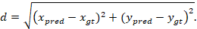

For segmentation evaluation, precision, recall, F-score, Dice coefficient, and IoU are computed from predicted and ground-truth masks:
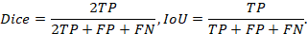

- Experimental Study
The current localization run demonstrates that the pipeline can produce accurate results on many images, but also fails badly on a small number of difficult cases. The verified current output contains 413 localization cases. The best optic disc error is 27.51 px and the worst is 2806.23 px. For fovea localization, the best error is 9.00 px and the worst is 1545.91 px. This indicates substantial variability across the dataset.

A compact summary of the current segmentation result is shown below.

Metric | Value
Precision | 0.1829
Recall | 0.6898
F-score | 0.2775
Dice | 0.2775
IoU | 0.1737
The segmentation results show a strong recall-precision trade-off. The method captures a large portion of the optic disc pixels, but it also includes many false positives around bright vessels, lesions, and neighboring retinal structures. The best per-image F-score reaches 0.8308, while several images fall near zero when thresholding fails to isolate the disc correctly.
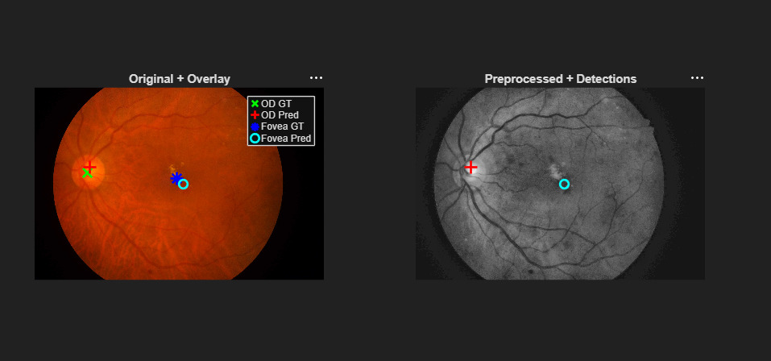
Figure 1: Qualitative Results for OD and Fovea Localization
- Conclusions
This project demonstrates a complete classical image-processing pipeline for optic disc segmentation and fovea localization. The pipeline is fully interpretable and can be executed end-to-end from a single MATLAB entry point. It provides reasonable results on many images, especially in cases with clear retinal structure and good contrast. However, the overall performance is limited by the simplicity of threshold-based segmentation and intensity-based fovea search.

The main future improvements should focus on adaptive thresholding, vessel-aware fovea search, optic disc boundary refinement, and more robust geometric modeling. Methods such as Hough circles, active contours, or deep learning-based segmentation would likely reduce the current false positives and improve robustness against image variation.
- References
- E. Porwal et al., IDRiD dataset paper.
- K. Zuiderveld, “Contrast Limited Adaptive Histogram Equalization,” in Graphics Gems IV, 1994.
- R. C. Gonzalez and R. E. Woods, Digital Image Processing.

