**Testing for Ben’s Tic-Tac-Toe**

I had to do a lot of testing for this project. First off lets just start with winning game combinations. Here are some examples of tests where horizontal, vertical, and diagonal were successful

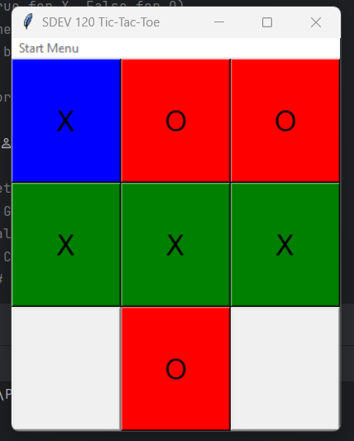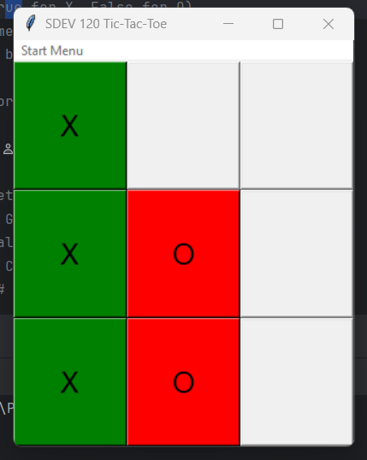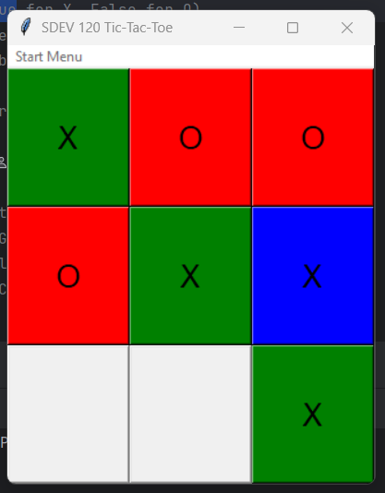

This was done across the entire board multiple times. All of the different ways are working.

When I started the X and the O just had a grey background. I decided it would be much better to have blue and red. As you can see.

After winning game combinations. I wanted to make sure I had a section where the user was prompted to type their initials. You are only allowed to type 3 LETTERS, not numbers or symbols. You can’t type less than 3 letters either. (This is something ill probably fix after the class is over) but if you don’t type three letters you are met with this.

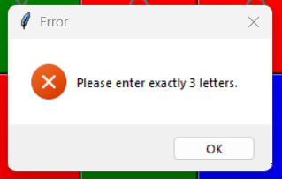

If you type less than 3 letters this box appears. Or if you type symbols or numbers. At first it was allowing you to type more than three letters and that bothered me. I had the system in place to type your name or whatever but I wanted to be like an old school arcade game so I made it so you can ONLY type in 3 letters.

After getting the game working and these errors put in I noticed that the window was starting at the top left of the screen. I decided to “center the windows” so when the player starts the program it appears right in the middle of the screen. Like this.

This was successful so I implemented it for all windows. No matter which window you select you are met with a centered application.

For the Game history section of the game I didn’t like how the Date and time were being presented. When I found the code to implement this, It had the date backwards, and the time was military. I changed it so it gives you standard time and the “American” way of showing the date (Month/Date/Year). Then it shows the players initials.

Now it looks like this

I was having trouble with the quit button after the program had run. Once you had declared a winner and entered in the initials it would take you back to the start screen. But I noticed that after the quit button wouldn’t work. You would have to click it 6 times and then it would end the application. I found out it had something to do with the Tk() being listed multiple times in the code. After some digging I changed the function in the quit button to exit the entire system and that seemed to work. Haven’t had any problems since. The application is working perfectly for me now.