**Southern**i**New**i**Hampshire**i**University**

**CS320**

**Juan**i**Velasquez**

## Functionality

GraviososiSalvaresidashboardihelpsigivesiusersicertainidataitypesiregardingitheirecuseianimalifilesiinitheidatabaseianimalishelter.iItilistsieverythingitheyineediwithinicategoriesilikeiwaterirescue,imountainioriwildernessirescue,iandidisasterioriindividualitracking.iThisiletsiusersireallyinarrowidowniwhatitheyiareilookingiforiwithinitheidatafile.iTheigraphsihelpitheiusersivisuallyiseeitheidataiinsteadiofijustireadinginumbersiaboutitheidata.iTheipieichartishows,itheibreediandigeolocation,ialsoiages.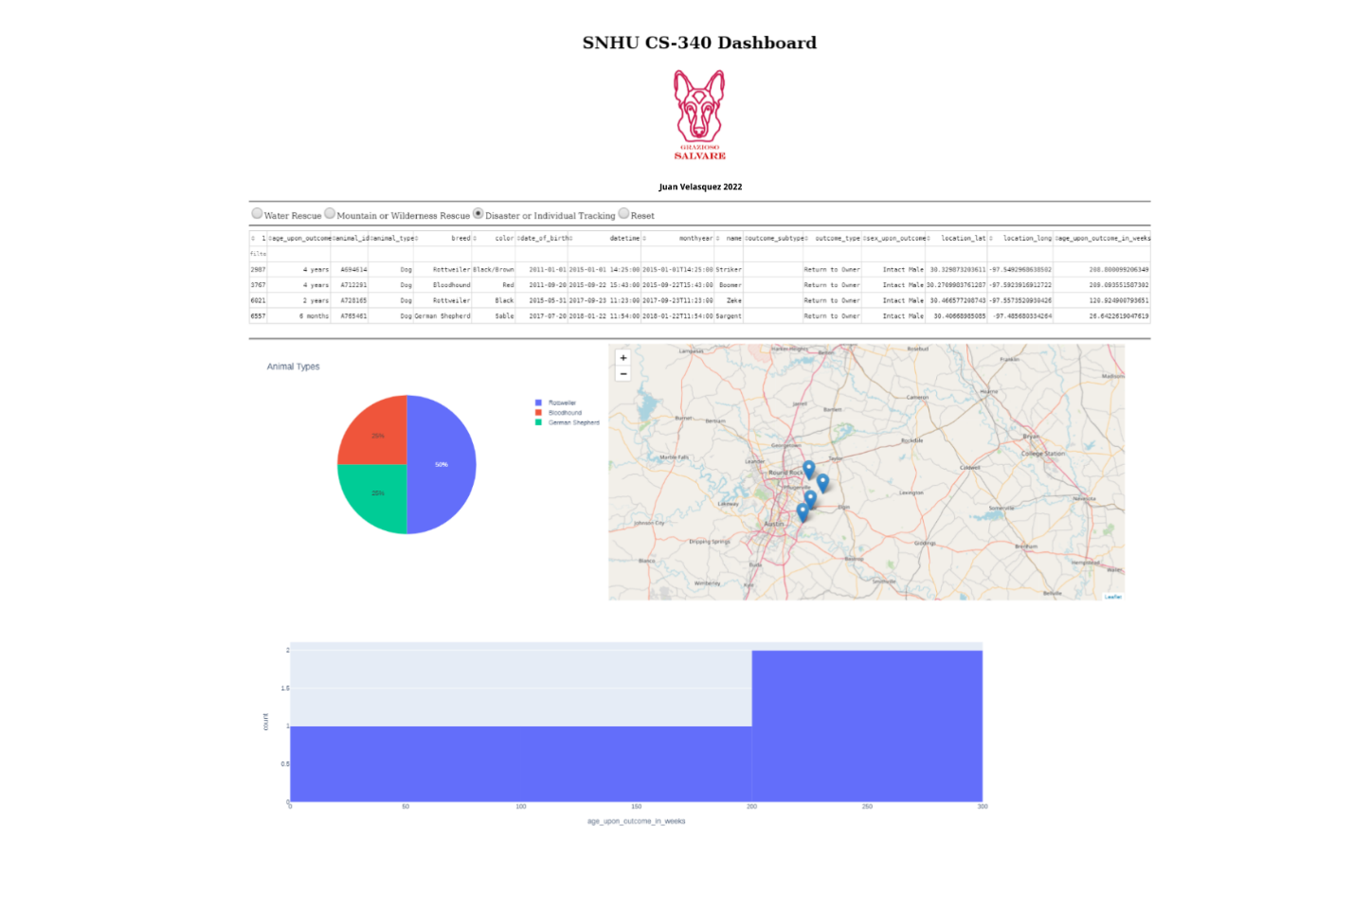

**Tools**

**Python**:iisitheiprogrammingilanguageithatithisiwasiwritteniin,ilotsiofivariablesianditheicorrectisyntaxiwasineedediforithisitoiworkiproperly.

**Dash**:iaiframeworkiwasineededitoiincorporateicertainifeaturesitoiinteractiwithiweb-basedifunctions

**Jupyter**i**Notebook**:ithisiwasianiIDEithatiwasiuseditoiwriteitheipythonicodeitestiproceduresianditheimainifunctionsimethodsiandiwasiuseditoigetitheiresults.i

**MongoDB**:iThisiwasiuseditoistoreitheidocumentsiandicollectionsiforitheiassignmentsiandikeptieverythingiorganizediwheniiticameitoitheiCRUDimethod.i

**Steps**

TheifirstistepiIitookiwasiimportingitheicorrectidocumentsiintoitheimongoiplatform.iThisiisitheimostiimportantistepibecauseipythonineedsitoiknowiwhatidocumentsitheyiareiimplementingitheicrudimethod.iAnotheriimportantistepiwasiwritingitheicrudimethodiiniorderitoicreate,iread,iupdate,iandideleteifunctionsisoithatimongoDBicanihandleiit.iTheniIineededitoimakeisureieverythingiwasiauthenticatediandithatiusersicredentialsiworkedisufficientlyiinitheimongoDBiplatform.iTheinextistepiwasitheifrontiendiapplicationiprocessithisiwasiusediwithidashiandithenisomeibuttonsiwhereineededitoifilterithroughitheidatabases.i

**Challenges**

TheimainichallengeiIicameiacrossiwasiusingitheidashitoigetitheifrontiwebiapplicationiworkingiproperly.iIifoundiitidifficultitoilearnihowitoigetiititoirunisuccessfullyiwithiinitheidatabaseifromimongo.iButiIiwasiableitoigetiitiupiandirunningismoothly.iAnotherichallengediIifaceiwasiactuallyitheicrudimethod,iIikeptihavingitoireferibackitoitheidocumentsiprovidediwheniiticameitoitheideleteifunction.i

## Contact

Velasquez Juan