Class Presentation
SQL
(DDL & DML)
Submitted By Submitted To,
Sharad Dubey Vani Mam

SQL
- SQL is Structured Query Language, which is a computer language for storing, manipulating and retrieving data stored in a relational database.
- SQL was the first commercial language
introduced for EF Codd's Relational model.
- Today almost all RDBMS ( MySql, Oracle, Infomix, Sybase, MS Access) uses SQL as the standard database language
- SQL functions fit into two broad categories
—Data definition language (DDL)
—Data manipulation language (DML)
- Based on relational algebra, but not entirely identical.
—Relations Tables
—Tuples Rows
—Attributes Columns

DML
- Data Manipulation Language (DML) statements are used for managing data within database.
- DIML commands are not auto-committed. It means changes are not permanent to database, they can be rolled back.
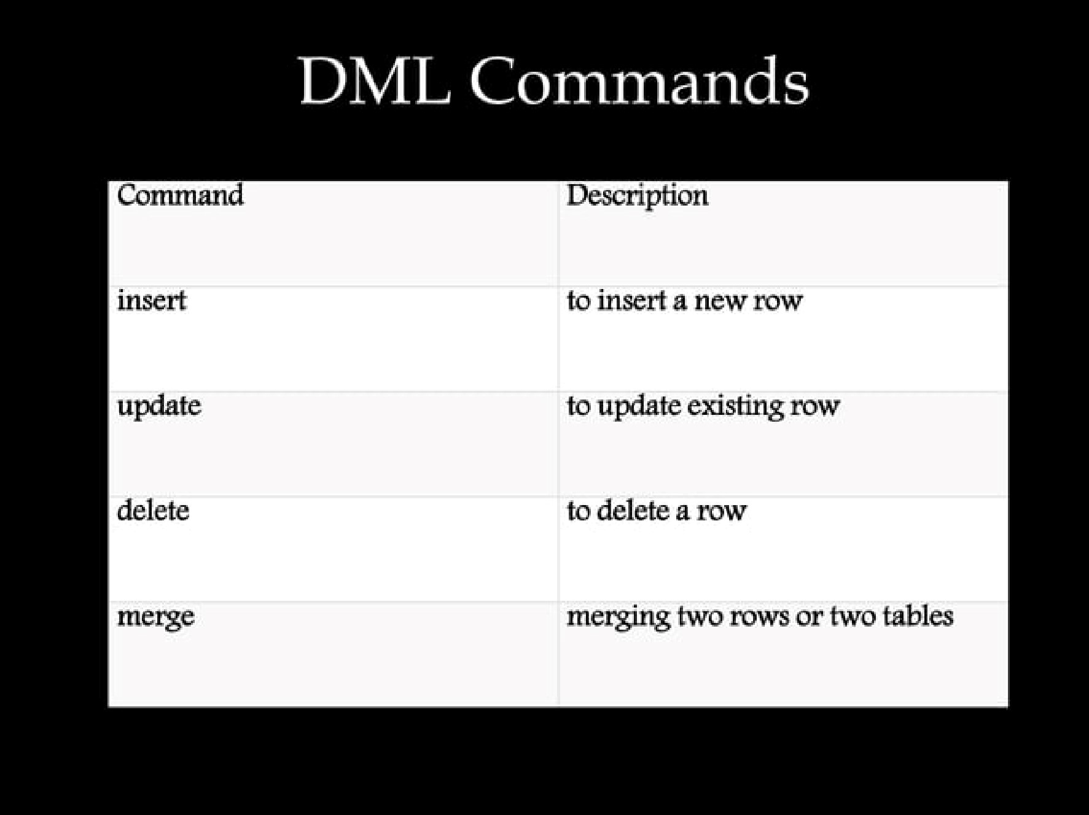

Insert
- Insert command is used to insert data into a table.
- Following is its general syntax,
INSERT into table-name values(datal ,data2.)
- For e.g.-
Consider a table Student with following fields.
S Name
- INSERT into Student values(101,'Adam ^{t},15);
The above command will insert a record

into Student table.
S Name age
101 15

Update
- Update command is used to update a row of a table.
- Following is its general syntax,
UPDATE table-name set column-name value

where condition;
S Name age
- 15
- Alex 18
103
• UPDATE Student set where s id-103;
The above command will update two columns of a record.

S id S Name
- 15
- Alex 18
- Abhi 17
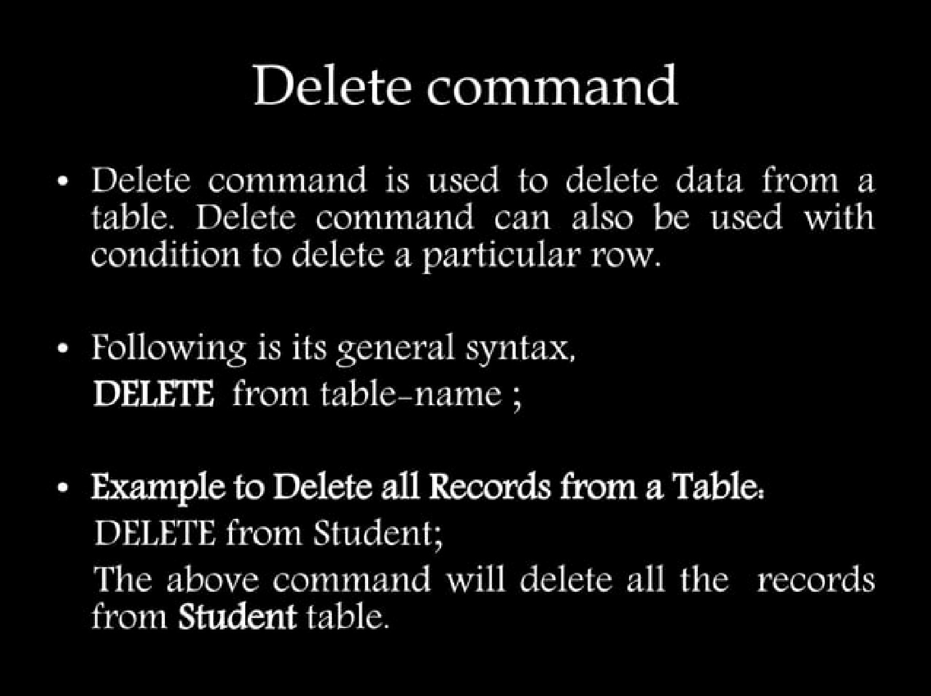

Example to Delete a particular Record from a
Table
• Consider the following Student table

S id S Name age
- 15
- 18
- Abhi 17

DELETE from Student where s id-103;
The above command will delete the record where s id is 103 from Student table.
Name age

- 15
- Alex 18

DDL
- Data Definition Language (DDL) statements are used to define the database structure or schema.
- All DDL commands are auto-committed. That means it saves all the changes permanently in the database.
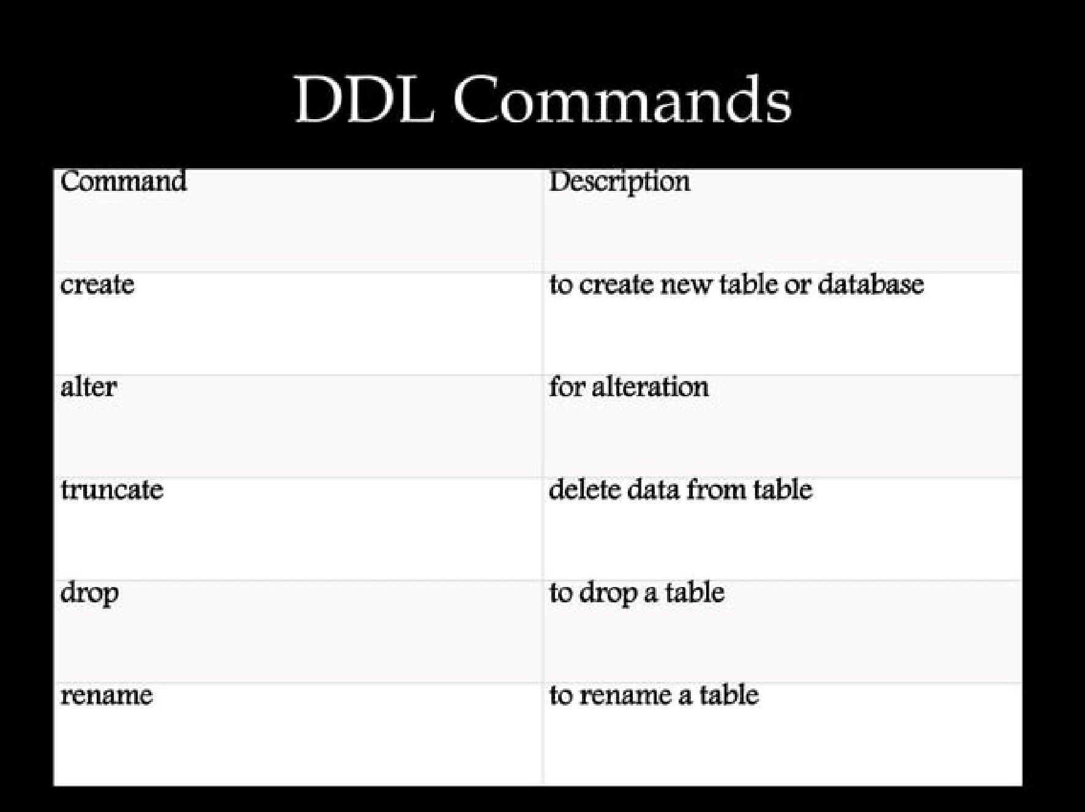

Create
- Create is a DDL command used to create a table or a database.
- Following is the Syntax, create database database-name;
- Example for Creating Database, create database Test;

Alter
• Alter command is used for alteration of table structures. There are various uses of alter command, such as,
Vto add a column to existing table
V to rename any existing column
Vto change datatype of any column or to modify its size.
Walter is also used to drop a column

Truncate
- Truncate command removes all records from a table. But this command will not destroy the table's structure. When we apply truncate command on a table its Primary key is initialized.
- Following is its Syntax, truncate table table-name;

Drop
- Drop query completely removes a table from database. This command will also destroy the table structure
- Following is its Syntax, drop table table-name;
- For Exampledrop table Student;

Rename
- Rename command is used to rename a table.
- Following is its Syntax, rename table old-table-name to new-table-name;
- For Example-
rename table Student to Student-record;
The above query will rename Student table to Student-record.


