7)

A

A->B = 4 1 A,G

A->G = 1 3 A,C

A->C = 3 4 A,B

--------------------------------------------------------

A->G

A->C = 3 3 A,C

A->B = 4 3 G,F

G->E = 7 4 A,B

G->F = 3 7 G,E

--------------------------------------------------------

A->G(1) /// A->C(3)

G->F = 3 3 G,F

A->B = 4 4 A,B

G->E = 7 7 G,E

C->F = 8 8 C,F

C->D = 11 11 C,D

--------------------------------------------------------

A->G(1)->F(3) /// A->C(3)

A->B = 4 4 A,B

G->E = 7 7 G,E

C->F = 8 8 C,F

C->D = 11 10 F,H

F->H = 10 11 F,H

--------------------------------------------------------

A->G(1)->F(3) /// A->C(3) /// A->B(4)

G->E = 7 7 G,E

C->F = 8 7 B,E

C->D = 11 8 C,F

F->H = 10 10 F,H

B->E = 7 11 C,D

--------------------------------------------------------

A->G(1)->F(3) /// A->G(1)->E(7) /// A->C(3) /// A->B(4)

C->F = 8 7 B,E

C->D = 11 8 C,F

F->H = 10 10 F,H

B->E = 7 11 C,D

--------------------------------------------------------

A->G(1)->F(3) /// A->G(1)->E(7) /// A->C(3) /// A->B(4)

C->F = 8 8 C,F

C->D = 11 10 F,H

F->H = 10 11 C,D

--------------------------------------------------------

A->G(1)->F(3) /// A->G(1)->E(7) /// A->C(3) /// A->B(4)

C->D = 11 10 F,H

F->H = 10 11 C,D

--------------------------------------------------------

A->G(1)->F(3)->H(10) /// A->G(1)->E(7) /// A->C(3) /// A->B(4)

C->D = 11 11 C,D

--------------------------------------------------------

A->G(1)->F(3)->H(10) /// A->G(1)->E(7) /// A->C(3)->D(11) /// A->B(4)

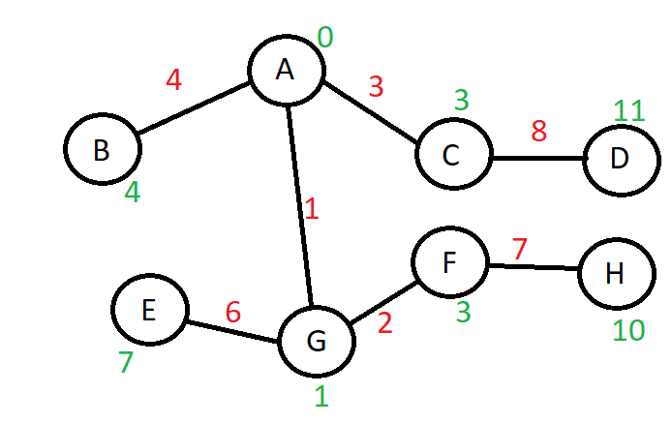

8)

|  |  |  |  |  |  |  |  |  |
| --- | --- | --- | --- | --- | --- | --- | --- | --- |
| - | A | B | C | D | E | F | G | H |
| A | - | 4 | 3 | 0 | 0 | 0 | 1 | 0 |
| B | 4 | - | 0 | 0 | 3 | 0 | 0 | 0 |
| C | 3 | 0 | - | 8 | 0 | 5 | 0 | 0 |
| D | 0 | 0 | 8 | - | 0 | 0 | 0 | 5 |
| E | 0 | 3 | 0 | 0 | - | 0 | 6 | 0 |
| F | 0 | 0 | 5 | 0 | 0 | - | 2 | 7 |
| G | 1 | 0 | 0 | 0 | 6 | 2 | - | 0 |
| H | 0 | 0 | 0 | 5 | 0 | 7 | 0 | - |

9)

|  |  |  |  |  |
| --- | --- | --- | --- | --- |
| A -> | B,4 -> | C,3 -> | G,1 -> | / |
| B -> | A,4 -> | E,3 -> | / |  |
| C -> | A,3 -> | D,8 -> | F,5 -> | / |
| D -> | C,3 -> | H,5 -> | / |  |
| E -> | B,3 -> | G,6 -> | / |  |
| F -> | C,5 -> | G,2 -> | H,7 -> | / |
| G -> | A,1 -> | E,6 -> | F,2 -> | / |
| H -> | D,5 -> | F,7 -> | / |  |
| / |  |  |  |  |

10)

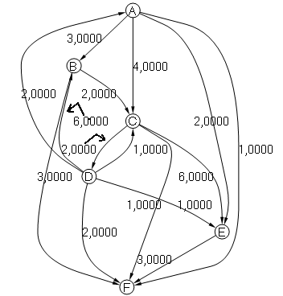

11)

Public int contarGrau()

{  
 return (edgesGoing.Count() + edgesComing.Count());

}

12)

A)Jorge

B)Jaime, Francisco

C)Jorge, Francisco, Frederico, Suzana