CS 480, Senior Project Proposal

Micah Argeropoulos

David Germain

1/15/2018

# Project Introduction

We would like to make an online replica of the turn-based strategy game [Blokus](https://en.wikipedia.org/wiki/Blokus). Players own an identical set of polyominoes. Players take turns placing a polyomino on the board. The first move is in a designated location; depending on the game variation, this could be a corner or closer in to the center of the board. Following polyominoes must be placed at the corner of the player’s previously placed polyominoes. However, the same piece may border opponents’ polyominoes anywhere. A player is out when they can no longer make valid moves. The game ends when all players are out of moves. Each square of a polyomino is worth one point. The player with the most points on the board wins.

The game will be one versus one; human versus human, AI versus human, and AI versus AI.

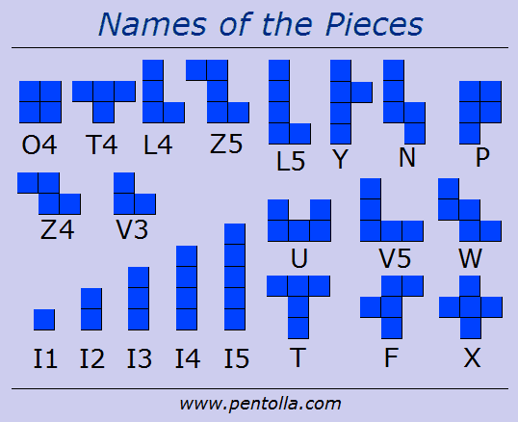

# Core Functionality (end goals)

Players place polyominoes and the server manage turns

Detect when the game is over, score the game, and display win screen.

Start screen with settings

User on client-side can rearrange unused polyominoes

Highlight the player’s open corners.

Highlight the possible placements of the selected piece at specific orientation.

Highlight each players’ most recently placed polyomino.

Setting page

Text chat

Editable username

AI has different difficulties (machine learning?)

Pass remaining turns

Create a notation for recording matches.

Export match as a file.

Watch replay

# Polish

Pretty UI

Notify the play when it is their turn.

Sound effects

AI profile pictures

Some way to contact us, the creators.

# Extra Credit

Live preview of piece in hand

Blunder detection

AI has chat personalities (taunts and applaud good and bad moves)

AI profile animated reactions

Polyomino rotation animation

Polyomino flip animation

Store previous matches on server