Improving Sacramento Light Rail Ridership by Promoting Light Rail Destinations
Introduction
Sacramento is home to a light rail system operated by the Sacramento Regional Transit. Their main customers are work commuters. For non-commuters the light rail is less popular. To improve ridership outside of the normal work-commute, the light rail system should promote popular destinations that are close to the light rail. Marketing by Sacramento Regional Transit that highlights the most popular destinations near the light rail could increase the appeal of taking light rail and increase ridership. This information would also be important for people visiting Sacramento, such as guests to the new hotel near the University and 65th St light rail station. Currently, there is no information on main attractions in proximity to light rail stations. Data science tools can quickly compile this information from the Internet to create new marketing materials to improve ridership.
Data
Light rail station locations and data from Foursquare, a website that collects venue information, will be used to provide the best-rated destinations in proximity to the light rail. Locations of the light rail stations come from the Sacramento Area Council of Governments (SACOG), which has a data repository available to the public. The light-rail station locations are shown in the Appendix. (http://data-sacog.opendata.arcgis.com/datasets/66dbe2e5407a443aa019f21839d4ebde_0) Information on venues within a half-mile (800 meters) radius from each light rail station will be collected by an “explore-call” to Foursquare’s API for each light rail location. Calls for each venue in the Foursquare API will be used to compile each venue’s rating.
Methodology
There are 54 distinct light rail stations along 3 lines in the system. The Gold Line runs from downtown Sacramento to Folsom. The Blue Line runs from north Sacramento to south Sacramento. The Green Line runs through downtown up to north downtown, but its future end destination will be the Sacramento International Airport.
Foursquare found 2,513 venues within a half-mile (800 meters) from a light rail station. After removing duplicate records for venues that were within one-half mile from multiple stations, there were 1,114 distinct venues remaining. The fields in the stations’ venues table include the name of the station, ‘Station’; station location coordinates, ‘Station Latitude’, ‘Station Longitude’; Foursquare’s unique venue ‘ID’, the venue name, ‘Venue’; the venue location coordinates, ‘Venue Latitude’, ‘Venue Longitude’, and the type of venue, ‘Venue Category’.
Ratings of each venue were compiled through calls to the Foursquare API using the venue’s Foursquare ID. Each venue and rating were then merged to the stations’ venues table on Venue ID.
Distance in miles to the closest light rail station for each venue was calculated using the Station and Venue location coordinates. The venue with the shortest distance to a light rail station was kept, while the records with longer distances for the same venue were dropped.
A view of the first two records in the venues table is displayed below. Notice that some venues are not rated on Foursquare and therefore have a rating of ‘NaN’.
Table 1: First Two Records of the Venues Table
 | Station | Station Latitude | Station Longitude | ID | Venue | Venue Latitude | Venue Longitude | Venue Category | Rating | Distance
0 | Marconi | 38.62124 | -121.42494 | 4d52bde4747f6dcbc25ed0d4 | 7-Eleven | 38.620045 | -121.419002 | Convenience Store | 6.0 | 0.331767
1 | Marconi | 38.62124 | -121.42494 | 4fab3115e4b00ae4ab25b4b2 | A & M Food & Liquor | 38.621162 | -121.423559 | Convenience Store | NaN | 0.074933

Chart 1, below, shows a bar graph of the number of venues that received each rating. Ratings ranged from a high of 9.3 to a low of 4.8. A statistical summary of ratings is shown below that in Table 2. After removing unrated venues, there are 808 venues counted. The mean average rating is 7.26 and the median is 7.3.
Chart 1: Number of Venues that Received Each Rating
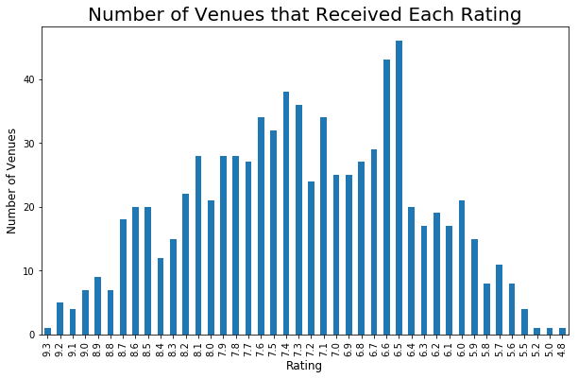
Table 2: Summary Statistics of Venue Ratings
count 808.000000
mean 7.264604
std 0.870747
min 4.800000
25% 6.600000
50% 7.300000
75% 7.900000
max 9.300000
Name: Rating, dtype: float64
Map 1, below, shows all the venues within a half-mile from each light rail station. Venues are represented by the blue markers and the light rail stations are the black markers.
Map 1 – Venues Compiled From Foursquare in Proximity the Light Rail
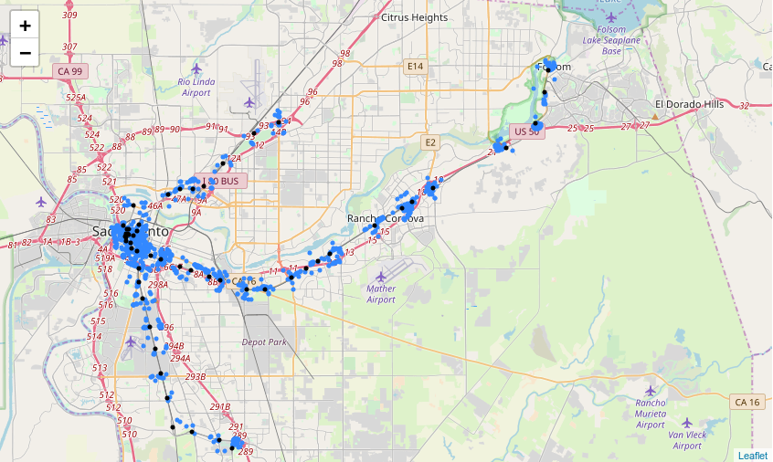
Results
In the Results section, we will review the venues and stations that Sacramento’s Regional Transit would want to promote as top destinations provided by the light rail.
Table 3, below, lists the top-rated venues, represented by venues with ratings of 8.8 or greater. The table is sorted in descending order by venue rating, where the best-rated venue is listed first. Regional Transit should promote these venues as light rail destinations to current and potential riders. The top venues include the Crocker Art Museum, Capitol Park, a grocery store called the Natural Foods Co-Op, a coffee shop Old Soul Co., a restaurant called Ella Dining Room & Bar, the State Capitol and the new arena for the Sacramento Kings called the Golden 1 Center. Building partnerships with these businesses could help improve ridership numbers for the light rail.
Table 3 – List of Top-Rated Venues with Rating of 8.8 or Greater
 | Station | Venue Category | Rating | Distance
Venue
Crocker Art Museum | 7th & Capitol | Art Museum | 9.3 | 0.44
Miosa Bride | Cathedral Square | Bridal Shop | 9.2 | 0.10
Capitol Park | Archives Plaza | Park | 9.2 | 0.21
Sacramento Natural Foods Co-op | 29th Street | Grocery Store | 9.2 | 0.07
The Sandwich Spot | 16th Street | Sandwich Place | 9.2 | 0.18
Old Soul Co. | 16th Street | Coffee Shop | 9.2 | 0.45
Ella Dining Room & Bar | Cathedral Square | American Restaurant | 9.1 | 0.06
California State Capitol | Archives Plaza | Capitol Building | 9.1 | 0.15
Golden 1 Center | 7th & K | Basketball Stadium | 9.1 | 0.09
Temple Coffee & Tea | 29th Street | Coffee Shop | 9.1 | 0.08
The Firehouse Restaurant | Sac Valley | American Restaurant | 9.0 | 0.35
California State Railroad Museum | Sac Valley | History Museum | 9.0 | 0.24
Track 7 Brewing Co. | City College | Brewery | 9.0 | 0.27
Temple Coffee & Tea | 9th & K | Coffee Shop | 9.0 | 0.06
Taylor's Market | 4th Ave/Wayne Hultgren | Grocery Store | 9.0 | 0.04
Zocalo | 16th Street | Mexican Restaurant | 9.0 | 0.42
South | 13th Street | Southern / Soul Food Restaurant | 9.0 | 0.24
Karen's Bakery & Cafe | Historic Folsom | Café | 8.9 | 0.10
Green Acres Nursery & Supply | College Greens | Garden Center | 8.9 | 0.24
Mother | Cathedral Square | Vegetarian / Vegan Restaurant | 8.9 | 0.04
Queen Sheba Ethopian Restaurant | Broadway | Ethiopian Restaurant | 8.9 | 0.18
Tower Cafe | Broadway | New American Restaurant | 8.9 | 0.32
Pipeworks | Alkali Flats | Gym | 8.9 | 0.47
Dad's Kitchen | 4th Ave/Wayne Hultgren | Diner | 8.9 | 0.07
Bottle & Barlow | 13th Street | Salon / Barbershop | 8.9 | 0.07
Mikuni | 12th & I | Sushi Restaurant | 8.9 | 0.35
Samuel Horne's Tavern | Historic Folsom | Gastropub | 8.8 | 0.21
Grange | 9th & K | New American Restaurant | 8.8 | 0.11
Coin-Op Game Room | 9th & K | Bar | 8.8 | 0.02
Freeport Bakery | 4th Ave/Wayne Hultgren | Bakery | 8.8 | 0.06
Lou's Sushi | 29th Street | Sushi Restaurant | 8.8 | 0.18
Zuda Yoga | 16th Street | Yoga Studio | 8.8 | 0.32
Uncle Vito's Slice of NY | 16th Street | Pizza Place | 8.8 | 0.19

Another way to present destinations for light rail riders is to promote individual light rail stations. This can be done by grouping the top five venues for each light rail station then promoting the stations that have the best-rated venues. Table 4, below, lists the top five venues near each station, sorted by the mean average rating of the top five venues near each light rail station where the stations with the best rated venues are listed first. Regional Transit should promote stations with the highest average ratings, and ignore those with the lowest scores. There are also five stations not in Table 4. Four of these stations did not have a rated venue within a half-mile of the light rail station. There is one station at Capitol and 8th St where all the venues within a half-mile were closer to another light rail station.
Table 4 – Top 5 Venues Near Each Light Rail Station
 |  | Venue | Venue Category | Venue Rating | Distance
Station | Station Rating
16th Street | 9.00 | Old Soul Co. | Coffee Shop | 9.2 | 0.45
16th Street | 9.00 | The Sandwich Spot | Sandwich Place | 9.2 | 0.18
16th Street | 9.00 | Zocalo | Mexican Restaurant | 9.0 | 0.42
16th Street | 9.00 | Uncle Vito's Slice of NY | Pizza Place | 8.8 | 0.19
16th Street | 9.00 | Zuda Yoga | Yoga Studio | 8.8 | 0.32
Cathedral Square | 8.92 | Miosa Bride | Bridal Shop | 9.2 | 0.10
Cathedral Square | 8.92 | Ella Dining Room & Bar | American Restaurant | 9.1 | 0.06
Cathedral Square | 8.92 | Mother | Vegetarian / Vegan Restaurant | 8.9 | 0.04
Cathedral Square | 8.92 | Cafeteria 15L | American Restaurant | 8.7 | 0.31
Cathedral Square | 8.92 | Pizza Rock | Pizza Place | 8.7 | 0.05
29th Street | 8.86 | Sacramento Natural Foods Co-op | Grocery Store | 9.2 | 0.07
29th Street | 8.86 | Temple Coffee & Tea | Coffee Shop | 9.1 | 0.08
29th Street | 8.86 | Lou's Sushi | Sushi Restaurant | 8.8 | 0.18
29th Street | 8.86 | Ink Eats & Drinks | American Restaurant | 8.6 | 0.32
29th Street | 8.86 | Biba | Italian Restaurant | 8.6 | 0.41
4th Ave/Wayne Hultgren | 8.82 | Taylor's Market | Grocery Store | 9.0 | 0.04
4th Ave/Wayne Hultgren | 8.82 | Dad's Kitchen | Diner | 8.9 | 0.07
4th Ave/Wayne Hultgren | 8.82 | Freeport Bakery | Bakery | 8.8 | 0.06
4th Ave/Wayne Hultgren | 8.82 | Oscar's Very Mexican Food | Mexican Restaurant | 8.7 | 0.21
4th Ave/Wayne Hultgren | 8.82 | Marie's Donuts | Bakery | 8.7 | 0.05
Sac Valley | 8.72 | California State Railroad Museum | History Museum | 9.0 | 0.24
Sac Valley | 8.72 | The Firehouse Restaurant | American Restaurant | 9.0 | 0.35
Sac Valley | 8.72 | Evangeline's | Gift Shop | 8.7 | 0.34
Sac Valley | 8.72 | Old Sacramento | Neighborhood | 8.6 | 0.30
Sac Valley | 8.72 | Rocky Mountain Chocolate Factory | Dessert Shop | 8.3 | 0.31
Historic Folsom | 8.72 | Karen's Bakery & Cafe | Café | 8.9 | 0.10
Historic Folsom | 8.72 | Samuel Horne's Tavern | Gastropub | 8.8 | 0.21
Historic Folsom | 8.72 | Snooks Candies & Ice Cream | Ice Cream Shop | 8.7 | 0.17
Historic Folsom | 8.72 | Marly & Moo | American Restaurant | 8.7 | 0.30
Historic Folsom | 8.72 | The Fat Rabbit Public House | Pub | 8.5 | 0.10
9th & K | 8.70 | Temple Coffee & Tea | Coffee Shop | 9.0 | 0.06
9th & K | 8.70 | Grange | New American Restaurant | 8.8 | 0.11
9th & K | 8.70 | Coin-Op Game Room | Bar | 8.8 | 0.02
9th & K | 8.70 | The Citizen Hotel, Autograph Collection | Hotel | 8.6 | 0.10
9th & K | 8.70 | Bud's Buffet | Sandwich Place | 8.3 | 0.09
8th & K | 8.70 | Frank Fat's | Chinese Restaurant | 8.7 | 0.08
13th Street | 8.68 | South | Southern / Soul Food Restaurant | 9.0 | 0.24
13th Street | 8.68 | Bottle & Barlow | Salon / Barbershop | 8.9 | 0.07
13th Street | 8.68 | Dad's Sandwiches | Sandwich Place | 8.6 | 0.15
13th Street | 8.68 | Urban Roots Brewing & Smokehouse | Brewery | 8.6 | 0.39
13th Street | 8.68 | Fox & Goose Public House | Pub | 8.3 | 0.18
Broadway | 8.64 | Tower Cafe | New American Restaurant | 8.9 | 0.32
Broadway | 8.64 | Queen Sheba Ethopian Restaurant | Ethiopian Restaurant | 8.9 | 0.18
Broadway | 8.64 | Tower Theatre | Indie Movie Theater | 8.7 | 0.33
Broadway | 8.64 | Sunh Fish | Fish Market | 8.4 | 0.28
Broadway | 8.64 | Jamba Juice | Juice Bar | 8.3 | 0.36
Alkali Flats | 8.50 | Pipeworks | Gym | 8.9 | 0.47
Alkali Flats | 8.50 | Taqueria Jalisco | Mexican Restaurant | 8.7 | 0.31
Alkali Flats | 8.50 | Sampino’s Towne Foods | Deli / Bodega | 8.3 | 0.36
Alkali Flats | 8.50 | Northstar Holistic Collective | Marijuana Dispensary | 8.3 | 0.14
Alkali Flats | 8.50 | Shine - Coffee | Art | Music | Coffee Shop | 8.3 | 0.17
7th & Capitol | 8.48 | Crocker Art Museum | Art Museum | 9.3 | 0.44
7th & Capitol | 8.48 | Morton's The Steakhouse | Steakhouse | 8.6 | 0.03
7th & Capitol | 8.48 | Il Fornaio | Italian Restaurant | 8.4 | 0.20
7th & Capitol | 8.48 | Riverfront Promenade | Pedestrian Plaza | 8.4 | 0.46
7th & Capitol | 8.48 | House Kitchen & Bar | New American Restaurant | 7.7 | 0.11
Archives Plaza | 8.44 | Capitol Park | Park | 9.2 | 0.21
Archives Plaza | 8.44 | California State Capitol | Capitol Building | 9.1 | 0.15
Archives Plaza | 8.44 | Zia's Delicatessen | Sandwich Place | 8.2 | 0.23
Archives Plaza | 8.44 | The California Museum | Museum | 8.0 | 0.08
Archives Plaza | 8.44 | Fluid Espresso Bar | Coffee Shop | 7.7 | 0.16
City College | 8.36 | Track 7 Brewing Co. | Brewery | 9.0 | 0.27
City College | 8.36 | Curtis Park | Park | 8.4 | 0.40
City College | 8.36 | Chipotle Mexican Grill | Mexican Restaurant | 8.3 | 0.48
City College | 8.36 | The Sandwich Spot | Sandwich Place | 8.2 | 0.31
City College | 8.36 | Meet and Eat | American Restaurant | 7.9 | 0.33
12th & I | 8.34 | Mikuni | Sushi Restaurant | 8.9 | 0.35
12th & I | 8.34 | Sacramento Theatre Company | Theater | 8.4 | 0.21
12th & I | 8.34 | The Torch Club | Nightclub | 8.2 | 0.24
12th & I | 8.34 | P.F. Chang's | Chinese Restaurant | 8.1 | 0.34
12th & I | 8.34 | Lucca Restaurant & Bar | Mediterranean Restaurant | 8.1 | 0.37
7th & K | 8.30 | Golden 1 Center | Basketball Stadium | 9.1 | 0.09
7th & K | 8.30 | Century DOCO and XD | Movie Theater | 8.2 | 0.21
7th & K | 8.30 | Yard House | American Restaurant | 8.2 | 0.22
7th & K | 8.30 | Macy's Taste Bar Cafe | Café | 8.0 | 0.20
7th & K | 8.30 | Kimpton Sawyer Hotel | Hotel | 8.0 | 0.13
48th Street | 8.28 | OneSpeed Pizza | Pizza Place | 8.6 | 0.26
48th Street | 8.28 | Trader Joe's | Grocery Store | 8.6 | 0.27
48th Street | 8.28 | Chocolate Fish Coffee | Coffee Shop | 8.4 | 0.27
48th Street | 8.28 | The Shack | Pub | 8.3 | 0.37
48th Street | 8.28 | Burr's Fountain | Ice Cream Shop | 7.5 | 0.27
23rd Street | 8.24 | The Waterboy | French Restaurant | 8.6 | 0.46
23rd Street | 8.24 | Federalist Public House & Beer Garden | Beer Garden | 8.4 | 0.43
23rd Street | 8.24 | Localis | New American Restaurant | 8.2 | 0.22
23rd Street | 8.24 | Kupros Craft House | Bar | 8.1 | 0.47
23rd Street | 8.24 | Zelda's Original Gourmet Pizza | Pizza Place | 7.9 | 0.34
Tiber | 8.23 | Capital Christian Center | Church | 8.6 | 0.48
Tiber | 8.23 | TOGO'S Sandwiches | Sandwich Place | 8.5 | 0.19
Tiber | 8.23 | Pine Tree House | Korean Restaurant | 7.6 | 0.26
College Greens | 8.14 | Green Acres Nursery & Supply | Garden Center | 8.9 | 0.24
College Greens | 8.14 | Roma II Pizzeria | Pizza Place | 8.2 | 0.16
College Greens | 8.14 | Sae Jong Teriyaki | Asian Restaurant | 8.0 | 0.27
College Greens | 8.14 | Starbucks | Coffee Shop | 7.8 | 0.06
College Greens | 8.14 | Raley’s | Supermarket | 7.8 | 0.12
8th & O | 8.08 | Insight Coffee Roasters | Coffee Shop | 8.7 | 0.34
8th & O | 8.08 | Wicked wich | Food Truck | 8.5 | 0.46
8th & O | 8.08 | Southside Park | Park | 7.8 | 0.46
8th & O | 8.08 | Capital Athletic Club | Gym / Fitness Center | 7.8 | 0.06
8th & O | 8.08 | Chocolate Fish Coffee Roasters | Coffee Shop | 7.6 | 0.43
Iron Point | 8.02 | Nike Factory Store | Sporting Goods Shop | 8.5 | 0.07
Iron Point | 8.02 | Century Folsom 14 | Movie Theater | 8.4 | 0.21
Iron Point | 8.02 | Coach Factory Outlet | Accessories Store | 8.1 | 0.19
Iron Point | 8.02 | Gap Factory Store | Clothing Store | 7.7 | 0.23
Iron Point | 8.02 | Teriyaki Station | Asian Restaurant | 7.4 | 0.14
University/65th St | 7.92 | Hornet Stadium | College Stadium | 8.1 | 0.33
University/65th St | 7.92 | Tower Brewing | Brewery | 8.1 | 0.16
University/65th St | 7.92 | The WELL at Sac State | College Gym | 7.9 | 0.37
University/65th St | 7.92 | Pita Pit | Sandwich Place | 7.8 | 0.11
University/65th St | 7.92 | Bikram Yoga Sacramento | Yoga Studio | 7.7 | 0.17
Cordova Town Center | 7.90 | KP International Market | Supermarket | 8.2 | 0.10
Cordova Town Center | 7.90 | Jamba Juice | Juice Bar | 8.1 | 0.28
Cordova Town Center | 7.90 | MOD Pizza | Pizza Place | 7.9 | 0.27
Cordova Town Center | 7.90 | El Puerto Mexican Restaurant | Mexican Restaurant | 7.7 | 0.12
Cordova Town Center | 7.90 | New York Bagel | Bagel Shop | 7.6 | 0.24
Sunrise | 7.78 | Brookfields Restaurant | American Restaurant | 8.5 | 0.23
Sunrise | 7.78 | Wendy's | Fast Food Restaurant | 8.0 | 0.25
Sunrise | 7.78 | California Family Fitness | Gym | 7.9 | 0.47
Sunrise | 7.78 | Formaggio Taverna and Patio | Italian Restaurant | 7.3 | 0.13
Sunrise | 7.78 | Certified Farmers' Market | Farmers Market | 7.2 | 0.10
Mather Field/Mills | 7.74 | Starbucks | Coffee Shop | 8.5 | 0.37
Mather Field/Mills | 7.74 | Rosie's Country Kitchen | Coffee Shop | 8.1 | 0.17
Mather Field/Mills | 7.74 | Planet Fitness | Gym / Fitness Center | 7.9 | 0.45
Mather Field/Mills | 7.74 | Sunrise Waffles | Breakfast Spot | 7.3 | 0.35
Mather Field/Mills | 7.74 | See's Candies | Candy Store | 6.9 | 0.47
Hazel | 7.74 | Cattlemens | Steakhouse | 8.2 | 0.13
Hazel | 7.74 | The Old Spaghetti Factory | Italian Restaurant | 8.1 | 0.18
Hazel | 7.74 | Rudy's Hideaway | Seafood Restaurant | 8.1 | 0.30
Hazel | 7.74 | Starbucks | Coffee Shop | 7.2 | 0.44
Hazel | 7.74 | Fort Rock Brewing | Brewery | 7.1 | 0.16
Zinfandel | 7.70 | Panda Express | Chinese Restaurant | 8.1 | 0.30
Zinfandel | 7.70 | Residence Inn Sacramento Rancho Cordova | Hotel | 7.9 | 0.40
Zinfandel | 7.70 | Chipotle Mexican Grill | Mexican Restaurant | 7.6 | 0.13
Zinfandel | 7.70 | Safeway | Grocery Store | 7.5 | 0.15
Zinfandel | 7.70 | Walgreens | Pharmacy | 7.4 | 0.19
Roseville Road | 7.70 | Haggin Oaks | Golf Course | 8.5 | 0.39
Roseville Road | 7.70 | Haggin Oaks Golf Super Shop | Sporting Goods Shop | 7.6 | 0.40
Roseville Road | 7.70 | Haggin Oaks Driving Range | Golf Driving Range | 7.0 | 0.46
7th & I | 7.70 | Billy's Market & Deli | Deli / Bodega | 7.7 | 0.07
59th Street | 7.70 | Corti Brothers | Grocery Store | 8.7 | 0.20
59th Street | 7.70 | Talini's Nursery & Garden Center | Garden Center | 7.7 | 0.31
59th Street | 7.70 | R/C Country Hobbies | Hobby Shop | 7.4 | 0.25
59th Street | 7.70 | Papa Murphy's | Pizza Place | 7.4 | 0.21
59th Street | 7.70 | Chipotle Mexican Grill | Mexican Restaurant | 7.3 | 0.22
Butterfield | 7.58 | Mo Du Rang | Korean Restaurant | 8.4 | 0.31
Butterfield | 7.58 | West Wind Sacramento 6 Drive-In | Drive-in Theater | 7.6 | 0.29
Butterfield | 7.58 | Pho Bac Hoa Viet - Bradshaw | Vietnamese Restaurant | 7.5 | 0.44
Butterfield | 7.58 | Golden Bowls Mongolian Bar-B-Q | Asian Restaurant | 7.2 | 0.27
Butterfield | 7.58 | Peking Restaurant | Chinese Restaurant | 7.2 | 0.27
Watt/I-80 | 7.56 | The Gun Range | Gun Range | 8.7 | 0.26
Watt/I-80 | 7.56 | Starbucks | Coffee Shop | 7.7 | 0.09
Watt/I-80 | 7.56 | Powerhouse Science Center - Discovery Campus | Science Museum | 7.4 | 0.46
Watt/I-80 | 7.56 | The Cheese Steak Shop | Sandwich Place | 7.0 | 0.09
Watt/I-80 | 7.56 | Sacramento Softball Complex | Baseball Field | 7.0 | 0.47
Cosumnes River College | 7.50 | Panda Express | Chinese Restaurant | 8.1 | 0.33
Cosumnes River College | 7.50 | Suki Sushi | Sushi Restaurant | 7.4 | 0.14
Cosumnes River College | 7.50 | Popeyes Louisiana Kitchen | Fried Chicken Joint | 7.4 | 0.19
Cosumnes River College | 7.50 | Target | Big Box Store | 7.3 | 0.42
Cosumnes River College | 7.50 | Starbucks | Coffee Shop | 7.3 | 0.42
Glenn | 7.48 | Out of Bounds Brewing Company | Brewery | 8.2 | 0.31
Glenn | 7.48 | The Original Mel's Diner | Diner | 7.9 | 0.48
Glenn | 7.48 | ampm | Convenience Store | 7.4 | 0.40
Glenn | 7.48 | The Waffle Experience | Breakfast Spot | 7.4 | 0.33
Glenn | 7.48 | Harley-Davidson of Folsom | Motorcycle Shop | 6.5 | 0.46
Fruitridge | 7.46 | La Esperanza | Supermarket | 7.9 | 0.44
Fruitridge | 7.46 | River City Gun Exchange | Sporting Goods Shop | 7.5 | 0.21
Fruitridge | 7.46 | Lalo's Restaurant | Mexican Restaurant | 7.3 | 0.32
Fruitridge | 7.46 | Jointed Cue | Pool Hall | 7.3 | 0.22
Fruitridge | 7.46 | Dairy Queen | Fast Food Restaurant | 7.3 | 0.12
Watt/Manlove | 7.44 | El Favorito Taqueria | Mexican Restaurant | 7.8 | 0.05
Watt/Manlove | 7.44 | Ninja Sushi | Sushi Restaurant | 7.5 | 0.22
Watt/Manlove | 7.44 | The Philadelphia Cheesesteak Co | Sandwich Place | 7.3 | 0.28
Watt/Manlove | 7.44 | YD House (Young Dong) | Korean Restaurant | 7.3 | 0.31
Watt/Manlove | 7.44 | Hong Kong House | Chinese Restaurant | 7.3 | 0.06
Royal Oaks | 7.34 | Chando's Tacos | Mexican Restaurant | 8.6 | 0.05
Royal Oaks | 7.34 | The Bolt | Gay Bar | 7.5 | 0.43
Royal Oaks | 7.34 | Popeyes Louisiana Kitchen | Fried Chicken Joint | 7.2 | 0.37
Royal Oaks | 7.34 | Grocery Outlet Bargain Market | Grocery Store | 6.8 | 0.31
Royal Oaks | 7.34 | Wienerschnitzel | Hot Dog Joint | 6.6 | 0.36
8th & H | 7.15 | La Bonne Soupe Cafe | Soup Place | 8.2 | 0.11
8th & H | 7.15 | 524 Mexican Restaurant | Mexican Restaurant | 6.1 | 0.37
Swanston | 6.94 | Harley Davidson of Sacramento | Motorcycle Shop | 8.1 | 0.23
Swanston | 6.94 | River City Phoenix | Marijuana Dispensary | 7.8 | 0.42
Swanston | 6.94 | Hilton Sacramento Arden West | Hotel | 6.6 | 0.33
Swanston | 6.94 | Sears Outlet | Outlet Store | 6.5 | 0.34
Swanston | 6.94 | Harvard Street Grille | American Restaurant | 5.7 | 0.33
Power Inn | 6.92 | Starbucks | Coffee Shop | 7.4 | 0.38
Power Inn | 6.92 | Starbucks | Coffee Shop | 7.2 | 0.15
Power Inn | 6.92 | El Pollo Loco | Fast Food Restaurant | 6.9 | 0.35
Power Inn | 6.92 | Hertz Rent a Car | Rental Car Location | 6.6 | 0.46
Power Inn | 6.92 | Wendy's | Fast Food Restaurant | 6.5 | 0.15
47th Ave | 6.80 | Laos Kitchen | Thai Restaurant | 7.3 | 0.45
47th Ave | 6.80 | JR's Texas Bar-B-Que | BBQ Joint | 6.3 | 0.24
Township 9 | 6.75 | Smart Foodservice Warehouse Stores | Warehouse Store | 7.6 | 0.39
Township 9 | 6.75 | Linda Taqueria | Mexican Restaurant | 6.6 | 0.42
Township 9 | 6.75 | SUBWAY | Sandwich Place | 6.5 | 0.33
Township 9 | 6.75 | FedEx | Shipping Store | 6.3 | 0.16
39th Street | 6.67 | Sunshine Cafe | Café | 7.2 | 0.46
39th Street | 6.67 | Starbucks | Coffee Shop | 6.7 | 0.27
39th Street | 6.67 | SUBWAY | Sandwich Place | 6.1 | 0.30
Starfire | 6.50 | Baskin-Robbins | Ice Cream Shop | 6.7 | 0.27
Starfire | 6.50 | SUBWAY | Sandwich Place | 6.5 | 0.32
Starfire | 6.50 | 7-Eleven | Convenience Store | 6.3 | 0.24
Arden/Del Paso | 6.44 | GOOD: Street Food + Design Market | Food Truck | 7.2 | 0.21
Arden/Del Paso | 6.44 | Stoney's Rockin Rodeo | Bar | 6.4 | 0.27
Arden/Del Paso | 6.44 | Thrift Town | Thrift / Vintage Store | 6.3 | 0.29
Arden/Del Paso | 6.44 | Iceland Skating Rink | Skating Rink | 6.2 | 0.16
Arden/Del Paso | 6.44 | KFC | Fried Chicken Joint | 6.1 | 0.07
Center Parkway | 6.40 | North Laguna Creek Park | Park | 6.4 | 0.45
Florin | 6.32 | Wienerschnitzel | Hot Dog Joint | 6.8 | 0.46
Florin | 6.32 | U-Haul Moving & Storage at Florin Rd | Storage Facility | 6.5 | 0.17
Florin | 6.32 | Adalberto's Mexican Food | Mexican Restaurant | 6.4 | 0.42
Florin | 6.32 | Little Caesars Pizza | Pizza Place | 6.0 | 0.18
Florin | 6.32 | Church's Chicken | Fried Chicken Joint | 5.9 | 0.16
Marconi | 6.00 | 7-Eleven | Convenience Store | 6.0 | 0.33

Map 2, below, highlights the stations that have the best rated destinations. The stations with the best-rated destinations are in green, stations with mid-ranged rated venues are yellow and the stations with the worst rated destinations are in red. The station rating is based on the mean average of the five best venues within one-half mile of the light rail station.
Map 2 – Light Rail Stations Highlighting Stations with Highest Rated Venues
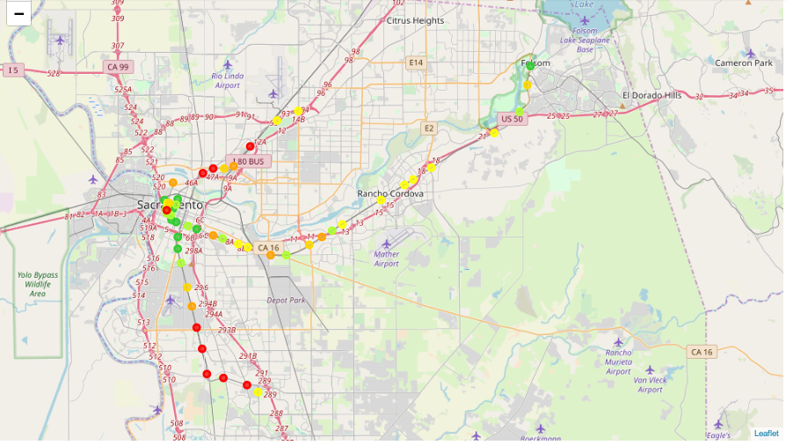
The best-rated stations are in the downtown area, expanding down to City College and out in Historic Folsom to the east.
Interactive maps that display recommended venues where the venue’s name, category, and rating appear when the marker is clicked on can provide helpful information to riders. There is a large group of recommended venues in the downtown area. Map 3, below, displays the venues on the “Grid” in Sacramento that have a rating of 8.8 or higher. Each marker color represents a specific light rail station. In Map 3, the venue Pipeworks is selected where the venue name, rating, closest light rail station, and venue category appear.

Map 3 – Closer Look at Top-Rated Venues Near Downtown Sacramento
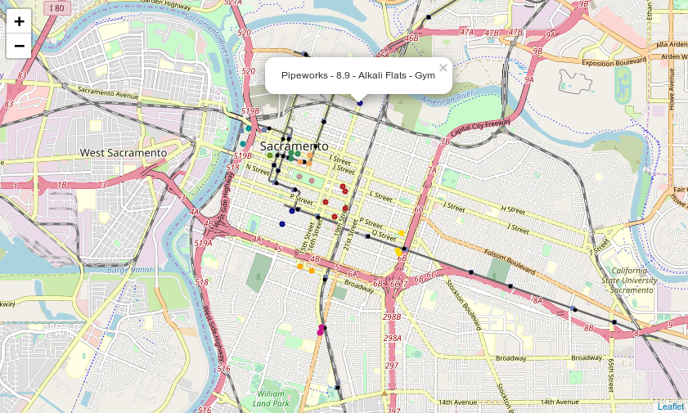

Table 5 below shows the variety of destinations the light rail has to provide among its highest rated venues. Many of the destinations are around food and beverage venues. There are also museums, fitness, and entertainment options.
Table 5 – Count of Venues with Rating of 88 or Greater by Venue Category

 | Station
Venue Category | Count
Coffee Shop | 3
American Restaurant | 2
Grocery Store | 2
Sushi Restaurant | 2
New American Restaurant | 2
Vegetarian / Vegan Restaurant | 1
Southern / Soul Food Restaurant | 1
Sandwich Place | 1
Salon / Barbershop | 1
Pizza Place | 1
Park | 1
Mexican Restaurant | 1
History Museum | 1
Gym | 1
Gastropub | 1
Art Museum | 1
Garden Center | 1
Ethiopian Restaurant | 1
Diner | 1
Capitol Building | 1
Café | 1
Bridal Shop | 1
Brewery | 1
Basketball Stadium | 1
Bar | 1
Bakery | 1
Yoga Studio | 1

Discussion
This exercise shows there are many destinations that Regional Transit can promote to improve ridership. This information used by a marketing team could entice more people to ride the light rail to improve ridership.
Regional Transit can take this information to improve the perceived value of the light rail. The light rail provides convenient transit to these destinations that include top-rated restaurants, museums, bars, grocery stores, fitness centers, and more by simply hopping on the light rail to enjoy at one’s leisure, on the weekend, or after work.
Each station has its own personality shown by this guide of highly rated venues near the light rail stations.
Come downtown to enjoy a concert or basketball game at the new arena, some fine dining at a new popular restaurant called Mother, without worrying about parking or having a designated driver.
Conclusion
Sacramento’s light rail system lacks popularity because there is little knowledge provided about popular destinations riders can enjoy by riding. Each station has its own special opportunities to enjoy at one’s leisure. However, riders are not aware of them. With this exercise, we are able to provide riders, guests, and residents the opportunities for having a fun night just by taking the light rail train and not having to worry about parking. The information could entice people to visit a new area of Sacramento to enjoy what it has to offer, from Historic Folsom to downtown, and to south Sacramento’s Broadway and Curtis Park areas, and everything in between. When someone is looking for something new to do in Sacramento they could get the idea from Regional Transit with knowledge it’s attainable by riding the light rail.
Appendix
Table 6 – List of Stations and Location Coordinates from SACOG

 | Station | Latitude | Longitude
0 | 12th & I | 38.581450 | -121.489901
1 | 13th Street | 38.571112 | -121.493731
2 | 16th Street | 38.569836 | -121.489329
3 | 23rd Street | 38.566692 | -121.478992
4 | 29th Street | 38.564645 | -121.471397
5 | 39th Street | 38.560764 | -121.457246
6 | 47th Ave | 38.511909 | -121.475913
7 | 48th Street | 38.558512 | -121.449025
8 | 4th Ave/Wayne Hultgren | 38.551589 | -121.488083
9 | 59th Street | 38.554650 | -121.435527
10 | 7th & Capitol | 38.578333 | -121.498680
11 | 7th & I | 38.582659 | -121.496810
12 | 7th & K | 38.580024 | -121.497950
13 | 8th & Capitol | 38.577472 | -121.497785
14 | 8th & H | 38.582677 | -121.495491
15 | 8th & K | 38.579778 | -121.496732
16 | 8th & O | 38.575467 | -121.498100
17 | 9th & K | 38.579548 | -121.495488
18 | Alkali Flats | 38.585414 | -121.488182
19 | Archives Plaza | 38.574374 | -121.494218
20 | Arden/Del Paso | 38.606308 | -121.457145
21 | Broadway | 38.559568 | -121.488015
22 | Butterfield | 38.567804 | -121.344592
23 | Cathedral Square | 38.578855 | -121.492340
24 | Center Parkway | 38.458386 | -121.427818
25 | City College | 38.541886 | -121.485279
26 | College Greens | 38.547067 | -121.393688
27 | Cordova Town Center | 38.598664 | -121.282923
28 | Cosumnes River College | 38.453782 | -121.418367
29 | Florin | 38.497674 | -121.471506
30 | Franklin Blvd | 38.463078 | -121.448484
31 | Fruitridge | 38.525107 | -121.479947
32 | Glenn | 38.662942 | -121.183605
33 | Globe | 38.602704 | -121.466244
34 | Hazel | 38.630419 | -121.212227
35 | Historic Folsom | 38.675963 | -121.180572
36 | Iron Point | 38.644601 | -121.190146
37 | Marconi | 38.621240 | -121.424940
38 | Mather Field/Mills | 38.584743 | -121.311311
39 | Meadowview | 38.483184 | -121.467090
40 | Morrison Creek | 38.465943 | -121.463007
41 | Power Inn | 38.547272 | -121.407402
42 | Roseville Road | 38.638707 | -121.401523
43 | Royal Oaks | 38.606189 | -121.447863
44 | Sac Valley | 38.584416 | -121.499643
45 | Starfire | 38.559341 | -121.362386
46 | Sunrise | 38.606675 | -121.266968
47 | Swanston | 38.607640 | -121.439639
48 | Tiber | 38.563891 | -121.353408
49 | Township 9 | 38.596426 | -121.491984
50 | University/65th St | 38.552615 | -121.427322
51 | Watt/I-80 | 38.645119 | -121.383441
52 | Watt/Manlove | 38.553842 | -121.373338
53 | Zinfandel | 38.594961 | -121.290724

