Microcontroller based Automatic Irrigation and Monitoring System

(MAIMS)For Small farms and Gardens

A Thesis Project

Presented to the Faculty of the

Computer engineering Program

STI College Malolos

In Partial Fulfilment

of the Requirements for the Degree

Bachelor of Science in Computer engineering.

De Castro, Miguel Jason C.

Dela Cruz, John Lherry P.

Marbella, Cliff M.

Mendoza, Carl Lloyd N.

February, 2020

ENDORSEMENT FORM FOR THESIS PROJECT DEFENSE

TITLE OF RESEARCH: Automatic Irrigation and Monitoring System

NAME OF PROPONENTS: John Lherry P. Dela Cruz

Miguel Jason C. De Castro

Cliff M. Marbella

Carl Lloyd N. Mendoza

In Partial Fulfilment of the Requirements

for the degree Bachelor of Science in Computer Engineering

has been examined and is recommended for Thesis Project Defense.

ENDORSED BY:

Mr. Christopher Rae S. Perez

Thesis Adviser

APPROVED FOR THESIS PROJECT DEFENSE

Mr. Christopher Rae Perez

Thesis Coordinator

NOTED BY:

Mr. Christopher Rae Perez

Program Head

February 2020

# APPROVAL SHEET

This thesis project titled: Automatic Irrigation and Monitoring System prepared and submitted by John Lherry P. Dela Cruz;Miguel Jason C. De Castro;Cliff M. Marbella; and Carl Lloyd N. Mendoza, in partial fulfilment of the requirements for the degree of Bachelor of Science in Computer engineering has been examined and is recommended for acceptance an approval.

Christopher Rae S. Perez

Thesis Adviser

Accepted and approved by the Thesis Review Panel

in partial fulfilment of the requirements for the degree of

Bachelor of Science in Computer Engineering

|  |  |
| --- | --- |
| Mr. Edwin Garcia | Ms. Joanne Perez |
| Local Member | Local Panel |

Mr. Leodigario Bongco

Lead Panelist

Noted:

|  |  |
| --- | --- |
| Mr. Christopher Rae S. Perez | Mr. Christopher Rae S. Perez |
| Thesis Coordinator | Program Head |

# Acknowledgements

Our group would likely to thank Sir Christopher Rae Perez Our thesis adviser and coordinator. Sir Rae have given us many consultations and provided us many suggestions and on how can we improve our project. As well as Sir Edwin Garcia who also gives ideas and inspiration to do our very best

To our parents as well who provided us support amidst of countless expenses to our project. We could not make it here without the encouragement and support of our love ones

*To God be the glory!*

# Abstract

Title of research**: Microcontroller based Automatic Irrigation and Monitoring System**

Researchers: John Lherry P. Dela Cruz

Miguel Jason C.De Castro

Cliff M.Marbella

Carl Lloyd N. Mendoza

Degree: Bachelor of Science in Computer Engineering

Date of Completion: February

Key words: Microntroller, Automatic, Irrigation and Monitoring

In Modern Times, Automation is found everywhere as it aids the humanity whether inside the manufacturing productions, Human Managements, appliances and device we have been used everyday. But as we strive to further development of the mankind by automating everything as possible it seems, agricultural sector is being left out especially in our country where planting crops have the impression of time consuming and tough to do and to monitor. While our project seems to be common with other agricultural projects. It won’t be able to help the wide agricultural fields as they have other innovative ways of collecting crops but instead the researchers study MAIMS to help persons who like to start planting crops but unable to due to having not enough time to monitor and water the plants they planting. And the researchers MAIMS to encourage people into planting inside an empty lots or empty plant beds.

# Table of Contents

|  |  |  |
| --- | --- | --- |
|  | | Page |
| Title Page | | i |
| Endorsement Form for Thesis Project Defense | | ii |
| Approval Sheet | | iii |
| Acknowledgements | | iv |
| Abstract | | v |
| Table of Contents | | vi |
| List of Tables | | vii |
| List of Figures | | viii |
| List of Appendices | | ix |
| Introduction | | 1 |
|  | Background of the problem | 2 |
|  | Overview of the current state of technology | 3 |
|  | Objectives of the study | 4 |
|  | Scope and limitations of the study | 4 |
| Literature Review | | 5 |
|  | Review of related literature, studies or systems | 7 |
|  | Synthesis | 8 |
| Microcontroller based Automatic Irrigation and Monitoring System | | 10 |
| Results and Discussions | | 13 |
| Conclusions and Recommendations | | 13 |
| References | | 17 |
| Appendices | | 18 |
|  | |  |
|  | |  |

# List of Table(s)

|  |  |  |
| --- | --- | --- |
| Table |  | Page |
| 1  2 | Test Cases  Thesis Expenses | 14  23 |
|  |  |  |

List of Figures

Figure

1 Prototyping model methodology 5

2 Irrigation Methods 7

3 MAIMS Design 8

4 MAIMS Flowchart 12

5 MAIMS Welcome display 25

6 MAIMS Ports 26

7 MAIMS Powersupply 26

8 MAIMS Welcome message 27

9 MAIMS Initialization 27

10 MAIMS UI 28

11 MAIMS Water and Moisture level 28

# List of Appendices

|  |  |  |
| --- | --- | --- |
| Appendix |  | Page |
|  | A. Gantt chart of activities | 16 |
|  | B. Actual Thesis Expenses | 18 |
|  | C. User’s Manual | 20 |
|  | D. Curriculum Vitae of Researchers | 25 |
|  |  |  |
|  |  |  |

# Introduction

Being in a generation full of automation, these days was not really as unperceivable as it used to be when we think about it way back a hundred years ago. Living in a world full of automation system and machines that are capable of performing tasks that may require a person years of experience to perform and even replace human expert in a certain profession, is very far from being just a science fiction in the current century that we are living in.

When we used to think about automation, it supposedly thinking about computer industry, commerce or any other fields that are associated with modernization. But automation is not only limited in such aspects. We can also apply automation in agriculture. Combining technology with agriculture may seem absurd for some people. As most of the small farmers are elderly and as we know most of the elderly people are not technologically adept as most of our today’s technology is built by younger generations. The technological absurdity is not only limited to elder people but it is also present to the people who is not fond of today’s current technology trend. The researchers believe that this absurdity is present among many gardeners and small farmers because they didn’t get to used it over their course of growing crops and other plants. But in today’s world where the demand for food is increasing rapidly meaning they have to double their outputs to cope up with the demand and as a result water levels inside a dam or ground water is decreasing swiftly and will greatly reduce the water supply for drinking and everyday use. The researchers believed that people who is technologically inept will be adept provided with proper training, evaluation and introduction of the current technology. It will not only help them with the automation as automation saves time and proven efficient but they will also help the environment in saving water.

Background of the problem

For many years gardening has been a hobby or profession of mankind. Whether it is in the form of ornamental gardening or crop growing truly it brings happiness and satisfaction to the gardeners whenever they see their flowers bloom or harvest their crops. But in today’s current age it seems that the number of people who do gardening are starting to dwindle in numbers. We can probably think of many factors regarding the decline in gardening. Why is it that many people are kind of reluctant towards the gardening? The most reason why people aren’t into much gardening is that they don’t have much time. Because the time they consume are being spent in works or other hobbies that can’t be compromised with gardening. The second reason is that many people here are living inside tight areas where lawns or vacant space are limited. Another reason is that many people feel that they are not suited for growing plants as they feel that these plants will eventually die out and therefore will be a waste of time and energy. This is some of the reasons why people do not want to do some gardening even though they want to.

Another focus of the problem is that the water levels inside the dam are diminishing. And the water inside the dam is being used in everyday lives such as drinking, bathing, cooking and the important agricultural sector and industrial sector. The fact is that whenever the water levels inside the dam reaches the critical limit, it will halt their irrigation operation. And when the operators halt the irrigation operations it will cause drought to many crops leading to food shortages causing high inflation to many crops such as the rice and sugarcanes. When we start to build a garden in order to maintain a good and healthy ornamental and vegetables alike. One household would consume at least 30 liters of water. During climate change where one climate phenomenon is hard to predict. We need to conserve the use of water. Last year, Angat water level plummeted into its critical level 159.78 meters on June 22, 2019. And due to this, water operations inside metro manila and other provinces are suffering water interruptions. This section does not intend people to further stray away towards gardening. In fact, the researchers wanted to encourage planting but by the means of efficiency and conserving the water. As planting, gardening provides a blissful experience when you harvest all the hard work and time you invested.

## **Overview of the current state and technology**

Approximately 10,000 years ago, human beings learned to cultivate soil for growing crops that they used for food. This enabled them to move from becoming a nomadic tribe to permanent settlers. They learned to use natural resources such as rivers for irrigation and natural fertilizers. Because of this, early civilizations tend to emerge only in locations along the river like the early Egyptians who first settled in the Nile River, the first Chinese Yangtze Civilization who first settled in the Yellow River, and the Mesopotamians who settled in Rivers Tigris and Euphrates not only utilizing the water for irrigation, but also the rich minerals that was being produced by the river is used as a natural fertilizer and made the soil fertile for cultivation.

The uses of irrigation system provided the early Egyptian for developing the one of the earliest form of commerce and business through barter system. The use of irrigation system gave birth to the creation of large farms that requires lots of manpower to manage making large scale farming a very costly process and leading farm owners to implement slavery. In other words, the use of irrigation system doesn’t really free from human beings as it’s costly and exhausting works. It just helps us to do more conveniently and increases the production of agricultural products.

Currently, most of province in the Philippines still uses manual irrigation system that uses canals that are connected to dams or river just like what the ancient Mesopotamians and Egyptian used. There are times when gardeners or farmers water their crops manually during drought or they simply don’t have a water supplier especially in rural areas. But as the population grow, the farms and vacant lands became cities and subdivision for people to live. This is where the project enters, the space for garden or plants are expected to be mostly gone in the future as urban cities grow. To solve this problem, the researchers wants to build an automated garden that is applicable and designed for urban areas. The researchers know the importance of plants because it gives food and oxygen to people.

**Objectives of the study**

To develop a system that will enhance the productivity of any farms and plantation by remote monitoring and applying automation using sensors.

To monitor the current status of plantations with user friendly android application

To lessen the manpower needed by using sensors that will automatically detect moisture in the soil.

To simplify the work needed by automatically watering the plant if the moisture sensor detected a dry soil.

## **Scopes and limitations of the study**

## **Scope**

* The system can be accessed using a user-friendly android application.
* The system is capable of detecting moisture in the soil.
* The soil can be watered automatically when the sensor detected a dry soil and can also be watered manually using the android application.
* The system provides notification through SMS.

**Limitations**

* Monitoring is only limited to the moisture of the soil and water level in the tank.
* Control is only limited to watering of the soil.
* The system doesn’t refill the water tank automatically.
* Cannot detect the flowing of water if the solenoid bulb does not work.

**LITERATURE REVIEW**

**Methodology**

Prototyping Model

We are going to conduct a system development model specifically prototyping as a method of research in developing the project. In this method, we are going to rework the prototype continuously until the perfect product is achieved. This is the best method to use for our scenario were in we don’t have all of the detailed project requirements and improvements ahead of our time. This is an iterative trial and error process between the user and the developers.

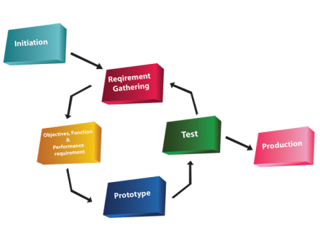 *Figure 1 Prototyping model methodology*

The step by step procedure of our prototype method are as follows:

1. We are going to gather a detailed information about the project as much as possible by interviewing experts in various departments or aspects of the existing system.
2. Next is creating the preliminary design based on the information gathered in step1
3. The first prototype will be developed based on the preliminary design.
4. Users will examine and test the design and the researchers will evaluate the suggestion for the improvement of the prototype.
5. Second prototype will be developed based on the suggested improvements of the users.
6. Users will again examine and test the 2nd prototype and will be evaluated by the researchers.
7. the process 3-6 will be iterated as many times as possible until the users are satisfied with the developed prototype.
8. The final system will be constructed based on the final prototype.
9. Regular evaluation and testing of the system will be conducted. Routine maintenance is carried out and on a continuing basis to prevent large scale failures and minimize downtime.

Review of related literature, studies or systems

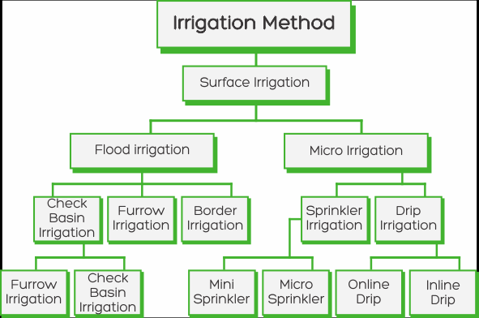

*Figure 2 Irrigation Methods*

Irrigation systems introduce several techniques in farming and agriculture industries. In our current age, people already developed several varieties of irrigation systems. The types of Irrigation system varies in how the water is supplied to the plants. The first type of Irrigation is the Surface Irrigation. The Flood Irrigation is considered as the oldest form of irrigation and has been used for thousands of years. It stores floodwater across the surface of the agricultural lands but currently it is heavily dependent on Dams/Reservoir and underwater wells. Surface irrigation can be subdivided into furrow and border strip. While flood irrigation can be practiced effectively and practically, it also have some environmental issues such as decrease in underground water level can lead to decrease in surface altitude which can lead into flooding of low lying areas. Storing floodwaters can lead to excessive liquefaction of the soil leaving it mushy and poor soil conditions. Another form of Irrigation system is Micro Irrigation.

The Micro Irrigation also called as localized irrigation uses low volume flow with lower pressure and flow than a sprinkler system. This type of micro irrigation system is called drip irrigation system. According to the website Netafim, Drip irrigation is the most efficient water and delivery system for growing crops as it delivers water and nutrients directly to the plants root zones. The water and nutrients are delivered through dripperlines. Each dripper emits drops containing water resulting in uniform application of water across the entire field. The drip Irrigation boasts a lot of advantages to the farmers as it conserves more water, easy to install, encourages healthier growth, reduced risk of soil erosion, and it maximized crop yield, according to the website eattheview.org.

## **Synthesis**

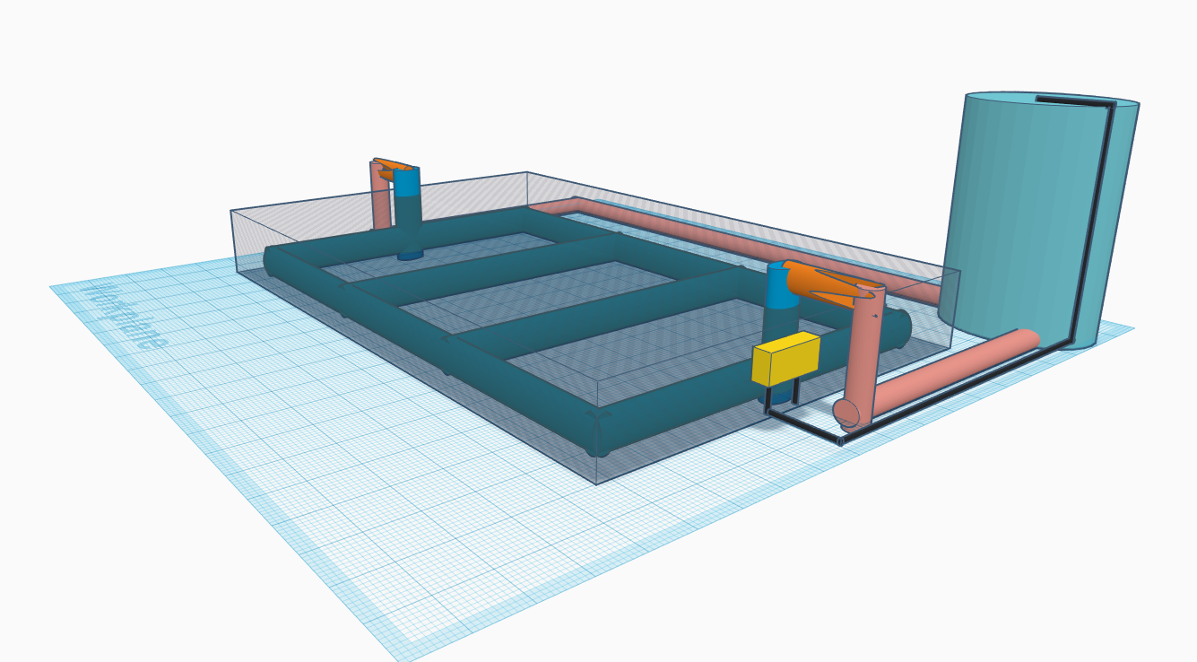

*Figure 3 MAIMS Design*

As stated in our review of systems. The researchers will use the method of micro irrigation system. The Micro Irrigation system should benefit small farmers, botanists and agriculturists. As it is easy to develop and its use of our technological advancements would further help them in managing their small farmland. The main difference of our micro irrigation system is that our group will provide wireless android-based implementation. The project will also be automated in terms of detecting the moisture of soil and water distribution on the plants. This system will be equipped with a water tank that is monitored using the android application. This android application will send notification to the user whenever the water level sensor in the tank detected a critical level of the water. We stumbled across a problem that the use of soil moisture sensor will make the project over expensive due to the need of equipping every plant with the sensor in order to cover every important area in the plant that is needed to be watered. That is why we are going to design The system in a way that all of the important area in the soil will be watered before the water reached the soil moisture sensor. This way, the project will need less moisture sensor. the system will implement drip irrigation method and will be running by using 1000kw and 36v electric motor controlled by an arduino mega microcontroller and connected to a21.33mm pvc pipe. The system will also use a router for the communication between the microcontroller and the android application. This system of communication will be achieved by equipping the microcontroller with an esp8266 a.k.a wifi module that will serve as the transceiver for the microcontroller. This will enable it to send and receive data from the router that is sent by the android application. The android application will be able to access the microcontroller by using the IP address assigned by the router to the microcontroller. The system will be powered through a 220v outlet and will be rectified to 5v and 36v to support the microcontroller and the dc electric motor. This system of automated irrigation that we are going to develop only support plants which is grown through the use of drip irrigation method such as tomato, cabbage, chili, okra cucumber, pumpkin and many other vegetables.

Microcontroller based Automatic Irrigation and Monitoring System

**Overview of the project**

In today’s world, Automation have reached far innovations and automation systems have fully helped the Humanity in doing and aiding human tasks. Such automation in the industries of manufacturing and as well as in the industry of human resource. And this is the exactly the reason why researchers wanted to automatize the watering of the plants. Researchers knew that such technologies already existed but it was only applicable through large gardens and parks. Researchers wanted to expand this idea by creating an automated irrigation system to peoples who wanted to plant a crop but unable to plant due to limited time management and limited space to where an individual resides.This project will greatly benefit small farmers and as well as the people who thinks of planting as their hobbies. Small farmers especially living inside well drought areas will be greatly beneficial to them as the MAIMS has its own irrigation system even though it is small in terms of volume size it will be environmentally friendly as it also reuses the excessive water from watering the plants. The researchers knew that the necessity of the water is very important in everyday lives and as a result the water levels inside a dam or other fresh water sources is greatly reduced and as water levels reach a critical point dam operators in Philippines will temporarily suspend the irrigation purposes of the dam. This is because crops requires a lot of water to grow and will greatly affect the allocation of fresh drinking water to the communities.

**System design specification**

The most basic component of MAIMS is the ESP8266 WIFI module. It is also one of the most important modules in the system. The system runs through a series of procedures performed by the microcontroller and modules interacting and exchanging data to one another. When operating, the first thing that the system is required to do is to connect to the cloud server of the RemoteXY by connecting the system in to a WIFI. This process is being performed by the ESP8266. When the android application and the MAIMS are already connected via RemoteXY cloud server, the exchange of data and information will be executed by the microcontroller. All of the sensors will then feed all of the data that has been gathered back in to the microcontroller. Then the microcontroller will send all of the processed data into the cloud server and will be received and displayed by the android app for the users monitoring. The plant will be watered depending on the digital data gathered by the soil moisture sensor.

The researchers decided to use the Arduino platform to control the Automatic irrigation system. Using the Arduino Uno Module and the Arduino Wifi Module, hardware can be controlled remotely by creating a separate android application. It can display sensor data, store and visualize it, among other cool things. There are two major components in the platform the MAIMS app and the Arduino library. In this project the Automatic Irrigation app provides a digital dashboard on your smartphone that displays real-time current condition of the plant based on the data that will be gathered by the sensors

The data processing in the system is done by the microcontroller and gathered by the sensor. In this system, the group utilized two major sensors that will be helpful to fulfill the requirements of this project. The first one is the FC-28 soil moisture sensor. The data that is being gathered by this sensor is the moisture of the soil. The moisture sensor works by estimating the soil volumetric water content based on the dielectric constant. The sensor will then return digital 1 or 0 values depending on the moisture in the soil digital 1 when the soil is dry and 0 if the soil is wet. The second sensor is the HC-SR04 ultra sonic sensor that will detect the water level in the tank. This sensor works by emitting a 40 000Hz ultra sound through the air and calculating the distance of the obstacle by using the time that the sound waves traveled back into the echo pin. The sensor then will return a time value in microseconds that will be converted to cm by multiplying to 0.034 cm per microseconds and dividing it by 2.

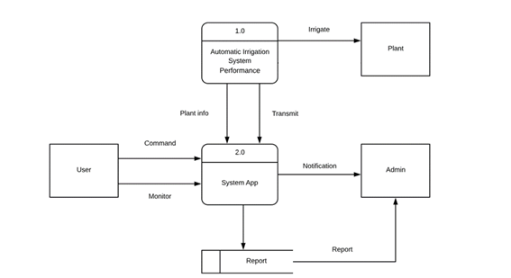

*Figure 3 MAIMS Flowchart*

# Results and Discussions

The researchers have three goals. The first goal is the projects should be environmentally friendly. The second goal is that should need to be dependable as the clients won’t be able to monitor each crops on a day by day basis. And this is why the researchers provided numerous tests and runs to achieve these two goals.

* **Stress testing** The researchers conducted a stress testing based on the scenarios where in the system is expected to malfunction or decrease its performance. It is done by connecting the ESP8266 into a poor strength connection. Weak connection disconnects the MAIMS into the cloud server most of the time resulting into a problem in monitoring. This test proved the high demand of the system to a strong internet connection.
* **Robustness testing** The researchers conducted an irrigation testing while the system is connected to a weak connection with the ping of 194ms. The result, plant irrigation is not affected by the poor internet connection. The water pump will irrigate the plant on time as long as the sensor is properly sending data into the microcontroller.
* **Performance testing** by conducting this test, the researchers are able to determine that the microcontroller is poorly performing when it comes to multi-tasking process. There are some cases when the email or the notification is not being sent because the microcontroller is still reading the soil moisture and the water level at the same time. This test proved that multiple processes at a time are unmanageable for the system. This problem has been solved by applying a 5 seconds delay in every process.
* **Usability testing** the system will automatically connect to the network almost immediately after you connect it into a power source. Once connected, the system will automatically perform all the tasks it is expected to do without the need for the user to do anything. The android application provided is equipped with a simple and user friendly UI complete with label in every component such as buttons, value display and level display. This application is composed of a single tab that looks more like a remote control than an android application.
* **Security testing** The system doesn’t provide any security login in its android application. The security of the system is ensured through the use of authentication token. The security testing is conducted by connecting the application to the cloud server using unauthorized authentication token. This test proved that the system will not be controlled by unauthorized users as long as the authentication token is unknown.
* **GUI testing** The android application of the system is composed of a single tab where all of the components such as buttons, value display, and level display are placed.
* **Accessibility** The software is only consisted of a single tab and is very easy to access with only one click.
* **Comprehensibility** all of the components such as buttons, value display, and level display are labelled with proper information that are easy to understand.

**Test Cases**

* + 1. **Test Cases**

|  |  |  |  |  |  |
| --- | --- | --- | --- | --- | --- |
| Test Case | Test Scenario | Test Steps | Test Data | Expected Result | Actual Result |
| Test 1 | Check if the ESP8266 is working properly | Type “AT” in the serial monitor | AT commands “AT ” | The serial monitor should return “ok” | No error occurred |
| Test 2 | Check the firmware version of the ESP8266 | . Type “AT+GMR” in the serial monitor | AT commands “AT+GMR” | The serial monitor should return “ok” and ESP firmware version | No error occurred |
| Test 3 | Test the ESP’s connection to WIFI | Type “AT+CWJAP=  ’Wifi_SSID’,’Wifi_Pass’” in the serial monitor | WIFI SSID,  WIFI password | The serial monitor should return “Wifi connected” and “Wifi got IP” | No error occurred |
| Test 4 | Check the MAIMS’s connection to the cloud server | Start the system by opening the serial monitor | MAIMS | The serial monitor should return ”Wifi connected” and display the connection’s ping(ms) | No error occurred |
| Test 5 | Check the android app’s connection to the cloud server | Start the app when the MAIMS is already connected to the server. | Android application | The app’s Millis value display should display the Millis of the MAIMS | No error occurred |
| Test 6 | Test the MAIMS’s connection to the android application | Click the LED button in the android application | LED lights | The LED in the MAIMS should turn on or off | No error occurred  (error sometimes occurs when connection |
| Test 7 | Test the soil moisture sensor | Stick the sensor into a dry or wet soil | Moisture of the soil | The moisture value display in the app should display “Dry” or “Wet” | No error occurred  (error sometimes occurs when connection strength is poor) |
| Test 8 | Test the ultra sonic sensor | Pour water in to the aquarium | Water height | The vertical level display in the app should display the water level in the aquarium | No error occurred  (error sometimes occurs when connection strength is poor) |
| Test 9 | Test the water pump and relay | Stick the sensor into a dry or wet soil | Moisture of the soil | The pump should turn on when the soil is inserted into a dry soil and off otherwise | No error occurred |
| Test 10 | Test the email feature of the MAIMS | Reduce the water height in the aquarium down to 1cm or less | Water height | The email address assigned should receive an email about critical water level | No error occurred  (error sometimes occurs when connection strength is poor) |
| Test 11 | Test the notification feature of the MAIMS | Stick the sensor into a dry or wet soil | Moisture of the soil | When the sensor detected a dry soil, the app should send a “Your plant is thirsty” notification. Otherwise, the app should send a “Your plant has been watered” notification | No error occurred  (error sometimes occurs when connection strength is poor) |

*Table 2 Setup of Maims*

# Conclusions and Recommendations

**Conclusions**

The researchers observed that when it was a dry season, farmers are having trouble watering their plants or there was a lack of water to water them all. It was also a problem that the weather is too hot that farmers or planters find it hard to water them all. That is why the purpose of this project is to help people who had a problem watering their plants and how seldom at home to water them.

The conclusion here is drawn that researchers made a more advanced project than other automatic irrigations. This project has an android application that you can control even though the user is not at home. The android application was made to remedy the problem of watering the plants manually when it is too hot outside or the user are just too tired of watering them all.

**Recommendations**

Based on the result and conclusions of the study, here are the recommendations need to be considered:

1 This should be use in drought areas to be more effective and useful.

2 This project needs a strong wifi connection to be used more effectively and no delays for the software to work.

3. The plants bed are stock together to save more space and water if the user are planting on rooftops or near the house when there is not much space left.

4. The use of drip irrigation for saving water especially in well drought areas.

When these recommendations are followed, it is easy to use this project and the user may be able to use it more productively. These recommendations should help the small farmers to achieve maximum efficiency in producing their crops output.

# References

New World Encyclopedia (2010). History of Agriculture Retrieved from http://www.newworldencyclopedia.org/entry/History_of_agriculture

Blog Impower Solution (2012) The messenger and the SMS Battle Retrieved from https://blog.impower.solutions/2017/06/smsvsmessenger.html

Wikipedia online encyclopedia (2001) The Yangtze Civilization Retrieved From https://en.wikipedia.org/wiki/Yangtze_civilization

Appendices

Appendix A. Gantt Chart

|  |  |  |  |  |  |  |  |  |  |  |  |  |  |  |  |  |  |  |  |  |  |  |  |  |  |  |  |  |  |  |  |  |  |  |  |  |  |  |  |  |  |  |  |
| --- | --- | --- | --- | --- | --- | --- | --- | --- | --- | --- | --- | --- | --- | --- | --- | --- | --- | --- | --- | --- | --- | --- | --- | --- | --- | --- | --- | --- | --- | --- | --- | --- | --- | --- | --- | --- | --- | --- | --- | --- | --- | --- | --- |
| MONTH 2019-2020 | JUNE | | | | JULY | | | | AUGUST | | | | SEPTEMBER | | | | OCTOBER | | | | NOVEMBER | | | | DECEMBER | | | | | JANUARY | | | | | FEBRUARY | | | | | MARCH | | | |
| ACTIVITY |
| Research for Thesis Title |  |  |  |  |  |  |  |  |  |  |  |  |  |  |  |  |  |  |  |  |  |  |  |  |  |  |  |  |  | |  |  |  |  | |  |  |  |  | |  |  |  |
| Writing the Proposal |  |  |  |  |  |  |  |  |  |  |  |  |  |  |  |  |  |  |  |  |  |  |  |  |  |  |  |  |  | |  |  |  |  | |  |  |  |  | |  |  |  |
| Concept |  |  |  |  |  |  |  |  |  |  |  |  |  |  |  |  |  |  |  |  |  |  |  |  |  |  |  |  |  | |  |  |  |  | |  |  |  |  | |  |  |  |
| Introduction |  |  |  |  |  |  |  |  |  |  |  |  |  |  |  |  |  |  |  |  |  |  |  |  |  |  |  |  |  | |  |  |  |  | |  |  |  |  | |  |  |  |
| Literature Review |  |  |  |  |  |  |  |  |  |  |  |  |  |  |  |  |  |  |  |  |  |  |  |  |  |  |  |  |  | |  |  |  |  | |  |  |  |  | |  |  |  |
| Project Management |  |  |  |  |  |  |  |  |  |  |  |  |  |  |  |  |  |  |  |  |  |  |  |  |  |  |  |  |  | |  |  |  |  | |  |  |  |  | |  |  |  |
| Check Documentation to Thesis Adviser |  |  |  |  |  |  |  |  |  |  |  |  |  |  |  |  |  |  |  |  |  |  |  |  |  |  |  |  |  | |  |  |  |  | |  |  |  |  | |  |  |  |
| Canvas of materials needed |  |  |  |  |  |  |  |  |  |  |  |  |  |  |  |  |  |  |  |  |  |  |  |  |  |  |  |  |  | |  |  |  |  | |  |  |  |  | |  |  |  |
| Buying the materials needed |  |  |  |  |  |  |  |  |  |  |  |  |  |  |  |  |  |  |  |  |  |  |  |  |  |  |  |  |  | |  |  |  |  | |  |  |  |  | |  |  |  |
| Testing of each materials |  |  |  |  |  |  |  |  |  |  |  |  |  |  |  |  |  |  |  |  |  |  |  |  |  |  |  |  |  | |  |  |  |  | |  |  |  |  | |  |  |  |
| Building a prototype |  |  |  |  |  |  |  |  |  |  |  |  |  |  |  |  |  |  |  |  |  |  |  |  |  |  |  |  |  | |  |  |  |  | |  |  |  |  | |  |  |  |
| Documentation Checking |  |  |  |  |  |  |  |  |  |  |  |  |  |  |  |  |  |  |  |  |  |  |  |  |  |  |  |  |  | |  |  |  |  | |  |  |  |  | |  |  |  |
| Prototype Testing |  |  |  |  |  |  |  |  |  |  |  |  |  |  |  |  |  |  |  |  |  |  |  |  |  |  |  |  |  | |  |  |  |  | |  |  |  |  | |  |  |  |
| Project Evaluation |  |  |  |  |  |  |  |  |  |  |  |  |  |  |  |  |  |  |  |  |  |  |  |  |  |  |  |  |  | |  |  |  |  | |  |  |  |  | |  |  |  |

Appendix B. Actual Thesis Expenses

THESIS EXPENSES

|  |  |  |  |
| --- | --- | --- | --- |
| Quantity | Specifics | Approximate Cost | Actual Cost |
| 1 | Arduino mega | ₱750 | ₱700 |
| 2 | FC-28 Soil Moisture sensor | ₱226 | ₱220 |
| 1 | Water pump | ₱700 | ₱700 |
| 1 | Ultra Sonic Sensor | ₱150 | ₱140 |
| 1 | ESP8266 Wifi Module | ₱282 | ₱282 |
| 8 | Loam soil | ₱400 | ₱450 |
| 5 | 21.33mm PVC pipe | ₱300 | ₱300 |
| 1 | Planters box | ₱1500 | ₱1500 |
| 1 | GSM Module | ₱999 | ₱999 |
| 1 | KD S4S EXT 2X2X12FT WOOD | ₱1000 | ₱1500 |
| 2 | Solenoid | ₱700 | ₱800 |
|  | Total | = ₱7000 | = ₱7591 |

Prepared by:

John Lherry P. Dela Cruz Miguel Jason C. De Castro

Ciff M. Marbella Carl Lloyd N. Mendoza

Noted by:

Josephine Gregorio Cruz Teofila Dela Cruz

Carolina Marquez Marbella Elvira N Mendoza

Approved by:

Sir Christopher Rae Perez

Thesis Adviser and Coordinator

Appendix C. USER’s MANUAL

Appendix C.

User’s Manual

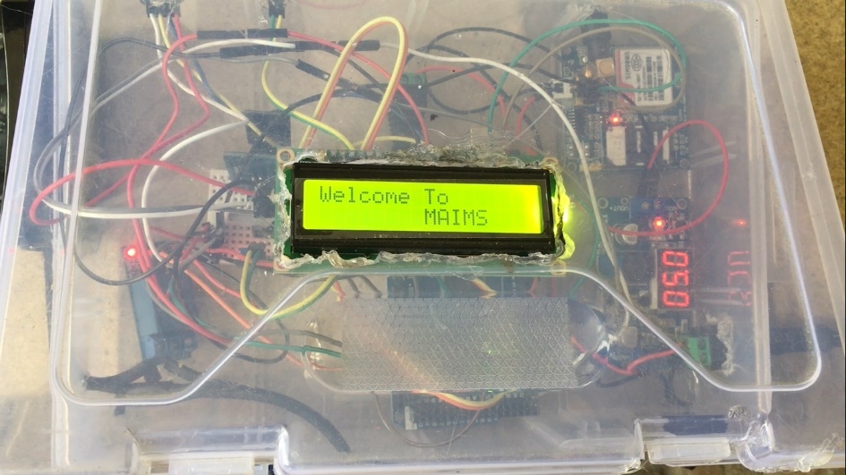

*Figure 4 MAIMS Welcome display*

The MAIMS requires the following components: (1) Arduino Uno microcontroller (2) FC-28 Soil moisture sensor (3) HC-SR04 ultra sonic sensor (4) 1 channel relay 5V (5) 12V DC water pump (6) ESP8266 WIFI module. The module that is responsible for the MAIMS connection to cloud is the ESP8266. It is installed in the system by connecting the VCC and CH_PD to a 3.3V pin, GND to the GND pin, RX to the digital pin 3, TX to digital pin 2 of the arduino. The Soil moisture sensor that is responsible for soil reading is installed by connecting its VCC to a 3.3V power source and the data pin to the digital pin 8 of the arduino. Since the water pump is powered by a 220V supply, the system requires an external 220V power supply connected to a relay. The water pump will then be connected to the microcontroller by connecting the VCC pin to 5V and the data pin to digital pin 9 of the arduino. Last thing is the installation of the ultra sonic sensor the will monitor the water level in the aquarium. It is done by connecting the trig pin to digital pin 10, echo pin to digital pin 11, and VCC to 5Vpin of the arduino.

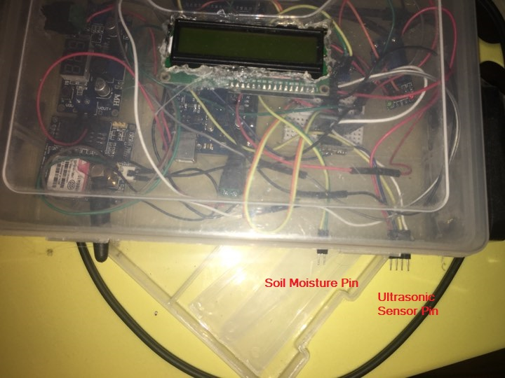

*Figure 5 MAIMS ports*

Plug the 4 pin Female port of the ultrasonic sensor and the 2 pin Female port of the soil moisture sensor.

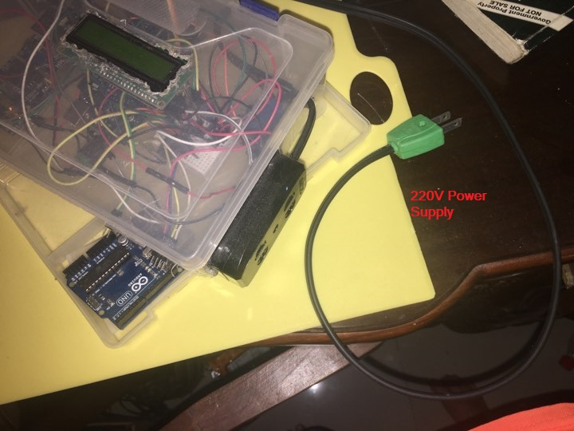

*Figure 6 MAIMS power supply*

Connect the System into a 220V power supply and plugin a 5v DC to power up the Microcontroller.

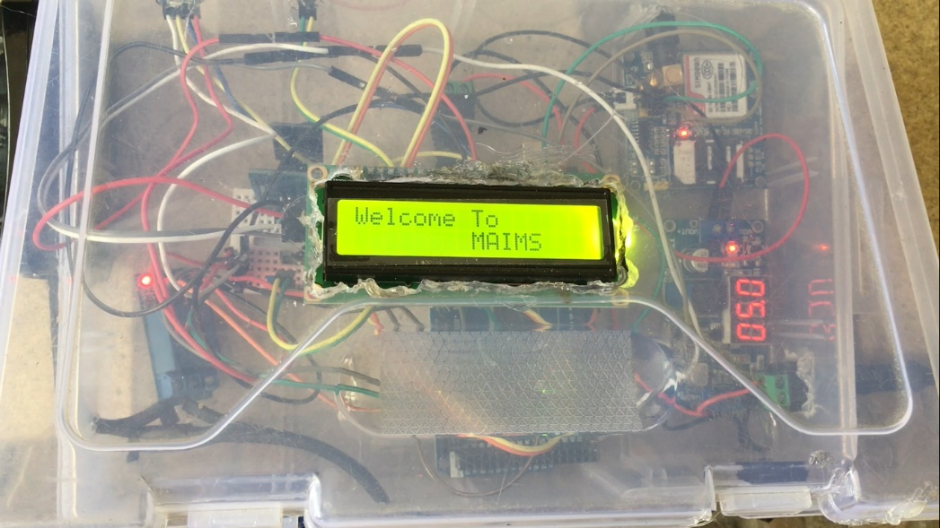

*Figure 5 MAIMS welcome message*

Press the switch on and the LCD should print “Welcome To MAIMS”

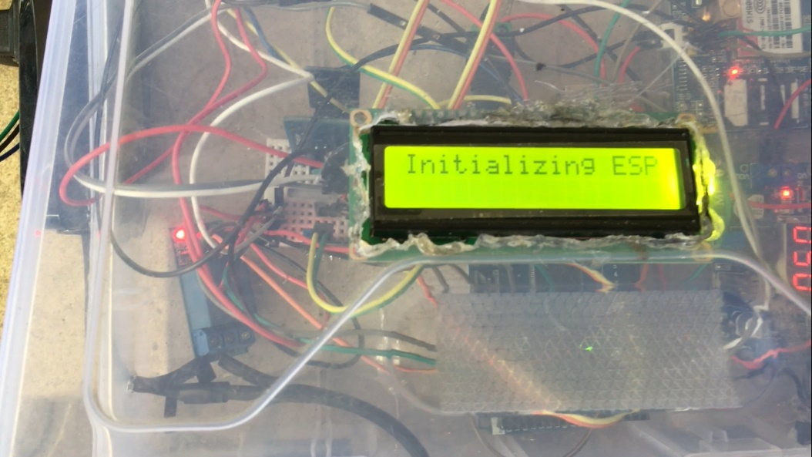

*Figure 6 MAIMS Initialization*

Wait for the ESP to Initialize and you should be able to connect to the access point provided by the ESP.

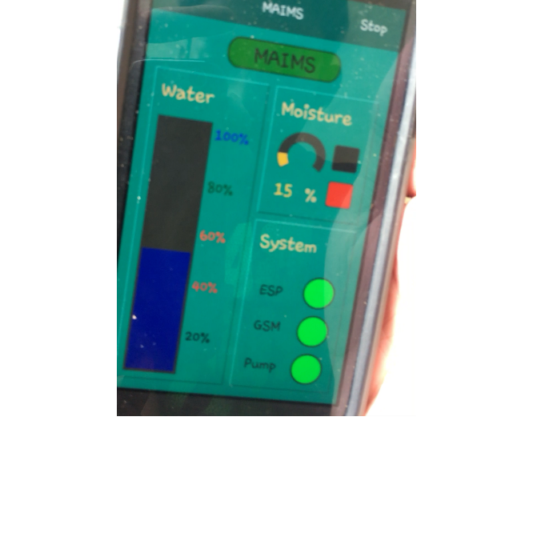

*Figure 9 MAIMS UI*

Once connected, you can now monitor the irrigation system using the android application.

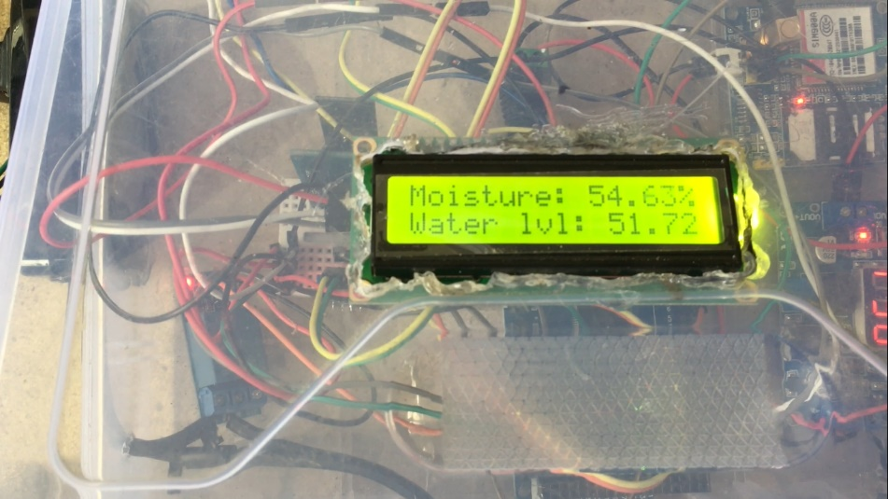

*Figure 10 MAIMS Moisture and water level*

You can also monitor the moisture of the soil and the water level in the tank by looking at the LCD screen.

Appendix D Source Code

#include <SoftwareSerial.h>

#include <Wire.h>

#include <LiquidCrystal_I2C.h>

#define REMOTEXY_MODE__ESP8266_HARDSERIAL_POINT

#include <RemoteXY.h>

// RemoteXY connection settings

#define REMOTEXY_SERIAL Serial

#define REMOTEXY_SERIAL_SPEED 115200

#define REMOTEXY_WIFI_SSID "MAIMS"

#define REMOTEXY_WIFI_PASSWORD "12345678"

#define REMOTEXY_SERVER_PORT 6377

// RemoteXY configurate

#pragma pack(push, 1)

uint8_t RemoteXY_CONF[] =

{ 255,0,0,21,0,12,1,8,13,5,

130,1,33,50,28,47,0,13,130,1,

2,14,29,83,0,13,66,1,4,26,

14,69,0,188,26,129,0,19,27,11,

4,0,6,49,48,48,37,0,129,0,

19,54,8,4,0,50,54,48,37,0,

129,0,19,41,8,4,0,131,56,48,

37,0,129,0,19,68,8,4,0,1,

52,48,37,0,129,0,19,82,8,4,

0,24,50,48,37,0,65,6,49,64,

9,9,0,65,6,49,86,9,9,0,

65,6,49,75,9,9,0,129,0,37,

77,9,4,0,24,71,83,77,0,129,

0,36,88,11,4,0,24,80,117,109,

112,0,129,0,33,59,0,6,0,16,

0,129,0,37,67,8,4,0,24,69,

83,80,0,131,1,19,3,30,8,1,

132,24,77,65,73,77,83,0,130,1,

33,14,28,34,0,13,129,0,35,17,

21,5,0,17,77,111,105,115,116,117,

114,101,0,129,0,4,17,14,5,0,

17,87,97,116,101,114,0,129,0,35,

53,21,5,0,17,83,121,115,116,101,

109,0,66,130,36,25,13,10,0,2,

26,65,10,51,27,7,7,0,65,12,

51,37,7,7,0,67,4,36,38,9,

6,0,2,13,11,129,0,45,39,5,

5,0,17,37,0 };

// this structure defines all the variables of your control interface

struct {

// output variable

int8_t level_1; // =0..100 level position

uint8_t led_esp_r; // =0..255 LED Red brightness

uint8_t led_esp_g; // =0..255 LED Green brightness

uint8_t led_pump_r; // =0..255 LED Red brightness

uint8_t led_pump_g; // =0..255 LED Green brightness

uint8_t led_gsm_r; // =0..255 LED Red brightness

uint8_t led_gsm_g; // =0..255 LED Green brightness

int8_t level_2; // =0..100 level position

uint8_t led_wet_g; // =0..255 LED Green brightness

uint8_t led_dry_r; // =0..255 LED Red brightness

char text_1[11]; // string UTF8 end zero

// other variable

uint8_t connect_flag; // =1 if wire connected, else =0

} RemoteXY;

#pragma pack(pop)

/////////////////////////////////////////////

// END RemoteXY include //

/////////////////////////////////////////////

SoftwareSerial SIM900(10,11); //rx,tx

LiquidCrystal_I2C lcd(0x27, 16, 2);

const int moisture1_pin = A0;

const int moisture2_pin = A1;

const int valve1_pin = 6;

const int valve2_pin = 5;

const int trigPin = 7;

const int echoPin = 8;

long duration;

double initDistance;

double distance;

boolean soilDry = false;

boolean waterCritical = false;

void setup(){

pinMode(moisture1_pin, INPUT);

pinMode(moisture2_pin, INPUT);

pinMode(valve1_pin, OUTPUT);

pinMode(valve2_pin, OUTPUT);

pinMode(trigPin, OUTPUT);

pinMode(echoPin, INPUT);

digitalWrite(valve1_pin, HIGH);

digitalWrite(valve2_pin, HIGH);

lcd.begin();

lcd.backlight();

lcd.print("Welcome To");

lcd.setCursor(8, 1);

lcd.print("MAIMS");

delay(4000);

lcd.clear();

lcd.setCursor(0,0);

lcd.print("Initializing ESP....");

RemoteXY_Init ();

delay(1000);

lcd.clear();

lcd.print("ESP8266 OK");

RemoteXY.led_esp_g = 250;

delay(2000);

lcd.clear();

lcd.print("Initializing GSM....");

SIM900.begin(115200);

delay(10000);

lcd.clear();

lcd.print("GSM OK");

RemoteXY.led_gsm_g = 250;

delay(2000);

lcd.clear();

}

void loop(){

RemoteXY_Handler ();

getMoisture1();

getMoisture2();

getLevel();

// TODO you loop code

// use the RemoteXY structure for data transfer

delay(100);

}

void getMoisture1(){

if(!waterCritical){

double mVal = analogRead(moisture1_pin);

double m_percent = (800 - mVal) / 800 * 100;

//lcd.clear();

lcd.setCursor(0,0);

if(m_percent > 25){

digitalWrite(valve1_pin, HIGH);

RemoteXY.led_pump_r = 250;

RemoteXY.led_pump_g = 0;

lcd.print("Moisture: " + String(m_percent) + "%");

RemoteXY.level_2 = m_percent;

RemoteXY.led_wet_g = 250;

RemoteXY.led_dry_r = 0;

dtostrf(m_percent, 0, 0, RemoteXY.text_1);

if(soilDry){

send_sms("Your Plant in box 1 Has Been Watered!");

}

soilDry = false;

}

else{

digitalWrite(valve1_pin, LOW);

RemoteXY.led_pump_g = 250;

RemoteXY.led_pump_r = 0;

lcd.print("Moisture = DRY!");

lcd.setCursor(0,1);

lcd.print("Water Pump: ON");

RemoteXY.level_2 = m_percent;

RemoteXY.led_dry_r = 250;

RemoteXY.led_wet_g = 0;

dtostrf(m_percent, 0, 0, RemoteXY.text_1);

if(!soilDry){

send_sms("Your Plant in box 1 is Thirsty! Pump System ON");

}

soilDry = true;

}

}

}

void getMoisture2(){

if(!waterCritical){

double mVal = analogRead(moisture2_pin);

double m_percent = (800 - mVal) / 800 * 100;

//lcd.clear();

lcd.setCursor(0,0);

if(m_percent > 25){

digitalWrite(valve2_pin, HIGH);

//RemoteXY.led_pump_r = 250;

// RemoteXY.led_pump_g = 0;

//lcd.print("Moisture: " + String(m_percent) + "%");

//RemoteXY.level_2 = m_percent;

//RemoteXY.led_wet_g = 250;

//RemoteXY.led_dry_r = 0;

//dtostrf(m_percent, 0, 0, RemoteXY.text_1);

if(soilDry){

send_sms("Your Plant in box 2 Has Been Watered!");

}

soilDry = false;

}

else{

digitalWrite(valve2_pin, LOW);

//RemoteXY.led_pump_g = 250;

//RemoteXY.led_pump_r = 0;

//lcd.print("Moisture = DRY!");

//lcd.setCursor(0,1);

//lcd.print("Water Pump: ON");

//RemoteXY.level_2 = m_percent;

//RemoteXY.led_dry_r = 250;

//RemoteXY.led_wet_g = 0;

//dtostrf(m_percent, 0, 0, RemoteXY.text_1);

if(!soilDry){

send_sms("Your Plant in box 2 is Thirsty! Pump System ON");

}

soilDry = true;

}

}

}

void getLevel(){

if(!soilDry){

digitalWrite(trigPin, LOW);

delayMicroseconds(2);

digitalWrite(trigPin, HIGH);

delayMicroseconds(10);

digitalWrite(trigPin, LOW);

duration = pulseIn(echoPin, HIGH);

initDistance = duration * 0.034 / 2;

distance = 35 - initDistance;

//lcd.clear();

lcd.setCursor(0,1);

double h_percent = (distance / 35) * 100;

if(h_percent > 20){

lcd.print("Water lvl: " + String(h_percent) + "%");

RemoteXY.level_1 = h_percent;

waterCritical = false;

}

else{

lcd.setCursor(0,0);

lcd.print("Water Level: ");

lcd.setCursor(5,1);

lcd.print("CRITICAL!");

RemoteXY.level_1 = h_percent;

if(!waterCritical){

send_sms("The Water in Your Tank is Critical Below 20%! Please Refill Immediately");

}

waterCritical = true;

}

}

}

void send_sms(String msg){

SIM900.print("AT+CMGF=1\r");

delay(100);

SIM900.println("AT + CMGS = \"+639156781264\"");

delay(100);

SIM900.println(msg);

delay(100);

SIM900.println((char)26);

delay(100);

SIM900.println();

delay(5000);

}

Appendix E Survey Questionnaire

Microntroller based Automatic Irrigation and monitoring system

A survey for gardening

Name (optional) __________________________________ Date _____________

Address _______________________________________________________

Yes No

1. Do you consider gardening? ( ) ( )
2. What plants do you consider planting?

____________________________________

­­­­­­­­­­­­­­­­­____________________________________

­­­­­­­­­­­­­­____________________________________

1. Do you have empty lots? ( ) ( )
2. If provided a proper plant box and other equipments. ( ) ( )

Would you consider planting/gardening?

1. Within your empty lot. Are there crops growing or ornamental ( ) ( )

Plants growing inside your lot?

_____________________________________________________________________________________

Please check the following conditions on why didn’t you consider planting/gardening:

( ) Limited time

( ) Limited space inside the home

( ) Lack of knowledge in properly growing plants

( ) Lacking in budget and resources

( ) Does not have the interest in gardening

( ) Others __________________________________

__________________________________

__________________________________

1. Would you consider planting/gardening if it had a feature of watering the plants automatically?

( ) Yes ( ) No (if no please state the reason ___________[optionally])

1. Do you mind if plants/crops are grown inside plant beds?

( ) Yes ( ) No

Appendix D. Curriculum Vitae of Researchers

Curriculum Vitae of

John Lherry P. Dela Cruz

#945 Purok 5 Santisima Trinidad, Malolos, Bulacan

johnravenrazor@yahoo.com/gmail.com

09266940440

EDUCATIONAL BACKGROUND

|  |  |  |
| --- | --- | --- |
| Level | Inclusive Dates | Name of school/ Institution |
| Tertiary | 2014-Present | STI College Malolos |
| Vocational/Technical | N/A | N/A |
| High School | 2010-2014 | St. Clement Academy |
| Elementary | 2004-2010 | Santisima Elem. School |

PROFESSIONAL OR VOLUNTEER EXPERIENCE

|  |  |  |
| --- | --- | --- |
| Inclusive Dates | Nature of Experience/  Job Title | Name and Address of Company or Organization |
| N/A | N/A | N/A |
|  |  |  |
|  |  |  |
|  |  |  |

Listed in reverse chronological order (most recent first).

AFFILIATIONS

|  |  |  |
| --- | --- | --- |
| Inclusive Dates | Name of Organization | Position |
| 2016-Present | CENSOR | Member |
|  |  |  |
|  |  |  |
|  |  |  |

Listed in reverse chronological order (most recent first).

SKILLS

|  |  |  |
| --- | --- | --- |
| SKILLS | Level of Competency | Date Acquired |
| Grammar Checker | Average |  |
| Document Specialist | Average |  |
| Python Coder | Average |  |

TRAININGS, SEMINARS OR WORKSHOP ATTENDED

|  |  |
| --- | --- |
| Inclusive Dates | Title of Training, Seminar or Workshop |
| 2018 | Techno Entrepreneurship |
|  |  |
|  |  |
|  |  |

Listed in reverse chronological order (most recent first).

Curriculum Vitae of

Miguel Jason C. De Castro

Block 8 lot 16 la aldea sub. Guiguinto bulacan

Jason_decastro16@yahoo.com

09771585192

EDUCATIONAL BACKGROUND

|  |  |  |
| --- | --- | --- |
| Level | Inclusive Dates | Name of school/ Institution |
| Tertiary | March 2020 | STI Malolos |
| High School | March 2013 | Lord Shepperd Academy |
| Elementary | March 2008 | Higher Ground Baptist Academy |

PROFESSIONAL OR VOLUNTEER EXPERIENCE

|  |  |  |
| --- | --- | --- |
| Inclusive Dates | Nature of Experience/  Job Title | Name and Address of Company or Organization |
|  |  |  |
|  |  |  |
|  |  |  |
|  |  |  |

Listed in reverse chronological order (most recent first).

AFFILIATIONS

|  |  |  |
| --- | --- | --- |
| Inclusive Dates | Name of Organization | Position |
| March 2017 | CENSOR | Member |
|  |  |  |
|  |  |  |
|  |  |  |

Listed in reverse chronological order (most recent first).

SKILLS

|  |  |  |
| --- | --- | --- |
| SKILLS | Level of Competency | Date Acquired |
| AutoCAD | Competent | 2016 |
| GameMaker | Beginner | 2017 |
| Written and spoken English | Competent | 2007 |

Project Designer Competent 2017

Graphic Designer Beginner 2018

TRAININGS, SEMINARS OR WORKSHOP ATTENDED

|  |  |
| --- | --- |
| Inclusive Dates | Title of Training, Seminar or Workshop |
| November 2016  November 2018 | STI National youth convention  Technopreneurship |
|  |  |
|  |  |

Listed in reverse chronological order (most recent first).

Curriculum Vitae of

Cliff M. Marbella

La Residencia Sub, Brgy. Pio Cruz Cosa, Calumpit Bulacan

Kaento05@gmail.com

09560566331

EDUCATIONAL BACKGROUND

|  |  |  |
| --- | --- | --- |
| Level | Inclusive Dates | Name of school/ Institution |
| Tertiary | 2015-2016  2016-Current | Trimex Institute Of Science and Tech  STI College Malolos |
| Vocational/Technical | N/A | N/A |
| High School | 2011-2012  2012-2013  2013-2015 | South City Homes Academy  Polangui General Comprehensive HS  Maramba National High School |
| Elementary | 2005-2009  2009-2011 | San Vicente Elementary School  Maramba Elementary School |

PROFESSIONAL OR VOLUNTEER EXPERIENCE

|  |  |  |
| --- | --- | --- |
| Inclusive Dates | Nature of Experience/  Job Title | Name and Address of Company or Organization |
| N/A |  |  |
| N/A |  |  |
| N/A |  |  |
| N/A |  |  |

Listed in reverse chronological order (most recent first).

AFFILIATIONS

|  |  |  |
| --- | --- | --- |
| Inclusive Dates | Name of Organization | Position |
| 2015-2016 | SCOPE (BSCpE) | Member |
| 2016-current | CENSOR | Menber |
|  |  |  |
|  |  |  |

Listed in reverse chronological order (most recent first).

SKILLS

|  |  |  |
| --- | --- | --- |
| SKILLS | Level of Competency | Date Acquired |
| Programming |  | 2016-current |

TRAININGS, SEMINARS OR WORKSHOP ATTENDED

|  |  |
| --- | --- |
| Inclusive Dates | Title of Training, Seminar or Workshop |
| November 2018 | Techno Entrepreneurship |

Curriculum Vitae of

Carl Lloyd N. Mendoza

Blk.103 lot 38 ph 5 Dreamcrest homes Longos Malolos Bulacan

mendozacarllloyd@yahoo.com

09212219924

EDUCATIONAL BACKGROUND

|  |  |  |
| --- | --- | --- |
| Level | Inclusive Dates | Name of school/ Institution |
| Tertiary | 2014-Present | STI College Malolos |
| Vocational/Technical | N/A | N/A |
| High School | 2010-2014 | Harvesters’ Mission Int’l School |
| Elementary | 2004-2010 | Bulihan Elem. School |

PROFESSIONAL OR VOLUNTEER EXPERIENCE

|  |  |  |
| --- | --- | --- |
| Inclusive Dates | Nature of Experience/  Job Title | Name and Address of Company or Organization |
| N/A | N/A | N/A |
|  |  |  |
|  |  |  |
|  |  |  |

Listed in reverse chronological order (most recent first).

AFFILIATIONS

|  |  |  |
| --- | --- | --- |
| Inclusive Dates | Name of Organization | Position |
| 2016-Present | CENSOR | Member |
|  |  |  |
|  |  |  |
|  |  |  |

Listed in reverse chronological order (most recent first).

|  |  |  |  |
| --- | --- | --- | --- |
| SKILLS | | Level of Competency | Date Acquired |
| English proficiency | | Intermediate |  |
| Word Proficient level  Vb.net Programming | | Intermediate  Average |  |
|  |

TRAININGS, SEMINARS OR WORKSHOP ATTENDED

|  |  |
| --- | --- |
| Inclusive Dates | Title of Training, Seminar or Workshop |
| 2018 | Techno Entrepreneurship |
|  |  |
|  |  |
|  |  |

Listed in reverse chronological order (most recent first).