

Karen

58, Piano Tutor

Independent, Artsy, Cultured, Meticulous, Trusting

About:

“I love spending time with my family, especially my grandchildren who love my new furry friend. Their love for my new puppy makes me want to share him with the world.”

Karen has a young small dog, a gift from her children and grandchildren. She doesn’t get out much as she has a part-time job as a stay-at-home piano tutor. She also just moved to a new suburb near her family members and she is looking to make new friends, but is shy when meeting new people. She thinks her dog, who needs plenty of exercise and dog/human interaction being so young, could be the key to helping her ease into a life with new friends.

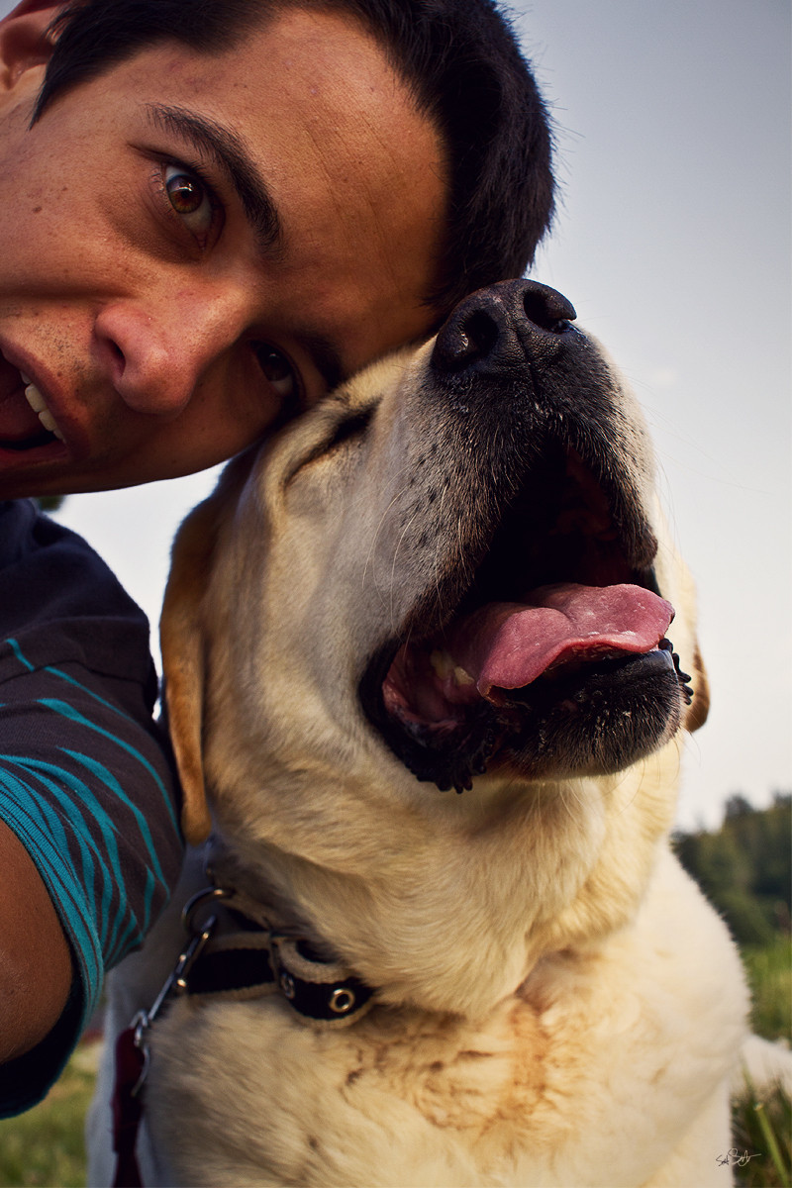

Justin

21, College Student

Young college boy who has a bigger dog. Lives in an apartment off his college campus and really wants to stay active in the community, and also wants to make his dog a big part of his journey to make more friends. Needs a way of doing that