**Automation Name:** EBP_EInvoice_Reprocess_V2

**Purpose:** To reprocess the invoice that failed to copy as the PDF file was missing at the time.

* Initially the invoices were attempted to be extracted but some invoices were not taken as the PDF are not present to the expected folder.
* These files were recorded and saved into a CSV file and sent to email.
* The program will pick the email with subject **EBP Invoice Extract Result [PROD]** that is unread and save into a specific drive.

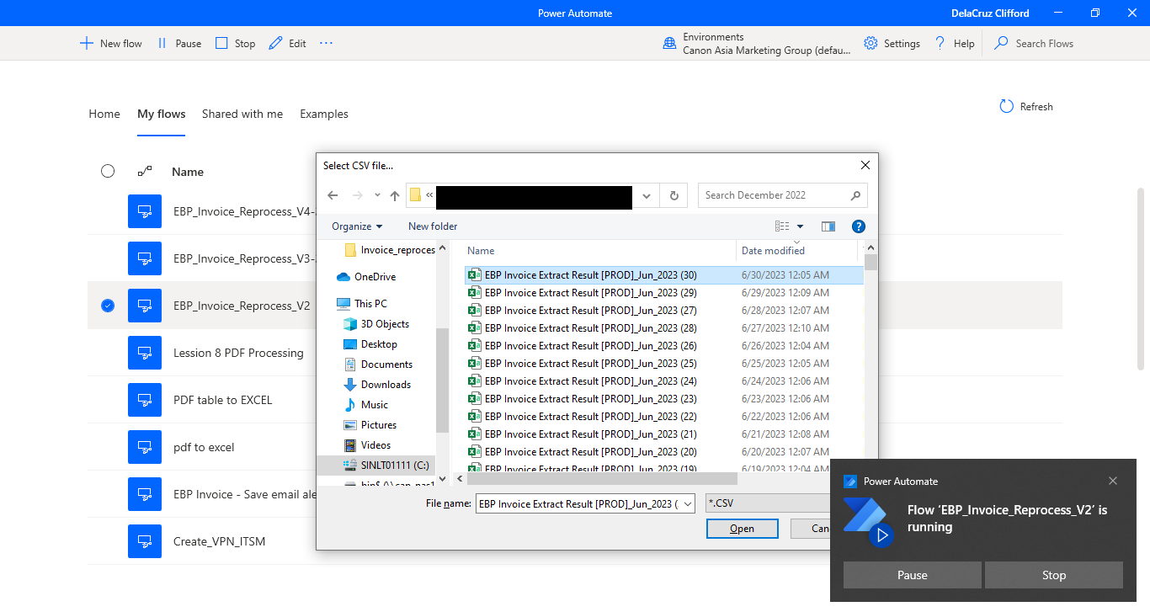

After selecting the file, it will:

1. process the file from CSV to EXCEL
2. Read the data and get the file path where the location of PDF file of invoice
3. Create the ROBOCOPY script to copy those PDF files into a specific folder
4. Run the BAT file created out of the ROBOCOPY scripts

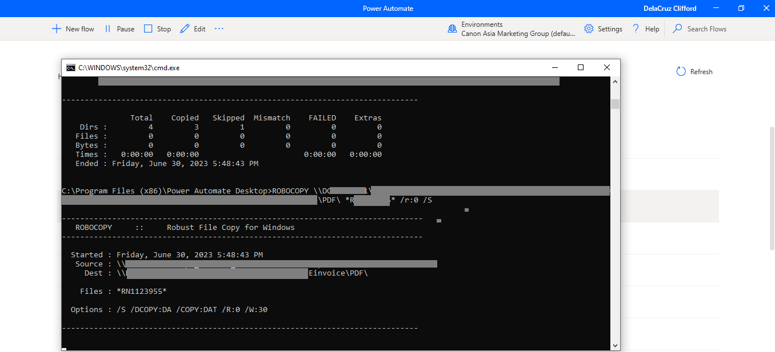

File folder destination (where another job will pick up the file and send to another system)

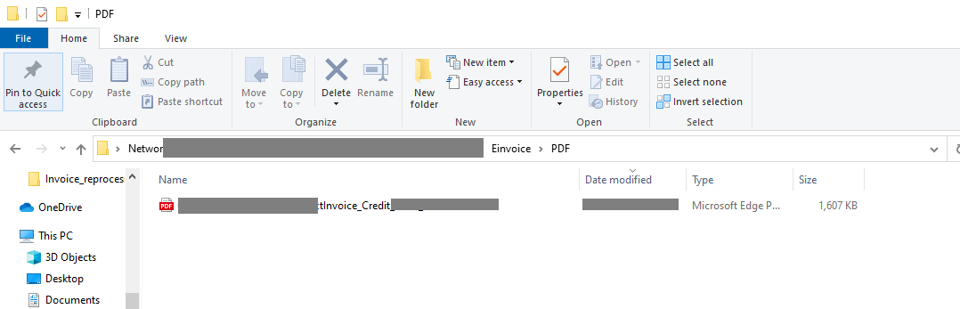

**Note:**

* The program is designed in Microsoft Power Automate Desktop
* The conversion of file from CSV to Excel requires a macro

* Folder named “Processed” is created to save the processed CSV to excel as well as the location of the ROBOCOPY batch job.
* Program is set to read email with specific subject. This program can be used to similar projects that requires reading through specific emails.