**CSC2034 Major Project**

**Human Computer Interaction (HCI)**

By Harry Clifford

Contents

Abstract 1

Links to created artefacts 1

What was done and how 1

Persona 2

Competitor Analysis 2

Hierarchical Task Analysis (HTA) 2

Requirements Gathering 3

Scenarios 3

Low-fidelity wireframe 4

Digital prototype 4

Cognitive walkthrough 5

Evaluation 5

Conclusions and Future Work 6

Appendices 7

# Abstract

This report summarises the findings of the work done within CSC2034’s Major Project specifically within the task description of HCI. The goal was to make a digital prototype for a crop growing app for a specified persona (Neil and Nadia) in my case. This was done by using many HCI methods including Competitor Analysis, Hierarchical Task Analysis, Requirements gathering, Scenarios, Low-fidelity wireframing and Cognitive walkthroughs. These were used as preparation and to provide guidance on the final digital prototype which aimed to fit with the specifications in the task description and provide a satisfying experience for the user.

## Links to created artefacts

HTA <https://miro.com/app/board/o9J_lGcB_Rw=/> Digital Prototype [Digital Prototype (1).pptx](https://newcastle-my.sharepoint.com/:p:/g/personal/b9021022_newcastle_ac_uk/EXCBsQJ8GH1CtAbDdk0oEHABO0eY2i7Xv22luNcij-DrQA?e=dkyYY7)

# What was done and how

To fulfil the task of creating a crop growing assistant I produced a range of materials following common HCI design practices.

## Persona

I chose to base my solution on the personas of Neil and Nadia to go for a “Middle-Aged” audience whilst providing to the slight variations in their living scenarios.

## Competitor Analysis[1]

To begin, I analysed a couple of competitors products that being the R.H.S’ grow your own application and the garden planner on grow veg’s website. I did this by going through each of their set-ups and attempting to use the application a similar way to that of Neil and Nadia’s use case. This led me into a couple of problems as the R.H.S’ app felt like reading a blog post about gardening not giving much assistance or guidance directly of any form whilst barraging the user with text and not much else effectively forcing a self-learning approach which is exactly what my personas don’t want. The grow veg website on the other hand involved setting up your own physical garden as a virtual space which was time consuming and would be ultimately pointless for Nadia who wanted to grow in pots and planters as she has no garden space to map out in this way whilst Neil would be turned away due to its long set up time. This allowed for me to consider which elements of each design I may want to use in my own solution whilst discarding any elements that would only add unnecessary complexity to the design I was starting to plan.

## Hierarchical Task Analysis (HTA) [2]

I created a Hierarchical Task Analysis (HTA, Viewable by the link above). Which helped me create a concrete flow of the way a user might complete the task of creating a garden space and populating it with plants within the solution I sought to design. As pointed out in an article in Applied Ergonomics “HTA representation is the starting point for the analysis rather than the end point” (Stanton, 2006) I aimed to use the creation of my HTA to serve as a basis for my analysis of design giving a rough overview of what the user experience could be rather than using it as an absolute. My HTA displays the idea of a recursive approach to garden creation first by making garden areas to split the virtual garden in the same way one might create areas in their real growing spaces. Before, adding plants to these areas as desired to create a filled area of various life. When creating my HTA I had a few difficulties as I struggled to grasp what direction I wanted to take the creation experience in before finally settling on a recursive creation style. This taught me to focus better on the way a user would interact with a solution with the general low-level style of HTA’s. Overall, my HTA allowed me to have greater confidence in creating the rest of my design following the ideas I setup within this design teaching me how to better design general goals for users within a design.

## Requirements Gathering

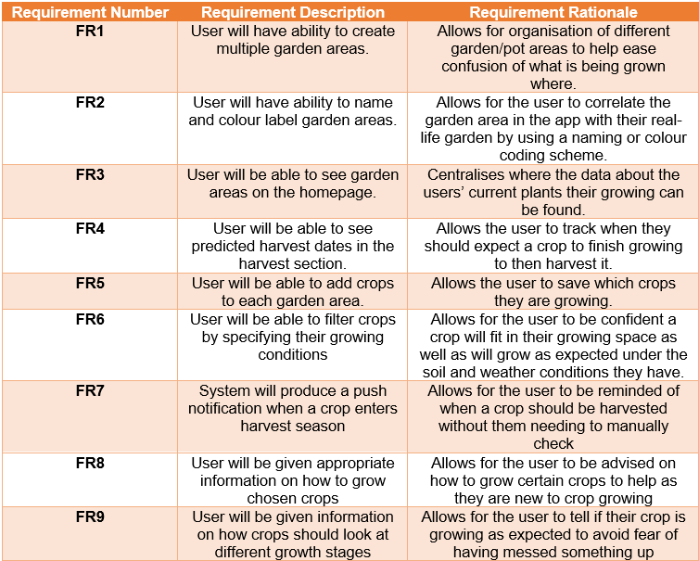During the process of requirements gathering I attempted to think about what the user would want to be able to get out of the proposed solution. This led to me creating specific requirements based on the small tasks a user would want to do day to day within my application. I then produced the rationale behind each of these requirements and how they would help an end user to get the most out of the proposed solution. I had completed this method for larger projects and have always found it useful as a method of thinking through the reasoning for using a specific feature/requirement rather than just assuming its existence. For example, I always planned for the user to be able to be able to add multiple garden areas but coming to the rationale was slightly difficult as I had effectively used it as an assumption which helped me renew its contextual importance for me. Especially when thinking about Neil’s needs with a large garden having the multiple garden sections would be vital to help him organise his space. This helped me keep my personas more in mind for the rest of my sections to make better design decisions.

Figure 1

## Scenarios [3]

When making my scenarios I attempted to get into the mindset of both Neil and Nadia once again and attempted to focus on the issues they personally must then later focus in to part of my design. This helped me learn how to better think about the process a user takes when thinking about looking for a solution to a real-life problem that could lead them to my product. This process led to me making some realisations of elements I should add to my solution. For example, Neil would likely want to get his children involved in the crop growing process meaning the created solution would need to be understandable or at least interpretable by young children so they could help him out in turn. Nadia on the other hand would need to be provided with plants specifically for pot and planter-based growing meaning this information would need to be filterable and findable for each individual plant. This taught me to remember the nuance in any specific users’ usage of an application and therefore to plan appropriate for any possible niche a user may need the application to fulfil.

## Low-fidelity wireframe

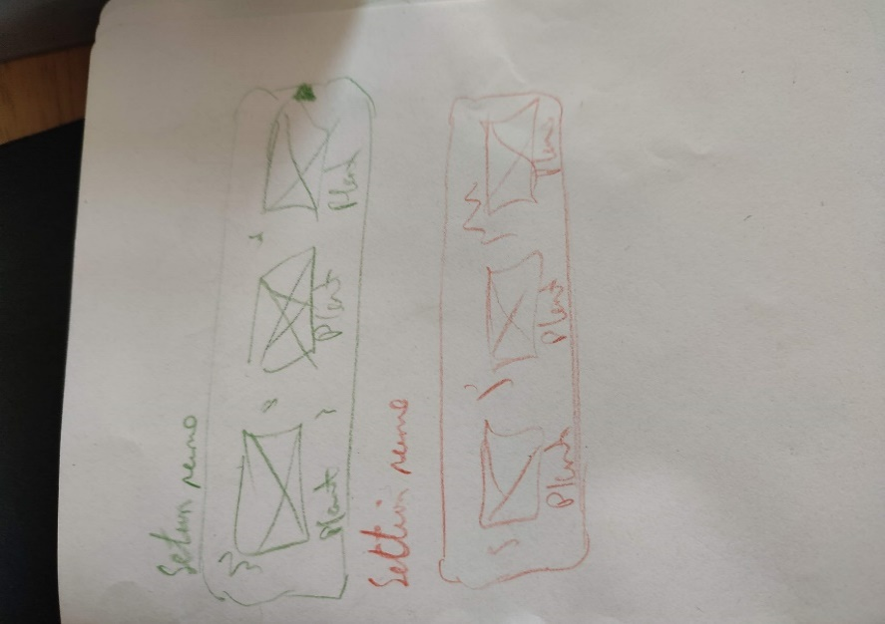Low fidelity wireframing is one of the design processes I struggled with most as I do not have much experience in any form of visual design. This meant that when asked to attempt to draw 8 different designs with 1 minute each I quickly ran out of what I would define as standard but good ideas. However, this led me to come up with more unique designs that I would not have been able to come up with otherwise. Figure 2 shows one of my more unique ending ideas where instead of using a standard display of boxes I attempted to create a design showing individual garden areas as orbs based on the number of plants inside of them which when clicked on would show these plants as similar orbs.

Figure 2

Figure 3

Figure 3, on the other hand, shows the more standard approach that I ended up going for. Although, a more intriguing approach can appeal more visually to a user I decided that the actual usability of the application would be far more important making this approach a far more sensible one. This taught me that although an approach looks more unique and newer it may not be the best idea in the long term especially considering the lack of technical experience among my personas.

## Digital prototype[4]

The making of the digital prototype was a challenge for me as mentioned earlier my actual practical front-end design experience is very limited. Going into it I planned on using either Figma or Adobe XD as my software of choice as they are general industry recommendations. However, I quickly found when attempting to use both in separate multi-hour sessions that the tools appeared very powerful but also that their learning curve was extremely steep. Therefore, I gave myself the challenge of creating the home page for my application in Figma as well as attempting to make it in PowerPoint to see which I could complete faster and to a higher standard. I found that the one I made in PowerPoint ended up looking far more polished and fit my design idea very successfully it also took me a relatively short amount of time taking me about 30 minutes due to my experience in its tools. On the other hand, Figma took me on and off sessions of about 5 hours to complete and did not fit my vision in the same way PowerPoint did. Therefore, I decided to cut my losses and use the tool I could create a better solution in. In future I would love to learn how to use Figma or Adobe XD, but I found their learning curves too aggressive for them to be functionally useful for me as someone new to the topic. I want to stress here how using tools you know you can use to get a quality solution will be a better use of my time that attempting to use something just because it a general industry tool and that I have now learnt to work with what I prefer rather than attempt to work in a way that I do not understand the usefulness of.

## Cognitive walkthrough[5]

Following the creation of my digital prototype I took it to my peers with a pair of common tasks a user might go through to see whether the experience lined up with my expectations. During this walkthrough, my peers followed the path I expected pointing out my expected user’s path in the exact way I imagined a user would attempt to reach their goals. However, they also pointed out a couple of points where clarity was lacking in my design. For example, one said that “It’d be nice to have text below the menu buttons to clarify what each one is as it could get confusing” this is something that had completely slipped my mind in the design process as I had been working with these icons for so long that their uses became intrinsic in my mind. This helped teach me to take a step back during my work so that I could try and get the wider picture as I had become too focused on the exact placement of individual elements on the page to notice the lack in clarity in what they mean although it should have been easy to see.

# Evaluation

My digital prototype provides a sample interface for a mobile application which aims to help novice food growers. It does this by providing a minimalistic vision of the food growing process from crop selection and organisation all the way to harvest. My goal was to make an application that the personas Neil and Nadia could both understand and use which helped them to grow food themselves. A minimalistic design helps complete this as they are both novice food growers with effectively 0 experience. This means that the application providing them with only the information they need and not attempting to bog them down in unnecessary details helps them get to grips with the experience quickly and easily leading to a higher quality experience for them. In specific Neil spends very little time on his phone and has a busy life looking after 3 kids as a stay-at-home father this means that the solution needed to provide him with a simple quick way of being setup which this prototype succeeds in doing. The interface also attempts to use a small amount of colour highlighting in the use of coloured names for garden sections helping with keeping a clean look whilst also providing a splash of life to the design. Within the design the user is also able to find crops based on their own specific situations, as shown in the prototype filters can be applied when searching for different crops allowing for the user to find crops based on month, sunlight times and the type of growing location as these are varying factors for growers external to their location. In addition to these filters an automatic filter would be applied based on the user’s location (which is entered upon sign up either via GPS location data or them entering it in manually) allowing for filtering based on region and soil type native to this region. This would also be editable within the settings menu if the user is using soil from a different region or if they have moved locations. I have tested this prototype both on my peers within HCI as well as a pair of external parties where although minor adjustments where recommended (including the addition of the ability to change soil type within settings) I have received positive judgment from both groups. My design is in no way perfect, it would not suit everybody’s needs and some competitors fill different parts of the food growing assistance for things such as complex garden plans (such as [www.growveg.co.uk/](http://www.growveg.co.uk/) ‘s more complicated garden planner). However, I believe this fulfils the desires of my personas as it provides a simple introduction to the hobby without requiring the same time and learning process of the competitors I looked at.

# Conclusions and Future Work

In conclusion I believe that this project has been an overwhelming success. I have worked on many different HCI methods and learned a lot about the process of creating an applications design from start to (almost) finish. I believe this project has helped me develop me a lot as a computer science as it has taught me to challenge myself by doing things I would not normally do or even think about. The low-fidelity wireframing is a great example of this as it is a process I would normally avoid doing as I don’t put much stock in my artistic abilities but getting design ideas on paper helped me better picture the general direction for my design rather than just sticking with the very first thing that I though of. If I were to continue work on this design solution, I would focus primarily on adding another layer of complexity to my application. Now the app does little more than provide organisation and general information about food to grow. Therefore, I would intend to add a gamification element to the application to deepen engagement as providing a user with a sense of reward for completing their growing may help encourage them to take part in it more and provide a more fulfilling solution overall. Personally, this project was hard for me as it was working with a lot of concepts and ideas I am not used too. However, I found that information was provided on these ideas excellently by Rachel, Meghan and Erkki which helped greatly in me getting to grips with these concepts and ideas. I enjoyed learning about these new methods and would love to become better at them and use them more in the future for more projects. If I were to do this again, I would try to focus on learning the ins and outs of a software like Figma or Adobe XD to better engage with the final digital design portion. As, although I managed to produce something I am proud of using PowerPoint I feel a lack of achievement and true increase in understanding from using a software that I have been using to since primary school to make quizzes. This would help me better engage overall with the learning experience but was not entirely necessary to produce this solution alone making it more of a wish than an actual flaw in the work I have done.

(word count: 2668 pre appendices)

# Appendices

Figure 1 3

Figure 2 4

Figure 3 4

Figure 4 7

Figure 5 7

Figure 6 10

Figure 4

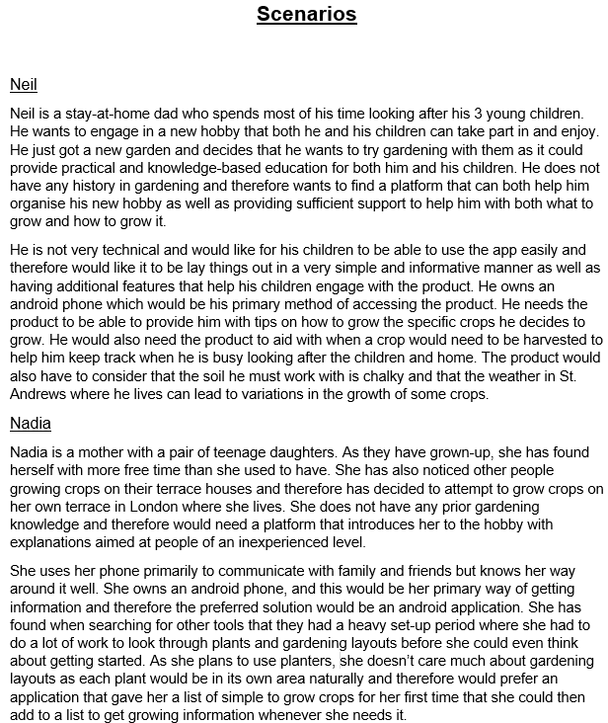

Figure 5

|  |  |  |  |
| --- | --- | --- | --- |
| Goal | Will the user know what to do? (visibility, instruction, labelling, symbols) | If the user does the right thing, do they know they did the right thing and understand that they are progressing towards their goal? (Feedback) | Comments and recommendation |
| Task 1:  Add a garden section | Yes, the step-by-step process is guided through as described in the subtasks | Yes, at the end a new garden section will be visible on the My Garden / Home screen | This should be the first task a user does so will introduce them to the application so needs to be a well guided process |
| Subtask 1.1:  Open Mid-Leaf Crisis App | Yes, after download the apps icon will appear in app trays and on the home screen if the user has placed it there | Yes, a login screen will be shown | An opening animation will provide the user with more immediate feedback to know the app is working as expected |
| Subtask 1.2:  Enter a username in the username field | Yes, the box has a label of “username” implying they should write a username there | Yes, the username they have entered will appear in the username textbox | Information about the possible length and containable characters in the username should be provided |
| Subtask 1.3:  Enter an email in the email field | Yes, the box has a label of “email” implying they should write their email there | Yes, the email they have entered will appear in the email textbox | The application should say if the email is in a valid form as it is being entered by the user to provide feedback |
| Subtask 1.4:  Enter a password in the password field | Yes, the box has a label of “password” implying they should write their password there | Yes, dots of the passwords length they have entered will appear in the password textbox | Before becoming a dot, each entered character should first be shown so the user can be confident that they inputted the correct character |
| Subtask 1.5:  Enter the confirmation password in the confirm password field | Yes, the box has a label of “confirm password” implying they should write their password there | Yes, dots of the passwords length they have entered will appear in the confirm password textbox | Before becoming a dot, each entered character should first be shown so the user can be confident that they inputted the correct character. Also, if the passwords are not of the same length the application should inform them of this. |
| Subtask 1.6:  Click Sign Up | Yes, the button saying “Sign Up” is located below the information text boxes and would be the next thing to click | Yes, if successful the My Garden / Home screen will be loaded. If unsuccessful they will get an error message | A loading animation should be played to keep a stylised look for the user |
| Subtask 1.7:  Click the plus button | Yes, the plus on the button implies it is used to add to the garden area they are in | Yes, the add garden section screen will be loaded | Whilst being clicked the button should change colour to imply it is being pressed |
| Subtask 1.8:  Enter the section name in the section name field | Yes, the box has a label of “Section Name” implying they should write a section name there | Yes, the garden name they have entered will appear in the garden name textbox | The user should be provided with a sample section name, so they know the sort of thing they are meant to write |
| Subtask 1.9:  Pick a section colour using the colour wheel in the section colour field | Yes, a colour selection box will be present that on click loads a colour selecting tool | Yes, the selected colour will appear in the colour selection box labelled section colour | The default selected colour should be unique to other created garden sections and a list of standard colours should be given |
| Subtask 1.10:  Write any notes about the section in the notes field | Yes, the box has a label of “Notes” implying they should write any notes they have there | Yes, any notes they write will be displayed in the “Notes” text box | The user should be made aware that this section does not need to be filled at this time and can be edited later |
| Subtask 1.11:  Click the Add Section button | Yes, the button saying “Add Section” is located below the information text boxes and would be the next thing to click | Yes, a new garden section will appear in the My Garden / Home page that they will have also be redirected too | Upon click the garden section should have a “pop” animation as it is added to the home screen to centre the users focus on it |
| Task 2:  Add a plant to a garden section | Yes, when looking for plants to add the user is most likely to attempt to follow this path | Yes, the new plant will appear in the appropriate garden section | The search screen should also be accessible from clicking the plus button within a newly created garden section saying add plant |
| Subtask 2.1:  Click the search for plants button | No, a symbol button with a bag of seeds is present but this could be unclear to an end user | Yes, the search screen will be loaded | Adding text saying what each button does would provide greater clarity on what each button does removing the end user’s possible confusion |
| Subtask 2.2:  Apply filters as appropriate | Yes, labelled boxes for filters will be at the top of the page | Yes, the filter boxes will change their text to show the applied filter | Filters should be saved between sessions and should provide information about what each means via an “i” icon |
| Subtask 2.3:  Click a desired plant in the list of results | Yes, a list of crops will be shown with basic information to give with clickable text and image | Yes, the plants information screen will be shown | The plant information provided should give a sense of difficulty as well as time to grow to help inform the user of whether it would be a good option for them |
| Subtask 2.4:  Click the plus button | Yes, the plus button implies adding the current shown plant to their garden | Yes, the add plant screen will be shown | Whilst being clicked the button should change colour to imply it is being pressed |
| Subtask 2.5:  Select the appropriate section from the drop-down menu in the section name field | Yes, the box has a label of “Section” implying they should select the section they want the plant to be added too | Yes, the selected section will be shown in the text box labelled “Section” | The list of sections should show their names in the colour of the section their representing to help remind the user of which is which |
| Subtask 2.6:  Write any notes about the plant in the notes field | Yes, the box has a label of “Notes” implying they should write any notes they have there | Yes, any notes they write will be displayed in the “Notes” text box | The user should be made aware that this section does not need to be filled at this time and can be edited later |
| Subtask 2.7:  Click the Add Plant button | Yes, the button saying “Add Section” is located below the information text boxes and would be the next thing to click | Yes, the selected plant will be shown in the garden section they added it to in the My Garden / Home page that they have been redirected too | Upon click the crop should have a “pop” animation as it is added to the appropriate garden section to centre the users focus on it |

Figure 6

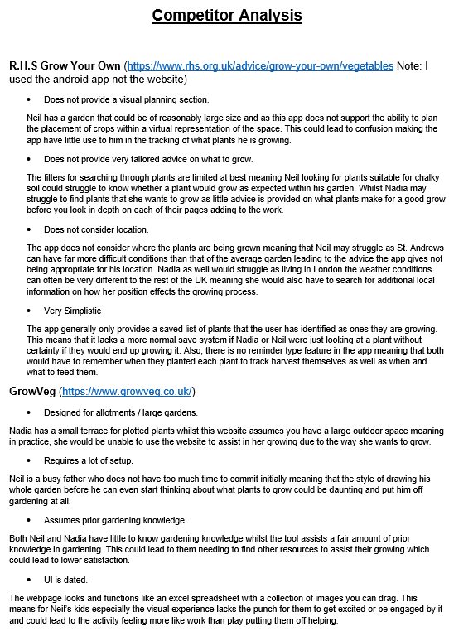

1. Figure 6
2. <https://miro.com/app/board/o9J_lGcB_Rw=/>
3. Figure 1
4. [Digital Prototype (1).pptx](https://newcastle-my.sharepoint.com/:p:/g/personal/b9021022_newcastle_ac_uk/EXCBsQJ8GH1CtAbDdk0oEHABO0eY2i7Xv22luNcij-DrQA?e=dkyYY7)
5. Figure 5