Compiled by
James E. Spencer
Emily Rubright
Sarah Meyer
Clifton Patterson
Alex Eyer

Fantasy Character Generator

Last updated: February 21, 2022

Overview - Executive summary

Elevator Pitch / High Concept
Fantasy Character Generator is an Android app for creating character data that offers one place to create and store all data for your characters for D&D players/Medieval Role Players.

Key Features/ Product goals
- Character Generator
Randomly generates attributes to be associated with a Character created within the app
- Downloadable PDF Stat Card
Create a downloadable and printable document card with the information of your new character

Target Audience
Primary:
Dungeons and Dragons Dungeon Masters use for Non-Player Character ideas and templates.
Secondary:
Authors/other creatives looking for motivation and ideas on new procedurally generated personalities.

Comparable products

NPCGEnerator.com
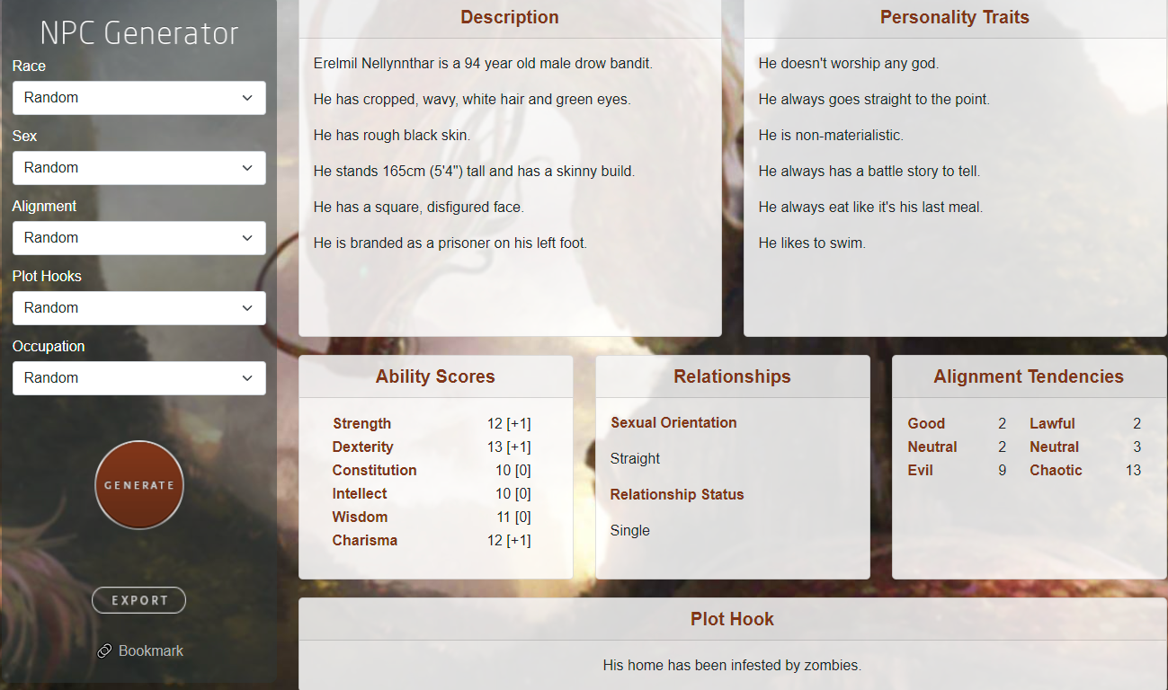
This web based system is approximately what we’re going for, with a lack of downloadable pdf, and usability on Android devices.

negatherium.com
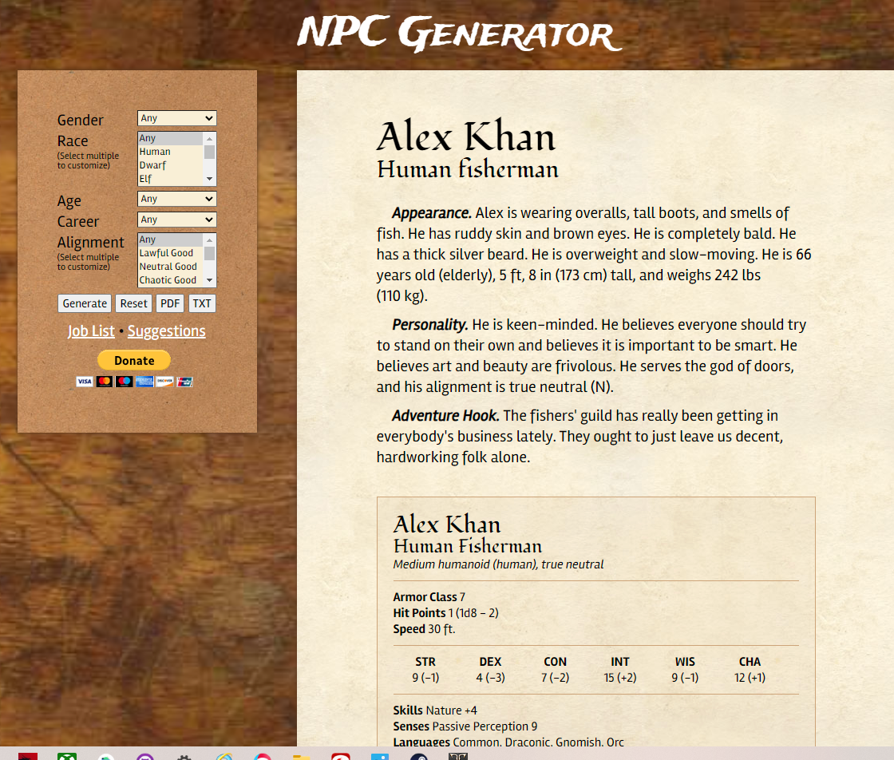
This app has more of our “character card” concept, but without a downloadable or printable functionality.

Character story plannerr
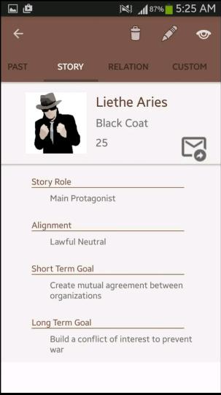
This android app is the closest we could find on the subject, and has more of a planning and story based character planning, with less emphasis on generation.

Character generation
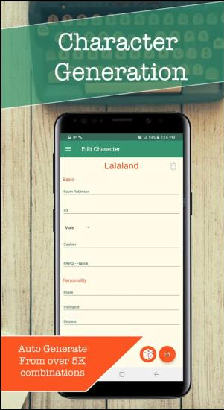
Character generation without the fantasy/D&D elements

GM WIzard
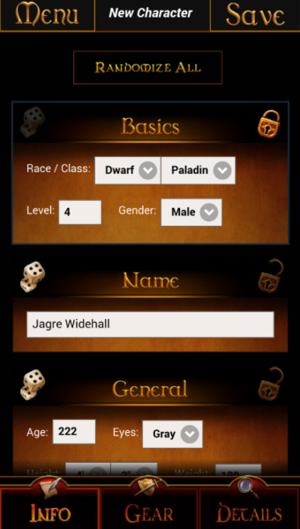
This app is specifically for Player Character generations in Dungeons and Dragons, but with less available for Non-Players.

Interactivity

SCreens and User interfaces

Screens
Main Screen
Generated Character Screen
Saved Characters Screen
Create Custom Character Screen
Credits Screen

Navigation Bar
Hamburger Style Navigation /
-Settings
-Credits
-Windows

Table View
N/A

Hardware interfaces

Requirements / System Overview

Data Architecture
Alignment, Ideals

APIs and libraries
Names, Races, Occupations, Bonds, Flaws, Physical Identifiers API

Client/Server
Android

Functional Descriptions
The user should be able to press generate, to procedurally generate a randomly generated character from a database of different APIs for aspects of a personality in a fictional world. The generated character will have conditional statements in place to assure that there are as little as possible “unrealistic” products of the generation.

Map integration
N/A

user generated content
The user will be able to create a custom character from scratch on the platform, export to PDF and print if they so desire.

User Acounts
(facebook, google)

User autentication
N/A

Synced information

Inventory managment
Allow space for 50 character slots, with a reasonably easy to use removal system from the UI.

Notifications
No notifications.

…

