Gant Chart

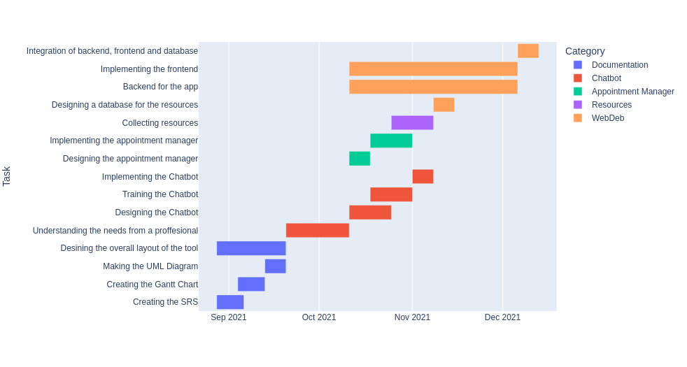
please visit the following link for viewing the interactive gantt chart:
https://se-mentalhealth-app.herokuapp.com/

Made by: Clifton Festus Malvea, Aditya Narayan Singh, Arslan Mansoor and Rohan Rajput

