Title: Exposure to air pollution during pregnancy and perinatal outcomes in Temuco, Chile (2009-2016)

Authors: Estela Blanco^{1,2}; José Daniel Conejeros¹; …

1: College UC y Escuela de Salud Pública, Pontificia Universidad Católica de Chile, Santiago, Chile.
2: Centro de Ciencia del Clima y la Resiliencia (CR2), Santiago, Chile

Corresponding Author: Estela Blanco^{1,2}

Conflicts of Interest Statement: The authors declare no conflicts of interest.

Acknowledgments: EB acknowledges FONDECYT N°11240322 and the Center for Climate and Resilience Research (CR)2, Chile, FONDAP/ANID 1523A0002.

CREDIT Statement:

Estela Blanco: Conceptualization, methodology, software, validation, resources, supervision, writing-original draft preparation.
José Daniel Conejeros: methodology, software, formal analysis.
…

Table X. Descriptive characteristics of the study population according to birth outcomes.
Variable | Full Sample | PTB | Very  PTB | Moderate PTB | Late  PTB
 | N=15398 | N=1326  (8.6%) | N=192  (1.2%) | N=100  (0.6%) | N=934  (6.1%)
Birth
Gestational Age | 38.8 (1.9) | 34.1 (2.2) | 29.8 (1.1) | 32.0 (0.0) | 35.3 (0.8)
Female | 50.6% (7787) | 56.7% (752) | 56.2% (108) | 57.0% (57) | 56.5% (528)
Cesarean | 34.7% (5340) | 55.8% (740) | 62.5% (120) | 65.0% (65) | 53.1% (496)
Mother
Age | 26.3 (6.8) | 28.0 (7.5) | 28.9 (7.8) | 28.4 (7.2) | 27.8 (7.5)
Nº of Births | 0.9 (1.1) | 0.8 (1.1) | 0.8 (0.9) | 0.7 (0.9) | 0.9 (1.1)
Education
None or primary | 13.2% (2029) | 10.7% (142) | 9.4% (18) | 11.0% (11) | 11.3% (106)
Secondary | 66.1% (10178) | 58.7% (779) | 59.4% (114) | 46.0% (46) | 60.3% (563)
Higher | 20.5% (3163) | 30.3% (402) | 30.7% (59) | 43.0% (43) | 28.2% (263)
Unemployed | 68.6% (10568) | 56.6% (751) | 49.5% (95) | 58.0% (58) | 59.1% (552)
Health insurance
FONASA A | 54.4% (8379) | 41.6% (551) | 37.5% (72) | 36.0% (36) | 43.7% (408)
FONASA B | 23.0% (3535) | 26.4% (350) | 31.8% (61) | 29.0% (29) | 24.7% (231)
FONASA C | 12.5% (1930) | 15.4% (204) | 10.9% (21) | 16.0% (16) | 16.5% (154)
FONASA D | 8.0% (1230) | 14.1% (187) | 15.1% (29) | 16.0% (16) | 13.3% (124)
PRIVATE | 2.1% (317) | 2.5% (33) | 4.7% (9) | 3.0% (3) | 1.7% (16)
Municipality
Padre las casas | 17.3% (2661) | 14.8% (196) | 14.6% (28) | 10.0% (10) | 15.8% (148)
Temuco | 82.7% (12737) | 85.2% (1130) | 85.4% (164) | 90.0% (90) | 84.2% (786)
Year
2009 | 3.7% (575) | 4.0% (53) | 8.3% (16) | 5.0% (5) | 3.2% (30)
2010 | 13.6% (2099) | 12.0% (159) | 14.6% (28) | 11.0% (11) | 11.6% (108)
2011 | 14.2% (2180) | 12.4% (164) | 14.1% (27) | 19.0% (19) | 10.9% (102)
2012 | 13.9% (2135) | 11.5% (152) | 13.5% (26) | 16.0% (16) | 11.1% (104)
2013 | 13.5% (2073) | 14.6% (193) | 11.5% (22) | 14.0% (14) | 14.8% (138)
2014 | 14.6% (2246) | 15.4% (204) | 11.5% (22) | 14.0% (14) | 15.8% (148)
2015 | 13.9% (2143) | 15.2% (201) | 12.5% (24) | 8.0% (8) | 16.5% (154)
2016 | 12.6% (1947) | 15.1% (200) | 14.1% (27) | 13.0% (13) | 16.1% (150)
Month
January | 8.0% (1225) | 7.5% (99) | 8.3% (16) | 10.0% (10) | 7.0% (65)
February | 7.3% (1123) | 7.6% (101) | 7.3% (14) | 8.0% (8) | 7.1% (66)
March | 8.3% (1284) | 8.2% (109) | 5.2% (10) | 9.0% (9) | 8.7% (81)
April | 8.2% (1262) | 6.6% (88) | 11.5% (22) | 6.0% (6) | 5.4% (50)
May | 7.7% (1183) | 8.3% (110) | 7.3% (14) | 12.0% (12) | 8.7% (81)
June | 7.8% (1199) | 7.6% (101) | 5.7% (11) | 7.0% (7) | 8.1% (76)
July | 8.0% (1238) | 7.8% (103) | 6.8% (13) | 5.0% (5) | 8.2% (77)
August | 8.0% (1238) | 8.7% (115) | 10.4% (20) | 7.0% (7) | 8.7% (81)
September | 8.9% (1367) | 9.5% (126) | 12.5% (24) | 9.0% (9) | 8.5% (79)
October | 9.4% (1454) | 9.0% (119) | 7.8% (15) | 5.0% (5) | 9.4% (88)
November | 8.7% (1336) | 8.5% (113) | 5.2% (10) | 11.0% (11) | 9.1% (85)
December | 9.7% (1489) | 10.7% (142) | 12.0% (23) | 11.0% (11) | 11.2% (105)
Note: For categorical variable values are represent with % and n in parenthesis, for numeric variables values are mean and standard deviation in parenthesis. PTB: preterm birth.

Figure X. Gestational exposure to air pollutants based on fixed-site estimation: trimester-specific and overall spatial distribution, 2009–2016.
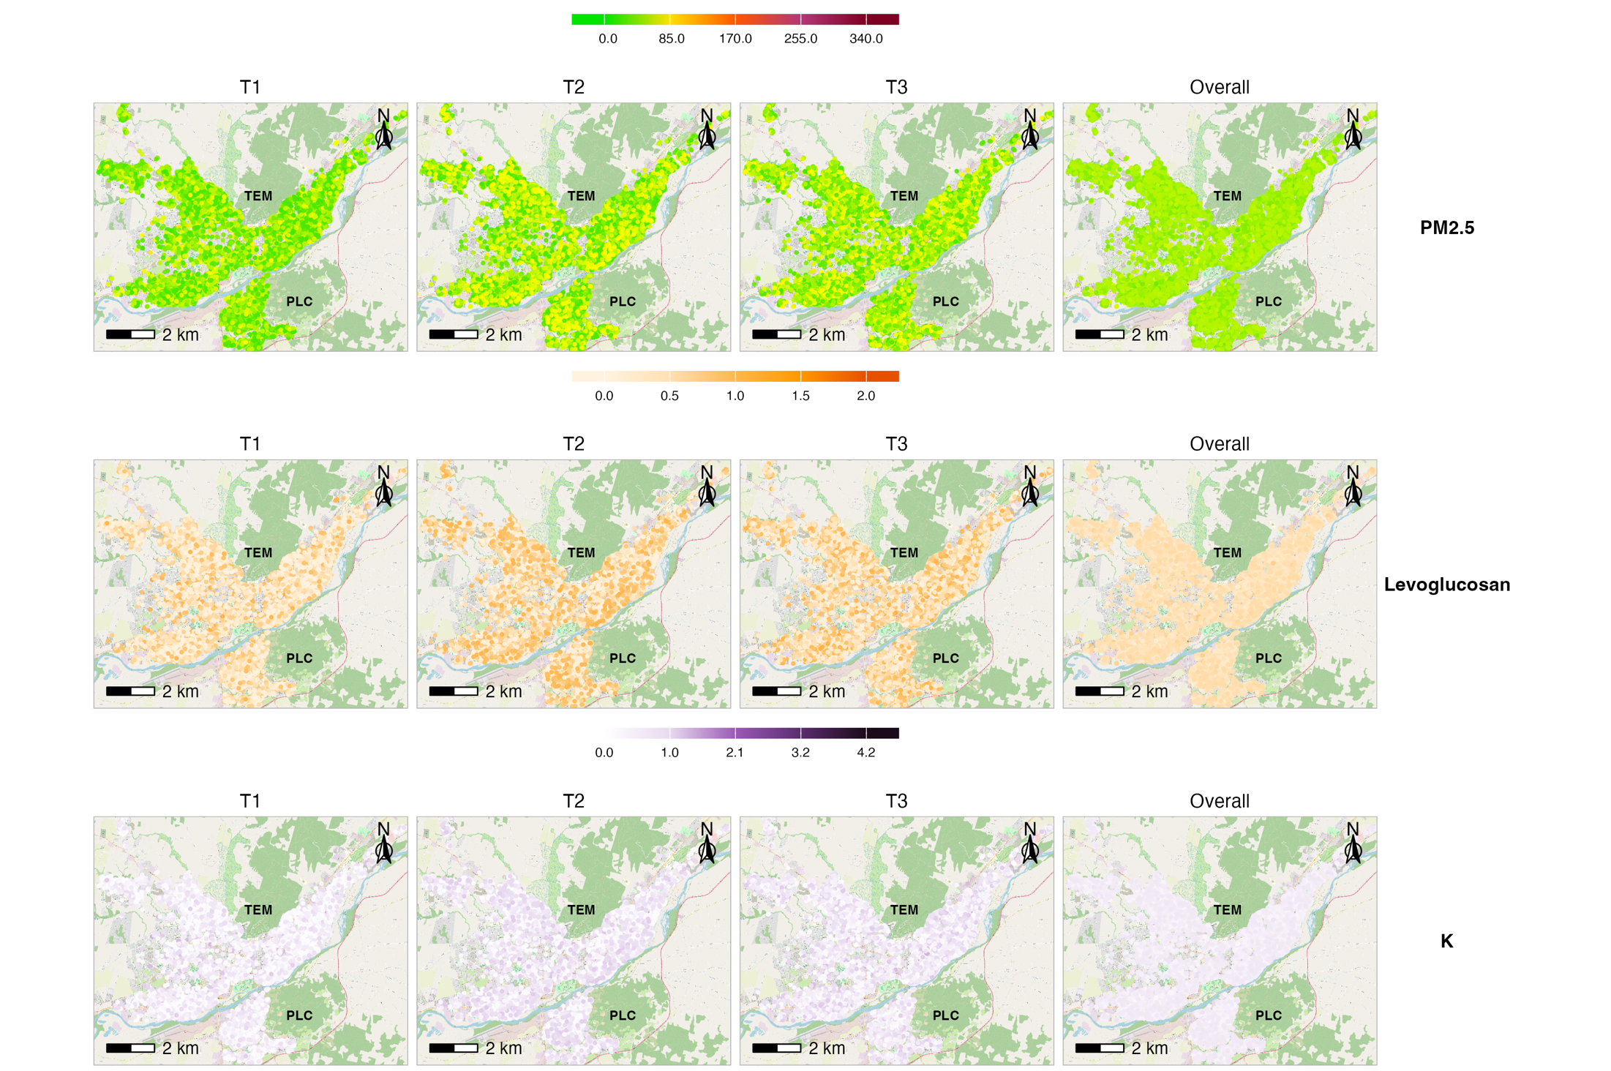Note: Exposure to air pollutants (PM₂.₅, levoglucosan, and potassium [K]) was estimated using fixed-site estimation. Panels display spatial distributions for each gestational trimester (T1, T2, T3) and overall pregnancy exposure. PM2.5 is expressed in µg/m³, while levoglucosan and K are presented in relative concentration units. TEM: Temuco and PLC: Padre Las Casas.
Figure X. Gestational exposure to air pollutants based on land-use regression: trimester-specific and overall spatial distribution, 2009–2016.
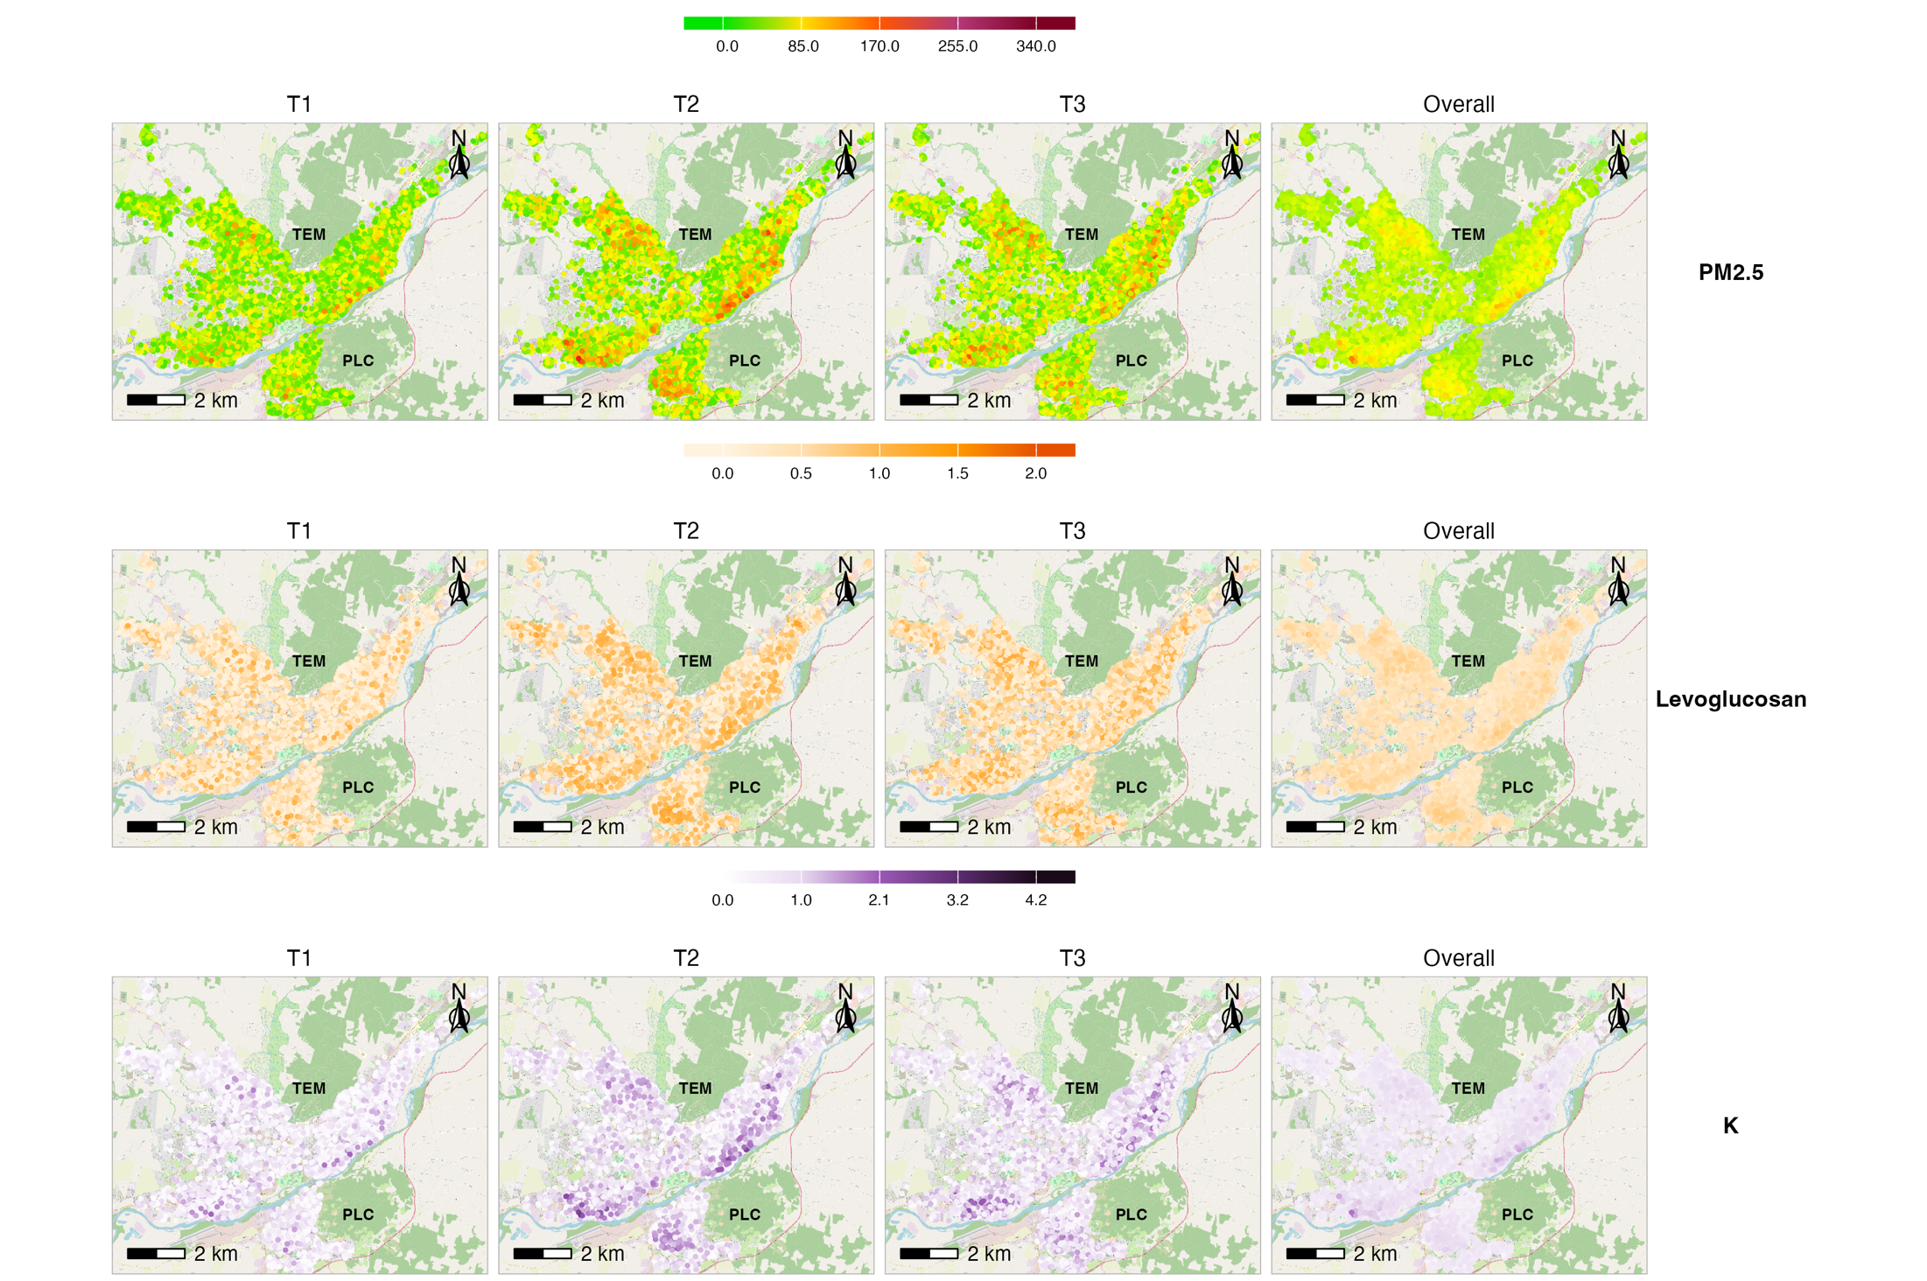
Note: Exposure to air pollutants (PM₂.₅, levoglucosan, and potassium [K]) was estimated using land-use regression. Panels display spatial distributions for each gestational trimester (T1, T2, T3) and overall pregnancy exposure. PM2.5 is expressed in µg/m³, while levoglucosan and K are presented in relative concentration units. TEM: Temuco and PLC: Padre Las Casas.
Table X. Mean (SD) maternal exposure to air pollutants during pregnancy by birth outcomes.

 |  | Fixed-site |  |  | Land-use regression
Contaminant | Exposure | Full Sample |  | PTB |  | Full Sample |  | PTB
PM_{2.5} | T1 | 35.81 (22.69) | 36.25 (22.82) |  | 57.75 (40.25) |  | 57.29 (40.32)
 | T2 | 37.09 (22.86) | 36.61 (22.48) |  | 59.92 (40.86) |  | 57.29 (39.54)
 | T3 | 35.77 (22.06) | 34.72 (22.25) |  | 57.69 (39.30) |  | 54.00 (37.75)
 | w20 | 37.19 (29.30) | 35.70 (27.74) |  | 60.08 (51.15) |  | 55.70 (46.78)
 | Overall | 36.09 (8.79) | 35.97 (11.26) |  | 58.21 (20.43) |  | 56.41 (23.35)
Levoglucosan | T1 | 0.45 (0.36) | 0.46 (0.36) |  | 0.47 (0.39) |  | 0.48 (0.38)
 | T2 | 0.47 (0.36) | 0.47 (0.36) |  | 0.50 (0.39) |  | 0.49 (0.38)
 | T3 | 0.45 (0.35) | 0.44 (0.36) |  | 0.48 (0.38) |  | 0.46 (0.38)
 | w20 | 0.47 (0.47) | 0.45 (0.45) |  | 0.50 (0.50) |  | 0.47 (0.46)
 | Overall | 0.46 (0.13) | 0.46 (0.17) |  | 0.48 (0.15) |  | 0.48 (0.19)
Potassium | T1 | 0.54 (0.39) | 0.55 (0.39) |  | 0.76 (0.58) |  | 0.77 (0.58)
 | T2 | 0.57 (0.39) | 0.56 (0.38) |  | 0.80 (0.59) |  | 0.77 (0.56)
 | T3 | 0.54 (0.38) | 0.53 (0.38) |  | 0.76 (0.57) |  | 0.72 (0.55)
 | w20 | 0.57 (0.52) | 0.54 (0.49) |  | 0.80 (0.76) |  | 0.74 (0.69)
 | Overall | 0.55 (0.14) | 0.55 (0.19) |  | 0.77 (0.26) |  | 0.76 (0.31)
Note: Values are presented as mean (standard deviation). T1–T3 correspond to pregnancy trimesters 1–3; w20 represents exposure during gestational week 20; Overall represents average exposure across pregnancy. Exposure estimates were derived from (A) fixed-site monitoring stations and (B) land-use regression (LUR) models. PTB: preterm birth.

Table X. Hazard ratios of preterm birth associated with air pollutant exposure during pregnancy.

 | PM_{2.5} |  | Levoglucosan |  | Potassium
Exposure | Crude | Adjusted | Crude | Adjusted | Crude | Adjusted
 | FIXED – SITE
 | HR: Δ+ 1 μg/m³ (95% CI)
W20 | 0.998 (0.996-1.000) | 0.998 (0.995-1.000) | 0.900 (0.796-1.017) | 0.876 (0.754-1.017) | 0.896 (0.800-1.002) | 0.874 (0.761-1.003)
T1 | 0.997 (0.993-1.002) | 1.006 (1.000-1.013) | 0.989 (0.715-1.369) | 1.539 (1.052-2.251) | 0.942 (0.715-1.241) | 1.492 (1.065-2.089)
T2 | 1.000 (0.997-1.003) | 0.996 (0.993-1.000) | 0.982 (0.829-1.162) | 0.813 (0.657-1.006) | 0.976 (0.836-1.139) | 0.802 (0.656-0.981)
T3 | 0.995 (0.990-1.000) | 1.000 (0.994-1.006) | 0.882 (0.631-1.235) | 1.089 (0.748-1.585) | 0.842 (0.632-1.123) | 1.057 (0.762-1.466)
Overall | 0.998 (0.992-1.005) | 1.004 (0.995-1.012) | 1.098 (0.710-1.697) | 1.444 (0.836-2.492) | 1.000 (0.676-1.481) | 1.345 (0.815-2.219)
 | HR: Δ+ 1 IQR (95% CI)
W20 | 0.927 (0.857-1.003) | 0.912 (0.828-1.005) | 0.931 (0.855-1.013) | 0.914 (0.825-1.012) | 0.929 (0.860-1.003) | 0.913 (0.832-1.002)
T1 | 0.898 (0.746-1.081) | 1.304 (1.021-1.664) | 0.994 (0.797-1.239) | 1.367 (1.056-1.770) | 0.962 (0.797-1.160) | 1.341 (1.064-1.689)
T2 | 0.999 (0.897-1.114) | 0.855 (0.742-0.984) | 0.988 (0.881-1.109) | 0.861 (0.745-0.996) | 0.983 (0.883-1.095) | 0.850 (0.740-0.978)
T3 | 0.835 (0.692-1.008) | 1.013 (0.809-1.268) | 0.922 (0.739-1.149) | 1.064 (0.833-1.359) | 0.893 (0.738-1.081) | 1.042 (0.840-1.291)
Overall | 0.981 (0.904-1.065) | 1.056 (0.949-1.175) | 1.023 (0.931-1.125) | 1.090 (0.969-1.226) | 1.003 (0.917-1.096) | 1.075 (0.961-1.204)
 | LAND-USE REGRESSION
 | HR: Δ+ 1 μg/m³ (95% CI)
W20 | 0.998 (0.997-0.999) | 0.998 (0.997-0.999) | 0.872 (0.776-0.981) | 0.850 (0.737-0.979) | 0.890 (0.823-0.963) | 0.877 (0.798-0.963)
T1 | 0.997 (0.995-0.999) | 1.002 (0.999-1.004) | 0.785 (0.600-1.026) | 1.226 (0.898-1.674) | 0.851 (0.733-0.988) | 1.152 (0.964-1.376)
T2 | 1.000 (0.998-1.002) | 0.998 (0.995-1.000) | 0.990 (0.842-1.163) | 0.811 (0.662-0.993) | 0.981 (0.879-1.095) | 0.842 (0.732-0.969)
T3 | 0.996 (0.993-0.998) | 0.997 (0.995-1.000) | 0.700 (0.529-0.925) | 0.867 (0.641-1.172) | 0.768 (0.656-0.900) | 0.874 (0.739-1.034)
Overall | 0.995 (0.992-0.998) | 0.998 (0.994-1.001) | 0.771 (0.533-1.116) | 0.967 (0.620-1.508) | 0.761 (0.612-0.946) | 0.896 (0.696-1.154)
 | HR: Δ+ 1 IQR (95% CI)
W20 | 0.884 (0.820-0.953) | 0.874 (0.799-0.956) | 0.906 (0.832-0.987) | 0.889 (0.802-0.984) | 0.897 (0.834-0.966) | 0.883 (0.809-0.965)
T1 | 0.839 (0.742-0.949) | 1.114 (0.957-1.296) | 0.845 (0.704-1.014) | 1.155 (0.934-1.428) | 0.860 (0.750-0.987) | 1.142 (0.970-1.346)
T2 | 0.999 (0.901-1.108) | 0.856 (0.751-0.976) | 0.993 (0.889-1.111) | 0.860 (0.748-0.989) | 0.982 (0.886-1.089) | 0.846 (0.742-0.964)
T3 | 0.764 (0.672-0.868) | 0.853 (0.746-0.976) | 0.784 (0.651-0.945) | 0.902 (0.739-1.101) | 0.789 (0.685-0.908) | 0.879 (0.758-1.019)
Overall | 0.878 (0.815-0.947) | 0.938 (0.861-1.021) | 0.943 (0.867-1.024) | 0.992 (0.898-1.095) | 0.909 (0.842-0.980) | 0.959 (0.879-1.046)
Note: Hazard ratios (OR) and 95% confidence intervals (CI) were estimated using Cox regression models for PM2.5, levoglucosan, and potassium. Crude models are unadjusted; adjusted models control for maternal age, education, employment and health insurance, infant sex, year of birth, month of birth, and municipality. T1–T3 correspond to pregnancy trimesters 1–3; W20 represents exposure at gestational week 20; Overall represents average exposure across pregnancy.

Figure X. Associations between gestational exposure to air pollutants and preterm birth.
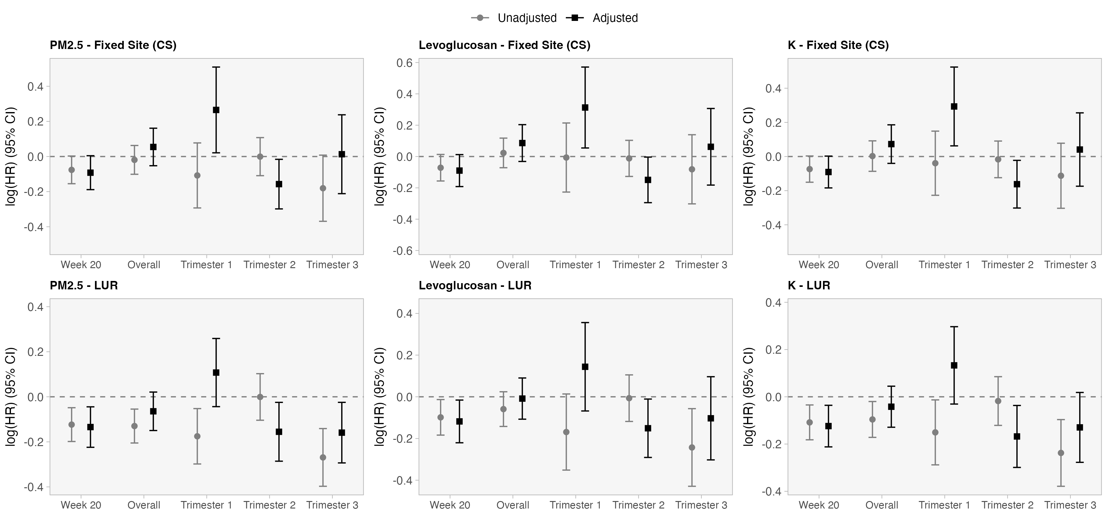

Note: Log hazard ratios (OR) and 95% confidence intervals (CI) were estimated using Cox regression models for PM2.5, levoglucosan, and potassium. Crude models are unadjusted; adjusted models control for maternal age, education, employment and health insurance, infant sex, year of birth, month of birth, and municipality. T1–T3 correspond to pregnancy trimesters 1–3; W20 represents exposure at gestational week 20; Overall represents average exposure across pregnancy. CS: Fixed-site; LUR: land-use regression model.

Figure X. Distributed lag model to associations between gestational exposure to air pollutants and preterm birth.

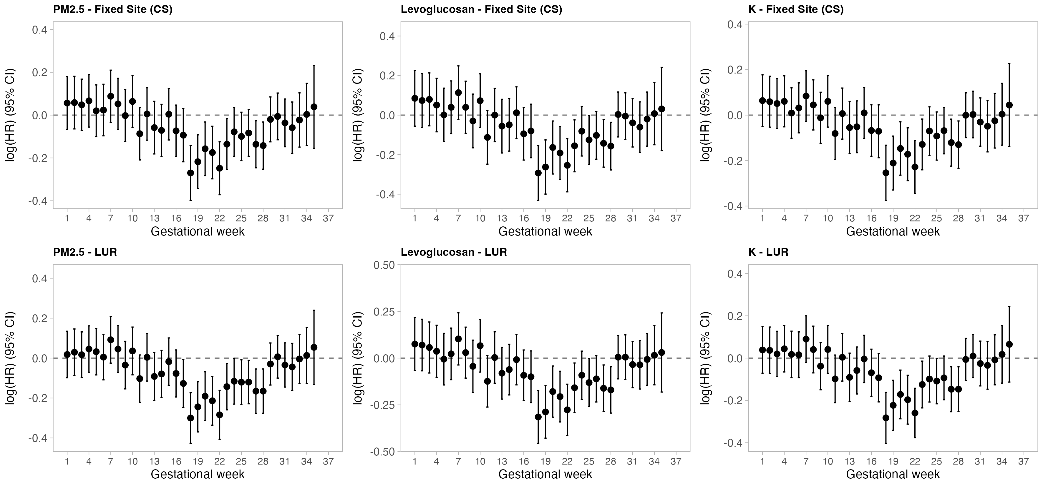
Note: Points represent log-transformed effect estimates (log(HR)) and 95% confidence intervals (CIs) from distributed lag models (DLMs) fitted using Cox regression. Each point reflects the association between exposure to air pollutants (PM2.5, levoglucosan, and potassium [K]) at a specific gestational week and the risk of the outcome, while simultaneously accounting for cumulative exposure from previous weeks. Cumulative exposure was modeled using an inverse decay weighting function (1/lag). Crude models are unadjusted; adjusted models control for maternal age, education, employment and health insurance, infant sex, year of birth, month of birth, and municipality. T1–T3 correspond to pregnancy trimesters 1–3; W20 represents exposure at gestational week 20; Overall represents average exposure across pregnancy. CS: Fixed-site; LUR: land-use regression model.

