Title: Exposure to air pollution during pregnancy and perinatal outcomes in Temuco, Chile (2009-2016)

Authors: Estela Blanco^{1,2}; José Daniel Conejeros¹; …

1: College UC y Escuela de Salud Pública, Pontificia Universidad Católica de Chile, Santiago, Chile.
2: Centro de Ciencia del Clima y la Resiliencia (CR2), Santiago, Chile

Corresponding Author: Estela Blanco^{1,2}

Conflicts of Interest Statement: The authors declare no conflicts of interest.

Acknowledgments: EB acknowledges FONDECYT N°11240322 and the Center for Climate and Resilience Research (CR)2, Chile, FONDAP/ANID 1523A0002.

CREDIT Statement:

Estela Blanco: Conceptualization, methodology, software, validation, resources, supervision, writing-original draft preparation.
José Daniel Conejeros: methodology, software, formal analysis.
…

Table X. Descriptive characteristics of the study population according to birth outcomes.
Variable | Full Sample | PTB | Very  PTB | Moderate PTB | Late  PTB | LBW | tLBW | SGA
 | N=15398 | N=1326  (8.6%) | N=192  (1.2%) | N=100  (0.6%) | N=934  (6.1%) | N=1031  (6.7%) | N=282  (1.8%) | N=1560  (10.1%)
Gestational Age | 38.8 (1.9) | 34.1 (2.2) | 29.8 (1.1) | 32.0 (0.0) | 35.3 (0.8) | 34.4 (2.9) | 37.8 (1.0) | 38.0 (2.5)
Female | 50.6% (7787) | 56.7% (752) | 56.2% (108) | 57.0% (57) | 56.5% (528) | 51.3% (529) | 46.5% (131) | 42.9% (670)
Male | 49.4% (7604) | 43.1% (571) | 43.8% (84) | 42.0% (42) | 43.3% (404) | 48.3% (498) | 53.2% (150) | 56.9% (887)
Mother Age | 26.3 (6.8) | 28.0 (7.5) | 28.9 (7.8) | 28.4 (7.2) | 27.8 (7.5) | 27.9 (7.5) | 26.6 (7.4) | 26.2 (7.1)
Year
2009 | 3.7% (575) | 4.0% (53) | 8.3% (16) | 5.0% (5) | 3.2% (30) | 4.7% (48) | 4.6% (13) | 3.9% (61)
2010 | 13.6% (2099) | 12.0% (159) | 14.6% (28) | 11.0% (11) | 11.6% (108) | 13.6% (140) | 16.0% (45) | 15.0% (234)
2011 | 14.2% (2180) | 12.4% (164) | 14.1% (27) | 19.0% (19) | 10.9% (102) | 13.4% (138) | 13.5% (38) | 13.6% (212)
2012 | 13.9% (2135) | 11.5% (152) | 13.5% (26) | 16.0% (16) | 11.1% (104) | 12.1% (125) | 13.5% (38) | 14.4% (225)
2013 | 13.5% (2073) | 14.6% (193) | 11.5% (22) | 14.0% (14) | 14.8% (138) | 13.5% (139) | 11.7% (33) | 12.8% (199)
2014 | 14.6% (2246) | 15.4% (204) | 11.5% (22) | 14.0% (14) | 15.8% (148) | 14.7% (152) | 14.5% (41) | 14.2% (221)
2015 | 13.9% (2143) | 15.2% (201) | 12.5% (24) | 8.0% (8) | 16.5% (154) | 13.6% (140) | 14.5% (41) | 14.2% (221)
2016 | 12.6% (1947) | 15.1% (200) | 14.1% (27) | 13.0% (13) | 16.1% (150) | 14.5% (149) | 11.7% (33) | 12.0% (187)
Month
January | 8.0% (1225) | 7.5% (99) | 8.3% (16) | 10.0% (10) | 7.0% (65) | 7.5% (77) | 6.4% (18) | 8.5% (132)
February | 7.3% (1123) | 7.6% (101) | 7.3% (14) | 8.0% (8) | 7.1% (66) | 7.3% (75) | 7.1% (20) | 6.7% (104)
March | 8.3% (1284) | 8.2% (109) | 5.2% (10) | 9.0% (9) | 8.7% (81) | 8.1% (83) | 7.4% (21) | 8.2% (128)
April | 8.2% (1262) | 6.6% (88) | 11.5% (22) | 6.0% (6) | 5.4% (50) | 7.7% (79) | 8.9% (25) | 7.2% (113)
May | 7.7% (1183) | 8.3% (110) | 7.3% (14) | 12.0% (12) | 8.7% (81) | 8.6% (89) | 9.6% (27) | 7.0% (109)
June | 7.8% (1199) | 7.6% (101) | 5.7% (11) | 7.0% (7) | 8.1% (76) | 7.5% (77) | 7.4% (21) | 7.4% (116)
July | 8.0% (1238) | 7.8% (103) | 6.8% (13) | 5.0% (5) | 8.2% (77) | 8.1% (83) | 8.5% (24) | 7.7% (120)
August | 8.0% (1238) | 8.7% (115) | 10.4% (20) | 7.0% (7) | 8.7% (81) | 8.2% (85) | 7.4% (21) | 8.4% (131)
September | 8.9% (1367) | 9.5% (126) | 12.5% (24) | 9.0% (9) | 8.5% (79) | 10.3% (106) | 11.3% (32) | 9.4% (146)
October | 9.4% (1454) | 9.0% (119) | 7.8% (15) | 5.0% (5) | 9.4% (88) | 9.6% (99) | 11.3% (32) | 10.9% (170)
November | 8.7% (1336) | 8.5% (113) | 5.2% (10) | 11.0% (11) | 9.1% (85) | 8.2% (85) | 6.7% (19) | 9.3% (145)
December | 9.7% (1489) | 10.7% (142) | 12.0% (23) | 11.0% (11) | 11.2% (105) | 9.0% (93) | 7.8% (22) | 9.4% (146)
Note: For categorical variable values are represent with % and n in parenthesis, for numeric variables values are mean and standard deviation in parenthesis. PTB: preterm birth; LBW: low birth weight; tLBW: low birth weight of term; SGA: small for gestational age.

Figure X. Temporal trends in adverse birth outcomes, 2009–2016.
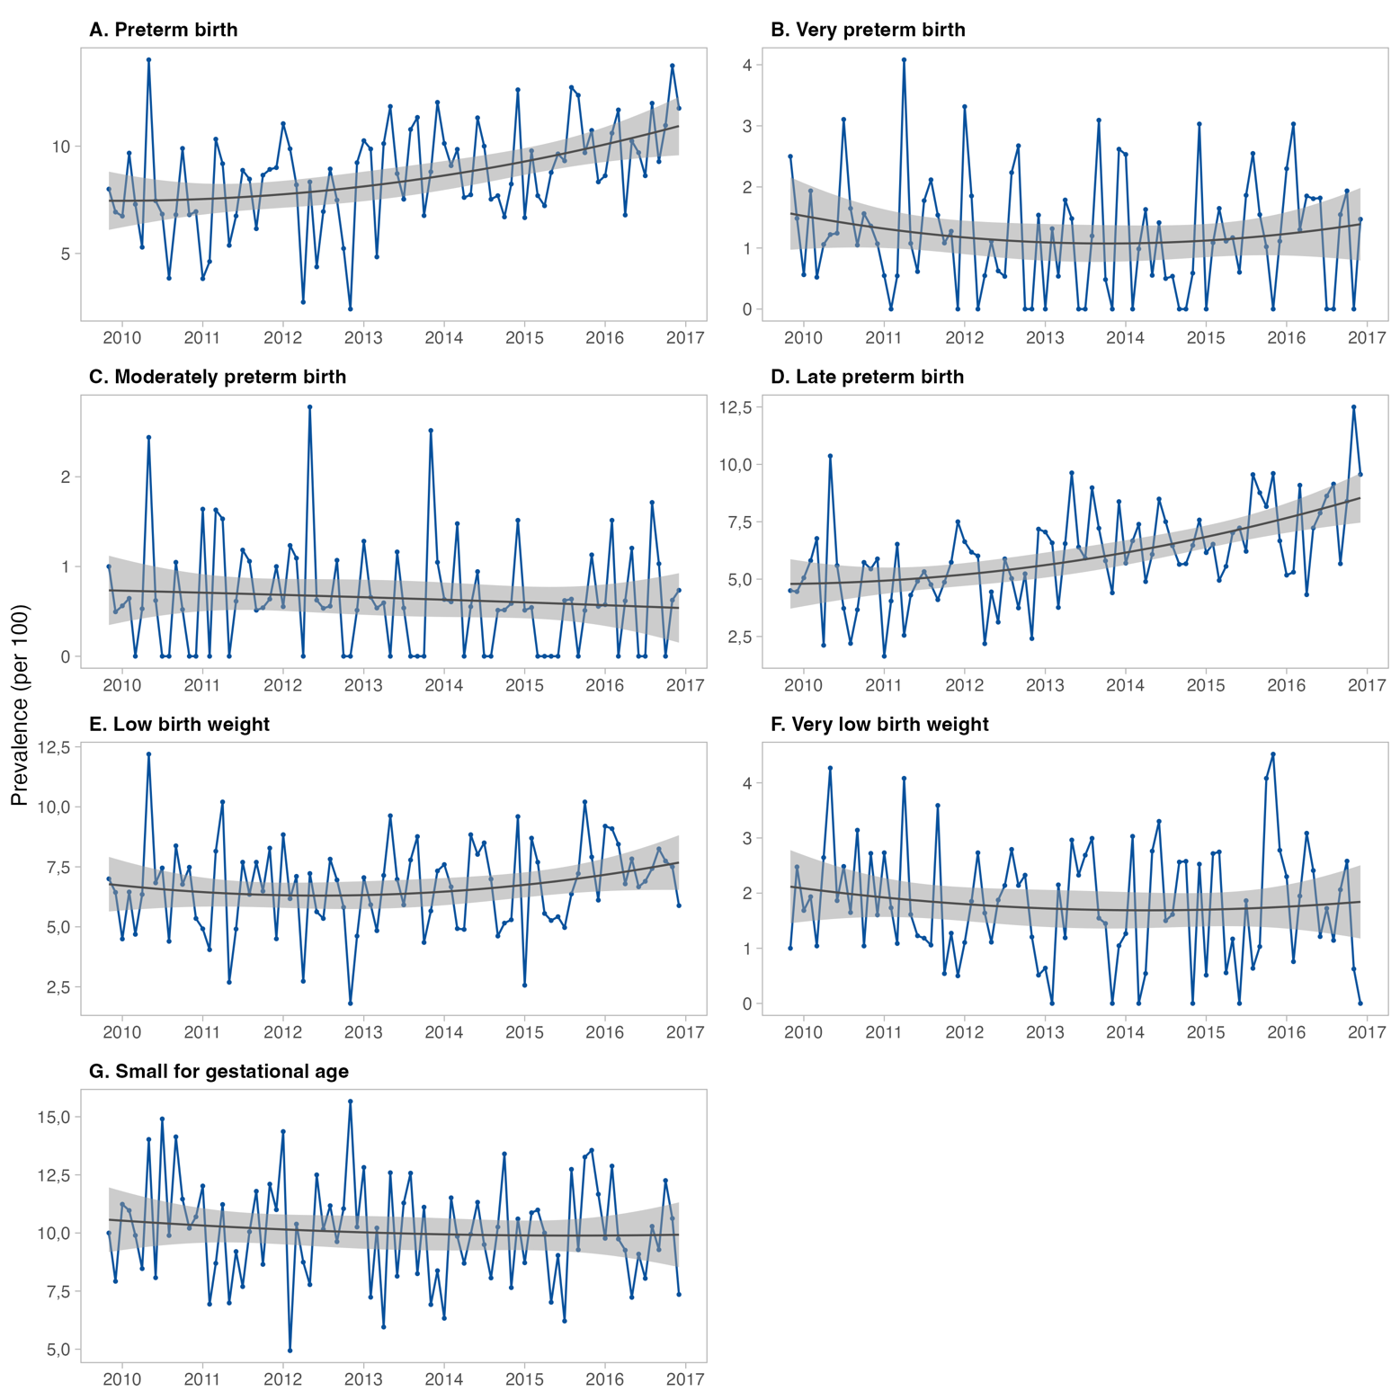
Note: Lines represent monthly prevalence (per 100 births). Solid lines indicate observed values; shaded areas represent 95% confidence intervals from cuadratic trend models.

Table X. Mean (SD) maternal exposure to air pollutants during pregnancy by birth outcomes.

Contaminant | Exposure | Full Sample | PTB | Very PTB | Moderate PTB | Late PTB | LBW | tLBW | SGA
 |  | Fixed site
PM_{2.5} | T1 | 35.81 (22.69) | 36.25 (22.82) | 37.17 (22.55) | 40.01 (22.53) | 35.64 (22.85) | 35.72 (22.69) | 33.94 (22.19) | 35.42 (22.78)
 | T2 | 37.09 (22.86) | 36.61 (22.48) | 38.44 (23.81) | 35.19 (21.77) | 36.35 (22.30) | 36.31 (22.55) | 35.27 (22.11) | 38.14 (22.92)
 | T3 | 35.77 (22.06) | 34.72 (22.25) | 35.35 (24.26) | 32.22 (23.06) | 34.88 (21.78) | 35.50 (22.65) | 36.93 (22.25) | 36.65 (22.11)
 | w20 | 37.19 (29.30) | 35.70 (27.74) | 38.18 (32.02) | 35.90 (29.55) | 35.32 (26.84) | 35.90 (27.91) | 36.19 (27.43) | 38.59 (29.83)
 | Overall | 36.09 (8.79) | 35.97 (11.26) | 37.32 (14.07) | 36.21 (12.14) | 35.66 (10.43) | 35.98 (11.23) | 35.44 (8.99) | 36.56 (9.40)
Levoglucosan | T1 | 0.45 (0.36) | 0.46 (0.36) | 0.47 (0.36) | 0.52 (0.36) | 0.45 (0.36) | 0.45 (0.36) | 0.42 (0.36) | 0.44 (0.36)
 | T2 | 0.47 (0.36) | 0.47 (0.36) | 0.49 (0.38) | 0.44 (0.35) | 0.46 (0.36) | 0.46 (0.36) | 0.44 (0.35) | 0.49 (0.36)
 | T3 | 0.45 (0.35) | 0.44 (0.36) | 0.44 (0.38) | 0.39 (0.37) | 0.44 (0.35) | 0.45 (0.36) | 0.47 (0.36) | 0.47 (0.35)
 | w20 | 0.47 (0.47) | 0.45 (0.45) | 0.48 (0.50) | 0.44 (0.45) | 0.45 (0.43) | 0.46 (0.45) | 0.46 (0.45) | 0.50 (0.48)
 | Overall | 0.46 (0.13) | 0.46 (0.17) | 0.47 (0.22) | 0.45 (0.19) | 0.45 (0.16) | 0.46 (0.17) | 0.44 (0.13) | 0.46 (0.14)
Potassium | T1 | 0.54 (0.39) | 0.55 (0.39) | 0.56 (0.39) | 0.61 (0.39) | 0.54 (0.39) | 0.54 (0.39) | 0.51 (0.38) | 0.54 (0.39)
 | T2 | 0.57 (0.39) | 0.56 (0.38) | 0.59 (0.41) | 0.53 (0.38) | 0.55 (0.38) | 0.55 (0.39) | 0.53 (0.38) | 0.58 (0.39)
 | T3 | 0.54 (0.38) | 0.53 (0.38) | 0.53 (0.41) | 0.48 (0.39) | 0.53 (0.37) | 0.54 (0.39) | 0.56 (0.38) | 0.56 (0.38)
 | w20 | 0.57 (0.52) | 0.54 (0.49) | 0.58 (0.57) | 0.54 (0.51) | 0.54 (0.47) | 0.55 (0.49) | 0.55 (0.48) | 0.59 (0.53)
 | Overall | 0.55 (0.14) | 0.55 (0.19) | 0.57 (0.24) | 0.55 (0.21) | 0.54 (0.17) | 0.55 (0.19) | 0.54 (0.15) | 0.56 (0.15)
 |  | Land-use regression model
PM_{2.5} | T1 | 57.75 (40.25) | 57.29 (40.32) | 56.60 (37.40) | 62.32 (37.37) | 56.67 (40.45) | 56.50 (39.75) | 54.69 (38.02) | 56.73 (39.68)
 | T2 | 59.92 (40.86) | 57.29 (39.54) | 57.18 (38.41) | 57.41 (41.95) | 57.24 (39.39) | 57.00 (39.63) | 56.91 (40.11) | 61.34 (41.01)
 | T3 | 57.69 (39.30) | 54.00 (37.75) | 51.59 (37.97) | 52.06 (41.57) | 55.03 (37.71) | 55.44 (39.24) | 59.67 (40.28) | 58.72 (39.32)
 | w20 | 60.08 (51.15) | 55.70 (46.78) | 56.51 (50.89) | 60.72 (59.71) | 55.22 (44.58) | 56.28 (47.81) | 58.27 (48.94) | 62.06 (52.22)
 | Overall | 58.21 (20.43) | 56.41 (23.35) | 55.84 (24.94) | 57.85 (26.28) | 56.37 (22.24) | 56.59 (23.46) | 57.20 (20.91) | 58.63 (21.15)
Levoglucosan | T1 | 0.47 (0.39) | 0.48 (0.38) | 0.49 (0.38) | 0.53 (0.38) | 0.47 (0.39) | 0.47 (0.39) | 0.45 (0.39) | 0.47 (0.39)
 | T2 | 0.50 (0.39) | 0.49 (0.38) | 0.50 (0.39) | 0.47 (0.39) | 0.48 (0.38) | 0.48 (0.38) | 0.48 (0.39) | 0.52 (0.39)
 | T3 | 0.48 (0.38) | 0.46 (0.38) | 0.45 (0.38) | 0.42 (0.39) | 0.47 (0.38) | 0.47 (0.38) | 0.49 (0.38) | 0.49 (0.38)
 | w20 | 0.50 (0.50) | 0.47 (0.46) | 0.49 (0.50) | 0.48 (0.52) | 0.47 (0.45) | 0.48 (0.47) | 0.49 (0.47) | 0.53 (0.51)
 | Overall | 0.48 (0.15) | 0.48 (0.19) | 0.48 (0.23) | 0.48 (0.22) | 0.48 (0.18) | 0.48 (0.19) | 0.48 (0.16) | 0.49 (0.17)
Potassium | T1 | 0.76 (0.58) | 0.77 (0.58) | 0.76 (0.55) | 0.83 (0.55) | 0.76 (0.58) | 0.75 (0.57) | 0.71 (0.55) | 0.75 (0.58)
 | T2 | 0.80 (0.59) | 0.77 (0.56) | 0.78 (0.57) | 0.75 (0.59) | 0.77 (0.56) | 0.76 (0.57) | 0.75 (0.57) | 0.82 (0.58)
 | T3 | 0.76 (0.57) | 0.72 (0.55) | 0.70 (0.56) | 0.68 (0.59) | 0.73 (0.54) | 0.74 (0.56) | 0.78 (0.57) | 0.78 (0.56)
 | w20 | 0.80 (0.76) | 0.74 (0.69) | 0.77 (0.77) | 0.78 (0.80) | 0.74 (0.66) | 0.75 (0.70) | 0.77 (0.72) | 0.83 (0.77)
 | Overall | 0.77 (0.26) | 0.76 (0.31) | 0.76 (0.35) | 0.76 (0.35) | 0.75 (0.29) | 0.75 (0.31) | 0.75 (0.27) | 0.78 (0.27)
Note: Values are presented as mean (standard deviation). T1–T3 correspond to pregnancy trimesters 1–3; w20 represents exposure during gestational week 20; Overall represents average exposure across pregnancy. Exposure estimates were derived from (A) fixed-site monitoring stations and (B) land-use regression (LUR) models. PTB: preterm birth; LBW: low birth weight; tLBW: term low birth weight; SGA: small for gestational age.

Table X. Risk of adverse birth outcomes associated with fixed-site air pollutant exposure during pregnancy.

 | PM_{2.5}  OR (95% CI) |  | Levoglucosan  OR (95% CI) |  | Potassium  OR (95% CI)
Exposure | Crude | Adjusted | Crude | Adjusted | Crude | Adjusted
 | PRETERM BIRTH
W20 | 0.998 (0.996-1.000) | 0.997 (0.995-1.000) | 0.900 (0.796-1.017) | 0.863 (0.745-0.999) | 0.896 (0.800-1.002) | 0.862 (0.754-0.987)
T1 | 0.997 (0.993-1.002) | 1.007 (1.001-1.013) | 0.989 (0.715-1.369) | 1.600 (1.100-2.329) | 0.942 (0.715-1.241) | 1.542 (1.105-2.151)
T2 | 1.000 (0.997-1.003) | 0.996 (0.993-1.000) | 0.982 (0.829-1.162) | 0.813 (0.659-1.002) | 0.976 (0.836-1.139) | 0.803 (0.659-0.979)
T3 | 0.995 (0.990-1.000) | 1.001 (0.995-1.007) | 0.882 (0.631-1.235) | 1.140 (0.788-1.650) | 0.842 (0.632-1.123) | 1.098 (0.796-1.516)
Overall | 0.998 (0.992-1.005) | 1.005 (0.996-1.013) | 1.098 (0.710-1.697) | 1.505 (0.878-2.580) | 1.000 (0.676-1.481) | 1.401 (0.855-2.296)
 | VERY PRETERM BIRTH
W20 | 1.001 (0.996-1.006) | 1.001 (0.995-1.006) | 1.030 (0.761-1.393) | 0.988 (0.692-1.410) | 1.063 (0.811-1.393) | 1.033 (0.751-1.421)
T1 | 1.005 (0.993-1.016) | 1.002 (0.987-1.016) | 1.294 (0.575-2.913) | 1.069 (0.432-2.648) | 1.287 (0.648-2.558) | 1.096 (0.487-2.465)
T2 | 1.002 (0.995-1.009) | 1.001 (0.992-1.009) | 1.130 (0.739-1.729) | 1.060 (0.636-1.766) | 1.130 (0.767-1.666) | 1.060 (0.657-1.709)
T3 | 1.003 (0.991-1.015) | 0.998 (0.984-1.013) | 1.141 (0.489-2.666) | 0.882 (0.356-2.188) | 1.155 (0.559-2.387) | 0.931 (0.420-2.063)
Overall | 1.016 (1.000-1.033) | 1.015 (0.994-1.036) | 2.894 (0.958-8.739) | 2.712 (0.719-10.230) | 2.828 (1.048-7.632) | 2.693 (0.802-9.051)
 | MODERATELY PRETERM BIRTH
W20 | 0.998 (0.992-1.005) | 0.998 (0.990-1.007) | 0.848 (0.548-1.311) | 0.840 (0.505-1.397) | 0.890 (0.599-1.322) | 0.891 (0.561-1.414)
T1 | 1.010 (0.994-1.027) | 1.012 (0.992-1.033) | 1.851 (0.598-5.728) | 1.918 (0.549-6.693) | 1.684 (0.654-4.339) | 1.841 (0.611-5.553)
T2 | 0.995 (0.985-1.005) | 0.989 (0.977-1.001) | 0.714 (0.382-1.334) | 0.522 (0.247-1.102) | 0.723 (0.408-1.280) | 0.517 (0.256-1.046)
T3 | 1.002 (0.985-1.020) | 0.998 (0.978-1.018) | 1.100 (0.336-3.601) | 0.791 (0.221-2.829) | 1.063 (0.384-2.940) | 0.813 (0.265-2.491)
Overall | 1.002 (0.979-1.024) | 0.997 (0.970-1.026) | 0.955 (0.209-4.367) | 0.804 (0.131-4.950) | 0.931 (0.236-3.669) | 0.726 (0.138-3.823)
 | LATE PRETERM BIRTH
W20 | 0.998 (0.995-1.000) | 0.996 (0.994-0.999) | 0.891 (0.771-1.030) | 0.826 (0.694-0.983) | 0.875 (0.766-1.000) | 0.814 (0.692-0.956)
T1 | 0.994 (0.989-1.000) | 1.009 (1.002-1.016) | 0.896 (0.611-1.314) | 1.883 (1.208-2.934) | 0.842 (0.608-1.166) | 1.775 (1.198-2.630)
T2 | 1.000 (0.997-1.003) | 0.995 (0.991-0.999) | 0.971 (0.796-1.183) | 0.741 (0.578-0.951) | 0.967 (0.806-1.160) | 0.736 (0.582-0.932)
T3 | 0.993 (0.987-0.999) | 1.002 (0.996-1.009) | 0.847 (0.571-1.256) | 1.308 (0.845-2.024) | 0.793 (0.565-1.111) | 1.226 (0.838-1.792)
Overall | 0.994 (0.987-1.002) | 1.001 (0.991-1.011) | 0.894 (0.536-1.491) | 1.234 (0.649-2.346) | 0.804 (0.506-1.275) | 1.169 (0.648-2.107)
 | LOW BIRTH WEIGHT
W20 | 0.998 (0.996-1.001) | 0.998 (0.995-1.000) | 0.913 (0.796-1.048) | 0.883 (0.750-1.038) | 0.912 (0.805-1.035) | 0.883 (0.760-1.025)
T1 | 0.999 (0.994-1.004) | 1.001 (0.994-1.008) | 0.940 (0.652-1.356) | 1.045 (0.687-1.590) | 0.948 (0.695-1.292) | 1.069 (0.736-1.552)
T2 | 0.999 (0.996-1.002) | 0.997 (0.993-1.001) | 0.941 (0.779-1.137) | 0.870 (0.690-1.098) | 0.930 (0.782-1.107) | 0.853 (0.685-1.062)
T3 | 0.999 (0.993-1.004) | 0.999 (0.993-1.006) | 0.921 (0.633-1.340) | 0.935 (0.622-1.406) | 0.932 (0.677-1.285) | 0.957 (0.671-1.366)
Overall | 0.999 (0.991-1.006) | 0.999 (0.990-1.008) | 0.990 (0.607-1.613) | 1.013 (0.556-1.846) | 0.951 (0.612-1.478) | 0.971 (0.561-1.683)
 | LOW BIRTH WEIGHT OF TERM
W20 | 0.999 (0.995-1.003) | 0.998 (0.993-1.003) | 0.935 (0.725-1.208) | 0.886 (0.656-1.196) | 0.928 (0.734-1.172) | 0.875 (0.664-1.152)
T1 | 0.997 (0.987-1.007) | 0.991 (0.979-1.004) | 0.663 (0.331-1.328) | 0.513 (0.232-1.133) | 0.747 (0.415-1.347) | 0.579 (0.285-1.174)
T2 | 0.997 (0.991-1.003) | 0.997 (0.990-1.004) | 0.861 (0.607-1.222) | 0.868 (0.564-1.337) | 0.843 (0.610-1.166) | 0.846 (0.562-1.274)
T3 | 1.000 (0.990-1.010) | 0.995 (0.984-1.007) | 0.806 (0.402-1.615) | 0.644 (0.306-1.354) | 0.907 (0.502-1.639) | 0.724 (0.379-1.382)
Overall | 0.992 (0.978-1.005) | 0.981 (0.964-0.998) | 0.528 (0.212-1.313) | 0.293 (0.094-0.917) | 0.556 (0.244-1.269) | 0.309 (0.109-0.872)
 | SMALL FOR GESTATIONAL AGE
W20 | 1.002 (1.000-1.004) | 1.001 (0.999-1.003) | 1.126 (1.009-1.256) | 1.094 (0.961-1.245) | 1.108 (1.004-1.223) | 1.076 (0.957-1.210)
T1 | 1.001 (0.997-1.005) | 1.000 (0.994-1.006) | 1.135 (0.841-1.534) | 1.090 (0.771-1.542) | 1.089 (0.843-1.406) | 1.046 (0.767-1.425)
T2 | 1.002 (0.999-1.004) | 1.002 (0.999-1.005) | 1.104 (0.946-1.289) | 1.097 (0.908-1.326) | 1.104 (0.958-1.272) | 1.100 (0.921-1.314)
T3 | 1.003 (0.998-1.007) | 1.002 (0.997-1.007) | 1.244 (0.913-1.694) | 1.193 (0.853-1.670) | 1.190 (0.913-1.549) | 1.145 (0.855-1.534)
Overall | 1.007 (1.001-1.013) | 1.005 (0.998-1.013) | 1.628 (1.086-2.440) | 1.476 (0.896-2.433) | 1.541 (1.070-2.219) | 1.408 (0.892-2.223)
Note: Odds ratios (OR) and 95% confidence intervals (CI) were estimated using logistic regression models for PM₂.₅, levoglucosan, and potassium. Crude models are unadjusted; adjusted models control for maternal age, infant sex, year of birth, month of birth, and municipality. T1–T3 correspond to pregnancy trimesters 1–3; W20 represents exposure at gestational week 20; Overall represents average exposure across pregnancy.

Table X. Risk of adverse birth outcomes associated with air pollutant exposure estimated by land-use regression models.

 | PM_{2.5}  OR (95% CI) |  | Levoglucosan  OR (95% CI) |  | Potassium  OR (95% CI)
Exposure | Crude | Adjusted | Crude | Adjusted | Crude | Adjusted
 | PRETERM BIRTH
W20 | 0.998 (0.997-0.999) | 0.998 (0.996-0.999) | 0.872 (0.776-0.981) | 0.834 (0.725-0.958) | 0.890 (0.823-0.963) | 0.859 (0.783-0.942)
T1 | 0.997 (0.995-0.999) | 1.001 (0.998-1.003) | 0.785 (0.600-1.026) | 1.154 (0.849-1.568) | 0.851 (0.733-0.988) | 1.079 (0.904-1.287)
T2 | 1.000 (0.998-1.002) | 0.998 (0.996-1.000) | 0.990 (0.842-1.163) | 0.820 (0.672-1.001) | 0.981 (0.879-1.095) | 0.849 (0.739-0.974)
T3 | 0.996 (0.993-0.998) | 0.996 (0.994-0.999) | 0.700 (0.529-0.925) | 0.822 (0.611-1.105) | 0.768 (0.656-0.900) | 0.820 (0.696-0.968)
Overall | 0.995 (0.992-0.998) | 0.996 (0.993-0.999) | 0.771 (0.533-1.116) | 0.899 (0.580-1.393) | 0.761 (0.612-0.946) | 0.806 (0.629-1.034)
 | VERY PRETERM BIRTH
W20 | 0.999 (0.996-1.001) | 0.997 (0.994-1.001) | 0.935 (0.698-1.252) | 0.874 (0.620-1.233) | 0.944 (0.778-1.145) | 0.894 (0.713-1.120)
T1 | 0.994 (0.989-0.999) | 0.993 (0.987-1.000) | 0.677 (0.343-1.336) | 0.624 (0.293-1.331) | 0.697 (0.472-1.027) | 0.658 (0.417-1.039)
T2 | 1.002 (0.997-1.006) | 1.000 (0.995-1.005) | 1.170 (0.778-1.760) | 1.035 (0.633-1.694) | 1.112 (0.842-1.469) | 1.017 (0.722-1.432)
T3 | 0.991 (0.986-0.997) | 0.989 (0.983-0.995) | 0.558 (0.271-1.147) | 0.455 (0.214-0.967) | 0.603 (0.396-0.917) | 0.529 (0.341-0.820)
Overall | 0.994 (0.987-1.001) | 0.990 (0.982-0.998) | 1.129 (0.446-2.855) | 0.857 (0.288-2.551) | 0.788 (0.454-1.369) | 0.603 (0.320-1.136)
 | MODERATELY PRETERM BIRTH
W20 | 1.000 (0.996-1.004) | 1.001 (0.996-1.005) | 0.918 (0.612-1.378) | 0.942 (0.588-1.508) | 0.968 (0.744-1.259) | 0.978 (0.724-1.321)
T1 | 1.002 (0.995-1.009) | 1.002 (0.994-1.011) | 1.361 (0.541-3.424) | 1.527 (0.545-4.279) | 1.111 (0.671-1.840) | 1.159 (0.643-2.086)
T2 | 0.999 (0.993-1.005) | 0.997 (0.990-1.004) | 0.795 (0.442-1.430) | 0.623 (0.308-1.256) | 0.875 (0.590-1.299) | 0.755 (0.468-1.219)
T3 | 0.998 (0.990-1.005) | 0.996 (0.988-1.004) | 0.871 (0.326-2.326) | 0.742 (0.262-2.096) | 0.844 (0.484-1.472) | 0.757 (0.424-1.351)
Overall | 0.999 (0.989-1.009) | 0.997 (0.987-1.008) | 0.891 (0.246-3.229) | 0.842 (0.189-3.750) | 0.855 (0.401-1.821) | 0.746 (0.320-1.741)
 | LATE PRETERM BIRTH
W20 | 0.998 (0.996-0.999) | 0.997 (0.995-0.999) | 0.870 (0.758-0.999) | 0.808 (0.685-0.953) | 0.879 (0.801-0.965) | 0.832 (0.745-0.930)
T1 | 0.997 (0.995-1.000) | 1.003 (1.000-1.006) | 0.841 (0.613-1.152) | 1.517 (1.058-2.174) | 0.876 (0.735-1.044) | 1.258 (1.024-1.546)
T2 | 1.000 (0.998-1.002) | 0.997 (0.994-0.999) | 0.951 (0.787-1.150) | 0.734 (0.580-0.929) | 0.957 (0.841-1.088) | 0.787 (0.668-0.927)
T3 | 0.997 (0.994-0.999) | 0.998 (0.996-1.001) | 0.804 (0.581-1.113) | 1.071 (0.758-1.515) | 0.830 (0.691-0.997) | 0.949 (0.784-1.148)
Overall | 0.995 (0.992-0.998) | 0.997 (0.993-1.001) | 0.747 (0.484-1.154) | 0.920 (0.547-1.546) | 0.752 (0.582-0.973) | 0.849 (0.633-1.139)
 | LOW BIRTH WEIGHT
W20 | 0.998 (0.997-1.000) | 0.998 (0.996-0.999) | 0.895 (0.785-1.020) | 0.865 (0.741-1.009) | 0.903 (0.828-0.986) | 0.873 (0.788-0.968)
T1 | 0.998 (0.995-1.000) | 0.999 (0.996-1.002) | 0.822 (0.608-1.111) | 0.935 (0.663-1.319) | 0.834 (0.704-0.987) | 0.895 (0.732-1.094)
T2 | 0.999 (0.997-1.001) | 0.998 (0.996-1.000) | 0.955 (0.797-1.144) | 0.873 (0.700-1.089) | 0.952 (0.842-1.077) | 0.884 (0.759-1.030)
T3 | 0.997 (0.995-1.000) | 0.997 (0.995-1.000) | 0.790 (0.579-1.078) | 0.814 (0.586-1.130) | 0.807 (0.677-0.962) | 0.800 (0.666-0.961)
Overall | 0.996 (0.993-0.999) | 0.995 (0.991-0.999) | 0.813 (0.537-1.231) | 0.818 (0.502-1.334) | 0.736 (0.576-0.942) | 0.693 (0.524-0.917)
 | LOW BIRTH WEIGHT OF TERM
W20 | 0.999 (0.997-1.002) | 0.999 (0.996-1.001) | 0.944 (0.742-1.202) | 0.900 (0.679-1.193) | 0.943 (0.803-1.106) | 0.906 (0.752-1.091)
T1 | 0.999 (0.995-1.004) | 0.998 (0.993-1.004) | 0.907 (0.517-1.592) | 0.806 (0.423-1.537) | 0.865 (0.630-1.188) | 0.802 (0.546-1.177)
T2 | 0.998 (0.994-1.001) | 0.998 (0.994-1.002) | 0.858 (0.614-1.199) | 0.855 (0.569-1.284) | 0.885 (0.704-1.112) | 0.883 (0.665-1.172)
T3 | 1.001 (0.997-1.006) | 1.001 (0.996-1.005) | 1.062 (0.604-1.870) | 0.959 (0.529-1.737) | 0.991 (0.723-1.357) | 0.934 (0.672-1.298)
Overall | 0.997 (0.992-1.003) | 0.996 (0.989-1.002) | 0.760 (0.350-1.647) | 0.579 (0.232-1.442) | 0.733 (0.463-1.161) | 0.612 (0.361-1.037)
 | SMALL FOR GESTATIONAL AGE
W20 | 1.001 (1.000-1.002) | 1.000 (0.999-1.002) | 1.130 (1.019-1.253) | 1.105 (0.979-1.247) | 1.054 (0.986-1.127) | 1.026 (0.949-1.110)
T1 | 0.999 (0.997-1.001) | 0.998 (0.996-1.001) | 1.160 (0.908-1.481) | 1.151 (0.869-1.525) | 0.926 (0.808-1.061) | 0.897 (0.761-1.057)
T2 | 1.001 (1.000-1.003) | 1.001 (0.999-1.003) | 1.098 (0.948-1.272) | 1.089 (0.912-1.301) | 1.079 (0.977-1.191) | 1.070 (0.947-1.209)
T3 | 1.000 (0.998-1.002) | 0.999 (0.997-1.001) | 1.259 (0.979-1.620) | 1.248 (0.956-1.629) | 0.977 (0.849-1.124) | 0.945 (0.816-1.094)
Overall | 1.001 (0.999-1.004) | 1.000 (0.997-1.003) | 1.633 (1.163-2.294) | 1.569 (1.052-2.340) | 1.079 (0.886-1.314) | 0.972 (0.776-1.218)
Note: Odds ratios (OR) and 95% confidence intervals (CI) were estimated using logistic regression models based on land-use regression (LUR) exposure estimates for PM₂.₅, levoglucosan, and potassium. Crude models are unadjusted; adjusted models control for maternal age, infant sex, year of birth, month of birth, and Municipality. T1–T3 correspond to pregnancy trimesters 1–3; W20 represents exposure at gestational week 20; Overall represents average exposure across pregnancy.

Table X. Hazard ratios for adverse birth outcomes associated with fixed-site air pollutant exposure during pregnancy.

 | PM_{2.5}  HR (95% CI) |  | Levoglucosan  HR (95% CI) |  | Potassium  HR (95% CI)
Exposure | Crude | Adjusted | Crude | Adjusted | Crude | Adjusted
 | PRETERM BIRTH
W20 | 0.998 (0.996-1.000) | 0.998 (0.995-1.000) | 0.906 (0.805-1.019) | 0.871 (0.757-1.001) | 0.902 (0.810-1.005) | 0.870 (0.765-0.990)
T1 | 0.997 (0.993-1.002) | 1.007 (1.001-1.013) | 0.991 (0.725-1.355) | 1.619 (1.126-2.329) | 0.946 (0.726-1.233) | 1.560 (1.129-2.154)
T2 | 1.000 (0.997-1.003) | 0.996 (0.993-1.000) | 0.983 (0.837-1.155) | 0.815 (0.667-0.996) | 0.977 (0.843-1.133) | 0.805 (0.666-0.973)
T3 | 0.995 (0.991-1.000) | 1.001 (0.995-1.007) | 0.887 (0.642-1.226) | 1.148 (0.805-1.638) | 0.849 (0.643-1.120) | 1.105 (0.811-1.505)
Overall | 0.999 (0.992-1.005) | 1.005 (0.997-1.013) | 1.109 (0.724-1.699) | 1.553 (0.919-2.624) | 1.011 (0.689-1.484) | 1.440 (0.891-2.330)
 | VERY PRETERM BIRTH
W20 | 1.001 (0.996-1.006) | 1.001 (0.995-1.006) | 1.029 (0.762-1.390) | 0.988 (0.694-1.406) | 1.062 (0.812-1.390) | 1.033 (0.752-1.417)
T1 | 1.005 (0.993-1.016) | 1.002 (0.987-1.016) | 1.294 (0.576-2.906) | 1.073 (0.434-2.651) | 1.287 (0.649-2.551) | 1.097 (0.489-2.465)
T2 | 1.002 (0.995-1.009) | 1.001 (0.992-1.009) | 1.129 (0.740-1.722) | 1.060 (0.638-1.760) | 1.129 (0.768-1.660) | 1.060 (0.659-1.705)
T3 | 1.003 (0.991-1.015) | 0.999 (0.984-1.013) | 1.143 (0.490-2.665) | 0.886 (0.358-2.191) | 1.157 (0.561-2.385) | 0.934 (0.422-2.063)
Overall | 1.016 (1.000-1.033) | 1.015 (0.995-1.036) | 2.906 (0.962-8.778) | 2.753 (0.731-10.372) | 2.839 (1.052-7.658) | 2.733 (0.814-9.174)
 | MODERATELY PRETERM BIRTH
W20 | 0.998 (0.992-1.005) | 0.998 (0.990-1.007) | 0.848 (0.549-1.310) | 0.840 (0.506-1.394) | 0.891 (0.600-1.322) | 0.891 (0.562-1.413)
T1 | 1.010 (0.994-1.027) | 1.013 (0.992-1.034) | 1.853 (0.596-5.755) | 1.980 (0.562-6.979) | 1.684 (0.653-4.347) | 1.903 (0.624-5.804)
T2 | 0.995 (0.985-1.005) | 0.989 (0.976-1.001) | 0.716 (0.385-1.333) | 0.515 (0.243-1.090) | 0.724 (0.410-1.280) | 0.509 (0.251-1.035)
T3 | 1.002 (0.985-1.020) | 0.998 (0.978-1.018) | 1.101 (0.335-3.620) | 0.795 (0.222-2.852) | 1.062 (0.383-2.947) | 0.817 (0.266-2.509)
Overall | 1.002 (0.980-1.025) | 0.998 (0.970-1.026) | 0.967 (0.208-4.493) | 0.824 (0.131-5.161) | 0.942 (0.236-3.762) | 0.741 (0.139-3.967)
 | LATE PRETERM BIRTH
W20 | 0.998 (0.995-1.000) | 0.997 (0.994-0.999) | 0.894 (0.777-1.029) | 0.832 (0.703-0.985) | 0.879 (0.772-1.000) | 0.820 (0.701-0.959)
T1 | 0.994 (0.989-1.000) | 1.010 (1.002-1.017) | 0.901 (0.619-1.310) | 1.973 (1.273-3.058) | 0.848 (0.617-1.165) | 1.858 (1.259-2.742)
T2 | 1.000 (0.997-1.003) | 0.995 (0.991-0.999) | 0.972 (0.804-1.177) | 0.738 (0.579-0.940) | 0.968 (0.812-1.154) | 0.731 (0.580-0.920)
T3 | 0.993 (0.988-0.999) | 1.003 (0.996-1.009) | 0.848 (0.576-1.247) | 1.328 (0.867-2.033) | 0.795 (0.571-1.106) | 1.241 (0.857-1.798)
Overall | 0.994 (0.987-1.002) | 1.002 (0.992-1.012) | 0.909 (0.546-1.516) | 1.328 (0.702-2.515) | 0.814 (0.514-1.290) | 1.244 (0.693-2.235)
 | LOW BIRTH WEIGHT
W20 | 0.998 (0.996-1.001) | 0.998 (0.995-1.000) | 0.914 (0.801-1.044) | 0.884 (0.756-1.033) | 0.914 (0.809-1.032) | 0.884 (0.766-1.020)
T1 | 0.999 (0.994-1.004) | 1.002 (0.995-1.008) | 0.933 (0.654-1.333) | 1.069 (0.707-1.617) | 0.940 (0.696-1.270) | 1.090 (0.754-1.575)
T2 | 0.999 (0.996-1.002) | 0.997 (0.993-1.001) | 0.944 (0.787-1.132) | 0.870 (0.695-1.089) | 0.934 (0.790-1.104) | 0.853 (0.690-1.055)
T3 | 0.998 (0.993-1.004) | 0.999 (0.993-1.006) | 0.912 (0.633-1.314) | 0.941 (0.633-1.399) | 0.923 (0.675-1.260) | 0.959 (0.679-1.355)
Overall | 0.998 (0.991-1.006) | 0.999 (0.990-1.008) | 0.991 (0.610-1.610) | 1.047 (0.579-1.894) | 0.949 (0.613-1.470) | 0.999 (0.581-1.719)
 | LOW BIRTH WEIGHT OF TERM
W20 | 0.999 (0.995-1.003) | 0.997 (0.993-1.002) | 0.925 (0.718-1.190) | 0.872 (0.650-1.170) | 0.917 (0.728-1.155) | 0.861 (0.657-1.129)
T1 | 0.996 (0.986-1.006) | 0.991 (0.978-1.004) | 0.633 (0.316-1.266) | 0.496 (0.219-1.126) | 0.714 (0.397-1.284) | 0.560 (0.270-1.165)
T2 | 0.997 (0.991-1.002) | 0.997 (0.990-1.004) | 0.859 (0.609-1.212) | 0.874 (0.571-1.337) | 0.842 (0.612-1.157) | 0.852 (0.570-1.274)
T3 | 0.999 (0.989-1.009) | 0.995 (0.983-1.007) | 0.766 (0.383-1.535) | 0.633 (0.301-1.331) | 0.863 (0.478-1.556) | 0.710 (0.372-1.355)
Overall | 0.990 (0.976-1.004) | 0.980 (0.962-0.998) | 0.481 (0.185-1.248) | 0.269 (0.082-0.878) | 0.507 (0.215-1.197) | 0.283 (0.096-0.830)
 | SMALL FOR GESTATIONAL AGE
W20 | 1.001 (1.000-1.003) | 1.001 (0.999-1.003) | 1.087 (0.980-1.205) | 1.057 (0.937-1.192) | 1.071 (0.976-1.175) | 1.041 (0.934-1.162)
T1 | 0.999 (0.995-1.004) | 1.000 (0.995-1.006) | 1.049 (0.788-1.395) | 1.094 (0.778-1.539) | 1.008 (0.791-1.284) | 1.049 (0.773-1.423)
T2 | 1.001 (0.999-1.004) | 1.001 (0.998-1.004) | 1.076 (0.931-1.244) | 1.055 (0.884-1.259) | 1.075 (0.941-1.228) | 1.057 (0.896-1.248)
T3 | 1.001 (0.997-1.005) | 1.001 (0.996-1.006) | 1.154 (0.860-1.550) | 1.170 (0.849-1.612) | 1.105 (0.859-1.421) | 1.123 (0.850-1.484)
Overall | 1.005 (0.999-1.011) | 1.005 (0.998-1.013) | 1.526 (1.010-2.305) | 1.502 (0.909-2.482) | 1.418 (0.981-2.052) | 1.417 (0.896-2.242)
Note: Hazard ratios (HR) and 95% confidence intervals (CI) were estimated using Cox proportional hazards models for PM₂.₅, levoglucosan, and potassium. Crude models are unadjusted; adjusted models control for maternal age, infant sex, year of birth, month of birth, and commune. T1–T3 correspond to pregnancy trimesters 1–3; W20 represents exposure at gestational week 20; Overall represents average exposure across pregnancy.

Table X. Hazard ratios for adverse birth outcomes associated with land-use regression air pollutant exposure during pregnancy.

 | PM_{2.5}  HR (95% CI) |  | Levoglucosan  HR (95% CI) |  | Potassium  HR (95% CI)
Exposure | Crude | Adjusted | Crude | Adjusted | Crude | Adjusted
 | PRETERM BIRTH
W20 | 0.998 (0.997-0.999) | 0.998 (0.996-0.999) | 0.879 (0.785-0.983) | 0.842 (0.737-0.961) | 0.895 (0.831-0.965) | 0.865 (0.792-0.945)
T1 | 0.997 (0.995-0.999) | 1.001 (0.998-1.003) | 0.788 (0.609-1.019) | 1.158 (0.861-1.557) | 0.855 (0.740-0.986) | 1.080 (0.910-1.281)
T2 | 1.000 (0.998-1.002) | 0.998 (0.996-1.000) | 0.991 (0.850-1.156) | 0.825 (0.682-0.999) | 0.982 (0.884-1.091) | 0.852 (0.747-0.973)
T3 | 0.996 (0.994-0.998) | 0.996 (0.994-0.999) | 0.705 (0.539-0.921) | 0.823 (0.620-1.093) | 0.774 (0.665-0.901) | 0.821 (0.701-0.962)
Overall | 0.995 (0.993-0.998) | 0.996 (0.993-0.999) | 0.775 (0.541-1.110) | 0.911 (0.596-1.393) | 0.766 (0.620-0.946) | 0.810 (0.638-1.030)
 | VERY PRETERM BIRTH
W20 | 0.999 (0.996-1.001) | 0.997 (0.994-1.001) | 0.935 (0.699-1.250) | 0.874 (0.622-1.230) | 0.944 (0.779-1.144) | 0.894 (0.715-1.119)
T1 | 0.994 (0.989-0.999) | 0.993 (0.987-1.000) | 0.677 (0.344-1.332) | 0.625 (0.294-1.329) | 0.698 (0.474-1.027) | 0.659 (0.418-1.039)
T2 | 1.002 (0.997-1.006) | 1.000 (0.995-1.005) | 1.168 (0.778-1.752) | 1.035 (0.635-1.688) | 1.110 (0.842-1.464) | 1.018 (0.724-1.430)
T3 | 0.991 (0.986-0.997) | 0.989 (0.983-0.995) | 0.558 (0.272-1.144) | 0.457 (0.216-0.966) | 0.604 (0.398-0.917) | 0.531 (0.343-0.820)
Overall | 0.994 (0.987-1.001) | 0.990 (0.982-0.998) | 1.126 (0.446-2.843) | 0.860 (0.290-2.552) | 0.788 (0.455-1.366) | 0.605 (0.322-1.137)
 | MODERATELY PRETERM BIRTH
W20 | 1.000 (0.996-1.004) | 1.001 (0.996-1.005) | 0.918 (0.613-1.375) | 0.939 (0.588-1.501) | 0.967 (0.744-1.258) | 0.975 (0.723-1.316)
T1 | 1.002 (0.995-1.008) | 1.002 (0.994-1.011) | 1.350 (0.537-3.395) | 1.542 (0.547-4.344) | 1.105 (0.668-1.827) | 1.161 (0.642-2.098)
T2 | 0.999 (0.993-1.005) | 0.997 (0.990-1.004) | 0.797 (0.444-1.429) | 0.618 (0.306-1.248) | 0.877 (0.592-1.298) | 0.752 (0.465-1.216)
T3 | 0.998 (0.990-1.005) | 0.996 (0.988-1.004) | 0.863 (0.323-2.304) | 0.733 (0.260-2.069) | 0.838 (0.481-1.460) | 0.749 (0.420-1.335)
Overall | 0.999 (0.989-1.009) | 0.997 (0.987-1.008) | 0.890 (0.244-3.256) | 0.842 (0.187-3.783) | 0.851 (0.398-1.818) | 0.740 (0.317-1.729)
 | LATE PRETERM BIRTH
W20 | 0.998 (0.997-0.999) | 0.997 (0.996-0.999) | 0.873 (0.763-0.997) | 0.813 (0.693-0.953) | 0.882 (0.805-0.965) | 0.835 (0.750-0.930)
T1 | 0.997 (0.995-1.000) | 1.003 (1.000-1.005) | 0.832 (0.612-1.131) | 1.532 (1.075-2.182) | 0.872 (0.735-1.035) | 1.264 (1.033-1.548)
T2 | 1.000 (0.998-1.002) | 0.997 (0.994-0.999) | 0.955 (0.796-1.147) | 0.735 (0.584-0.924) | 0.959 (0.847-1.086) | 0.786 (0.670-0.922)
T3 | 0.997 (0.994-0.999) | 0.998 (0.996-1.001) | 0.792 (0.577-1.087) | 1.052 (0.751-1.472) | 0.824 (0.689-0.986) | 0.934 (0.777-1.124)
Overall | 0.995 (0.992-0.998) | 0.997 (0.993-1.001) | 0.742 (0.482-1.142) | 0.936 (0.561-1.561) | 0.748 (0.581-0.964) | 0.845 (0.634-1.127)
 | LOW BIRTH WEIGHT
W20 | 0.998 (0.997-1.000) | 0.998 (0.996-0.999) | 0.896 (0.789-1.016) | 0.865 (0.746-1.003) | 0.904 (0.831-0.984) | 0.874 (0.792-0.964)
T1 | 0.998 (0.995-1.000) | 0.999 (0.996-1.002) | 0.813 (0.607-1.088) | 0.940 (0.671-1.317) | 0.831 (0.705-0.979) | 0.898 (0.737-1.094)
T2 | 0.999 (0.998-1.001) | 0.998 (0.996-1.000) | 0.957 (0.804-1.139) | 0.874 (0.706-1.081) | 0.954 (0.847-1.074) | 0.886 (0.764-1.027)
T3 | 0.997 (0.995-0.999) | 0.997 (0.995-0.999) | 0.780 (0.577-1.054) | 0.806 (0.587-1.108) | 0.803 (0.677-0.953) | 0.795 (0.666-0.950)
Overall | 0.996 (0.992-0.999) | 0.995 (0.991-0.998) | 0.801 (0.533-1.206) | 0.818 (0.507-1.322) | 0.731 (0.574-0.931) | 0.691 (0.526-0.909)
 | LOW BIRTH WEIGHT OF TERM
W20 | 0.999 (0.997-1.001) | 0.998 (0.996-1.001) | 0.930 (0.733-1.180) | 0.882 (0.669-1.162) | 0.931 (0.795-1.090) | 0.890 (0.742-1.069)
T1 | 0.999 (0.995-1.003) | 0.998 (0.993-1.004) | 0.859 (0.491-1.503) | 0.786 (0.407-1.518) | 0.838 (0.611-1.148) | 0.782 (0.528-1.159)
T2 | 0.998 (0.994-1.001) | 0.998 (0.994-1.002) | 0.857 (0.616-1.191) | 0.851 (0.570-1.269) | 0.883 (0.705-1.106) | 0.880 (0.666-1.162)
T3 | 1.001 (0.997-1.005) | 1.000 (0.996-1.005) | 1.004 (0.572-1.763) | 0.929 (0.515-1.678) | 0.956 (0.699-1.308) | 0.909 (0.655-1.261)
Overall | 0.997 (0.991-1.003) | 0.995 (0.988-1.002) | 0.701 (0.316-1.558) | 0.542 (0.213-1.378) | 0.688 (0.430-1.101) | 0.576 (0.337-0.983)
 | SMALL FOR GESTATIONAL AGE
W20 | 1.000 (0.999-1.001) | 1.000 (0.999-1.001) | 1.084 (0.983-1.194) | 1.059 (0.946-1.185) | 1.025 (0.963-1.092) | 0.999 (0.928-1.075)
T1 | 0.998 (0.997-1.000) | 0.998 (0.996-1.000) | 1.055 (0.838-1.329) | 1.115 (0.848-1.466) | 0.890 (0.781-1.013) | 0.888 (0.756-1.042)
T2 | 1.001 (1.000-1.002) | 1.001 (0.999-1.003) | 1.069 (0.932-1.228) | 1.046 (0.885-1.235) | 1.055 (0.961-1.157) | 1.041 (0.929-1.166)
T3 | 0.999 (0.997-1.001) | 0.999 (0.997-1.001) | 1.151 (0.906-1.461) | 1.177 (0.914-1.515) | 0.942 (0.824-1.077) | 0.925 (0.805-1.063)
Overall | 1.000 (0.997-1.002) | 0.999 (0.996-1.002) | 1.451 (1.034-2.035) | 1.462 (0.987-2.166) | 0.992 (0.817-1.205) | 0.921 (0.739-1.147)
Note: Hazard ratios (HR) and 95% confidence intervals (CI) were estimated using Cox proportional hazards models for PM₂.₅, levoglucosan, and potassium. Crude models are unadjusted; adjusted models control for maternal age, infant sex, year of birth, month of birth, and commune. T1–T3 correspond to pregnancy trimesters 1–3; W20 represents exposure at gestational week 20; Overall represents average exposure across pregnancy.

Figure X. Weekly associations between PM_{2.5} exposure (central site) and adverse birth outcomes using cox distributed lag models.
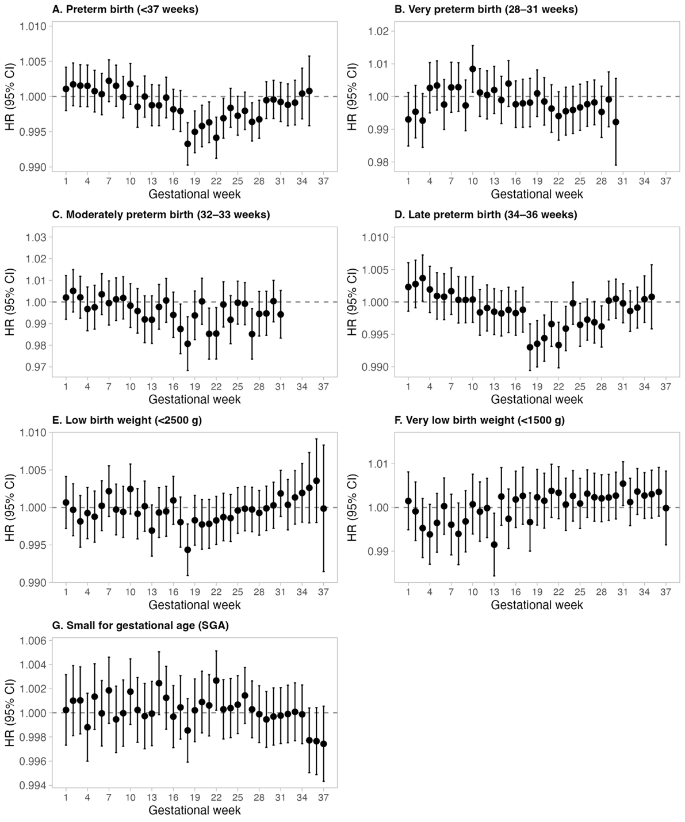
Note: Points represent hazard ratios (HR) and vertical bars indicate 95% confidence intervals from distributed lag Cox proportional hazards models estimating the association between weekly PM_{2.5} exposure during gestation (weeks 1–37) and the risk of adverse birth outcomes. The dashed horizontal line indicates HR = 1. Models are adjusted for maternal age, infant sex, year of birth, month of birth, and municipality.
Figure X. Weekly associations between PM_{2.5} exposure (land-use regression model) and adverse birth outcomes using cox distributed lag models.

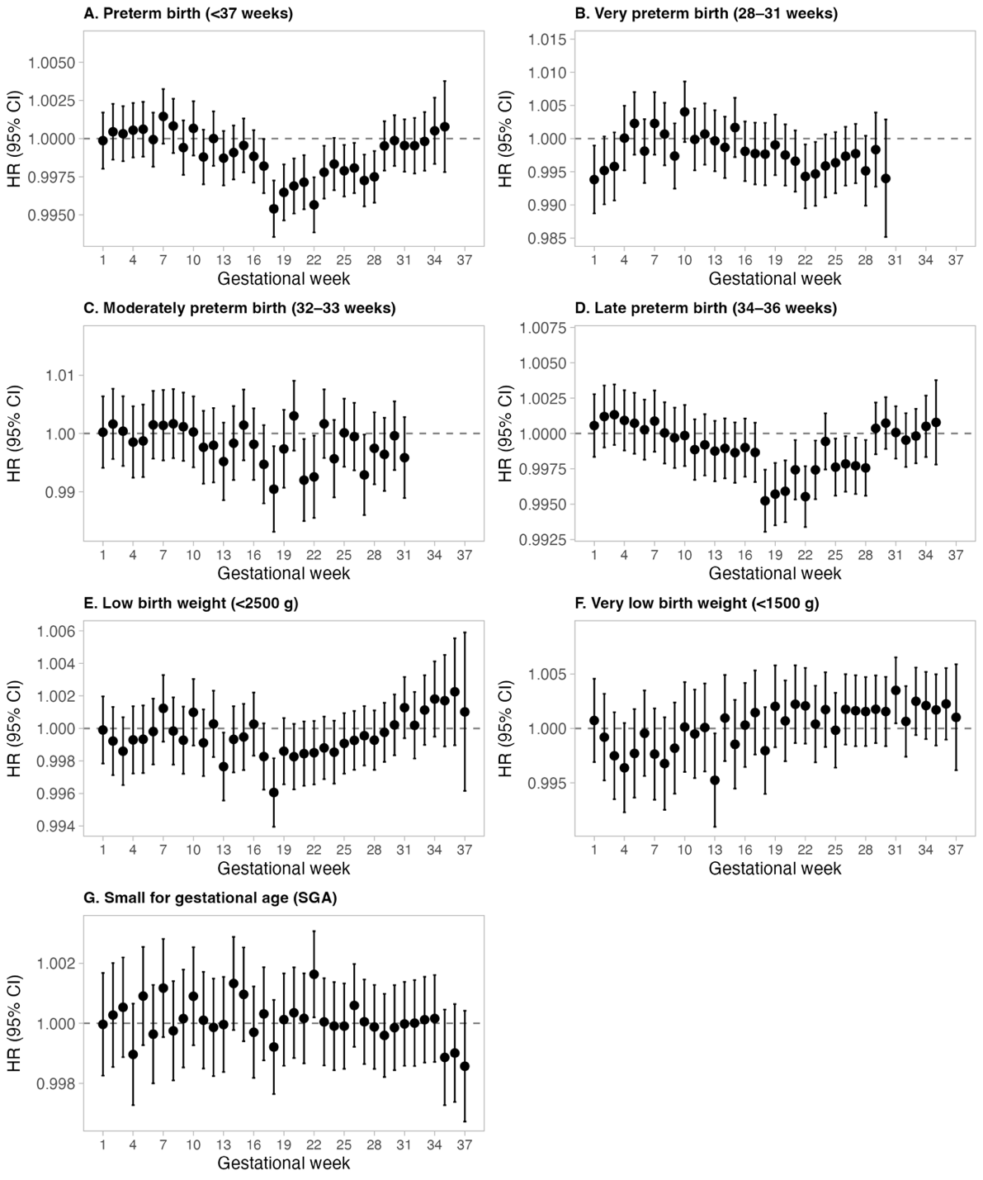
Note: Points represent hazard ratios (HR) and vertical bars indicate 95% confidence intervals from distributed lag Cox proportional hazards models estimating the association between weekly PM_{2.5} exposure during gestation (weeks 1–37) and the risk of adverse birth outcomes. The dashed horizontal line indicates HR = 1. Models are adjusted for maternal age, infant sex, year of birth, month of birth, and municipality.
Figure X. Weekly associations between levoglucosan exposure (central site) and adverse birth outcomes using cox distributed lag models.
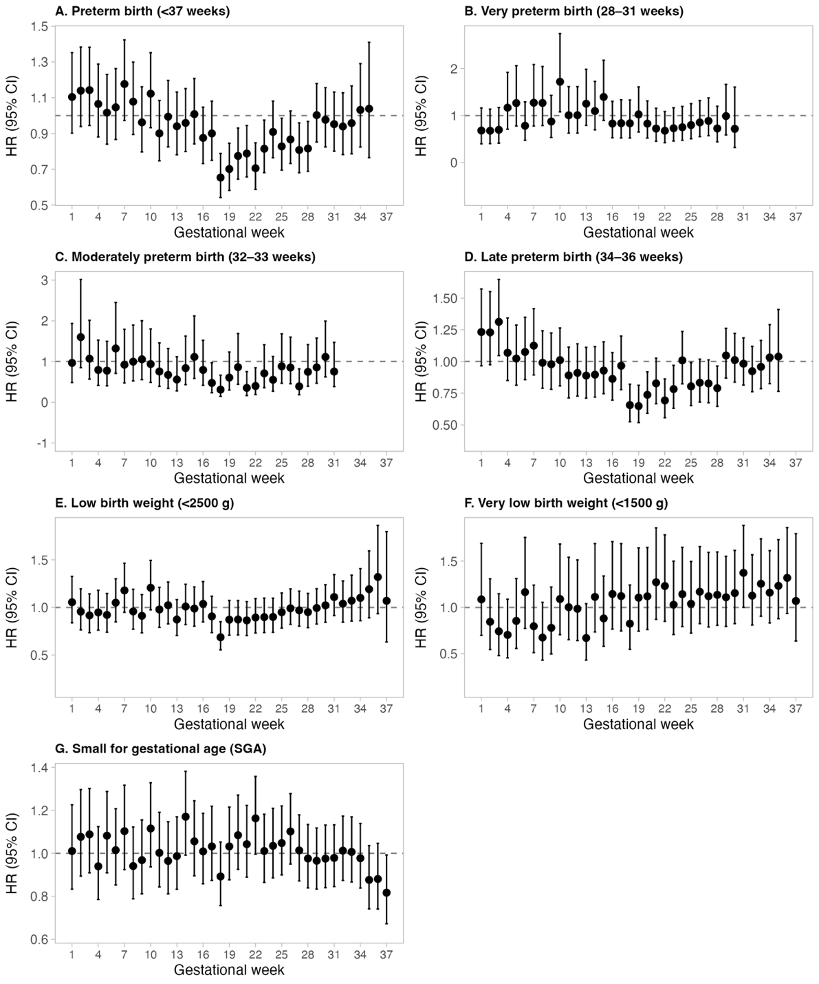
Note: Points represent hazard ratios (HR) and vertical bars indicate 95% confidence intervals from distributed lag Cox proportional hazards models estimating the association between weekly levoglucosan exposure during gestation (weeks 1–37) and the risk of adverse birth outcomes. The dashed horizontal line indicates HR = 1. Models are adjusted for maternal age, infant sex, year of birth, month of birth, and municipality.

Figure X. Weekly associations between levoglucosan exposure (land-use regression model) and adverse birth outcomes using cox distributed lag models.

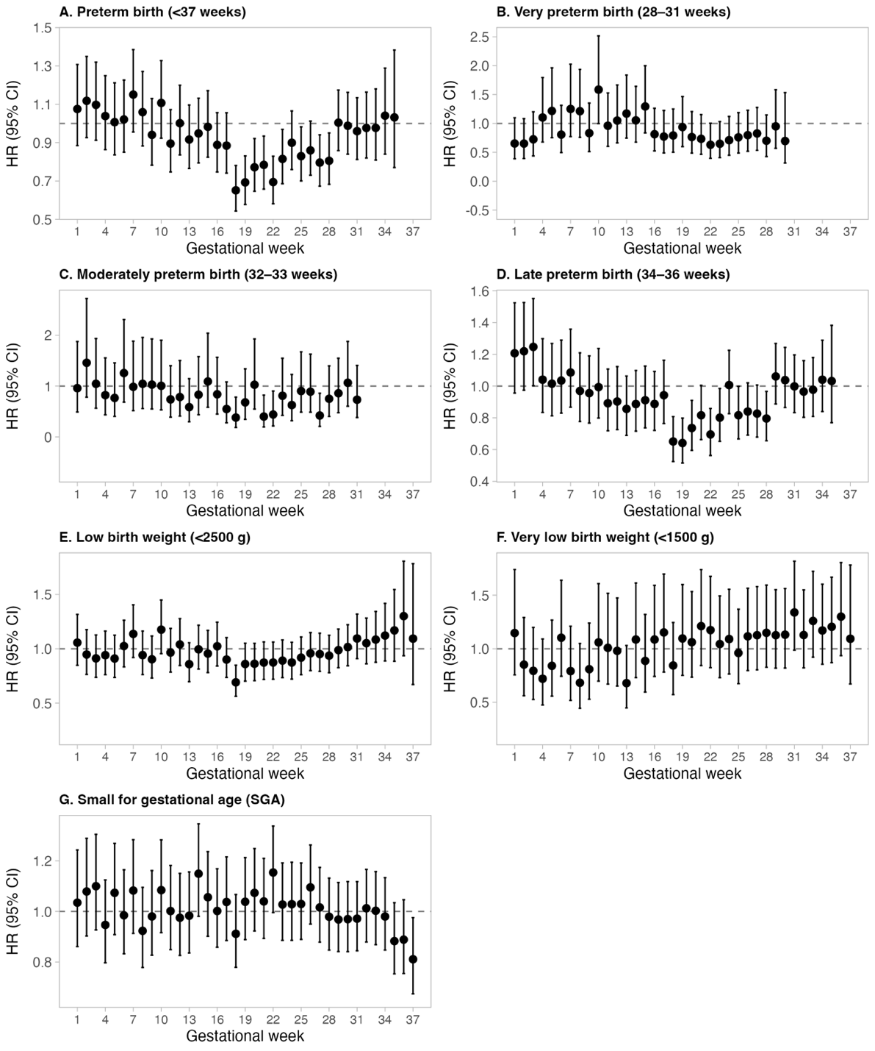
Note: Points represent hazard ratios (HR) and vertical bars indicate 95% confidence intervals from distributed lag Cox proportional hazards models estimating the association between weekly levoglucosan exposure during gestation (weeks 1–37) and the risk of adverse birth outcomes. The dashed horizontal line indicates HR = 1. Models are adjusted for maternal age, infant sex, year of birth, month of birth, and municipality.
Figure X. Weekly associations between potassium exposure (central site) and adverse birth outcomes using cox distributed lag models.
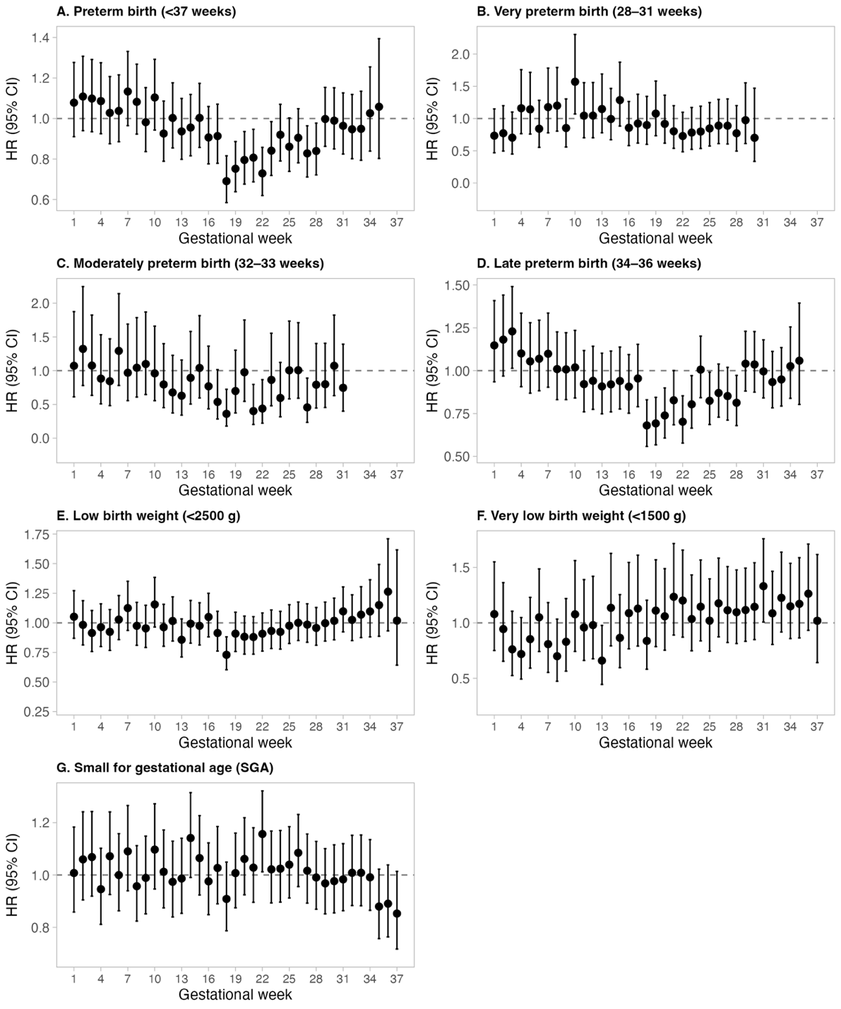
Note: Points represent hazard ratios (HR) and vertical bars indicate 95% confidence intervals from distributed lag Cox proportional hazards models estimating the association between weekly potassium exposure during gestation (weeks 1–37) and the risk of adverse birth outcomes. The dashed horizontal line indicates HR = 1. Models are adjusted for maternal age, infant sex, year of birth, month of birth, and municipality.
Figure X. Weekly associations between potassium exposure (land-use regression model) and adverse birth outcomes using cox distributed lag models.
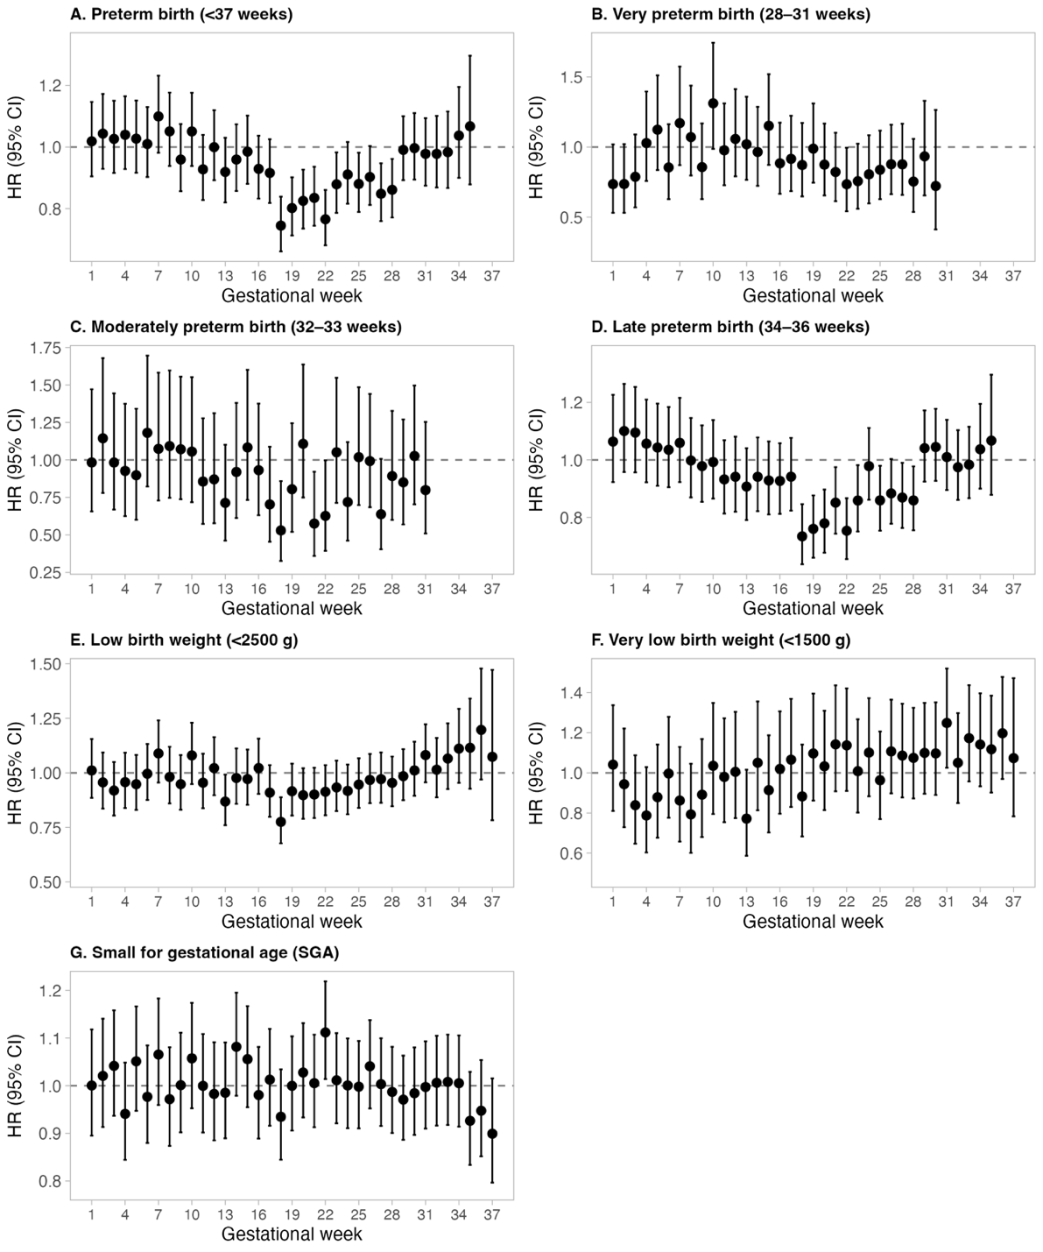
Note: Points represent hazard ratios (HR) and vertical bars indicate 95% confidence intervals from distributed lag Cox proportional hazards models estimating the association between weekly potassium exposure during gestation (weeks 1–37) and the risk of adverse birth outcomes. The dashed horizontal line indicates HR = 1. Models are adjusted for maternal age, infant sex, year of birth, month of birth, and municipality.

Complementary figures (only central site cox models, but in the output file show sp results and logit):

PM2.5

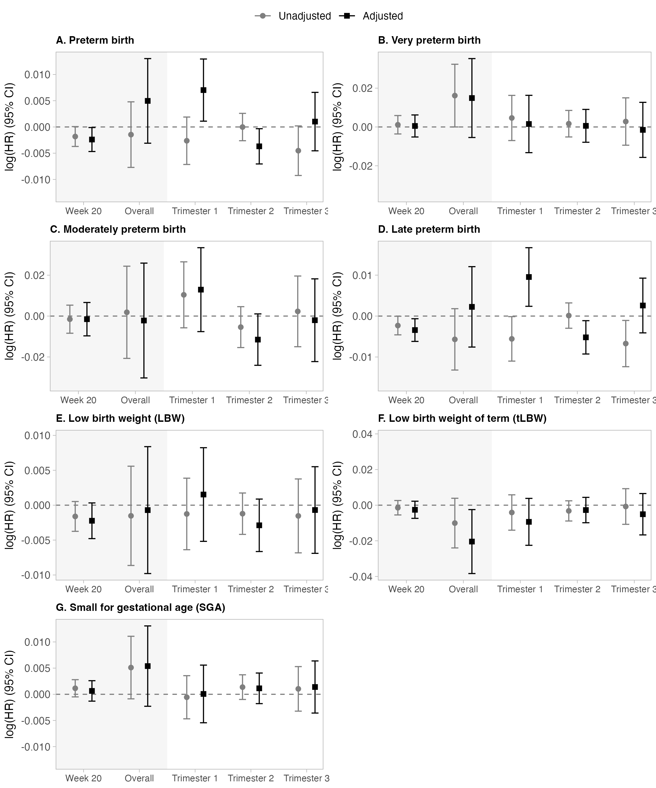

Levo:
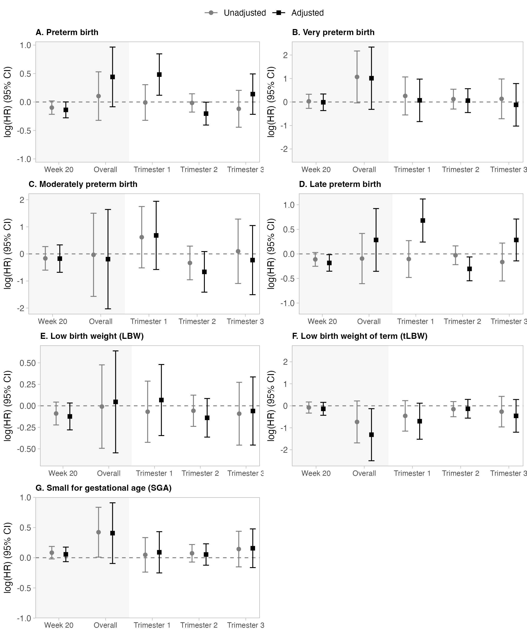

Ksol
