OSeMOSYS for Transmission
OSTRAM
BAU Scenario Results Report
South Asia Power System Connectivity Model
Deliverable #2
UN ESCAP Energy Division
April 2026

1. Executive Summary
This report presents the results of the Business-as-Usual (BAU) scenario for the OSTRAM (OSeMOSYS for Transmission) South Asia Power System Connectivity Model. The BAU constitutes the first of three scenarios agreed with UN ESCAP Energy Division. The other two are Optimize VRE and VRE Target. The BAU sets the reference baseline for the project. Subsequent scenarios will measure alternative low-carbon and renewable pathways against it.
The BAU run uses an updated data package built on improved sources from each country, drawing on national master plans, utility data, and operator reports, covering Bangladesh, Bhutan, India (five sub-regions: North, East, Northeast, West, South), Maldives, Nepal, and Sri Lanka over the 2023–2050 horizon. The scenario reflects current country planning for new generation, restricts transmission expansion to currently existing and firmly committed interconnectors verified against primary sources, and dispatches the resulting system on a least-cost basis without a carbon penalty.
[Add 1–2 sentences with the highest-level numerical takeaways once results are finalized: regional capacity in 2030/2050, regional generation, total system cost, BAU emissions trajectory, and any single most striking insight.]

2. Scenario Framework
Three scenarios were defined with UN ESCAP Energy Division to bracket the policy space for South Asian power system connectivity. The BAU establishes the reference; Optimize VRE caps fossil and nuclear additions to those already planned and lets the optimizer cover residual demand with renewables and additional interconnection; VRE Target imposes country renewable energy targets aligned with SDG7. The full specification is summarized below.
Scenario | Generation | Interconnector
BAU | Based on countries' planning; all additional generation capacity optimized in terms of economy without carbon penalty. | Currently existing and under construction.
Optimize VRE | Only conventional fossil fuel and nuclear plants already listed in the planning are included; all additional power plants must be VRE. | Includes candidate interconnectors (planned and proposed).
VRE Target | VRE increased to development targets aligned with country VRE planning and SDG7 roadmap. | Existing, planned and proposed lines, with additional capacity allowed.

3. Methodology
This section describes the OSTRAM modelling framework that produced the BAU results. It begins with what OSTRAM is and the transmission detail it adds to OSeMOSYS Global, then walks through the BAU calibration template, the timeslice architecture, the B-stage solving pipeline, and the transmission validation that defines the BAU corridor set.

3.1 What is OSTRAM
OSTRAM (OSeMOSYS for Transmission) is a customization layer built on top of OSeMOSYS Global, not a separate model. The same modelling framework runs underneath; OSTRAM sits on top to customise data, overrides and scenarios for the South Asian region. The relationship between the three layers can be thought of as follows:
- OSeMOSYS: the core open-source modelling framework. It is written in GMPL and defines the equations, variables and constraints of the energy system optimisation problem. [2]
- OSeMOSYS Global: generates the base global dataset. It provides starting inputs and the model structure that OSTRAM extends. [1]
- OSTRAM: the customization layer. It adds Excel-based scenario and data overrides, and brings in the customized transmission detail required for South Asia.
OSTRAM does not replace OSeMOSYS or OSeMOSYS Global. Improvements upstream propagate to OSTRAM automatically; conversely, OSTRAM choices stay isolated to the regional run and do not affect the global framework.
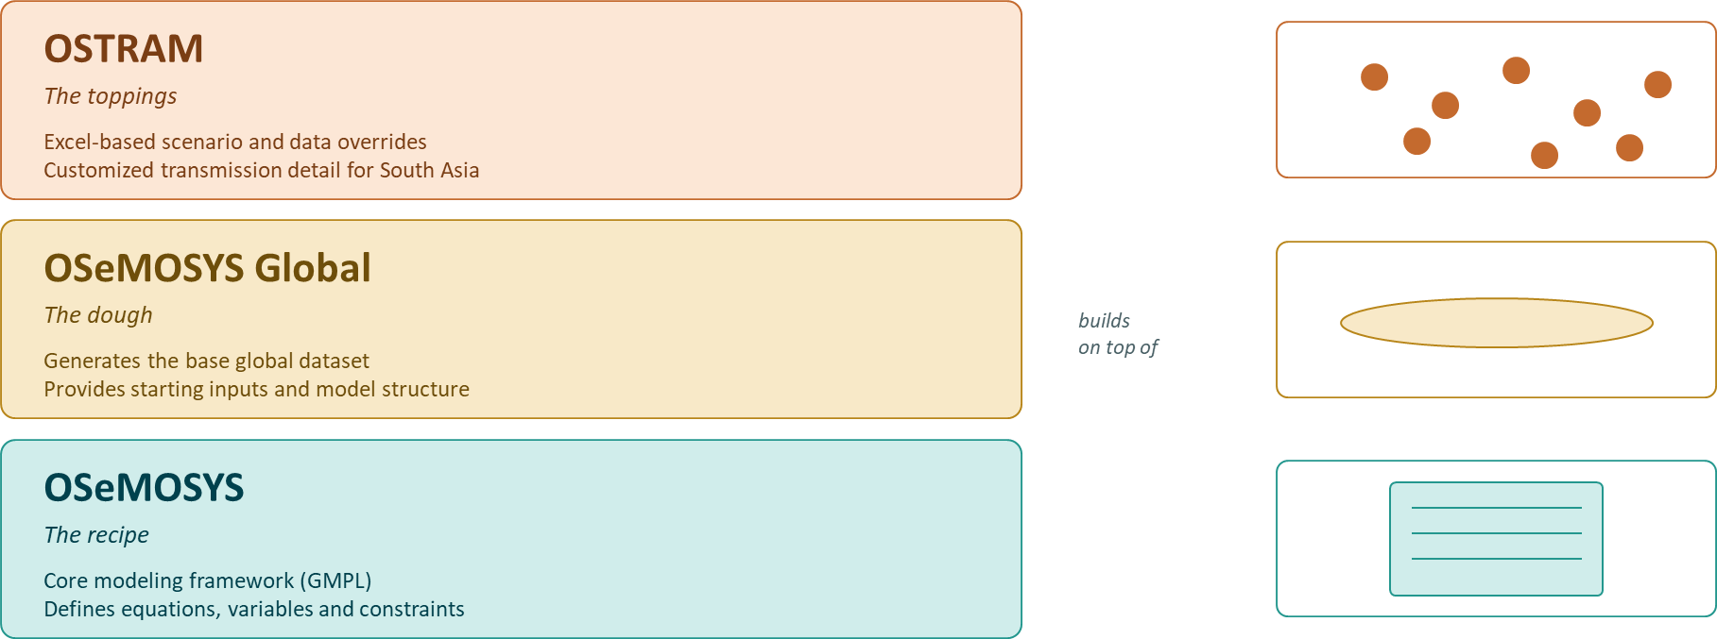
FIGURE 3.1. OSTRAM as a customization layer

3.2 The "T" in OSTRAM: Transmission Investment Detail
The defining feature of OSTRAM is the level of detail it brings to transmission investment. Standard OSeMOSYS Global treats inter-regional transfer capacity at a relatively coarse level; OSTRAM customizes the investment options available to the model so that peak-demand sizing of cross-border and inter-regional links becomes an explicit decision variable.
Three transmission investment options are exposed to the model:
- New lines: greenfield AC and HVDC corridors.
- Reconductoring: upgrading the capacity of existing lines.
- Cross-border links: inter-country interconnectors.
Why this detail matters: peak demand in one region must be met by generation elsewhere when local supply is short. Transmission capacity (not just energy) therefore becomes a binding decision variable, and getting its representation right is what allows the model to quantify the value of regional integration.
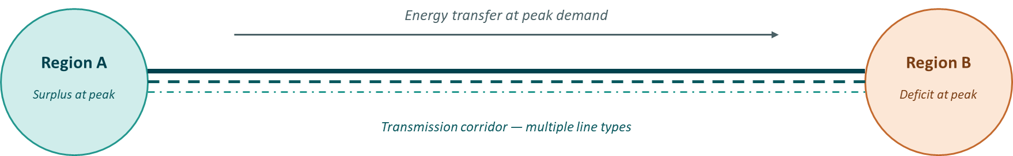
FIGURE 3.2. Transmission corridor concept

3.3 BAU Calibration Template
OSTRAM uses a single workbook, the BAU Calibration Template, in which the user can specify OSeMOSYS parameters. It serves as the source of truth for every input the model needs over the 2023–2050 horizon for all six countries. Every scenario, BAU included, starts as a copy of this workbook with targeted edits. Parallel data sources are explicitly avoided.
The template is organized into four colour-coded groups, each with a distinct role in the data flow:
Sheet group | Role | Sheets
Blue | Model inputs — read directly by the compiler to populate OSeMOSYS. | Fixed_Horizon_Parameters · Primary_Techs · Secondary_Techs · Demand_Projection · Demand_Techs · Emissions · VariableCost (7 sheets).
Red | Timeslice layer — overwritten by the OSTRAM timeslice Python when resolution changes. | Capacities_CF · Demand_Profiles · Yearsplit_Template · DaySplit (4 sheets).
Orange | Interconnector layer — the focus of the study. | Interconnectors (qualitative corridor registry, 51 projects) · Interconnector_Params (TRNCBD_ technologies read by OSeMOSYS).
Green | Provenance and audit trail — plant-level evidence behind blue inputs. Not read by the compiler. | Existing_Generation (~2,112 plants) · Planned_Generation (~541 projects) · Technology_Costs · RE_Targets_Policies (4 sheets).

The compiler reads the blue, red and orange sheets directly. Green sheets feed the blue sheets. For example, Existing_Generation feeds ResidualCapacity, Planned_Generation feeds TotalAnnualMinCapacityInvestment, and Technology_Costs feeds CapitalCost and FixedCost. The Secondary_Techs sheet is the heart of the model. It carries existing-fleet ResidualCapacity, AvailabilityFactor, Efficiency, CapitalCost, FixedCost, and the committed pipeline (TotalAnnualMinCapacityInvestment). For BAU, hard ceilings (TotalAnnualMaxCapacity) and floors (TotalAnnualMinCapacity) are deliberately left empty. This lets the optimisation speak.
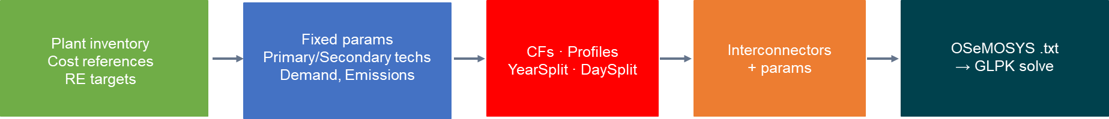
FIGURE 3.3. Template flow
Six ground rules keep the template a reliable source of truth: column names are a contract and must not be renamed or reordered; sheets are not merged and rows are not deleted (techs unavailable at a node are zeroed via TotalAnnualMaxCapacity = 0); units are fixed (GW, PJ, USD2023, fractions 0–1, with CapacityToActivityUnit = 31.536); red sheets are script-owned and never edited by hand; a backstop technology (PWRBCK) is provisioned at every node at ~99,999 USD/kW to catch infeasibility without ever building in practice; and scenarios are created by copying the file, never by forking it in place.
To keep the calibration template intact across runs, the pipeline never edits it directly. Each run copies the template to a separate working file where all compute happens, and a small script then writes out the input workbooks the solver consumes. This keeps the source of truth safe from crashes, makes runs reproducible, and lets us recover from any downstream corruption by simply deleting and re-running.
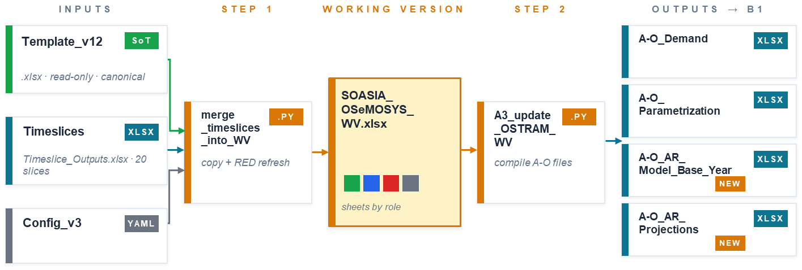
FIGURE 3.4. Working Version pipeline

3.4 Timeslice Architecture
OSeMOSYS represents sub-annual time as a fixed set of timeslices. Each timeslice combines a season and a daypart and partitions the 8,760 hours of a year into representative blocks. The standard OSeMOSYS Global timeslice calendar is temperate (Winter, Spring, Summer, Autumn). It is inappropriate for monsoon Asia: it splits the SW monsoon across seasons and merges the March–April heat peaks with winter months. OSTRAM therefore designs and adopts its own timeslice scheme.

3.4.1 Seasons: IMD four-season calendar
OSTRAM adopts the India Meteorological Department four-season calendar, which is aligned with the physical monsoon cycle that drives hydro inflows, cooling demand, and seasonal wind regimes across all six countries:
- S1: Winter (Dec–Feb)
- S2: Pre-monsoon (Mar–May)
- S3: SW Monsoon (Jun–Sep)
- S4: Post-monsoon (Oct–Nov)

3.4.2 Dayparts: sensitivity sweep across 23 schemes
The daypart structure (how the 24 hours of a day are divided) determines how well the model separates solar-available from dark hours and resolves the evening demand peak. The chosen scheme was selected through a systematic sensitivity sweep of 23 candidate schemes spanning four design families: equal-width baselines (2–24 dp), solar-window corners, morning-ramp designs, and physics-informed peak/shoulder splits.
Each candidate was scored on three independent information axes: demand fit (45% weight, combining step-reconstruction RMSE, peak preservation, and worst-region RMSE), solar differentiation (45% weight, via the coefficient of variation of block-mean solar capacity factors), and wind differentiation (10% weight). Aggregation used capacity-weighting across seven primary regions (416 GW total), with a defensibility penalty on blocks shorter than 3 hours. Seasonal robustness was verified across all four individual seasons and under eight weight-perturbation regimes.

3.4.3 Selected scheme: 5dp (solar 6–17 tight)
The selected daypart scheme is the 5-daypart "solar 6–17 tight", with hour boundaries placed to capture the hours when solar generation is actually available (06:00–17:00 local time). It was chosen from the broader sweep as the best trade-off between two competing concerns: simulation time, which grows with the number of timeslices, and resolution quality, both for the demand profile and for the renewable capacity factors that drive VRE dispatch decisions. Coarser schemes solve faster but lose key intra-day structure; finer schemes resolve more but make the model substantially slower without proportional gains in fit. The 5-daypart tight-solar scheme sits at the inflection point of that curve.

3.4.4 Underlying data
Hourly demand profiles were assembled from national grid operator data: 55,012 half-hourly PGCB records for Bangladesh [6]; 109,440 hourly Grid-India rows for the five Indian sub-regions (2023–2025); 8,712 hourly PUCSL records for Sri Lanka [7]; literature profiles (Simkhada et al. 2022) and NDOR seasonal weights for Nepal; BPC Power Data Book hourly profiles [8] and BPSO seasonal weights for Bhutan; and STELCO Yearbook monthly production for Maldives [9] (seasonal fractions only; daypart estimated). Renewables.ninja hourly capacity factors for solar and wind were downloaded for all 10 nodes for 2014–2022, yielding approximately 1.6 million hourly observations per resource [5]. Hydro capacity factors were built from country-specific operational data (CEA monthly reports [10], NEA NDOR daily reports [11], BPSO quarterly reports, PUCSL 15-minute dispatch [7]).

3.5 The B-Stage Pipeline
Once the working version and its A-O files are produced, a two-script pipeline solves the model. The B-stage takes a scenario's four Excel inputs and produces a concatenated, solver-validated results CSV. It handles any number of scenarios discovered automatically from the file system.
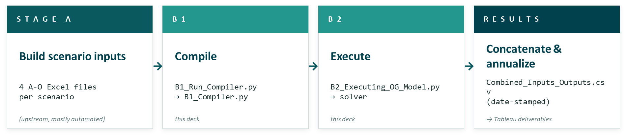
FIGURE 3.5. End-to-end pipeline architecture

3.5.1 Inputs: four Excel workbooks per scenario
Each scenario folder (named A1_Outputs_<SCENARIO>/) contains four workbooks. A-O_AR_Model_Base_Year defines base-year activity ratios. A-O_AR_Projections defines yearly trajectories (projection modes: flat, yearly %Δ, user-defined). A-O_Demand carries annual demand per fuel/tech, projection rules, and timeslice-level demand profiles. A-O_Parametrization (12 sheets) carries everything else OSeMOSYS needs: capital and fixed costs, residual capacities, capacity factors, reserve margins, emission factors, and UDC inputs.

3.5.2 B1: Compile
B1_Run_Compiler.py walks every sibling folder starting with A1_Outputs_, points the YAML at it, and calls B1_Compiler.py. Auto-discovery removes the need for any hand-maintained scenario list. The compiler walks four processing blocks against the active scenario. (1) Activity ratios: joins base year × projections and applies the projection mode for each (tech, fuel, mode) row across 2023–2050. (2) Demand: builds trajectories (flat or GDP-linked) and cross-checks timeslice coverage. (3) Parametrization: walks the 12 parametrization sheets, handling capacity limits, unit conversions, and residual-capacity-aware target interpolation. (4) Structure and sets: emits the 11 set CSVs (YEAR, TECHNOLOGY, FUEL, TIMESLICE, EMISSION, MODE_OF_OPERATION, REGION, DAYTYPE, DAILYTIMEBRACKET, SEASON, STORAGE).
B1 emits two complementary products: human-readable A-O_*_COMPLETED workbooks (same sheet structure as inputs, with every year column filled in, used for QA and stakeholder review), and machine-readable per-parameter CSVs in otoole-wide format that B2 consumes.

3.5.3 B2: Execute
B2_Executing_OG_Model.py runs five steps per scenario. (1) Align: writes parameter CSVs into the OSeMOSYS Global template shape. (2) otoole convert: produces <scenario>_0.txt, the GMPL data file OSeMOSYS expects [12]. (3) Preprocess: resolves any pre-solve transformations. (4) Solve: calls glpsol / cbc / cplex / gurobi with deterministic seeds, solver chosen via YAML flag. (5) Parse: otoole results reads the .sol back into per-variable CSVs, and a helper concatenates them into one scenario output CSV. Steps 1 to 3 are wrapped in try/except so a single scenario failure does not abort the run. Step 4 is what takes wall time.
Scenarios run serial (default for QA and the L2 validation loop) or parallel (one YAML flag, with chunk_scenarios() splitting work across multiprocessing workers). Final outputs are concatenated into a single date-stamped Combined_Inputs_Outputs.csv that is the single artefact downstream Tableau dashboards point at.

3.6 Transmission Review
The full set of internal and cross-border transmission entries used by the model has been independently validated against publicly accessible national planning documents, multilateral development bank project records, and national utility websites. The exercise is documented in detail in a companion validation report (Planned Transmission Validation Report, April 2026); only its main outcomes are summarized here.
Country | Projects reviewed | Primary planning source
Bangladesh | 10 | Integrated Energy & Power Master Plan (IEPMP) 2023 [14]; PGCB Ongoing & Upcoming Project Lists.
Bhutan | 11 | BPC Power Data Book 2024 [8]; Bhutan Power System Master Plan 2040 (JICA) [15]; NTGMP 2018.
India | 18 | CEA National Electricity Plan Vol. II — Transmission 2022–32; PGCIL Capex Plan; MoP Green Energy Corridor portal.
Sri Lanka | 21+ | CEB Long Term Generation Expansion Plan (LTGEP) 2025–2044, approved May 2025 [13]; GREAT 2025–2030.
Maldives | 9 | Maldives Energy Roadmap 2024–2033, Ministry of Climate Change, Environment & Energy [16].
Nepal | 29 | NEA Annual Report FY 2024/25 [11]; NIETTP project documentation (400 kV backbone).

Two cross-file inconsistencies resolved before the BAU run. (i) Butwal–Gorakhpur 400 kV — India lists circuit 1 as operational since 2021; Nepal lists circuit 2 as planned for 2026/27. These are distinct lines; the Nepal entry has been re-labelled as the second circuit to prevent double-counting. (ii) India–Sri Lanka HVDC — India's NEP 2022–32 estimates COD 2028–30; Sri Lanka's LTGEP 2025–2044 [13] (approved May 2025, post-dating the NEP) sets COD 2039 in CEB's least-cost generation expansion model. The LTGEP value is adopted as base case.
The validation also confirms a strongly hub-and-spoke regional topology. Every cross-border line in the dataset terminates in or transits Indian territory; Bangladesh–Nepal and Bhutan–Bangladesh trade is India-transited, never direct. Sri Lanka and Maldives remain isolated. Where source documents conflict with each other, the more recent or higher-authority document is adopted in BAU; remaining items are carried into the gaps-and-actions tracker for resolution in the next iteration.

4. BAU Scenario Specification
The BAU serves as the project's reference scenario. It represents the trajectory each country is currently pursuing, prior to the application of any additional policy lever. The defining features of the run are as follows:
- Generation follows current country planning. Additional capacity is selected on a least-cost basis, with no carbon penalty and no renewable target imposed.
- Transmission expansion is restricted to existing and firmly committed lines (Section 3.7).
- A reserve margin is enforced, and storage availability is constrained.
- No early retirement of existing plants is assumed in this run.
It is important to note that, under current oil and natural gas price projections, solar and wind technologies are already cost-competitive across much of the system. The BAU should therefore not be interpreted as a fossil-heavy scenario by default. The combination of restricted transmission expansion, no early retirement, constrained storage availability, and the enforced reserve margin is what preserves the scenario's business-as-usual character.

5. Model Inputs
Every input that enters the BAU run is held in a single source-of-truth workbook (OSTRAM Template v17). The table below summarizes what goes in and where it comes from. Detailed citations are embedded in the workbook itself and will accompany the next deliverable.
Input | What enters the model | Where it comes from
Demand | Annual electricity demand 2023–2050, by node. | National master plans of each country.
Existing fleet | Plant-level inventory of all operational generation across the six countries. | National utilities and operator data.
Planned fleet | Committed projects with published COD. | National utility project lists.
Cost & performance | CapitalCost, FixedCost, AvailabilityFactor, Efficiency for every technology and country. | Country plans where available; international benchmarks (NREL ATB [3], IEA WEO [4]) otherwise.
VRE & hydro profiles | Capacity factors by timeslice for solar, wind and hydro at every node. | Renewables.ninja for VRE [5]; country operational data for hydro.
Cross-border transmission | Operational corridors plus firmly committed lines (see Section 3.7). | Validation against country planning documents.

Scenario dials are kept empty in BAU. Three parameters are deliberately left blank: TotalAnnualMaxCapacity, TotalAnnualMinCapacity, and TotalTechnologyAnnualActivityUpperLimit. They will be activated for Optimize VRE (capping fossil and nuclear additions) and VRE Target (enforcing renewable energy targets). No carbon penalty is applied in BAU.
No early retirement. South Asian utilities frequently extend the operational life of existing thermal plants 5–10 years beyond their nameplate lifetimes. The BAU therefore omits early retirement, keeping the fossil fleet larger and avoiding spurious renewable build-out driven by retirement-induced capacity gaps. This will be revisited alongside UN ESCAP's overarching retirement-vs-extension stance.
Annual investment ceilings. The BAU caps how much new generation can be added each year in any region. Without this cap, the optimizer can over-build candidate technologies in a single year, ignoring real-world limits on financing, supply chains, and permitting. The ceiling starts at 0.5% of each region's installed pool in 2024 and grows in step with electricity demand. Because residual capacity stays roughly flat under the no-early-retirement assumption, the ceiling rises with demand rather than with the installed pool. Demand growth varies by region, with Bangladesh expanding about 3.8× by 2050, Eastern India 3.6×, and Western India 3.1×, and each region's ceiling tracks its own path. All generation technologies in a region share the same yearly envelope, and the optimizer chooses how to allocate it on cost. Where committed projects exceed the computed ceiling, it is raised just enough to keep the model feasible without granting blanket headroom elsewhere. Storage, transmission, and primary fuels are governed by separate parameters.
Calibration to historical data is a planned next step. A future iteration can add a TotalTechnologyAnnualActivityLowerLimit for years with observed generation data, forcing the model to reproduce the historical record before projecting forward. This would likely shift results in the early years.

6. Indicator Framework
Seven indicators, defined in the project Terms of Reference, are reported for the BAU and will be reported consistently for the two subsequent scenarios. Indicators 1–7 are tabulated and visualized; Indicator 8 (Power Flow Maps) is delivered through the dashboard and through static seasonal snapshots in this report.
# | Indicator | Description / Notes
1 | Capacity Mix | Installed capacity by technology, by country and aggregated, across milestone years.
2 | Generation Mix | Annual electricity generation by technology, by country and aggregated, across milestone years.
3 | Initial Investment | Cumulative CAPEX over the planning horizon, disaggregated by technology and country.
4 | Overall Cost | Total system cost: initial cost + fuel cost + O&M cost. Country-level taxes excluded per TOR.
5 | Potential Savings | Reference indicator for comparison against Optimize VRE and VRE Target scenarios in subsequent deliverables.
6 | Carbon Emissions | Annual CO₂ emissions from electricity generation, by country and aggregated.
7 | Energy Flow | Inter-node and cross-border flows for representative seasons (e.g. peak regional load day, peak VRE day).

7. Results
The remainder of this section presents the BAU results indicator by indicator. All results derive from the same model run; the underlying outputs are available in the OSTRAM dashboard and in the OSTRAM repository at the tag corresponding to this deliverable.

7.1 Capacity Mix

FIGURE 7.1 Capacity by technology [GW]

7.2 Generation Mix

FIGURE 7.2 Generation by technology [GW]

[Insert generation-mix figure: stacked area / bar chart of annual generation (TWh or PJ) by technology, regional total + country panels. Description of fuel-mix evolution and renewable share trajectory.]
FIGURE 7.3 Production by technology [GW]

[Insert renewable-share table or callout: VRE share of generation in 2025, 2030, 2035, 2040, 2050.]

7.3 Initial Investment
FIGURE 7.4 CAPEX [MUSD]
[Insert cumulative CAPEX figure: by technology and by country, over the horizon. Highlight which technologies and which nodes drive investment.]

7.4 Overall System Cost
FIGURE 7.5 Overall System cost [MUSD]
[Insert overall-cost figure or table: CAPEX + Fuel + O&M, by category and by country. Note that taxes are excluded per TOR. If multiple cost scenarios were run (Conservative / Moderate / Ambitious), show the band.]
Note on cost comparability. As discussed by the modelling team, the least-cost framing of the BAU does not by itself capture energy security or resilience. To support like-for-like comparison with the Optimize VRE and VRE Target scenarios in the next deliverable, a complementary cost-per-unit-of-energy indicator may be reported alongside CAPEX + OPEX.

7.5 Potential Savings
FIGURE 7.6 Discounted cost [MUSD] ?
[Reserved for cross-scenario comparison. In this BAU report, this section establishes the reference values against which Optimize VRE and VRE Target savings will be computed.]

7.6 Carbon Emissions
FIGURE 7.7 Annual Emissions [Mt CO2]
FIGURE 7.8 Accumulated Emissions [Mt CO2]
[Insert annual CO₂ figure: regional total + per-country stack, 2023–2050. Indicate cumulative emissions over the horizon.]

7.7 Energy Flow
FIGURE 7.9 esta es la de RENO ? [Mt CO2]
[Insert two seasonal flow maps: (a) day with peak regional load, (b) day when VRE output reaches maximum. Each map shows directed corridor flows in GW and net inter-node balance. Refer to the dashboard for the full interactive set.]

8. Discussion of results
Several caveats should be kept in mind when interpreting the BAU results:
[Bullets / short paragraphs covering: (i) least-cost optimisation does not capture energy security or resilience; (ii) at current fuel-price levels, even the BAU shows a strong economic pull toward VRE — "BAU" should not be read as "fossil-heavy by default"; (iii) reliability indicators (e.g. energy-not-supplied) are not reported in this deliverable and are flagged for follow-up; (iv) retirement is disabled in this first run — sensitivity to extended-life assumptions is recommended; (v) interconnector flow direction depends on relative marginal costs and may differ materially between scenarios.]
Known timeslice limitations also apply. The 08–17 solar block averages over the INDNO 11:00 demand maximum, leading to a modest (~4%) midday underestimate; INDNO midday thermal dispatch results should be treated as directional. Block-mean wind treatment loses intra-block variability (intra-block CV ~0.55), so wind integration costs are systematically underestimated at penetrations above ~30%. Nepal and Bhutan demand profiles are representative daily shapes from literature, not observed hourly data, and Maldives daypart splits are estimated. These limitations are accepted for tractability and flagged for future work.

9. Next Steps
With BAU results delivered, the project moves to the Optimize VRE run. Two methodological refinements have been flagged for that cycle: (i) introduction of an energy-security indicator (share of locally produced vs imported energy, defined country by country to handle exporters such as fossil-resource-rich nations); and (ii) a cost-per-unit-of-energy indicator to complement CAPEX + OPEX comparisons.
Milestone | Notes
BAU Results + Exchange Maps (this delivery) | Reference scenario; calibration benchmarked against regional studies.
UN ESCAP forum presentation | Pitch the analytical framework; introduce energy-security and cost-per-unit-of-energy framing.
Optimize VRE Results | VRE profile sensitivities if uncertainty is high.
Training Session 2 | Results and illustrative scenarios.
VRE Target Results | Policy documents review in detail.
Final Package + Handover | Complete reproducible run packages.
Policy Compatibility Report | Subregional modelling compatibility synthesis.

11. References
[1] OSeMOSYS Global, “OSeMOSYS Global: An open-source, open-data global electricity system model generator,” GitHub repository, 2024. [Online]. Available: https://github.com/OSeMOSYS/osemosys_global
[2] M. Howells et al., “OSeMOSYS: The Open Source Energy Modelling System,” Energy Policy, vol. 39, no. 10, pp. 5850–5870, 2011.
[3] National Renewable Energy Laboratory (NREL), “2024 Annual Technology Baseline (ATB),” Golden, CO, 2024. [Online]. Available: https://atb.nrel.gov/
[4] International Energy Agency (IEA), “World Energy Outlook 2025,” IEA, Paris, 2025. [Online]. Available: https://www.iea.org/reports/world-energy-outlook-2025
[5] S. Pfenninger and I. Staffell, “Using bias-corrected reanalysis to simulate current and future wind power output,” Energy, vol. 114, pp. 1224–1239, 2016. [Online]. Available: https://www.renewables.ninja/
[6] Power Grid Company of Bangladesh (PGCB), “Hourly electricity generation dataset (2015–2025),” UCI Machine Learning Repository, CC BY 4.0, 2025. DOI: 10.24432/C59P6V
[7] Public Utilities Commission of Sri Lanka (PUCSL), “15-minute dispatch data for Sri Lanka (363 daily sheets, 2023),” Colombo, Sri Lanka, 2024.
[8] Bhutan Power Corporation Limited (BPC), “Power Data Book 2024,” Thimphu, Bhutan, 2024. [Online]. Available: https://www.bpc.bt
[9] State Electric Company Limited (STELCO), “Annual Report 2024,” Malé’, Maldives, 2024. [Online]. Available: https://www.stelco.com.mv/
[10] Central Electricity Authority (CEA), “National Electricity Plan (Volume I) Generation,” Ministry of Power, Government of India, New Delhi, 2023. [Online]. Available: https://cea.nic.in/
[11] Nepal Electricity Authority (NEA), System Operation Department, “Yearly Operational Report of Nepal for FY 2079/80,” Load Dispatch Centre (LDC), Kathmandu, Nepal, 2023. [Online]. Available: https://www.nea.org.np/
[12] T. Barnes and W. Usher, “otoole: OSeMOSYS tools for energy system modelling,” Journal of Open Source Software, 2021. [Online]. Available: https://github.com/OSeMOSYS/otoole
[13] Ceylon Electricity Board (CEB), “Long Term Generation Expansion Plan 2025–2044,” Transmission and Generation Planning Branch, Colombo, Sri Lanka, May 2025.
[14] Japan International Cooperation Agency (JICA) and Institute of Energy Economics, Japan (IEEJ), “Integrated Energy and Power Master Plan (IEPMP) for Bangladesh,” Government of Bangladesh, Dhaka, Nov. 2023.
[15] JICA, TEPCO HD, and Nippon Koei, “Power System Master Plan 2040 (PSMP 2040),” Department of Energy, Ministry of Economic Affairs, Thimphu, Bhutan, Nov. 2019.
[16] Government of Maldives, “Maldives Energy Roadmap,” Ministry of Environment, Climate Change and Energy, Malé, 2024.

