This analysis tracks the same compilation of GHGs as in AR6 WGIII. We follow the same approach for estimating uncertainties and CO2-equivalent emissions. We also use the same type of data sources but make important changes to the specific selection of data sources to further improve the quality of the data, as suggested in the knowledge gap discussion of the WGIII report (Dhakal et al., 2022). Instead of using EDGAR data (which are now available as version 87), we use GCB data for CO2-FFI, PRIMAP-hist “CR” data for CH4 and N2O, and atmospheric concentrations with best-estimate lifetimes for UNFCCC F-gas emissions (Hodnebrog et al., 2020). As in AR6 WGIII we use GCB for net CO2-LULUCF emissions, taking the average of three bookkeeping models (BLUE by Hansis et al., 2015; H&C by Houghton and Castanho, 2023; OSCAR by Gasser et al., 2020). This year we now also include estimates of N2O and CH4 emissions from global biomass fires, sourced from GFED.

There are three reasons for these specific data choices. First, national greenhouse gas emissions inventories tend to use improved, higher-tier methods for estimating emissions fluxes than global inventories such as EDGAR or CEDS (Dhakal et al., 2022; Minx et al., 2021). As GCB and PRIMAP-hist “CR” integrate the most recent national inventory submissions to the UNFCCC, selecting these databases makes best use of country-level improvements in data-gathering infrastructures. It is important to acknowledge, however, that national inventories differ substantially with respect to reporting intervals, applied methodologies and emissions factors. Notably, the PRIMAP-hist “CR” dataset has significantly lower total CH4 emissions relative to both the other datasets reported here, and global atmospheric inversion estimates evaluated in this paper. A substantive body of literature has evaluated national level CH4 inversions versus inventories, finding a tendency for the former to exceed the latter (Deng et al. 2022; Tibrewal et al. 2024; Janardanan et al. 2024; Scarpelli et al. 2022). Compared to the median of reported inversion models from Deng et al. 2022, PRIMAP-Hist CR reports lower CH4 emissions for India, the EU27+UK, Brazil, Russia and Indonesia, but not in the case of China and the United States (Fig 1).

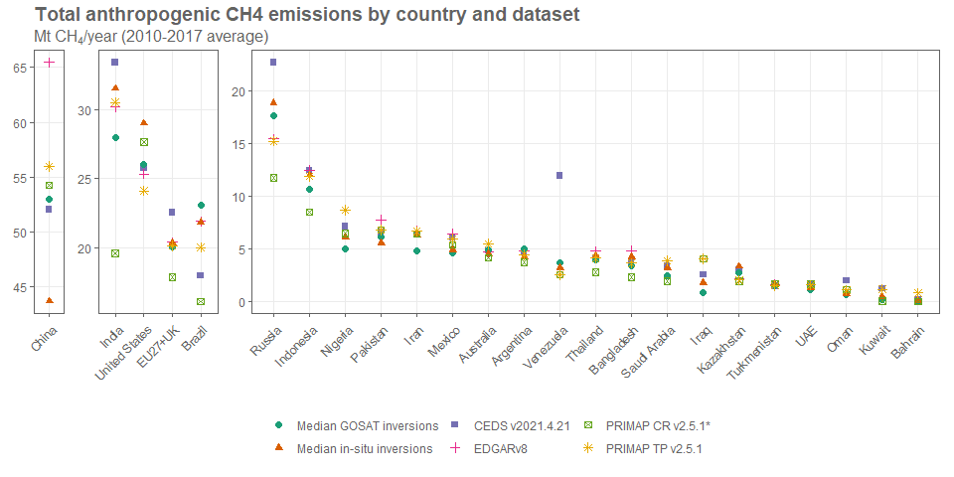

Figure 1: Total anthropogenic CH4 emissions by country and dataset. Median GOSAT and in-situ inversions are sourced from Deng et al. 2022, using the “Method 1” approach of partitioning natural and anthropogenic CH4 fluxes (excluding biomass fires). See section 2.1 for a list of other datasets.