GHG-Emissions-Assessment

William F. Lamb

18 4 2023

# Setup

# Functions

# Source emissions files

## Joining with `by = join_by(gas)`  
## `summarise()` has grouped output by 'year'. You can override using the  
## `.groups` argument.

# Join data

# Generate plots

## GHGs

## Warning: The `size` argument of `element_line()` is deprecated as of ggplot2 3.4.0.  
## ℹ Please use the `linewidth` argument instead.  
## This warning is displayed once every 8 hours.  
## Call `lifecycle::last_lifecycle_warnings()` to see where this warning was  
## generated.

## Warning: The `size` argument of `element_rect()` is deprecated as of ggplot2 3.4.0.  
## ℹ Please use the `linewidth` argument instead.  
## This warning is displayed once every 8 hours.  
## Call `lifecycle::last_lifecycle_warnings()` to see where this warning was  
## generated.

## Warning: Removed 682 rows containing non-finite values (`stat_align()`).

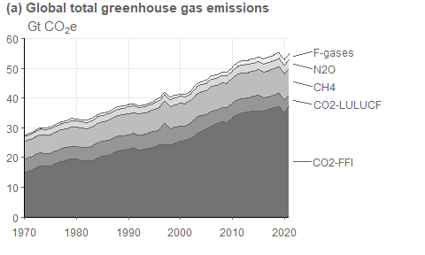

## CO2 FFI

## Warning: Using `size` aesthetic for lines was deprecated in ggplot2 3.4.0.  
## ℹ Please use `linewidth` instead.  
## This warning is displayed once every 8 hours.  
## Call `lifecycle::last_lifecycle_warnings()` to see where this warning was  
## generated.

## Warning: Removed 451 rows containing missing values (`geom_path()`).

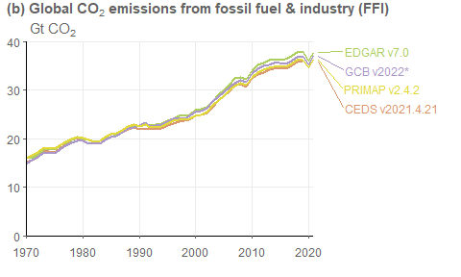

## CO2 LUC

## Warning: Removed 44 rows containing missing values (`geom_path()`).

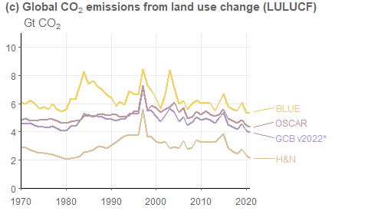

## CH4

## Warning: Removed 220 rows containing missing values (`geom_path()`).

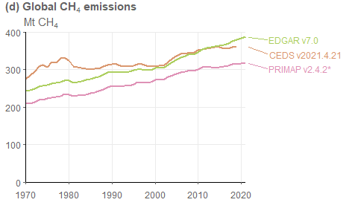

## N2O

## Warning: Removed 220 rows containing missing values (`geom_path()`).

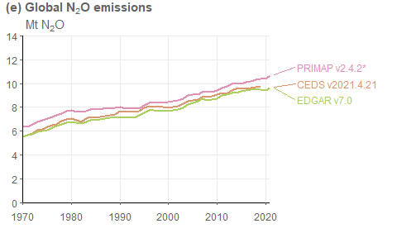

## F-gases

## Warning: Removed 440 rows containing missing values (`geom_path()`).

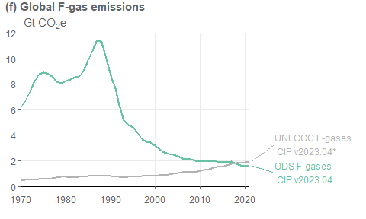

## Combines plot of all sources

## Warning: Removed 682 rows containing non-finite values (`stat_align()`).

## Warning: Removed 451 rows containing missing values (`geom_path()`).

## Warning: Removed 44 rows containing missing values (`geom_path()`).

## Warning: Removed 220 rows containing missing values (`geom_path()`).  
## Removed 220 rows containing missing values (`geom_path()`).

## Warning: Removed 440 rows containing missing values (`geom_path()`).

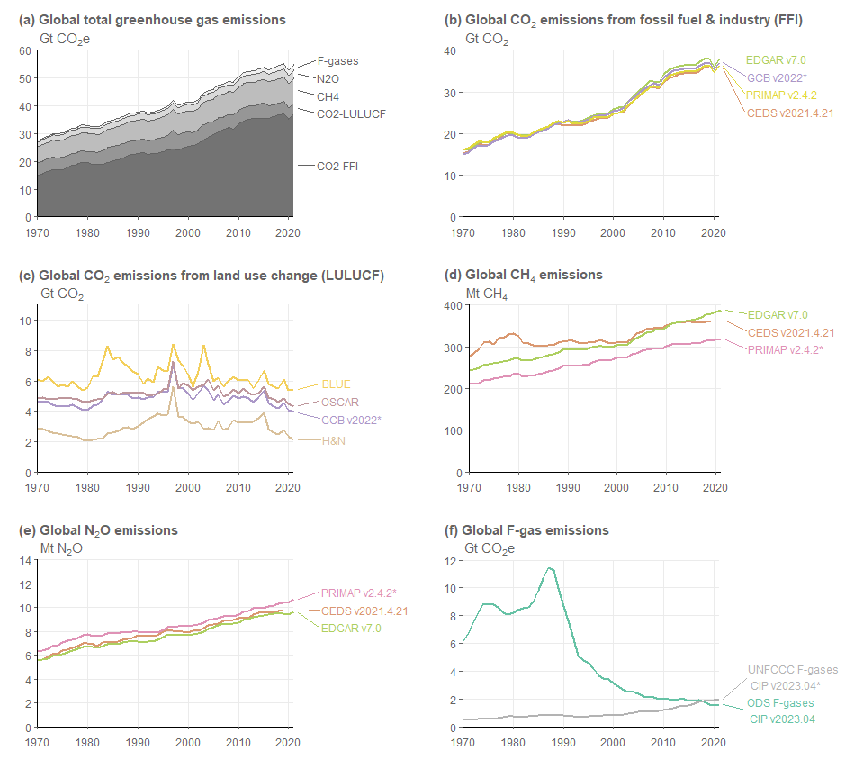

## Table of results

## `summarise()` has grouped output by 'label'. You can override using the  
## `.groups` argument.  
## `summarise()` has grouped output by 'cut', 'label'. You can override using the  
## `.groups` argument.

## Warning in file.create(to[okay]): kann Datei 'results/section_2_2_table.xlsx'  
## nicht erzeugen. Grund 'Permission denied'

## Comparison to AR6

## Joining with `by = join_by(year)`  
## Joining with `by = join_by(year, label)`