4.6 Land Cover

Walther C.A. Cámaro García, Ned Dwyer, Gavin Smith

Land cover - the observed (bio)-physical cover on the Earth’s surface, including grassland, forest, built environment, etc – plays a key role in climate dynamics such as water and energy exchanges between the ground and the atmosphere, and contributes to the capture and release of greenhouse gases and aerosols. Land cover is the result of complex interactions between regional climatic conditions and socio-economic factors and changes in cover can be due to climate change on a regional scale as well as directly due to human activities. Increase in artificial areas, for example, leads to soil disruption and sealing thereby causing carbon emissions and reduction in capacity for carbon sequestration; disturbance and removal of peatlands also cause carbon emissions whilst their protection and restoration provide valuable sequestration. Information on land cover change is essential in order to understand and quantify these effects.

Photo: ©Barry O Dwyer

Measurements

Land cover is derived from analysis of a variety of data sources. At the local-scale ground surveys are the most effective tool whereas on regional and national scales aerial and satellite images are used. Aerial imagery from Ordnance Survey Ireland (OSi) dates back to the 1970s, but it is only since 1990 that regular, systematic land-cover mapping of Ireland, using satellite imagery, has taken place as part of the European Commission’s CORINE[1] programme. Until now, CORINE has been the only initiative in place in Ireland that provides a set of time series of land cover data, however with a coarse (25ha) spatial resolution that misses many important environmental features within the very fragmented landscape of Ireland.

To address these shortcomings, a range of land cover mapping initiatives have taken place during recent years with the aim of producing a higher quality national land cover dataset for Ireland.

The *Irish Land Mapping Observatory* (ILMO) project (2012 – 2014) aimed at integrating several data sources, such as those from radar and optical satellites, in order to improve classification of agricultural lands so as to facilitate reporting on national greenhouse gas emissions related to land use.

The *TaLAM – Toward Land Cover Accounting and Monitoring* project (2014 – 2016) focused on developing a process for mapping land cover compatible with the CORINE product but overcoming its limited spatial and temporal resolution.

The *Biomass Retrieval in Ireland using Active Remote Sensing - BRIAR* project (2015 – 2017) aimed at demonstrating the use of radar remote sensing to estimate biomass in scrub and hedgerows. These habitats are an important feature of the Irish landscape due to their roles in biodiversity, agricultural management, and potential carbon sequestration.

These projects were all precursors to an ongoing initiative led by OSi and the EPA, on behalf of a national land cover working group, to develop an accurate and detailed set of land cover maps for Ireland (Story Box 5).

‘Peatlands represent almost 14% of Irish land cover and are an essential feature in the regulation of the climate by removing carbon.’

Time-series and Trends

Figure 4.9 shows the CORINE 2018 land cover map for Ireland. The relevant classes for Ireland are distributed in 6 main categories: Artificial Surfaces, Agricultural Areas, Semi Natural and Low Vegetation Areas, Forest and Wetlands. More than half of the country is covered by agricultural areas, mainly represented by pastures. Wetlands are the second main class covering Ireland, mainly formed by peatlands that are a key land cover type in the regulation of the climate by removing carbon, however they release carbon when disturbed.

Figure 4.10 shows the distribution of land cover classes across the country for the 1990 and 2018 CORINE maps. Agricultural areas currently cover almost 68% of the country and no significant change has been observed during the last three decades. Artificial surfaces, which are linked to urbanisation cover less than 3% of the country, however there has been an almost 65% increase compared to 1990. Forest and semi natural vegetation areas have increased their extent by almost 30% over the last three decades. Conversely, wetlands, now occupy approx. 15% of the country, but have decreased their area by almost 20% since 1990.

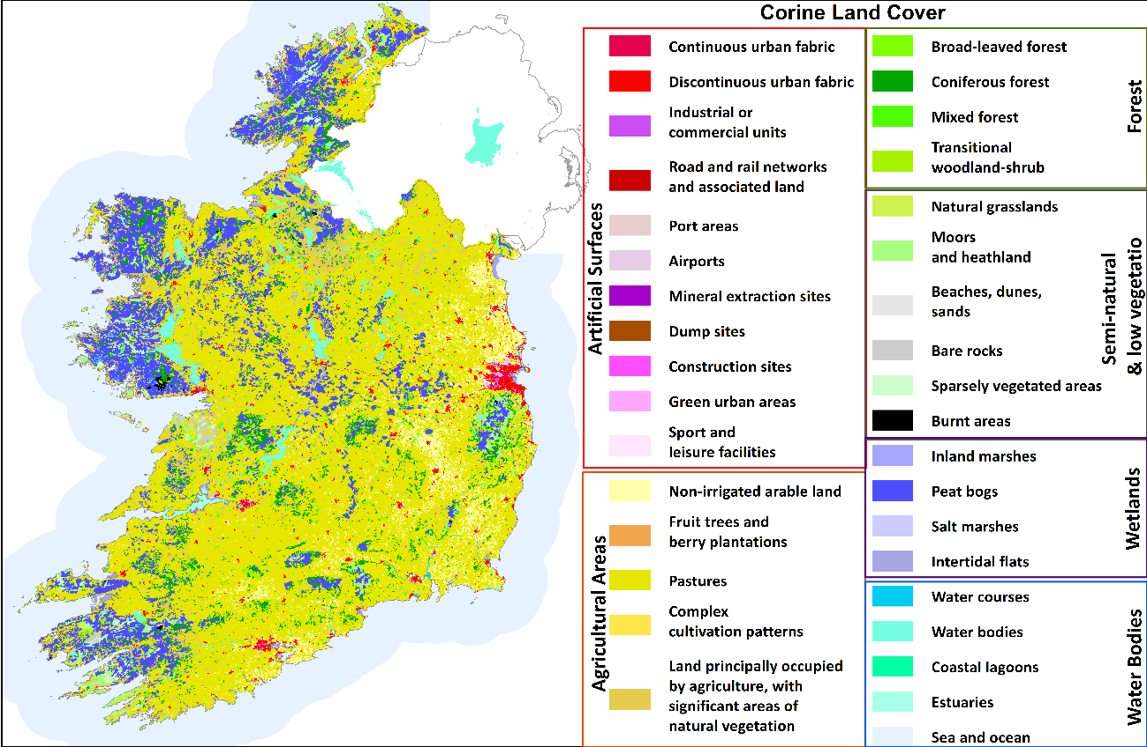

**Figure 4.9.** CORINE land cover map of Ireland (2018)

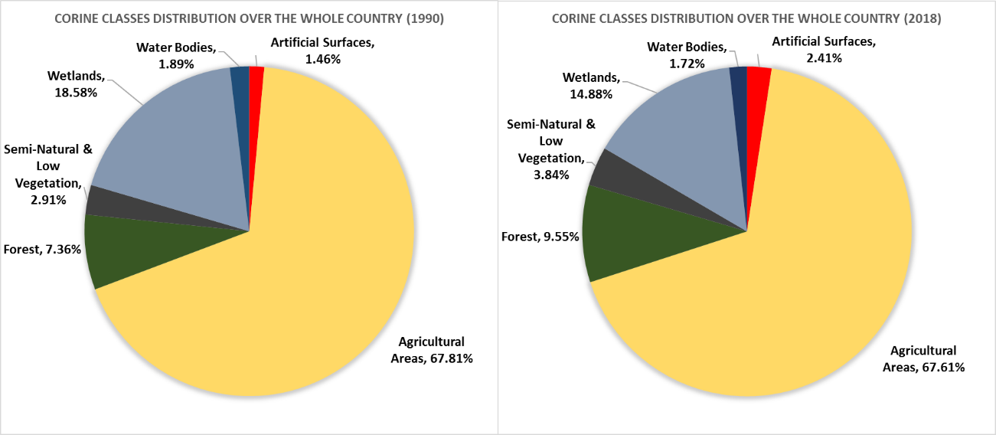

**Figure 4.10.**  CORINE main category distribution over Ireland (% national area) for the CORINE 1990 version (left) and for the CORINE 2018 version (right)

Figure 4.11 shows the percentage of cumulative change observed in the CORINE time series since 1990. Artificial surfaces show the greatest cumulative increase, with a particularly high rate between 1990 and 2006. Forest areas have also increased being particularly marked during the 1990s. Semi-natural & low vegetation areas decreased slightly in the 1990s, but since then have continuously increased during the last two decades. On the other hand, the wetlands class is mostly formed by peat and a continuous decreasing trend is observed in this land cover class.

“The new national land cover dataset will have a spatial resolution 250 times better than the current maps.”

. 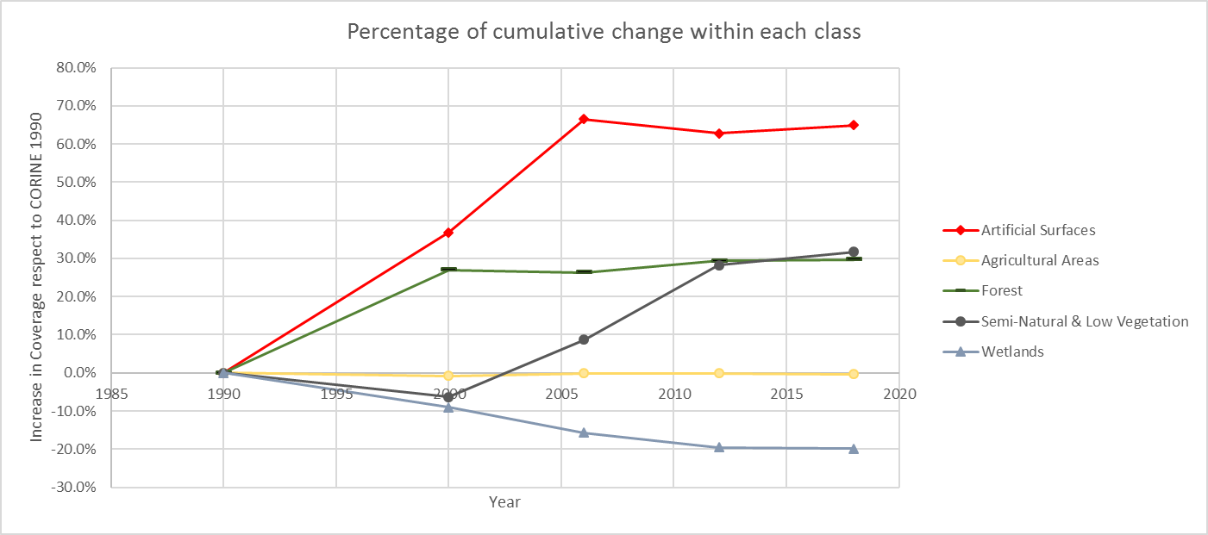

**Figure 4.11.** Percentage of cumulative change within each main category for the five CORINE versions between 1990 and 2018.

Further Information:

* ***Land Cover ESSENTIAL CLIMATE VARIABLE (ECV). GCOS FACTSHEETS:* (**[**https://gcos.wmo.int/en/essential-climate-variables/land-cover/**](https://gcos.wmo.int/en/essential-climate-variables/land-cover/) ***)***
* ***The CORINE dataset in Ireland:***

***(***[**https://www.epa.ie/soilandbiodiversity/soils/land/corine/**](https://www.epa.ie/soilandbiodiversity/soils/land/corine/)**)**

* ***View CORINE maps for all of Europe: (***[**https://land.copernicus.eu/pan-european/corine-land-cover**](https://land.copernicus.eu/pan-european/corine-land-cover)**)**
* ***The ILMO project:***

***(***[**https://landmapping.wordpress.com/ilmo/**](https://landmapping.wordpress.com/ilmo/)**)**

* ***The TALAM project:***

***(***[**https://landmapping.wordpress.com/talam/**](https://landmapping.wordpress.com/talam/)**)**

* ***The BRIAR project:***

***(***[**https://landmapping.wordpress.com/briar-biomass-retrieval-in-ireland-using-active-remote-sensing/**](https://landmapping.wordpress.com/briar-biomass-retrieval-in-ireland-using-active-remote-sensing/)**)**

* ***Irish Times article on Ireland´s new land cover mapping initiative: (***[**https://www.irishtimes.com/news/science/ireland-needs-needs-more-detailed-land-use-maps-1.4010070**](https://www.irishtimes.com/news/science/ireland-needs-needs-more-detailed-land-use-maps-1.4010070)**)**

Maintaining the Observations

The EPA currently oversees production of the CORINE land cover maps for the Republic of Ireland. The latest version was released in 2018. The next update is expected in 2024.

The EPA and several other public bodies (National Parks and Wildlife Service (NPWS), Teagasc, Ordnance Survey Ireland (OSi), the Heritage Council and the Department of Agriculture, Food and the Marine (DAFM)) set up a national land cover and habitats working group in 2011 to identify a way to produce higher quality national land cover datasets for Ireland. Initiatives such as ILMO, TaLAM and BRIAR have supported the development of a national land cover mapping methodology. These projects are an essential point of reference for the current EPA and OSi led initiative aimed at generating a new Land Cover dataset with a spatial resolution of almost 250 times better than CORINE (Story Box 5).

1. Co-ORdinated INformation on the Environment (CORINE)