4.7 Fraction of Absorbed Photosynthetically Active Radiation (FAPAR)

Walther C.A. Cámaro García, Ned Dwyer

Radiation from the sun plays an essential role in all biological process on Earth. Part of this radiation is absorbed by vegetation and provides the energy required for growth. This radiation is called FAPAR or the Fraction of Absorbed Photosynthetically Active Radiation. Regular observations of FAPAR are essential to understand the seasonal growth cycle of vegetation and its inter-annual variability. FAPAR observations have been shown to be a good indicator for detecting drought impacts on vegetation productivity. In addition, monitoring the variation in FAPAR over time provides information on how efficiently plants absorb CO2 and is useful to identify climate change effects on vegetation health and behaviour.

Photo: @Vytenis Malisauskas

Measurements

FAPAR is challenging to measure on the ground in tall and heterogeneous vegetation environments. Measurements tend to be made at local scales and for research studies and are labour intensive to implement. Globally, only a small group of short land cover types, in a few climatic zones, have been adequately characterized through FAPAR measurements. There is no long-term *in situ* FAPARmonitoring programme in Ireland. Regional FAPAR estimates are generally based on observations from satellite sensors, which have the ability to measure the visible and infra-red radiation reflected by the Earth’s surface on a regular basis. The Copernicus Global Land Service (CGLS) generates a FAPAR dataset as part of a set of vegetation monitoring products. This dataset is derived from the SPOT VEGETATION and PROBA-V satellite programmes.

‘The highest photosynthetic activity over Ireland is observed from May to July. Western margins of the country show the lowest values of FAPAR.

Time-series and Trends

Figure 4.12 shows a heat map of 10-Day averaged FAPAR derived over Ireland using the CGLS dataset. The red colour represents the 10-day periods with the highest values; only 5% of the values are at or above the threshold of 0.76 (the 95th percentile). A seasonal trend is observed, where the highest values occur during summer, particularly in June, when vegetation tends to have higher photosynthetic activity, whilst the lowest values are observed during winter months. The highest values in the time series are in the summer periods between 2007 and 2009, and between 2013 and2017.

Figure 4.13 shows a set of maps of the 10-day FAPAR derived from the CGLS over Ireland in 2018 for the periods (a) 1–10 January; (b) 1–10 April; (c) 1–10 June; (d) 1–10 September. This illustrates how photosynthetic activity varies spatially during the year. The brown colour corresponds to areas with high photosynthetic activity and yellow/white areas indicate vegetation with a low degree of photosynthetic activity. The western margins have the lowest photosynthetic activity in the country during all periods.

‘A ground-based FAPAR observation system should be considered in order to validate and support satellite observations.’



**Figure 4.12.** Heat map of 10-Day periods of average FAPAR over Ireland derived from the Copernicus Global Land Service (CGLS) datasets for the period 1999 to 2018. The data are presented as percentiles. For example, the 75th percentile means that 75% of all the values are below 0.72 and 25% of the values are above it.

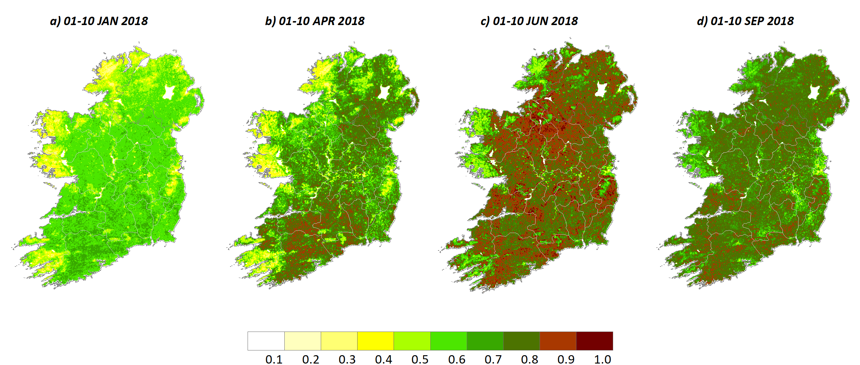

**Figure 4.13.**  Fraction of Absorbed Photosynthetically Active Radiation (FAPAR) during four 10-day periods in 2018 derived from the Copernicus Global Land Service (CGLS) datasets. © European Union, Copernicus Land Monitoring Service 2020, European Environment Agency (EEA)

Further Information:

* ***FAPAR ESSENTIAL CLIMATE VARIABLE (ECV). GCOS FACTSHEETS:* (**[**https://gcos.wmo.int/en/essential-climate-variables/fapar/**](https://gcos.wmo.int/en/essential-climate-variables/fapar/)***)***
* ***Copernicus Global Land Service (CGLS) data: (***[**https://land.copernicus.eu/global/products/fapar**](https://land.copernicus.eu/global/products/fapar)***)***
* ***Joint Research Centre (JRC) FAPAR project: (***[**https://fapar.jrc.ec.europa.eu/Home.php**](https://fapar.jrc.ec.europa.eu/Home.php)***)***
* ***Sentinel Global Vegetation Index (FAPAR) description: (***[**https://sentinel.esa.int/web/sentinel/technical-guides/sentinel-3-olci/level-2/olci-global-vegetation-index-fapar**](https://sentinel.esa.int/web/sentinel/technical-guides/sentinel-3-olci/level-2/olci-global-vegetation-index-fapar)***)***

Maintaining the Observations

The CGLS is one of the Copernicus services that provide satellite information that may be used to monitor a number of vegetation parameters around the globe. The global FAPAR dataset available is derived from several satellite sensors. Currently, the CGLS team is updating the dataset based on SENTINEL-3 OLCI and SLSTR sensors as new data sources.

Comprehensive analysis of satellite-derived FAPAR spatio-temporal trends for Ireland needs to be carried out. A ground-based observation system should also be considered in order to validate and support the satellite observations.