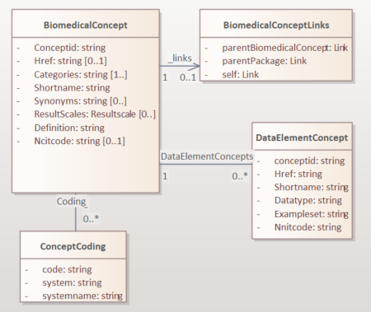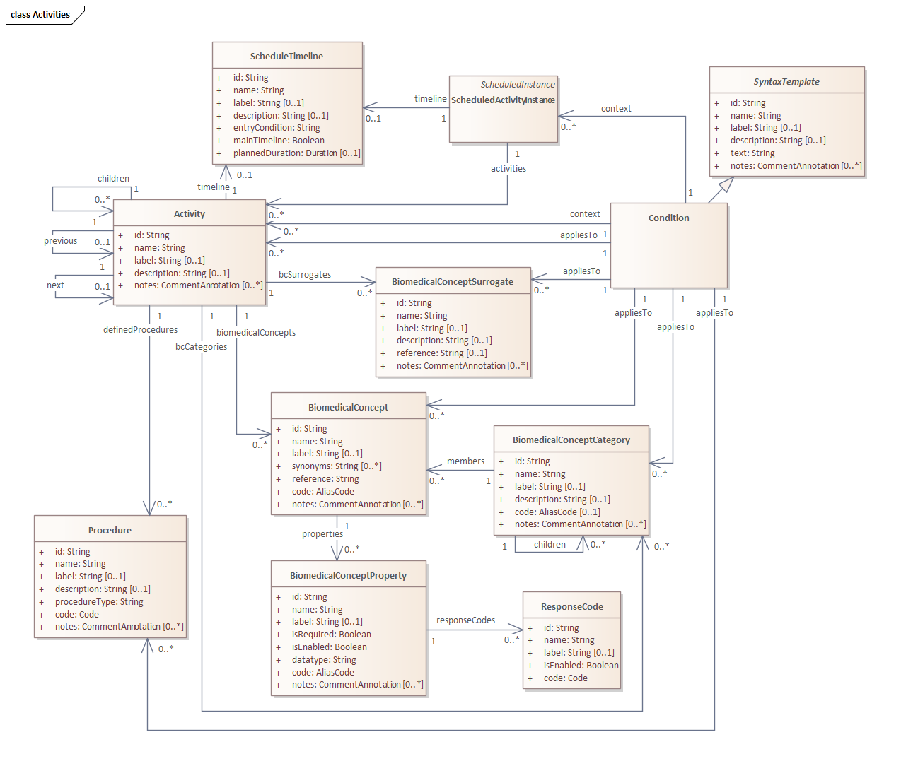

Mapping
CDISC BC library path | USDM BC path | Comments
BiomedicalConcept.ConceptId |  | Generate unique id in new USDM BiomedicalConcept dataset
BiomedicalConcept.Href | BiomedicalConcept.reference
BiomedicalConcept.Categories | BiomedicalConceptCategory.label | Can be added later:  - Each separate category needs to be checked with categories already stored in the BiomedicalConceptCategory class  - If not present, add  - In addition: add reference as childId to the corresponding generated new BiomedicalConcept.id
BiomedicalConcept.ShortName | BiomedicalConcept.label +  BiomedicalConcept.code.standardCode.decode
BiomedicalConcept.Synonyms | BiomedicalConcept.synonyms
BiomedicalConcept.ResultScale | BiomedicalConcept.notes.text | Generate unique id to BiomedicalConcept.notes.id
BiomedicalConcept.Definition | BiomedicalConcept.notes.text | Generate unique id to BiomedicalConcept.notes.id
ncitcode | BiomedicalConcept.code.standardCode.code
BiomedicalConcept.Coding.code | BiomedicalConcept.code.standardCodeAliases.code
BiomedicalConcept.Coding.systemname | BiomedicalConcept.code.standardCodeAliases.codeSystem | Decode and codeSystemVersion not available in BC output.
BiomedicalConcepts.DataElementConcepts.conceptid |  | Generate new id in new USDM BiomedicalConceptProperty dataset
BiomedicalConcepts.DataElementConcepts.shortname | BiomedicalConcept.BiomedicalConceptProperty.code.standardCode.decode  BiomedicalConcept.BiomedicalConceptProperty.label
BiomedicalConcepts.DataElementConcepts.Datatype | BiomedicalConcept.BiomedicalConceptProperty.datatype
BiomedicalConcepts.DataElementConcepts.ExampleSet | BiomedicalConcept.BiomedicalConceptProperty.responseCodes.label | Each value in the ExampleSet (delimited by ;) will be a new instance in the responseCode entity. No codes provided.

Functionality
- Select category – (opslaan in BiomedicalConceptCategory class)
- Select Biomedical Concepts based on the selected BiomedicalConceptCategory
  - Store in USDM BiomedicalConcept class
  - Add indication of self-specificed set thereapeutic areas (step 2)
- Select DataElement Concepts
  - Store the selected DataElement Concepts in the BiomedicalConceptProperty class
  - For each selected data element concept/property indicate whether it is enabled and/or required
  - Select subset of example set and store as related response codes and indicate for each one whether enabled

