 |  | Gastroenterology Associates of North America  123 Health Drive Springfield, IL 62704 Phone: (217) 555-1212  Fax: (217) 555-1213
You have undergone a colonoscopy, a diagnostic procedure in which a flexible, light tube was used to examine the lining of your large intestine (colon). The sedation you received for the procedure will continue to affect your judgment and coordination for the rest of the day. For your safety, it is essential that you carefully follow these instructions.  Transportation: You must be discharged into the care of a responsible adult who will drive you home. You are not permitted to drive, take a taxi or rideshare alone, or use public transportation by yourself.  Rest and Supervision: A responsible adult must stay with you for the remainder of the day and night. It is important to rest at home for the rest of today.  Dietary Guidelines  Begin by drinking clear liquids (such as water, apple juice, ginger ale, or broth) once you are home.  If you tolerate clear liquids well, you may advance to a light meal a few hours later. Good choices include soup, toast, crackers, or yogurt.  Immediate Post-Procedure Care |  |  | - Normal Colon  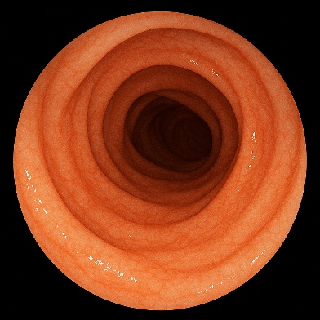
- Colon
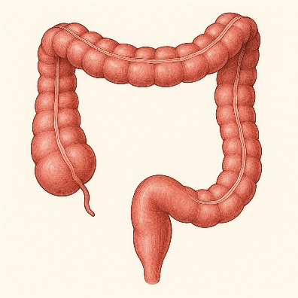
Impressions:

Normal Colonoscopy: The entire colon, from the cecum to the rectum, was visualized and appeared normal. There were no polyps, masses, diverticula, or evidence of inflammation.
Activity: You may feel tired and bloated for the rest of the day. It is important to rest. Do not drive, operate machinery, or make any important decisions for at least 24 hours. You must have a responsible adult stay with you for the remainder of the day. You may resume normal activities tomorrow.
Diet: You may resume your normal diet as tolerated. Start with clear liquids and light foods (e.g., soup, gelatin, crackers) and advance to a regular diet if you are not experiencing nausea or significant bloating. Avoid heavy, greasy, or spicy foods for the first 24 hours.
Follow-up: Based on the normal findings of your colonoscopy, your next routine screening colonoscopy is recommended in 10 years. We will send a reminder to you at that time. If you experience any severe abdominal pain, persistent nausea or vomiting, fever, or significant rectal bleeding, please contact our office immediately or go to the nearest emergency room.

