 |  | Coastal Gastroenterology Institute  200 Oceanfront Medical Plaza Charleston, SC 29401  Phone: (843) 555-2000  Fax: (843) 555-2001  Procedure Date: June 21, 2025
You have now completed your colonoscopy procedure, which was performed with the aid of intravenous sedation. The sedative medications are very effective but have lingering effects that will impair your judgment, motor skills, and memory for up to 24 hours. For your personal safety and well-being, it is imperative that you (and your designated escort) carefully review and follow these detailed post-procedure instructions.  IMMEDIATE POST-PROCEDURE SAFETY (Next 24 Hours)  These restrictions are not recommendations; they are mandatory for your safety.  Transportation and Escort: You must be driven home by a responsible adult. You are strictly forbidden from driving a vehicle, operating a bicycle, or taking public transportation (bus, taxi, rideshare) alone.  Constant Supervision: A responsible adult must remain with you for the remainder of the day and overnight. The effects of anesthesia can increase the risk of falls, confusion, and accidental injury. This person's role is to assist you and to seek medical help should any complications arise.  Restricted Activities: You must avoid all of the following activities for a full 24 hours:  Operating any machinery, including power tools, kitchen appliances, and lawn equipment. |  |  | - Normal Colon  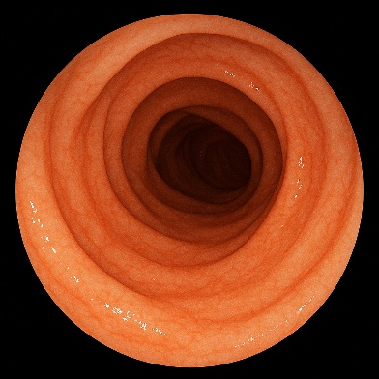
- Colon
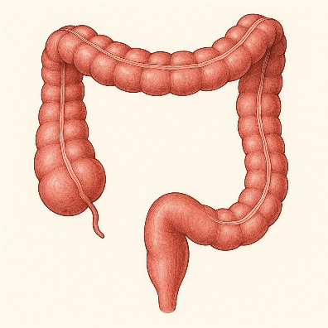
Impressions:

Negative Colonoscopy: Successful and complete colonoscopy to the terminal ileum. The quality of the bowel preparation was excellent, allowing for full mucosal visualization. There were no polyps, masses, inflammatory changes, or other abnormalities noted throughout the colon.
Procedure Findings: Your colonoscopy was entirely normal. No tissue samples (biopsies) were taken, so there will be no follow-up pathology report.
Follow-Up Schedule: Based on these normal findings and national guidelines, we recommend you repeat a screening colonoscopy in 10 years.

