 |  | Maple Valley Digestive Health Clinic  55 Green Mountain Way Burlington, VT 05401  Phone: (802) 555-6789  Fax: (802) 555-6790  Procedure Date: June 21, 2025
You have undergone a colonoscopy with sedation. The medication you received will impair your judgment and reflexes for the remainder of the day. For your safety, a responsible adult is required to drive you home and monitor you.  For the next 24 hours, you must not drive a car, operate machinery, or make any important legal or financial decisions. Please rest at home for the rest of today. You may resume your normal schedule tomorrow. It is normal to feel bloated or have gas pains; walking may help relieve this. |  |  | - Normal Colon  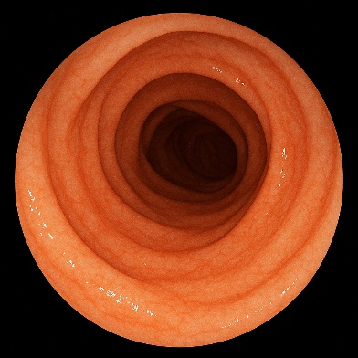
- Colon
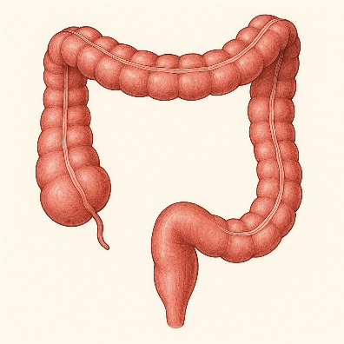
Impressions:

Normal Colonoscopy: The endoscope was advanced without difficulty to the cecum, which was identified by the appendiceal orifice. The bowel preparation was adequate for a complete mucosal evaluation. The entire visualized colon was found to be normal, with no polyps, inflammation, or other lesions identified.
Diet: Start with clear liquids or a light snack. You may advance to your regular diet as tolerated. Avoid alcoholic beverages for 24 hours.
Follow-Up: Since this screening examination was normal, your next routine colonoscopy is due in 10 years. No biopsies were taken.
Warning Signs: Please contact our office for non-urgent questions. Go to the nearest emergency room if you develop severe abdominal pain, a fever over 101°F, chills, or significant rectal bleeding.

